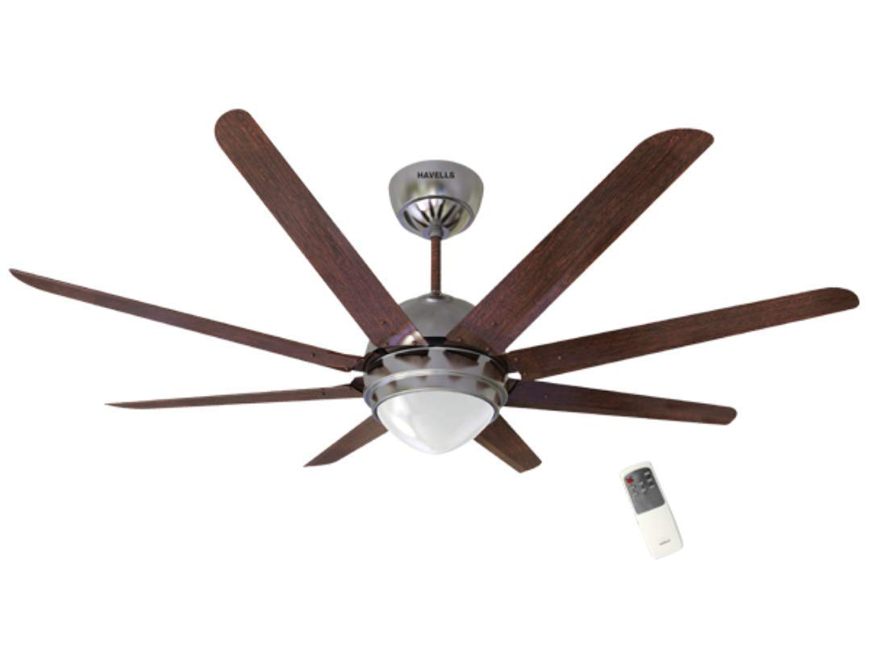

## Product description

Add a dash of elegance amalgamated with power, performance, comfort, safety and durability. The Havells ceiling fans are an imperative part of every home and are built to be energy efficient. Add a sense of style and exuberance to your rooms and offices with our innovative and trendy designs. With easy installation, our range of ceiling Fans is a fit and forget proposition. Ceiling Fans are an imperative part of any household. What you select for your house depicts your style and when people walk in through that door, Havells ceiling fans help you make an impression. The Fans for your roof come in different varieties. Embrace your choices with options like underlight Fans, energy saving fans, decorative fans, metallic Fans, high speed Fans, regular Fans. It is only with these appliances, that a house feels like home and we understand this. The biggest benefit with Havells Fans is that there is no compromise on the performance and the energy usage is always minimum. It is time you upgrade your homes with the most trendy and unique fans. Explore the range of fans online relaxing on the couch and make a statement.