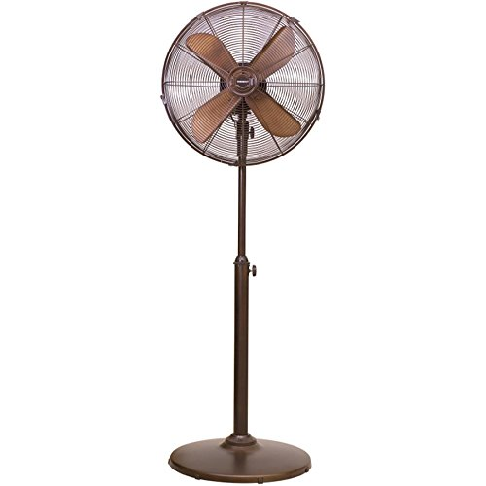

## Product description

full metal body with metal blades. it gives an antique looks