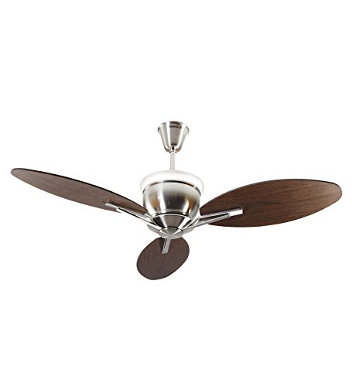

**Product description**

Havells entered fan business in mid-2003 and has emerged as one of the fastest growing fan brand in the Indian market. Havells has captured the customer's fancy with innovative designs and excellent finishes. From premium fans in exquisite antique finishes to fans specially designed for kids to dual color fans and high speed fans. Havells offers a complete range to meet varied individual needs.