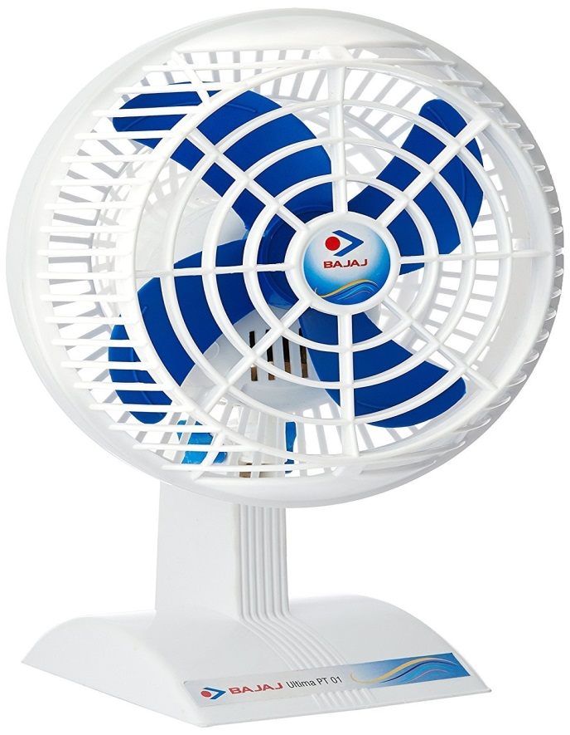

**Product description**

Bajaj ultima pt01 200 mm personal fan comes equipped with a powerful motor for higher air delivery. This high speed fan is fitted with aerodynamically designed pp blades. This fan?S great features and good looks makes it a great buy. Feature 1 : seek and stylish feature 2 : powerful motor for higher air delivery, specially designed for indian conditions. Feature 3 : aerodynamically designed pp blades brand : bajaj model : ultima pt01 table fan type : fans fan inch : 7.87 Sweep : 200 mm rpm : 2300 rpm air delivery : 50 cmm blades type : pp blades no. Of blades : 4 power consumption : 48 w power supply required : voltage 220-230 v ac 50 hz segment : economy additional features : an elegant high speed fan with modern looks, powerful motor for higher air delivery, specially designed for indian conditions, aerodynamically designed pp blades, compact design with powder coated guards sales package : unit, user manual, warranty card warranty : 1 year manufacturer warranty