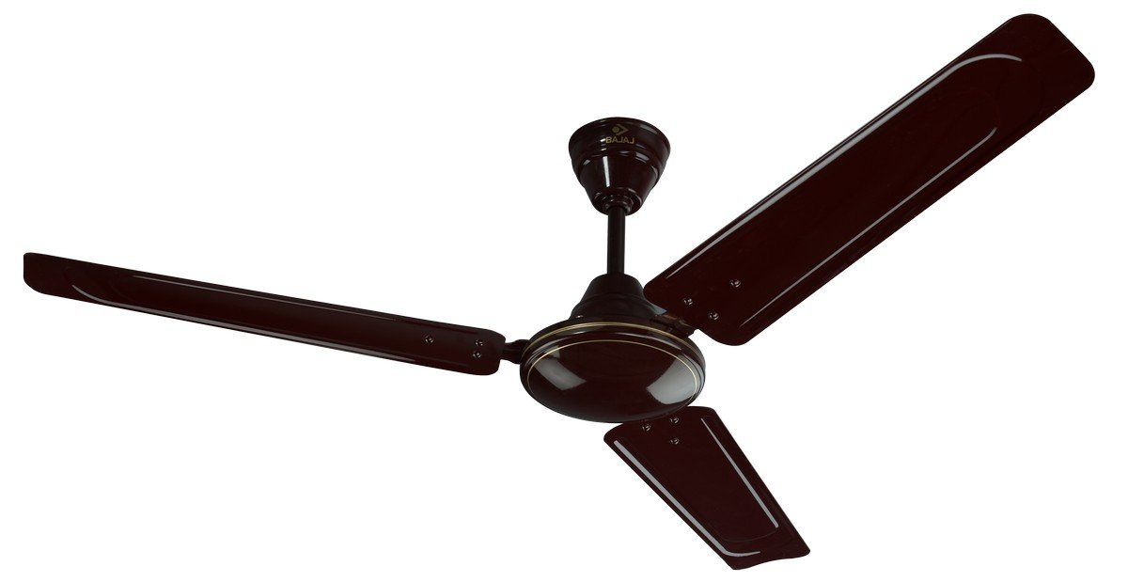

**Product description**

Known for speed, known for style, Bajaj Fans has something for every home, office and commercial space. Our wide offering include ceiling, pedestal, wall, table, exhaust and industrial fans. Our premium, economy and energy efficient ranges offer world class performance and looks absolutely stunning. We have something for the kids too with our specially designed Disney fans that will put a smile on every child's face. So adorn your home with Bajaj Fans today.