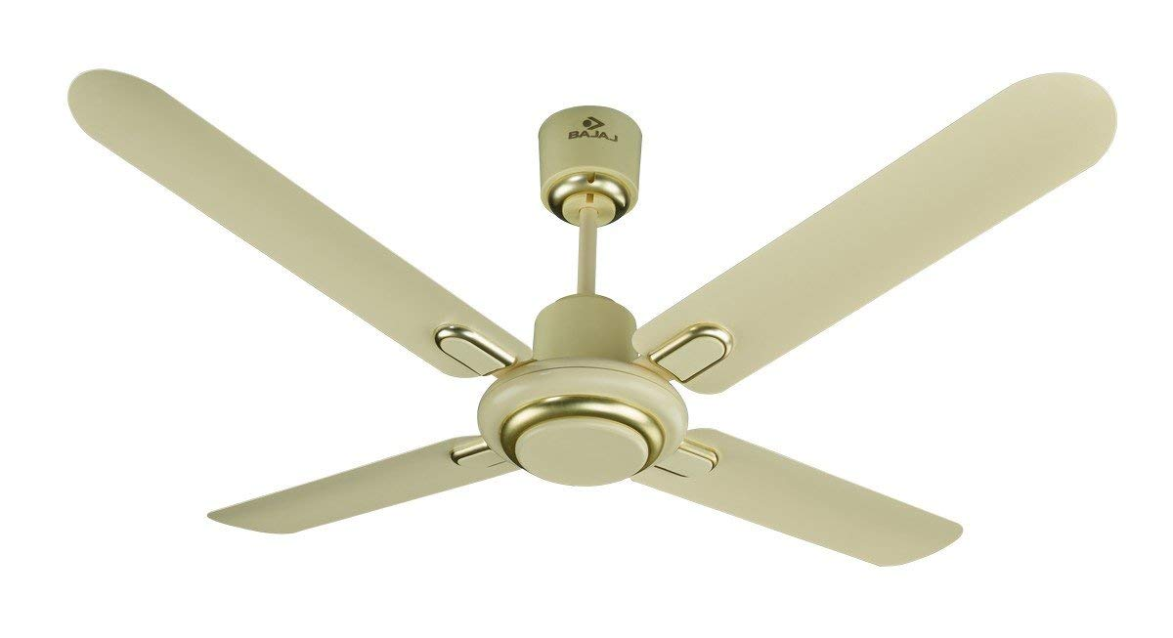

**Product description**

**Specification:**  
Color Family:-Ivory  
  
Rated Power (Watts):-65  
  
Minimum Air Delivery (CMM):-225  
  
Rated Speed (RPM):-330  
  
SWEEP SIZE (mm):-1200  
  
Warranty ( Years):-2  
  
No of Blades:-4  
  
Motor Box Dimension (lxhxw) (in mm):-233 x 215 x 231  
  
Blade Box Dimension (lxhxw) (in mm):-545 x 140 x 63