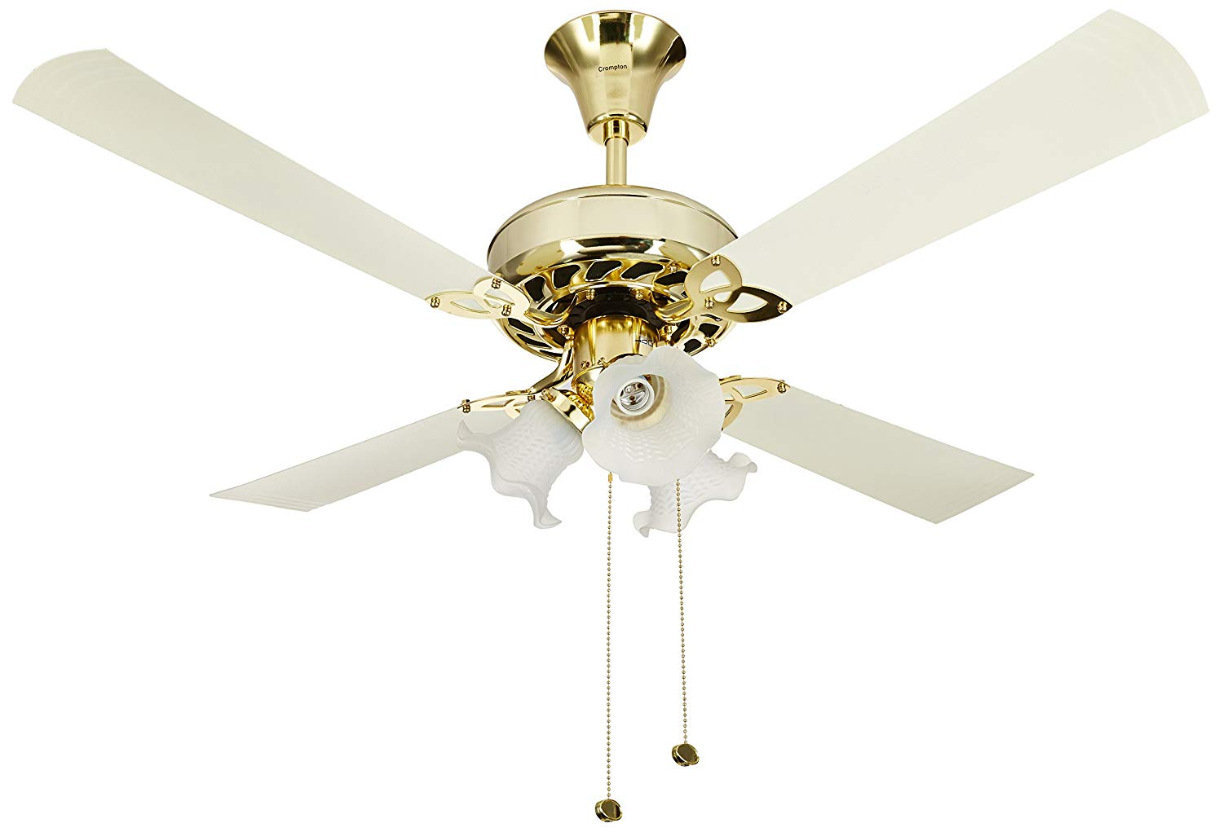

**Product description**

Color Name:**Ivory**

Ceiling fans have always been India’s go-to solution to beat the heat. As a cost-effective air circulator system, modern high speed ceiling fans not only help to keep your home cool and breezy, but can also add style to your room. Crompton’s range of ceiling fans offer the right balance of aesthetics and utility, and help to make sure that you stay cool, no matter what the weather. With easily adjustable speeds, Crompton’s range offers an option to fit any kind of aesthetic setting.   
Note: Incase of any issue with the product, kindly contact brand at 1800 419 0505 (9 am to 7 pm) Monday to Saturday.  
  
**Technical Specifications:**  
  
Sweep (mm):1200 mm  
  
Speed (RPM):320  
  
Air Delivery (cu.mtr/min):200  
  
Power Input (W):72