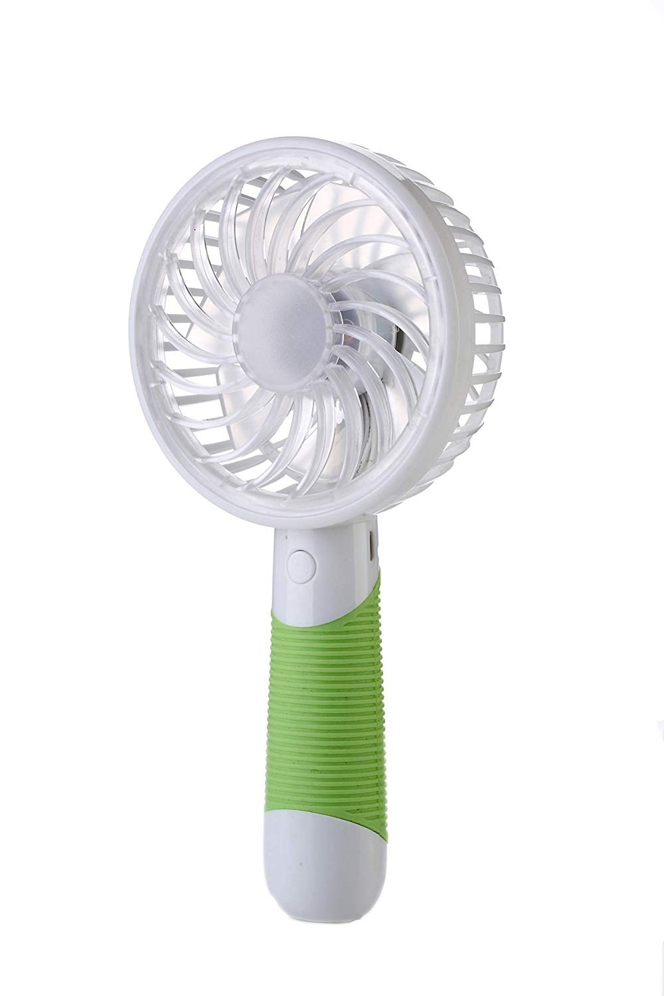

## Important information

##### Legal Disclaimer:

Our products have been well tested, examined and packaged before sending off. You can rest assured that your purchase at our store is guaranteed. Any problem please feel free to contact us first so that we can supply the best service for you.

## Product description

Color Name:**Green**

As temperatures start to rise and summer approaches,One can’t help but think about the question : "how can we best keep ourselves cool this summer?" This Portable, Rechargeable, Sleek Compact but very effective Mini Fan is the right Fit; you can carry it anywhere, use it anywhere as per your convenience. Though this product looks small and cute, its performance is simply surprising. It has 2 speed control and very good air throw. Product comes with Charging Cable and hanging cord; once fully charged it gives backup upto 3 hrs on Normal Speed and upto 2.5 hr on high speed.