Laptop prices prediction

Dataset:

-Link in Kaggle: [https://www.kaggle.com/datasets/mrsimple07/laptoppriceprediction)](%20https://www.kaggle.com/datasets/mrsimple07/laptoppriceprediction))

-Dataset descebtion:

The dataset emulates laptop prices, capturing various features commonly associated with laptops and their corresponding simulated prices. The dataset encompasses key attributes such as brand, processor speed, RAM size, storage capacity, screen size, and weight.

-dataset original shape(1000)

Wrangling & Preprocessing

-this data doesn’t contain null or duplicated values but have no value ‘0’ in coloumns .

Encoding:

-using LablEncoder

. before encoding:

S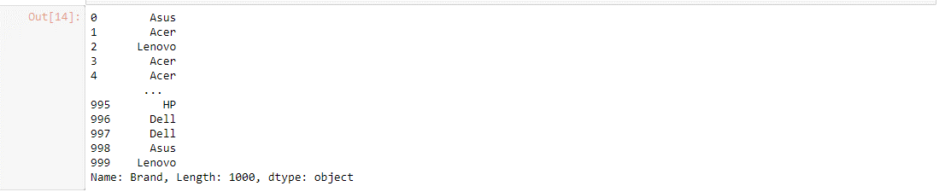

. after encoding:

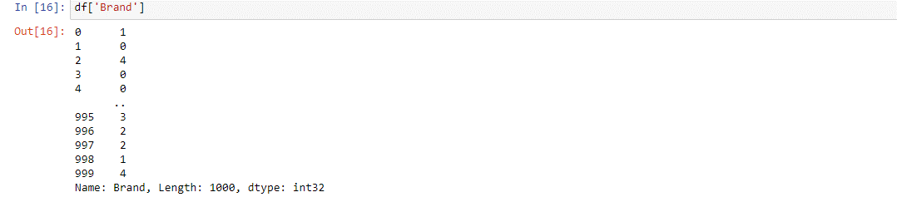

Checking correlation:

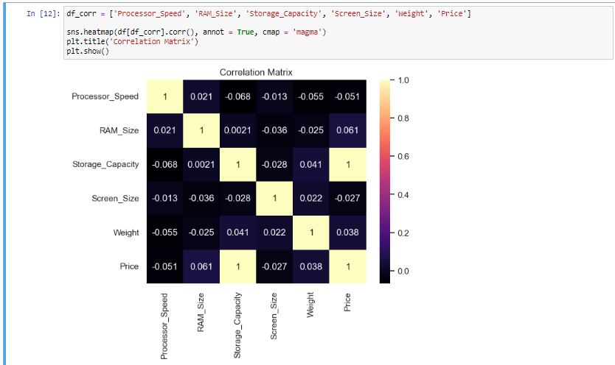

Normalizing:

-Using StandardScaler.

Splitting data:

Train and test with:test_size=0.2 and random_state=42.

Applying KFold with:

K=5 , shuffle=True,random_state=42.

X_train_fold.shape(640,6)

Y_train_fold.shape(600,)

X_test_fold.shape(160,6)

Y_test_fold.shape(160,)

Modeling:

Using SVR with parameters:

[c=1 , kernel=’rbf’ , gamma=’scale’]

Evaluation

Applying some metrics:

