Student Health Monitoring and Early Detection Using Machine Learning Techniques
Faculty of computer
University Malaysia Pahang
CB22021@adab.umpsa.edu.my
BCI3333: Machine Learning Final Project
TS DR NABILAH FILZAH MOHD RADZUAN

Abstract—This project presents the development of a machine learning-based solution for Student Health Monitoring and Early Detection within a smart campus environment. Using the Student Depression Dataset from Kaggle, the system is designed to identify students who may be at risk of depression based on academic, lifestyle, and psychological indicators. The dataset contains 27,901 records and 18 attributes, including age, gender, academic pressure, sleep duration, dietary habits, financial stress, family history of mental illness, and suicidal thoughts. The target variable is Depression, which makes the task suitable for binary classification. The project is developed using Python and will later be deployed as an interactive web application, allowing users to input student-related factors and receive early risk predictions. This approach demonstrates how machine learning can support early intervention, improve student well-being, and contribute to a healthier smart campus environment
- Analyze the Theme and Chosen Dataset for Future ML Model

The chosen theme for the project is Student Health Monitoring and Early Detection, which aims to detect potential health issues among students before they progress to a more severe stage. In a smart campus environment, this theme is of great significance as students are likely to experience academic stress, poor sleep habits, financial stress, and emotional issues that can impact their mental health and overall performance. Early detection is crucial as it will enable universities and support services to intervene early, give students counselling and enhance their well-being and academic success.
The Student Depression Dataset was chosen for this project because it is highly related to the selected theme, and it can be used for supervised machine learning classification. The data set has 27,901 observations and 18 variables, such as demographic, academic, behavioral, and psychological. These are Age, Gender, Academic Pressure, Work Pressure, CGPA, Study Satisfaction, Job Satisfaction, Sleep Duration, Dietary Habits, Work/Study Hours, Financial Stress, Family History of Mental Illness and the target variable Depression. The dataset is binary (depressed or not) making it suitable for the classification modelling and confusion matrix evaluation. The dataset is also suitable for feature selection and deployment due to the presence of both meaningful student-related indicators that can be used to predict mental health risk and a variety of noise.
Descriptive Analysis for the Selected Dataset:

Before developing the machine learning model, a descriptive analysis was conducted to learn about the structure and characteristics of the data. The dataset contains both numerical and categorical attributes, making it suitable for exploring student behavior, academic conditions, and lifestyle patterns. For numerical variables like age, academic pressure, CGPA, study satisfaction, job satisfaction, work/study hours, and financial stress, statistical measures like mean, minimum, maximum and standard deviation can be used to summarize. Categorical variables like gender, city, profession, sleep duration, diet, and family history offer valuable information for the groups themselves, that is, on a group level.
The dataset is very pertinent to the project as the majority of the data are about students and student-like academic scenarios. The depression class exists in both categories of the target variable, thus validating the binary prediction of the data set. The data has been described and it appears that there are several factors that could contribute to mental health risk that may not be directly attributable to one factor alone. This allows for the study of correlations between academic stress, sleep patterns and depression risk. Overall, the descriptive analysis indicates that the data is suitable for building a robust machine learning model for early detection of student health problems, given its diversity and structure.

- Identifying and handling the missing values

The isna() and sum() functions were used to find missing values in the data set. This method records the number of missing values for each column. The output indicates that there are no missing values in the attributes, except for the Financial Stress attribute, which has 3 missing values. This means that the dataset is very complete and can be used for further processing.
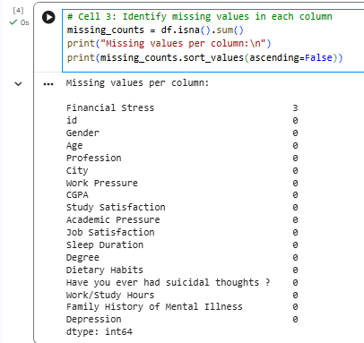

The exact location of the missing values was determined by filtering the rows where there was a missing value (df[df.isnull().any(axis=1)]. This will enable the incomplete observations to be looked at directly before deciding on an appropriate handling strategy.
The percentage of missing values was computed to assess the effect of missing data on the data set. The results revealed that the lost data were very small percentage of the data (about 0.01%). Hence, the missing values were assumed to be negligible.
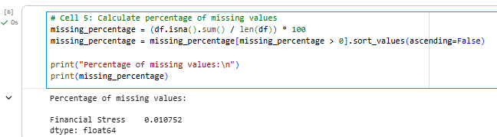

- Visualize Missing Values
A horizontal bar chart was created to make the missing values in the data more visible. The visualization verifies that there is missing data for the Financial Stress column, but no missing data for the other variables. This is in line with the choice of handling missing values with a simple method.
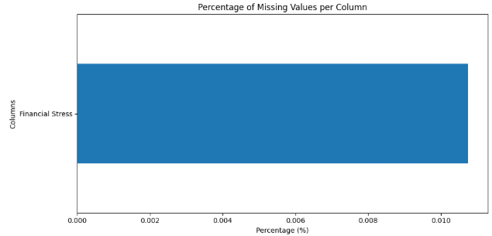

- Remove Missing Values
The dropna() function was used to eliminate the rows with missing values as only three of the records had missing values. The number of records removed was very small relative to the size of the data set. This method therefore allowed the data set to be maintained without introducing potential bias into the data set through imputation.
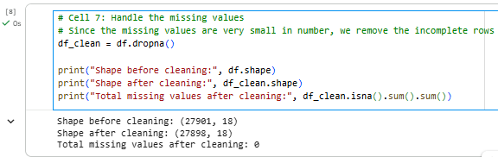

- Verify Cleaned Dataset
The cleaning process was then applied to the dataset and the data was inspected once again using isna().sum(). The results indicated that there were no missing values in any of the attributes. Hence, the data set was deemed suitable for preprocessing and machine learning modelling.

- MACHINE LEARNING MODELLING

To predict whether a student is experiencing depression (Yes/No), two supervised machine learning algorithms were applied:
- a. Random Forest Classifier
- b. Support Vector Machine (SVM)
Both models were trained and evaluated using the cleaned Student Depression Dataset after handling missing values and preprocessing the categorical variables. The objective of using two different classification techniques is to compare their predictive performance and determine the most suitable model for deployment in a student health monitoring application.

Machine Learning Preparation:
The necessary libraries were imported, such as Pandas for handling data, Scikit-learn for training and evaluating models, and Seaborn and Matplotlib for visualization and plotting.
pd.read_csv() was used to load the data set. The dataset includes several categorical variables like Gender, Sleep Duration, Dietary Habits, and Family History of Mental Illness, and label encoding was used to convert these categorical data into numerical data that can be used by machine learning algorithms.
The features (X) and target variable (y) were then separated. The independent variables are demographic, academic, lifestyle and psychological variables and the target variable is depression, which is a binary variable (0=No depression, 1=Depression).
The train_test_split() function was used to split the data into a training set and a testing set. The test size was chosen to be 20%, which means 80% of the data was used for training and 20% for testing. The results have been made reproducible by setting random_state=42.
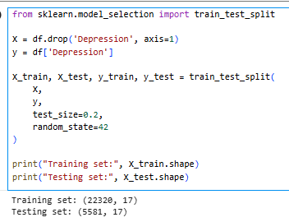

The data was split into training and testing sets using train-test split method. 80% of the data was used for training and 20% for testing. This way, the models are tested on data they have not seen before, giving a better sense of how well they will predict new data.
Model 1: Random Forest Classifier
Random Forest algorithm was chosen as the first classification model for this project. Random Forest is an ensemble learning method in which several decision trees are built at training time and their predictions are averaged to get the final prediction.
Random Forest was selected as it is robust to complex relationships between variables and numerous features in a structured dataset. It is also immune to overfitting, particularly compared to a single decision tree. Furthermore, Random Forest provides feature importance scores, which are beneficial for feature selection and model interpretation.
Random Forest can effectively model the interaction between academic stress, financial stress, sleep habits, lifestyle habits, and psychological factors, which are crucial in understanding the risk of depression among students. Thus, it is very applicable to binary classification problems, like to determine whether or not a student is depressed.
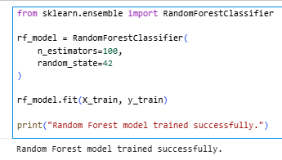
Initial 100 decision trees were used for the Random Forest classifier and the training set was used for training. To reproduce the experimental results, the parameter random_state=42 was used. In the training process, several decision trees were built from different partitions of the data set and the prediction was made based on the maximum voting method. This method helps to increase the accuracy of classification and avoid overfitting.

Model 2: Support Vector Machine (SVM)
The second machine learning algorithm chosen for this study was Support Vector Machine (SVM) classifier. SVM is a supervised learning algorithm that aims to find the best decision boundary (hyperplane) between classes that maximizes the margin between the classes. SVM was selected due to its solid theoretical base and good performance in binary classification.
This study has two classes, depressed and non-depressed students, making SVM an ideal choice for this task. Moreover, SVM can be used to process high dimensional data and it is able to generalize well to unseen data, thus it has good prediction performance. SVM can be used to classify students with high and low depression risk based on demographic data, academic status, lifestyle factors, and psychological factors, which has proven to be effective in the field of student health monitoring. Therefore SVM can be used as a good complementary model to Random Forest, which allows for a comprehensive comparison of various classification methods.

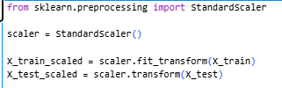

The numerical values of the input variables were standardized using the StandardScaler technique, which is known as feature scaling. This pre-processing step normalizes the features so that they have a mean of zero and standard deviation of one. Support Vector Machine uses distance calculation in the optimization process, thus standardization makes all features contribute equally to the training process of the model.
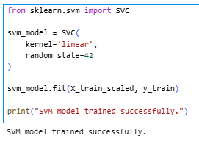
A linear kernel was used for training the Support Vector Machine (SVM) classifier. The linear kernel was chosen since it is efficient in terms of classification performance and yields a simple decision boundary that may be easily interpreted. The training phase algorithm determined the best hyperplane that can maximize the separation distance between depressed and non-depressed students.

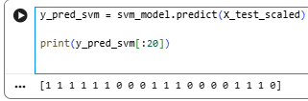

After the training process, Support Vector Machine model was used to predict the depression status of students in the test data. These results will then be used to assess the classification accuracy of the model using confusion matrices and performance metrics, similar to the Random Forest predictions.

1. Random Forest Confusion Matrix:

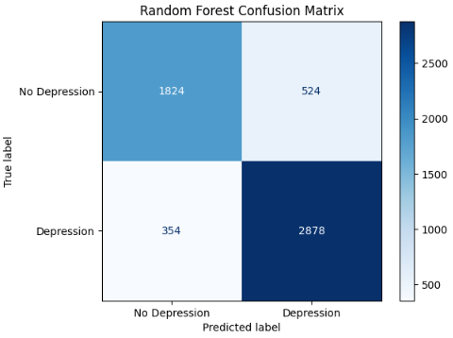
The confusion matrix was created to assess the classification accuracy of the Random Forest model. It computes the number of correct and incorrect predictions made by the model by comparing the labels predicted by the model with the true labels. The confusion matrix gives a detailed insight into the model's performance in identifying the depressed and non-depressed students.
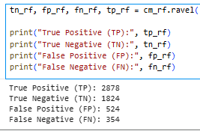

The confusion matrix was used to obtain the values of True Positive (TP), True Negative (TN), False Positive (FP) and False Negative (FN). The following values are used to compute a number of classification performance metrics.
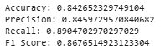
The four classification metrics, namely Accuracy, Precision, Recall, and F1-score were used for further evaluation of the Random Forest model. These metrics give a comprehensive perspective of the model's predictive capability from various angles.

2. SVM Confusion Matrix:

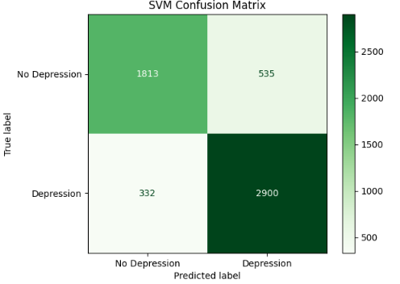
The classification performance of the Support Vector Machine model was evaluated by using a confusion matrix, like the Random Forest model. The confusion matrix shows the distribution of correct and incorrect predictions of the SVM classifier.
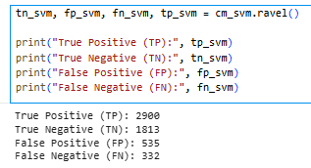
The values of the confusion matrix for the SVM model were retrieved to get the number of True Positive, True Negative, False Positive and False Negative predictions. These values were then used to calculate the evaluation metrics.
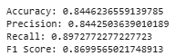

Accuracy, Precision, Recall and F1-score were used to evaluate the SVM model. These measures were used to evaluate the model's ability to detect students' depression.

Example of calculation for both (random forest & SVM):

Accuracy:
Accuracy = (TP + TN) / (TP + TN + FP + FN)
= (TP value + TN value) / Total Samples
= XXXX / XXXX
= 0.XXXX

Precision:
Precision = TP / (TP + FP)
= TP value / (TP value + FP value)
= 0.XXXX

Recall:
Recall = TP / (TP + FN)
= TP value / (TP value + FN value)
= 0.XXXX

F1 Score:
F1 Score = 2 × (Precision × Recall) / (Precision + Recall)
= 0.XXXX

Metric | Random Forest | SVM
Accuracy | 0.8426 | 0.8446
Precision | 0.8459 | 0.8442
Recall | 0.8904 | 0.8972
F1 Score | 0.8676 | 0.8699

- FEATURE SELECTION

A. Random Forest Feature Selection:
Random Forest naturally gives feature importance scores that indicate the contribution of each feature to the model's prediction. This approach was selected as it is directly applicable to the Random Forest model, and provides a straightforward means of determining the most important factors associated with student depression risk.
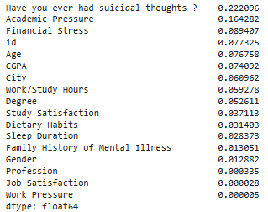

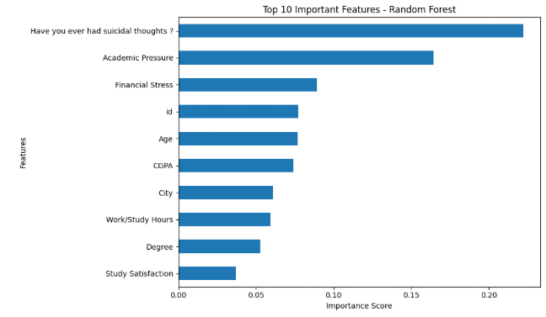

Random Forest model used feature importance as the feature selection method. This is a way of ranking the input variables in order of their importance to the prediction process. The results indicate which features are most influential in identifying a student's risk for depression. This method is appropriate for the Random Forest algorithm because it is a built-in feature of the algorithm and the scores are easy to interpret and reliable. The model is simplified to include only the most important variables, making it easier to interpret and less likely to contain unnecessary information.

B. Support Vector Machine (SVM) Feature Selection

The best approach for SVM is Recursive Feature Elimination (RFE). The method of RFE is to iteratively train the model and eliminate the least significant feature until the desired number of features is reached. This approach was selected because SVM does not directly give the importance of the features, and RFE is used to determine the most informative features for classification.
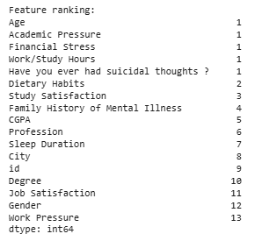

The feature selection method used for SVM model was Recursive Feature Elimination (RFE). The model is evaluated repeatedly, and the least useful variables are eliminated until the best subset of variables is reached. This approach is suitable for SVM since it will enable the selection of the most important variables to the classification boundary. The SVM is sensitive to irrelevant or weak features; RFE enhances the focus of the model, diminishes dimensionality, and enhances its generalization capabilities for unseen data.

- COMPREHENSIVE ANALYSIS FOR BOTH MODELS

Two machine learning models (Random Forest Classifier and Support Vector Machine (SVM)) were developed and then a comprehensive evaluation was performed to identify the best model for deployment in the Student Health Monitoring and Early Detection application.
The Random Forest Classifier is an ensemble learning algorithm that builds multiple decision trees and merges the results by majority voting. It can deal with complex relationships between variables and is robust to overfitting. The Random Forest model was trained with student demographic, academic, lifestyle and psychological attributes to predict depression in this project.
Support Vector Machine (SVM) is a supervised learning algorithm that finds the best hyperplane for separating different classes from the data with the widest possible margin. The second model chosen was SVM because of its ability to learn and generalize well and its effectiveness in binary classification. The same data set was used for training and the same performance measures were used for testing the model to ensure that the comparisons are fair.

The evaluation results of both models are presented in Table I.
Metric | Random Forest | SVM
Accuracy | 0.8426 | 0.8446
Precision | 0.8459 | 0.8442
Recall | 0.8904 | 0.8972
F1 Score | 0.8676 | 0.8699

Both models showed good predictive power in identifying students who were depressed, based on the results. Random Forest had slightly higher Precision, suggesting that it had a slightly better rate of avoiding false positive predictions. But the Support Vector Machine always outperformed with higher Accuracy, Recall and F1-score.
Recall is one of the most important evaluation metrics from a practical point of view in this study. A system's goal is to detect the students who might be suffering from depression as early as possible, so reducing the number of false negatives is crucial. A false negative prediction is when a student who is depressed is predicted to not be depressed, thus delaying intervention and support services.
The SVM model had the highest Recall value (89.72%), indicating that it was best at correctly identifying students who are experiencing depression. In addition, SVM had the best F1 score of 86.99% which shows the good balance between Precision and Recall. The higher value of the Accuracy also indicates that SVM performs more accurately in overall classification.
Hence, Support Vector Machine (SVM) model was chosen as the best model for deployment in this project. The model fits well with the main goal of student health monitoring systems, which is early identification and intervention rather than maximising prediction accuracy.
Random Forest also showed competitive performance, but SVM model is a better combination of the evaluation metrics for real-life use in the student health monitoring system. There is a need for periodic retraining and regular monitoring of the deployed model to ensure the predictive performance and to adjust to the possible changes in student behavioral patterns over time.

- DEPLOYMENT
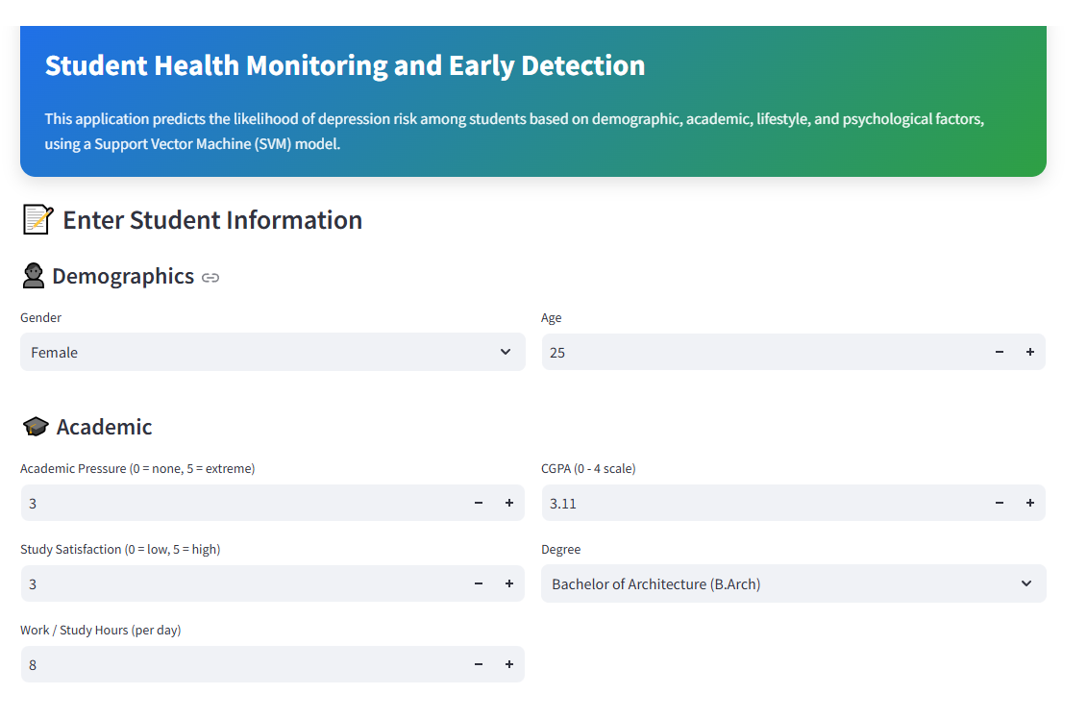
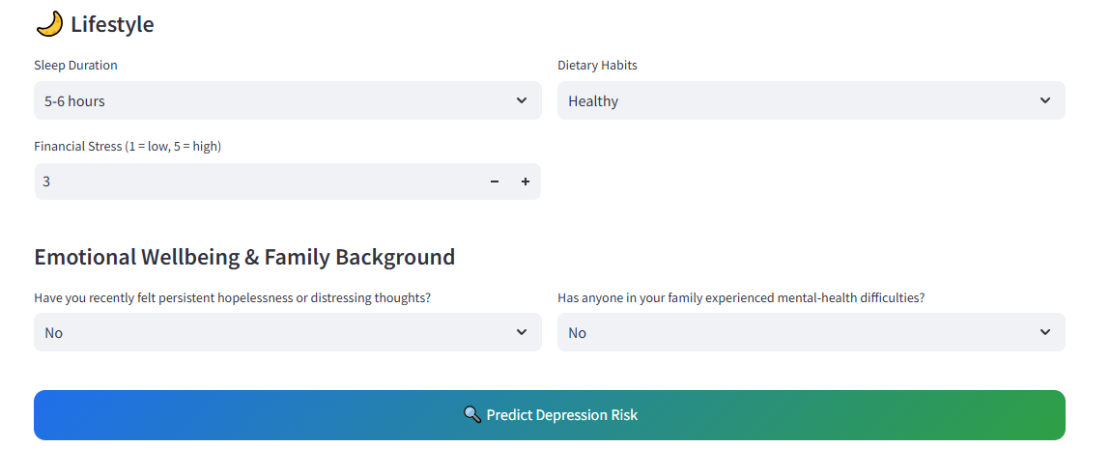
The Support Vector Machine (SVM) classifier was chosen as the final machine learning model to be used for deployment. The model was selected for its overall best performance, with the highest Accuracy, Recall, and F1-score compared to the other algorithms being tested. A Streamlit web app was built to make the trained model an interactive tool for students' health monitoring and early detection.
The Web App enables students to input their personal data such as demographic, academic, lifestyle and psychological data. Once the necessary information is entered, the application applies the same preprocessing methods as used when training the model to process the entered information and then provides a prediction of the student's depression risk.
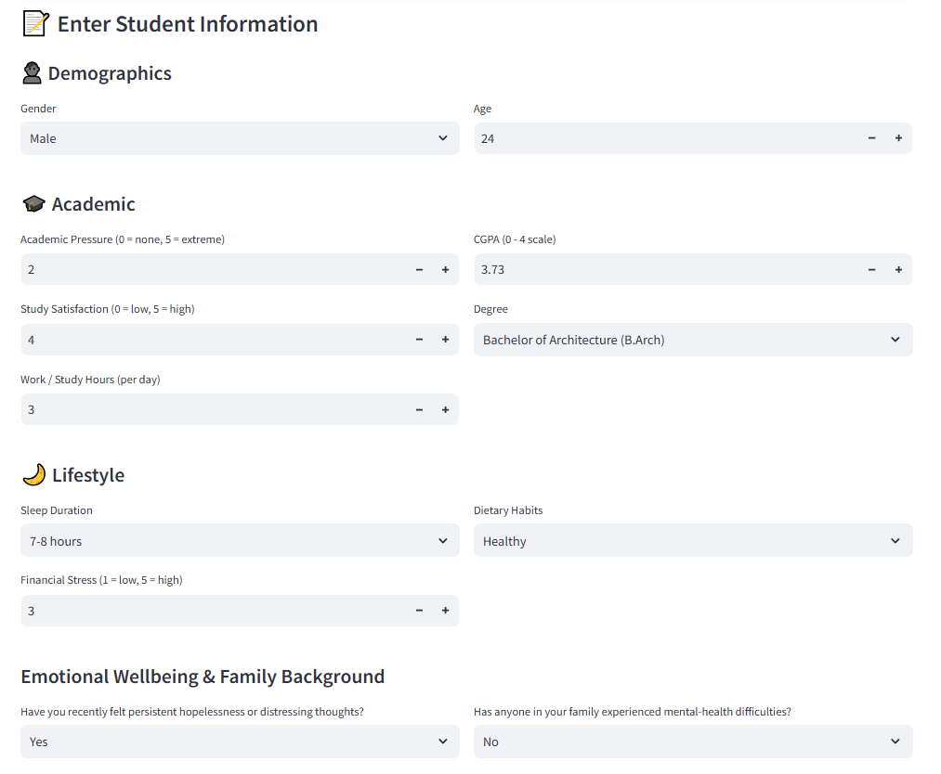
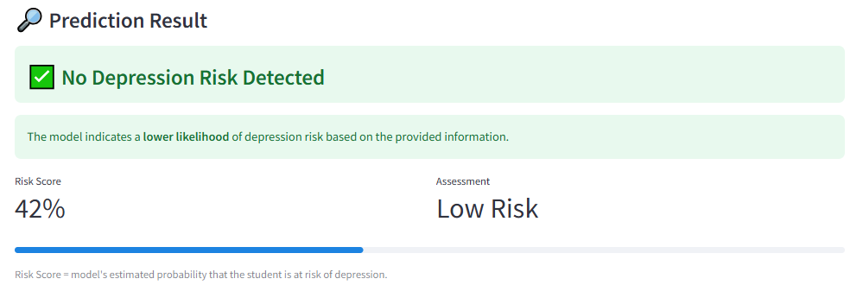
The application that is deployed gives real-time prediction results from the user inputs. When the model identifies a potential depression risk, a suitable warning message is issued. If not, the application shows that there was no risk of depression. This feature allows for quick screening and can aid in early intervention in schools.

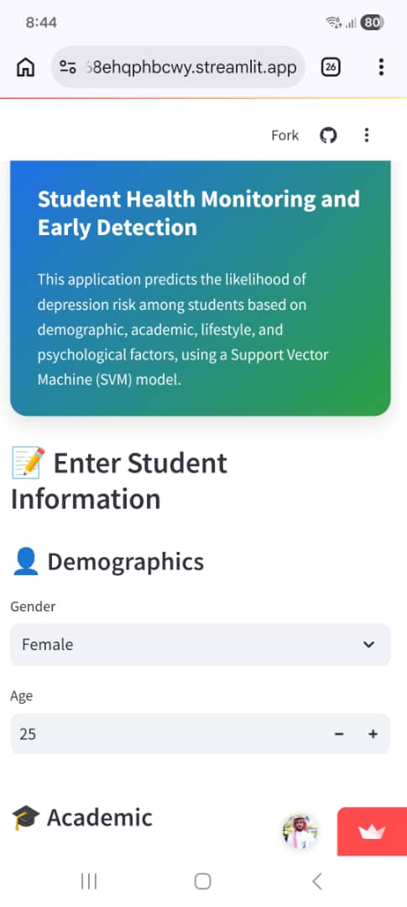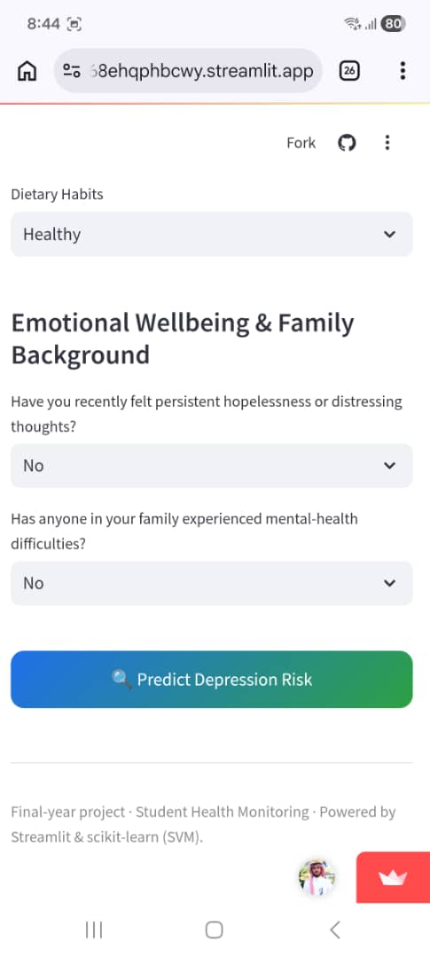

The application was developed to be responsive and work on different devices, such as tablets, smartphones, laptops, and desktop computers, for better accessibility. The user interface is responsive, allowing users to access the prediction system easily regardless of the platform they use, without compromising functionality or usability.

Deployment application:
Deployment URL: https://student-health-monitoring-zfavdyluty868ehqphbcwy.streamlit.app/

- Tools and Libraries Used
This project utilized several Python libraries to support the machine learning development process, including data preprocessing, model training, evaluation, and visualization.
A. Pandas
Pandas was used for data loading, manipulation, and preprocessing. The library facilitated the handling of missing values, dataset exploration, feature preparation, and transformation of the Student Depression Dataset prior to model training.
B. Scikit-learn
Scikit-learn was used as the primary machine learning library in this project. It was utilized for train-test splitting, feature scaling, Support Vector Machine (SVM) modelling, Random Forest modelling, feature selection, confusion matrix generation, and performance evaluation metrics such as Accuracy, Precision, Recall, and F1-score.
C. Matplotlib
Matplotlib was used to generate visualizations throughout the project. The library was applied to display missing value analysis, feature importance charts, and confusion matrices to assist in data exploration and model evaluation.

- CONCLUSION
This project developed a machine learning-based Student Health Monitoring and Early Detection system with the Student Depression Dataset with success. The data was preprocessed using techniques such as handling missing data, label encoding, feature scaling, and feature selection. Random Forest and Support Vector Machine (SVM) were used to train and test two classification algorithms to obtain confusion matrices and performance metrics.
The evaluation results showed that both models had good predictive performance. However, the SVM model achieved the highest accuracy, recall and f1 score, making it the most appropriate model to deploy. An online application was designed using Streamlit to enable users to enter student-related data and get instant depression risk prediction.
The proposed system shows the potential of using machine learning to assist in identifying students in need of mental health support early. There are opportunities for future enhancements such as the use of larger datasets, further psychological indicators and more sophisticated machine learning methods to further enhance predictive performance.
- References

- Kaggle: https://www.kaggle.com/ , https://www.kaggle.com/code/salehahmedsaleh/student-depression/input
- scikit-learn, https://scikit-learn.org/stable/
- Simplilearn, https://www.simplilearn.com/10-algorithms-machine- learning-engineers-need-to-know-article
- Augury, Machine Learning And AI In Manufacturing https://www.augury.com/blog/production-health/machine-learning-and- ai-in-manufacturing-a-quick-guide-to-the-fundamentals/
- Machine learning mastery, How to Choose a Feature Selection Method For Machine Learning, https://machinelearningmastery.com/feature- selection-with-real-and-categorical-data/
- Searche ngine journal , Streamlit Tutorial For SEOs, https://www.searchenginejournal.com/streamlit-tutorial-with-user- authentication-and-dockerfile/469205/
- Streamlit, https://streamlit.io/
- Simplilearn, https://www.simplilearn.com/10-algorithms-machine- learning-engineers-need-to-know-article

