PulseFit Gym
Documentation

1. Project Overview Document

Introduction to the project, its objectives, and scope
PulseFit is a modern, comprehensive MERN-stack web application developed to replace manual gym management processes (such as paper class sign-ups, cash tracking, and physical inventory counting) with a digitized, real-time platform.
- Objectives:
- Provide a responsive Member Portal for self-registration, active plan tracking, class booking, and gym market purchases.
- Provide a secure Admin Dashboard for operational oversight, managing users, scheduling classes, tracking equipment health, and monitoring financial/subscription KPIs.
Scope: The system covers user authentication (JWT), subscription logic (one active plan at a time), class capacity enforcement, inventory decrementing, and feedback loops. Native mobile applications and third-party payment gateways are explicitly out of scope; all transactions are assumed to be settled physically at the front desk while being recorded digitally.

Entities involved and their roles
1. Admin: Gym staff or managers. They have full access to `/api/admin/*` and standard routes. They can Create/Edit/Delete plans, classes, equipment, and products. They resolve feedback and view revenue stats.
2. Member: Authenticated users. They can hold one active subscription, book available class seats, reserve market products (which decrements digital stock), and submit feedback.
3. Guest: Unregistered visitors. They can browse the public-facing pages (Home, Plans, Classes, Market) but are intercepted by `ProtectedRoute` components when attempting to book or buy.

2. Functional Requirements Document (FRD)
Detailed description of the system's functionalities from a user perspective.

Function 1: Class Booking System
Members can view a calendar of upcoming fitness classes and reserve seats.
- - The system displays upcoming classes filtered by type (HIIT, Yoga, Strength) and intensity (low, moderate, high).
- - The backend rigidly enforces capacity limits. If `enrolled >= capacity`, the POST `/api/bookings` route returns a 400 Bad Request.
- - A compound unique index in MongoDB `{ userId: 1, classId: 1 }` prevents a user from booking the same class twice.
- - When a booking is cancelled, the class `enrolled` integer is decremented by 1.

Function 2: Subscription Management System
Manages the lifecycle of a member's gym access.
- - Members browse active plans sorted by price. Inactive plans are hidden via the `isActive: true` database filter.
- - A member can only hold ONE active subscription. Attempting to subscribe while an active plan exists triggers an API rejection.
- - Subscriptions calculate `endDate` dynamically upon creation by adding the plan's `durationDays` to the current `startDate`.
- - The `price` is snapshotted into the Subscription document so future plan price changes do not affect existing members.

Function 3: Gym Market Inventory (Bonus Extraction)
- - Members reserve products (e.g., Protein Powder) for front desk pickup.
- - Reserving immediately decrements the `stock` field in the Product document.
- - Admins change reservation status to 'picked_up' or 'cancelled'. Cancelling restores the stock count.

3. Technical Requirements Document (TRD)

Technical specifications covering architecture, components, and integrations
The application utilizes a decoupled architecture. The Frontend is a React 18 Single Page Application that communicates asynchronously with an Express.js REST API. State is managed globally via a React Context API (`AuthContext`), which securely parses and stores JWTs in localStorage. Axios interceptors are used to globally attach the `Authorization: Bearer <token>` header to all outbound protected requests and handle 401 Unauthorized responses by forcing a logout.

Infrastructure requirements & Server Configurations
- Server: Node.js runtime environment. Express server runs on port 5000.
- Database: MongoDB Atlas cloud cluster. Mongoose ODM is used to enforce schema strictness.
- Environment Variables: Requires `MONGO_URI`, `JWT_SECRET` (for signing tokens), `JWT_EXPIRE` (set to 7d), and `PORT`.

Development tools, frameworks, and libraries used
- Frontend Dependencies:
- react (v18.2): Core UI library.
- react-router-dom (v6.x): Client-side routing and protected route wrappers.
- axios: HTTP client for API interaction.
- lucide-react: Iconography suite.
- Backend Dependencies:
- express (v4.x): Web server framework.
- mongoose: Database modeling and validation.
- bcryptjs: Cryptographic hashing for user passwords.
- jsonwebtoken: Generating stateless authentication tokens.
- cors: Cross-Origin Resource Sharing middleware.
- dotenv: Loading environment variables.

Designing Architecture (Visualizations)
Architecture Diagram (Generated conceptually based on Mermaid logic):
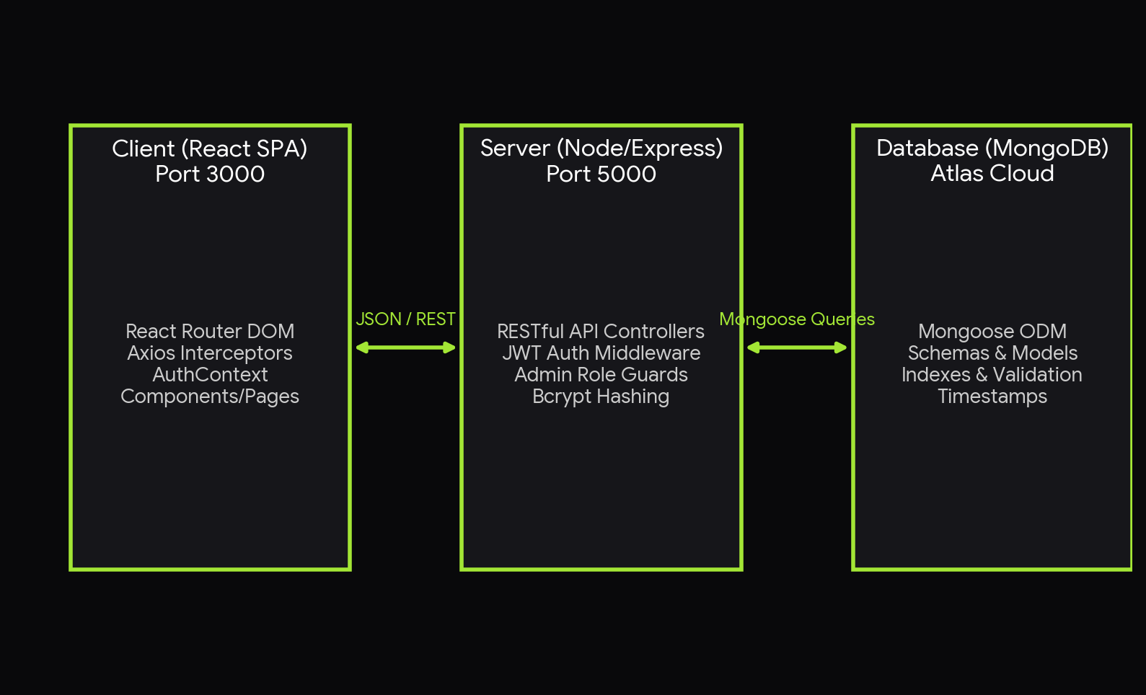
Sequence Diagram - Class Booking Flow:
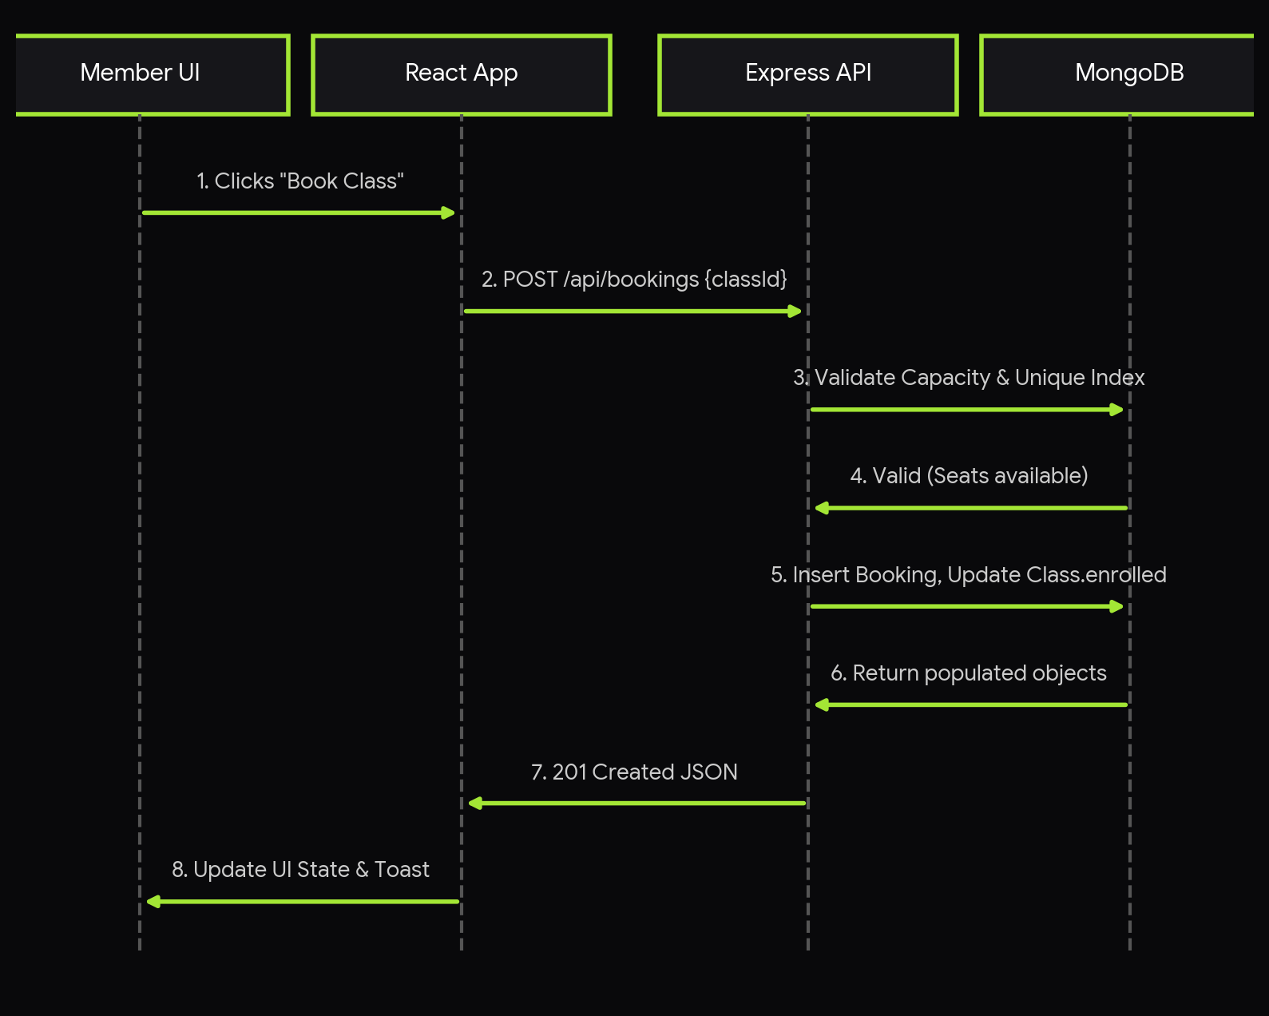
Original Mermaid Syntax for Architecture:
graph TB
Client[React App] --> Axios
Axios -- HTTP/JWT --> Express[Node/Express API]
Express --> Middleware[Auth/Admin Guards]
Middleware --> Controllers[REST Controllers]
Controllers --> Mongoose
Mongoose --> MongoDB[Atlas Cluster]

4. Database Schema Documentation
All collections use Mongoose timestamps (`createdAt`, `updatedAt`).

Collection: Users
Details: Constraints: email is UNIQUE. roles: 'member', 'admin'.
- - fullName: String, required
- - email: String, required, unique, lowercase
- - passwordHash: String, required (bcrypt)
- - phone: String, optional
- - role: String, default 'member'
- - status: String, default 'active'

Collection: Plans
Details: Constraints: category is enum.
- - title: String, required
- - description: String
- - price: Number, required
- - durationDays: Number, required
- - category: String, enum ['Drop-in', 'Monthly', 'Annual']
- - features: [String]
- - isActive: Boolean, default true

Collection: Subscriptions
Details: Relationships: FK to User, FK to Plan.
- - userId: ObjectId, ref 'User', required
- - planId: ObjectId, ref 'Plan', required
- - startDate: Date, required
- - endDate: Date, required
- - status: String, enum ['active', 'cancelled', 'expired'], default 'active'
- - price: Number, required (snapshotted)

Collection: Classes
Details: Constraints: intensity is enum.
- - name: String, required
- - instructor: String, required
- - type: String, required
- - scheduledAt: Date, required
- - durationMinutes: Number, required
- - capacity: Number, required
- - enrolled: Number, default 0
- - intensity: String, enum ['low', 'moderate', 'high']

Collection: Bookings
Details: Relationships: FK to User, FK to Class. UNIQUE compound index {userId, classId}.
- - userId: ObjectId, ref 'User', required
- - classId: ObjectId, ref 'Class', required
- - status: String, enum ['booked', 'cancelled'], default 'booked'

Collection: Products
Details: Gym Market items.
- - name: String, required
- - category: String, required
- - price: Number, required
- - stock: Number, default 0
- - imageUrl: String
- - isActive: Boolean, default true

Collection: ProductReservations
Details: Relationships: FK to User, FK to Product.
- - userId: ObjectId, ref 'User', required
- - productId: ObjectId, ref 'Product', required
- - productName: String, required (snapshotted)
- - price: Number, required (snapshotted)
- - status: String, enum ['reserved', 'picked_up', 'cancelled'], default 'reserved'

Collection: Equipment
Details: Internal tracking.
- - name: String, required
- - category: String, required
- - location: String, required
- - status: String, enum ['available', 'in_use', 'maintenance', 'retired']
- - notes: String

Collection: Feedbacks
Details: User feedback.
- - userId: ObjectId, ref 'User', optional
- - memberName: String, default 'Anonymous'
- - message: String, required
- - rating: Number, min 1, max 5, required
- - resolved: Boolean, default false

5. API Documentation
Documentation for integration with external systems about internal APIs used within the application. Adheres strictly to the requested Template.

Title: "Auth Register"
Description: Registers a new member account and issues a JWT token.
Base URL: http://localhost:5000/api
Endpoint: POST /auth/register — Returns user object and token.

Parameters (Query Strings / Body):
- fullName (required): String
- email (required): String
- password (required): String
- phone (optional): String

Response Structure (JSON):
- message: Success string.
- token: JWT Bearer token.
- user: Object containing id, fullName, email, role.

Example Section:
Request: POST /auth/register { "fullName": "John Doe", "email": "jdoe@test.com", "password": "Secret123!" }
Response (JSON):
{
"message": "User registered successfully",
"token": "eyJhbGciOiJIUzI1NiIsInR...",
"user": {
"id": "60d5ec...",
"fullName": "John Doe",
"email": "jdoe@test.com",
"role": "member"
}
}

Errors Section (HTTP Status Codes):
- 400 Bad Request: Missing parameters or email already in use.
- 500 Internal Server Error: Database write failure.
----------------------------------------

Title: "Auth Login"
Description: Authenticates a user using bcrypt comparison and issues a JWT.
Base URL: http://localhost:5000/api
Endpoint: POST /auth/login — Returns user object and token.

Parameters (Query Strings / Body):
- email (required): String
- password (required): String

Response Structure (JSON):
- message: Success string.
- token: JWT token.
- user: User object.

Example Section:
Request: POST /auth/login { "email": "jdoe@test.com", "password": "Secret123!" }
Response (JSON):
{
"message": "Login successful",
"token": "eyJhbGciOiJIUzI1NiIsInR...",
"user": {
"id": "60d5ec...",
"fullName": "John Doe",
"email": "jdoe@test.com",
"role": "member"
}
}

Errors Section (HTTP Status Codes):
- 400 Bad Request: Invalid email or password.
- 500 Internal Server Error.
----------------------------------------

Title: "Get All Plans"
Description: Retrieves gym membership plans.
Base URL: http://localhost:5000/api
Endpoint: GET /plans — Returns a list of plans.

Parameters (Query Strings / Body):
- all (optional): Boolean query. If true, returns inactive plans (Admin only).

Response Structure (JSON):
- Array of Plan objects. Each contains:
- id
- title
- description
- price
- durationDays
- category
- features
- isActive

Example Section:
Request: GET /plans?all=false
Response (JSON):
[
{
"_id": "60d1...",
"title": "Starter Pulse",
"description": "Basic access",
"price": 29,
"durationDays": 30,
"category": "Monthly",
"features": [
"Open gym"
],
"isActive": true
}
]

Errors Section (HTTP Status Codes):
- 500 Internal Server Error: Database timeout.
----------------------------------------

Title: "Create Plan (Admin)"
Description: Creates a new membership plan tier.
Base URL: http://localhost:5000/api
Endpoint: POST /plans — Returns the created plan.

Parameters (Query Strings / Body):
- title (required)
- price (required)
- durationDays (required)
- category (required)
- features (optional array)

Response Structure (JSON):
- message: Success string.
- plan: The newly created plan object.

Example Section:
Request: POST /plans (Requires Admin JWT) { "title": "Pro", "price": 49, "durationDays": 30, "category": "Monthly" }
Response (JSON):
{
"message": "Plan created",
"plan": {
"_id": "60d2...",
"title": "Pro",
"price": 49,
"durationDays": 30,
"category": "Monthly",
"isActive": true
}
}

Errors Section (HTTP Status Codes):
- 400 Bad Request: Schema validation failed.
- 401 Unauthorized: Token missing.
- 403 Forbidden: User is not an admin.
----------------------------------------

Title: "Subscribe to Plan"
Description: Binds a user to a plan. Snapshots price and calculates dates.
Base URL: http://localhost:5000/api
Endpoint: POST /subscriptions — Returns subscription object.

Parameters (Query Strings / Body):
- planId (required): ObjectId of the target plan.

Response Structure (JSON):
- message: Success string.
- subscription: Object with userId, planId, startDate, endDate, status, price.

Example Section:
Request: POST /subscriptions (Requires JWT) { "planId": "60d1..." }
Response (JSON):
{
"message": "Subscribed successfully",
"subscription": {
"_id": "sub1",
"userId": "usr1",
"planId": "60d1...",
"startDate": "2026-05-16",
"endDate": "2026-06-15",
"status": "active",
"price": 29
}
}

Errors Section (HTTP Status Codes):
- 400 Bad Request: User already has an active subscription.
- 404 Not Found: Plan does not exist.
----------------------------------------

Title: "Get Upcoming Classes"
Description: Retrieves the gym class schedule.
Base URL: http://localhost:5000/api
Endpoint: GET /classes — Returns an array of classes.

Parameters (Query Strings / Body):
- type (optional): Filter by class type (e.g., Yoga).
- intensity (optional): Filter by intensity.

Response Structure (JSON):
- Array of Class objects. Each contains:
- id
- name
- instructor
- type
- scheduledAt
- durationMinutes
- capacity
- enrolled
- intensity

Example Section:
Request: GET /classes?type=HIIT
Response (JSON):
[
{
"_id": "cls1",
"name": "Morning HIIT",
"instructor": "Marcus",
"type": "HIIT",
"scheduledAt": "2026-05-17T08:00:00Z",
"durationMinutes": 45,
"capacity": 20,
"enrolled": 15,
"intensity": "high"
}
]

Errors Section (HTTP Status Codes):
- 500 Internal Server Error.
----------------------------------------

Title: "Book a Class"
Description: Enrolls user in a class. Checks capacity and increments enrolled count.
Base URL: http://localhost:5000/api
Endpoint: POST /bookings — Returns booking confirmation.

Parameters (Query Strings / Body):
- classId (required): ObjectId of the class.

Response Structure (JSON):
- message: Success string.
- booking: Object containing userId, classId, and status.

Example Section:
Request: POST /bookings (Requires JWT) { "classId": "cls1" }
Response (JSON):
{
"message": "Booking successful!",
"booking": {
"_id": "bk1",
"userId": "usr1",
"classId": "cls1",
"status": "booked"
}
}

Errors Section (HTTP Status Codes):
- 400 Bad Request: Class is full, or user already booked this class.
- 404 Not Found: Class missing.

Title: "Cancel Booking"
Description: Updates booking status to cancelled and decrements class enrollment.
Base URL: http://localhost:5000/api
Endpoint: PATCH /bookings/:id/cancel — Returns updated booking.

Parameters (Query Strings / Body):
- id (path parameter): Booking ObjectId.

Response Structure (JSON):
- message: Cancellation string.
- booking: Updated booking object.

Example Section:
Request: PATCH /bookings/bk1/cancel (Requires JWT)
Response (JSON):
{
"message": "Booking cancelled",
"booking": {
"_id": "bk1",
"status": "cancelled"
}
}

Errors Section (HTTP Status Codes):
- 400 Bad Request: Already cancelled.
- 403 Forbidden: Booking belongs to another user.
- 404 Not Found.

Title: "Get Market Products"
Description: Retrieves inventory available for purchase.
Base URL: http://localhost:5000/api
Endpoint: GET /products — Returns array of products.

Parameters (Query Strings / Body):
- category (optional): Filter string.

Response Structure (JSON):
- Array of Product objects. Each contains:
- id
- name
- category
- price
- stock
- imageUrl
- isActive

Example Section:
Request: GET /products
Response (JSON):
[
{
"_id": "prod1",
"name": "Whey Protein",
"category": "Supplements",
"price": 39.99,
"stock": 10,
"isActive": true
}
]

Errors Section (HTTP Status Codes):
- 500 Internal Server Error.
----------------------------------------

Title: "Reserve Product"
Description: Reserves an item for front desk pickup. Decrements stock.
Base URL: http://localhost:5000/api
Endpoint: PATCH /products/:id/buy — Returns reservation receipt.

Parameters (Query Strings / Body):
- id (path parameter): Product ObjectId.

Response Structure (JSON):
- message: Instructions.
- product: Updated product object.
- reservation: Newly created reservation object.

Example Section:
Request: PATCH /products/prod1/buy (Requires JWT)
Response (JSON):
{
"message": "Reserved! Pay at front desk.",
"product": {
"_id": "prod1",
"stock": 9
},
"reservation": {
"_id": "res1",
"userId": "usr1",
"productId": "prod1",
"productName": "Whey Protein",
"price": 39.99,
"status": "reserved"
}
}

Errors Section (HTTP Status Codes):
- 400 Bad Request: Out of stock.
- 404 Not Found.
----------------------------------------

Title: "Get Equipment (Admin)"
Description: Retrieves internal gym asset tracking.
Base URL: http://localhost:5000/api
Endpoint: GET /equipment — Returns equipment list.

Parameters (Query Strings / Body):
- status (optional): Filter by available, in_use, maintenance.

Response Structure (JSON):
- Array of Equipment objects. Each contains:
- id
- name
- category
- location
- status
- notes

Example Section:
Request: GET /equipment (Requires Admin JWT)
Response (JSON):
[
{
"_id": "eq1",
"name": "Treadmill A",
"category": "Cardio",
"location": "Floor 1",
"status": "available",
"notes": ""
}
]

Errors Section (HTTP Status Codes):
- 401 Unauthorized
- 403 Forbidden
----------------------------------------

Title: "Submit Feedback"
Description: Submit a gym review/complaint. Public route, optional JWT.
Base URL: http://localhost:5000/api
Endpoint: POST /feedback — Returns feedback object.

Parameters (Query Strings / Body):
- message (required): String.
- rating (required): Number 1-5.
- memberName (optional): String.

Response Structure (JSON):
- message: Success string.
- feedback: Created feedback object.

Example Section:
Request: POST /feedback { "rating": 5, "message": "Great gym!" }
Response (JSON):
{
"message": "Feedback submitted",
"feedback": {
"_id": "fb1",
"rating": 5,
"message": "Great gym!",
"memberName": "Anonymous",
"resolved": false
}
}

Errors Section (HTTP Status Codes):
- 400 Bad Request: Missing message or invalid rating.
----------------------------------------

Title: "Get All Users (Admin)"
Description: Retrieves member list for admin dashboard.
Base URL: http://localhost:5000/api
Endpoint: GET /users — Returns user array.

Parameters (Query Strings / Body):
- search (optional): Regex query against fullName or email.

Response Structure (JSON):
- Array of User objects (password hashes excluded).

Example Section:
Request: GET /users?search=john (Requires Admin JWT)
Response (JSON):
[
{
"_id": "usr1",
"fullName": "John Doe",
"email": "jdoe@test.com",
"role": "member",
"status": "active"
}
]

Errors Section (HTTP Status Codes):
- 401 Unauthorized
- 403 Forbidden
----------------------------------------

