ggplot_hook

Yousuf

2023-01-23

## Setting up my environment

Notes: setting up my R environment by loading the ‘tidyverse’ and ‘palmerpenguiens’ packages

library(tidyverse)

## Warning: package 'tidyverse' was built under R version 4.2.2

## ── Attaching packages ─────────────────────────────────────── tidyverse 1.3.2 ──  
## ✔ ggplot2 3.4.0 ✔ purrr 0.3.4   
## ✔ tibble 3.1.8 ✔ dplyr 1.0.10  
## ✔ tidyr 1.2.0 ✔ stringr 1.4.1   
## ✔ readr 2.1.2 ✔ forcats 0.5.2

## Warning: package 'ggplot2' was built under R version 4.2.2

## Warning: package 'dplyr' was built under R version 4.2.2

## ── Conflicts ────────────────────────────────────────── tidyverse_conflicts() ──  
## ✖ dplyr::filter() masks stats::filter()  
## ✖ dplyr::lag() masks stats::lag()

library(palmerpenguins)

## Warning: package 'palmerpenguins' was built under R version 4.2.2

## Visualizations

Here we will go through a series of visualizations

### Flipper and body mass in purple

Here we plot a flipper length against body mass

ggplot(data = penguins,aes(x=flipper_length_mm,y=body_mass_g))+  
 geom_point(color="Purple")

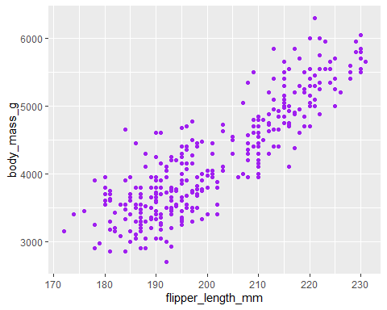

### Flipper and body mass by species

Here we plot a flipper length against body mass

ggplot(data = penguins,aes(x=flipper_length_mm,y=body_mass_g))+  
 geom_point(aes(shape=species))

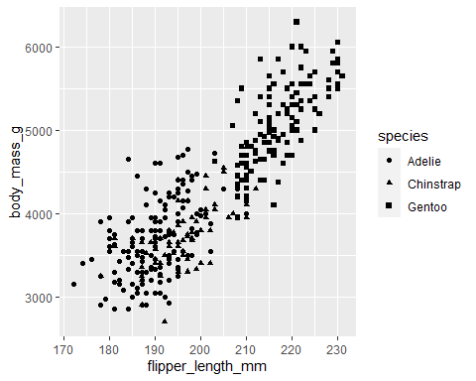

### Flipper and body mass by species and sex

Here we plot a flipper length against body mass

ggplot(data = penguins,aes(x=flipper_length_mm,y=body_mass_g))+   
 geom_point(aes(color=species, shape=species))+  
 facet_wrap(~sex)

