TASK 1
Single-Layer Perceptron vs Adaline
Classifying penguin species with two features at a time
Team ID: T17
Team members
# | Name | ID
1 | تسنيم مأمون شله | 2022170723
2 | تقى أحمد رجب قناوي | 2023170152
3 | لينه هشام محمد فاضل | 2023170459
4 | مريم سعيد فوزي | 2023170585
5 | يوسف محمد إبراهيم محمد | 2023170738
6 | يوسف كرم عبدالفضيل عبدالعال | 2023170736

1. Setup
For this task we classified pairs of penguin species using only two features at a time, and compared a single-layer Perceptron with an Adaline. Every number and plot in this report comes from one run of our final code on the supplied penguins.csv (150 penguins, 50 per species).
- Data. Two rows had missing measurements. We filled them with the average of the same species. OriginLocation was turned into numbers (Torgersen = 0, Biscoe = 1, Dream = 2).
- Train/test split. From each class we take 30 random samples for training and the other 20 for testing, so every experiment has 60 training and 40 test samples. The seed is fixed (42), so both algorithms see exactly the same samples.
- Normalization. Features are standardized (z-score) using the training mean and standard deviation only. The plots use the original units, so we convert the decision boundary back before drawing it.
- Settings. Learning rate 0.01, at most 300 epochs, MSE threshold 0.001, bias on, and small random starting weights (seed 42).
- Metrics. Accuracy and confusion matrix on the 40 test samples. One sample is worth 2.5 percentage points. In every title the first class is class A (+1, the positive class) and the second is class B (-1).
- How to read the plots. Filled circles are training points, hollow squares are test points, and the green line (with a star at each end) is the decision boundary.

2. How well does each feature separate the species?
Before looking at the plots, it helps to know how far apart the species are on each feature. Table 1 shows the difference between the two species averages divided by the spread within the species (the standard deviation). Roughly, a value above 2 means a clean split and a value below 1 means heavy overlap. It uses all 50 penguins of each species.
Class pair | Culmen Length | Culmen Depth | Flipper Length | Origin Location | Body Mass
Adelie vs Chinstrap | 3.46 | 0.27 | 1.22 | 1.57 | 0.11
Adelie vs Gentoo | 3.03 | 3.59 | 4.84 | 0.00* | 2.85
Chinstrap vs Gentoo | 0.45 | 3.46 | 3.26 | perfect** | 2.83
Table 1. How far apart each species pair is on each feature (difference of averages divided by standard deviation).
* Adelie lives on all three islands and Gentoo only on Biscoe (code 1). Both averages come out at 1.0 even though the distributions are different, so this number understates what location can tell us. It also shows that a 0/1/2 code is a poor way to store a category. ** Chinstrap only appears on Dream and Gentoo only on Biscoe, so the two never share a location value.
Three patterns explain most of what follows. Adelie vs Chinstrap is hard, because only bill length (and a little flipper length) differs. Gentoo is easy to separate from both other species: it is much heavier, has much longer flippers and a shallower bill. And OriginLocation is a special case: it says nothing useful about Adelie, who live everywhere, but it separates Chinstrap from Gentoo perfectly.

3. Summary of the ten combinations
We ran each combination with both algorithms. Together they cover all three species pairs and every feature, and they include both good and bad results.
# | Classes / features | Perceptron | Adaline | Verdict
1 | Adelie vs Gentoo / CulmenLength + FlipperLength | 100.0% | 100.0% | Good
2 | Adelie vs Gentoo / CulmenDepth + BodyMass | 100.0% | 100.0% | Good
3 | Adelie vs Gentoo / OriginLocation + BodyMass | 82.5% | 82.5% | Bad
4 | Adelie vs Chinstrap / CulmenLength + CulmenDepth | 100.0% | 100.0% | Good
5 | Adelie vs Chinstrap / CulmenLength + BodyMass | 90.0% | 100.0% | Medium
6 | Adelie vs Chinstrap / CulmenDepth + BodyMass | 50.0% | 55.0% | Bad (worst)
7 | Adelie vs Chinstrap / FlipperLength + BodyMass | 77.5% | 70.0% | Bad
8 | Chinstrap vs Gentoo / CulmenDepth + FlipperLength | 100.0% | 100.0% | Good
9 | Chinstrap vs Gentoo / CulmenLength + OriginLocation | 100.0% | 100.0% | Good (but a shortcut)
10 | Chinstrap vs Gentoo / FlipperLength + BodyMass | 92.5% | 92.5% | Medium
Table 2. Test accuracy (40 test samples). Green is 95% or more, yellow 80 to 94%, red below 80%.

4. Results and analysis for each combination

4.1 Adelie vs Gentoo: CulmenLength and FlipperLength (Good)
Perceptron: 100.0%  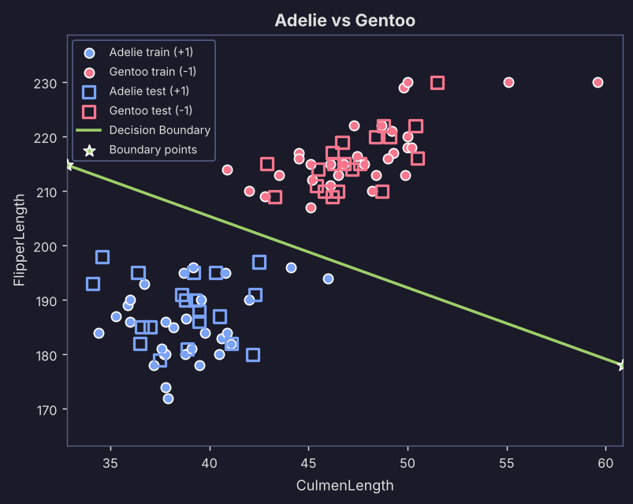 |  |  |  | Adaline: 100.0%  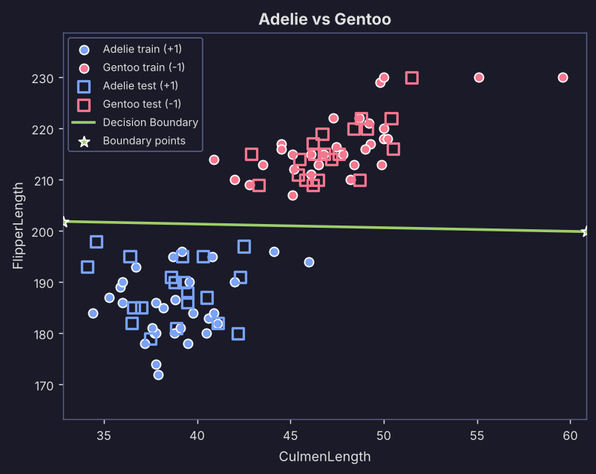
Figure 1. Decision boundary on the original feature scale, Adelie (+1) vs Gentoo (-1).
Algorithm | Test acc. | Train acc. | TN / FP / FN / TP |  | Train MSE | Val. MSE | Epochs
Perceptron | 100.0% | 100.0% | 20 / 0 / 0 / 20 |  | 0.000 | 0.000 | 1
Adaline | 100.0% | 100.0% | 20 / 0 / 0 / 20 |  | 0.068 | 0.078 | 300

The plot shows two tight, well-separated groups. Adelie sits in the lower left (short bills, short flippers) and Gentoo in the upper right. Flipper length does most of the work: Adelie flippers average about 187 mm and Gentoo about 216 mm. Bill length helps too, at roughly 39 mm against 48 mm.
Both models got all 40 test penguins right. The Perceptron finished in a single epoch and its weights barely moved from their random starting values, so the gap between the groups must be wide. Adaline also separates them, but its error levels off at about 0.07 on training data and 0.08 on test data and never reaches the 0.001 threshold. That is normal for Adaline. It measures its error on the raw output against targets of exactly +1 and -1, so it only hits zero if every point lands exactly on its target. The few Gentoo penguins with very long bills (55 to 60 mm) are far from the line and cause no trouble.

4.2 Adelie vs Gentoo: CulmenDepth and BodyMass (Good)
Perceptron: 100.0%  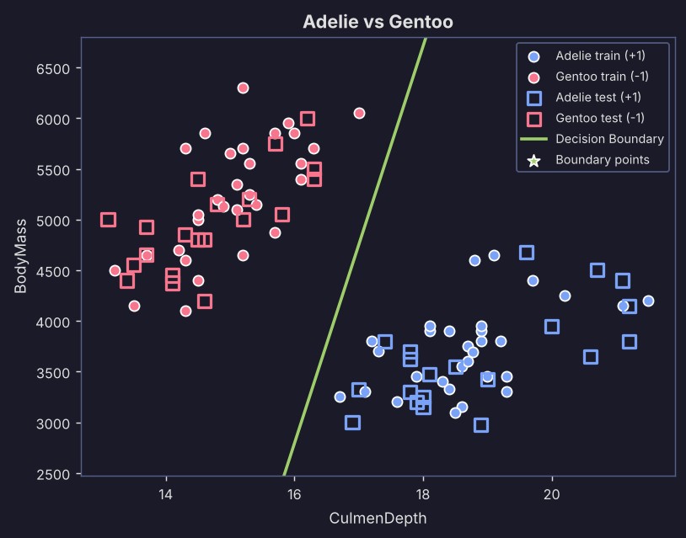 |  |  |  | Adaline: 100.0%  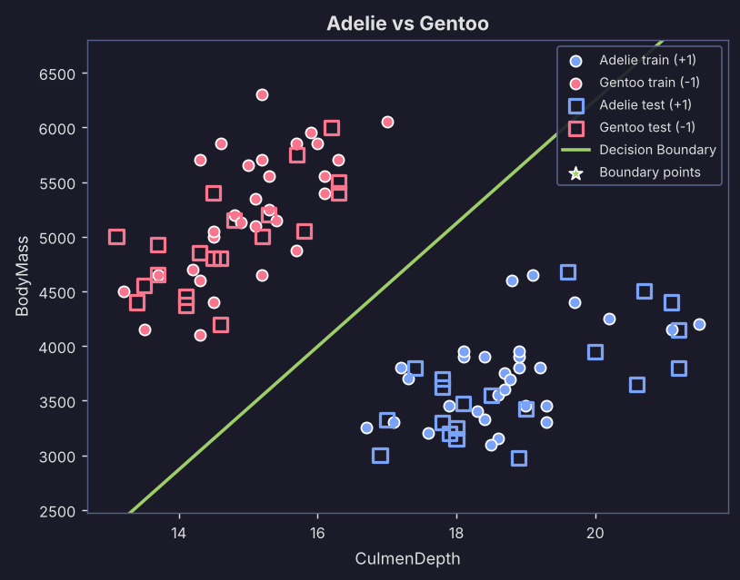
Figure 2. Decision boundary on the original feature scale, Adelie (+1) vs Gentoo (-1).
Algorithm | Test acc. | Train acc. | TN / FP / FN / TP |  | Train MSE | Val. MSE | Epochs
Perceptron | 100.0% | 100.0% | 20 / 0 / 0 / 20 |  | 0.000 | 0.000 | 1
Adaline | 100.0% | 100.0% | 20 / 0 / 0 / 20 |  | 0.033 | 0.037 | 300

Another easy case. Gentoo penguins are much heavier than Adelie (about 5,100 g against 3,700 g) and have shallower bills (about 15 mm against 19 mm). Either feature alone already separates them well, and together they leave a wide empty gap between the two groups.
Both models reach 100% on the test set. Adaline's final error (0.033 on training, 0.037 on test) is lower than in combination 1, which fits the wider gap: its output ends up closer to the +1 and -1 targets. It also uses both features at once, with weights of about +0.61 for CulmenDepth and -0.47 for BodyMass.

4.3 Adelie vs Gentoo: OriginLocation and BodyMass (Bad)
Perceptron: 82.5%  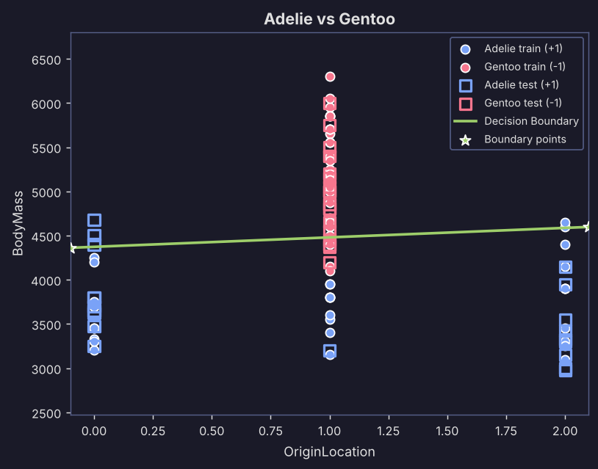 |  |  |  | Adaline: 82.5%  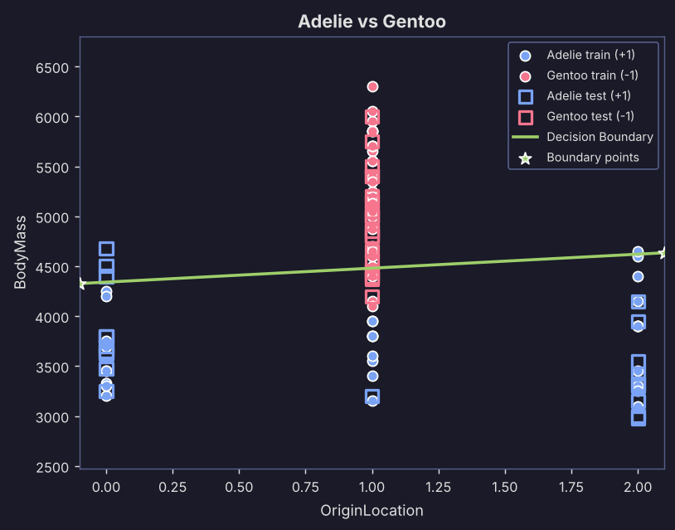
Figure 3. Decision boundary on the original feature scale, Adelie (+1) vs Gentoo (-1).
Algorithm | Test acc. | Train acc. | TN / FP / FN / TP |  | Train MSE | Val. MSE | Epochs
Perceptron | 82.5% | 91.7% | 16 / 4 / 3 / 17 |  | 0.167 | 0.350 | 300
Adaline | 82.5% | 93.3% | 16 / 4 / 3 / 17 |  | 0.150 | 0.200 | 300

This is our first clear failure, and the reason is the encoding. We turned OriginLocation into numbers (Torgersen = 0, Biscoe = 1, Dream = 2). Every Gentoo in the data was recorded on Biscoe, so all Gentoo points sit in one column at x = 1. Adelie penguins appear in all three columns. A straight line cannot pick out the middle value of a three-value code, so location alone cannot split these classes. The average code is 1.0 for both species, which is why its separation score is 0.00.
Both models end up with an almost flat boundary at around 4,400 to 4,500 g. They ignore location and decide on body mass alone (the BodyMass weight is roughly 8 to 10 times the OriginLocation weight). Light Adelie penguins are classified correctly, but the heaviest Adelie (4,200 to 4,700 g) are called Gentoo, and the lightest Gentoo (about 4,100 to 4,500 g) are called Adelie. Both models make the same mistakes: 16 TN, 4 FP, 3 FN, 17 TP, which gives 82.5%. The Perceptron also never settles (final training error 0.167, even though it was 0.133 at epoch 4) because the two classes cannot be separated by a line using these features.

4.4 Adelie vs Chinstrap: CulmenLength and CulmenDepth (Good)
Perceptron: 100.0%  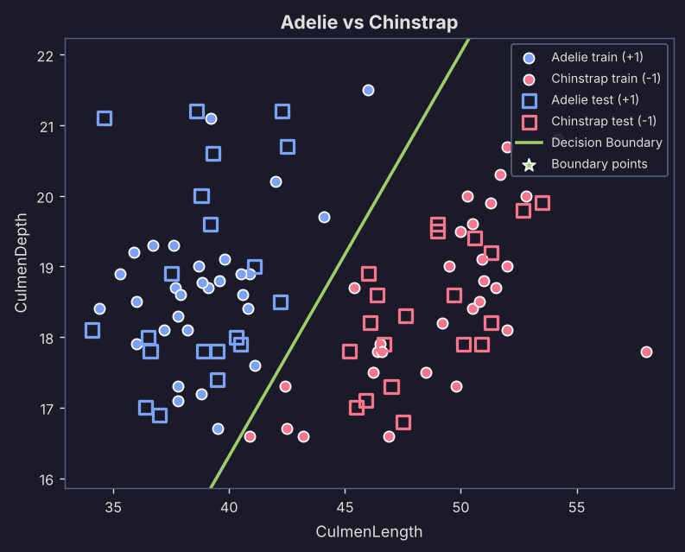 |  |  |  | Adaline: 100.0%  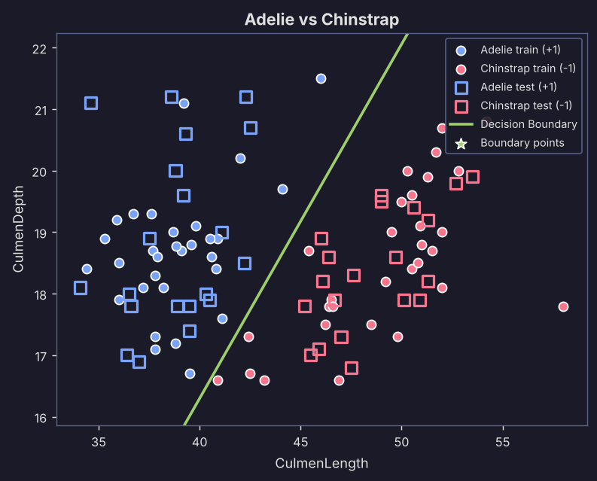
Figure 4. Decision boundary on the original feature scale, Adelie (+1) vs Chinstrap (-1).
Algorithm | Test acc. | Train acc. | TN / FP / FN / TP |  | Train MSE | Val. MSE | Epochs
Perceptron | 100.0% | 100.0% | 20 / 0 / 0 / 20 |  | 0.000 | 0.000 | 4
Adaline | 100.0% | 100.0% | 20 / 0 / 0 / 20 |  | 0.096 | 0.091 | 300

Adelie against Chinstrap is the hardest species pair, but bill length separates it cleanly. Chinstrap bills are about 10 mm longer (48.9 mm against 38.8 mm). Bill depth is almost useless here (18.8 mm against 18.5 mm), so the two groups sit side by side along the x axis and are completely mixed along the y axis.
Both models score 100% on the test set. The weights agree with the picture: Adaline puts a large weight on CulmenLength (-0.92) and a small one on CulmenDepth (+0.30), so the boundary is a steep line decided mostly by bill length. The Perceptron needed 4 epochs. This is the only Adelie vs Chinstrap pair where both models are perfect, which makes it our best choice for this species pair.

4.5 Adelie vs Chinstrap: CulmenLength and BodyMass (Medium)
Perceptron: 90.0%  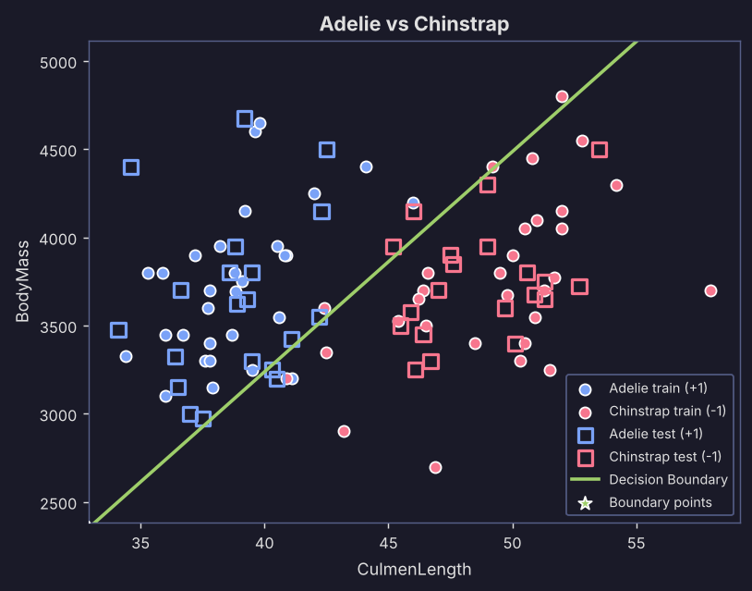 |  |  |  | Adaline: 100.0%  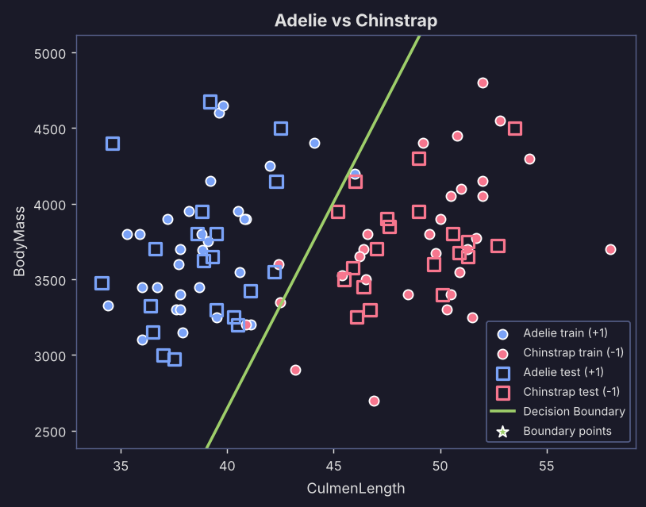
Figure 5. Decision boundary on the original feature scale, Adelie (+1) vs Chinstrap (-1).
Algorithm | Test acc. | Train acc. | TN / FP / FN / TP |  | Train MSE | Val. MSE | Epochs
Perceptron | 90.0% | 93.3% | 18 / 2 / 2 / 18 |  | 0.133 | 0.200 | 300
Adaline | 100.0% | 93.3% | 20 / 0 / 0 / 20 |  | 0.109 | 0.112 | 300

Bill length is still doing the work here, but it is now paired with body mass, which tells us almost nothing about these two species (3,696 g against 3,744 g on average). The groups overlap vertically and are offset horizontally, with a narrow zone between about 42 and 46 mm where a few Adelie and Chinstrap points meet.
This is the clearest example of the two algorithms disagreeing. Adaline draws a steep line at about 43 to 44 mm (weights -0.92 for CulmenLength and +0.25 for BodyMass) and scores 100%. The Perceptron ends with a tilted line that cuts diagonally through both groups and scores 90% (2 false positives and 2 false negatives). The MSE history in section 5 shows why. Because a few training points overlap, the Perceptron keeps making corrections and its training error jumps between 0.03 and 0.17 from one epoch to the next. Our code keeps the weights from the last epoch, and that one happened to be a bad one (the best was epoch 26, at 0.033). Adaline updates smoothly and does not have this problem. Both models get the same share of the training set right (93.3%), so Adaline's perfect test score is partly down to a lucky split.

4.6 Adelie vs Chinstrap: CulmenDepth and BodyMass (Bad (worst))
Perceptron: 50.0%  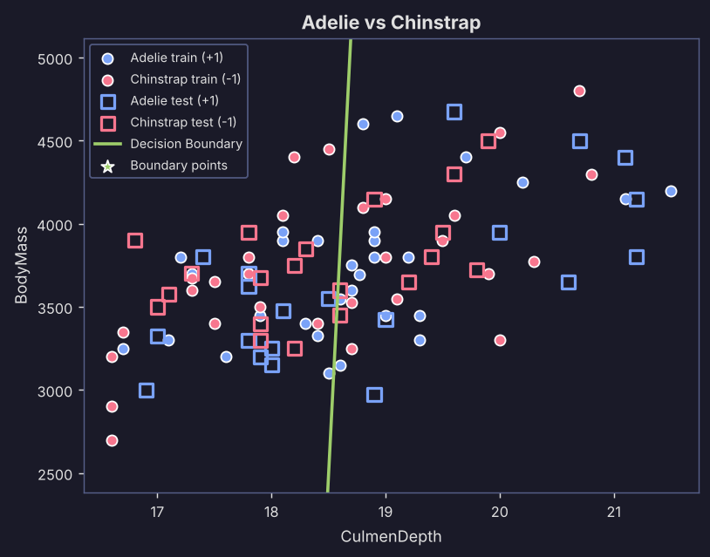 |  |  |  | Adaline: 55.0%  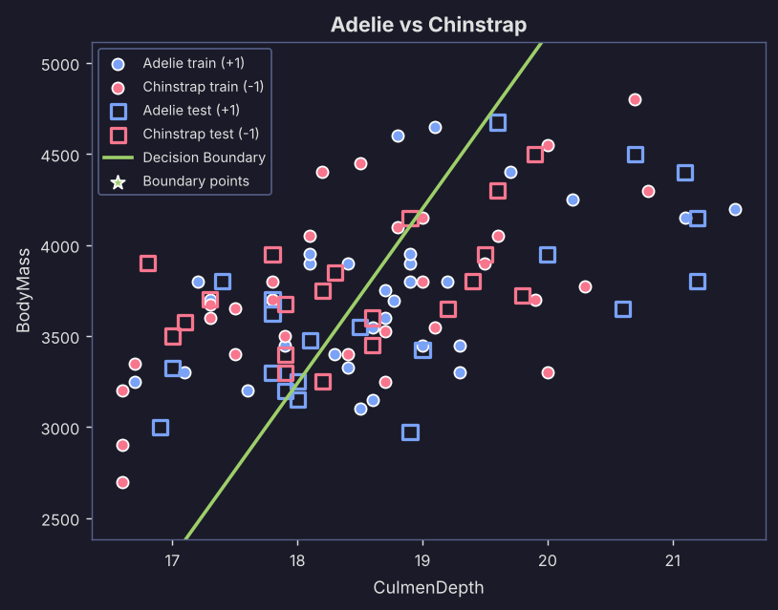
Figure 6. Decision boundary on the original feature scale, Adelie (+1) vs Chinstrap (-1).
Algorithm | Test acc. | Train acc. | TN / FP / FN / TP |  | Train MSE | Val. MSE | Epochs
Perceptron | 50.0% | 56.7% | 11 / 9 / 11 / 9 |  | 0.867 | 1.000 | 300
Adaline | 55.0% | 58.3% | 11 / 9 / 9 / 11 |  | 0.494 | 0.469 | 300

This is the worst combination in the whole study. Neither feature separates Adelie from Chinstrap: bill depth differs by only 0.3 mm on average and body mass by about 50 g, which is tiny next to the spread within each species. Red and blue points are completely mixed, and no straight line can do better than guessing.
The Perceptron scores 50% (11 TN, 9 FP, 11 FN, 9 TP, a coin flip) and Adaline 55%. The Perceptron's line is almost vertical at about 18.5 mm, and its training error stays high for all 300 epochs (0.73 at best, 0.87 at the end). Adaline's final error is 0.49, very close to 0.5, which is the error you would get by always predicting 0 for targets of +1 and -1. So Adaline learned almost nothing beyond the average. This is what two features with no useful information look like.

4.7 Adelie vs Chinstrap: FlipperLength and BodyMass (Bad)
Perceptron: 77.5%  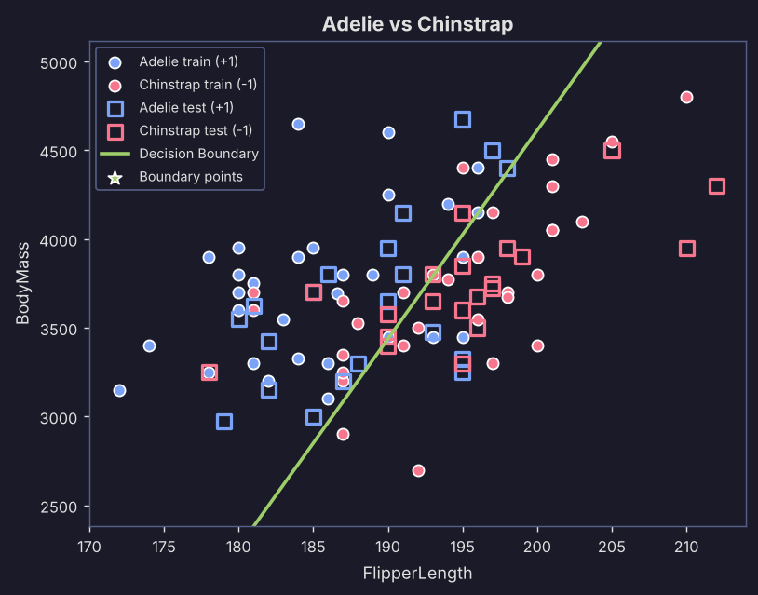 |  |  |  | Adaline: 70.0%  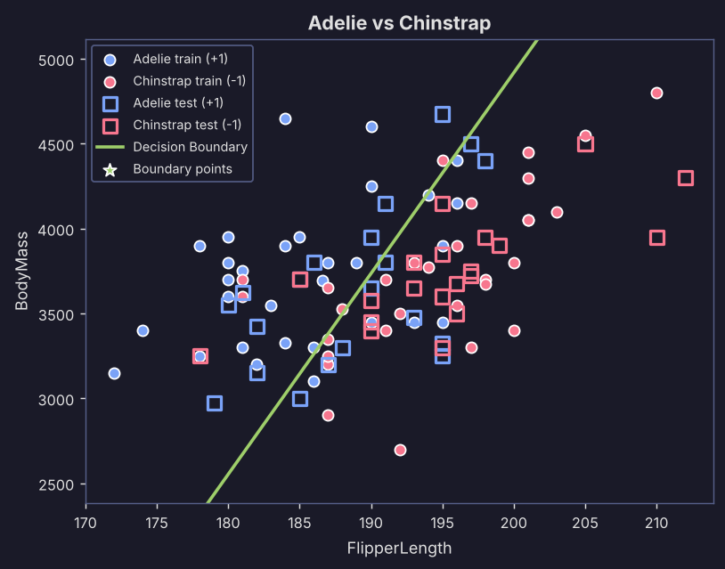
Figure 7. Decision boundary on the original feature scale, Adelie (+1) vs Chinstrap (-1).
Algorithm | Test acc. | Train acc. | TN / FP / FN / TP |  | Train MSE | Val. MSE | Epochs
Perceptron | 77.5% | 78.3% | 14 / 6 / 3 / 17 |  | 0.433 | 0.450 | 300
Adaline | 70.0% | 78.3% | 18 / 2 / 10 / 10 |  | 0.296 | 0.398 | 300

Flipper length gives a weak hint for this pair (Chinstrap flippers average about 195 mm against 187 mm for Adelie), and body mass adds nothing. The groups overlap heavily and the best a line can do is a tilted split with plenty of mistakes.
The Perceptron reaches 77.5% (14 TN, 6 FP, 3 FN, 17 TP) and Adaline 70% (18 TN, 2 FP, 10 FN, 10 TP). This is one of the few cases where the Perceptron wins. Adaline's results lean heavily one way: it labels most borderline penguins as Chinstrap and misses 10 of the 20 Adelie (recall 0.50). Adaline tries to minimize squared error, not the number of wrong answers, so its line can be a good least-squares fit and still a worse classifier. Extreme points such as the Chinstrap at 4,800 g and the Adelie at about 4,650 g probably pull it that way. A lower MSE does not always mean a higher accuracy.

4.8 Chinstrap vs Gentoo: CulmenDepth and FlipperLength (Good)
Perceptron: 100.0%  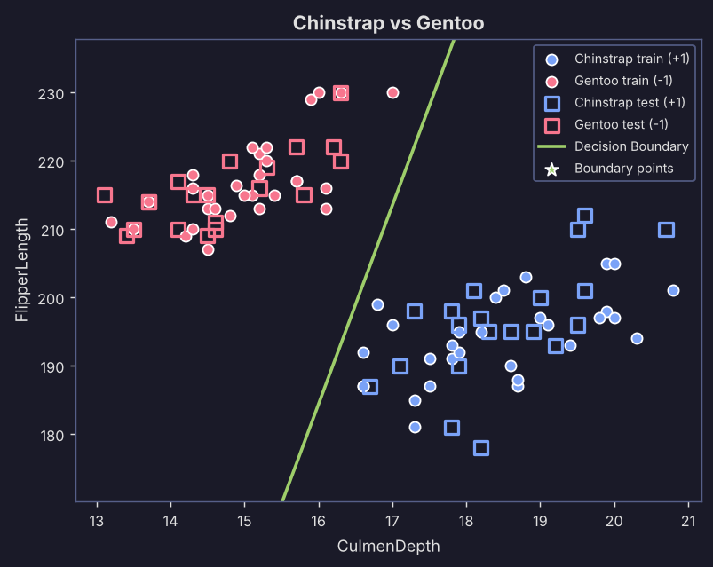 |  |  |  | Adaline: 100.0%  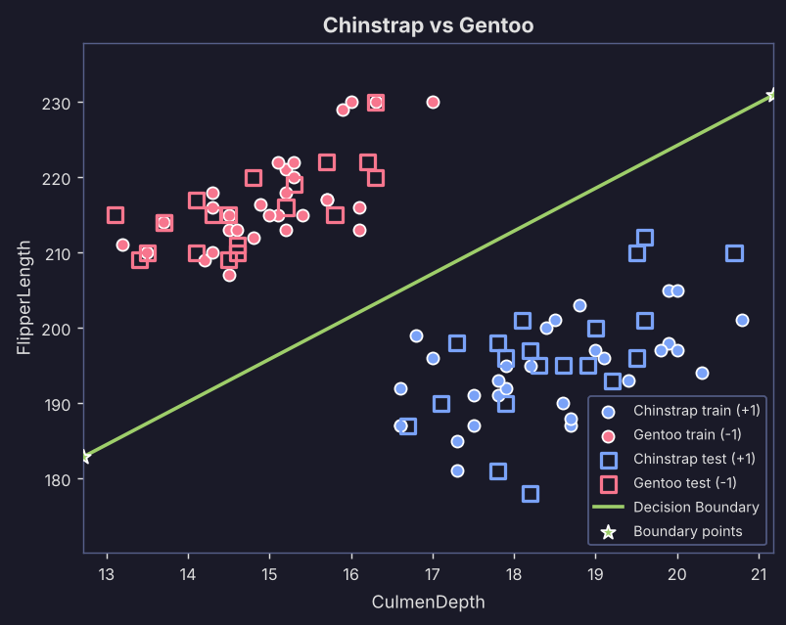
Figure 8. Decision boundary on the original feature scale, Chinstrap (+1) vs Gentoo (-1).
Algorithm | Test acc. | Train acc. | TN / FP / FN / TP |  | Train MSE | Val. MSE | Epochs
Perceptron | 100.0% | 100.0% | 20 / 0 / 0 / 20 |  | 0.000 | 0.000 | 1
Adaline | 100.0% | 100.0% | 20 / 0 / 0 / 20 |  | 0.029 | 0.034 | 300

Chinstrap and Gentoo differ a lot on both axes. Gentoo bills are shallower (14.9 mm against 18.5 mm) and Gentoo flippers are much longer (216 mm against 195 mm). The plot shows two well-separated groups, Chinstrap at the upper left and Gentoo at the lower right.
Both models reach 100% on the test set, and the Perceptron needed only one epoch. Adaline's final error (0.029 on training, 0.034 on test) is the lowest of any run where Adaline used all 300 epochs, which suggests this pair has the widest gap of all the combinations we tried. Adaline gives the two features almost equal and opposite weights (+0.51 and -0.58), so it is effectively comparing bill depth with flipper length.

4.9 Chinstrap vs Gentoo: CulmenLength and OriginLocation (Good (but a shortcut))
Perceptron: 100.0%  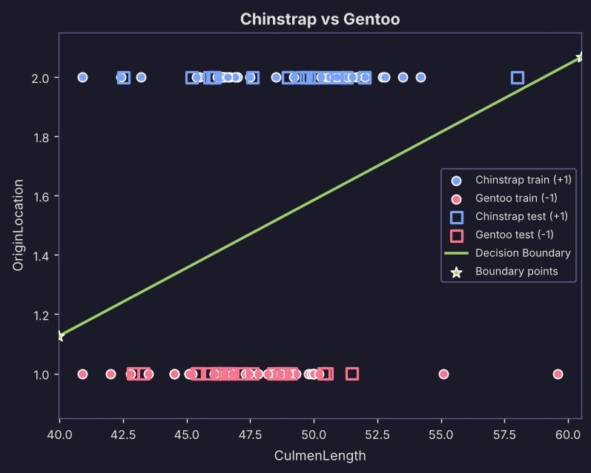 |  |  |  | Adaline: 100.0%  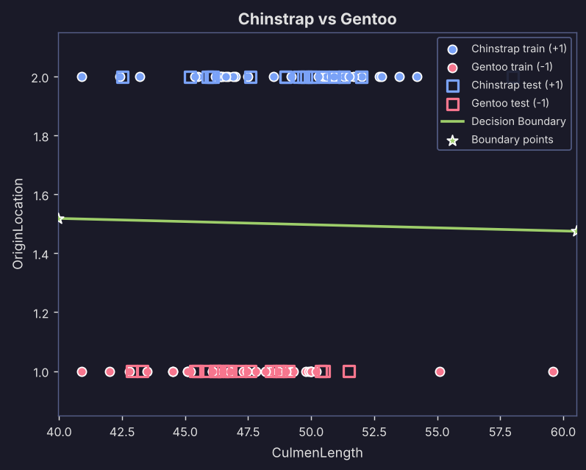
Figure 9. Decision boundary on the original feature scale, Chinstrap (+1) vs Gentoo (-1).
Algorithm | Test acc. | Train acc. | TN / FP / FN / TP |  | Train MSE | Val. MSE | Epochs
Perceptron | 100.0% | 100.0% | 20 / 0 / 0 / 20 |  | 0.000 | 0.000 | 1
Adaline | 100.0% | 100.0% | 20 / 0 / 0 / 20 |  | 0.001 | 0.001 | 6

This plot looks different from the others because the points fall into two horizontal stripes. Every Chinstrap in this dataset was recorded on Dream (code 2) and every Gentoo on Biscoe (code 1), so OriginLocation alone separates the species perfectly and the boundary sits at about 1.5. Bill length is a poor feature for this pair (48.9 mm against 47.5 mm), and along the x axis the two stripes overlap almost completely.
Both models score 100%, and the weights show where the signal comes from: about 0.96 on OriginLocation against 0.01 on CulmenLength for Adaline. Adaline also reaches the 0.001 error threshold after only 6 epochs, the only run of our ten where that happens. We should be careful about reading this as a real success. It only works because of where the birds happened to be sampled. A Chinstrap colony found on Biscoe would fool the model. We kept this example to show that a feature can separate classes perfectly for reasons that do not carry over to new data.

4.10 Chinstrap vs Gentoo: FlipperLength and BodyMass (Medium)
Perceptron: 92.5%  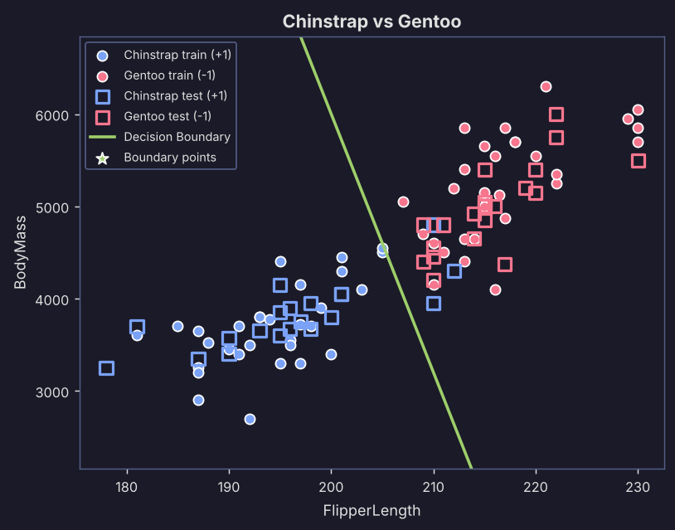 |  |  |  | Adaline: 92.5%  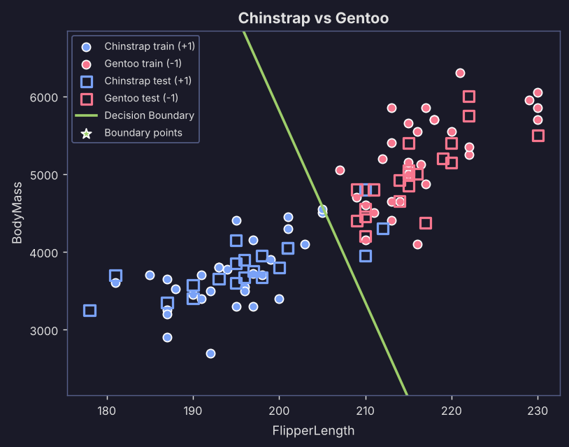
Figure 10. Decision boundary on the original feature scale, Chinstrap (+1) vs Gentoo (-1).
Algorithm | Test acc. | Train acc. | TN / FP / FN / TP |  | Train MSE | Val. MSE | Epochs
Perceptron | 92.5% | 100.0% | 20 / 0 / 3 / 17 |  | 0.000 | 0.150 | 1
Adaline | 92.5% | 100.0% | 20 / 0 / 3 / 17 |  | 0.106 | 0.161 | 300

Flipper length and body mass both point towards Gentoo (longer and heavier), so the classes lie along a diagonal band with Chinstrap at the lower left and Gentoo at the upper right. The two groups touch where the longest-flippered Chinstrap (210 to 212 mm) meet the shortest-flippered Gentoo (about 207 to 210 mm).
Both models get 100% on the training data but 92.5% on the test data, with identical confusion matrices (20 TN, 0 FP, 3 FN, 17 TP). The three mistakes are long-flippered Chinstrap penguins classified as Gentoo. The line falls right where the groups meet, and neither algorithm tries to leave a safe margin, so it hugs the training points. A few test points near the line then land on the wrong side. This is a small gap between training and test accuracy, not a failure to learn.

5. What the training curves show
The MSE charts explain why the two algorithms behave so differently. We picked one case with separable classes (combination 1) and one with overlapping classes (combination 5).
Perceptron  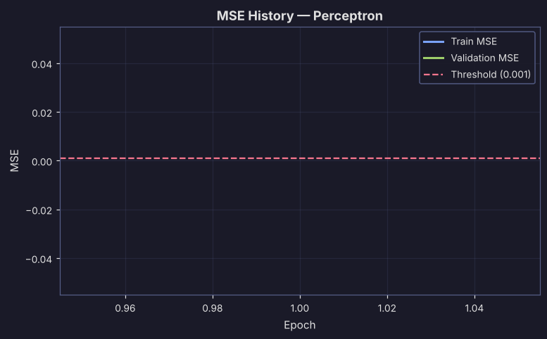 | Adaline  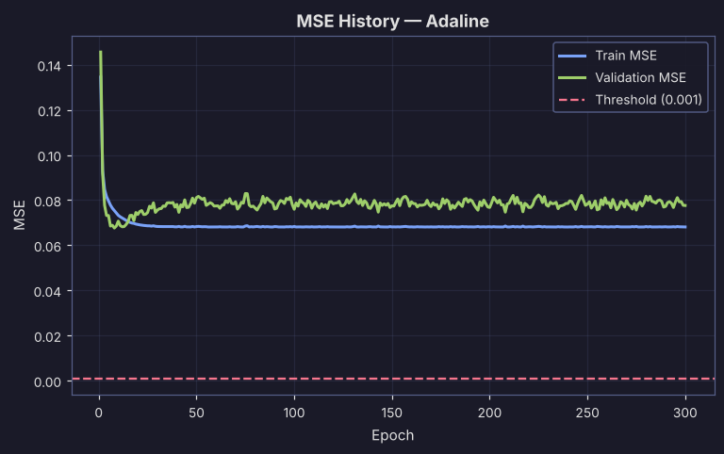
Figure 11. MSE history for combination 1 (separable data). The Perceptron stops after one epoch, while Adaline's error levels off at about 0.07.
Perceptron  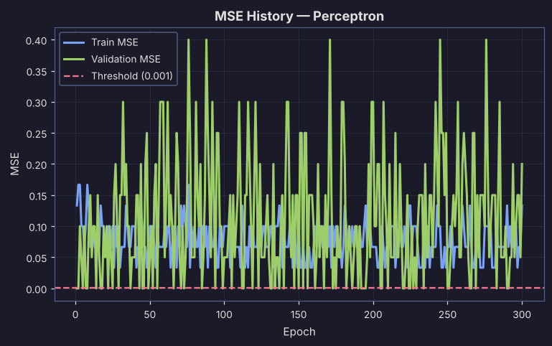 | Adaline  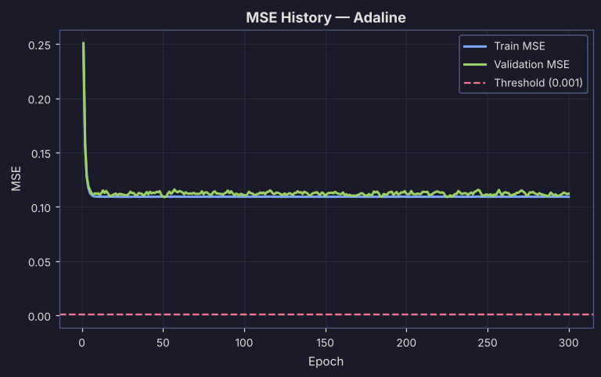
Figure 12. MSE history for combination 5 (overlapping classes). The Perceptron's error keeps jumping, so where it stops is partly luck, while Adaline settles.
- Separable data. The Perceptron stops as soon as its error reaches zero, often in the first epoch, so it is very fast. Adaline never gets under the 0.001 threshold because its error is measured against exactly +1 and -1. It therefore runs all 300 epochs, with no loss in accuracy.
- Overlapping data. The Perceptron only changes its weights when it makes a mistake, and on overlapping data it makes mistakes in every epoch. Its error keeps bouncing and never settles. Adaline's update depends on the size of the error on every sample, so its curve drops smoothly and levels off. That is why Adaline did better in combination 5, and why a Perceptron that stops at the last epoch can be unlucky.
- Test curves. The test error usually sits a little above the training error and is noisier, since it only uses 40 samples.

6. Confusion matrices
Accuracy alone hides what kind of mistakes a model makes, so Table 3 gives the confusion matrix for every run, not only the best ones. Each plot shows a different pattern of errors, and the matrices are the quickest way to compare them. All counts come from the 40 test penguins (20 per class).
How to read it. Rows are the true class and columns are the prediction. Class A is the first species in the combination (+1, the positive class) and class B is the second (-1). Green cells are correct answers. Red cells are mistakes: the top-right cell is a false negative (an A penguin called B) and the bottom-left cell is a false positive (a B penguin called A). A perfect run has 20 in both green cells and zeros in the red ones.
# | Combination | Actual class | Perceptron |  | Adaline
# | Combination | Actual class | Predicted +1 | Predicted -1 | Predicted +1 | Predicted -1
1 | Adelie vs Gentoo  CulmenLength + FlipperLength | A (+1) | 20 | 0 | 20 | 0
1 | Adelie vs Gentoo  CulmenLength + FlipperLength | B (-1) | 0 | 20 | 0 | 20
2 | Adelie vs Gentoo  CulmenDepth + BodyMass | A (+1) | 20 | 0 | 20 | 0
2 | Adelie vs Gentoo  CulmenDepth + BodyMass | B (-1) | 0 | 20 | 0 | 20
3 | Adelie vs Gentoo  OriginLocation + BodyMass | A (+1) | 17 | 3 | 17 | 3
3 | Adelie vs Gentoo  OriginLocation + BodyMass | B (-1) | 4 | 16 | 4 | 16
4 | Adelie vs Chinstrap  CulmenLength + CulmenDepth | A (+1) | 20 | 0 | 20 | 0
4 | Adelie vs Chinstrap  CulmenLength + CulmenDepth | B (-1) | 0 | 20 | 0 | 20
5 | Adelie vs Chinstrap  CulmenLength + BodyMass | A (+1) | 18 | 2 | 20 | 0
5 | Adelie vs Chinstrap  CulmenLength + BodyMass | B (-1) | 2 | 18 | 0 | 20
6 | Adelie vs Chinstrap  CulmenDepth + BodyMass | A (+1) | 9 | 11 | 11 | 9
6 | Adelie vs Chinstrap  CulmenDepth + BodyMass | B (-1) | 9 | 11 | 9 | 11
7 | Adelie vs Chinstrap  FlipperLength + BodyMass | A (+1) | 17 | 3 | 10 | 10
7 | Adelie vs Chinstrap  FlipperLength + BodyMass | B (-1) | 6 | 14 | 2 | 18
8 | Chinstrap vs Gentoo  CulmenDepth + FlipperLength | A (+1) | 20 | 0 | 20 | 0
8 | Chinstrap vs Gentoo  CulmenDepth + FlipperLength | B (-1) | 0 | 20 | 0 | 20
9 | Chinstrap vs Gentoo  CulmenLength + OriginLocation | A (+1) | 20 | 0 | 20 | 0
9 | Chinstrap vs Gentoo  CulmenLength + OriginLocation | B (-1) | 0 | 20 | 0 | 20
10 | Chinstrap vs Gentoo  FlipperLength + BodyMass | A (+1) | 17 | 3 | 17 | 3
10 | Chinstrap vs Gentoo  FlipperLength + BodyMass | B (-1) | 0 | 20 | 0 | 20
Table 3. Test-set confusion matrices for all ten combinations, Perceptron and Adaline.
What the matrices show. Five combinations (1, 2, 4, 8 and 9) are perfect for both models, with all 40 test penguins correct, and Adaline is perfect on combination 5 as well. Those matrices all look the same. The interesting ones are the others.
In combination 3 both models make the same seven mistakes (4 false positives and 3 false negatives). In combination 5 the Perceptron makes 2 and 2, while Adaline makes none. In combination 6 each model is close to a coin flip, with the errors spread evenly over both classes. In combination 7 the two models fail in different ways. The Perceptron makes 6 false positives and 3 false negatives, but Adaline leans towards Chinstrap: it makes only 2 false positives and 10 false negatives, so it calls half of the Adelie penguins Chinstrap, which is why its accuracy is lower. In combination 10 both models make the same three false negatives and no false positives: the only mistakes are long-flippered Chinstrap penguins called Gentoo.
We include the matrices for every run because the best runs alone would show only the diagonal. The mistakes in the weaker runs are what tell us how the features and the algorithms fail.

7. Which features achieved the highest accuracy?
Ten combinations only show part of the picture, so we also ran every pair of features (10 pairs) for every species pair (3 pairs) with both algorithms. That is 60 runs with the same settings. Table 4 averages each feature pair over the three species pairs and both algorithms.
Feature pair | Adelie vs Chinstrap | Adelie vs Gentoo | Chinstrap vs Gentoo | Average
CulmenLength + CulmenDepth | 100.0% | 100.0% | 97.5% | 99.2%
CulmenLength + OriginLocation | 95.0 / 100.0 | 95.0 / 97.5 | 100.0% | 97.9%
CulmenLength + FlipperLength | 95.0 / 100.0 | 100.0% | 95.0% | 97.5%
CulmenLength + BodyMass | 90.0 / 100.0 | 92.5 / 97.5 | 97.5 / 95.0 | 95.4%
FlipperLength + OriginLocation | 85.0% | 100.0% | 100.0% | 95.0%
CulmenDepth + OriginLocation | 67.5 / 77.5 | 100.0% | 100.0% | 90.8%
CulmenDepth + FlipperLength | 60.0 / 77.5 | 100.0% | 100.0% | 89.6%
FlipperLength + BodyMass | 77.5 / 70.0 | 100.0% | 92.5% | 88.8%
OriginLocation + BodyMass | 77.5% | 82.5% | 100.0% | 86.7%
CulmenDepth + BodyMass | 50.0 / 55.0 | 100.0% | 100.0% | 84.2%
Table 4. Test accuracy for all 10 feature pairs. One value means Perceptron and Adaline agree; otherwise it is Perceptron / Adaline.

Conclusions
- Highest overall accuracy: CulmenLength + CulmenDepth. It averages 99.2%: 100% for Adelie vs Chinstrap and for Adelie vs Gentoo, and 97.5% for Chinstrap vs Gentoo, with both algorithms. It is the only pair that does well on all three species pairs, because bill length separates Adelie from Chinstrap while bill depth separates Gentoo from the other two. CulmenLength + OriginLocation (97.9%) and CulmenLength + FlipperLength (97.5%) come next.
- Perfect scores with both algorithms. Seven feature pairs for Adelie vs Gentoo (CulmenLength+CulmenDepth, CulmenLength+FlipperLength, CulmenDepth+FlipperLength, CulmenDepth+OriginLocation, CulmenDepth+BodyMass, FlipperLength+OriginLocation, FlipperLength+BodyMass) and six for Chinstrap vs Gentoo (CulmenLength+OriginLocation, CulmenDepth+FlipperLength, CulmenDepth+OriginLocation, CulmenDepth+BodyMass, FlipperLength+OriginLocation, OriginLocation+BodyMass). For Adelie vs Chinstrap only one pair is perfect for both: CulmenLength+CulmenDepth.
- Best single features. CulmenLength is the key feature for Adelie vs Chinstrap: every feature pair above 85% for that species pair contains it. For the two comparisons involving Gentoo, CulmenDepth and FlipperLength show up most in the perfect pairs (7 and 6 of the 13).
- Worst results. CulmenDepth + BodyMass for Adelie vs Chinstrap (50% and 55%, basically chance), then CulmenDepth + FlipperLength (60% and 77.5%) and CulmenDepth + OriginLocation (67.5% and 77.5%) for the same species pair. Bill depth and body mass tell us almost nothing about Adelie vs Chinstrap.
- Perceptron vs Adaline. They match on separable data. On overlapping data Adaline is usually more stable (combination 5: 100% against 90%), but it is not always more accurate (combination 7: 70% against 77.5%), because it minimizes squared error instead of the number of mistakes.
- A warning about OriginLocation. Its perfect scores for Chinstrap vs Gentoo come from where the penguins were sampled, not from their bodies. The physical measurements (CulmenDepth, FlipperLength and CulmenLength) are the more trustworthy features.
- A warning about sample size. Each test set has only 40 penguins and we used a single random split, so one mistake moves accuracy by 2.5 points. Differences of 2.5 to 5 points should not be over-read.

