**CSE211, Web Programming, Fall Semester 24/25**

**Assignemnt #1: Websites Conceptual Design and Mock up**

**ID: 222101978, Name: Yousef Nabih Fadel Taha**

**Part 1: Research**

Characteristics of web 2:

* Interactive: to entice users to register, ask questions, purchase, download, or click more
* Fresh: intended to highlight recent developments
* Informative: Websites are excellent sources of information, and the goal is to let users utilize them to do research, pick up knowledge, and educate themselves.
* Less cluttered: The era of really intricate navigation is over; the simpler you can make it, the better.
* Pertinent: Visitors prefer brief, colorful material to long, drawn-out copy.

Characteristics of web 3:

* Web 3.0's metadata and semantic technologies enhance information organization, enabling machines to provide accurate search results and better access to relevant information.
* Web 3.0 utilizes artificial intelligence and machine learning algorithms for advanced data processing, resulting in more personalized and intelligent services and applications.
* Web 3.0, incorporating decentralized technologies like blockchain and peer-to-peer networks, can enhance security, privacy, and trust in online transactions and communications.
* Web 3.0 enhances user experience by providing relevant, personalized content, faster, and seamless interactions, resulting in a more enjoyable and efficient experience.
* Web 3.0's decentralized nature can boost innovation and entrepreneurship by enabling the creation of new, decentralized applications and services without centralized control or intermediaries.

Characteristics of web 4:

* Web 4.0 seamlessly integrates with the Internet of Things, facilitating seamless communication and data exchange between physical devices, sensors, and online systems.
* Web 4.0 systems utilize AI-powered data analysis, user preferences, and environmental factors to make autonomous decisions, reducing the need for human intervention.
* Web 4.0 leverages decentralized technologies like blockchain for secure, transparent, and tamper-resistant data transactions, reducing the need for centralized authorities.
* Web 4.0 is anticipated to enhance user experience by integrating technologies like virtual reality, augmented reality, and 3D visualization, blurring the gap between physical and digital realms.

Key features of web 2 and how it empowers the power of networks:

* Key Features

1. Social interaction and collaboration are enhanced through user-generated content, social networking platforms, community-driven content creation, interactive commenting, discussion features, and collaborative editing and content sharing.
2. Technical features include AJAX, RSS feeds for content syndication, third-party integration APIs, rich user interfaces, browser-based applications, and cloud computing infrastructure.
3. User-centric design features intuitive interfaces, personalized options, user profiles and avatars, tagging and folksonomy, and easy content creation tools.

* How it empowers the power of networks

1. Social media platforms like Facebook, Twitter, LinkedIn, Instagram, YouTube, Wikipedia, Medium, GitHub, and marketplace platforms like Amazon, eBay, Etsy, and Airbnb facilitate information sharing, collaboration, and accommodation sharing.

Key features of web 3 and how it empowers the meaning of data and knowledge connections:

* Key features of web 3

1. Semantic Web Technologies, such as RDF, OWL, SPARQL, and Linked Data, facilitate machine-readable data formats. Decentralization through blockchain technology, AI, and data ownership and privacy involve self-sovereign identity, decentralized identifiers, and user-controlled data sharing.

* Knowledge connection features

1. Semantic understanding involves ontology-based relationships, context-aware processing, meaning interpretation, conceptual mapping, and knowledge inference. Data interoperability allows cross-platform exchange and universal access. Knowledge graphs facilitate entity relationships and dynamic linking.

* Knowledge Enhancement:
  1. Automated reasoning, knowledge organization, and knowledge sharing are key technologies used in various fields, including decision support, taxonomies, ontologies, classification systems, relationship mapping, and community engagement.

Web 4:

1. AI and machine learning in Web 4.0 enable personalized experiences by anticipating user needs and delivering relevant content, suggestions, or actions in real-time based on user interaction.
2. Web 4.0 envisions a world where AI and human interactions are integrated, enabling real-time communication and intuitive, empathetic interactions.
3. The Internet of Things (IoT) is a key component of Web 4.0, integrating everyday devices into a smart ecosystem that communicates and adapts to user needs, fostering a responsive environment.

5 – Collective Intelligence, social networking, social media, and social bookmarking are essential elements that have revolutionized knowledge sharing, community building, decision-making, innovation, and global connectivity. These elements enable diverse perspectives, professional development, content creation, and trend identification, enhancing decision-making and global connectivity.

6 – Social media and related technologies are revolutionizing businesses' operations, competition, and growth in the digital age. They enable marketing, customer relations, market intelligence, and business model innovation. Key strategic benefits include operational efficiency, market expansion, and improved customer experience. These technologies are essential for current and future operations, enhancing customer experience and competitive advantage.

**References:**

<https://www.techtarget.com/whatis/definition/Web-20-or-Web-2#:~:text=Web%202.0%20is%20characterized%20by,post%2Ddot%2Dcom%20bubble>

<https://www.techtarget.com/searchcio/tip/10-core-features-of-Web-30-technology>

<https://www.strivemindz.com/blog/what-is-web-4-0/>

**Part 2: Website Planning**

1. The website is an online book store used for buy books or reading online.
2. The website aimed for buying books online weather hard copies or digital copies and reading books online.
3. Readers from all ages.
4. Problems may be with the pressure on the website server when publishing new books or limited offers, that may cause downgrade for user browsing experience.
5. Office supplies like pens, pencils, notebook, etc.
6. It will serve the client by creating an account on the website then he could buy any product available on the website or add any product to his favorites or wish list.
7. By creating account
8. Through the Nav bar the client could go to log in or sign up and navigate through categories, favorites and his cart.
9. The results will be sent to the backend servers
10. It will help in organizing users accounts and their purchased items.
11. By taking users feedbacks on the website periodically and fixing any issue or problem in the website as soon as possible without affecting the user experience.
12. <https://diwanegypt.com/> , <https://dardawen.com/> Because these are two of the most famous publishing houses in Egypt and most of new books be published on them.
13. a. The website goal is offering books for users.
14. Categories

Favorites

Cart

About us

1. Homepage contains background, search bar, images for books, footer, logo. Categories contains four categories of books each category contains a photo describes the category. About us page contains two paragraphs one for describing the website and the other for describing the services that the website serves.

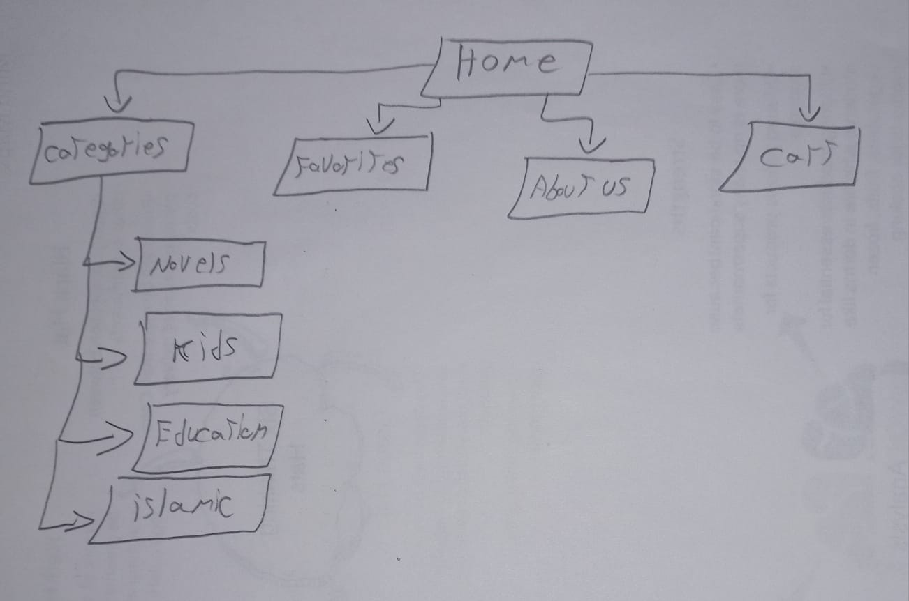

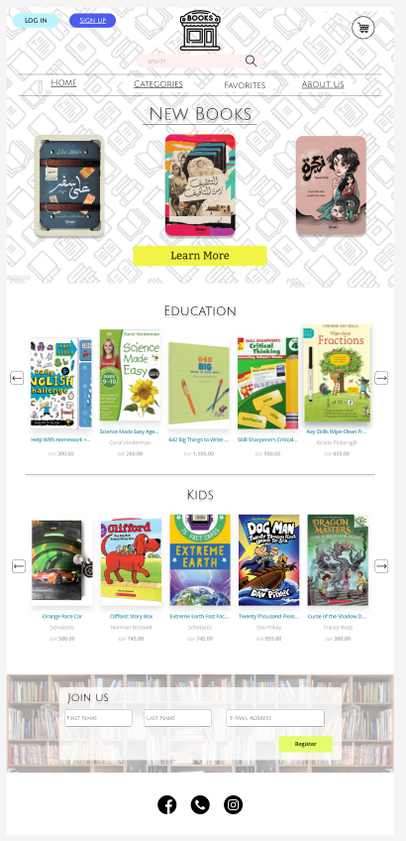

Homepage

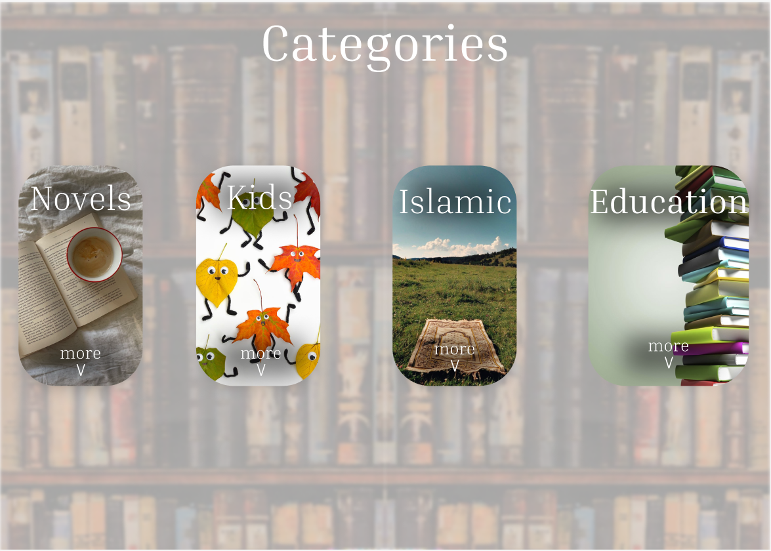Categories

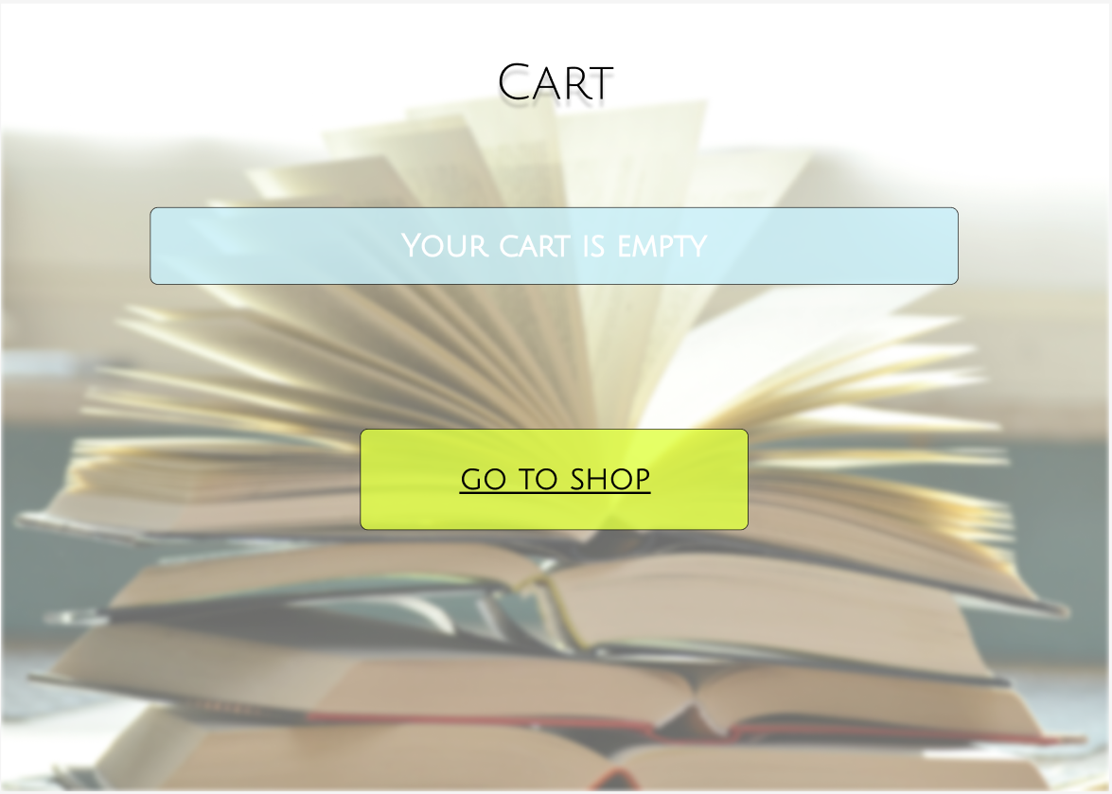

Cart

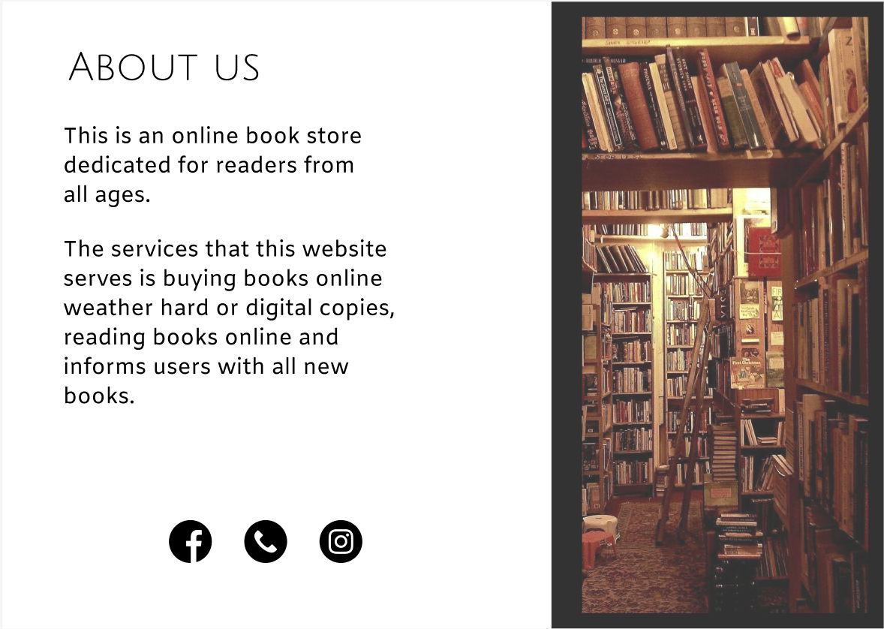

About us

HTML Structure:

<!DOCTYPE html>

<html lang="en">

<head>

    <meta charset="UTF-8">

    <meta name="viewport" content="width=device-width, initial-scale=1.0">

    <title>Book Store</title>

</head>

<body>

    <img src="Logo.jpg" alt="Logo">

    <h1>New Books</h1>

    <img src="New Books.jpg" alt="Books">

    <h2>Learn More</h2>

    <h1>Education</h1>

    <img src="Education Books.jpg" alt="Education Books">

    <hr />

    <h1>Kids</h1>

    <img src="Kids Books.jpg" alt="Kids Books">

    <img src="Join us.jpg" alt="Join us">

    <h2>Join us</h2>

</body>

</html>