XSS
Use Case: Attacker wants to Steal users email address
In a University account
- Attacker signs in with his own account into the University account
- They go to “Edit Profile” which is vulnerable to XSS attacks but instead of typing an actual Bio they type a script like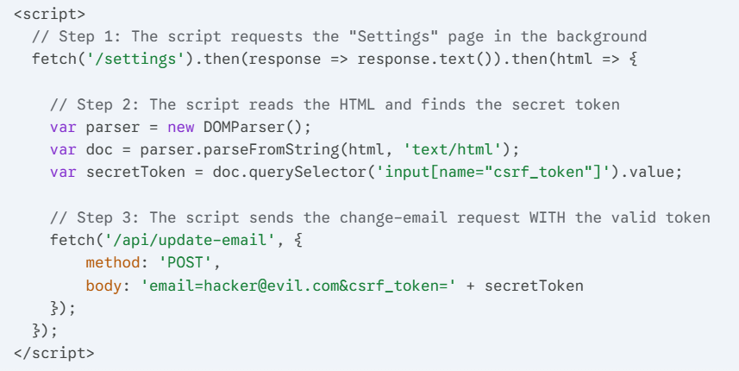
- Edit profile succeeds and Script is saved to database
- Now the victim wants to load for example “Latest students profiles”
- When the attacker’s profile is loaded from the Database it executes the script
- Now The attacker has full access to Client Side DOM of victim
  - This is MUCH different than having access to server side functionalities attacker only has access to client side
  - Attacker could now do many things like use all functionalities this user is allowed to do, he can do many things like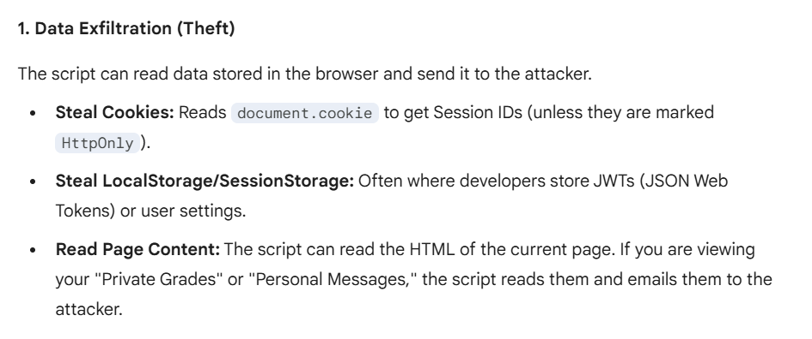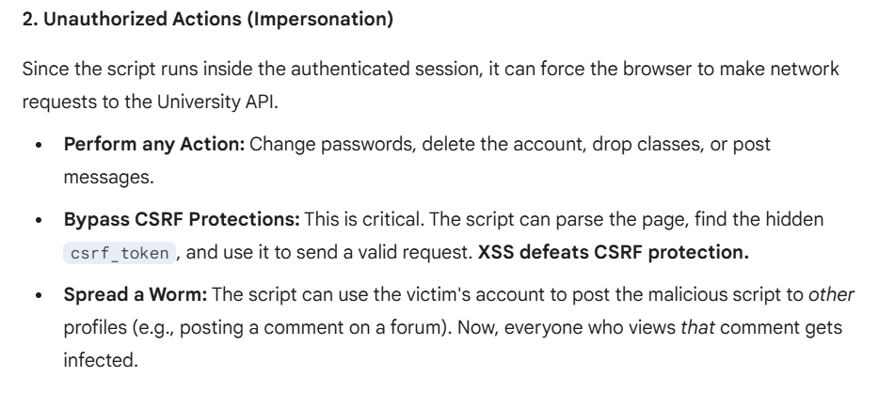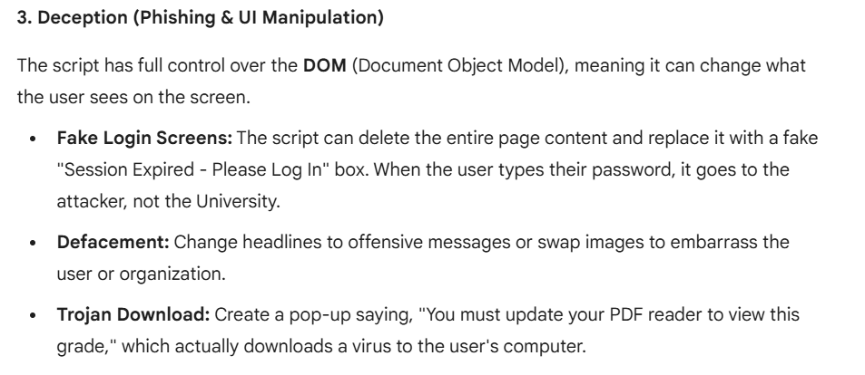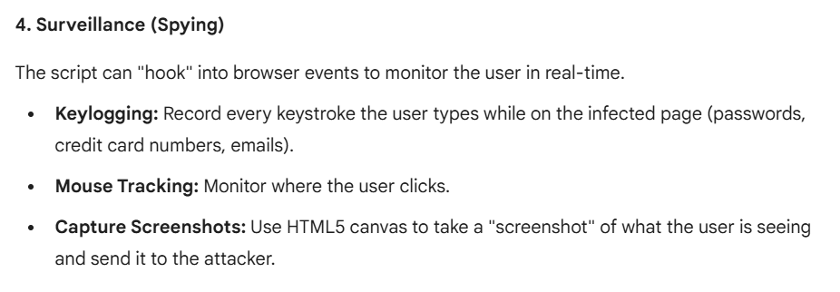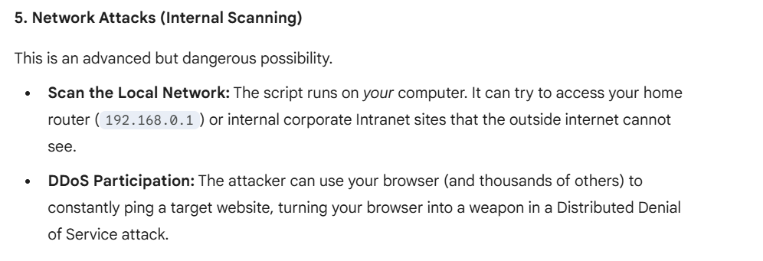
- If the attacker saves a script like the one above then this is what he is capable of doing so instead attackers embed a script like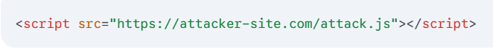
  - This script allows changing the script dynamically instead of using a static script attacker can now keep changing from his server what attack.js does

