**Effect of ambient pressure on laser welding of AlSi10Mg fabricated by  
selected laser melting**

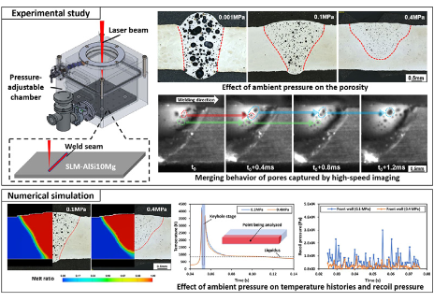

**This work attempted to introduce high pressure to reduce the formation of pores in the laser welding of the fused alsilomg.**

**Study of the effect of laser ambient pressure during laser welding and its effect on aluminum alloy, the laser beam hitting the surface, and the amount of heat.**

**The effect of the laser and the factors that control the voids generated during welding.**

**Ambient pressure of the laser beam.**

**Effect of stress on welding section shape and expectation ratio test.**

**The welding area is a linear relationship that increases the intensity of the output from the lamp due to its effect on the laser beam and the shape of the welding funnel in the area of ​​​​the metal section, and the shape of the weld changes from funnel to an hourglass.**

**And Figure 5 shows comparisons of 3 images inside each column, where the linear energy remains constant also towards the weld to maintain the second linear energy in each column.**

**The result is that it reduces the formation of cracks in the laser welding line.**

**to reduce pore generation in laser welding of selective laser melted AlSi10Mg**

**the impacts of laser welding parameters and ambient pressure on the porosity and weld geometry were examined. Porosity ratio was found linearly increasing with the laser power or linear energy.**

**As pressure increased from 0.1 MPa to 0.4 MPa, the porosity ratio was dramatically decreased from 10.2% to 2.3% accompanied by a decline in porosity size and weld penetration depth**

**the reduced porosity ratio was resulted from the high pressure which limited pore growth and merging.**

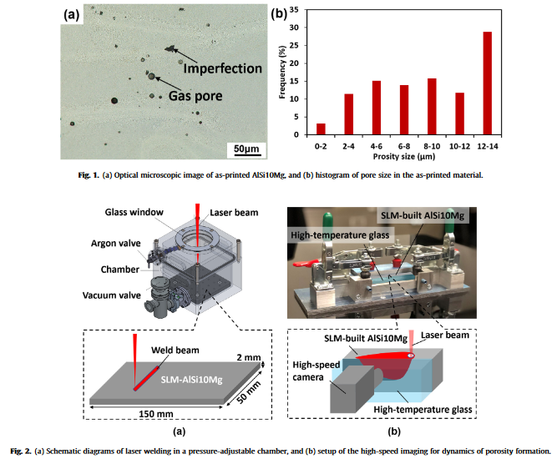

**Weld geometry and porosity should be highly considered since these two factors predominantly determine the joining strength inthe Al laser welding.**

**adequate weld width**

**in over-lap configuration**

**penetration depth is essential for a sound butt joint**

**the effects of laser power and linear energy on the weld geometry and porosity  
are analyzed.**

**Fig. 5 shows the cross-sectional images of the welds fabricated  
under one standard atmospheric pressure (1 atm, 0.1 MPa), under different laser power (3.5 kW, 5 kW, and 5.5 kW) and linear energy  
(28 J/mm, 33 J/mm, and 43 J/mm).**

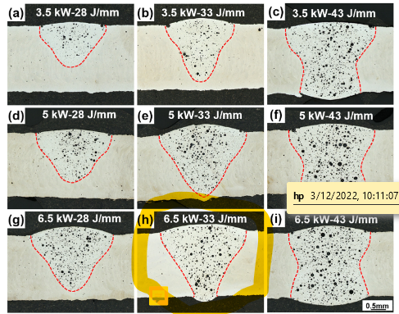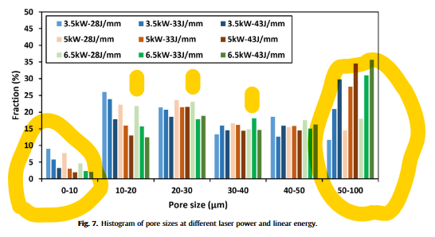

**From the above results in terms of the weld geometry and porosity, it can be learned that the increases of linear energy and laser power are helpful to increase weld depth and width; how-ever, the porosity would increase as well, especially for the coars-ened pores.**

**Effects of ambient pressure**

**full-penetration weld in this case (Fig. 5(h)). The keyhole depth close to the sheet thickness is pre-ferred, which can avoid material loss due to the full keyhole pene-tration. The high/low vacuum environments (0.001 MPa and  
0.01 MPa)**

**Ar gas to various pressure levels (from 0.1 to 0.4 MP)**

**(Fig. 8(a)), the weld has a full penetration, narrow width, and large pores. Under the low vacuum ambiance of 0.01 MPa, the weld is changed to be funnel-shaped with decreased porosity ratio (Fig. 6(b)). Relatively, the weld under standard atmospheric pressure (0.1 MPa) has a widened fusion zone with small pores (Fig. 8(c)). With increasing atmospheric pressure from 0.1 MPa to 0.3 MPa, the weld depth and porosity both decrease (Fig. 8(c-e)). When the pressure is beyond 0.3 MPa, weld depth and porosity are not changed further  
(Fig. 8(f)).**

**Fig-8**

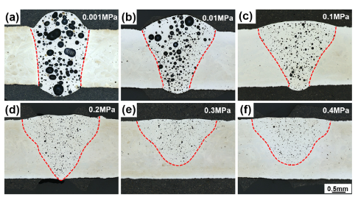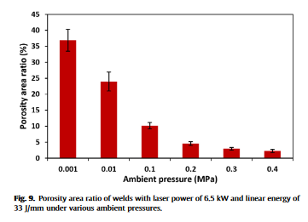

**Therefore, based on the current laser beam spot size (0.6 mm),**

**indicates that the large pores in the weld pool do not generate from the initial stage but grow by merging the small pores.**

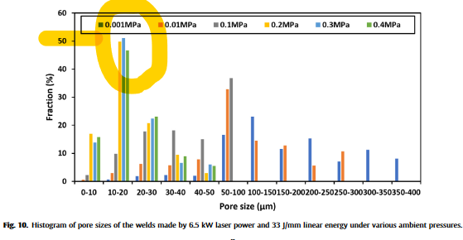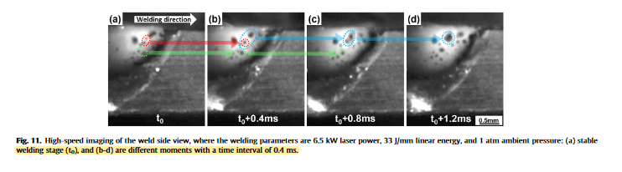

**Conclusions:  
The porosity ratio of the printed and unwelded SLM-built  
AlSi10Mg metal is pretty low, only 0.6%, and the dominant pore  
sizes are 12–14 lm. However, the size of the SLM-built part is lim-  
ited by the chamber size. Increasing the size of the chamber is  
costly due to the high cost of large SLM equipment. Hence, welding  
technologies are introduced to produce a large part by joining  
small components together. The traditional laser welding under  
standard ambient pressure caused significant growth of pre-  
existing pores in the weld fusion zone. The present research work  
investigated and evaluated the pore formation with different weld-  
ing parameters (laser power and linear energy) and ambient pres-  
sure (vacuum and high pressure)**