Course Project (Mathematics and Linear Algebra for AI)
Available: 10th March 2025 Due Date: 15th April 2025

Part 1 (MNIST Dataset):
Task 1: Consider the Conv_AutoEncoder_Pytorch.ipynb notebook. Make sure to familiarize yourself with the code. Run the code and check the different outputs.

Task 2: The embedding size is set to 2 in the notebook. Change the embedding size to 5, 10 and 20. Produce the training loss using the plot_training_loss() function.

Task 3: Show samples of the generated images using the plot_generated_images function.

Task 4: Plot the latent space of the generated embeddings using the plot_latent_space_with_labels function for embedding sizes of 5, 10 and 20.
Important Note 1: Make sure to use PCA to display the 2D projection of the generated embeddings.
Important Note 2: If you use tSNE projections in addition to PCA, you will get a bonus!

Task 5: Plot the histograms of the generated embeddings for embedding sizes of 5, 10 and 20 as we did for the case of embedding size 2 below:
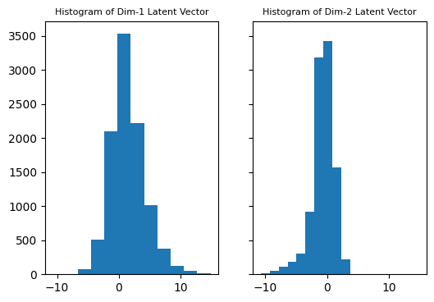
Task 6: Use the AutoEncoder with embedding size 2 in inference. Feed each image in the test set and keep modifying the 1st dimension of the embedding from -10 to 10 in steps of 0.1 and display the reconstructed image as an animation (gif file).

Task 7: Use the AutoEncoder with embedding size 2 in inference. Feed each image in the test set and keep modifying the 2nd dimension of the embedding from -10 to 10 in steps of 0.1 and display the reconstructed image as an animation (gif file).

Part 2 (CelebA Dataset*):
*https://pytorch.org/vision/main/generated/torchvision.datasets.CelebA.html

Task 1: Modify the Conv_AutoEncoder_Pytorch.ipynb notebook to work with the CelebA dataset.

Task 2: Set the embedding size to 32 and 64. Produce the training loss using the plot_training_loss() function.

Task 3: Show samples of the generated images using the plot_generated_images** function.
**Important Note: You may need to modify the plot_generated_images function

Task 4: Plot the latent space of the generated embeddings using the plot_latent_space_with_labels function for embedding sizes of 32 and 64.
Important Note 1: Make sure to use PCA to display the 2D projection of the generated embeddings.
Important Note 2: If you use tSNE projections in addition to PCA, you will get a bonus!

Task 5: Plot the histograms of the generated embeddings for embedding sizes of 32 and 64.

Task 6: Use the AutoEncoder with embedding size 32 in inference. Feed each image in the test set and keep modifying the 1st dimension of the embedding from -10 to 10 in steps of 0.1 and display the reconstructed image as an animation (gif file).

Task 7: Use the AutoEncoder with embedding size 64 in inference. Feed each image in the test set and keep modifying the 2nd dimension of the embedding from -10 to 10 in steps of 0.1 and display the reconstructed image as an animation (gif file).

