Freight Rate Machine Learning Report
FUTURE-AWARE FREIGHT RATE REGRESSION
Machine Learning Engineering Assessment
Prepared October 2026

Development | Final prediction set | Jul-Oct backtest | Final output
48,000 labeled loads | 12,000 future loads | $114.20 mean MAE | 12,000 scorer-validated rates

Executive Summary
This assessment develops a reproducible regression pipeline for predicting posted freight rates. The development data covers January through October 2025, while the unlabeled prediction set covers November and December. Because this is a strict future prediction problem, model selection used expanding-window monthly holdouts rather than random cross-validation.
The selected model is a CatBoost regressor trained on rate per mile with an MAE objective and distance sample weights. At 400 boosting iterations it achieved $114.20 mean temporal MAE, 4.78% WAPE, and $42.41 mean median absolute error. It improved mean MAE by approximately 17.7% over the median-RPM business baseline.
- Negative weights were repaired with absolute value while retaining anomaly indicators.
- All imputation statistics were learned inside each temporal training fold.
- quote_signal was excluded after a month-by-month stability analysis and ablation test.
- Eight-city cold-start simulations tested geographic generalization before final fitting.
- The final 12,000 predictions and all 31 December chart rows passed the supplied scorer.

1. Objective and Data
The objective is to estimate posted_rate for every load in the supplied validation set and to produce a fixed December rate curve for a Lexington-to-Fort Wayne dry-van load. The model must generalize across future dates, market conditions, unseen cities, and previously unseen route combinations.
Dataset | Rows | Period | Role
Development | 48,000 | 2025-01-01 to 2025-10-31 | Labeled training and temporal validation
Validation | 12,000 | 2025-11-01 to 2025-12-31 | Final unlabeled inference
December chart | 31 | 2025-12-01 to 2025-12-31 | Fixed-load daily scenario

2. Exploratory Analysis and Data Quality
The target has a mean of $2,373.98 and a median of $2,030.76. A conservative rate-per-mile IQR rule identified 663 extreme rows (1.38%). Tested configurations predict this segment poorly. Possible contamination is one hypothesis alongside legitimate rare events and omitted predictors.
Issue | Development | Validation | Treatment
Missing weight | 300 | 165 | Equipment median plus indicator
Negative weight | 292 | 145 | Absolute value plus indicator
Missing market index | 374 | 249 | Fold-local median plus indicator
Extreme RPM target | 663 | Unknown | Robust MAE objective

The validation set adds 8 cities absent from development: Allentown, Charlotte, Chicago, Jackson, Knoxville, Laredo, Norfolk, San Diego. Only 87.83% of final validation rows use a directed route observed during development, so categorical route information is paired with distance and geographic features.
The market-index mean shifts from 1.083 in development to 0.927 in validation. quote_signal is also unstable: its August correlation with rate per mile is -0.014, while other months alternate between positive and negative relationships.

3. Preprocessing and Feature Engineering
- Remove load_id from model features and keep posted_rate separate as the target.
- Convert negative weight to absolute weight; add missing and negative-weight indicators.
- Impute weight by equipment and market index globally within each fitted training fold.
- Create route, log-distance, coordinate deltas, haversine distance, and bearing features.
- Create linear and cyclical day-of-week and day-of-year calendar features.
- Preserve pickup, delivery, equipment, and route as native CatBoost categorical features.
The preprocessing component implements the sklearn fit/transform contract. This ensures that imputation values are estimated from training rows only and applied unchanged to each holdout.

4. Validation Strategy
Four expanding-window folds mirror the final future-prediction setting. Random splitting was rejected because it would mix nearby market regimes and overstate the usefulness of temporally unstable features.
Fold | Training window | Validation month
1 | January-June | July
2 | January-July | August
3 | January-August | September
4 | January-September | October

MAE was the primary selection metric. RMSE, median absolute error, WAPE, RMSLE, bias, regular-target error, outlier-target error, and route coverage were retained as diagnostics.

5. Model Selection
Candidate | Mean MAE | WAPE | Mean RMSE
CatBoost RPM MAE, no quote | $114.36 | 4.78% | $627.48
CatBoost direct MAE, no quote | $115.63 | 4.84% | $627.65
CatBoost RPM MAE, with quote | $118.82 | 4.98% | $629.99
Median RPM baseline | $138.84 | 5.82% | $634.73
CatBoost direct RMSE, no quote | $177.60 | 7.42% | $657.94

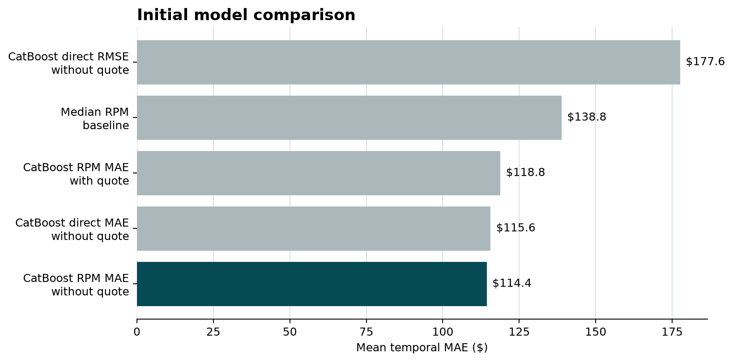
Predicting RPM matches the economic structure of freight pricing. Distance sample weights make the RPM MAE objective equivalent to dollar MAE after rate reconstruction. The quote ablation supports excluding quote_signal for the future validation regime.

6. Robustness Checks
Iterations | Mean MAE | Worst-month MAE | Runtime
400 | $114.20 | $148.13 | 126 s
600 | $114.36 | $150.70 | 189 s
800 | $114.48 | $151.57 | 254 s

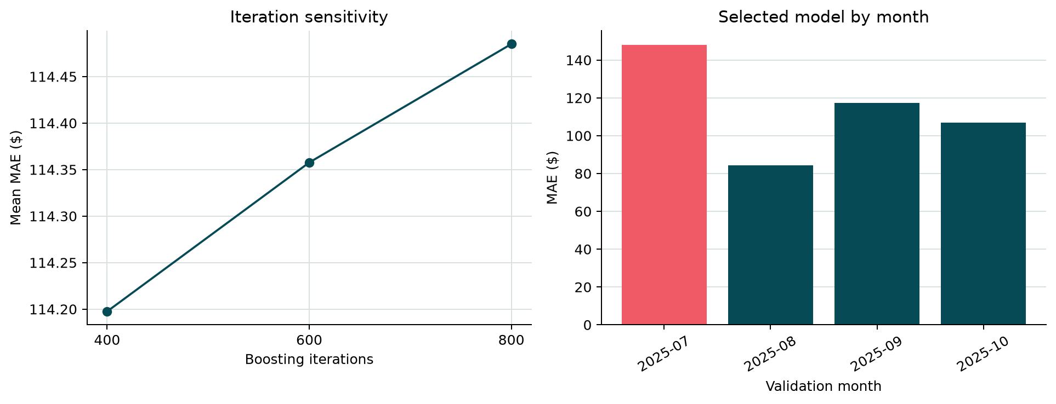
The 400-iteration configuration had the best mean and worst-month MAE. In three October stress tests, each removing eight cities entirely from prior training, keeping route produced $146.70 mean MAE versus $149.35 without route. Route was therefore retained.

7. Final Model and Performance
Component | Final choice
Estimator | CatBoostRegressor
Target | posted_rate / distance
Objective | MAE
Sample weighting | distance
Iterations / depth | 400 / 7
Learning rate / L2 | 0.05 / 5.0
quote_signal | Excluded
Route | Included

Mean MAE | Worst month | Median AE | WAPE | Bias
$114.20 | $148.13 | $42.41 | 4.78% | -$21.33

On regular backtest targets, mean MAE was $61.02. For rows extreme under the conservative RPM rule it was $3,880.05, which explains the much larger $627.62 RMSE. Tested configurations predict this segment poorly; possible contamination is one hypothesis alongside legitimate rare events and omitted predictors.

8. Final Inference and December Scenario
The final model was refit on all 48,000 labeled rows and generated 12,000 predictions. Rates range from $185.03 to $6,833.10; all are finite, positive, uniquely aligned to load_id, and accepted by the supplied scorer.
The chart input fixes Lexington to Fort Wayne, 360 miles, Dry Van, and 32,000 lb. Coordinates are recovered from the labeled city mapping. Because market_index is absent from the chart input, each date uses the daily mean from the supplied unlabeled validation covariates. quote_signal remains unused.
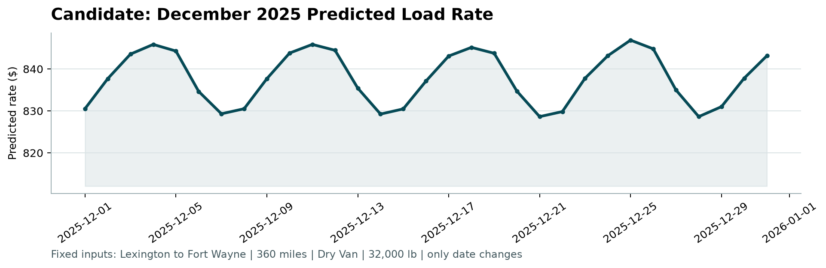
Figure: scorer-generated December prediction curve. Range $828.64-$846.87; mean $837.86.

9. Limitations and Production Considerations
- The assessment does not specify the hidden scoring metric or acceptance threshold.
- Approximately 1.4% of development targets are extreme under the conservative RPM rule; tested configurations predict this segment poorly. Possible contamination is one hypothesis alongside legitimate rare events and omitted predictors.
- Historical backtest error is concentrated in RPM-extreme rows; final-period novelty risk is unmeasured because its labels are hidden.
- December market enrichment uses unlabeled validation covariates and should be replaced by an explicit market feed in production.
- A deployed system should monitor monthly error, route coverage, feature drift, prediction ranges, and calibration by equipment and distance band.

10. Reproducibility
The complete pipeline can be reproduced from the repository root:
.\.venv\Scripts\python.exe -m unittest discover -s tests -v
.\.venv\Scripts\python.exe -m src.train --iterations 600
.\.venv\Scripts\python.exe -m src.robustness
.\.venv\Scripts\python.exe -m src.predict --iterations 400
.\.venv\Scripts\python.exe score.py --predictions validation_predictions.csv --december-predictions december_predictions.csv
Final environment: Python 3.12.3, pandas 2.3.3, NumPy 2.5.3, scikit-learn 1.9.1, and CatBoost 1.2.10. Ten automated tests and the supplied scorer passed.

Conclusion
The final pipeline combines future-aware validation, robust loss, domain feature engineering, explicit instability tests, and scorer-validated outputs. Performance is strong for ordinary freight loads. Historical backtest error is concentrated in RPM-extreme rows, while final-period novelty risk remains unmeasured.

