- Introduction
  - Description of the design and its purpose
  - Goals of the verification process
- Verification Environment
  - Description of the simulation environment
  - List of all verification components
  - Details of the simulation flow
- Features to be Verified
  - List of all design features to be verified
  - Description of the expected behavior of each feature
- Test Plan
  - List of all test cases
  - Description of the purpose and scope of each test case
  - Expected results for each test case
  - Pass/fail criteria for each test case
- Code/Functional/Assertion Coverage Plan
  - Description of the code coverage metrics to be used
  - Goal for each coverage metric
  - Methodology for measuring code coverage
- Bug Tracking
  - Methodology for tracking and reporting bugs
  - Reporting format for each bug
  - Bug severity levels and priority
- Sign-off Criteria
  - Criteria for determining when verification is complete
  - Criteria for determining if the design is ready for tapeout
  - Verification closure process

Introduction

Description of the design and its purpose:

I-Extension
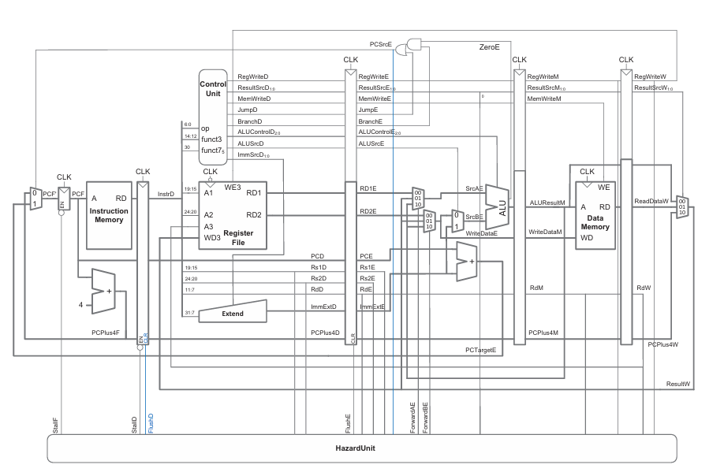

Fetch Stage:
the fetch stage is the first step of the instruction pipeline, where the processor retrieves the next instruction from memory. The Program Counter (PC) holds the address of the instruction to be fetched, which is sent to memory. The instruction is then read from memory and stored in the Instruction Register (IR) for decoding in the next stage. In a typical pipelined RISC-V processor, the fetch stage operates concurrently with other stages, ensuring a continuous flow of instructions to maximize performance. To enhance efficiency, techniques like instruction prefetching and branch prediction may be used.

Decode Stage:
In the decode stage of a 32-bit RISC-V processor, the fetched instruction is interpreted to determine the operation and its required operands. The Instruction Register (IR) holds the fetched instruction, which is then broken down into its opcode, source and destination registers, and immediate values if applicable. The register file is accessed to read the required operands, with register addresses specified by the instruction fields (rs1, rs2, rd). Additionally, control signals are generated based on the opcode, directing the subsequent execution stage. For immediate-type instructions, sign extension is performed to prepare the immediate value for processing. Efficient decoding ensures smooth pipeline operation, minimizing stalls and hazards

Execute Stage:
n the execute stage of a 32-bit RISC-V processor, the instruction performs its core computation or operation. The Arithmetic Logic Unit (ALU) executes arithmetic, logical, shift, or comparison operations based on the decoded control signals. For register-based instructions, operands from the register file are processed in the ALU. For memory-related instructions (load/store), effective addresses are computed by adding the base register to the sign-extended immediate value. In branch instructions, target addresses are calculated, and conditions are evaluated to determine if the branch should be taken. This stage is critical for pipeline performance, as forwarding and hazard detection mechanisms help maintain efficient execution flow.

Memory Stage:
In the memory stage of a 32-bit RISC-V processor, memory-related instructions such as load (LW, LH, LB) and store (SW, SH, SB) access data memory. If the instruction is a load, the computed memory address from the execute stage is used to retrieve data from memory, which is then stored in a temporary register for later use in the write-back stage. If the instruction is a store, the computed address is used to write data from the register file into memory. For non-memory instructions, this stage is bypassed. Efficient memory access mechanisms, such as caching and memory alignment, help optimize performance and reduce pipeline stalls

Write Back Stage:
in the write-back stage of a 32-bit RISC-V processor, the final results of the instruction execution are written back to the register file if needed. For arithmetic and logical instructions, the result from the ALU is stored in the destination register (rd). For load instructions, the data retrieved from memory in the memory stage is written to the specified register. Store instructions do not require a write-back, as they only update memory. This stage ensures that computation results are properly saved for future instructions, completing the instruction cycle. Efficient write-back handling is crucial for maintaining pipeline performance and avoiding unnecessary stalls.

Hazard Control Unit:
the hazard control unit in a 32-bit RISC-V processor is responsible for detecting and handling hazards that can disrupt the smooth execution of the instruction pipeline. There are three main types of hazards:
- Data Hazards – Occur when an instruction depends on the result of a previous instruction that has not yet completed. These are managed using techniques like data forwarding (bypassing) and pipeline stalls (inserting NOPs).
- Control Hazards – Arise from branch instructions when the next instruction’s address is uncertain. Solutions include branch prediction, delayed branching, and flushing mispredicted instructions from the pipeline.
- Structural Hazards – Happen when two or more instructions compete for the same hardware resource (e.g., memory or ALU). These are usually resolved through resource duplication or stalling.
The hazard control unit works dynamically to detect these hazards and apply the appropriate resolution techniques, ensuring efficient pipeline execution while minimizing performance loss.

M-Extension


Multiplication Unit:
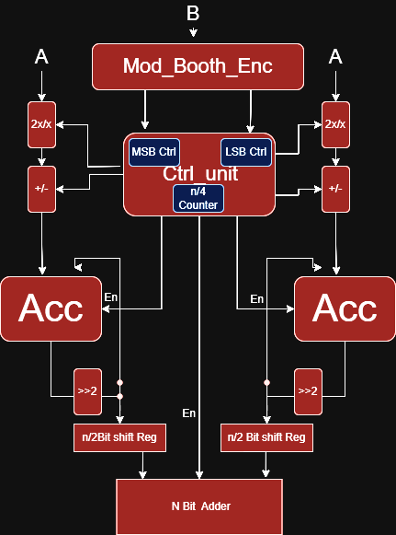

Control Unit Changes:

Integration:

Key Feature of RISC-V:

Load:
In a 32-bit RISC-V processor, a load instruction (e.g., LW, LH, LB) reads data from memory into a register. The effective memory address is calculated by adding a sign-extended immediate to the base register (rs1). The retrieved data is then placed into the destination register (rd) in the write-back stage.

Store:
In a 32-bit RISC-V processor, a store instruction (e.g., SW, SH, SB) writes data from a register to memory. The memory address is computed by adding a sign-extended immediate to the base register (rs1). The data from the source register (rs2) is then stored at the computed address during the memory stage.

Branch:
In a 32-bit RISC-V processor, a branch instruction (e.g., BEQ, BNE, BLT) conditionally changes the Program Counter (PC) based on a comparison between two registers (rs1 and rs2). The target address is computed using a sign-extended immediate added to the PC. If the condition is met, execution jumps to the target address; otherwise, the next sequential instruction executes.

jump:
In a 32-bit RISC-V processor, jump instructions (JAL, JALR) update the Program Counter (PC) to a target address, enabling unconditional control flow changes. JAL computes the target using a sign-extended immediate, while JALR uses a base register (rs1) and an immediate. The return address (PC + 4) is stored in the destination register (rd) for function calls and returns.

Logical instruction:
In a 32-bit RISC-V processor, logic instructions (e.g., AND, OR, XOR, NOR) perform bitwise operations between two registers (rs1, rs2) and store the result in the destination register (rd). These operations manipulate individual bits without affecting the control flow or memory. The result is directly written back in the write-back stage.

Integer instruction:
In a 32-bit RISC-V processor, integer arithmetic instructions (e.g., ADD, SUB) perform basic arithmetic operations on integer values stored in registers (rs1, rs2) and store the result in the destination register (rd). These instructions use the ALU to carry out the operation. The result is then written back to the register file in the write-back stage.

Multiplication instruction:
The MUL instruction in a 32-bit RISC-V processor performs multiplication of two integer values stored in registers (rs1, rs2). The product is computed using the ALU and stored in the destination register (rd). This instruction is part of the integer arithmetic instructions, and the result is written back in the write-back stage.

Goals of the verification process:
- Check that I-extension Module can Execute all I instruction Set.
- Check that M-extension Module can Execute (M & I) instruction Set.
- Check that Integration Done properly.
- Check all key features of RISC-V
- Cover almost all possible interactions in both.
- Cover Corner cases with respect to operands
- Make sure the Top module met the golden model result in scoreboard
using DBI that interface with python script via C- DPI
- Verify the Register file content using RAL concept in UVM.

Verification Environment:

UVM Structure:
I- Extension:
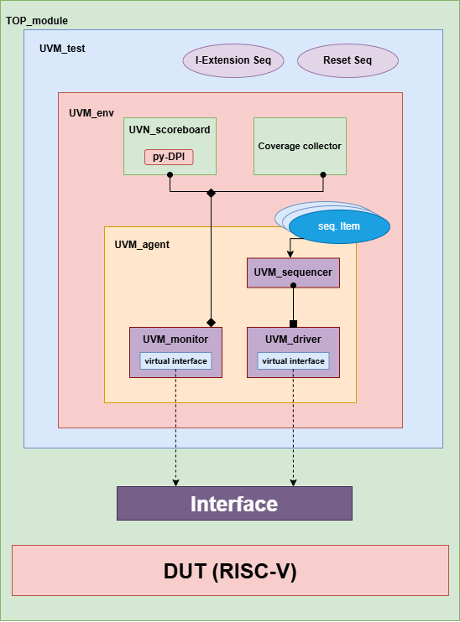

List of all verification components

Details of the simulation flow

(M+I) Extension :
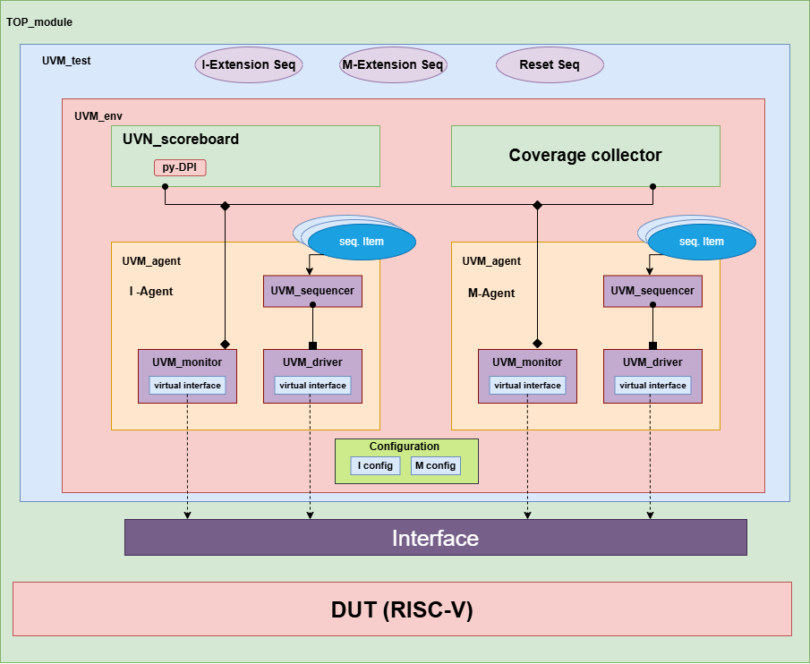

List of all verification components

Details of the simulation flow

Features To Be Verified:

Load:

Store:

Branch:

jump:

Logical instruction:

Integer instruction:

Multiplication instruction:

Description of the expected behavior of each feature

Test Plan

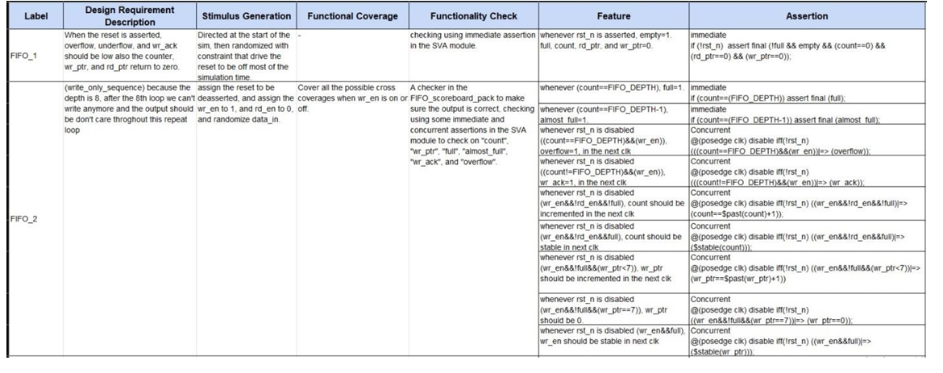
Excel sheet and its link

Coverage Plan:

Coverage groups:

SVA:

Bug Tracking:

Bug Report:


Excel sheet and its link

UVM code:

Simulation logs:

Exit criteria and Results:

