DATADOSE
Pharmaceutical Drug Interaction Analytics Platform
PYSPARK STREAMING PIPELINE GUIDE
What DataBricks_Pyspark.ipynb Does, Cell by Cell, and How to Run It
Notebook: DataDoseDepi_Pipeline_v5 | Kafka -> PySpark -> Neo4j -> Snowflake

1. What This Notebook Does
DataBricks_Pyspark.ipynb is a live streaming pipeline. It listens to a Kafka topic where new prescription events arrive in real time, enriches every single event with a drug-interaction lookup against a Neo4j graph database, computes a risk score, and writes the enriched result straight into Snowflake — continuously, every 10 seconds, for as long as the stream is running.
This is different in kind from the batch notebook described in the Databricks ↔ Snowflake Connection Guide. That guide's notebook reads and writes data on demand, one cell at a time. This notebook starts a long-running streaming query that keeps working in the background, batch after batch, until you explicitly stop it.
WHO THIS IS FOR | Whoever runs or maintains the live ingestion pipeline — the notebook that keeps STAGING.STG_TRANSACTION continuously populated with enriched, risk-scored prescription events as they happen.

1.1 The Four Systems Involved
- Aiven Kafka — the message queue. A separate program, simulator.py, publishes prescription events as JSON onto a topic called DataDose.in.
- Databricks (this notebook) — reads the Kafka stream, parses each JSON message, enriches it, and writes the result onward.
- Neo4j AuraDB — a graph database that already knows which drugs interact with which, and through which shared ingredient. The notebook queries it once per incoming prescription.
- Snowflake — the destination. Enriched rows land in STAGING.STG_TRANSACTION, the same staging table described in the Dimensional Model Guide, ready to be promoted into the fact table.

2. The Pipeline at a Glance
Every notebook cell ultimately serves one of the four stages below. Read top to bottom: a message is born in Kafka, Spark picks it up and asks Neo4j whether it's dangerous, a risk score is computed, and the enriched result lands in Snowflake.
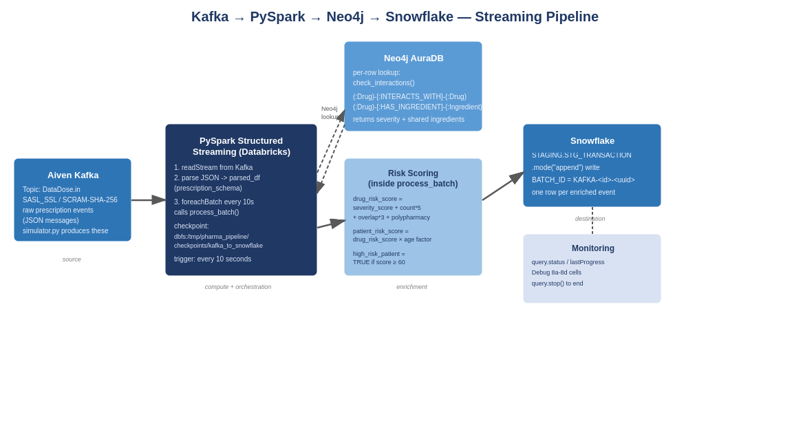

3. Why This Notebook Is Built This Way

3.1 Why Structured Streaming instead of a batch job
A batch job runs once and finishes. This pipeline instead uses Spark Structured Streaming, which treats the Kafka topic as an unbounded table that keeps growing — Spark simply re-checks it every trigger interval (here, every 10 seconds) and processes only the new messages since last time. That's the right model for prescriptions: they don't arrive in neat daily files, they arrive one at a time, continuously, and a pharmacist's alert dashboard needs to reflect that within seconds, not after an overnight batch.

3.2 Why foreachBatch instead of a simpler streaming write
Spark can write a stream directly to many destinations, but Snowflake and Neo4j both need custom per-row logic — querying Neo4j for each prescription's drug list, then computing a risk score, before anything gets written. foreachBatch is Spark's escape hatch for exactly this: it hands you a regular, static DataFrame for each micro-batch, which the notebook can .collect() into normal Python rows, loop over, enrich one at a time, and write out with an ordinary Snowflake batch write. Step 7's process_batch function is that escape hatch.

3.3 Why checkpointing matters
CHECKPOINT_PATH in Step 8 tells Spark where to durably record which Kafka offsets have already been processed. If the cluster restarts or the notebook is re-run, Spark resumes from the last checkpoint instead of either replaying everything from the beginning or silently skipping messages. Without a checkpoint, a restart could double-write rows or lose them.

3.4 Why the graph database lives outside Snowflake
Drug-interaction checking is a graph traversal problem at its core: “does drug A connect to any drug in this list, directly or through a shared ingredient?” Neo4j answers that kind of question natively and fast. Rather than reimplementing graph traversal in SQL on every incoming row, the pipeline asks Neo4j directly and only sends the final enriched, flattened result to Snowflake — which is what Snowflake is good at storing and what Power BI is good at querying.

3.5 Why every Step has a Debug cell
Each numbered Step cell defines something (a connection, a function, a schema) without doing anything irreversible. The Debug cell directly underneath it actually exercises that thing in a small, safe way — a connection ping, a 5-message sample, a dry run that writes clearly-tagged test rows (BATCH_ID = 'KAFKA-9999-*'). This lets you verify every stage in isolation before Step 8 commits to running the real, continuous pipeline.

4. Cell-by-Cell Walkthrough

4.1 Step 0 — Install Dependencies
Installs the neo4j Python driver via %pip install neo4j. Databricks's Python environment doesn't include it by default. The Debug 0 cell simply imports it and prints the version, confirming the install worked before anything else depends on it.

4.2 Step 1 — Credentials and Configuration
This is the cell every other cell depends on. It defines two small helper functions, get_env and get_secret_or_env, and uses them to load every credential and setting the pipeline needs:
- get_env reads a plain (non-secret) environment variable, falling back to a default if one is provided.
- get_secret_or_env checks an environment variable first, then falls back to a Databricks secret scope lookup (dbutils.secrets.get) — this is how passwords and usernames are kept out of the notebook's actual text.
Three groups of settings are loaded this way: Kafka connection details (bootstrap servers, topic, username/password from the datadose secret scope), Neo4j connection details (URI, user, password — also from datadose), and the Snowflake sf_options dictionary (account URL, user, password, database, schema, warehouse, role).
UPDATED | Snowflake's sfUser and sfPassword now come from the pharma-snowflake secret scope, matching the scope created in the Setup Guide. Kafka and Neo4j credentials remain on the separate datadose scope — they were never affected by the Snowflake account rotation.
Because sfURL is read with get_env('SNOWFLAKE_URL', required=True) rather than being hardcoded, this notebook needed no edits at all when the Snowflake account changed — only the underlying secret/environment value needs to be current.

4.3 Step 2 — Verify ca.pem Certificate
Aiven Kafka requires TLS, and the Spark JVM needs a local certificate file to trust it. This step checks that the certificate (uploaded to the Databricks workspace) actually exists at the configured path, then copies it to /tmp/ca.pem — because the Spark JVM can read paths under /tmp but cannot read Databricks Workspace paths directly. If the file is missing, it raises a clear error with the three steps to fix it (download from Aiven, upload to your Databricks user folder, update the path).

4.4 Step 3 — Neo4j Connection and Helper Functions
Defines get_neo4j_driver() (a lazily-created, reused connection) and the core function the whole pipeline depends on: check_interactions(new_drug, current_drugs). For a given new prescription and the patient's existing medications, it runs two Cypher queries against Neo4j:
- One that follows (:Drug)-[:INTERACTS_WITH]-(:Drug) relationships to find direct, known interactions, ranked so the worst severity (Major > Moderate > Minor) comes first.
- One that follows (:Drug)-[:HAS_INGREDIENT]->(:Ingredient)<-[:HAS_INGREDIENT]-(:Drug) to find drugs that share an active ingredient even if no direct interaction edge exists — catching risk that a simple interaction lookup alone would miss.
The three Debug cells under Step 3 test this in increasing depth: 3a just confirms Neo4j is reachable at all, 3b inspects what's actually in the graph (node and relationship counts, a few sample drug names), and 3c runs a real test case (warfarin against aspirin, ibuprofen, and metformin) that should come back as a known Major interaction — a meaningful, realistic sanity check rather than a trivial connectivity test.

4.5 Step 4 — Snowflake Connection and Schema Verification
Runs a simple identity query (CURRENT_USER(), CURRENT_DATABASE(), CURRENT_WAREHOUSE(), CURRENT_ROLE()) to confirm the connection works at all. Debug 4a checks the result against expected values.
UPDATED | Debug 4a's expected SF_USER is now PYSPARK_SVC, not the old DATADOSE01. The pipeline authenticates as the dedicated service account — the same one created in the Setup Guide — not as your personal admin login, so the check now verifies the identity that's actually in use.
Debug 4b goes further: it queries INFORMATION_SCHEMA.COLUMNS to confirm STAGING.STG_TRANSACTION actually exists with the expected columns before the pipeline tries to write to it — catching a missing-schema problem early with a clear message pointing back to the schema DDL, rather than failing deep inside a streaming write.

4.6 Step 5 — Kafka Structured Streaming Reader
Defines kafka_stream_df using spark.readStream, not spark.read — the difference between defining a continuous, unbounded source versus reading a fixed snapshot. The connection options here matter: kafka.security.protocol and kafka.sasl.mechanism configure SASL_SSL/SCRAM-SHA-256 authentication (Aiven's requirement), kafka.ssl.truststore.location points at the /tmp/ca.pem copied in Step 2, and startingOffsets is set to 'latest' — meaning the live pipeline only picks up new messages from the moment it starts, not the topic's entire history.
Debug 5a checks the raw schema Spark gives you for any Kafka source (key, value, topic, partition, offset, timestamp, timestampType) — note value is still raw bytes at this point, not yet parsed JSON. Debug 5b does a one-off batch read of up to 5 real messages (using startingOffsets='earliest' just for this test) to prove real data is actually flowing from simulator.py before building anything on top of it.

4.7 Step 6 — JSON Schema and Stream Parsing
Defines prescription_schema, a strict StructType matching exactly what simulator.py emits (transaction_id, patient_id, pharmacy_id, pharmacy_city, new_drug, new_drug_dose, new_drug_form, current_drugs as an array, patient_age, patient_gender, timestamp). parsed_df then casts the raw Kafka value to a string and applies F.from_json against that schema, producing a proper structured streaming DataFrame with one column per field.
Debug 6a checks the resulting column set matches exactly what's expected (13 columns: the 11 schema fields plus raw_json and kafka_timestamp, kept alongside for lineage and debugging). Debug 6b parses a handful of real messages end-to-end and prints each field individually, flagging if any of the three most important fields (transaction_id, new_drug, pharmacy_id) come back null — which would indicate a schema mismatch with whatever simulator.py is actually sending.

4.8 Step 7 — process_batch: the Enrichment Function
This is the heart of the pipeline. For every micro-batch, process_batch(batch_df, batch_id):
- Collects the batch into ordinary Python rows and tags the whole batch with a unique BATCH_ID (KAFKA-<batch_id>-<8 hex chars>) for traceability.
- For each row, calls check_interactions() against Neo4j using that row's new_drug and current_drugs.
- Computes current_meds_count and a polypharmacy_flag (TRUE once a patient is on 5 or more current medications).
- Computes drug_risk_score from a weighted formula: a severity base score (Major=40, Moderate=20, Minor=10) plus 5 points per interaction found, 3 points per shared ingredient, and a flat 5-point polypharmacy penalty — capped at 100.
- Computes patient_risk_score by adjusting the drug score for age (older patients get a small upward multiplier), and sets high_risk_patient = TRUE once that score reaches 60 or higher.
- Builds one dictionary per row matching STG_TRANSACTION's columns exactly, then writes the whole batch to Snowflake in a single .mode('append') call.
Debug 7 is a full dry run: it reads 5 real messages directly from Kafka (bypassing the live stream), runs them through process_batch with batch_id=9999 (so the resulting rows are unmistakably tagged KAFKA-9999-* and easy to find or clean up later), and then queries Snowflake to confirm the rows actually landed with sensible enrichment values.

4.9 Step 8 — Start the Live Streaming Pipeline
query = (
parsed_df.writeStream
.foreachBatch(process_batch)
.option('checkpointLocation', CHECKPOINT_PATH)
.trigger(processingTime='10 seconds')
.start()
)
This single cell is where everything defined above actually goes live. It ties parsed_df (Step 6) to process_batch (Step 7), checkpoints progress to dbfs:/tmp/pharma_pipeline/checkpoints/kafka_to_snowflake, and triggers a new micro-batch every 10 seconds. Once this cell runs, the notebook does not block — query.start() returns immediately and the pipeline keeps running in the background, even as you run other cells below it.

4.10 Step 9 — Monitor and Stop
Four Debug cells let you watch the running pipeline without interrupting it:
- 8a — a one-shot snapshot: is the stream active, and what did the last batch look like (rows/sec, current Kafka offset).
- 8b — watches 6 checks, 10 seconds apart, printing live batch IDs and throughput — useful for confirming the stream is actually progressing, not stalled.
- 8c — queries Snowflake directly for the most recent rows written by the live stream (explicitly excluding the KAFKA-9999-* dry-run rows from Step 7's debug), as ground truth that data is really arriving.
- 8d — a summary health check: total records, how many had an interaction, how many were high-risk, the average patient risk score, and the timestamp of the last write — a single glance answer to “is this pipeline healthy right now.”
Finally, query.stop() ends the streaming query cleanly. The pipeline does not stop on its own — it will keep running (and keep paying for cluster compute) until this cell is run or the cluster is terminated.

5. Practical Guidance

5.1 Recommended run order
Run Steps 0 through 7 in order, including every Debug cell beneath each one — each Debug cell is there specifically to catch a failure at that stage before it can cascade into a confusing error two steps later. Only run Step 8 once every preceding Debug cell has passed. Once Step 8 is running, use the Step 9 Debug cells freely — they only read, they never interfere with the stream.

5.2 Before starting the live stream, make sure
- simulator.py is running somewhere and actively publishing to the DataDose.in topic — several Debug cells depend on it, and the live stream will simply sit idle without it.
- The pharma-snowflake secret scope actually contains current values for snowflake-user and snowflake-password — if the Snowflake password is ever rotated again, only the secret needs updating, not this notebook.
- The cluster has the Snowflake Spark connector and JDBC driver installed (Maven libraries, per the Connection Guide's Step 4) — this pipeline cannot write to Snowflake without them.

5.3 Cleaning up test data
Every dry-run / debug write to Snowflake is tagged with a recognizable BATCH_ID (KAFKA-9999-* from Debug 7). If you want STAGING.STG_TRANSACTION to contain only real pipeline output, you can safely delete rows matching that pattern — they're easy to find precisely because the notebook tags them that way on purpose.

5.4 Stopping and restarting safely
Always call query.stop() (Step 9) rather than just detaching the notebook or killing the cluster. A clean stop lets the checkpoint reflect exactly what was processed. If the pipeline is restarted later by re-running Step 8, it will resume from the checkpoint and will not reprocess or skip messages, as long as the checkpoint path itself isn't deleted.

6. Quick-Reference Glossary
Term | Meaning
readStream / writeStream | Spark APIs for unbounded, continuously-updating sources and sinks, as opposed to read/write for fixed, one-time data.
Micro-batch | One small chunk of new data Spark Structured Streaming processes per trigger interval (here, every 10 seconds).
foreachBatch | A Structured Streaming sink that hands you a regular static DataFrame per micro-batch, so you can run custom logic (like a Neo4j lookup) that isn't a built-in streaming sink.
Checkpoint | A durable record of which data has already been processed, so a restart resumes correctly instead of duplicating or losing data.
Trigger interval | How often Spark checks the source for new data and runs a micro-batch. Set here to processingTime='10 seconds'.
sf_options | The dictionary of Snowflake connection parameters (URL, user, password, database, schema, warehouse, role) passed to every Snowflake read/write call.
Secret scope | A named, access-controlled container of credentials in Databricks, retrieved via dbutils.secrets.get(scope, key) instead of being written in plain text in the notebook.
Polypharmacy | Clinically, taking 5 or more medications concurrently — flagged here as POLYPHARMACY_FLAG and factored into the risk score.
Drug / Patient risk score | 0–100 composite scores computed in process_batch from interaction severity, ingredient overlap, polypharmacy, and (for patient score) age.

RELATED DOCUMENTS | Pair this guide with the Dimensional Model Guide (for what STAGING.STG_TRANSACTION feeds into) and the Databricks ↔ Snowflake Connection Guide (for cluster setup and the simpler, on-demand notebook pattern).

