DATADOSE
Pharmaceutical Drug Interaction Analytics Platform
DIMENSIONAL MODEL GUIDE
Why a Star Schema, What the Code Builds, and How to Pull Insight From It
Schema Version 3.0 | PHARMA_ANALYTICS_DB | Snowflake on Azure

1. What This Document Covers
DataDoseSchema_v3.sql builds the data warehouse behind the DataDose platform: the structure that turns raw prescription and drug-safety data into something a pharmacist, analyst, or BI dashboard can actually query in seconds. This guide explains the design in plain terms — what a dimensional model is, why this schema uses one, what each block of the SQL file actually creates, and how to turn the finished tables into insight for an end user.
WHO THIS IS FOR | Anyone setting up, maintaining, or building reports on top of PHARMA_ANALYTICS_DB — data engineers running the SQL, analysts writing queries, and stakeholders who want to understand what the platform is capable of telling them.

1.1 How the Sections Are Organized
- Section 2 — what dimensional modeling is, in plain language, using this schema as the example
- Section 3 — why this specific design was chosen over alternatives, and what it buys you
- Section 4 — a visual map of the star schema
- Section 5 — a walkthrough of what each block of SQL actually creates and why
- Section 6 — how to extract insight: example questions, the queries that answer them, and how to read the results
- Section 7 — a quick-reference glossary of schema terms

2. What Is Dimensional Modeling?
Dimensional modeling is a way of organizing data around two kinds of tables: facts and dimensions.

2.1 Facts — the events that happened
A fact table stores measurable events — things that happened, with numbers attached. In this schema that's FACT_PRESCRIPTION_TRANSACTION: every single row is one prescription being filled. Each row carries measures like INTERACTION_COUNT, DRUG_RISK_SCORE, and POLYPHARMACY_FLAG — the numbers and flags you'd want to total, average, or filter on.

2.2 Dimensions — the context around each event
A dimension table stores the descriptive context that explains who, what, where, and when for each fact. This schema has five: DIM_DRUG (what was prescribed), DIM_PHARMACY (where), DIM_PATIENT (who, de-identified), DIM_DATE (when), and DIM_INGREDIENT (the underlying active ingredients, linked through a bridge table since one drug can contain several ingredients).
Every dimension connects to the fact table through a foreign key — a surrogate key (an auto-generated integer, like DRUG_SK or PHARMACY_SK) rather than the natural name itself. That indirection is deliberate: it lets a drug's name or classification change over time without rewriting every transaction row that referenced it.

2.3 Why "star" schema?
Picture the fact table in the middle and each dimension table radiating outward in a single hop — that shape is literally why it's called a star schema. No dimension links to another dimension first; everything connects directly to the fact table at the center. That single-hop design is what keeps queries fast and easy to write: a query that wants "interactions by drug class, by month, by pharmacy" joins the fact table to three dimensions directly, with no intermediate hops.

3. Why This Schema Uses This Design
A few deliberate design choices in this schema are worth calling out, because each one solves a specific real-world problem for a pharma analytics platform.

3.1 Staging Layer — absorb messy data before it touches anything important
STG_DRUG_METADATA and STG_TRANSACTION store every column as VARCHAR (plain text), even values that are really numbers or booleans. This is intentional: source systems (FDA API feeds, pharmacy POS exports, CSV drops) don't always agree on formatting — a boolean might arrive as "True", "1", or "Y" depending on the day. Staging absorbs that inconsistency safely, and the RAW_RECORD VARIANT column keeps the entire original payload for audit and debugging. Only after the data is cleaned and validated does it get cast to proper types and "promoted" into the dimension and fact tables.

3.2 SCD Type 2 on DIM_DRUG — keep history instead of overwriting it
Drug metadata changes — a new warning gets added, a therapeutic classification gets updated. DIM_DRUG uses Slowly Changing Dimension Type 2 (SCD2): instead of overwriting a drug's row when something changes, it closes out the old row (sets EXPIRY_DATE and IS_CURRENT = FALSE) and inserts a new row as the current version. This means a query against historical transactions always reflects what was true about a drug at the time of that prescription — which matters in a regulated pharma context where you may need to reconstruct "what did we know about this drug on this date."

3.3 De-identified patient dimension — HIPAA by design
DIM_PATIENT stores zero personally identifiable information. PATIENT_TOKEN is a hashed identifier, and attributes like AGE_BAND and GENDER_CODE are deliberately bucketed/coarse rather than exact. This lets the platform analyze patient-level risk patterns — polypharmacy trends, risk tiers — without ever holding data that would put it in HIPAA's direct-identifier category.

3.4 Pre-aggregated ANALYTICS tables and views — fast dashboards, cheap queries
DRUG_INTERACTION_SUMMARY, PHARMACY_RISK_SUMMARY, and PATIENT_RISK_PROFILE are not raw data — they're pre-computed rollups, refreshed on a schedule. Without them, a dashboard KPI like "average risk score this month, by pharmacy" would have to scan and aggregate the entire fact table live, every time someone opens the dashboard. By precomputing the heavy aggregation once and storing the result, dashboards read a small, ready-made table instead — the same idea behind V_DRUG_SAFETY_SUMMARY, which exists specifically to feed Power BI KPI cards without expensive live computation.

3.5 Cluster keys — matched to how the data actually gets queried
Each table's CLUSTER BY clause is chosen to match its most common filter pattern, not chosen arbitrarily. DIM_DRUG clusters on (IS_CURRENT, THERAPEUTIC_GROUP, DOSAGE_FORM) because most BI queries filter to current records within a drug class and form. The fact table clusters on (TX_DATE_SK, PHARMACY_SK, INTERACTION_SEVERITY) because most reporting slices by time, location, and severity. Clustering tells Snowflake how to physically co-locate matching rows, which keeps large scans fast as the data grows.

3.6 Graph export surface — bridging to Neo4j
Drug interactions are naturally a graph problem (drug A connects to drug B through a shared ingredient), which relational tables don't represent elegantly. Rather than modeling the whole platform as a graph, this schema keeps the warehouse relational for everyday BI use and adds V_DRUG_INTERACTION_GRAPH purely as an export surface — a flattened view shaped exactly the way Neo4j's import tools expect, with NEO4J_EXPORT_LOG tracking every export run so re-runs don't create duplicates.

4. The Schema at a Glance
The diagram below shows the full star: the fact table in the center, the five dimensions radiating out, and the drug-ingredient bridge table connecting DIM_DRUG to DIM_INGREDIENT (since one drug formulation can contain multiple active ingredients, and one ingredient can appear in multiple drugs).
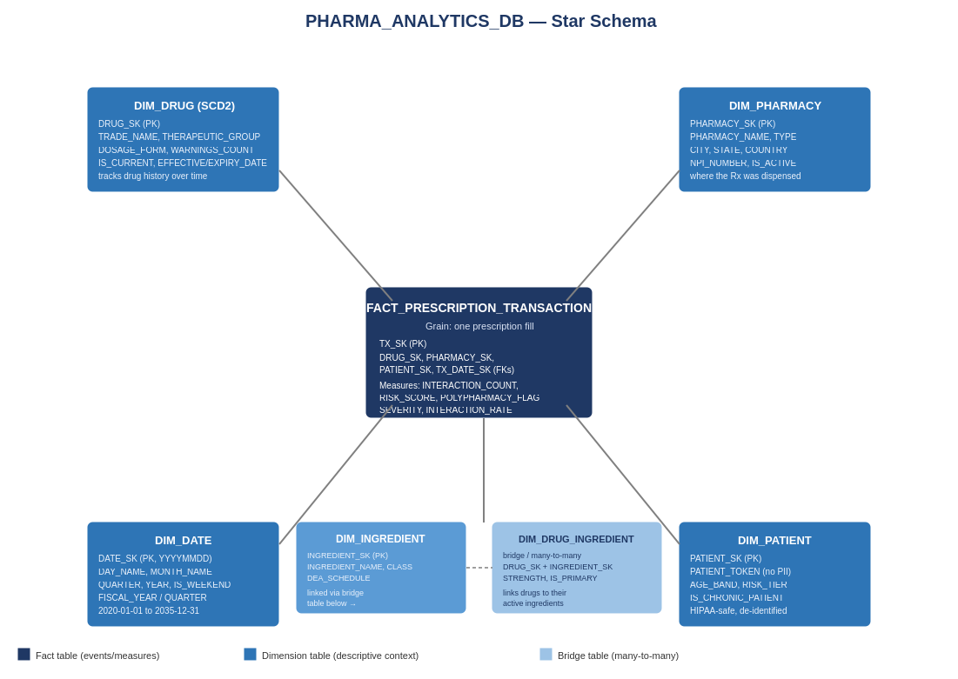

5. What the Code Actually Builds — Block by Block
DataDoseSchema_v3.sql is organized into eleven labeled blocks, run in order. Here's what each one does and why it exists.

5.1 Block 0 — Warehouse
Creates PHARMA_WH, the compute engine that runs every query. It's sized X-SMALL with AUTO_SUSPEND = 60 (suspends after 60 seconds idle) and AUTO_RESUME = TRUE, so you're only paying for compute while something is actually running.

5.2 Block 1 — Database & Schemas
Creates PHARMA_ANALYTICS_DB and four schemas that map directly to the dimensional-model layers: STAGING (raw landing zone), DIMENSIONS, FACTS, and ANALYTICS (rollups and export views). Separating these into schemas — rather than one flat namespace — makes permissions, organization, and mental model all clearer: you always know what kind of table you're looking at from its schema name.

5.3 Block 2 — Role & Service User
Creates PYSPARK_ROLE and grants it SELECT/INSERT/UPDATE/DELETE across every schema, including FUTURE tables (so a new table added later doesn't silently lack permissions). PYSPARK_SVC is the service account Databricks uses to read and write data programmatically — kept separate from your own admin login so ETL access can be revoked or rotated independently of human access.

5.4 Block 3 — Staging Tables
STG_DRUG_METADATA and STG_TRANSACTION, both VARCHAR-typed as explained in Section 3.1. Each carries a RAW_RECORD VARIANT column (full original JSON) and an IS_PROCESSED flag that PySpark flips to TRUE once a row has been successfully promoted into the dimension/fact layer — this is what makes incremental loads possible instead of reprocessing everything every run.

5.5 Block 4 — Dimension Tables
Built in dependency order: DIM_DATE must exist first (the INSERT statement immediately after it populates 5,844 calendar-day rows from 2020-01-01 through 2035-12-31 using Snowflake's GENERATOR function — no external calendar file needed). Then DIM_DRUG (SCD2, described in 3.2), DIM_INGREDIENT, DIM_PHARMACY, DIM_PATIENT, and finally DIM_DRUG_INGREDIENT, the bridge table — built last because it has foreign keys into both DIM_DRUG and DIM_INGREDIENT, so both must already exist.

5.6 Block 5 — Fact Table
FACT_PRESCRIPTION_TRANSACTION — the center of the star. Built last among the core tables because its foreign keys reference every dimension. Each row is one prescription fill, carrying the foreign keys plus the measures: interaction detection results, risk scores, polypharmacy flags. This is the table almost every analytical query ultimately touches.

5.7 Block 6 — Analytics Tables
DRUG_INTERACTION_SUMMARY (one row per drug-pair, used for both BI and the Neo4j export), PHARMACY_RISK_SUMMARY (daily rollup per pharmacy), PATIENT_RISK_PROFILE (longitudinal risk snapshot per patient per date), and NEO4J_EXPORT_LOG (audit trail for graph exports). These are refreshed periodically by scheduled jobs rather than computed live.

5.8 Blocks 7 & 8 — Search Optimization & Row Access Policy (commented out)
Both blocks are wrapped in /* ... */ because they require Snowflake Enterprise edition, and this account is on Standard. Search Optimization would speed up point lookups on text fields like TRADE_NAME; the Row Access Policy is a HIPAA-style scaffold that would restrict who can query DIM_PATIENT by role. Uncomment and run these only after upgrading the account edition.

5.9 Block 9 — Views
Three views, all usable on Standard edition:
- V_DRUG_INTERACTION_GRAPH — flattens drug + interaction data into the shape Neo4j's import tools expect (described in 3.6)
- V_HIGH_RISK_PRESCRIPTIONS — surfaces only transactions flagged high-risk, major-severity, or polypharmacy, joined with readable drug/pharmacy/date context, for clinical alert dashboards
- V_DRUG_SAFETY_SUMMARY — pre-aggregated per-drug safety KPIs including a computed RISK_SCORE and TOTAL_SAFETY_BURDEN, feeding Power BI cards directly

5.10 Block 10 — Verification Queries
A checklist to confirm the build worked: row counts, the expected DIM_DATE range, today's date row, the DIM_DRUG default-date fix, the PYSPARK_ROLE grants, and a connectivity smoke test run as PYSPARK_ROLE itself rather than as admin — so you're verifying the same access the service account will actually use in production.

6. Extracting Insight: From Tables to Answers
The real point of this schema is to let someone ask a business or clinical question in plain English and get there with one query. Below are realistic questions an end user — a pharmacist, safety officer, or analyst — might ask, the query that answers each one, and what to look for in the result.

6.1 "Which drug pairs cause the most serious interactions?"
Query DRUG_INTERACTION_SUMMARY directly — it's already pre-aggregated, so this is fast even at scale:
SELECT DRUG_A_NAME, DRUG_B_NAME, SHARED_INGREDIENT,
INTERACTION_SEVERITY, OBSERVED_TX_COUNT, INTERACTION_RATE
FROM ANALYTICS.DRUG_INTERACTION_SUMMARY
WHERE INTERACTION_SEVERITY = 'Major'
ORDER BY OBSERVED_TX_COUNT DESC
LIMIT 20;
How to read it: OBSERVED_TX_COUNT tells you how often this pair actually shows up together in real prescriptions — a high-severity pair with a high count is your top priority for a clinical alert rule, while a high-severity pair with a near-zero count may be rare enough to deprioritize.

6.2 "Which pharmacies have the riskiest patient population right now?"
SELECT p.PHARMACY_NAME, p.CITY, p.STATE,
prs.HIGH_RISK_TX_COUNT, prs.MAJOR_INTERACTION_COUNT,
prs.AVG_RISK_SCORE
FROM ANALYTICS.PHARMACY_RISK_SUMMARY prs
JOIN DIMENSIONS.DIM_PHARMACY p ON prs.PHARMACY_SK = p.PHARMACY_SK
WHERE prs.SUMMARY_DATE_SK = (SELECT MAX(SUMMARY_DATE_SK)
FROM ANALYTICS.PHARMACY_RISK_SUMMARY)
ORDER BY prs.AVG_RISK_SCORE DESC
LIMIT 10;
How to read it: this answers an operational question — where should a pharmacist-in-charge focus extra review? Filtering to the most recent SUMMARY_DATE_SK gives today's snapshot rather than an all-time average, which matters because risk concentration shifts week to week.

6.3 "Show me every prescription that needs clinical review today."
This is exactly what V_HIGH_RISK_PRESCRIPTIONS was built for — no joins required on the user's end:
SELECT DRUG_NAME, THERAPEUTIC_GROUP, PHARMACY_NAME, CITY,
INTERACTION_SEVERITY, INTERACTING_DRUGS, PATIENT_RISK_SCORE
FROM ANALYTICS.V_HIGH_RISK_PRESCRIPTIONS
WHERE TX_DATE = CURRENT_DATE()
ORDER BY PATIENT_RISK_SCORE DESC;
How to read it: this view already pre-filters to major severity, polypharmacy, or high-risk-patient transactions, so every row returned is something worth a human glance — no extra filtering logic needed downstream.

6.4 "Which drug classes carry the highest overall safety burden?"
V_DRUG_SAFETY_SUMMARY already computes RISK_SCORE and TOTAL_SAFETY_BURDEN per drug — roll it up by therapeutic group:
SELECT THERAPEUTIC_GROUP,
COUNT(*) AS DRUG_COUNT,
ROUND(AVG(RISK_SCORE), 2) AS AVG_RISK_SCORE,
SUM(TOTAL_SAFETY_BURDEN) AS TOTAL_BURDEN
FROM ANALYTICS.V_DRUG_SAFETY_SUMMARY
GROUP BY THERAPEUTIC_GROUP
ORDER BY AVG_RISK_SCORE DESC;
How to read it: this is the query a Power BI "Risk by Drug Class" bar chart runs under the hood. High AVG_RISK_SCORE with a low DRUG_COUNT flags a small, consistently risky class worth a closer look; high TOTAL_BURDEN with many drugs may just reflect a large, heavily-prescribed category rather than unusual risk per drug.

6.5 "How has a specific patient's risk trended over time?"
SELECT dd.FULL_DATE, prp.CURRENT_MEDS_COUNT, prp.PATIENT_RISK_SCORE,
prp.POLYPHARMACY_FLAG, prp.MAX_INTERACTION_SEVERITY
FROM ANALYTICS.PATIENT_RISK_PROFILE prp
JOIN DIMENSIONS.DIM_DATE dd ON prp.PROFILE_DATE_SK = dd.DATE_SK
JOIN DIMENSIONS.DIM_PATIENT pt ON prp.PATIENT_SK = pt.PATIENT_SK
WHERE pt.PATIENT_TOKEN = '<hashed_patient_token>'
ORDER BY dd.FULL_DATE;
How to read it: because PATIENT_RISK_PROFILE stores one row per patient per snapshot date, plotting PATIENT_RISK_SCORE over FULL_DATE shows whether a patient's risk is climbing, stable, or improving — useful for care management follow-up, and only possible because the dimension model keeps history instead of overwriting it.

6.6 General tips for getting good answers out of this schema
- Always filter DIM_DRUG (and any join to it) on IS_CURRENT = TRUE unless you specifically want historical versions — otherwise SCD2 history can quietly duplicate or skew results.
- Prefer the ANALYTICS views and summary tables over querying FACT_PRESCRIPTION_TRANSACTION directly when the question is a rollup — they're already computed and will be faster.
- Use DIM_DATE for any date-based grouping (month, quarter, weekday vs. weekend) instead of computing date parts in every query — the dimension already has YEAR, MONTH_NAME, QUARTER, IS_WEEKEND, and fiscal columns precomputed.
- When a question spans drugs and their ingredients (e.g. "which ingredient appears in the most interacting drugs"), go through DIM_DRUG_INGREDIENT — that's what the bridge table exists for.

7. Quick-Reference Glossary
Term | Meaning
Fact table | Stores measurable events with numeric measures. Here: FACT_PRESCRIPTION_TRANSACTION.
Dimension table | Stores descriptive context (who/what/where/when) that a fact links to.
Surrogate key (SK) | An auto-generated integer ID (e.g. DRUG_SK) used for joins instead of a natural name.
Natural key (NK) | The real-world identifier a row represents (e.g. an NPI number or ingredient name).
Grain | What one row of a fact table represents. Here, one row = one prescription fill.
SCD Type 2 | A way of tracking history by inserting a new row (and closing the old one) instead of overwriting on change. Used on DIM_DRUG.
Bridge table | Resolves a many-to-many relationship. DIM_DRUG_INGREDIENT links drugs to their multiple ingredients.
Staging layer | Raw landing zone for ETL loads before validation/promotion; VARCHAR-typed to absorb source inconsistency.
Cluster key | Tells Snowflake how to physically organize a table's data to speed up its most common filters.
View | A saved, reusable query that looks like a table — used here to pre-shape data for BI and graph export.

NEXT STEPS | Pair this guide with the New Account Setup Guide (Section 8) when deploying the schema, and with the Power BI / Databricks integration steps (Setup Guide Section 10) when connecting BI tools to these tables and views.

