Software Engineering project

Beni suef National university

Software Engineering

2024/2025

Table of Contents

Team Information: 2

Project proposal: 3

Project Idea: 3

Project scope: 3

Main functionalities: 3

Development platform: 4

Stakeholders: 4

Similar applications in the market: 4

SRS (Software requirement specification) 4

Functional Requirements 4

Non-Functional Requirements 4

Software Design 5

Activity Diagram 5

Use Case 5

Use case tables 5

Use case Diagram 6

Class diagram 6

Object diagram 6

ERD(ER-MODEL) 7

Sequence diagrams 7

Sequence diagram1 7

Use case 1 : 7

Sequence diagram 7

Sequence diagram2 8

Use case 2 : 8

Sequence diagram 8

Sequence diagram3 8

Use case 3 : 8

Sequence diagram 8

Communication diagrams 8

Communication diagram 1 8

Communication diagram 2 8

Communication diagram .. 8

System sequence diagram 8

|  |  |  |  |  |
| --- | --- | --- | --- | --- |
|  | **ID**  **[Ordered by ID]** | **Full Name**  **[In Arabic]** | **Attendance**  **[Handwritten Signature]** | **Final Grade** |
| **1** | 220100264 | Youssef Taha Mohamed Badawi |  |  |
| **2** | 220100219 | Mustafa Ahmed Hamed Younis |  |  |
| **3** | 220100167 | Maher Ibrahim Al-Shahat |  |  |
| **4** | 220100034 | Israa Ahmed Fathy |  |  |

# Project proposal:

## Project Idea: Medical Image Classification and Reporting System

## Project scope:

* Overview

An AI-powered system to analyze X-ray, MRI, and CT scans for disease detection, improving diagnostic accuracy and efficiency.

* Objectives

1. Develop a deep learning-based classification model.
2. Enhance image preprocessing and model accuracy.
3. Provide a user-friendly interface for doctors.
4. Ensure compliance with medical regulations.

* Scope Limitations

## The system will not provide a final medical diagnosis (only AI-based recommendations).

## Limited to specific diseases (e.g., pneumonia, tumors, fractures) in the first phase.

## Requires medical expert validation before clinical use

## Main functionalities:

1. An AI-powered medical imaging platform that automates disease detection in X-rays, CT scans,

and MRIs, assisting radiologists with faster and more accurate diagnoses.

1. Provides AI-based solutions for detecting various medical conditions from imaging data, offering automated insights to enhance radiology workflows.
2. Uses AI to detect abnormalities in chest X-rays and mammograms, helping doctors improve early disease detection and diagnostic accuracy.

## Development platform:

Developing a **Medical Image Classification** system requires a well-structured platform that integrates data processing, model training, and deployment. Below are the key components of the development platform:

1. **Programming Languages** like **Python** is the primary language due to its extensive AI/ML libraries

and ease of use.

2. **Machine Learning Frameworks** such as

* scikit-learn (evaluation metrics)
* **TensorFlow** (Ideal for deep learning and CNN-based image classification)
* **PyTorch** (Preferred for research and dynamic computation graphs.)
* **Keras** (High-level API for TensorFlow to simplify model building)

3. **Image Processing & Computer Vision Libraries**

* **OpenCV**: For image preprocessing (resizing, filtering, contrast enhancement).
* **Pillow**: For handling medical images and PNG conversion

4. **Medical Image Handling & Datasets** (NIH Chest X-ray Dataset & Brain Tumor MRI Dataset)

* pydicom (DICOM handling)

5. **Computational Resources** (Cloud Platforms & GPUs or TPUs)

6. **Deployment & Integration** (Flask or Streamlit or FastAPI)

## Stakeholders:

## Healthcare Professionals

* + **Doctors & Radiologists** -> Use the system for faster and more accurate diagnosis.
  + Medical Technicians
  + **Department of Diagnostic Radiology**
  + **Healthcare Institutions** -> to assist doctors in diagnosis with high accuracy

## Patients

* + This system enables patients to be assured of their safety
* May be some of Stakeholders is Research & Academic Institutions such as Universities & AI Labs & Medical Schools & Data Scientists & ML Engineers & Computer Vision Experts -> by using this system for training future healthcare professionals and Conduct research and contribute to improving the models and improve image preprocessing and feature extraction

## Similar applications in the market:

Several AI-powered applications are currently being used for **medical image classification** to assist radiologists and healthcare professionals in diagnosing diseases from X-ray, MRI, and CT scan images such as:

1. Qure.ai https://www.qure.ai/

* An AI-powered medical imaging platform that automates disease detection in X-rays, CT scans,
* and MRIs, assisting radiologists with faster and more accurate diagnoses.

2. Zebra Medical Vision

* Provides AI-based solutions for detecting various medical conditions from imaging data, offering automated insights to enhance radiology workflows.

3. Arterys

* A cloud-based AI imaging platform that enables real-time, automated analysis of medical scans, focusing on cardiology, oncology, and neurology.

4. Lunit INSIGHT

* Uses AI to detect abnormalities in chest X-rays and mammograms, helping doctors improve early disease detection and diagnostic accuracy.

5. Google DeepMind Health

* Develops AI-driven healthcare solutions, including medical imaging analysis and predictive models for disease detection and patient care optimization.

# SRS (Software requirement specification)

## Functional Requirements

|  |  |  |
| --- | --- | --- |
|  | User requirements | System requirements |
| Req1 | 1.The system shall have  Register and Login feature | 1.1 A button for registering and logging in shall  be available  1.2 The patient shall be able to login in the  system by his email and password  1.3 The new patients shall be able to create a  new account to be able to use the system  1.4 A table in the database shall be created for  all users  1.5 The system shall verify each patient’s  information (email and password)  1.6 After verification the system shall displays  account home page  to the Patient. |
| Req2 | 2.Medical Image Upload & Preprocessing | 2.1 Patients shall upload medical images in DICOM, PNG, or JPG formats. 2.2 The system shall enhances image (contrast enhancement, noise reduction, resizing, normalization techniques). 2.3 A database shall store uploaded images and metadata. |
| Req3 | 3.AI-Based Image Classification | 3.1 The system shall process images using a deep learning model. 3.2 The AI model shall classify diseases (e.g., pneumonia, tumors, fractures). 3.3 The system shall provide a confidence score for each classification result. 3.4 Heatmaps shall be generated to explain AI predictions. |
| Req4 | 4.Report Generation & Export | 4.1 The system shall generate diagnostic reports. 4.2 Patients shall export reports in PDF format. |
| Req5 | 5.Integration with Hospital Systems | 5.1 The system shall support PACS/DICOM integration. 5.2 Patients shall access medical history linked to patient images. |

## Non-Functional Requirements

|  |  |  |
| --- | --- | --- |
|  | User requirements | System requirements |
| Req1 | 1.Performance | 1.1 The system shall classify an image within 5 seconds. 1.2 The AI model shall maintain an accuracy of at least 90%. |
| Req2 | 2.Security | 2.1 Patient data shall be encrypted in storage and transmission. 2.2 Only authorized medical professionals shall access patient data. 2.3 The system shall comply with HIPAA and GDPR regulations. |
| Req3 | 3.Portability | 3.1 The system shall be accessible via web and mobile platforms. |
| Req4 | 4.Scalability | 4.1 The system shall handle increasing medical image datasets without performance loss. 4.2 The AI model shall be upgradable with new disease classifications.  4.3 Support for multiple concurrent users. |
| Req5 | 5.Maintainability | 5.1 The system architecture shall support easy updates and feature expansion. 5.2 Documentation shall be provided for maintainability and future enhancements. |
| Req6 | 6.Usability | 6.1 Intuitive UI for non-technical medical professionals. |

# Software Design

## Activity Diagram

## Use Case

### Use case tables

|  |  |
| --- | --- |
| **Use Case ID** | **UC-002** |
| Use Case Name | Analyze & Classify Image |
| Actor | System |
| Description | The AI model analyzes the uploaded image and classifies potential diseases. |
| Pre-conditions | A valid image must be uploaded. |
| Steps | 1. System preprocesses the image.  2. AI model runs classification.  3. System generates a confidence score and heatmap explanation. |
| Post-conditions | The classification results are stored and ready for viewing. |
| Exceptions | 1. Image quality too low for analysis. 2. Model fails to process the image |
| Use Case Name | View Results & Explanation |

|  |
| --- |
|  |
|  |
|  |

|  |  |
| --- | --- |
| **Use Case ID** | **UC-003** |
| Actor | Doctor / Radiologist |
| Description | The user views the classification results and AI-generated explanations. |
| Pre-conditions | A classified image must exist. |
| Steps | 1. User selects an analyzed image.  2. System displays classification results.  3. System provides heatmaps and confidence scores. |
| Post-conditions | The user reviews the results and makes a diagnosis decision. |
| Exceptions | 1. Results not found due to a processing error. |

|  |  |
| --- | --- |
| **Use Case ID** | **UC-004** |
| Use Case Name | Download Report |
| Actor | Doctor / Radiologist |
| Description | The user downloads a report containing analysis results. |
| Pre-conditions | Image must be analyzed. |
| Steps | 1. User selects an analyzed image.  2. System generates a report (PDF format).  3. User downloads the report. |
| Post-conditions | The report is saved on the user's device. |
| Exceptions | 1. Report generation failure. |

|  |  |
| --- | --- |
| **Use Case ID** | **UC-005** |
| Use Case Name | User & Role Management |
| Actor | Administrator |
| Description | The admin manages user accounts and roles. |
| Pre-conditions | Admin must be logged in. |
| Steps | 1. Admin creates/edits/deletes user accounts.  2. Admin assigns roles and permissions. |
| Post-conditions | Users are assigned appropriate access rights. |
| Exceptions | 1. Unauthorized access attempt. |

### Use case Diagram

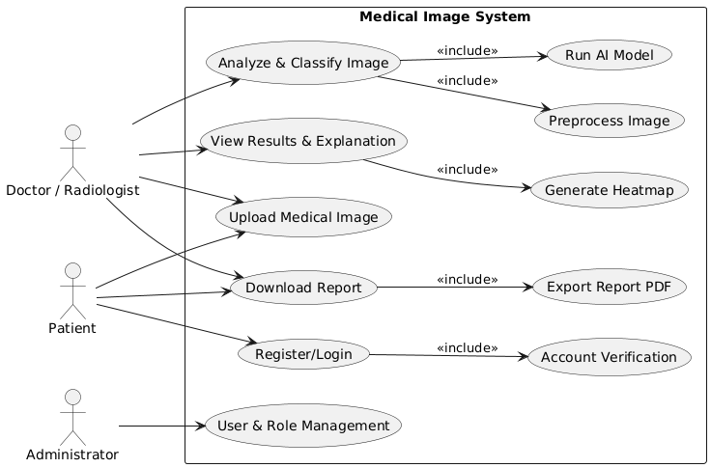

## Class diagram

## Object diagram

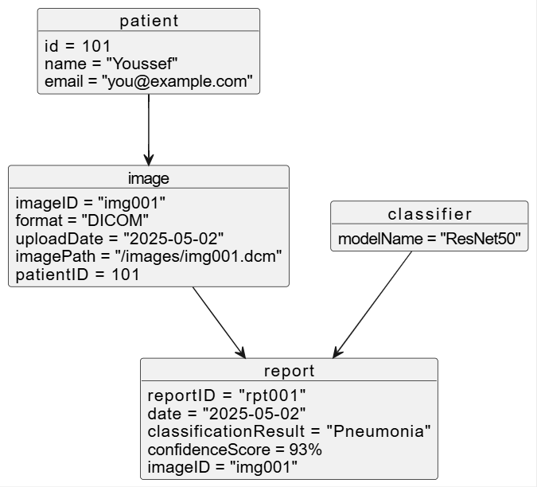

## ERD (ER-MODEL)

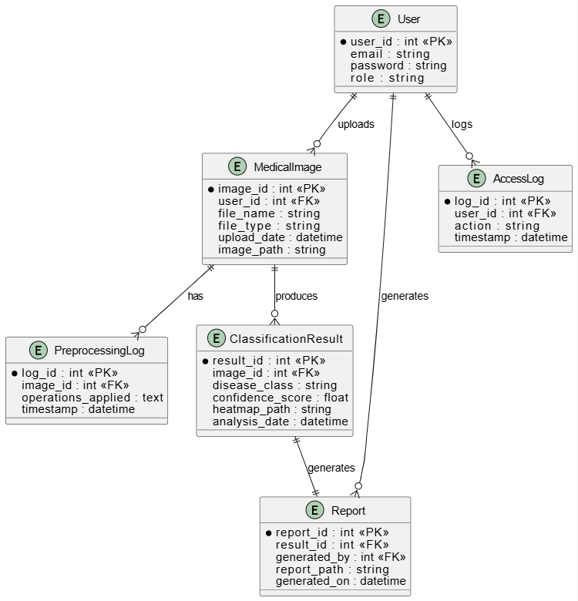

## Sequence diagrams

Sequence Diagram 1: upload medical image

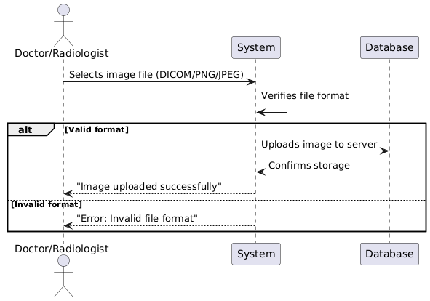

Sequence Diagram2: Analyze & Classify Image

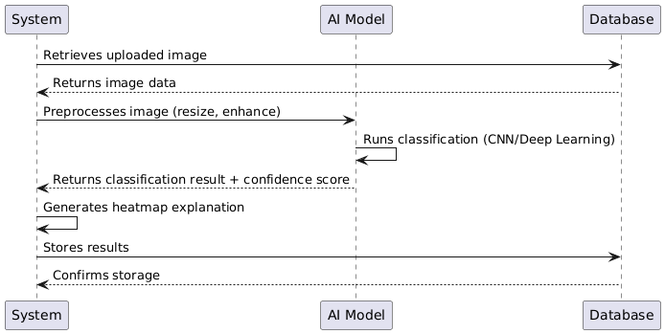

Sequence Diagram3:Model process

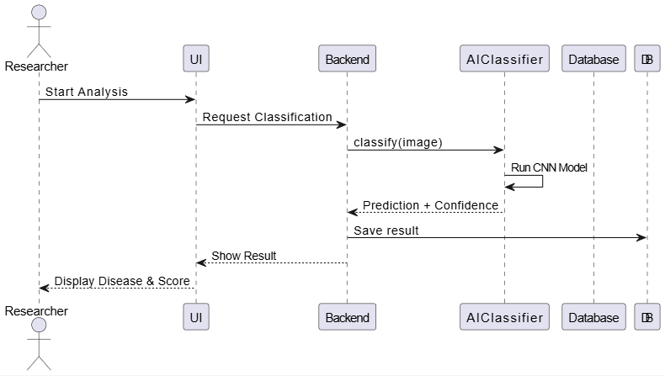

Sequence Diagram4:View Results & Explanation

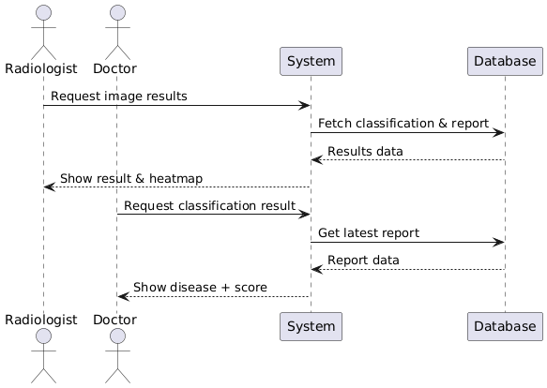

Sequence Diagram5: Generate report

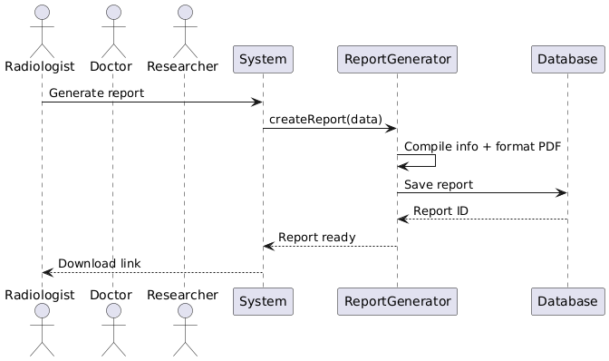

## Communication diagrams

### Communication diagram 1: upload medical image

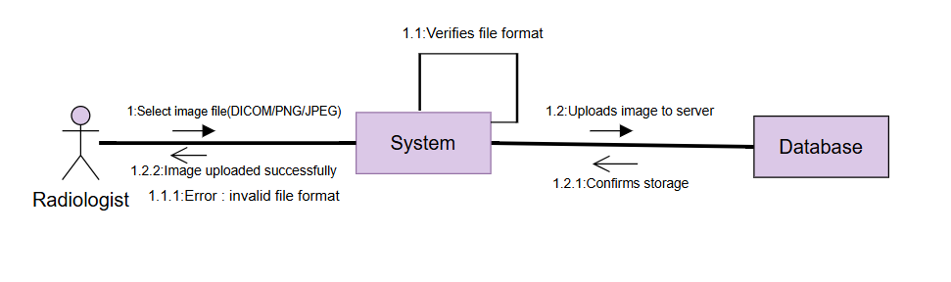Communication diagram 2: Analyze & Classify Image

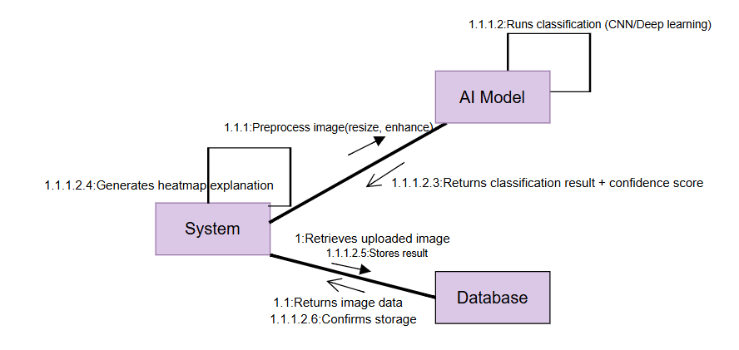

### Communication diagram 3: Model Process

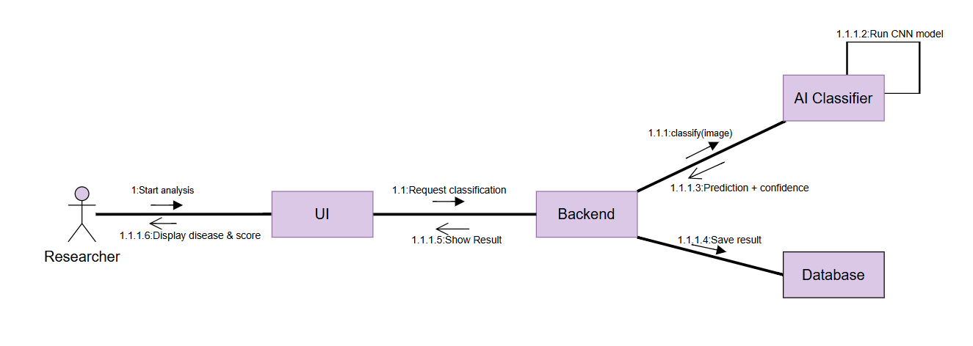

Communication diagram4: View Results & Explanation

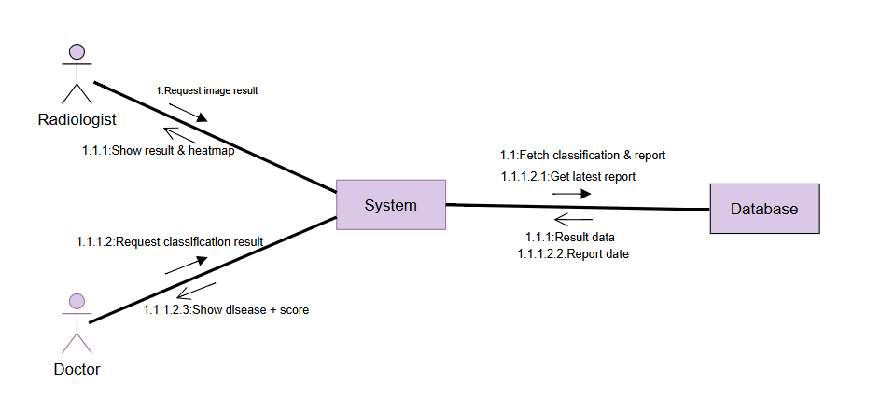

Communication diagram5: generate report

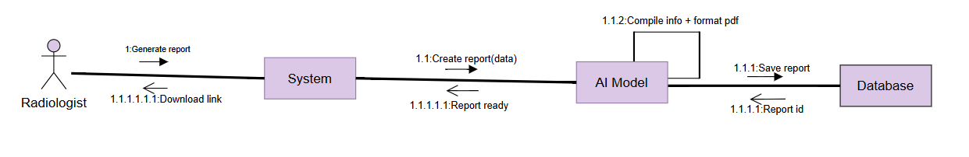

## System sequence diagram