To enhance customer loyalty
- What is the most shipping mode used by our customers ?
- Who are our top 10 customer sales and order frequency ?
- Also top 10 order frequency ?
To monitor our strength and weakness
- Which segment of clients generate the most sales ?
- Which city has the most sales value ?
- Which state generate the most sales percentage by region ?
To measure performance
- What are the top performing product categories in terms of sales and profit ?
- What is the most profitable product ?
Customer experience
- On average how long it take the order to reach the client Based on each shipping mode ??

Compony XX Data Department Report

Executive Summary
We exported the sales data from our database and we conducted some analysis on it to gain insights into some of our sales operations and study ways of enhancing our services .

Scop
- To enhance customer loyalty
- To monitor our strength and weakness
- To measure performance
- Customer experience
Data operation :
Here are the tables we used to conduct our analysis
- Order table
- Return table
- People table

The analysis
Customer loyalty
What is the most shipping mode used by our customers ?
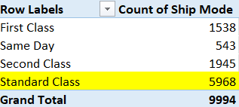
Based on the table above we counted the number of times each shipping mode occurred on order table
And found Standard class is the most one

Recommendation
We should focus on the standard mode shipping mode
Find way to reduce cost of shipping mode
First class is should removed as possible

