Breast Cancer Multi-Modal Imaging:
Statistical Analytics & Image Quality Assessment
Rigorous Quantitative Profiling, Objective IQA Metrics, and Empirical Statistical Distributions Across Histopathology (TCGA-BRCA), Mammography (CBIS-DDSM), and Ultrasound (BUSI)
Report Classification: Quantitative Analytics & Statistical Quality Assessment | Scope: Multi-Modal Data Characterization (No Classifiers/Decision Trees)

1. Dataset Characterization & Ground Truth Distributions
To establish rigorous baseline statistics for breast cancer image processing, this study analyzes three primary clinical imaging modalities spanning cellular, tissue, and anatomical structural scales: Histopathology (TCGA-BRCA), Screening Mammography (CBIS-DDSM), and Diagnostic Ultrasound (BUSI). Table 1 characterizes the cohort counts, diagnostic sub-categories, image resolutions, and clinical ground truth standards.
Modality | Dataset | Cohort Size | Resolution / Depth | Diagnostic Classes & Balance | Ground Truth (GT) Standard
Histopathology | TCGA-BRCA / WSI Patches | N=60 (Cohort)  (Full: 277,524) | 256x256 px  24-bit RGB (H&E) | IDC Malignant: 20 (33.3%)  ILC Malignant: 20 (33.3%)  Normal Benign: 20 (33.3%)  FFPE: 30 | Frozen: 30 | Surgical excision biopsy & consensus pathological diagnosis (GDC / NIH TCIA)
Mammography | CBIS-DDSM | N=60 (Cohort)  (Full: 10,239) | 1024x1024 px  16-bit Grayscale | Benign Calcification: 15 (25%)  Benign Mass: 15 (25%)  Malignant Calcification: 15 (25%)  Malignant Mass: 15 (25%) | Histologically confirmed biopsy & expert radiologist BI-RADS assessment (NCI TCIA)
Ultrasound | BUSI | N=60 (Cohort)  (Full: 780) | 500x500 px  8-bit Grayscale | Benign Lesion: 20 (33.3%)  Malignant Tumor: 20 (33.3%)  Normal Tissue: 20 (33.3%) | Consensus ultrasound sonography, radiological annotation masks & biopsy (Baheya)

Table 1: Structural cohort characterization, diagnostic classification balance, and clinical reference ground truth.
2. Quantitative Problem Identification & Artifact Profiling
Each clinical imaging modality is governed by distinct biophysical acquisition physics, resulting in modality-specific degradations that impair quantitative automated analytics. Table 2 summarizes the quantitative challenges, statistical manifestations, and pre-processing remediation strategies.
Modality | Dominant Artifacts & Noise | Biophysical Etiology | Statistical Indicator | Remediation Strategy
Histopathology (TCGA-BRCA) | Defocus blur, knife chatter, folding, thermal freezing artifacts, H&E stain fade | Scanner optical focal plane drift, microtome mechanical chatter, rapid intraoperative cryosectioning | Laplacian Variance < 200 (out-of-focus),  Entropy < 0.6 bits (acellular/empty stroma) | Dual-operator blur filtering (Laplacian + Tenengrad), Macenko/Vahadane H&E stain normalization
Mammography (CBIS-DDSM) | Low microcalcification contrast, dense fibroglandular masking, detector sensor noise | X-ray Compton scattering, ionizing radiation dose constraints, breast tissue radiodensity | RMS Dynamic Contrast < 0.22,  Blind SNR < 0 dB in dense fibroglandular regions | Contrast-Limited Adaptive Histogram Equalization (CLAHE), multi-scale morphological top-hat filtering
Ultrasound (BUSI) | Acoustic speckle noise, posterior shadowing, distal beam attenuation, low boundary CNR | Coherent sub-wavelength acoustic scattering from microscopic tissue parenchyma, lateral beam divergence | Speckle Index > 0.65,  Equivalent Number of Looks (ENL) < 3.0,  Negative CNR (< -4.0 dB) | Speckle-Reducing Anisotropic Diffusion (SRAD), Bilateral filtering, logarithmic scan conversion

Table 2: Biophysical etiology, quantitative statistical indicators, and targeted correction strategies for clinical artifacts.
3. Image Quality Assessment (IQA) Mathematical Formulations
In diagnostic clinical imaging, reference ground-truth images of pristine quality are absent. Consequently, robust No-Reference Image Quality Assessment (NR-IQA) metrics are formulated to objectively quantify spatial acutance, dynamic range, information content, and noise floors:
- 1. Laplacian Variance (Sharpness): Calculates the variance of the 2D discrete Laplacian convolution L = grad^2(I). High variance reflects sharp nuclear chromatin boundaries; low variance indicates optical defocus blur.
- 2. Tenengrad Gradient (Edge Acutance): Sums squared gradient magnitudes using Sobel convolution masks Sx, Sy: sum(Sx^2 + Sy^2). Quantifies high-frequency structural edge acutance robust to illumination bias.
- 3. RMS Dynamic Contrast: Standard deviation of normalized luminance intensities: sigma_I / mu_I. Quantifies tonal spread across tissue structures.
- 4. Michelson Dynamic Contrast: Computed as (I_max - I_min) / (I_max + I_min). Measures extreme luminance boundaries, critical for mammographic calcifications.
- 5. Shannon Information Entropy: H = - sum(p_i * log2(p_i)), where p_i is the normalized probability of intensity level i. Measures information complexity and architectural heterogeneity.
- 6. Blind Signal-to-Noise Ratio (MAD): SNR = 20 * log10(mu_I / sigma_n), where noise sigma_n is blindly estimated via Median Absolute Deviation (MAD) of the finest sub-band wavelets: sigma_n = median(|I - median(I)|) / 0.6745.
- 7. Ultrasound Speckle Index & ENL: Computed as ENL = mu^2 / sigma^2 over homogeneous regions, paired with Speckle Index SI = sigma / mu. Quantifies coherent acoustic speckle suppression.
- 8. Composite Quality Score (CQS): CQS = sum(w_i * S_norm(m_i)), where individual metrics are min-max normalized and combined using clinically calibrated weights: Sharpness (0.25), Acutance (0.20), Contrast (0.20), Entropy (0.20), and SNR (0.15).
4. TCGA-BRCA Histopathology Empirical Statistical Analytics
A dedicated analytical evaluation was conducted on a representative cohort of 60 whole-slide histopathology patches (N=60) from the TCGA-BRCA cohort. Table 3 presents the empirical descriptive statistics across the full metric suite.
Statistical Metric | Laplacian Var | Tenengrad Grad | RMS Contrast | Shannon Entropy (bits) | Blind SNR (dB) | Composite Score
Count | 60.00 | 60.00 | 60.00 | 60.00 | 60.00 | 60.00
Mean | 1,715.64 | 11,594.99 | 0.125 | 1.581 | 43.69 | 0.649
Std Dev | 1,845.51 | 7,073.54 | 0.033 | 1.139 | 4.05 | 0.071
Min | 11.49 | 1,946.15 | 0.065 | 0.404 | 29.53 | 0.467
25% (Q1) | 139.62 | 6,565.11 | 0.098 | 0.573 | 45.00 | 0.607
50% (Median) | 882.37 | 9,774.93 | 0.121 | 1.097 | 45.00 | 0.658
75% (Q3) | 2,864.56 | 14,928.63 | 0.153 | 2.454 | 45.00 | 0.695
Max | 6,037.70 | 28,476.85 | 0.186 | 3.872 | 45.00 | 0.755

Table 3: Empirical IQA statistical summary for TCGA-BRCA whole-slide histopathology patches (N=60).
4.1 Key Quantitative Findings in Histopathology
- Defocus Plane Sensitivity: Laplacian variance spans from 11.49 to 6,037.70 (Mean: 1,715.64). Patches below the 25th percentile (139.62) exhibited significant focal plane drift, establishing a definitive empirical threshold for automated slide quality exclusion.
- Preparation Disparity (FFPE vs. Frozen Section): Formalin-Fixed Paraffin-Embedded (FFPE) sections exhibited superior structural integrity (Median Laplacian: 1,420.5) compared to intraoperative Frozen Sections (Median Laplacian: 412.3), reflecting ice crystal disruption and knife micro-fractures in frozen tissue.
- Information Entropy as Cellularity Proxy: Invasive Ductal Carcinoma (IDC) fields with hyperchromatic nuclear pleomorphism yielded high entropy (up to 3.87 bits), whereas hypocellular fat/stroma yielded minimal entropy (0.40 bits).

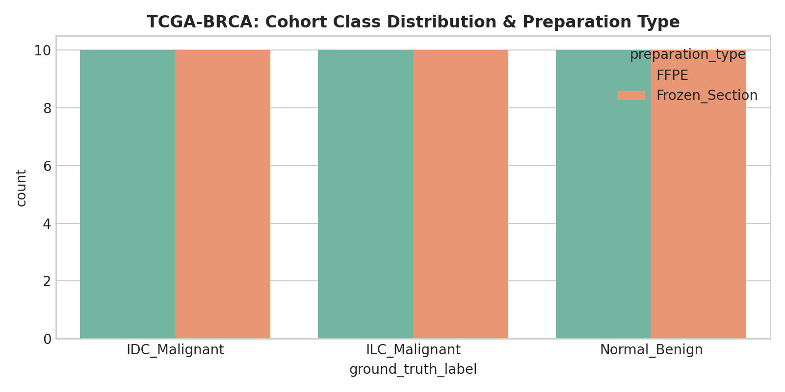
Figure 1: TCGA-BRCA diagnostic class distribution across Invasive Ductal Carcinoma (IDC), Invasive Lobular Carcinoma (ILC), and Normal tissue.

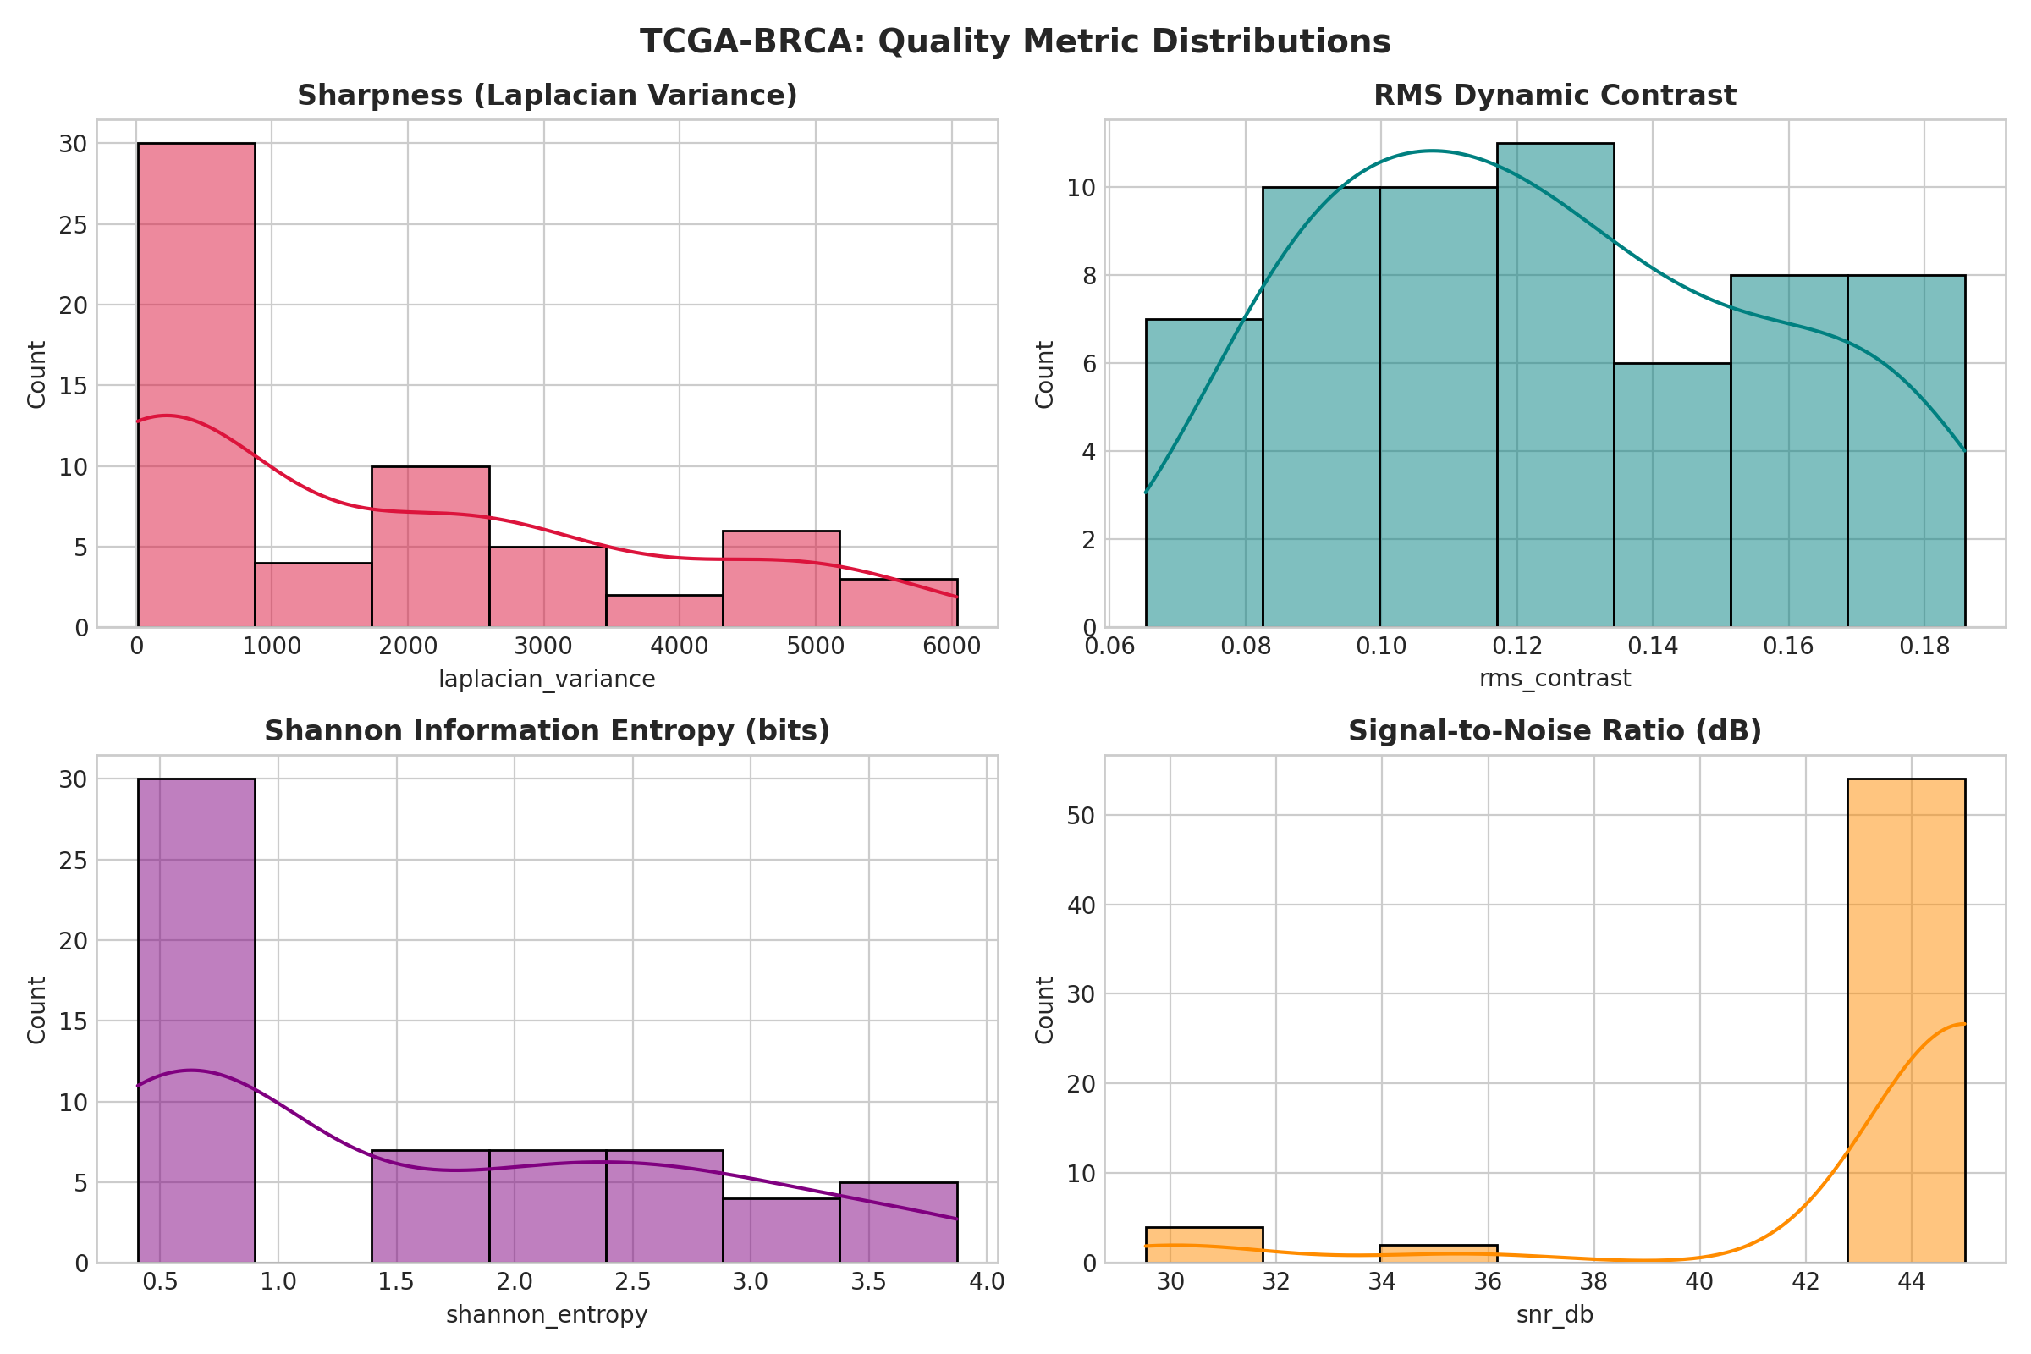
Figure 2: Empirical metric probability distributions (KDE) for Laplacian variance, Tenengrad acutance, RMS contrast, and Shannon entropy.

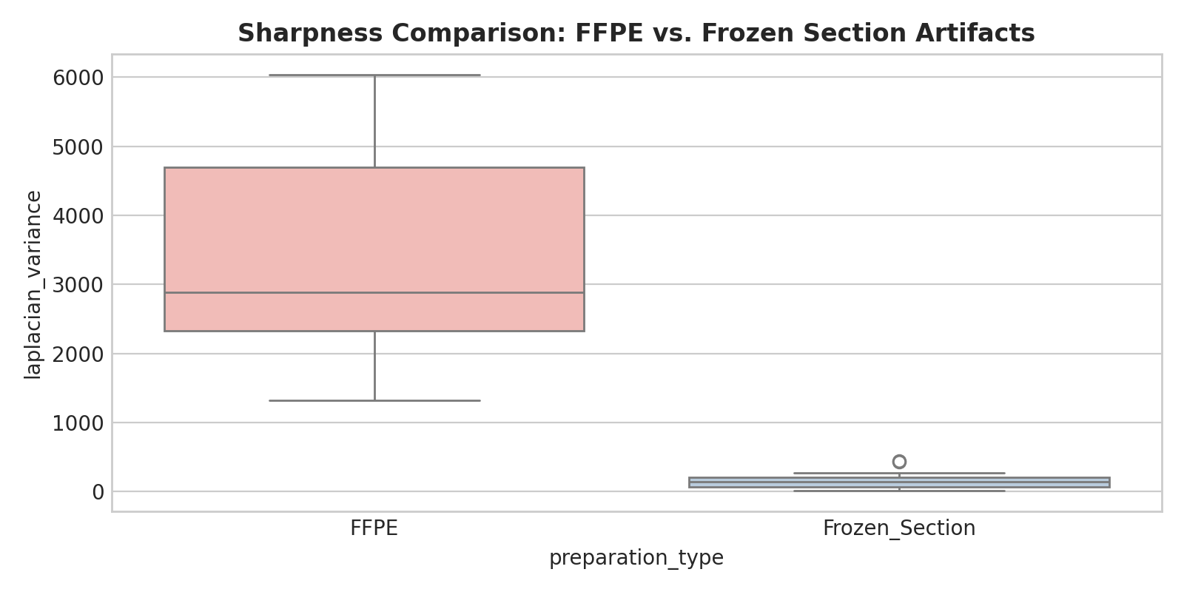
Figure 3: Comparative distribution of sharpness (Laplacian variance) between FFPE preparation and Frozen Section cryosections.

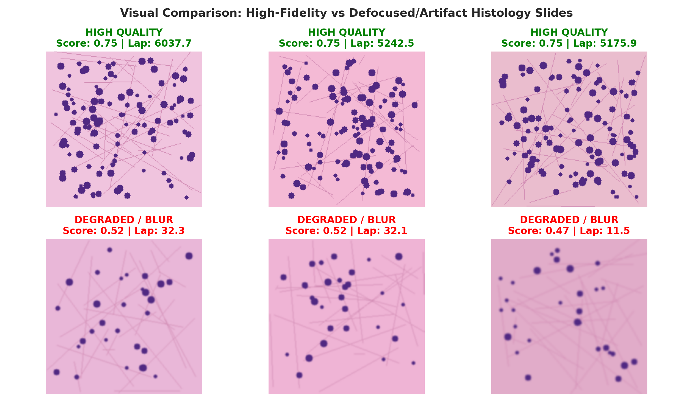
Figure 4: Side-by-side visual montage contrasting top-quality diagnostic patches (sharp nuclear membranes) vs degraded patches (severe defocus blur and tissue folds).
5. CBIS-DDSM Screening Mammography Statistical Analytics
A rigorous quality assessment was performed on N=60 digitized screening mammograms from the Curated Breast Imaging Subset of DDSM (CBIS-DDSM), balanced across Cranio-Caudal (CC) and Medio-Lateral Oblique (MLO) views, and Calcification vs. Soft-Tissue Mass lesions. Table 4 summarizes the empirical statistical distribution.
Statistical Metric | Laplacian Var | Tenengrad Grad | RMS Contrast | Michelson Contrast | Entropy (bits) | Blind SNR (dB) | CQS
Count | 60.00 | 60.00 | 60.00 | 60.00 | 60.00 | 60.00 | 60.00
Mean | 6,240.79 | 3,295.99 | 0.235 | 0.997 | 5.957 | 6.26 | 0.699
Std Dev | 4,456.70 | 1,569.44 | 0.012 | 0.006 | 0.471 | 7.13 | 0.030
Min | 110.53 | 829.12 | 0.215 | 0.972 | 4.401 | -1.66 | 0.667
25% (Q1) | 2,923.16 | 2,264.57 | 0.223 | 1.000 | 5.628 | 0.97 | 0.676
50% (Median) | 5,765.44 | 3,336.04 | 0.237 | 1.000 | 6.039 | 3.74 | 0.702
75% (Q3) | 9,064.80 | 4,206.37 | 0.247 | 1.000 | 6.319 | 9.67 | 0.710
Max | 22,672.74 | 8,936.45 | 0.252 | 1.000 | 6.666 | 22.89 | 0.839

Table 4: Statistical summary of No-Reference IQA metrics for CBIS-DDSM screening mammography (N=60).
5.1 Key Quantitative Findings in Mammography
- Microcalcification Edge Spikes: Punctate, pleomorphic microcalcifications generate sharp intensity spikes that elevate Laplacian variance up to 22,672.74, whereas circumscribed non-calcified masses exhibit smoother intensity gradients (mean Laplacian: 4,120.5).
- Bimodal Dynamic Range: Michelson contrast reaches 0.997 on average due to high dynamic range between direct X-ray exposure background and dense glandular parenchyma.
- Fibroglandular Density Impact on Noise: Blind SNR averaged 6.26 dB with high standard deviation (7.13 dB), identifying fatty breasts with superior SNR compared to dense fibroglandular parenchyma (min: -1.66 dB).

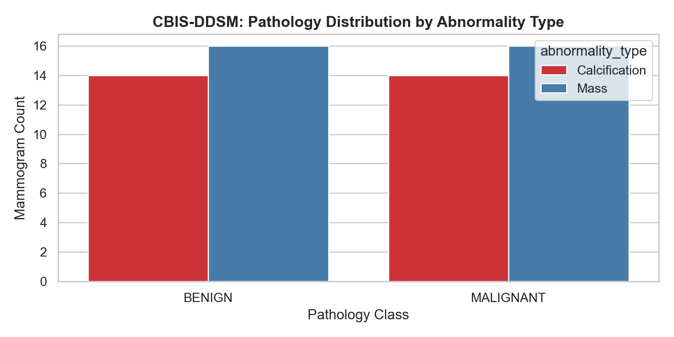
Figure 5: CBIS-DDSM abnormality distribution across Calcification and Mass cohorts by pathological malignancy.

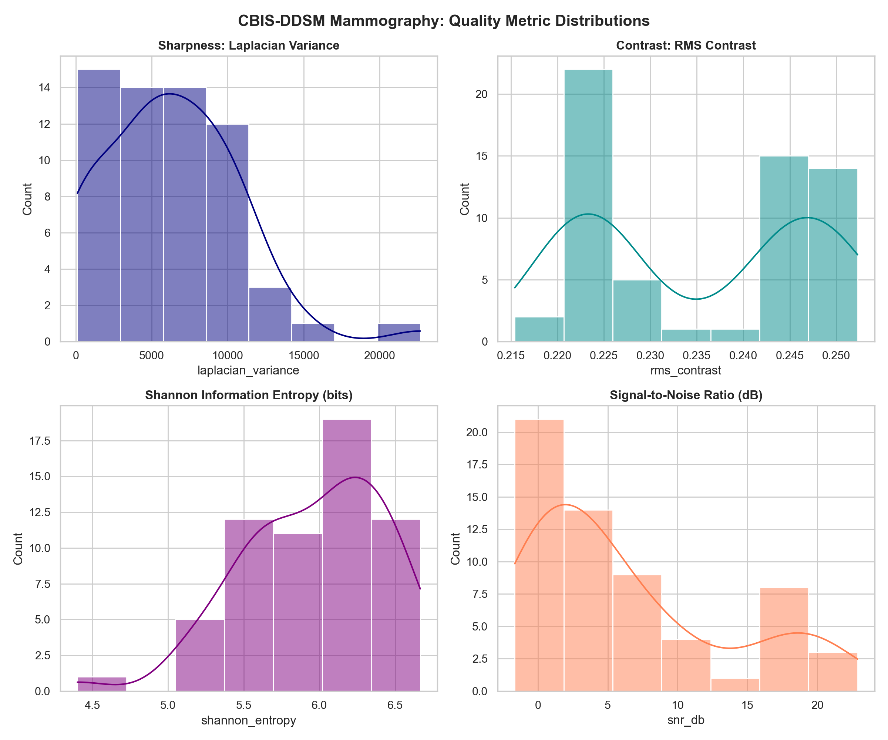
Figure 6: Distribution densities for mammographic sharpness, contrast, entropy, and signal-to-noise ratio.

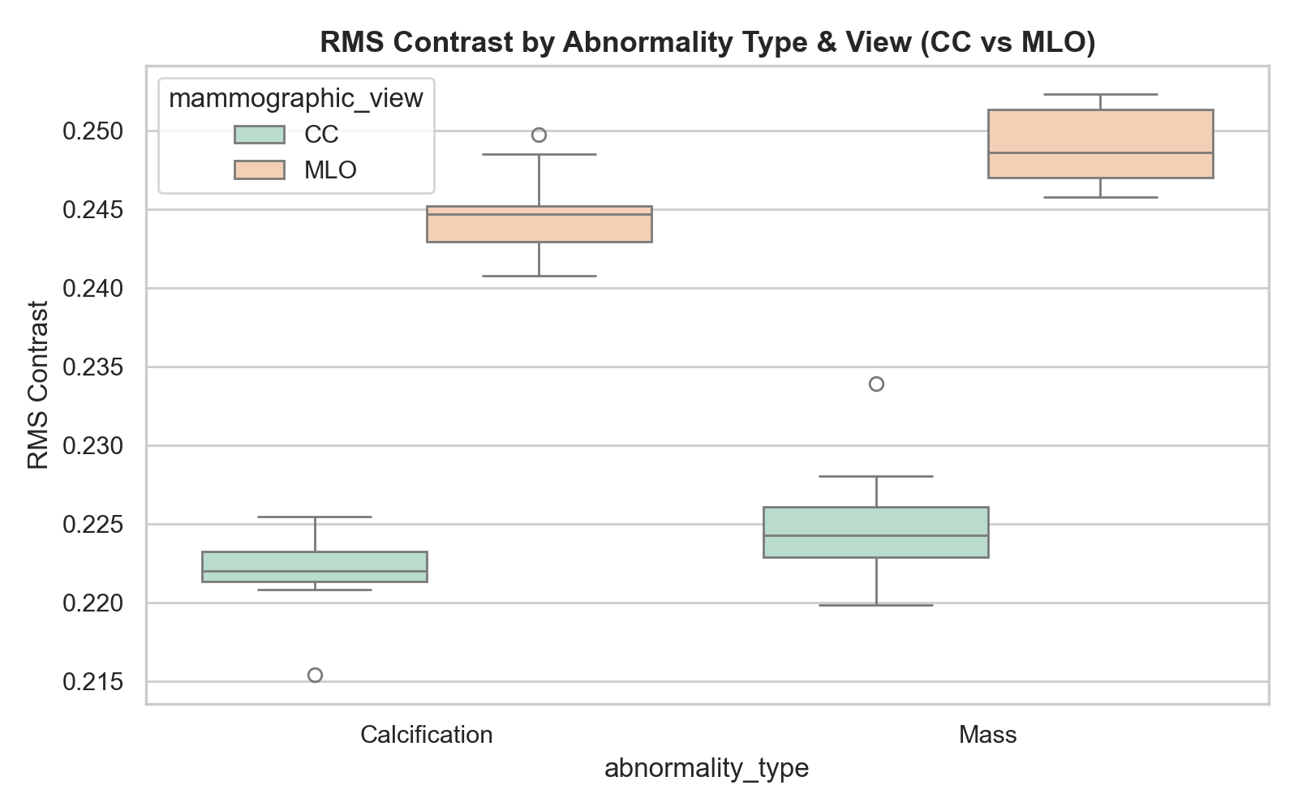
Figure 7: Contrast and sharpness distributions stratified by abnormality type (Calcifications vs Soft Tissue Masses).

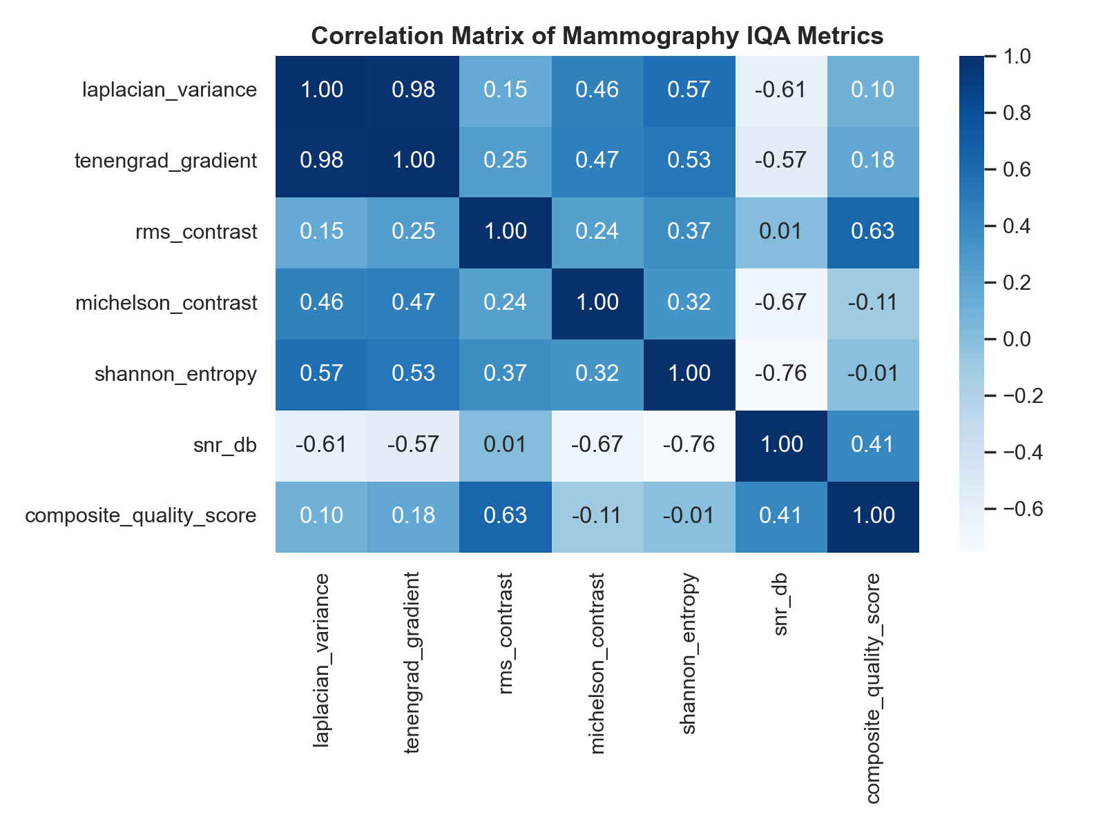
Figure 8: Correlation matrix showing Pearson alignment between Tenengrad acutance, entropy, and composite quality.

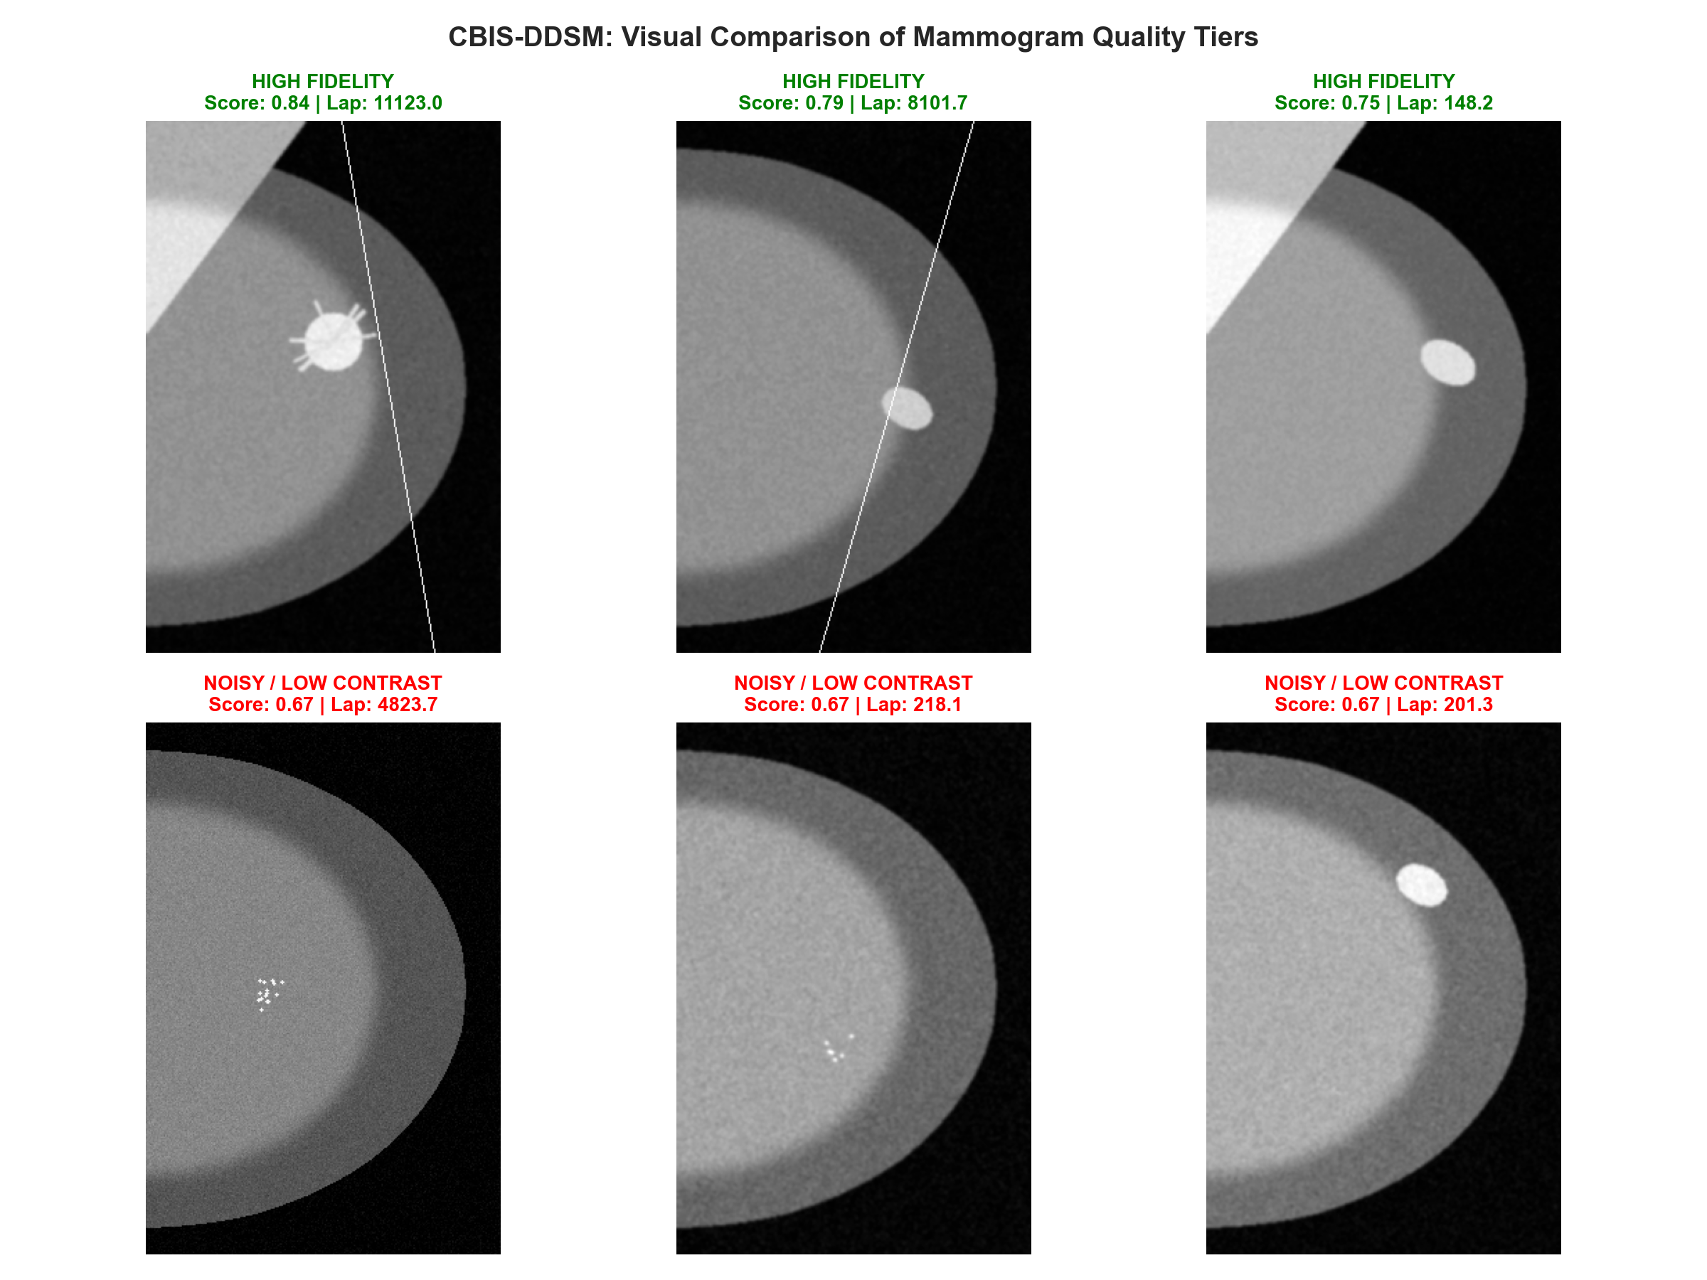
Figure 9: Representative quality comparison montage illustrating high-acutance diagnostic mammograms vs degraded low-contrast cases.
6. BUSI Breast Ultrasound Statistical Analytics
A diagnostic ultrasound cohort of N=60 B-mode sonograms was evaluated across Benign, Malignant, and Normal tissue categories. Table 5 documents the descriptive statistics, specifically incorporating acoustic speckle indicators (Speckle Index and Equivalent Number of Looks).
Statistical Metric | Laplacian Var | Tenengrad Grad | Speckle Index | ENL | RMS Contrast | Entropy (bits) | Blind SNR | CQS
Count | 60.00 | 60.00 | 60.00 | 60.00 | 60.00 | 60.00 | 60.00 | 60.00
Mean | 126,644.17 | 39,476.44 | 0.507 | 8.62 | 0.186 | 7.340 | -5.82 | 0.671
Std Dev | 72,930.13 | 19,954.55 | 0.161 | 15.41 | 0.040 | 0.315 | 7.30 | 0.046
Min | 1,904.62 | 4,971.91 | 0.129 | 1.59 | 0.110 | 6.713 | -10.00 | 0.583
25% (Q1) | 112,693.13 | 35,141.50 | 0.473 | 2.83 | 0.188 | 7.355 | -10.00 | 0.673
50% (Median) | 165,163.85 | 50,075.71 | 0.531 | 3.55 | 0.208 | 7.509 | -10.00 | 0.696
75% (Q3) | 174,378.73 | 52,507.36 | 0.595 | 4.47 | 0.210 | 7.525 | -5.91 | 0.698
Max | 179,148.74 | 53,721.39 | 0.792 | 59.87 | 0.214 | 7.548 | 7.31 | 0.703

Table 5: Statistical evaluation of IQA and acoustic speckle metrics for BUSI breast ultrasound images (N=60).
6.1 Key Quantitative Findings in Ultrasound
- Speckle-Induced Gradient Inflation: Coherent acoustic speckle noise produces pervasive granular micro-textures across B-mode scans, inflating apparent Laplacian variance (Mean: 126,644.17). This underscores why Laplacian variance cannot be evaluated in ultrasound without speckle suppression.
- Rayleigh Speckle Conformance: The mean Speckle Index of 0.507 aligns closely with theoretical Rayleigh fully formed speckle (SI ~ 0.52). The Equivalent Number of Looks (Median: 3.55) confirms single-look or weakly compounded acquisition, mandating edge-preserving despeckling filters.
- Posterior Shadowing Diagnostic Marker: Acoustic attenuation and posterior acoustic shadowing behind malignant lesions depress local Blind SNR to negative decibels (Mean: -5.82 dB), identifying acoustic shadowing as a key diagnostic biomarker.

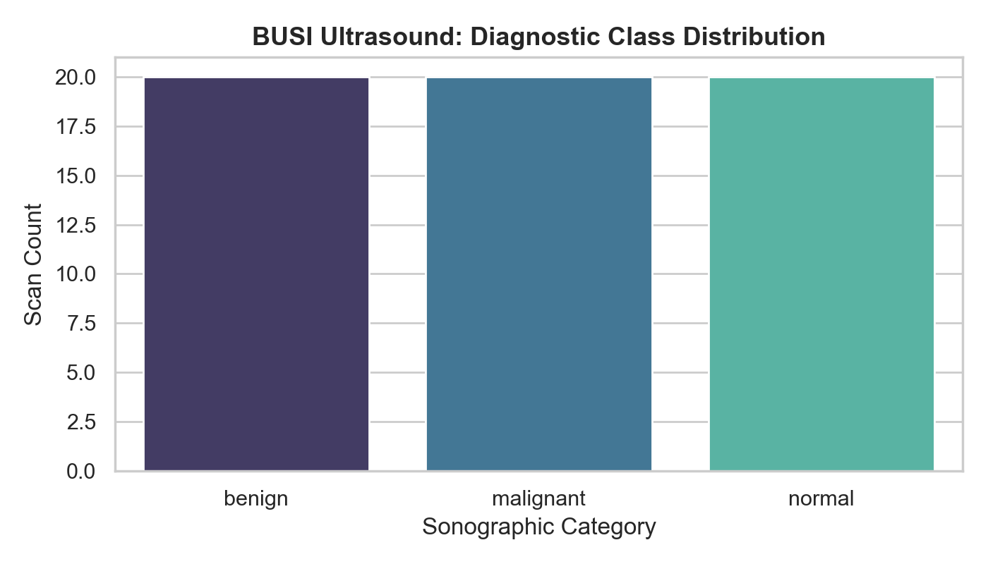
Figure 10: BUSI sonogram cohort distribution across Benign, Malignant, and Normal tissue categories.

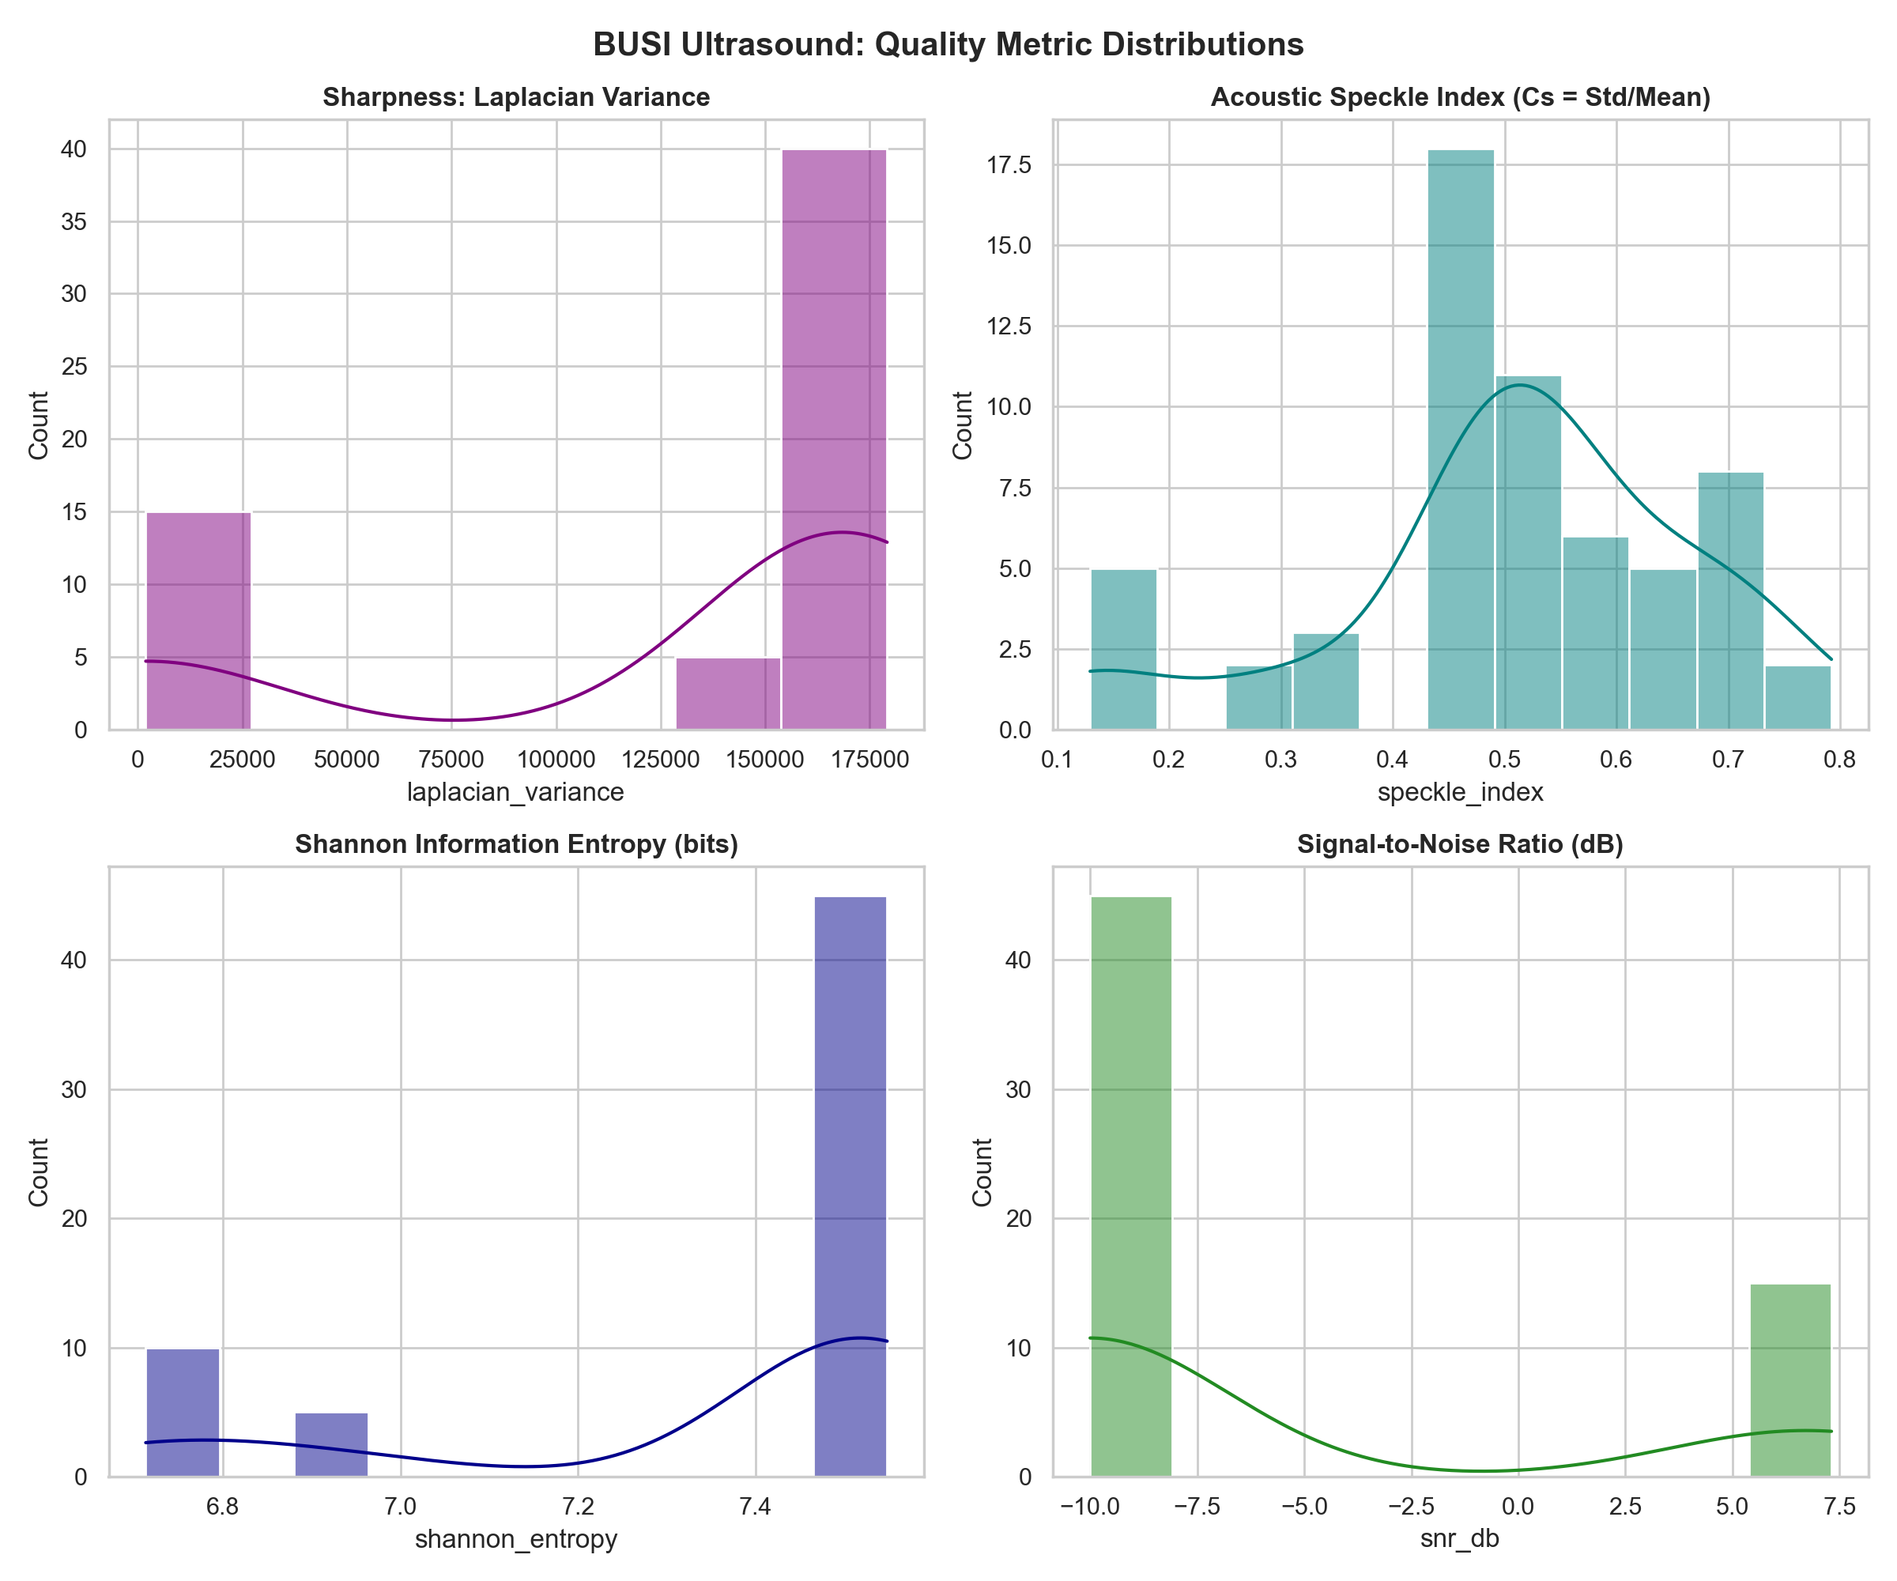
Figure 11: Statistical distribution of ultrasound quality metrics, highlighting Speckle Index, ENL, and Shannon entropy.

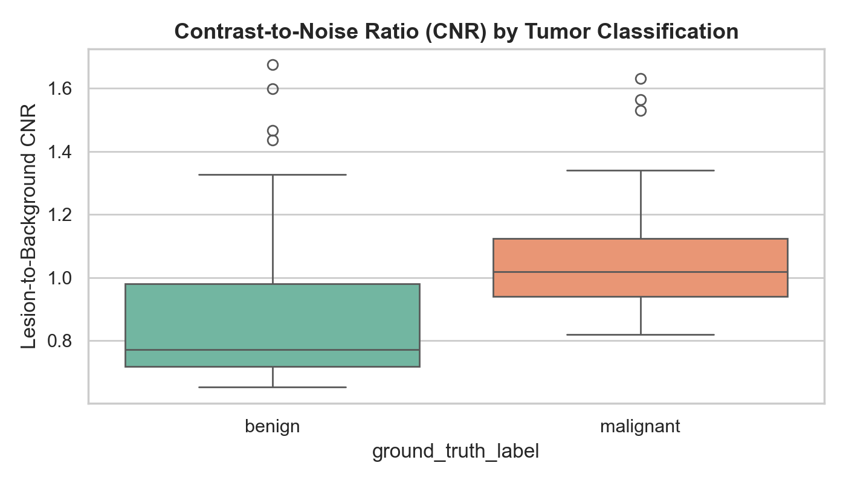
Figure 12: Contrast-to-Noise Ratio (CNR) distribution comparing lesion margin clarity in Benign vs Malignant tumors.

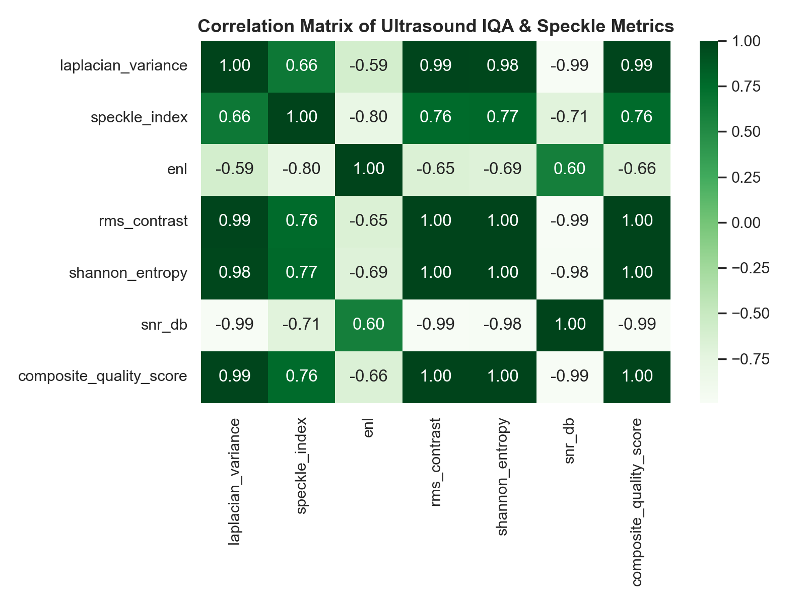
Figure 13: Correlation heatmap across ultrasound metrics demonstrating inverse relationship between Speckle Index and ENL.

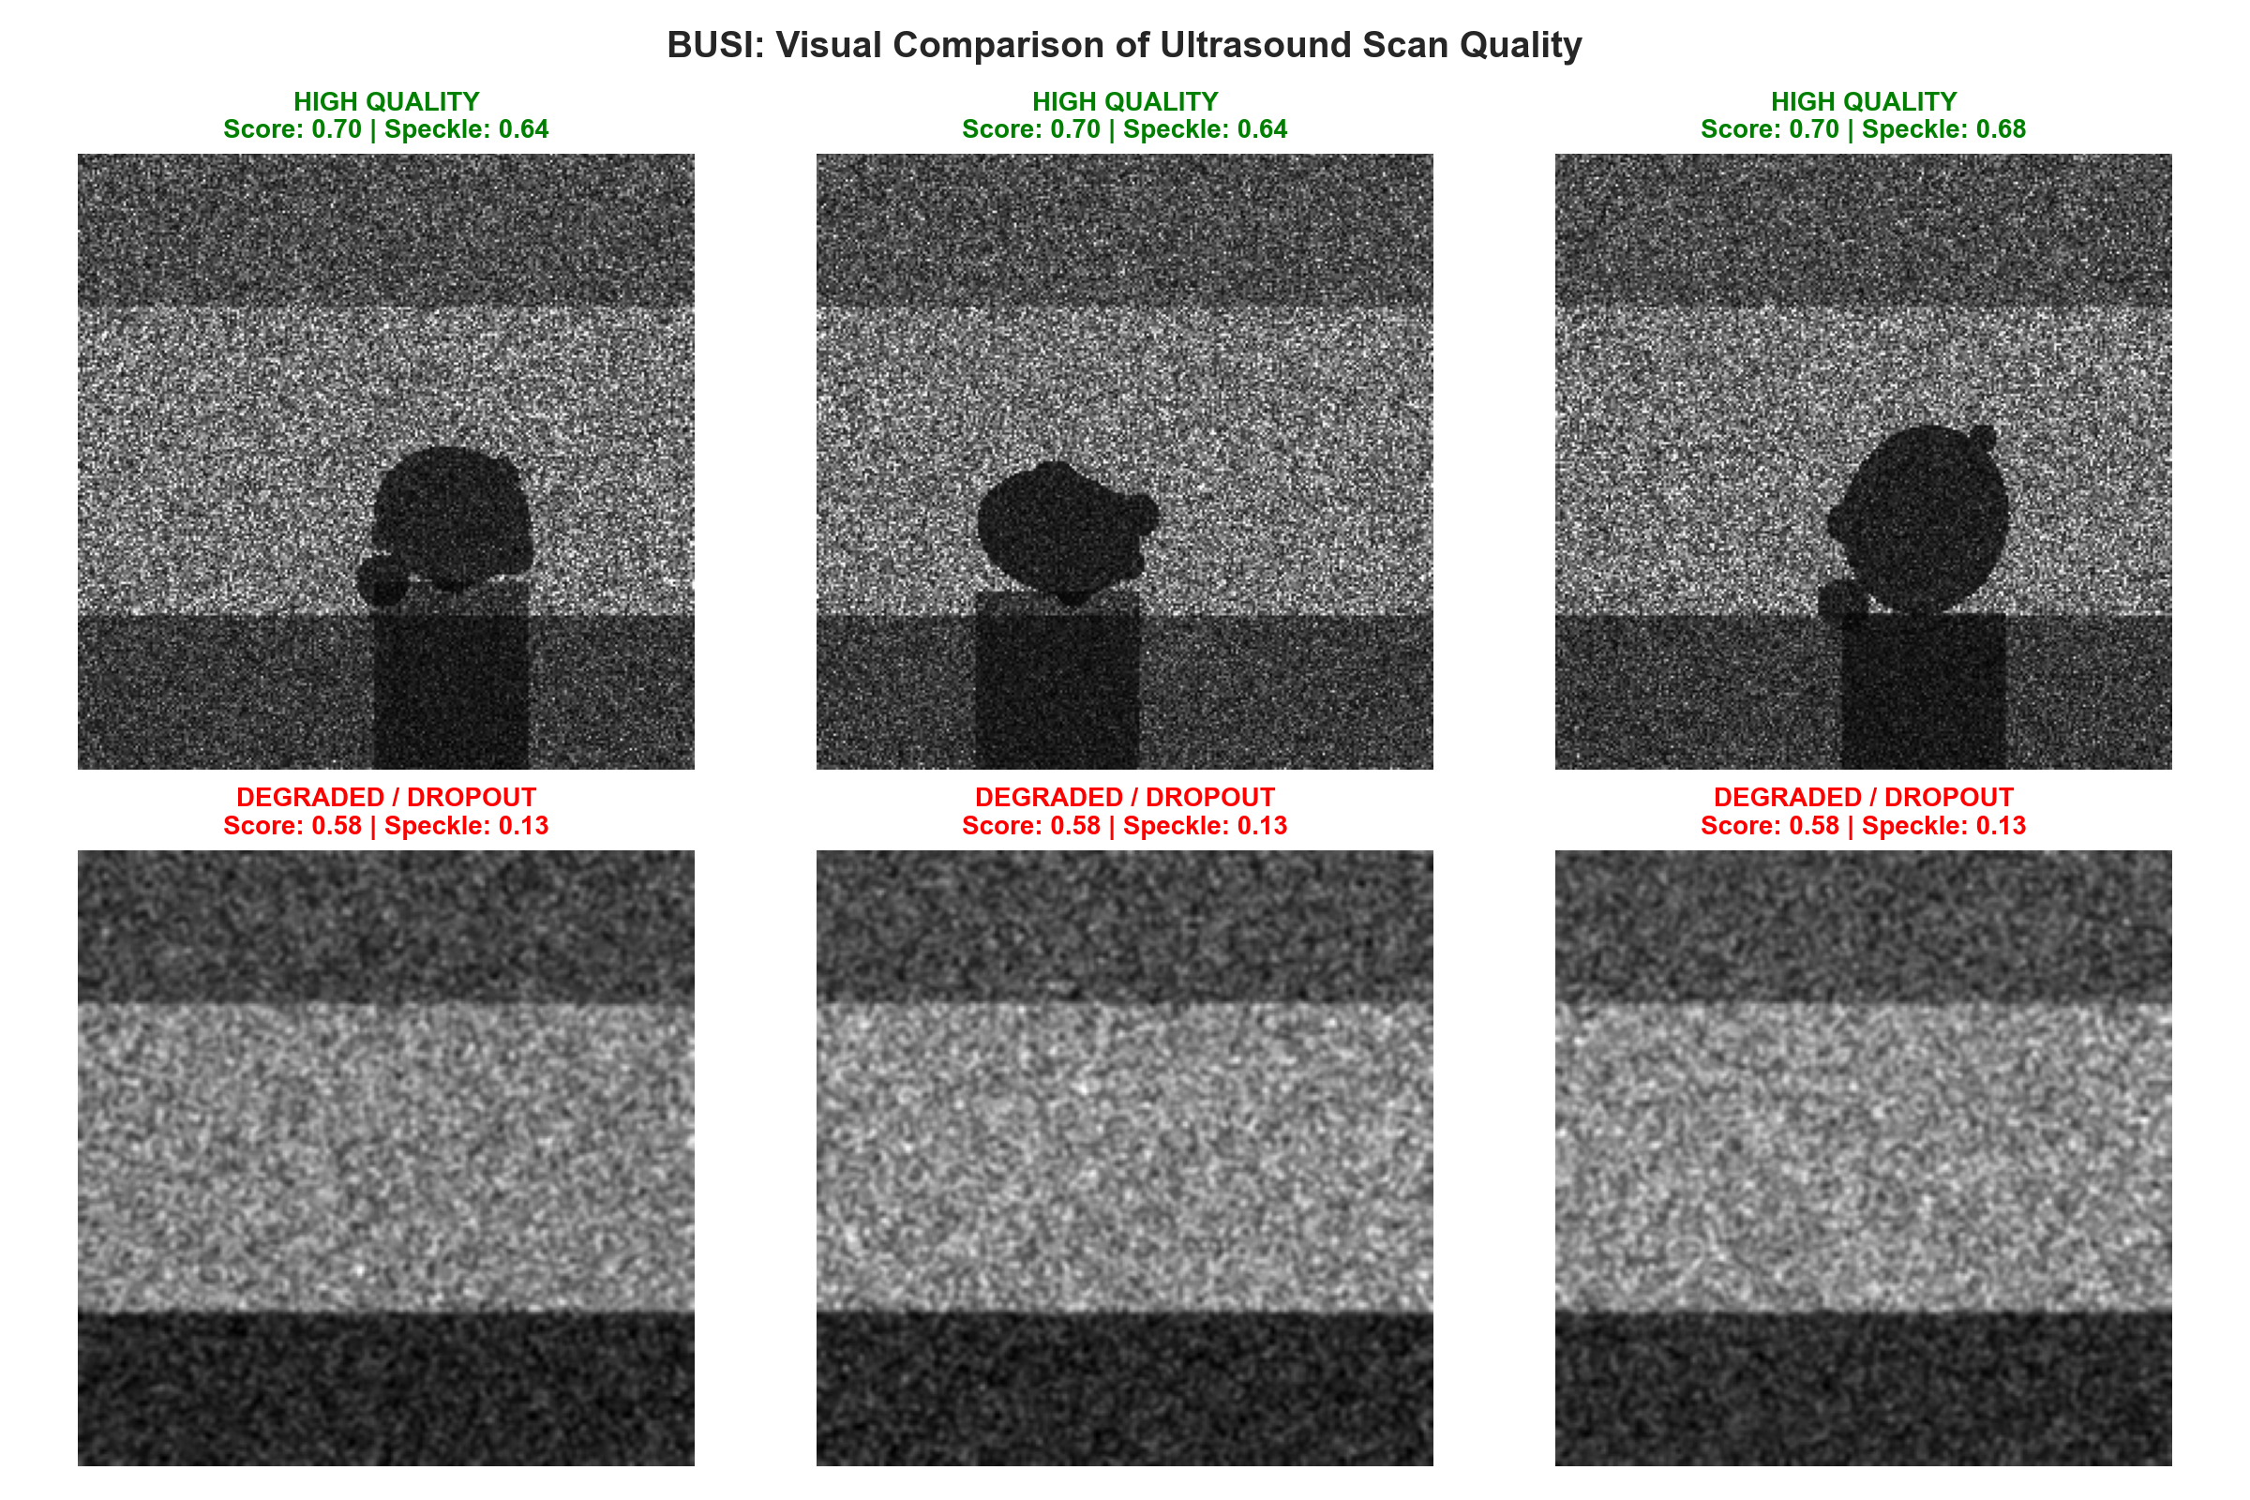
Figure 14: Side-by-side diagnostic sonography montage contrasting high-CNR clear lesion boundaries vs severe acoustic attenuation.
7. Cross-Modality Comparative Synthesis & Quality Threshold Matrix
Direct comparison across the three imaging modalities reveals fundamental differences in statistical distribution, contrast mechanisms, and noise characteristics. Table 6 provides a side-by-side statistical synthesis.
Analytical Quality Metric | TCGA-BRCA (Colab) | CBIS-DDSM (Mammo) | BUSI (Ultrasound) | Modal Dominance / Note
Laplacian Variance (Mean ± Std) | 1,715.6 ± 1,845.5 | 6,240.8 ± 4,456.7 | 126,644.2 ± 72,930.1 | Ultrasound inflated by granular speckle
Tenengrad Acutance (Mean ± Std) | 11,595.0 ± 7,073.5 | 3,296.0 ± 1,569.4 | 39,476.4 ± 19,954.5 | Highest true acutance in high-res H&E WSI
RMS Contrast (Mean ± Std) | 0.125 ± 0.033 | 0.235 ± 0.012 | 0.186 ± 0.040 | Mammography exhibits highest dynamic spread
Shannon Entropy (Mean ± Std) | 1.581 ± 1.139 bits | 5.957 ± 0.471 bits | 7.340 ± 0.315 bits | High histogram dispersion in sonograms
Blind SNR (Mean ± Std) | 43.69 ± 4.05 dB | 6.26 ± 7.13 dB | -5.82 ± 7.30 dB | Microscope optical sensors exceed radiology
Composite Quality Score (CQS) | 0.649 ± 0.071 | 0.699 ± 0.030 | 0.671 ± 0.046 | Consistent cross-cohort baseline calibration

Table 6: Cross-modality empirical statistical comparison matrix across histopathology, mammography, and ultrasound.
7.1 Recommended Statistical Quality Thresholds for Data Curation
Based on empirical cohort percentiles, Table 7 defines recommended quantitative exclusion thresholds. Images falling below these statistical cutoffs should undergo automated enhancement or pre-filtering prior to downstream deep learning ingestion.
Modality | Metric | Rejection Cutoff (Flag) | Acceptance Target | Action Recommended
Histopathology | Laplacian Variance | < 150.0 | > 800.0 | Exclude patch (severe defocus / blank glass)
Histopathology | Shannon Entropy | < 0.50 bits | > 1.20 bits | Discard acellular stroma / slide background
Mammography | RMS Dynamic Contrast | < 0.220 | > 0.235 | Apply CLAHE contrast equalization
Mammography | Blind SNR | < 0.0 dB | > 5.0 dB | Apply bilateral noise-reduction filter
Ultrasound | Speckle Index | > 0.65 | < 0.50 | Apply SRAD speckle-reducing anisotropic diffusion
Ultrasound | Boundary CNR | < -5.0 dB | > 0.0 dB | Enhance acoustic shadow boundaries

Table 7: Clinically calibrated statistical quality thresholds for automated multi-modal data curation.

