🍽
Smart Restaurant Management System
Project Idea Proposal - Phase 1
Graduation Project: Full Stack Application (Backend + Frontend) | 2026

1. Project Idea Description
Smart Restaurant Management System is a comprehensive digital platform designed to streamline daily restaurant operations. The system provides a secure, scalable solution for managing orders, users, menus, and inventory replacing manual processes with an organized, role-driven digital workflow.
In Phase 1, the project focuses on building a robust Core Management System that includes:
- Secure JWT-based authentication system
- Role-Based Access Control (RBAC) for different staff types
- Full Menu Management (categories & products)
- Orders System with a clearly defined status workflow
- Inventory Management with automatic stock deduction
- Basic Dashboard with key performance indicators

The architecture is designed from the ground up to be extensible, allowing future integration of advanced analytics and AI-powered prediction layers without requiring a full system rebuild.

2. Roles & Permissions
The system implements a four-tier Role-Based Access Control (RBAC) model to ensure that each user type has clearly scoped capabilities:

Role | Permissions
Admin (Owner) | Full system control: manage users, menu, inventory, and all reports
Manager | Manage products & categories, monitor orders, update inventory, view dashboard
Cashier | Create and close orders, view own orders, modify orders before preparation starts
Kitchen Staff | View incoming orders, update order status (Preparing / Ready) only
Permissions are enforced via middleware on every protected route, ensuring no role can access functionality outside its scope.

3. Core Features (Phase 1)

3.1 Authentication & Authorization
- User registration with encrypted passwords (bcrypt)
- JWT-based login with token validation middleware
- Route protection and permission enforcement per role
- Soft-delete for users (no permanent deletion)

3.2 Menu Management
- CRUD operations for Categories (e.g., Beverages, Mains, Desserts)
- CRUD operations for Products with price, cost, and availability
- Auto-calculated profit margin (price − cost)
- Business rule: prevent deletion of products linked to past orders
- Business rule: prevent ordering unavailable products

3.3 Orders System (Core Business Logic)
- Create new orders with product selection and quantity
- Auto-calculated totals: Subtotal + Tax
- Status workflow enforced by role:
- Pending → Preparing → Ready → Completed
- Pending → Cancelled
- Cashier can modify orders only while status is Pending
- Inventory auto-deducted upon order confirmation
- Full order history with timestamps

3.4 Inventory Management
- Real-time quantity tracking per product
- Low-stock alerts when quantity falls below threshold (default: 5 units)
- Every stock movement logged in InventoryLog for full auditability
- System blocks order creation if stock is insufficient

3.5 Basic Dashboard
- Total daily sales revenue
- Total number of orders
- Top-selling products
- Order distribution by status

4. High-Level System Structure

4.1 Backend Stack
Layer | Technology | Purpose
Runtime | Node.js | Server-side JavaScript execution
Framework | Express.js | HTTP routing and middleware pipeline
Database | MongoDB + Mongoose | Flexible document storage with schema validation
Authentication | JWT + bcrypt | Secure session management and password hashing
Validation | Custom Middleware (Manual Validation) | Input validation and sanitization logic

4.2 Database Design
The system uses MongoDB with 7 core collections:
Collection | Key Relationships
Users | Referenced by Orders (cashier_id) and InventoryLog (performedBy)
Categories | One-to-Many with Products
Products | Many-to-One with Categories; One-to-One with Inventory; One-to-Many with OrderItems
Orders | Many-to-One with Users; One-to-Many with OrderItems
OrderItems | Many-to-One with Orders and Products (composite unique key)
Inventory | One-to-One with Products; auto-deducted on order confirmation
InventoryLog | Audit trail for all stock movements (restock / deduction)

4.2.1 Entity Relationship Diagram (ERD)
The following diagram illustrates the full database schema and entity relationships for Phase 1:
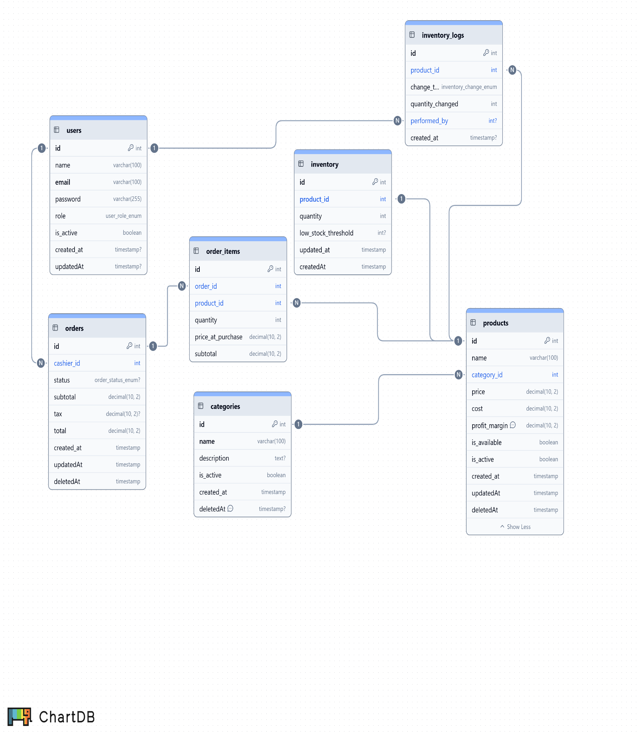

5. Development Plan
Phase | Focus Area | Deliverables
Phase 1.1 | Authentication & Users | Secure login system, JWT middleware, RBAC enforcement
Phase 1.2 | Menu & Categories | Full CRUD for categories and products, validation rules
Phase 1.3 | Orders System | Order workflow, total calculation, inventory deduction on confirmation
Phase 1.4 | Inventory | Quantity tracking, low-stock alerts, movement logging
Phase 1.5 | Dashboard | MongoDB Aggregation pipelines, KPI endpoints, frontend charts
Phase 2 (Future) | Advanced Analytics | Peak-hour analysis, profit margin reports, staff performance
Phase 3 (Future) | AI Prediction | Demand forecasting, smart restocking, sales prediction
Each phase is designed as an independent deliverable, enabling incremental testing and demonstration throughout the development cycle.

6. API Structure (Phase 1)
The following REST API endpoints define the full backend interface for Phase 1. All protected routes require a valid JWT token and are enforced by role-based middleware

6.1 Authentication & Users
Security foundation: JWT-based authentication with role enforcement on every protected route.

Method | Endpoint | Description | Access
POST | /api/auth/register | Register a new user (admin / manager / cashier / kitchen) | Admin
POST | /api/auth/login | Login and receive JWT token | Public
GET | /api/auth/me | Get current authenticated user's data | All roles
PUT | /api/auth/profile | Update own profile information | All roles
POST | /api/auth/change-password | Change own password | All roles
GET | /api/users | List all system users | Admin
PUT | /api/users/:id/role | Update a user's role | Admin
DELETE | /api/users/:id | Deactivate a user account (soft delete) | Admin

6.2 Categories
Prevents deletion of categories that contain active products.

Method | Endpoint | Description | Access
GET | /api/categories | List all categories | All roles
GET | /api/categories/:id | Get category details | All roles
POST | /api/categories | Create a new category | Admin / Manager
PUT | /api/categories/:id | Update category information | Admin / Manager
DELETE | /api/categories/:id | Soft-delete category (blocked if has active products) | Admin / Manager

6.3 Products (Menu Items)
Supports filters by category, price range, and availability. Profit margin is auto calculated.

Method | Endpoint | Description | Access
GET | /api/products | List products (filter: category, price, availability) | All roles
GET | /api/products/:id | Get product details | All roles
POST | /api/products | Create a new product | Admin / Manager
PUT | /api/products/:id | Update product data | Admin / Manager
DELETE | /api/products/:id | Soft-delete product (blocked if linked to orders) | Admin / Manager
PATCH | /api/products/:id/status | Toggle availability (in-stock / out-of-stock) | Admin / Manager

Business Logic:
- Prevent selling unavailable products
- Auto-calculate profit margin (price − cost)
- Block deletion of products linked to past orders

6.4 Orders (Core Business Logic)
The heart of the system manages the full order lifecycle with strict status transitions.

Method | Endpoint | Description | Access
GET | /api/orders | List all orders (filter: date, cashier, status) | Admin / Manager
GET | /api/orders/:id | Get order details with items | Admin / Manager / Cashier
POST | /api/orders | Create a new order | Cashier
PUT | /api/orders/:id | Modify order (Pending status only) | Cashier
PATCH | /api/orders/:id/status | Update order status | Kitchen / Cashier
DELETE | /api/orders/:id | Cancel an order | Cashier / Admin

Order Status Workflow:

Transition | Allowed By | Rule
Pending → Preparing | Kitchen Staff | Locks order from further edits
Preparing → Ready | Kitchen Staff | Notifies cashier for pickup
Ready → Completed | Cashier | Closes the order
Pending → Cancelled | Cashier / Admin | Only before preparation begins

Business Logic:
- Inventory is auto deducted when an order is confirmed
- Orders cannot be edited once status moves to Preparing
- Kitchen staff can only update status; cannot modify order contents

6.5 Inventory Management
Tracks real-time stock levels and logs every movement for full auditability.

Method | Endpoint | Description | Access
GET | /api/inventory | View full inventory list | Admin / Manager
GET | /api/inventory/:productId | Get stock details for a product | Admin / Manager
PUT | /api/inventory/:productId | Update product quantity | Admin / Manager
POST | /api/inventory/restock | Add new stock (restock operation) | Admin / Manager
GET | /api/inventory/low-stock | List products below stock threshold | Admin / Manager
GET | /api/inventory/logs | View full inventory movement history | Admin / Manager

Business Logic:
- Order creation is blocked if requested quantity exceeds available stock
- Every stock deduction and restock is recorded in InventoryLog with timestamp and performed-by reference

