**in terminal:**

**flutter pub add provider**

**Provider : a way for you to get specific data from the sea of contexts**

**Provider vs change notified provider**

**Provider change value but not reflects on widget**

**Widget not rebuilder**

**note: context flows down not up**

**how to use it : create top most widget and share it to one or more widgets**

**ex: User(model) -> MyApp(we create provider in it) -> Home (widget)**

**Multi provider**

**merges multiple providers in a single linear widget tree**

**improve readability and reduce boilerplate (الشكل النمطي)**

**how to use provider return the same type of data**

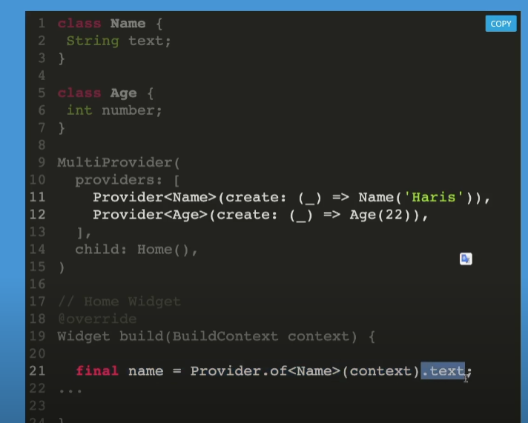

**Proxy provider: update child when its data changes**

**Proxy provider<T,R>:**

**T: refers to data object type that is being listened**

**R: refers to the result object type to be passed down its**

**update parameters**

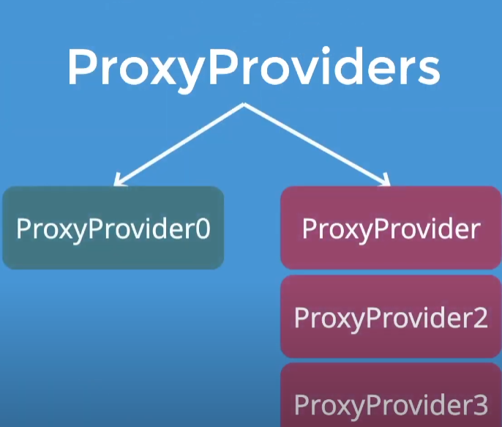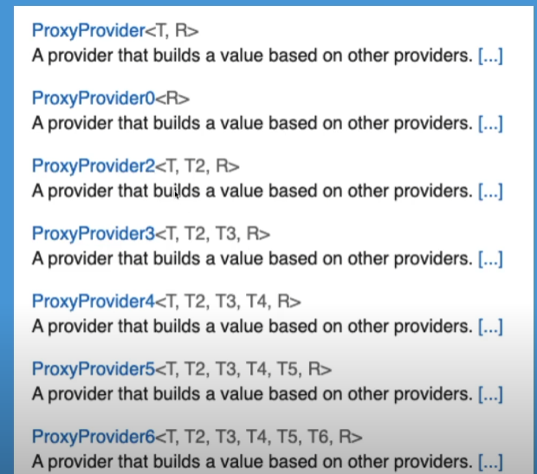

**Provider.of<T>(context)**

   final pro = Provider.of<HomeViewModel>(context);

**Consumer**

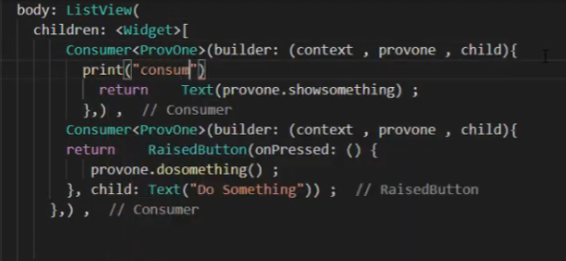

**context.read<T>(context) read provider not rebuild**

    final pro = Provider.of<HomeViewModel>(context,listen: false);

**context.watch<T>() read provider and rebuild**

    final pro = Provider.of<HomeViewModel>(context,listen: true);

**selector**

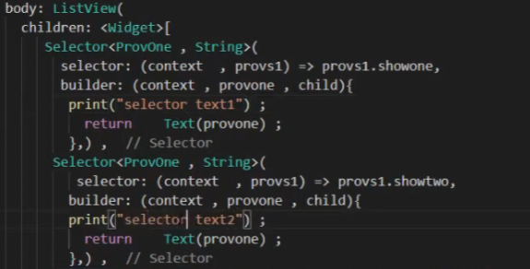

**Consumer and selector listen to data changing through notify listener by consumer rebuild widget but selector not do that**

