
TELCOPULSE
A Distributed Telecom Big Data Analytics Platform
THE COMPLETE PROJECT BOOK
Architecture, implementation, data pipelines, analytics and engineering evidence from six laptops to six dashboards
TEAM Mahmoud Saleh | Ali Tharwat | Yossef ElToor | Basel Tarek | Mohamed Saleh
TRAINING Huawei HCIA Big Data, National Telecommunication Institute (NTI)
PRESENTED TO Eng. Ahmed Hassan
PROJECT PERIOD October 2026
EDITION Version 3.0, practitioner edition, prepared 22 October 2026

Project Information
Item | Detail
Project title | TelcoPulse: A Distributed Telecom Big Data Analytics Platform
Training programme | Huawei HCIA Big Data training with the National Telecommunication Institute (NTI)
Category | Big Data Engineering and Telecom Analytics
Presented to | Eng. Ahmed Hassan
Team members | Mahmoud Saleh; Ali Tharwat; Yossef El-Toor; Basel Tarek
Project period | October 2026
Document | TelcoPulse Complete Project Book, Version 3.0 (practitioner edition)
Prepared | 22 October 2026
Status | Complete edition: reference implementation and operations documentation

RECORDED PROJECT FACT Academic-use note: this document was prepared for academic evaluation and learning. Dataset and software names are the property of their respective owners. No credentials or secrets are included.

Project Team
The TelcoPulse platform was designed, built and documented by the four team members below, under the guidance of the project instructor.

Eng. Ahmed Hassan
INSTRUCTOR | PROJECT PRESENTED TO

  Mahmoud Saleh  TEAM MEMBER |   Ali Tharwat  TEAM MEMBER |   Yossef ElToor  TEAM MEMBER |   Basel Tarek  TEAM MEMBER
Huawei HCIA Big Data | National Telecommunication Institute (NTI) | October 2026

Preface
TelcoPulse began as a question: how much of a real telecom analytics platform can six ordinary laptops and a router reproduce? This book is the answer in engineering form. It describes a complete platform, from the router and the six Windows laptops to the six Superset dashboards, and it explains every layer: why it exists, how it is configured, how data flows through it and how it is validated and operated.
The book documents the platform as a finished system. Recorded project facts are used exactly as recorded: the six-laptop range 192.168.1.11 to 192.168.1.16, the service endpoints, the container names, the S3A settings, the ClickHouse schemas and the Curated results. Where the original scripts and configuration files are not reproduced verbatim, the book gives a reference implementation that is consistent with those facts. The companion asset archive contains every listing as a file.

Acknowledgments
The team thanks Eng. Ahmed Hassan, to whom the project is presented, the National Telecommunication Institute (NTI) and the Huawei HCIA Big Data training programme that framed this work, and the open-source communities behind Apache Spark, Apache Kafka, ClickHouse, Apache Superset, Docker and RustFS.

Executive Summary
TelcoPulse is a distributed telecom Big Data analytics platform built on six physical Windows laptops (addresses 192.168.1.11 to 192.168.1.16) connected by a local router-based network. Services run as Linux containers through Docker Desktop with the WSL 2 backend. The platform combines RustFS S3-compatible object storage with Raw, Processed and Curated zones, an Apache Spark cluster for distributed batch processing, Apache Kafka and Spark Structured Streaming for a synthetic near-real-time path, ClickHouse for analytical storage, and Apache Superset for six dashboard areas.
The batch pipeline processes ten source files from the Raw zone into Processed and then Curated datasets and loads them into ClickHouse. The recorded Curated outputs total 31,904,092 rows (LTE 18,750,012; NR 7,558,148; GSM 5,595,932), approximately 31.9 million. An earlier intermediate Processed result of 34,117,453 rows in 44 Parquet files is a different pipeline stage. The streaming pipeline turns synthetic events into one-minute KPI windows, detects anomalies against a rolling baseline and records data-quality and benchmark information.
Recorded endpoints: Spark Master 192.168.1.11:7077, RustFS 192.168.1.12:9000, Kafka 192.168.1.12:9092 and ClickHouse HTTP 192.168.1.15:8123 with database telecom_db. The five analytical tables kpi_batch, kpi_stream, anomalies, quality_report and benchmark_runs keep their recorded schemas. The book provides deployment templates, the reference code, SQL, dashboard specifications, test procedures, operations runbooks and a deployment checklist.
AS-BUILT The repository places the Kafka broker on 192.168.1.13:9092 with topic telecom_stream and processes the stream with a Python consumer. The recorded Curated total of 31,904,092 rows covers nine of ten files (Dataset_03_NR_3500 failed), the batch load into ClickHouse and the Superset provisioning script are not implemented, and the design chapters are superseded where Part VII differs.

Abstract
This book documents the design, implementation and operation of TelcoPulse, a six-laptop distributed Big Data lab for telecom performance analytics. It covers the network and container infrastructure, the distributed Spark cluster, the S3-compatible Raw, Processed and Curated data lake, the batch and streaming pipelines, the ClickHouse analytical model, data-quality and anomaly-detection methods, six Superset dashboards, testing, troubleshooting and benchmarking methodology. Keywords: Big Data, Apache Spark, Kafka, ClickHouse, Superset, RustFS, S3A, telecom analytics, Docker, WSL 2.

Table of Contents
Part I: Project Foundations 1
1 Introduction to TelcoPulse 2
2 Problem Statement, Requirements and Scope 6
3 Architecture and Technology Decisions 8
Part II: Physical and Container Infrastructure 12
4 Router and Six-Laptop Network Setup 13
5 IP Addressing and Connectivity Validation 19
6 Windows, Docker Desktop and WSL 2 21
7 Distributed Service Deployment 23
8 Apache Spark Master and Workers 30
Part III: Data Engineering 33
9 Telecom Datasets and Synthetic Data 34
10 RustFS and S3-Compatible Object Storage 36
11 Raw, Processed and Curated Architecture 38
12 The Distributed Spark Batch Pipeline 40
13 Parquet Output and Curated Validation 47
14 Data Lineage and Data Quality 50
Part IV: Streaming and Analytical Storage 52
15 Kafka and Event Generation 53
16 Spark Structured Streaming 57
17 ClickHouse Analytical Storage and Schemas 60
18 Anomaly Detection 66
Part V: Analytics and Dashboards 69
19 Apache Superset Integration 70
20 Executive Overview Dashboard 72
21 RAN Performance Analytics Dashboard 74
22 Real-Time Streaming Monitor 76
23 Anomaly Detection Dashboard 78
24 Data Quality Dashboard 80
25 Platform Benchmarking Dashboard 82
Part VI: Testing, Operations and Evaluation 84
26 End-to-End Integration Testing 85
27 Troubleshooting and Engineering Decisions 87
28 Performance Evaluation and Limitations 89
29 Lessons Learned and Future Work 92
Part VII: As-Built Guide, Challenges and Evaluation 93
30 As-Built Repository Reference 94
31 Replication Guide: Rebuilding TelcoPulse Step by Step 115
32 Problems, Challenges and Solutions 119
33 Features, Advantages and Disadvantages 125
Appendix A Project Directory and File Inventory 129
Appendix B Network and Service Inventory 130
Appendix C Docker and Deployment Commands 131
Appendix D Spark Configuration and Job Submission 132
Appendix E S3A and RustFS Configuration 133
Appendix F Code Listings Index 134
Appendix G ClickHouse Schemas and SQL 135
Appendix H Dashboard Inventory 136
Appendix I Deployment and Reproducibility Checklist 137
Appendix J Glossary and References 138
Appendix K Operations Runbooks 139

List of Figures
Figure 1 End-to-end TelcoPulse architecture 4
Figure 2 TelcoPulse animated showcase 5
Video 1 TelcoPulse platform walkthrough 5
Figure 3 Layers on each physical laptop 8
Figure 4 Batch pipeline 10
Figure 5 Streaming pipeline 10
Figure 6 Configuration evolution recorded during development 11
Figure 7 Network topology of the six-laptop lab 13
Figure 7a Router device information (Status > Device) 14
Figure 7b WAN connections reported Disconnected (Basic > WAN) 14
Figure 7c LAN host settings (Basic > LAN) 16
Figure 7d DHCP server settings 16
Figure 7e IP Address Reserve table with the six laptop reservations 17
Figure 7f Reading adapters with getmac /v 17
Figure 8 Host IP, container IP, published port and service endpoint 20
Figure 9 Distributed Spark architecture 30
Figure 10 Raw, Processed and Curated lineage 38
Figure 11 Batch pipeline 40
Figure 12 Recorded Curated rows by technology 47
Figure 13 Data-quality flow 50
Figure 14 Streaming pipeline 53
Figure 15 ClickHouse analytical model 60
Figure 16 Anomaly workflow 66
Figure 17 Six dashboard areas and their source tables 70
Figure 18 As-built host and service map 94
Figure 19 Replication roadmap 115

List of Tables
Table 1 Functional requirements 6
Table 2 Non-functional requirements 6
Table 3 Scope decisions 7
Table 4 Component inventory 9
Table 5 Data-flow summary 9
Table 6 Technology decisions and rationale 10
Table 7 Network dependencies by component 13
Table 7a Router settings captured from the web interface 14
Table 7b Router configuration steps 15
Table 7c Address reservations as built 17
Table 8 Host IP inventory (evidence-based) 19
Table 9 Address concepts 19
Table 10 Network validation status 20
Table 11 Role placement across the six laptops 23
Table 12 Service ports 24
Table 13 Spark configuration 30
Table 14 Monitoring signals 32
Table 15 Public dataset inventory 34
Table 16 Field glossary and cautions 34
Table 17 Recorded storage facts 36
Table 18 Recorded S3A configuration 37
Table 19 S3A test scripts observed during development 37
Table 20 Zone-by-zone summary 38
Table 21 Batch stages 40
Table 22 Curation rules 44
Table 23 Failure handling in the jobs 46
Table 24 Curated outputs (recorded results) 47
Table 25 Processed and Curated are different stages 47
Table 26 Validation layers 48
Table 27 quality_report columns 50
Table 28 Kafka configuration 53
Table 29 Event fields (JSON) 54
Table 30 Streaming job behaviour 58
Table 31 Tables of telecom_db 60
Table 32 kpi_batch columns 62
Table 33 kpi_stream columns 63
Table 34 anomalies columns 63
Table 35 benchmark_runs columns 63
Table 36 Detection methods 66
Table 37 Score and severity 66
Table 38 Aggregation rules 71
Table 39 Dashboard summary: Executive Overview Dashboard 72
Table 40 Charts: Executive Overview Dashboard 72
Table 41 Dashboard summary: RAN Performance Analytics Dashboard 74
Table 42 Charts: RAN Performance Analytics Dashboard 74
Table 43 Dashboard summary: Real-Time Streaming Monitor 76
Table 44 Charts: Real-Time Streaming Monitor 76
Table 45 Dashboard summary: Anomaly Detection Dashboard 78
Table 46 Charts: Anomaly Detection Dashboard 78
Table 47 Dashboard summary: Data Quality Dashboard 80
Table 48 Charts: Data Quality Dashboard 80
Table 49 Dashboard summary: Platform Benchmarking Dashboard 82
Table 50 Charts: Platform Benchmarking Dashboard 82
Table 51 Test matrix with acceptance criteria 85
Table 52 Decisions that shaped the platform 87
Table 53 Diagnostic guide 87
Table 54 Measures 89
Table 55 Experiments 90
Table 56 Future work 92
Table 66 Repository files and their role 94
Table 67 Design chapters versus repository 95
Table 68 Curated inspection summary (show_out.txt) 113
Table 68a Run history, 21 October 2026 113
Table 68b Quality audit per file (clean_out.txt) 113
Table 69 Prerequisites and offline kit 115
Table 70 Phases 1 to 4: network, laptops, image and object storage 116
Table 71 Phases 5 to 8: Spark, batch jobs, ClickHouse and Superset 116
Table 72 Phases 9 and 10: streaming, dashboards and acceptance 117
Table 73 Port conflicts when services share a laptop 118
Table 74 Acceptance checks 118
Table 75 Features of the platform 125
Table 76 Advantages 125
Table 77 Limitations and how to mitigate them 126
Table 78 Expected outcomes and how to verify them 127
Table 79 Recommended improvements, in priority order 127
Table 57 Recorded historical script names 129
Table 58 Service endpoints (latest configuration) 130
Table 59 spark-submit parameters 132
Table 60 S3A properties 133
Table 61 Bucket layout 133
Table 62 Code index 134
Table 63 Dashboard inventory 136
Table 64 Glossary 138
Table 65 Backup and recovery 139

Acronyms and Abbreviations
Acronym | Meaning
API | Application Programming Interface
CQI | Channel Quality Indicator
CSV | Comma-Separated Values
DDL | Data Definition Language
GSM | Global System for Mobile Communications (2G)
HCIA | Huawei Certified ICT Associate
HTTP | Hypertext Transfer Protocol
KPI | Key Performance Indicator
LAN | Local Area Network
LTE | Long-Term Evolution (4G)
MIMO | Multiple-Input Multiple-Output
NR | New Radio (5G)
NTI | National Telecommunication Institute
PM | Performance Management
RAN | Radio Access Network
RRC | Radio Resource Control
S3 | Simple Storage Service (API)
S3A | Hadoop S3A filesystem connector
SQL | Structured Query Language
WSL 2 | Windows Subsystem for Linux, version 2

How to Use This Book
- Evaluators: read the Executive Summary, Chapters 1 to 3, 13 and the dashboard chapters.
- Students: follow Part II and Appendix I to deploy the environment; study the jobs in Chapters 12, 16 and 18.
- Reviewers: use Appendices A to H as inventories and Appendix K for operations.
- Replicators: follow Chapter 31 step by step, use Chapter 30 for the exact files, Chapter 32 when something fails and Chapter 33 for trade-offs.

Each major topic is explained in the order what, why, how, communication, validation and limitation. Cross-references name chapters and appendices rather than page numbers.

Scope and Conventions
The book describes the complete platform. Four kinds of statement are used, and the coloured notes in the text mark the places where the distinction matters.
RECORDED PROJECT FACT Recorded project facts: endpoints, container names, image names, S3A settings, ClickHouse schemas and the recorded results.
DESIGN HISTORY Design history: earlier configurations (for example the Master at 192.168.1.10 and the 192.168.1.10 to .15 plan) that were superseded. They are never presented as current.
REFERENCE IMPLEMENTATION Reference implementation: configuration templates, code and SQL written to be consistent with the recorded facts. They are not the verbatim original scripts, and they contain no credentials.
AS-BUILT As-built facts: configuration and code taken from the repository (TelcoPulseCluster), screenshots of the lab router and recorded logs. When they differ from a design chapter, the as-built fact wins (Part VII).
Boundaries. The platform is a local educational lab. It processes public and synthetic data only, and its streaming source is a synthetic generator. This edition contains screenshots of the lab router (Chapter 4) and the animated GIF (Chapter 1); it contains no benchmark measurements, and the benchmark chapter defines how measurements are produced and recorded. A video slot is reserved in Chapter 1.

PART I
Project Foundations
Why TelcoPulse exists, what it must do, and how the architecture was chosen.
CHAPTER 1

Introduction to TelcoPulse
TelcoPulse is a distributed telecom Big Data analytics platform built as a graduation project in the Huawei HCIA Big Data training programme delivered with the National Telecommunication Institute (NTI). It was developed by Mahmoud Saleh, Ali Tharwat and Yossef El-Toor and presented to Eng. Ahmed Hassan during October 2026. The project demonstrates, on six physical Windows laptops connected by a local router-based network, how a modern data platform is assembled from independent open-source services: object storage, a distributed batch engine, an event-streaming bus, an analytical database and a dashboard layer.
This book is the engineering record of that work. It is written as a reference for three readers: an evaluator who needs to judge scope and achievement, a student who wants to reproduce or extend the environment, and a technical reviewer who wants to follow the data from its first byte to the last chart. The book separates recorded project facts (endpoints, names, schemas and results), design history, and the reference implementation that completes the description of the platform; the conventions are explained in the front matter.

1.1 Motivation: why telecom analytics
A mobile network continuously produces performance-management (PM) counters from every base station and sector: how many users are attached, how many resource blocks are occupied, how much data crossed the radio interface, how much energy the radio and baseband units consumed. Engineers use these measurements to dimension capacity, find congested cells, detect equipment faults, track energy cost and verify that customers receive the quality they pay for. The signal of interest is rarely in a single reading. It emerges when millions of readings from thousands of cells are aggregated over time, compared with a baseline, and cross-checked against data-quality rules.

1.2 Why large telecom data needs distributed processing
Three properties make telecom data difficult for a single machine. Volume: radio counters arrive per cell and per quarter-hour, so row counts grow multiplicatively with cells, intervals and technologies. The final Curated outputs of this project alone are reported at 31,904,092 rows, and the project target for combined public and synthetic input was 10 GB or more. Velocity: operational monitoring needs results within seconds or minutes, not after an overnight job. Variety: 2G (GSM), 4G (LTE) and 5G (NR) counters are defined differently, arrive in different files, and need technology-specific cleaning.
Distributed processing addresses volume by splitting a dataset into partitions that are processed in parallel by executors on several machines. A message broker addresses velocity by decoupling producers from consumers and buffering events. An analytical column store addresses the final step by answering aggregate queries over many rows quickly. TelcoPulse deliberately includes all three so that each can be studied in a working system.

1.3 Project goals
- Build a distributed Big Data lab from six physical laptops connected on one local network.
- Deploy the data platform as Linux containers managed with Docker and Docker Compose.
- Implement a batch path: telecom datasets to object storage, Spark transformation, and Curated outputs.
- Implement a near-real-time path: synthetic events to Kafka, Spark Structured Streaming and ClickHouse.
- Store analytical results in ClickHouse for SQL access.
- Investigate data quality and anomalies.
- Visualise results through six Apache Superset dashboard areas.
- Measure and document platform behaviour and limitations.

1.4 What the system demonstrates, and what it does not
TelcoPulse demonstrates the engineering of an end-to-end analytics pipeline in a constrained lab. It is a local educational lab, not a production telecom deployment. It does not connect to an operator network, it does not process subscriber-identifying data, it provides no high availability or disaster recovery, and its streaming source is a synthetic generator rather than a live operator feed. Production systems add security hardening, capacity planning, automated deployment, monitoring and operational processes that are outside the scope of a ten-day graduation project.
RECORDED PROJECT FACT The streaming source is synthetic. The project must never be described as receiving a live mobile-network-operator production feed.

1.5 Evolution of the project
The project was planned as ten days: eight for implementation and two for testing and evaluation. The original scope included Apache NiFi and Airflow; both were deliberately removed from the final proposed scope to keep the implementation focused. They are therefore not part of the deployed platform. Development proceeded in stages that this book follows: planning, physical network preparation, container deployment, Spark cluster setup, S3-compatible storage integration, batch ingestion and processing, Processed and Curated validation, ClickHouse integration, Kafka streaming and dashboard development.
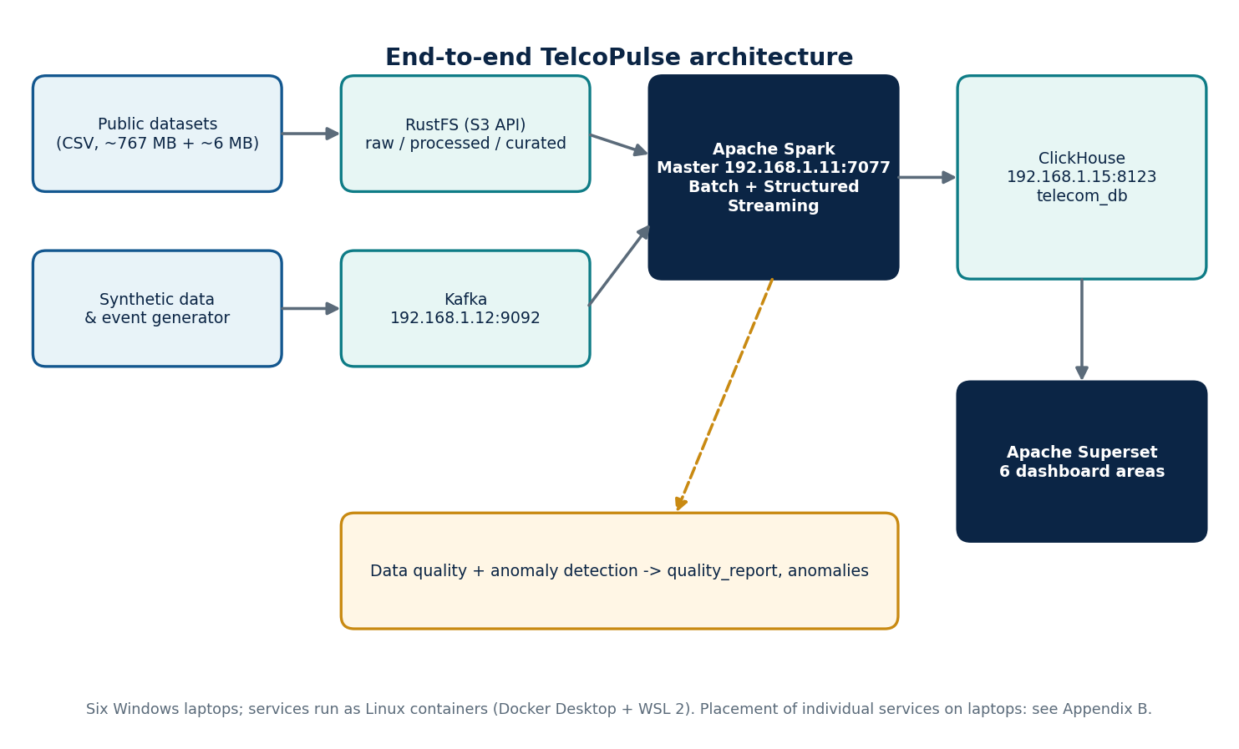
Figure 1 | End-to-end TelcoPulse architecture
Data enters as public and synthetic datasets, is stored and transformed, lands in ClickHouse, and is explored in Superset. Chapter 3 explains each component.

1.6 How the book is organised
Part I explains requirements and architecture. Part II builds the physical and container infrastructure. Part III covers data sources, the S3-compatible data lake, the batch pipeline and validation of the Curated outputs. Part IV covers Kafka, Structured Streaming, ClickHouse and anomaly detection. Part V documents the six dashboard areas. Part VI covers testing, troubleshooting, performance and lessons learned. The appendices collect inventories, commands, schemas and checklists so that the project can be reproduced and audited.

1.7 Project animation
The animated GIF below shows the running TelcoPulse platform. It plays in the Word edition and in web browsers; the PDF edition shows a single frame, because a PDF page cannot play an animation.

Figure 2 | TelcoPulse animated showcase
Animated GIF showing the platform in operation.

1.8 Video walkthrough
A recorded walkthrough of the running platform accompanies this book. The frame below is the reserved slot for it. In the Word edition, click inside the frame and use Insert > Video > Online Video, or paste the link on the line underneath so readers can open it directly. The PDF edition shows the same frame with the link.
VIDEO SLOT
TelcoPulse: six laptops, one distributed telecom analytics platform
Insert the walkthrough video here (16:9 recommended)

Video link: [paste the video URL here]
Video 1 | TelcoPulse platform walkthrough
Suggested running order: network and router (Chapter 4), Spark and storage (Chapters 8 to 10), batch jobs (Chapter 12), stream and anomalies (Chapters 15 and 18), dashboards (Part V).
CHAPTER 2

Problem Statement, Requirements and Scope

2.1 Problem statement
Telecom performance data is large, heterogeneous and time-stamped, and the insight it holds is only reachable through a pipeline that ingests, stores, cleans, aggregates and presents it. The graduation-project problem is: how can a team with six ordinary Windows laptops and a local router assemble a working distributed pipeline for telecom performance data, covering both batch and near-real-time paths, and make its results inspectable through dashboards?

2.2 Functional requirements
Table 1 | Functional requirements
ID | Requirement | Realised by
FR1 | Ingest public and synthetic telecom datasets into object storage | RustFS raw zone
FR2 | Transform data in parallel across several machines | Apache Spark Master and Workers
FR3 | Keep intermediate and final results in separate zones | Processed and Curated zones
FR4 | Produce cleaned per-technology outputs (LTE, NR, GSM) | Spark batch pipeline
FR5 | Ingest a continuous stream of synthetic events | Event generator and Kafka
FR6 | Aggregate streaming events and persist results | Spark Structured Streaming and ClickHouse
FR7 | Store analytical results for SQL access | ClickHouse telecom_db
FR8 | Record data-quality metrics and detected anomalies | quality_report and anomalies tables
FR9 | Present results in dashboards | Apache Superset
FR10 | Record benchmark experiments | benchmark_runs table

2.3 Non-functional requirements
Table 2 | Non-functional requirements
Quality attribute | Requirement | Notes
Reproducibility | Services deployable from container definitions | Docker Compose templates per laptop role (Appendix C)
Observability | Service state inspectable | Spark Master UI (:8080), Worker UI (:8081), container logs
Security hygiene | No secrets in published material | Credentials supplied through environment variables
Honesty of evidence | Results labelled by evidence level | Applied throughout this book
Scalability (lab scale) | Add Spark Workers without changing jobs | Spark standalone model
Fault tolerance | Not a goal | No high-availability design is claimed

2.4 Constraints
- Hardware: six physical Windows 10/11 laptops of ordinary specification. Per-laptop CPU, RAM and disk sizing is applied through the WSL 2 and executor settings in Chapters 6 and 8.
- Software: Linux containers only through Docker Desktop with the WSL 2 backend; the hosts are never native Linux servers.
- Network: a local router-based network mixing Ethernet and Wi-Fi.
- Time: ten days in total.
- Data: public datasets plus synthetic workloads; no operator data.

2.5 Expected workload and scale
The initially reported public inputs are small compared with the target: about 767.2 MB for the radio-access-network counter dataset and about 6.47 MB for a separate LTE channel/context dataset. The project target was a workload of 10 GB or more, reached by combining public data with synthetic data. That 10 GB figure is a target; the achieved input volume has not been established by the supplied evidence. What has been reported is the size of the final result: 31,904,092 Curated rows.

2.6 Scope boundaries
Table 3 | Scope decisions
Item | Decision | Evidence class
Apache NiFi | Removed from scope; not deployed | Confirmed scope decision
Apache Airflow | Removed from scope; not deployed | Confirmed scope decision
Live operator feed | Excluded; synthetic events only | Confirmed
High availability | Not attempted | Confirmed design limit
Production security hardening | Not attempted | Recommended future work
Windows Server / native Linux hosts | Not used; hosts are Windows with Docker Desktop | Confirmed

CHAPTER 3

Architecture and Technology Decisions
This chapter introduces the architecture at the level of components and data flow. Later chapters expand each element. The configuration of the platform changed during development; where the book states a host or endpoint, it also states whether the value comes from the later recorded configuration or from an earlier proposal.
AS-BUILT The repository (TelcoPulseCluster) is authoritative for replication. It implements the batch path with PySpark jobs ingest_raw.py and clean_curate.py, and the streaming path with a Python Kafka consumer (stream_processor.py) instead of a Spark Structured Streaming job. Part VII lists every difference between the design chapters and the repository.

3.1 Layered view
The platform has five logical layers: infrastructure (laptops, router, Docker Desktop and WSL 2), storage (RustFS S3-compatible object storage), processing (Apache Spark for batch and Structured Streaming, Kafka for event transport), analytical storage (ClickHouse) and presentation (Apache Superset). Data quality and anomaly detection cut across the processing and analytical layers.
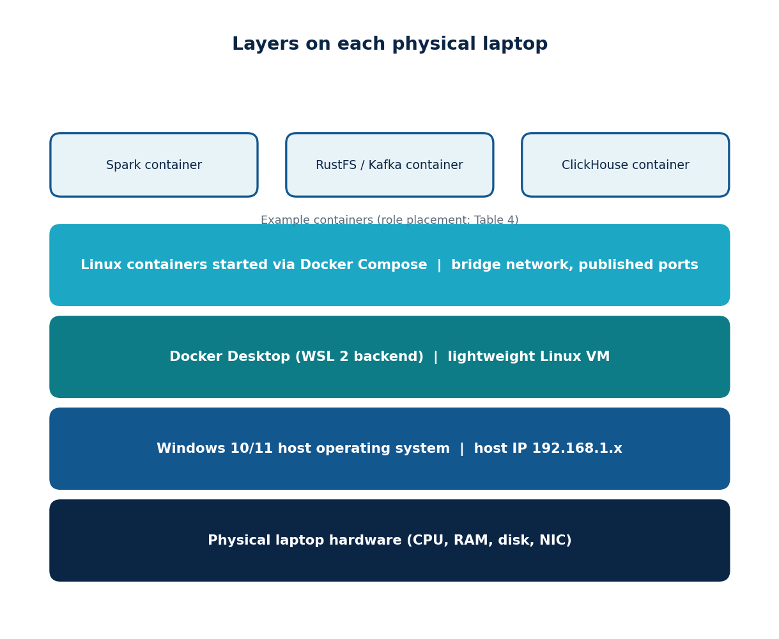
Figure 3 | Layers on each physical laptop
Every host is a Windows laptop. Docker Desktop runs a lightweight Linux virtual machine through WSL 2, and the platform services run as containers inside it.

3.2 Component inventory
Table 4 | Component inventory
Component | Responsibility | Inputs | Outputs | Recorded endpoint / status
Docker Desktop + WSL 2 | Run Linux containers on Windows | Images, Compose files | Running containers | Confirmed approach
Apache Spark Master | Coordinate the cluster | Applications, worker registrations | Resource grants | 192.168.1.11:7077 (later config); UI :8080
Spark Workers | Run executors | Tasks | Task results | Worker UI :8081 (tp-spark-worker1); count: verify
RustFS | S3-compatible object store | S3 API calls | Objects in raw, processed, curated | 192.168.1.12:9000 (later config)
Apache Kafka | Event transport | Synthetic events | Topic records | 192.168.1.12:9092 (recorded)
ClickHouse | Analytical SQL store | Batch and stream results | Query results | 192.168.1.15:8123; telecom_db
Apache Superset | Dashboards | SQL against ClickHouse | Charts, dashboards | Host and port: verify
Event generator | Create synthetic events | Scenario parameters | Kafka records | Script: verify

3.3 Data-flow summary
Table 5 | Data-flow summary
Flow | From | To | Mechanism | Status
Batch ingest | Public and synthetic CSV | RustFS raw | Upload to S3 API | Confirmed in outline; upload procedure: verify
Batch transform | RustFS raw | Processed, Curated | Spark with S3A | Reported; scripts partly available
Batch to analytics | Curated | ClickHouse kpi_batch | Spark loader job (Chapter 17) | Implemented
Stream produce | Event generator | Kafka | Kafka producer | Designed; topic name: verify
Stream process | Kafka | ClickHouse kpi_stream | Spark Structured Streaming | Designed; code: verify
Presentation | ClickHouse | Superset | SQL connection | Designed; status per dashboard: verify

3.3.1 Batch and streaming paths
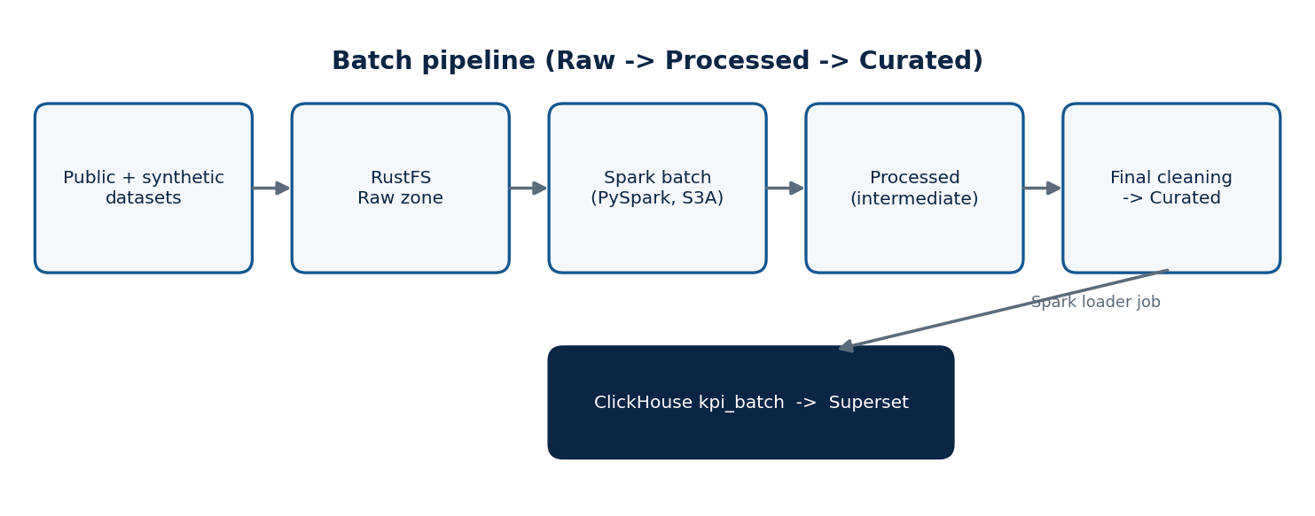
Figure 4 | Batch pipeline
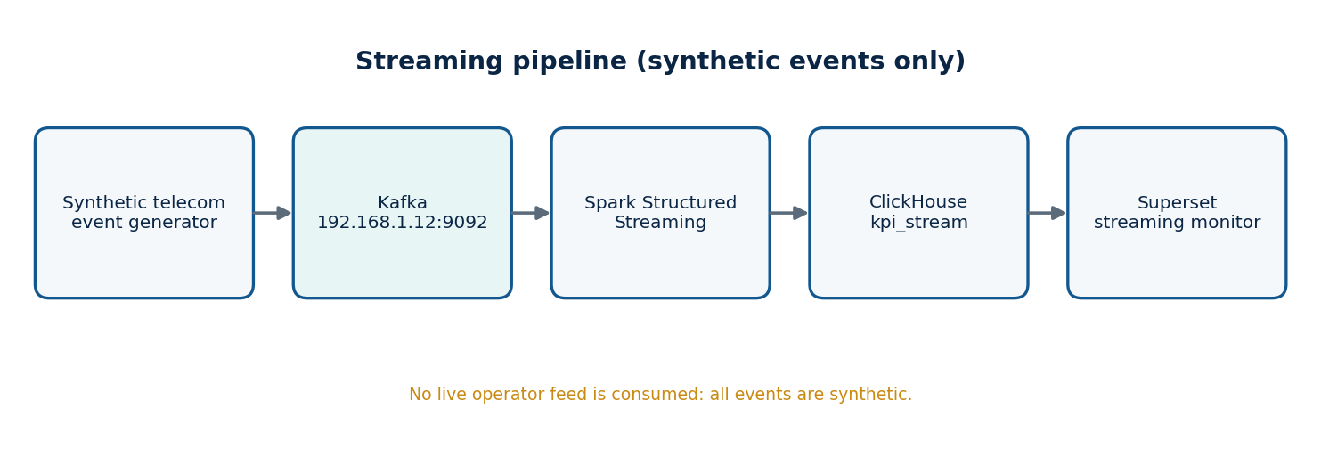
Figure 5 | Streaming pipeline
The streaming source is a synthetic event generator.

3.4 Technology decisions
The rationale below is partly evidence and partly engineering reasoning. Each row says which.
Table 6 | Technology decisions and rationale
Choice | Why it suits this project | Rationale type
Docker + Compose | Identical Linux runtime on every Windows laptop; declarative service definitions | Engineering rationale
Apache Spark (standalone) | Distributes batch work over several laptops; one engine for batch and streaming | Engineering rationale; standalone Master confirmed
RustFS (S3 API) | Lightweight S3-compatible store accessible through Spark S3A | Confirmed implementation; historical MinIO naming noted in Chapter 10
Parquet | Columnar, compressed, schema-carrying files that Spark reads efficiently | Confirmed output format
Kafka | Decouples event production from consumption; standard Spark source | Engineering rationale
ClickHouse | Column store with fast aggregate SQL for dashboards | Engineering rationale
Superset | Open-source BI with ClickHouse connectivity and SQL Lab | Engineering rationale
No NiFi / Airflow | Keep scope achievable in ten days | Confirmed scope decision

DESIGN HISTORY An earlier proposal assigned .10 to Spark Master and Superset, .11 to object storage, .12 to Kafka and the generator, .13 to Spark Worker 1, .14 to ClickHouse and .15 to Spark Worker 2. That plan used 192.168.1.10 to 192.168.1.15. It is not the final addressing plan: the final range is 192.168.1.11 to 192.168.1.16, and later recorded endpoints differ from the proposal (for example ClickHouse at .15 and object storage at .12).
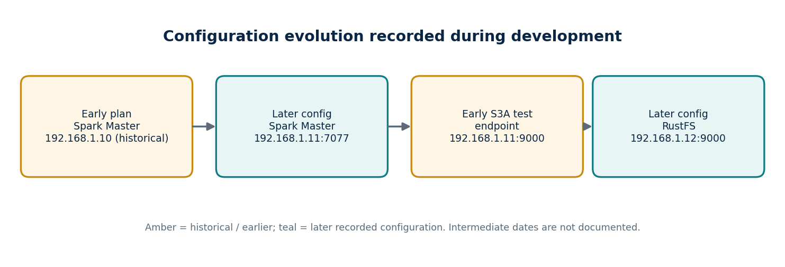
Figure 6 | Configuration evolution recorded during development
PART II
Physical and Container Infrastructure
Six Windows laptops, one router, and the Linux containers that run on top of them.
CHAPTER 4

Router and Six-Laptop Network Setup
A distributed system is only as reliable as the network between its nodes. Spark executors fetch data from object storage, the driver talks to the Master, Kafka producers and consumers exchange records, and Superset queries ClickHouse. Every one of those conversations crosses the physical network of the lab.

4.1 The physical environment
The lab consists of six physical laptops running Windows 10/11, connected through a local router-based network that uses a combination of Ethernet and Wi-Fi. A Huawei HG531 V1 router was used during the network setup and was configured for Access Point / local network use. In that role the router provides the shared layer-2/layer-3 segment on which the laptops see each other; the platform does not depend on any router feature beyond local connectivity.
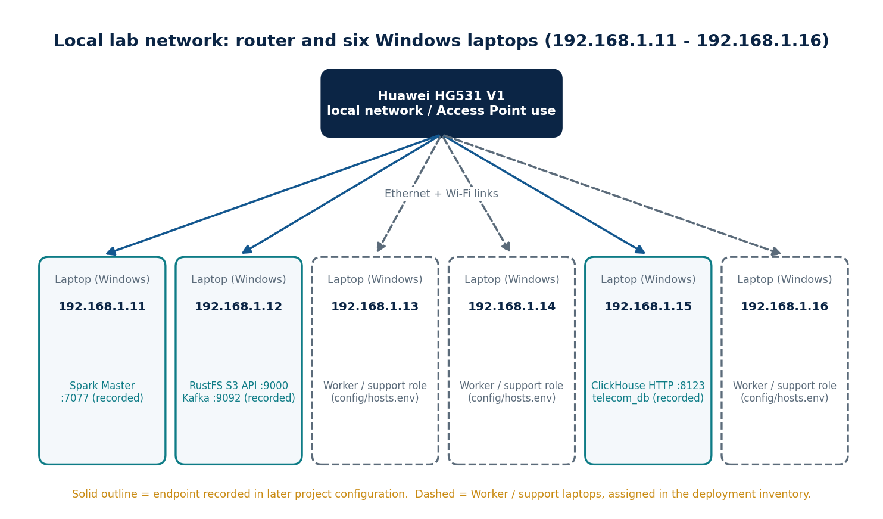
Figure 7 | Network topology of the six-laptop lab
Solid outlines mark hosts with recorded service endpoints. Dashed outlines mark laptops used for Spark Workers and support roles; their assignment is held in the deployment inventory (config/hosts.env).

4.2 Why the network matters to each component
Table 7 | Network dependencies by component
Component | Network conversation | Consequence of failure
Spark driver / Master | Driver registers with Master on :7077 | Application cannot start
Spark executors | Connect back to driver ports; read S3A endpoint | Tasks stall or fail
Spark to RustFS | HTTP to the S3 API on :9000 | Reads and writes fail
Event generator to Kafka | TCP to :9092 | No events enter the pipeline
Spark to Kafka | TCP to :9092 | Streaming query cannot read
Spark to ClickHouse | HTTP :8123 (or native port) | Results not stored
Superset to ClickHouse | HTTP :8123 | Dashboards show no data

4.3 Ethernet versus Wi-Fi
Mixed Ethernet and Wi-Fi is acceptable for a lab but it matters for interpretation. Wi-Fi shares a half-duplex radio medium, so throughput and latency vary with signal quality and with traffic from other laptops. Any benchmark taken on this network must record the link type (the network_mode field exists in benchmark_runs for that purpose) and must not be read as representative of a wired data-centre fabric.

4.4 As-built: the Vodafone HG531 router
In the real lab the network was provided by a router belonging to a team member: a Vodafone-branded Huawei HG531 V1 ADSL router (Figure 7a). It was used only as the local network for the six laptops, which joined it over Wi-Fi and Ethernet. The WAN side of the router was not part of the platform: when the screens in this section were captured, both WAN connections reported Disconnected (Figure 7b). Treat the cluster as an isolated local network. Every container image, Maven JAR and dataset must be downloaded before the laptops are moved onto it, or fetched through a second connection.
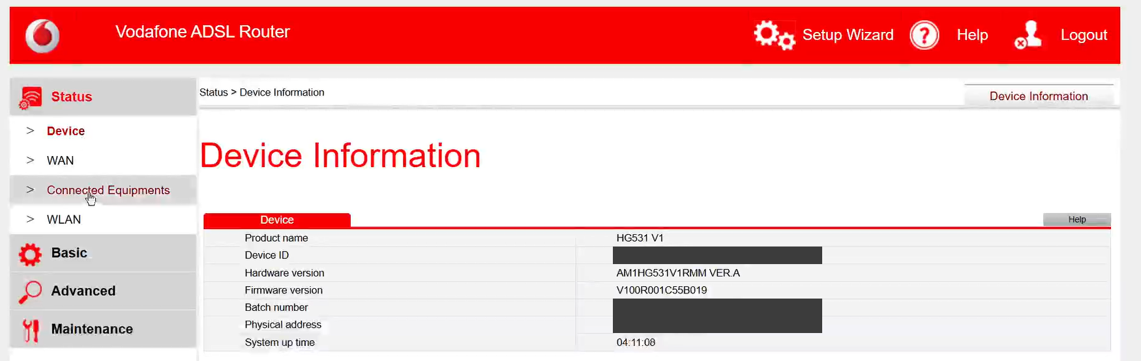
Figure 7a | Router device information (Status > Device)
Model HG531 V1, firmware V100R001C55B019. The device ID, batch number and physical address values were blanked before publication.
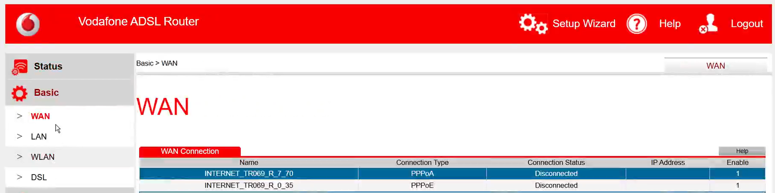
Figure 7b | WAN connections reported Disconnected (Basic > WAN)
The credentials form below the table was cropped out. The lab ran as an isolated local network.
Table 7a | Router settings captured from the web interface
Item | Value | Screenshot
Model / firmware | HG531 V1 / V100R001C55B019 (hardware AM1HG531V1RMM VER.A) | Figure 7a
Router (gateway) address | 192.168.1.1, subnet mask 255.255.255.0 | Figure 7c
Second IP address | Disabled (192.168.2.1 greyed out) | Figure 7c
DHCP server | Enabled | Figure 7d
Address pool | 192.168.1.2 to 192.168.1.254 | Figure 7d
Lease duration | 1 day, 0 hours, 0 minutes, 0 seconds (not infinite) | Figure 7d
DNS servers handed to clients | 62.240.110.198 (primary), 62.240.110.197 (secondary) | Figures 7d, 7e
WAN connections | INTERNET_TR069_R_7_70 (PPPoA) and INTERNET_TR069_R_0_35 (PPPoE), both Disconnected | Figure 7b
Management interface | http://192.168.1.1 (plain HTTP; the browser shows Not secure) | Figures 7a, 7c

4.5 Step-by-step router configuration
The goal is simple: every laptop must receive the same IP address every time, because Spark, Kafka, RustFS and ClickHouse are reached by address (Chapter 5). The router does this with DHCP address reservations. Follow Table 7b in order. The administrator login is printed on the router label; change it from the default and do not publish it.
Table 7b | Router configuration steps
Step | Where | Action | Expected result
1 | Browser on any laptop | Open http://192.168.1.1 and sign in with the router administrator account. | Router pages load. A Not secure warning is normal (HTTP).
2 | Status > Device | Check model and firmware (Figure 7a). | HG531 V1, firmware V100R001C55B019.
3 | Basic > WAN | Note the WAN state (Figure 7b). No change is needed for a local-only lab. | Connections may show Disconnected.
4 | Basic > LAN > LAN Host Settings | Router IP 192.168.1.1, mask 255.255.255.0, second IP left disabled (Figure 7c). | The gateway of the lab is 192.168.1.1.
5 | Basic > LAN > DHCP Server | Tick Enable. Start 192.168.1.2, end 192.168.1.254, lease 1 day. Press Submit (Figure 7d). | Laptops obtain addresses automatically.
6 | Same page, IP Address Reserve | Press New. Enter the laptop MAC (Section 4.6) and its reserved IP. Submit. Repeat for all six laptops (Figure 7e). | Six rows, 192.168.1.11 to .16.
7 | Every laptop | Disconnect and reconnect the network, or run ipconfig /release then ipconfig /renew. Then run ipconfig. | IPv4 address equals the reserved address.
8 | Every laptop | Run the ping matrix of Chapter 5. | All replies, no timeouts.

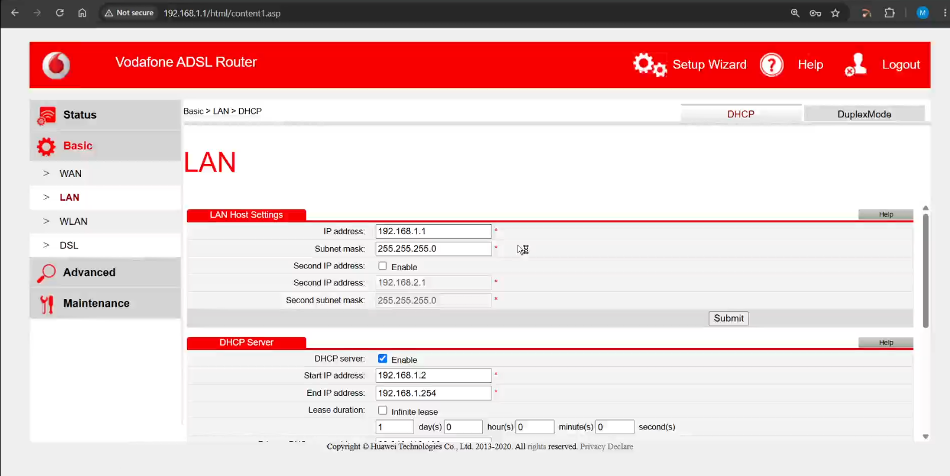
Figure 7c | LAN host settings (Basic > LAN)
Gateway 192.168.1.1 with mask 255.255.255.0; the second IP address is disabled.
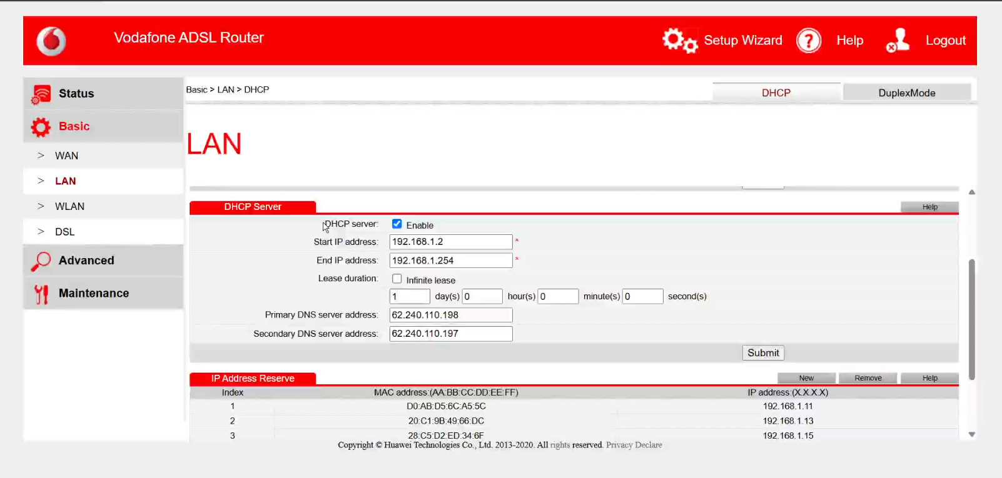
Figure 7d | DHCP server settings
Pool 192.168.1.2 to .254 with a one-day lease. Reservations (below) override the pool for the six laptops.
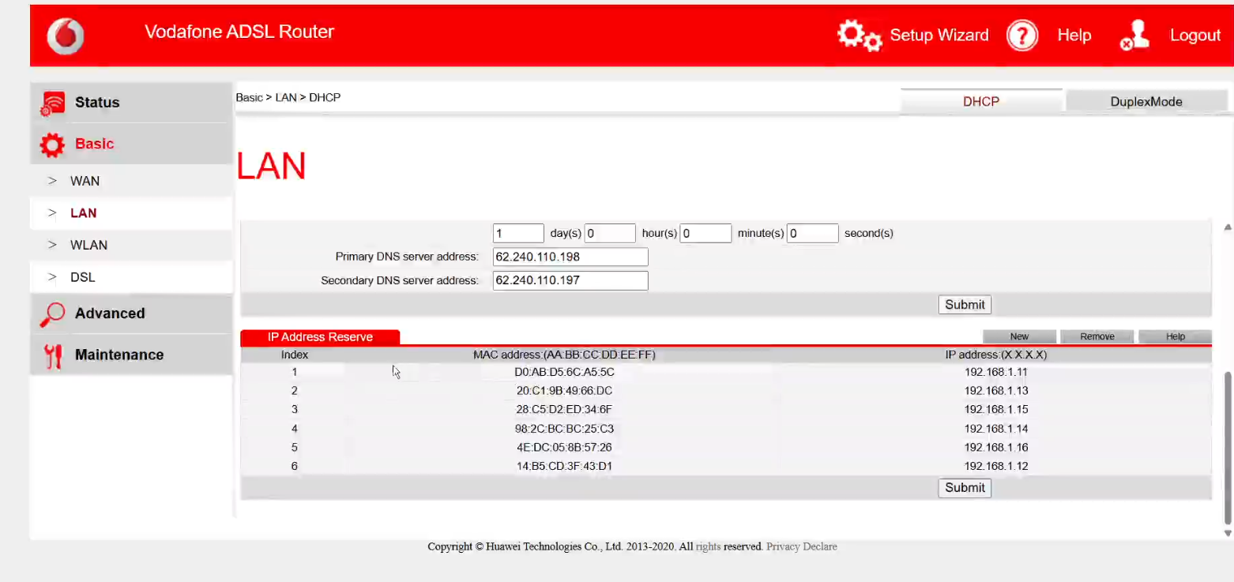
Figure 7e | IP Address Reserve table with the six laptop reservations
The reservation table is the single source of truth for the lab addressing plan.

4.6 Finding the MAC address to reserve
A reservation binds an IP address to a MAC address, so the MAC must belong to the network adapter that actually carries the laptop traffic. On Windows, open Command Prompt and run getmac /v (Figure 7f). The output lists every adapter with its connection name, adapter description and physical address.
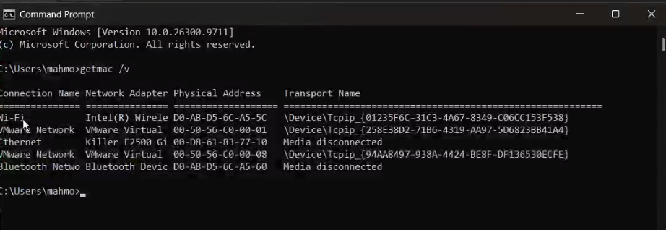
Figure 7f | Reading adapters with getmac /v
The Wi-Fi adapter (Intel, D0-AB-D5-6C-A5-5C) is the one reserved as 192.168.1.11. Ethernet shows Media disconnected; VMware and Bluetooth adapters are ignored.
Table 7c | Address reservations as built
IP address | Reservation index | MAC address (from the router) | Role and basis
192.168.1.11 | 1 | D0:AB:D5:6C:A5:5C | Spark Master and driver (repository: spark.driver.host 192.168.1.11). MAC matches the Wi-Fi adapter in Figure 7f.
192.168.1.12 | 6 | 14:B5:CD:3F:43:D1 | RustFS object storage (recorded project endpoint 192.168.1.12:9000).
192.168.1.13 | 2 | 20:C1:9B:49:66:DC | Kafka broker and Kafka UI (repository: advertised EXTERNAL listener 192.168.1.13:9092).
192.168.1.14 | 4 | 98:2C:BC:BC:25:C3 | Spark Worker (repository README cluster layout, Web UI port 8081). The worker compose file is not in the repository.
192.168.1.15 | 3 | 28:C5:D2:ED:34:6F | ClickHouse and Superset (repository: ClickHouse URL 192.168.1.15:8123; both services in one compose file).
192.168.1.16 | 5 | 4E:DC:05:8B:57:26 | Spark Worker (repository README cluster layout, Web UI port 8081). The worker compose file is not in the repository.

4.7 Router pitfalls and recommendations
- Reserve the right adapter. A laptop with Wi-Fi, Ethernet and VMware adapters has several MAC addresses, and only one belongs to the connection in use. If a laptop later switches from Wi-Fi to Ethernet it presents a different MAC and receives a different address, so update the reservation first.
- Switch off random hardware addresses for the lab Wi-Fi network in Windows (Settings > Network & internet > Wi-Fi > the network). A rotating MAC silently breaks a reservation. This is a recommendation; it is not visible in the screenshots.
- Renew leases after any change. The pool lease is one day; reconnect each laptop or run ipconfig /renew after editing reservations.
- Plan for no Internet. With the WAN disconnected, docker pull and Maven downloads fail. Pull images and download the two S3A JARs beforehand (Chapter 31, Phase 0).
- Protect the router. The management page is plain HTTP. Change the default administrator password, keep the router off any public network and never publish its login or PPP credentials.
- Expect lab-grade performance. A consumer ADSL router with Wi-Fi is a shared medium. Treat benchmark numbers as relative, not absolute (Chapter 28).

CHAPTER 5

IP Addressing and Connectivity Validation

5.1 The addressing plan
The six physical laptops use addresses in the range 192.168.1.11 through 192.168.1.16. The range 192.168.1.10 to 192.168.1.15 appeared only in an earlier proposal and must not be used as the final plan.
Table 8 | Host IP inventory (evidence-based)
Host IP | Recorded service endpoint | Evidence class
192.168.1.11 | Spark Master 192.168.1.11:7077 | Later configuration (recorded)
192.168.1.12 | RustFS S3 API :9000; Kafka :9092 | Later configuration (recorded)
192.168.1.13 | Worker / support role (assigned in config/hosts.env) | Deployment inventory
192.168.1.14 | Worker / support role (assigned in config/hosts.env) | Deployment inventory
192.168.1.15 | ClickHouse HTTP :8123; database telecom_db | Recorded configuration
192.168.1.16 | Worker / support role (assigned in config/hosts.env) | Deployment inventory

RECORDED PROJECT FACT The recorded endpoints are service endpoints. They show that those services were reachable at those addresses in the later configuration, but they do not by themselves prove the full mapping of all six laptops or that no other services run on the same hosts. For example, RustFS and Kafka share an IP in the record; the book does not assume more about their placement than that.

5.2 Four address concepts
Confusion between addresses is the most common cause of distributed-system misconfiguration. Four concepts must be kept apart.
Table 9 | Address concepts
Concept | Example | Reachable from
Physical host IP | 192.168.1.12 | Every device on the LAN
Container IP | Docker bridge address (172.x.x.x range, typical) | Inside that laptop only
Published host port | Host :9000 mapped to container :9000 | The LAN, through the host IP
Service endpoint | 192.168.1.12:9000 | What clients and executors should be configured with

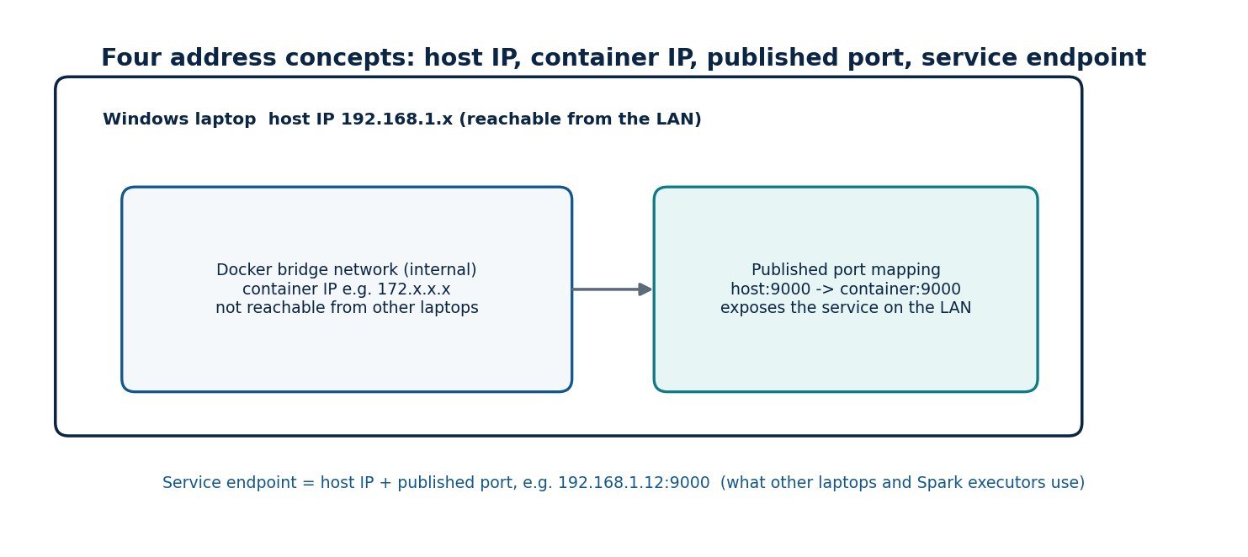
Figure 8 | Host IP, container IP, published port and service endpoint

5.3 Connectivity validation
The team tested inter-device connectivity with ping. A successful ping proves only that ICMP echo packets travel between two hosts. It does not prove that Spark port 7077, the S3 port 9000 or Kafka port 9092 is open, that Windows Defender Firewall permits it, or that a container has published the port. Validation therefore proceeds in layers: reachability (ping), port reachability (TCP connect), then application protocol (Spark Master UI, S3 listing, Kafka metadata, ClickHouse HTTP ping).
Listing 1 | Recommended layered connectivity checks (Windows PowerShell)
Environment: Windows PowerShell on any laptop. Recommended procedure; not a recorded historical command.
# 1. Reachability: replace the target with a host from Table "Host IP inventory"
ping 192.168.1.12

# 2. TCP port reachability from Windows PowerShell
Test-NetConnection -ComputerName 192.168.1.12 -Port 9000
Test-NetConnection -ComputerName 192.168.1.11 -Port 7077

# 3. Application level (ClickHouse HTTP interface answers "Ok.")
curl.exe http://192.168.1.15:8123/ping

ENGINEERING NOTE These are standard Windows tools chosen to match the service endpoints in Appendix B. Run them from any laptop after every network change.
Table 10 | Network validation status
Test | Status | Evidence
Ping between laptops | Performed during network preparation | Procedure in this chapter
TCP port tests | Runbook step (Appendix K) | Test-NetConnection
Firewall rules | Inbound rules per service port (Appendix C) | New-NetFirewallRule

CHAPTER 6

Windows, Docker Desktop and WSL 2

6.1 Why the hosts remain Windows machines
The six laptops are ordinary Windows 10/11 machines. Rather than reinstalling Linux on each, the team used Docker Desktop with its WSL 2 backend. WSL 2 (Windows Subsystem for Linux, version 2) runs a real Linux kernel inside a lightweight utility virtual machine. Docker Desktop uses it to run the Docker engine, so containers see a Linux environment while the laptop remains a Windows machine. The laptops are therefore never native Linux servers, and commands that run in a Linux container shell are not interchangeable with PowerShell commands on the host.

6.2 Images, containers and Compose
A container image is a read-only template containing a filesystem and default command. A container is a running instance of an image with its own process space and writable layer. Docker Compose describes a set of containers, their networks, published ports and volumes in a YAML file and starts them with one command. Compose does not run services across hosts; with six laptops, each laptop runs its own Compose project and the services find each other through host IP addresses and published ports.

6.3 Container networking
By default a container attaches to a Docker bridge network and receives a private address that other laptops cannot route to. To make a service reachable across the LAN, the container publishes a port (-p host:container or the Compose ports section), and clients use the Windows host IP plus the host port. The observed Spark Worker container tp-spark-worker1 ran in bridge mode and published its Web UI on port 8081, which is exactly this pattern.
RECORDED PROJECT FACT Observed properties of container tp-spark-worker1: image telcopulse-spark-s3a:3.5.9, network mode bridge, Web UI published on port 8081.
A practical consequence of bridge networking for Spark is that executors must be able to connect back to the driver. In a later configuration the Spark Master service exposed driver-related ports 7078 and 7079 in addition to 7077 and 8080. Such ports must be published and permitted by the firewall, and the advertised host address must be the laptop IP rather than a container address.

6.4 Persistent data
Container filesystems are discarded when a container is removed. Persistent services therefore mount storage from the host. The project directory on one machine was G:\TelcoPulse, with folders config, data, docker, jobs, docs and logs, and object-storage data was kept under G:\TelcoPulse\data\minio in an early configuration.
DESIGN HISTORY The directory name data\minio identifies the earlier configuration. It must not be read as proof that the final storage product is MinIO; Chapter 10 documents the later S3-compatible service, RustFS.

6.5 Resource limits
WSL 2 by default takes a share of the host RAM and CPUs, configurable through a .wslconfig file on Windows. Six laptops each running a container stack alongside Windows, a browser and an IDE are memory-constrained, and executor memory must be sized with that in mind. A reference .wslconfig is listed below; size memory and processors to each laptop.
Listing 2 | Recommended inspection commands
Environment: Windows PowerShell with Docker Desktop running. Recommended; container name taken from the recorded worker.
# Windows PowerShell
wsl --status
wsl -l -v
docker version
docker compose version

# Windows PowerShell: running containers and their published ports
docker ps --format "table {{.Names}}\t{{.Image}}\t{{.Ports}}\t{{.Status}}"

# Windows PowerShell: network mode of one container
docker inspect tp-spark-worker1 --format "{{.HostConfig.NetworkMode}}"

Listing 3 | WSL 2 resource configuration
Environment: Windows. Apply with wsl --shutdown, then restart Docker Desktop. Values are per-laptop sizing.
# %UserProfile%\.wslconfig (apply with: wsl --shutdown, then restart Docker Desktop)
[wsl2]
memory=8GB
processors=4
swap=2GB

CHAPTER 7

Distributed Service Deployment
This chapter describes how every TelcoPulse service is packaged, configured and started across the six laptops. All templates are in the companion assets (docker/, config/, powershell/) and are listed here. They are a coherent reference deployment built around the recorded endpoints. Commands name their environment: Windows PowerShell on the laptop, or a Linux shell inside a container.
AS-BUILT Hosts as built: Spark Master on .11, RustFS on .12, Kafka and Kafka UI on .13, ClickHouse and Superset on .15, with .14 and .16 as worker or support laptops. See Table 7c and Figure 18. The compose files actually used are reproduced in Chapter 30.

7.1 Role placement
Table 11 | Role placement across the six laptops
Laptop | Roles | Endpoints
192.168.1.11 | Spark Master; driver for client-mode jobs | 7077 cluster, 8080 UI, 7078/7079 driver, 4040 application UI
192.168.1.12 | RustFS object storage; Kafka broker | S3 API 9000, console 9001, Kafka 9092
192.168.1.15 | ClickHouse | HTTP 8123, native 9000, database telecom_db
Remaining laptops (.13, .14, .16) | Spark Worker containers, Superset, event generator | Worker UI 8081, executor range 7100-7120, Superset 8088

The three recorded roles are fixed. The remaining laptops are assigned from the pool of .13, .14 and .16 in config/hosts.env (Listing below), so each Worker, Superset and generator command reads its address from one file instead of embedding it.
Listing 4 | Deployment inventory template
File: config/hosts.env.template
# TelcoPulse deployment inventory (copy to hosts.env on every laptop; never commit secrets)
# Recorded endpoints (latest configuration)
SPARK_MASTER_HOST=192.168.1.11
SPARK_MASTER_PORT=7077
S3_ENDPOINT=http://192.168.1.12:9000
KAFKA_BOOTSTRAP=192.168.1.12:9092
CH_HOST=192.168.1.15
CH_PORT=8123
CH_DB=telecom_db
KAFKA_TOPIC=telco.events
# Laptops used for Spark Workers, Superset and the event generator are chosen from the
# remaining hosts (192.168.1.13, .14, .16) and written here when assigned.
WORKER_HOSTS=<LAN_IP_OF_WORKER_LAPTOPS>
SUPERSET_HOST=<LAN_IP_OF_SUPERSET_LAPTOP>
# Secrets: set in the shell or a private .env file excluded from version control
AWS_ACCESS_KEY_ID=<SET_AT_DEPLOYMENT>
AWS_SECRET_ACCESS_KEY=<SET_AT_DEPLOYMENT>
CH_USER=<SET_AT_DEPLOYMENT>
CH_PASSWORD=<SET_AT_DEPLOYMENT>

7.2 Service port map
Table 12 | Service ports
Service | Port | Protocol / purpose | Firewall rule on host
Spark Master | 7077 | Cluster RPC | Inbound TCP from 192.168.1.0/24
Spark Master UI | 8080 | HTTP | Inbound TCP
Spark driver | 7078, 7079, 4040 | Driver RPC, block manager, app UI | Inbound TCP
Spark Worker UI | 8081 | HTTP | Inbound TCP
Worker executor range | 7100-7120 | Block manager, shuffle | Inbound TCP
RustFS | 9000, 9001 | S3 API, console | Inbound TCP
Kafka | 9092 | Broker (advertised 192.168.1.12:9092) | Inbound TCP
ClickHouse | 8123, 9000 | HTTP, native | Inbound TCP
Superset | 8088 | HTTP | Inbound TCP

Listing 5 | Windows firewall rule (elevated PowerShell)
File: powershell/firewall.ps1
# Run in an elevated Windows PowerShell on the laptop that hosts the service.
# Example for the Spark Master laptop (192.168.1.11); adjust ports per role.
$ports = 7077,8080,7078,7079,4040
New-NetFirewallRule -DisplayName "TelcoPulse Spark Master" -Direction Inbound `
-Protocol TCP -LocalPort $ports -RemoteAddress 192.168.1.0/24 -Action Allow

7.3 Container images
Spark uses a single custom image, telcopulse-spark-s3a:3.5.9, built on apache/spark:3.5.9-scala2.12-java11-python3-r-ubuntu. The build adds the S3A connector (hadoop-aws with the matching AWS SDK bundle), the Spark-Kafka connector and its dependencies, and the Python libraries the jobs need (clickhouse-connect, pandas, pyarrow, psutil). Using the same image for Master and Workers guarantees identical Python and JVM libraries on every node, which is what lets executors run the jobs unchanged.
Listing 6 | Dockerfile of telcopulse-spark-s3a:3.5.9
Environment: Windows PowerShell: docker build -t telcopulse-spark-s3a:3.5.9 docker/spark
# telcopulse-spark-s3a:3.5.9 - Spark with S3A, Kafka and ClickHouse client support
FROM apache/spark:3.5.9-scala2.12-java11-python3-r-ubuntu
USER root
ARG SPARK_VERSION=3.5.9
ARG HADOOP_AWS=3.3.4
ARG AWS_BUNDLE=1.12.262
ARG MVN=https://repo1.maven.org/maven2
RUN cd /opt/spark/jars \
&& curl -fsSLO $MVN/org/apache/hadoop/hadoop-aws/$HADOOP_AWS/hadoop-aws-$HADOOP_AWS.jar \
&& curl -fsSLO $MVN/com/amazonaws/aws-java-sdk-bundle/$AWS_BUNDLE/aws-java-sdk-bundle-$AWS_BUNDLE.jar \
&& curl -fsSLO $MVN/org/apache/spark/spark-sql-kafka-0-10_2.12/$SPARK_VERSION/spark-sql-kafka-0-10_2.12-$SPARK_VERSION.jar \
&& curl -fsSLO $MVN/org/apache/spark/spark-token-provider-kafka-0-10_2.12/$SPARK_VERSION/spark-token-provider-kafka-0-10_2.12-$SPARK_VERSION.jar \
&& curl -fsSLO $MVN/org/apache/kafka/kafka-clients/3.4.1/kafka-clients-3.4.1.jar \
&& curl -fsSLO $MVN/org/apache/commons/commons-pool2/2.11.1/commons-pool2-2.11.1.jar
RUN pip3 install --no-cache-dir clickhouse-connect pandas pyarrow psutil
COPY spark-defaults.conf /opt/spark/conf/spark-defaults.conf
USER spark

Build the image once per laptop that runs Spark (or build once and docker save/docker load it to the others) so that every node holds exactly the same image.

7.4 Spark Master laptop (192.168.1.11)
Listing 7 | Spark Master Compose file
Environment: Windows PowerShell: docker compose -f docker/spark/compose.master.yml up -d
# Laptop 192.168.1.11 - Spark Master (and driver for client-mode submissions)
services:
spark-master:
image: telcopulse-spark-s3a:3.5.9
container_name: tp-spark-master
hostname: spark-master
command: >
/opt/spark/bin/spark-class org.apache.spark.deploy.master.Master
--host 0.0.0.0 --port 7077 --webui-port 8080
environment:
SPARK_PUBLIC_DNS: 192.168.1.11
AWS_ACCESS_KEY_ID: ${AWS_ACCESS_KEY_ID}
AWS_SECRET_ACCESS_KEY: ${AWS_SECRET_ACCESS_KEY}
CH_HOST: 192.168.1.15
CH_USER: ${CH_USER}
CH_PASSWORD: ${CH_PASSWORD}
ports:
- "7077:7077" # cluster endpoint
- "8080:8080" # Master Web UI
- "7078:7078" # driver RPC (spark.driver.port)
- "7079:7079" # driver block manager
- "4040:4040" # application UI
volumes:
- ../../jobs:/opt/telcopulse/jobs:ro
- ../../scripts:/opt/telcopulse/scripts:ro
- ../../logs:/opt/telcopulse/logs
restart: unless-stopped

Key choices: the Master binds to 0.0.0.0 inside the container so published ports work, while SPARK_PUBLIC_DNS advertises the LAN address 192.168.1.11 to browsers and workers. Ports 7078 and 7079 are published because jobs are submitted in client mode from this container, so executors on other laptops must connect back to the driver there. Credentials are passed from the shell environment and never written into the Compose file.

7.5 Spark Worker laptops
Listing 8 | Spark Worker Compose file
Environment: Windows PowerShell on each worker laptop, with WORKER_NO and WORKER_PUBLIC_IP in .env
# Worker laptops (one container per laptop; set WORKER_NO and WORKER_PUBLIC_IP in .env)
services:
spark-worker:
image: telcopulse-spark-s3a:3.5.9
container_name: tp-spark-worker${WORKER_NO:-1}
command: >
/opt/spark/bin/spark-class org.apache.spark.deploy.worker.Worker
spark://192.168.1.11:7077 --webui-port 8081
--cores ${WORKER_CORES:-2} --memory ${WORKER_MEMORY:-3g}
--work-dir /opt/spark/work
environment:
SPARK_PUBLIC_DNS: ${WORKER_PUBLIC_IP}
SPARK_LOCAL_HOSTNAME: ${WORKER_PUBLIC_IP}
ports:
- "8081:8081" # Worker Web UI
- "7100-7120:7100-7120" # executor / block-manager range
volumes:
- spark-work:/opt/spark/work
restart: unless-stopped
volumes:
spark-work:

The Worker container is named tp-spark-workerN (the observed first Worker is tp-spark-worker1). It runs in the default bridge network and publishes its Web UI on 8081 and an executor port range, and it registers with spark://192.168.1.11:7077. --cores and --memory bound what the Worker offers to the cluster so that Windows and Docker Desktop keep headroom on a laptop.

7.6 Object storage and Kafka laptop (192.168.1.12)
Listing 9 | RustFS and Kafka Compose file
Environment: Windows PowerShell: docker compose -f docker/rustfs-kafka/compose.yml up -d
# Laptop 192.168.1.12 - RustFS (S3 API :9000) and Kafka (:9092)
services:
rustfs:
image: rustfs/rustfs:${RUSTFS_TAG}
container_name: tp-rustfs
environment:
RUSTFS_ACCESS_KEY: ${AWS_ACCESS_KEY_ID}
RUSTFS_SECRET_KEY: ${AWS_SECRET_ACCESS_KEY}
RUSTFS_VOLUMES: /data
RUSTFS_ADDRESS: ":9000"
RUSTFS_CONSOLE_ENABLE: "true"
ports:
- "9000:9000" # S3-compatible API
- "9001:9001" # management console
volumes:
- ${TP_DATA_DIR:-../../data/rustfs}:/data
restart: unless-stopped

kafka:
image: apache/kafka:${KAFKA_TAG}
container_name: tp-kafka
environment:
KAFKA_NODE_ID: 1
KAFKA_PROCESS_ROLES: broker,controller
KAFKA_LISTENERS: PLAINTEXT://:9092,CONTROLLER://:9093
KAFKA_ADVERTISED_LISTENERS: PLAINTEXT://192.168.1.12:9092
KAFKA_CONTROLLER_LISTENER_NAMES: CONTROLLER
KAFKA_LISTENER_SECURITY_PROTOCOL_MAP: CONTROLLER:PLAINTEXT,PLAINTEXT:PLAINTEXT
KAFKA_CONTROLLER_QUORUM_VOTERS: 1@localhost:9093
KAFKA_OFFSETS_TOPIC_REPLICATION_FACTOR: 1
KAFKA_TRANSACTION_STATE_LOG_REPLICATION_FACTOR: 1
KAFKA_TRANSACTION_STATE_LOG_MIN_ISR: 1
KAFKA_LOG_RETENTION_HOURS: 72
ports:
- "9092:9092"
volumes:
- kafka-data:/var/lib/kafka/data
restart: unless-stopped
volumes:
kafka-data:

RustFS exposes the S3-compatible API on 9000 and a management console on 9001; its data directory is a host folder so objects survive container re-creation. Kafka runs as a single KRaft node (broker and controller in one process). The advertised listener is 192.168.1.12:9092; this is the address Kafka returns to clients after the first connection, so producers and Spark on other laptops can reach it. Image tags (RUSTFS_TAG, KAFKA_TAG) are set in the environment file; use tags from the vendors' release pages and keep the environment variable names consistent with the chosen RustFS release notes.
After first start, create the three buckets with the RustFS console or any S3 client, and the Kafka topic with the helper script.
Listing 10 | Create the Kafka topic
Environment: Linux shell inside tp-kafka (PowerShell: docker exec tp-kafka bash -c "..." or docker exec -it tp-kafka bash)
#!/usr/bin/env bash
# Run on the Kafka laptop (PowerShell: docker exec tp-kafka ...); shown as container command.
/opt/kafka/bin/kafka-topics.sh --bootstrap-server 192.168.1.12:9092 \
--create --if-not-exists --topic telco.events --partitions 3 --replication-factor 1

Listing 11 | Create buckets with an S3 client (example: AWS CLI, Windows PowerShell)
Environment: Windows PowerShell with the AWS CLI installed (any S3 client works).
$env:AWS_ACCESS_KEY_ID = "<SET_AT_DEPLOYMENT>"; $env:AWS_SECRET_ACCESS_KEY = "<SET_AT_DEPLOYMENT>"
foreach ($b in "raw","processed","curated") {
aws --endpoint-url http://192.168.1.12:9000 s3 mb s3://$b
}
aws --endpoint-url http://192.168.1.12:9000 s3 ls
# Upload the ten source files
aws --endpoint-url http://192.168.1.12:9000 s3 cp .\data\raw\ s3://raw/ --recursive --exclude "*" --include "Dataset_*.csv"

7.7 ClickHouse laptop (192.168.1.15)
Listing 12 | ClickHouse Compose file
Environment: Windows PowerShell: docker compose -f docker/clickhouse/compose.yml up -d
# Laptop 192.168.1.15 - ClickHouse (HTTP :8123, native :9000), database telecom_db
services:
clickhouse:
image: clickhouse/clickhouse-server:${CLICKHOUSE_TAG}
container_name: tp-clickhouse
environment:
CLICKHOUSE_DB: telecom_db
CLICKHOUSE_USER: ${CH_USER}
CLICKHOUSE_PASSWORD: ${CH_PASSWORD}
CLICKHOUSE_DEFAULT_ACCESS_MANAGEMENT: "1"
ports:
- "8123:8123"
- "9000:9000"
ulimits:
nofile: {soft: 262144, hard: 262144}
volumes:
- ch-data:/var/lib/clickhouse
- ../../sql:/docker-entrypoint-initdb.d:ro
restart: unless-stopped
volumes:
ch-data:

The SQL folder is mounted into /docker-entrypoint-initdb.d, so the table definitions of Chapter 17 run automatically on the first start with an empty data volume. Port 8123 is the HTTP interface used by Superset and by the Python jobs. The named volume ch-data persists the database.

7.8 Superset laptop
Listing 13 | Superset image
File: docker/superset/Dockerfile
ARG SUPERSET_TAG=latest
FROM apache/superset:${SUPERSET_TAG}
USER root
RUN pip install --no-cache-dir clickhouse-connect
COPY superset_config.py /app/pythonpath/superset_config.py
USER superset

Listing 14 | Superset configuration
File: docker/superset/superset_config.py. SUPERSET_SECRET_KEY is generated per deployment.
import os
SECRET_KEY = os.environ["SUPERSET_SECRET_KEY"] # generated per deployment
SQLALCHEMY_DATABASE_URI = "sqlite:////app/superset_home/superset.db"
ROW_LIMIT = 50000
SQLLAB_TIMEOUT = 120
SUPERSET_WEBSERVER_TIMEOUT = 120
FEATURE_FLAGS = {"DASHBOARD_NATIVE_FILTERS": True, "DASHBOARD_CROSS_FILTERS": True}

Listing 15 | Superset Compose file
File: docker/superset/compose.yml
# Superset laptop (address held in hosts.env as SUPERSET_HOST)
services:
superset:
build: .
image: telcopulse-superset:local
container_name: tp-superset
environment:
SUPERSET_SECRET_KEY: ${SUPERSET_SECRET_KEY}
ports:
- "8088:8088"
volumes:
- superset-home:/app/superset_home
restart: unless-stopped
volumes:
superset-home:

Listing 16 | First-time Superset initialisation (container shell)
Environment: Windows PowerShell calling docker exec (use ` instead of \ for line continuation in PowerShell).
docker exec -it tp-superset superset db upgrade
docker exec -it tp-superset superset fab create-admin --username <ADMIN_USER> \
--firstname TelcoPulse --lastname Admin --email <ADMIN_EMAIL> --password <ADMIN_PASSWORD>
docker exec -it tp-superset superset init

7.9 Event generator
The generator runs as a container on a worker or support laptop. Its image and run command are in Chapter 15.

7.10 Start-up order and health checks
- ClickHouse (192.168.1.15) and RustFS/Kafka (192.168.1.12) come up first; they have no dependencies.
- Create buckets, upload source files, create the Kafka topic.
- Spark Master (192.168.1.11), then the Worker containers; confirm the Workers on the Master UI.
- Run the batch jobs (Chapter 12), then the streaming job and generator (Chapters 15 and 16).
- Start Superset last and connect it to ClickHouse (Chapter 19).

Listing 17 | Cluster reachability check
Environment: Windows PowerShell on any laptop.
# Cluster reachability check; run from any laptop.
$targets = @(
@{n="Spark Master"; h="192.168.1.11"; p=7077},
@{n="Spark Master UI"; h="192.168.1.11"; p=8080},
@{n="RustFS S3 API"; h="192.168.1.12"; p=9000},
@{n="Kafka"; h="192.168.1.12"; p=9092},
@{n="ClickHouse HTTP"; h="192.168.1.15"; p=8123}
)
foreach ($t in $targets) {
$r = Test-NetConnection -ComputerName $t.h -Port $t.p -WarningAction SilentlyContinue
"{0,-16} {1}:{2} -> {3}" -f $t.n, $t.h, $t.p, $(if ($r.TcpTestSucceeded) {"OPEN"} else {"CLOSED"})
}
curl.exe -s http://192.168.1.15:8123/ping

CHAPTER 8

Apache Spark Master and Workers

8.1 Roles and execution model
Spark standalone mode has three cooperating roles. The Master (tp-spark-master, spark://192.168.1.11:7077) tracks registered Workers and grants resources to applications. Each Worker (tp-spark-workerN) offers a fixed number of cores and memory from one laptop and launches executors on request. The driver runs the application: it builds the query plan, divides it into stages and tasks, and schedules tasks on executors. In TelcoPulse jobs are submitted in client mode from the Master container, so the driver lives at 192.168.1.11 and executors connect back to it on ports 7078 and 7079.
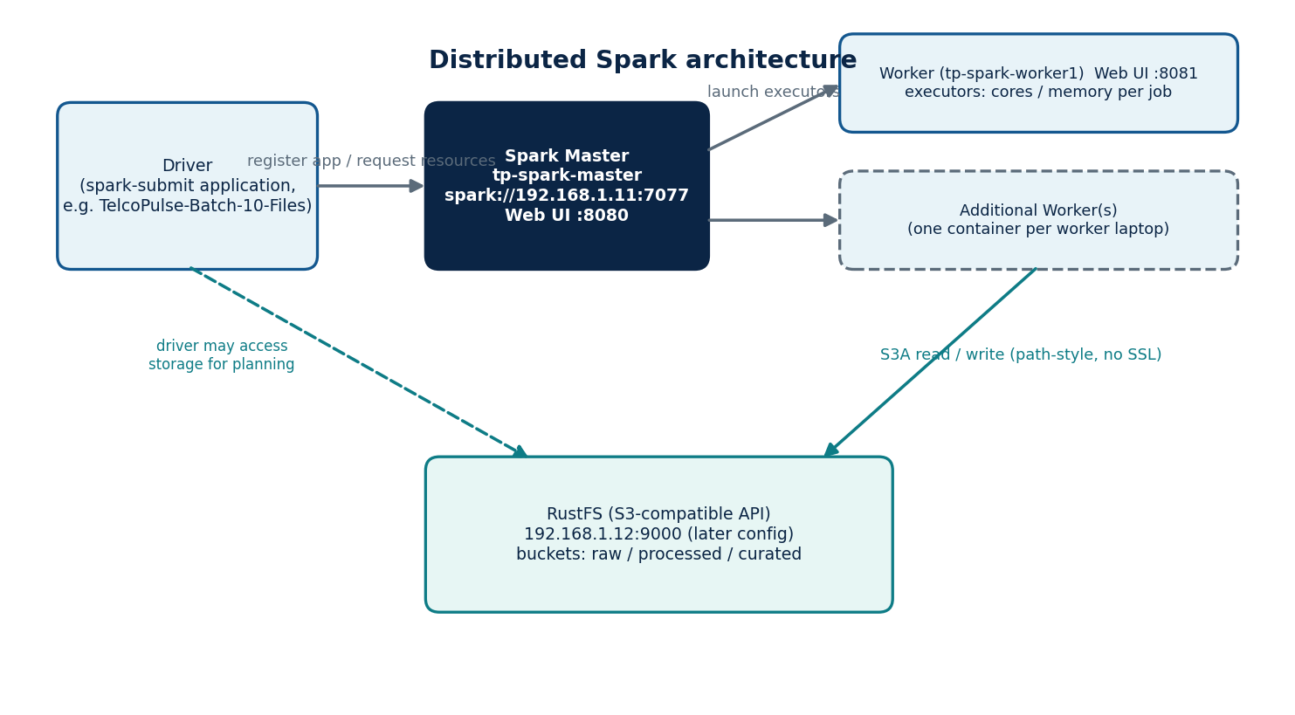
Figure 9 | Distributed Spark architecture

8.2 Recorded and reference configuration
Table 13 | Spark configuration
Item | Value | Source
Master container | tp-spark-master | Recorded
Base image | apache/spark:3.5.9-scala2.12-java11-python3-r-ubuntu | Recorded
Application image | telcopulse-spark-s3a:3.5.9 | Recorded
Master endpoint | spark://192.168.1.11:7077 | Recorded (latest)
Master Web UI / ports | 8080; driver ports 7078, 7079 | Recorded
Worker container | tp-spark-worker1 (bridge, UI 8081) | Recorded
Executor sizing | 2 cores, 2 GB per executor; 4 total cores (defaults of submit_batch.sh) | Reference sizing, adjustable
Shuffle partitions | 48 | Reference setting

The earlier Master configuration used host 192.168.1.10 with bind address 0.0.0.0; it was superseded by 192.168.1.11:7077 and is retained in Chapter 3 only as design history.
Listing 18 | spark-defaults.conf baked into the image
File: spark/spark-defaults.conf
spark.master spark://192.168.1.11:7077
spark.driver.host 192.168.1.11
spark.driver.bindAddress 0.0.0.0
spark.driver.port 7078
spark.blockManager.port 7079
spark.sql.session.timeZone UTC
spark.sql.shuffle.partitions 48
spark.serializer org.apache.spark.serializer.KryoSerializer
spark.hadoop.fs.s3a.path.style.access true
spark.hadoop.fs.s3a.connection.ssl.enabled false
spark.hadoop.fs.s3a.endpoint http://192.168.1.12:9000
spark.hadoop.fs.s3a.aws.credentials.provider org.apache.hadoop.fs.s3a.SimpleAWSCredentialsProvider
spark.hadoop.fs.s3a.connection.maximum 64
spark.hadoop.fs.s3a.fast.upload true

spark.driver.host is the address executors use to reach the driver; spark.driver.bindAddress=0.0.0.0 lets the driver listen inside its container; the fixed driver and block-manager ports make firewall rules predictable. The S3A properties point at RustFS with path-style access and no TLS; the access keys are supplied by the jobs from the environment, not from this file.

8.3 Sizing executors on laptops
A Worker offers --cores and --memory; an application takes executors of --executor-cores and --executor-memory, capped by --total-executor-cores. With a Worker of 2 cores and 3 GB, one 2-core, 2 GB executor fits; the remaining memory is headroom for the JVM overhead and the host. Total executor cores equal the number of tasks that can run in parallel, so doubling Workers doubles parallelism only if the input has enough partitions: a 10-file batch job produces partitions per file block, and spark.sql.shuffle.partitions (48) sets the parallelism of shuffles.

8.4 Job submission
Listing 19 | Batch submission script (ten-file pipeline, curation, load)
Environment: Linux shell inside tp-spark-master (docker exec -it tp-spark-master bash).
#!/usr/bin/env bash
# Run inside tp-spark-master (client mode; the driver is this container).
set -euo pipefail
SUBMIT="/opt/spark/bin/spark-submit --master spark://192.168.1.11:7077 \
--executor-cores ${EXEC_CORES:-2} --executor-memory ${EXEC_MEM:-2g} \
--total-executor-cores ${TOTAL_CORES:-4} \
--py-files /opt/telcopulse/jobs/common.py,/opt/telcopulse/jobs/anomaly_common.py"
$SUBMIT --name TelcoPulse-Batch-10-Files /opt/telcopulse/jobs/batch_ingest_process.py
$SUBMIT --name TelcoPulse-Curate /opt/telcopulse/jobs/batch_curate.py lte nr gsm
$SUBMIT --name TelcoPulse-Load-kpi_batch /opt/telcopulse/jobs/load_clickhouse_batch.py --truncate

Listing 20 | Streaming submission script
Environment: Linux shell inside tp-spark-master.
#!/usr/bin/env bash
# Run inside tp-spark-master. The streaming job is long-running.
exec /opt/spark/bin/spark-submit --master spark://192.168.1.11:7077 \
--executor-cores 1 --executor-memory 1g --total-executor-cores 2 \
--py-files /opt/telcopulse/jobs/common.py,/opt/telcopulse/jobs/anomaly_common.py \
--name TelcoPulse-Stream-KPI /opt/telcopulse/jobs/stream_kpi.py

--master names the cluster endpoint; --name sets the application name shown in the Master UI (TelcoPulse-Batch-10-Files for the ten-file batch); --executor-cores, --executor-memory and --total-executor-cores bound resources; --py-files ships the shared helper modules to executors. Credentials are inherited from the container environment and are placed into the Hadoop configuration by common.py.

8.5 Monitoring and what each signal proves
Table 14 | Monitoring signals
Signal | Where | What it shows
Worker ALIVE | Master UI :8080 | Worker registered and heartbeating
Application RUNNING | Master UI :8080 | Application accepted; executors allocated
Jobs, Stages, Tasks | Driver UI :4040 | Progress, skew, failed tasks
Executors tab | Driver UI :4040 | Per-executor tasks, GC, shuffle
Task logs | Worker UI :8081 (stdout/stderr) | Errors raised inside executors
Output counts | Job stdout (PROCESSED_*, CURATED_*) | Data actually written

Registration and allocation show that scheduling works; only the output counts and the read-back checks of Chapter 13 show that the data pipeline completed correctly.

8.6 Distributed execution test
Listing 21 | Distributed S3A test
Environment: submit with spark-submit as in Listing above. Prints the row count and the set of executor hosts that processed partitions.
"""Distributed S3A smoke test: reads a raw CSV and reports which executors ran tasks."""
import socket
from common import build_spark

spark = build_spark("TelcoPulse-S3A-Cluster-Test")
df = spark.read.option("header", True).csv("s3a://raw/Dataset_01_LTE_2100.csv").repartition(12)
print("ROWS=", df.count())
hosts = (df.rdd.mapPartitions(lambda it: [socket.gethostname()] if next(iter(it), None) else [])
.collect())
print("EXECUTOR_HOSTS=", sorted(set(hosts)))
spark.stop()

The test proves two things the Master UI cannot: that executors on different laptops can read from RustFS over S3A, and that tasks genuinely ran on more than one host (the printed host set has more than one entry when two or more Workers are active). It follows the progression of the earlier smoke tests: S3A smoke test, single-file test, RustFS batch test, then the full ten-file batch.
PART III
Data Engineering
Telecom datasets, the S3-compatible data lake, and the distributed batch pipeline.
CHAPTER 9

Telecom Datasets and Synthetic Data

9.1 Public datasets
Table 15 | Public dataset inventory
Dataset | Reported details | Role
Performance Management Counters from Live 5G, 4G and 2G Radio Access Network | RAN PM counters; GSM/2G, LTE/4G and NR/5G; Slovakia context; 15-minute intervals; about 767.2 MB initially reported | Primary batch input
LTE channel/context dataset (mobility, ns-3) | About 6.47 MB initially reported | Considered as a supplementary LTE context source
Synthetic batch and stream data | Generated with the reference generators (Chapters 9 and 15) | Supplements public data toward the 10 GB target

RECORDED PROJECT FACT The two public datasets are separate. They must not be assumed joinable: joining requires compatible keys, identical entity definitions and compatible time semantics, none of which the supplied evidence establishes. No join between them is claimed.
The recorded batch input path s3a://raw/Dataset_01_LTE_2100.csv shows a naming convention of the form Dataset_NN_<technology>_<frequency>.csv, where 2100 suggests a frequency band in MHz. The batch application name TelcoPulse-Batch-10-Files indicates ten input files were processed together.

9.2 Telecom measurements
Fields that appear in the project include base station, sector, timestamp, source file, frequency, radio-unit energy consumption, baseband energy consumption, maximum active users (downlink and uplink), downlink and uplink data volume, RRC users, resource-block utilisation, CQI ranks, MIMO rank and time-slot availability and utilisation. Their meaning follows the source dataset definition, so the book explains them as concepts and flags what remains to be checked.
Table 16 | Field glossary and cautions
Field | Concept | Caution
base_station, sector | Cell site and its sector | Identifier formats differ between batch (String) and stream (UInt8 sector)
ts / window_start, window_end | Measurement time / aggregation window | 15-minute granularity in the public data; stream windows set by the job
frequency_mhz / frequency_band | Carrier frequency | Not a substitute for a technology label
radio_unit_energy_consumption, baseband_energy_consumption | Energy used by radio and baseband units | Unit follows the source dataset; do not assume kWh
max_active_users_dl/ul, active_users_* | Concurrent active users | Max versus average are different statistics
max_rrc_users, rrc_users | Users in RRC connected state | Same caution as above
data_volume_dl, data_volume_ul | Traffic volume | May be a cumulative counter rather than interval volume; check the dataset definition before summing
rb_utilization | Share of radio resource blocks used | Percentages must be averaged, not summed
cqi_rank_1..4 | Channel-quality indicator by rank | Distribution-style fields; semantics from source
mimo_rank_dl | Spatial-multiplexing rank | Source-defined
ts_available, ts_used, ts_utilization | Time-slot availability and use | Relevant to the technology that defines time slots

ENGINEERING NOTE Before any SUM over data_volume_* is trusted, determine from the dataset documentation whether the field is an interval increment or a running counter. Summing a cumulative counter over time produces a number with no physical meaning; the correct treatment is a difference between consecutive readings, with counter resets handled.

9.3 Synthetic data
The streaming path is fed by synthetic events. The kpi_stream schema documents what the generator provides: is_synthetic, scenario_id, generation_version, a technology label, and a data_source field. The anomalies schema adds injected_label, which distinguishes anomalies that were deliberately injected into a scenario from those that the detector found without that label. Together they let an analyst measure whether the detector found what was injected, provided the generator and detector sources are available.
Synthetic data was also used to reach the project target of 10 GB or more of combined input. The batch-side synthetic files follow the same Dataset_NN_<technology>_<band>.csv naming convention as the public files, so the pipeline treats both uniformly.
CHAPTER 10

RustFS and S3-Compatible Object Storage

10.1 Object storage concepts
Object storage holds data as objects (bytes plus metadata) addressed by a key inside a bucket. There are no real directories; slashes in a key create a hierarchy only by convention. The S3 API (list, get, put, delete over HTTP) is a de-facto standard, so many tools, including Spark through the S3A connector, can use any compatible server.

10.2 RustFS and the MinIO naming history
The implementation uses RustFS, an S3-compatible object store. Early design material and the early host directory name data\minio refer to MinIO. The book treats the final implementation as RustFS and treats the MinIO references as historical. The two are not interchangeable: they have different images, console features and configuration, and configuration for one should not be copied to the other without verification.
DESIGN HISTORY Earlier configuration: S3A endpoint http://192.168.1.11:9000 and host path G:\TelcoPulse\data\minio. Later configuration: RustFS S3 API at 192.168.1.12:9000. The two endpoints are not simultaneously the final one.

10.3 Zones and buckets
Three buckets or logical zones were created: raw, processed and curated. An object raw/test.txt was present in an early storage test, and s3a://raw/Dataset_01_LTE_2100.csv was used as a Spark input. In the reference layout, processed holds <technology>/ Parquet datasets and curated holds <technology>/dt=<date>/ partitions (Chapters 11 and 12).
Table 17 | Recorded storage facts
Item | Value | Class
Buckets | raw, processed, curated | Confirmed
Early test object | raw/test.txt | Confirmed
Input example | s3a://raw/Dataset_01_LTE_2100.csv | Confirmed
Output format | Parquet | Confirmed
Processed layout | s3a://processed/<technology>/ (Parquet) | Reference layout
Curated layout | s3a://curated/<technology>/dt=<date>/ (Parquet) | Reference layout

10.4 S3A connector configuration
Spark reaches S3-compatible storage through the S3A filesystem (URIs starting with s3a://). S3A needs an endpoint, path-style addressing (because a bare IP address has no DNS name for virtual-hosted buckets), a credentials provider, and a flag for SSL. The recorded test configuration was:
Table 18 | Recorded S3A configuration
Property | Recorded value | Purpose
fs.s3a.endpoint | http://192.168.1.11:9000 (earlier test); later 192.168.1.12:9000 | Where the S3 API listens
fs.s3a.path.style.access | true | Use http://host/bucket/key addressing
fs.s3a.connection.ssl.enabled | false | Plain HTTP inside the lab network
fs.s3a.aws.credentials.provider | SimpleAWSCredentialsProvider | Use an explicit key pair
Credential source | Environment variables AWS_ACCESS_KEY_ID and AWS_SECRET_ACCESS_KEY | Keep secrets out of code

RECORDED PROJECT FACT Credentials were read from the environment variables AWS_ACCESS_KEY_ID and AWS_SECRET_ACCESS_KEY. This book never prints key values. Treat any key that was ever pasted into a chat, a screenshot or a Git repository as compromised and rotate it.
In PySpark these Hadoop properties are passed either with spark-submit --conf spark.hadoop.fs.s3a.<name>=<value> or on the SparkSession builder with the same spark.hadoop. prefix. Because executors, not only the driver, read from storage, the endpoint must be reachable from every Worker laptop and every executor must have the credentials available.

10.5 Smoke tests that built confidence
Table 19 | S3A test scripts observed during development
Script | Purpose (as far as recorded) | Evidence
/tmp/s3a_smoke_test.py | Smoke test of S3A access; Master log showed application TelcoPulse-S3A-Smoke-Test | Registration in Master log
/tmp/one_file_test.py | Single-file test | Name recorded; content not available
/tmp/test_rustfs_batch.py | Batch test reading s3a://raw/Dataset_01_LTE_2100.csv; app TelcoPulse-RustFS-Batch-Test | Configuration recorded
docker\spark\test_s3a_cluster.py | Distributed S3A test | Name recorded; content not available
/tmp/batch_all_10.py | Ten-file batch job; app TelcoPulse-Batch-10-Files | Name and imports recorded

The progression from smoke test to single file to full batch mirrors good engineering practice: prove connectivity first, then one file, then the whole workload.
CHAPTER 11

Raw, Processed and Curated Architecture
The data lake separates data by processing stage. The separation protects original data, makes intermediate results reusable and gives downstream consumers a stable, cleaned dataset.
CAUTION The recorded Curated total of 31,904,092 rows covers nine of the ten source files. Dataset_03_NR_3500.csv failed at ingestion when Spark executors were lost, and curation then stopped on it (Section 32.16). The NR figure of 7,558,148 rows therefore excludes that file.
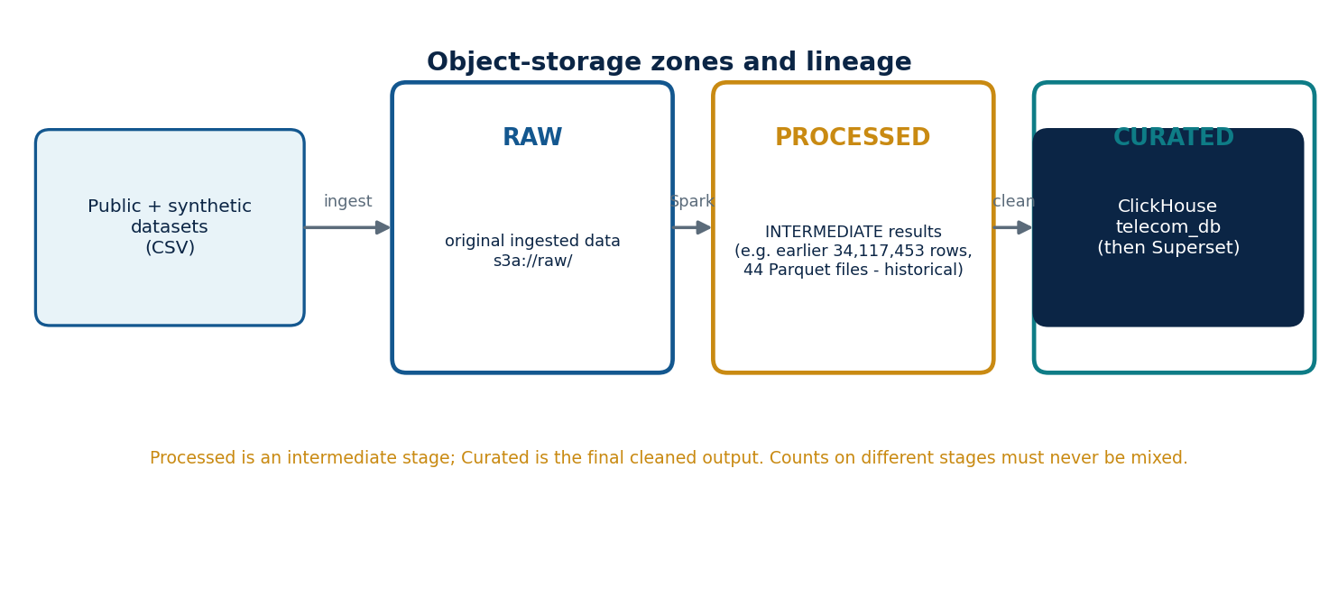
Figure 10 | Raw, Processed and Curated lineage
Table 20 | Zone-by-zone summary
Aspect | Raw | Processed | Curated
Purpose | Original ingested data, unchanged | Intermediate results of data preparation and transformation | Final cleaned datasets for downstream analytics
Inputs | Public and synthetic datasets | Raw | Processed (after final cleaning and preparation)
Format | CSV as ingested (e.g. Dataset_01_LTE_2100.csv) | Parquet | Parquet
Recorded size | Source CSV volume | Earlier run: 34,117,453 rows in 44 Parquet files (historical) | 31,904,092 rows: LTE, NR, GSM (reported)
Consumers | Spark batch jobs | Final cleaning jobs | ClickHouse, then Superset (design)
Validation | Existence, readability | Counts, files | Counts, schema, rules (Chapter 13)
Path | s3a://raw/Dataset_*.csv | s3a://processed/<technology>/ | s3a://curated/<technology>/

RECORDED PROJECT FACT Processed is an intermediate stage; Curated is the final cleaned output. The 34,117,453-row, 44-file figure belongs to an earlier intermediate Processed result and must not be compared with, or substituted for, the final Curated totals.
The decline in row count from the earlier Processed figure (34,117,453) to the Curated total (31,904,092) is 2,213,361 rows, about 6.5 percent. That difference is arithmetic only. Its cause (removed duplicates, invalid rows, different datasets or different run scope) cannot be stated without the processing logs, and the two figures may come from different runs, so the book draws no conclusion from it.
CHAPTER 12

The Distributed Spark Batch Pipeline
The batch pipeline turns the ten raw source files into Curated per-technology datasets and loads them into ClickHouse. It runs as three Spark applications in sequence: ingest and process (Raw to Processed), curate (Processed to Curated with quality accounting), and load (Curated to kpi_batch). This chapter lists the reference implementation; the project's original working scripts used the same structure, and the recorded fragment of /tmp/batch_all_10.py (imports of os, SparkSession, lit and current_timestamp) corresponds to the ingest stage below.
AS-BUILT The repository runs this pipeline as ingest_raw.py and clean_curate.py (Listings 76 and 77) with show_curated.py for profiling (Listing 83). The script names, helper modules and the third stage (load into ClickHouse) described in this chapter are the reference design; the load stage does not exist in the repository.
REFERENCE IMPLEMENTATION The listings in this book are the reference implementation shipped in the companion assets. They are written to be internally consistent and runnable against the documented endpoints and schemas. They are not the verbatim original scripts.

12.1 Pipeline overview
Figure 11 | Batch pipeline
Table 21 | Batch stages
Stage | Application name | Input | Output | Script
1 Ingest and process | TelcoPulse-Batch-10-Files | s3a://raw/Dataset_*.csv (10 files) | s3a://processed/<tech>/ (Parquet) | batch_ingest_process.py
2 Curate | TelcoPulse-Curate | s3a://processed/<tech>/ | s3a://curated/<tech>/dt=<date>/ and quality_report | batch_curate.py
3 Load | TelcoPulse-Load-kpi_batch | s3a://curated/<tech>/ | telecom_db.kpi_batch | load_clickhouse_batch.py

12.2 Shared helpers
Listing 22 | common.py: SparkSession, ClickHouse client, run identifiers
Runs in: every job (driver). Prerequisites: AWS_ACCESS_KEY_ID, AWS_SECRET_ACCESS_KEY in the environment; CH_* for ClickHouse.
"""Shared helpers for TelcoPulse Spark jobs (reference implementation)."""
import os, uuid, datetime as dt
from pyspark.sql import SparkSession

S3_ENDPOINT = os.environ.get("S3_ENDPOINT", "http://192.168.1.12:9000")
CH_CFG = dict(host=os.environ.get("CH_HOST", "192.168.1.15"),
port=int(os.environ.get("CH_PORT", "8123")),
username=os.environ.get("CH_USER", "default"),
password=os.environ.get("CH_PASSWORD", ""),
database=os.environ.get("CH_DB", "telecom_db"))

def build_spark(app_name):
"""SparkSession with S3A settings for RustFS. Keys come from the environment."""
return (SparkSession.builder.appName(app_name)
.config("spark.hadoop.fs.s3a.endpoint", S3_ENDPOINT)
.config("spark.hadoop.fs.s3a.path.style.access", "true")
.config("spark.hadoop.fs.s3a.connection.ssl.enabled", "false")
.config("spark.hadoop.fs.s3a.aws.credentials.provider",
"org.apache.hadoop.fs.s3a.SimpleAWSCredentialsProvider")
.config("spark.hadoop.fs.s3a.access.key", os.environ["AWS_ACCESS_KEY_ID"])
.config("spark.hadoop.fs.s3a.secret.key", os.environ["AWS_SECRET_ACCESS_KEY"])
.config("spark.sql.session.timeZone", "UTC")
.getOrCreate())

def ch_client():
import clickhouse_connect
return clickhouse_connect.get_client(**CH_CFG)

def new_run_id(prefix):
return f"{prefix}-{dt.datetime.utcnow():%Y%m%dT%H%M%S}-{uuid.uuid4().hex[:6]}"

build_spark applies the recorded S3A settings: endpoint http://192.168.1.12:9000, path-style access true, SSL false, and SimpleAWSCredentialsProvider with keys read from the environment. Because spark.hadoop.* settings are shipped with the job, executors receive them without needing their own environment variables. The session time zone is fixed to UTC so that timestamps are identical on every laptop.

12.3 Stage 1: Raw to Processed
Listing 23 | batch_ingest_process.py
Runs in: tp-spark-master (driver) with executors on the Workers. Output: s3a://processed/<technology>/.
"""Stage 1 - Raw -> Processed.
Discovers Dataset_*.csv in s3a://raw/, normalises headers, casts types, adds lineage
columns and writes one Parquet dataset per technology to s3a://processed/<tech>/."""
import os, re, sys
from functools import reduce
from pyspark.sql import functions as F, DataFrame
from common import build_spark, new_run_id

EXPECTED_FILES = int(os.environ.get("EXPECTED_FILES", "10"))
NAME_RE = re.compile(r"Dataset_(\d+)_([A-Za-z0-9]+)_(\d+)", re.I)

# canonical column -> (spark type, accepted source header aliases after snake_case)
CANON = {
"base_station": ("string", ["base_station", "bs", "site", "site_id", "cell", "basestation"]),
"sector": ("string", ["sector", "sector_id", "cell_sector"]),
"ts": ("timestamp", ["ts", "timestamp", "time", "datetime", "date_time"]),
"frequency_mhz": ("int", ["frequency_mhz", "frequency", "freq", "freq_mhz"]),
"radio_unit_energy_consumption": ("double", ["radio_unit_energy_consumption", "ru_energy"]),
"baseband_energy_consumption": ("double", ["baseband_energy_consumption", "bb_energy"]),
"max_active_users_dl": ("double", ["max_active_users_dl"]),
"max_active_users_ul": ("double", ["max_active_users_ul"]),
"data_volume_dl": ("double", ["data_volume_dl", "dl_volume", "volume_dl"]),
"data_volume_ul": ("double", ["data_volume_ul", "ul_volume", "volume_ul"]),
"max_rrc_users": ("double", ["max_rrc_users"]),
"rb_utilization": ("double", ["rb_utilization", "prb_utilization", "rb_util"]),
"cqi_rank_1": ("double", ["cqi_rank_1"]), "cqi_rank_2": ("double", ["cqi_rank_2"]),
"cqi_rank_3": ("double", ["cqi_rank_3"]), "cqi_rank_4": ("double", ["cqi_rank_4"]),
"rrc_users": ("double", ["rrc_users"]),
"active_users_ul": ("double", ["active_users_ul"]),
"active_users_dl": ("double", ["active_users_dl"]),
"mimo_rank_dl": ("double", ["mimo_rank_dl"]),
"ts_available": ("double", ["ts_available"]), "ts_used": ("double", ["ts_used"]),
"ts_utilization": ("double", ["ts_utilization"]),
}

def snake(name):
return re.sub(r"[^a-z0-9]+", "_", name.strip().lower()).strip("_")

def list_raw(spark):
jvm, conf = spark._jvm, spark._jsc.hadoopConfiguration()
pattern = jvm.org.apache.hadoop.fs.Path("s3a://raw/Dataset_*.csv")
fs = pattern.getFileSystem(conf)
return sorted(s.getPath().toString() for s in fs.globStatus(pattern))

def load_one(spark, path):
m = NAME_RE.search(os.path.basename(path))
tech, band = m.group(2).upper(), int(m.group(3))
df = spark.read.option("header", True).csv(path) # all strings
df = df.toDF(*[snake(c) for c in df.columns])
cols = []
for canon, (typ, aliases) in CANON.items():
src = next((a for a in aliases if a in df.columns), None)
expr = F.col(src) if src else F.lit(None)
if canon == "frequency_mhz" and not src:
expr = F.lit(band) # band from file name
cols.append(expr.cast(typ).alias(canon))
return (df.select(*cols)
.withColumn("technology", F.lit(tech))
.withColumn("source_file", F.lit(os.path.basename(path))))

def main():
spark = build_spark("TelcoPulse-Batch-10-Files")
run_id = new_run_id("proc")
files = list_raw(spark)
print(f"RUN_ID={run_id} FILES_FOUND={len(files)}")
if len(files) != EXPECTED_FILES:
sys.exit(f"Expected {EXPECTED_FILES} source files, found {len(files)}: {files}")
by_tech = {}
for p in files:
by_tech.setdefault(NAME_RE.search(os.path.basename(p)).group(2).upper(), []).append(p)
total = 0
for tech, paths in by_tech.items():
dfs = [load_one(spark, p) for p in paths]
out = (reduce(DataFrame.unionByName, dfs)
.withColumn("processed_at", F.current_timestamp())
.withColumn("run_id", F.lit(run_id)))
out.write.mode("overwrite").parquet(f"s3a://processed/{tech.lower()}/")
n = spark.read.parquet(f"s3a://processed/{tech.lower()}/").count()
total += n
print(f"PROCESSED technology={tech} files={len(paths)} rows={n}")
print(f"PROCESSED_TOTAL_ROWS={total}")
spark.stop()

if __name__ == "__main__":
main()

How it works. list_raw asks the Hadoop filesystem for the files matching Dataset_*.csv and the job stops if the number found differs from the expected ten. Each file name encodes the technology and band (Dataset_01_LTE_2100.csv is LTE, 2100); the job reads the file as text-typed CSV, converts every header to snake case, maps the source headers to the canonical column names through the alias table and casts to the canonical types. Canonical columns missing from a file become nulls, and the frequency comes from the file name when the file has no frequency column. Files of the same technology are combined with unionByName, lineage columns (source_file, technology, processed_at, run_id) are added, and the result is written as Parquet. The Processed zone therefore holds typed, normalised data that is complete but not yet cleaned.

12.4 Stage 2: Processed to Curated
Listing 24 | batch_curate.py
Runs in: tp-spark-master (driver). Output: s3a://curated/<technology>/dt=<date>/ and rows in telecom_db.quality_report.
"""Stage 2 - Processed -> Curated, with data-quality accounting.
Applies validity rules and de-duplication, writes s3a://curated/<tech>/dt=<date>/ and
records one quality_report row per technology."""
import sys
from datetime import datetime
from pyspark.sql import functions as F
from common import build_spark, ch_client, new_run_id

KPI_COLS = ["radio_unit_energy_consumption", "baseband_energy_consumption",
"max_active_users_dl", "max_active_users_ul", "data_volume_dl", "data_volume_ul",
"max_rrc_users", "rb_utilization", "cqi_rank_1", "cqi_rank_2", "cqi_rank_3",
"cqi_rank_4", "rrc_users", "active_users_ul", "active_users_dl", "mimo_rank_dl",
"ts_available", "ts_used", "ts_utilization"]
NON_NEGATIVE = [c for c in KPI_COLS if c not in ("rb_utilization", "ts_utilization")]
PCT = ["rb_utilization", "ts_utilization"]
KEY = ["base_station", "sector", "ts", "frequency_mhz"]

def rule_ok(df):
"""Boolean column: row satisfies every validity rule."""
ok = (F.col("ts").isNotNull() & F.col("base_station").isNotNull()
& (F.trim(F.col("base_station")) != "") & F.col("sector").isNotNull())
for c in PCT:
ok = ok & (F.col(c).isNull() | F.col(c).between(0, 100))
for c in NON_NEGATIVE:
ok = ok & (F.col(c).isNull() | (F.col(c) >= 0))
return ok

def main(techs):
spark = build_spark("TelcoPulse-Curate")
run_id, ch, rows = new_run_id("curate"), ch_client(), []
for tech in techs:
df = spark.read.parquet(f"s3a://processed/{tech}/").cache()
total = df.count()
missing = df.select(*[F.sum(F.col(c).isNull().cast("long")).alias(c)
for c in KPI_COLS]).first()
missing_values = int(sum(v or 0 for v in missing))
passing = df.filter(rule_ok(df))
n_pass = passing.count()
curated = passing.dropDuplicates(KEY)
curated = (curated.withColumn("has_network_metrics",
F.when(F.coalesce(F.col("rb_utilization"), F.col("data_volume_dl"),
F.col("rrc_users")).isNotNull(), 1).otherwise(0))
.withColumn("dt", F.to_date("ts")))
curated.write.mode("overwrite").partitionBy("dt").parquet(f"s3a://curated/{tech}/")
valid = spark.read.parquet(f"s3a://curated/{tech}/").count()
rows.append([run_id, datetime.utcnow(), "batch",
f"curated_{tech}", total, valid, total - valid, missing_values,
n_pass - valid, round(100.0 * valid / max(total, 1), 4)])
print(f"CURATED technology={tech.upper()} total_in={total} rows={valid}")
df.unpersist()
ch.insert("quality_report", rows, column_names=["run_id", "run_timestamp", "pipeline",
"dataset_name", "total_records", "valid_records", "invalid_records",
"missing_value_count", "duplicate_count", "validity_rate_pct"])
print("CURATED_TOTAL_ROWS=", sum(r[5] for r in rows))
spark.stop()

if __name__ == "__main__":
main(sys.argv[1:] or ["lte", "nr", "gsm"])

Table 22 | Curation rules
Rule | Definition | Effect
Required fields | ts, base_station (non-blank) and sector present | Row removed if any is missing
Percentage range | rb_utilization and ts_utilization between 0 and 100 when present | Row removed if outside
Non-negative measures | Energy, user, volume, CQI, rank and slot fields are not negative | Row removed if negative
De-duplication | One row per (base_station, sector, ts, frequency_mhz) | Extra copies removed
Derived flag | has_network_metrics = 1 when rb_utilization, data_volume_dl or rrc_users is present | Column added
Partitioning | dt = date of ts | Directory partitions

Curated is the final cleaned output. The number of rows that survive the rules and de-duplication is the valid_records figure for each technology and, summed, is the Curated total that Chapter 13 reconciles with the reported counts (LTE 18,750,012; NR 7,558,148; GSM 5,595,932; total 31,904,092).

12.5 Stage 3: Curated to ClickHouse
Listing 25 | load_clickhouse_batch.py
Runs in: tp-spark-master (driver); executors insert over HTTP to 192.168.1.15:8123.
"""Stage 3 - Curated -> ClickHouse telecom_db.kpi_batch.
Executors insert their own partitions over the ClickHouse HTTP interface."""
import sys
from pyspark.sql import functions as F
from common import build_spark, ch_client, CH_CFG

COLS = ["base_station", "sector", "ts", "source_file", "frequency_mhz",
"radio_unit_energy_consumption", "baseband_energy_consumption", "max_active_users_dl",
"max_active_users_ul", "data_volume_dl", "data_volume_ul", "max_rrc_users",
"rb_utilization", "cqi_rank_1", "cqi_rank_2", "cqi_rank_3", "cqi_rank_4", "rrc_users",
"active_users_ul", "active_users_dl", "mimo_rank_dl", "ts_available", "ts_used",
"ts_utilization", "has_network_metrics"]
CHUNK = 50000

def make_inserter(cfg):
def insert_partition(rows):
import clickhouse_connect
client = clickhouse_connect.get_client(**cfg)
buf = []
for r in rows:
buf.append(tuple(r))
if len(buf) >= CHUNK:
client.insert("kpi_batch", buf, column_names=COLS); buf = []
if buf:
client.insert("kpi_batch", buf, column_names=COLS)
return insert_partition

def main(techs, truncate):
spark = build_spark("TelcoPulse-Load-kpi_batch")
if truncate:
ch_client().command("TRUNCATE TABLE kpi_batch")
for tech in techs:
df = (spark.read.parquet(f"s3a://curated/{tech}/")
.select(*COLS).repartition(24))
df.foreachPartition(make_inserter(CH_CFG))
print(f"LOADED technology={tech.upper()}")
n = ch_client().query("SELECT count() FROM kpi_batch").first_row[0]
print("KPI_BATCH_ROWS=", n)
spark.stop()

if __name__ == "__main__":
args = [a for a in sys.argv[1:] if not a.startswith("--")]
main(args or ["lte", "nr", "gsm"], "--truncate" in sys.argv)

Each executor connects directly to ClickHouse and inserts its own partition in chunks of 50,000 rows, so the load scales with the number of executors instead of funnelling through the driver. --truncate empties kpi_batch before a full reload, which makes the stage safely repeatable. The Curated schema already matches kpi_batch column for column, with the Curated-only columns (technology, processed_at, run_id, dt) dropped by the explicit column list.

12.6 Running the pipeline
Listing 26 | Run the batch pipeline (Linux shell inside tp-spark-master)
Environment: first line in Windows PowerShell; the others inside the container.
docker exec -it tp-spark-master bash
export EXPECTED_FILES=10
/opt/telcopulse/scripts/submit_batch.sh 2>&1 | tee /opt/telcopulse/logs/batch_$(date +%Y%m%dT%H%M%S).log

The Master Compose file mounts jobs/ and scripts/ into the container. The script prints the lines FILES_FOUND, PROCESSED technology=..., PROCESSED_TOTAL_ROWS, CURATED technology=... and CURATED_TOTAL_ROWS, which are the evidence used for validation.

12.7 Distributed execution behaviour
Spark splits each CSV into partitions of about one HDFS-style block, and each partition becomes a task. Tasks run in parallel across the cores granted to the application; each task writes its own Parquet part file, so a logical dataset is a directory of many files (the historical Processed result consisted of 44 Parquet files). Shuffles, such as dropDuplicates in the curate stage, move rows between laptops over the LAN, which is where network quality affects batch time. cache() keeps the Processed technology dataset in executor memory between the several passes of the quality accounting; if executors run short of memory, Spark spills to disk instead of failing.

12.8 Error handling
Table 23 | Failure handling in the jobs
Condition | Behaviour
Wrong number of source files | Ingest exits with a clear message listing the files found
File name not matching the convention | Job fails at name parsing; fix the name and re-run
S3 endpoint or credentials wrong | Spark raises an S3A error at the first read; no partial output is promoted
Header variant not in the alias table | Column is loaded as null; the null count appears in missing_value_count
Re-run after partial failure | Writes use overwrite per technology; the loader supports --truncate

CHAPTER 13

Parquet Output and Curated Validation

13.1 Recorded results
Table 24 | Curated outputs (recorded results)
Technology | Rows | Share of total
LTE | 18,750,012 | 58.8%
NR | 7,558,148 | 23.7%
GSM | 5,595,932 | 17.5%
Total | 31,904,092 | 100%

Arithmetic check: 18,750,012 + 7,558,148 = 26,308,160, and 26,308,160 + 5,595,932 = 31,904,092, approximately 31.9 million rows. The shares are computed from these counts.
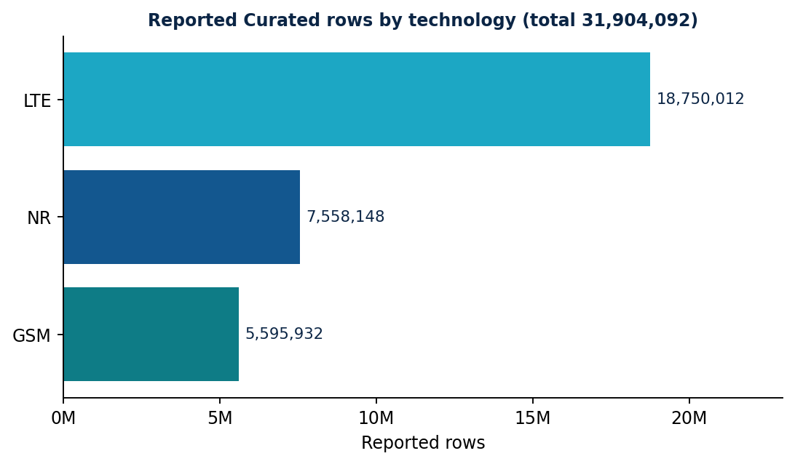
Figure 12 | Recorded Curated rows by technology
Bar chart drawn from the recorded counts.
Table 25 | Processed and Curated are different stages
Stage | Figure | Meaning
Processed (historical result) | 34,117,453 rows in 44 Parquet files | Intermediate result before final cleaning
Curated (latest result) | 31,904,092 rows (LTE, NR, GSM) | Final cleaned output used downstream
Difference | 2,213,361 rows (about 6.5% of Processed) | Arithmetic only; the per-rule breakdown is what quality_report records

The two figures describe different pipeline stages and must not be interchanged. In the reference pipeline the reduction between the stages is produced by the validity rules and de-duplication of Chapter 12, and the quality job records how many rows each rule class removed in quality_report.

13.2 Validation layers
Table 26 | Validation layers
Layer | Question | Method
File existence | Did the job write objects? | List s3a://curated/<tech>/ and count part files
Parquet readability | Can Spark read them? | spark.read.parquet(path)
Schema correctness | Right columns and types? | printSchema() against the kpi_batch columns
Row count | Do counts match the recorded results? | Per-technology count() and sum
Business rules | Do values obey the rules? | Re-apply the Chapter 12 rules; the violation count must be zero
Data quality | How many rows were removed and why? | quality_report rows for the run
Warehouse consistency | Does ClickHouse hold what Curated holds? | count() of kpi_batch_v by technology

A successful write proves only the first layer. Each later layer answers a different question, and all of them are run by the verification script below.
Listing 27 | verify_curated.py: read-back validation
Runs in: tp-spark-master via spark-submit. A run is accepted when match=True for each technology, violations and duplicates are 0, and ClickHouse counts equal the Curated counts.
from pyspark.sql import functions as F
from common import build_spark, ch_client
from batch_curate import rule_ok, KEY

RECORDED = {"lte": 18750012, "nr": 7558148, "gsm": 5595932} # recorded results
spark, total = build_spark("TelcoPulse-Verify-Curated"), 0
for tech, expected in RECORDED.items():
df = spark.read.parquet(f"s3a://curated/{tech}/") # readability
n = df.count(); total += n # row count
bad = df.filter(~rule_ok(df)).count() # business rules
dups = n - df.dropDuplicates(KEY).count() # duplicates
print(f"{tech.upper()} rows={n} recorded={expected} match={n == expected}"
f" rule_violations={bad} duplicates={dups} columns={len(df.columns)}")
print("TOTAL", total, "recorded", sum(RECORDED.values()))
rows = ch_client().query("SELECT technology, count() FROM kpi_batch_v GROUP BY technology")
print("CLICKHOUSE", rows.result_rows)
spark.stop()

The script compares a fresh run against the recorded results; a different count is not an error in itself but a signal that the inputs or rules changed, and it must be explained and recorded before the recorded figures are updated.

13.3 Interpreting the counts
A row count confirms volume. Matching it confirms completeness of the files; it does not confirm units or the absence of LTE rows inside the NR dataset. The business-rule layer and the technology derivation in kpi_batch_v cover those risks, and the quality report adds the accounting of what was removed.
CHAPTER 14

Data Lineage and Data Quality

14.1 Lineage
Lineage answers where a number came from. Every Processed row carries source_file, technology, processed_at and run_id; source_file survives into kpi_batch, so any ClickHouse row can be traced to its CSV. The zone-level lineage is shown in Chapter 11. The quality run identifier (run_id in quality_report) links a quality row to the batch run that produced it.

14.2 The quality_report model
Table 27 | quality_report columns
Column | Type | Meaning
run_id | String | Identifier of the quality run (for example curate-20261022T101500-ab12cd)
run_timestamp | DateTime | When the run completed
pipeline | LowCardinality(String) | batch or stream
dataset_name | LowCardinality(String) | curated_lte, curated_nr, curated_gsm, kpi_stream
total_records | UInt64 | Rows examined (Processed input for batch)
valid_records | UInt64 | Rows passing all rules after de-duplication (Curated rows)
invalid_records | UInt64 | total_records - valid_records (rule failures plus removed duplicates)
missing_value_count | UInt64 | Null KPI values in the input (values, not rows)
duplicate_count | UInt64 | Rows that passed the rules but were duplicates of another row
validity_rate_pct | Float32 | 100 x valid_records / total_records

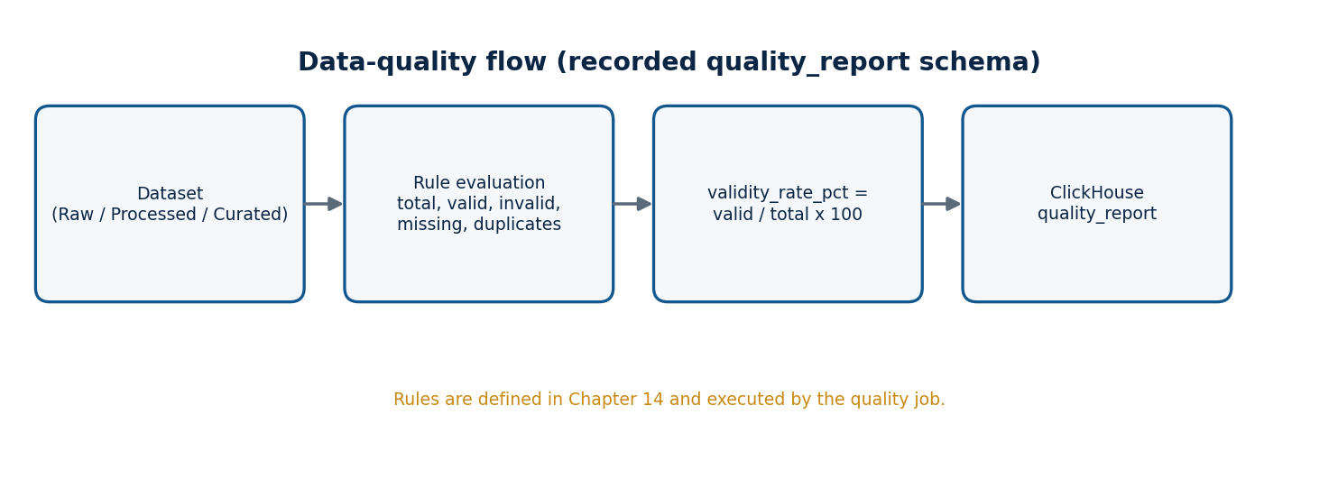
Figure 13 | Data-quality flow

14.3 Batch quality accounting
The curate job computes the metrics in one pass over the Processed dataset and inserts one row per technology. missing_value_count counts null KPI values across 19 KPI columns, so one row with three missing values adds three; invalid_records counts rows. The two are therefore not comparable, and duplicate_count is reported separately so that an analyst can tell removed duplicates from rule failures.

14.4 Stream quality
Listing 28 | Stream quality report (ClickHouse SQL)
Environment: clickhouse-client or SQL Lab; run_id is supplied as a query parameter. Schedule it hourly from any laptop.
-- Stream quality report for the last 24 hours. Parameter: run_id.
INSERT INTO telecom_db.quality_report
SELECT {run_id:String}, now(), 'stream', 'kpi_stream',
total, total - invalid_rows, invalid_rows, 0, total - uniq,
toFloat32(100 * (total - invalid_rows) / greatest(total, 1))
FROM
(
SELECT count() AS total,
countIf(rb_utilization < 0 OR rb_utilization > 100 OR active_users_dl < 0
OR data_volume_dl < 0 OR isNaN(rb_utilization)) AS invalid_rows,
uniqExact(window_start, base_station, sector) AS uniq
FROM telecom_db.kpi_stream
WHERE window_start >= now() - INTERVAL 24 HOUR
);

The stream check applies range rules (utilisation between 0 and 100, non-negative users and volume, no NaN) and counts duplicate windows by comparing count() with uniqExact over the window key. Stream columns are not nullable, so missing_value_count is 0 for the stream by construction.

14.5 Reading quality results
Listing 29 | Latest quality per dataset (ClickHouse SQL)
Environment: Superset SQL Lab.
SELECT dataset_name, argMax(validity_rate_pct, run_timestamp) AS validity_pct,
argMax(invalid_records, run_timestamp) AS invalid,
argMax(duplicate_count, run_timestamp) AS duplicates
FROM telecom_db.quality_report GROUP BY dataset_name ORDER BY dataset_name;

Quality gates for operations: a batch run is accepted when validity is at or above the agreed threshold for each technology and valid_records equals the Curated count; the threshold is a deployment parameter (the project uses the recorded Curated totals as the acceptance reference).
PART IV
Streaming and Analytical Storage
Kafka, Spark Structured Streaming, ClickHouse and anomaly detection.
CHAPTER 15

Kafka and Event Generation

15.1 Role of Kafka
AS-BUILT The repository broker advertises 192.168.1.13:9092 (EXTERNAL listener) and the topic is telecom_stream. The generator emits an event every 0.10 s, uses a 300 s window constant and simulates four sites (Site 36, 42, 88, 101). Examples below that show 192.168.1.12 or telco.events belong to the design chapters; substitute the as-built values (Listings 72, 79 and 80).
Apache Kafka is a distributed log. Producers append records to topics; a topic is divided into partitions, each an ordered, durable sequence; consumers read at their own pace and track their position as an offset. In TelcoPulse Kafka decouples the synthetic event generator from Spark: the generator can emit at one rate while Structured Streaming consumes at another, and a short Spark restart does not lose events because Kafka retains them (72 hours in the reference configuration).
Figure 14 | Streaming pipeline
The streaming source is a synthetic event generator.

15.2 Deployment and topic
Table 28 | Kafka configuration
Item | Value
Broker endpoint | 192.168.1.12:9092 (recorded)
Mode | Single-node KRaft (broker and controller)
Advertised listener | PLAINTEXT://192.168.1.12:9092
Topic | telco.events
Partitions / replication factor | 3 / 1 (single-broker lab; no fault tolerance)
Key | base_station (keeps one station's events ordered within a partition)
Value | UTF-8 JSON
Retention | 72 hours

A client first contacts the bootstrap address, then receives broker metadata containing the advertised listener and connects there. Because the advertised address is the LAN address, producers and Spark executors on other laptops connect successfully; an advertised container-internal name would make the port look open but fail afterwards.

15.3 Event structure
Table 29 | Event fields (JSON)
Field | Type | Meaning
event_time | string (ISO 8601, UTC) | Time the event describes (event time)
base_station, sector | string, int | Cell identity
technology, frequency_band | string, int | LTE, NR or GSM; carrier band
rb_utilization | double | Resource-block utilisation, 0 to 100
active_users_dl | double | Active downlink users
data_volume_dl, data_volume_ul | double | Interval traffic of the event (synthetic units); additive by design
radio_quality_cqi | double | Radio quality indicator
radio_unit_energy, baseband_energy | double | Energy readings (synthetic units)
scenario_id | string | baseline, or inject-<id> during an injected anomaly
generation_version | string | Generator version (gen-1.0)

Stream volumes are interval increments by generator design, so summing them inside a window is valid. Batch data volumes must be checked against the source definition before summing (Chapter 9).

15.4 The event generator
Listing 30 | event_generator.py
Runs in: a Python container (or any Python 3.11 environment with confluent-kafka) on a worker or support laptop.
"""Synthetic telecom event generator -> Kafka topic (JSON, keyed by base_station).
All events are synthetic. Anomaly scenarios are injected with a labelled scenario_id."""
import argparse, json, math, random, time, uuid, datetime as dt
from confluent_kafka import Producer

VERSION = "gen-1.0"
TECH_BANDS = {"LTE": [800, 1800, 2100], "NR": [3500], "GSM": [900]}
KPI_PROFILE = { # baseline mean, sd (synthetic units)
"rb_utilization": (45, 8), "active_users_dl": (60, 12), "data_volume_dl": (120, 25),
"data_volume_ul": (30, 7), "radio_quality_cqi": (9, 1.2),
"radio_unit_energy": (210, 12), "baseband_energy": (95, 6)}

def build_cells(n):
techs, cells = list(TECH_BANDS), []
for i in range(1, n + 1):
t = techs[i % len(techs)]
for sector in (1, 2, 3):
cells.append(dict(bs=f"BS-{i:03d}", sector=sector, tech=t,
band=random.choice(TECH_BANDS[t])))
return cells

def diurnal(now): # smooth daily load pattern, 0.7 .. 1.3
h = now.hour + now.minute / 60
return 1.0 + 0.3 * math.sin((h - 9) / 24 * 2 * math.pi)

def make_event(cell, now, scenario, spike):
ev = {"event_time": now.strftime("%Y-%m-%dT%H:%M:%S.%f")[:-3] + "Z",
"base_station": cell["bs"], "sector": cell["sector"],
"technology": cell["tech"], "frequency_band": cell["band"],
"scenario_id": scenario, "generation_version": VERSION}
d = diurnal(now)
for k, (mu, sd) in KPI_PROFILE.items():
v = random.gauss(mu * (d if k in ("active_users_dl", "data_volume_dl",
"data_volume_ul", "rb_utilization") else 1), sd)
if spike and k == spike["kpi"]:
v *= spike["factor"]
ev[k] = round(max(v, 0.0), 3)
ev["rb_utilization"] = min(ev["rb_utilization"], 100.0)
return ev

def main():
ap = argparse.ArgumentParser()
ap.add_argument("--bootstrap", default="192.168.1.12:9092")
ap.add_argument("--topic", default="telco.events")
ap.add_argument("--stations", type=int, default=20)
ap.add_argument("--rate", type=float, default=50, help="events per second")
ap.add_argument("--duration", type=int, default=0, help="seconds, 0 = forever")
ap.add_argument("--anomaly-prob", type=float, default=0.002,
help="chance per second of starting an injected spike")
ap.add_argument("--seed", type=int, default=42)
a = ap.parse_args()
random.seed(a.seed)
p = Producer({"bootstrap.servers": a.bootstrap, "linger.ms": 50,
"compression.type": "lz4", "acks": "1"})
cells, spikes, start, sent = build_cells(a.stations), {}, time.time(), 0
while a.duration == 0 or time.time() - start < a.duration:
tick = time.time()
now = dt.datetime.utcnow()
if random.random() < a.anomaly_prob * 1.0:
c = random.choice(cells)
spikes[(c["bs"], c["sector"])] = dict(
kpi=random.choice(["rb_utilization", "active_users_dl", "data_volume_dl"]),
factor=random.uniform(2.0, 3.5), left=random.randint(30, 90),
sid=f"inject-{uuid.uuid4().hex[:6]}")
for _ in range(max(1, int(a.rate))):
c = random.choice(cells)
sp = spikes.get((c["bs"], c["sector"]))
ev = make_event(c, now, sp["sid"] if sp else "baseline", sp)
p.produce(a.topic, key=c["bs"], value=json.dumps(ev))
sent += 1
for k in list(spikes):
spikes[k]["left"] -= 1
if spikes[k]["left"] <= 0:
del spikes[k]
p.poll(0)
time.sleep(max(0, 1.0 - (time.time() - tick)))
p.flush()
print("EVENTS_SENT=", sent)

if __name__ == "__main__":
main()

The generator builds a population of cells (stations with three sectors each, technologies assigned round-robin, bands per technology) and emits --rate events per second at random cells. Baseline KPIs are Gaussian around profile means, and traffic-related KPIs follow a smooth daily pattern. With probability --anomaly-prob per second it starts a spike scenario on one cell: for 30 to 90 seconds one KPI is multiplied by a factor between 2.0 and 3.5 and the affected events carry a unique scenario_id beginning with inject-. A fixed --seed makes runs reproducible.
Listing 31 | Generator image
File: docker/generator/Dockerfile
FROM python:3.11-slim
RUN pip install --no-cache-dir confluent-kafka
COPY event_generator.py /app/event_generator.py
ENTRYPOINT ["python", "/app/event_generator.py"]

Listing 32 | Run the generator (Windows PowerShell)
File: scripts/run_generator.ps1
# Windows PowerShell on the generator laptop
docker build -t telcopulse-generator docker/generator
docker run --rm telcopulse-generator --bootstrap 192.168.1.12:9092 --topic telco.events --rate 50

15.5 Connectivity checks
Listing 33 | Kafka checks
Environments are marked in the comments; the last two commands run inside the Kafka container.
# Windows PowerShell: broker port reachable from the generator or Spark laptop
Test-NetConnection -ComputerName 192.168.1.12 -Port 9092

# Container shell inside tp-kafka: topic exists and receives events
/opt/kafka/bin/kafka-topics.sh --bootstrap-server 192.168.1.12:9092 --describe --topic telco.events
/opt/kafka/bin/kafka-console-consumer.sh --bootstrap-server 192.168.1.12:9092 \
--topic telco.events --from-beginning --max-messages 5

15.6 The early file-based test
DESIGN HISTORY An early test used a sample file /data/input/telecom_events.csv and an output path /data/output/event_counts, with expected counts of data 4, call 4 and sms 2. It validated the read-aggregate-write pattern before Kafka was added and is unrelated to the final workload.
CHAPTER 16

Spark Structured Streaming

16.1 Concepts applied
AS-BUILT In the repository the stream is processed by stream_processor.py, a Python consumer that applies four anomaly rules and writes to ClickHouse over HTTP (Listing 80). The Spark Structured Streaming job in this chapter is the reference design and a documented upgrade path; it is not what ran in the lab.
Structured Streaming treats a stream as an unbounded table and runs a query as a series of micro-batches. TelcoPulse uses an event-time window of one minute: events are grouped by the time they describe (event_time), not by when they arrive. A watermark of 30 seconds tells Spark how long to wait for late events before a window is considered complete. The output mode is append, so each window is emitted once, after the watermark passes its end; this avoids repeated partial rows for the same window in ClickHouse. A checkpoint on S3A storage stores offsets and state so the query resumes after a restart.

16.2 The streaming job
Listing 34 | stream_kpi.py
Runs in: tp-spark-master (driver). Submitted with scripts/submit_stream.sh.
"""Kafka -> Spark Structured Streaming -> ClickHouse kpi_stream (+ anomalies).
1-minute event-time windows, 30 s watermark, append mode (each window emitted once)."""
import os, datetime as dt
from pyspark.sql import functions as F
from pyspark.sql.types import StructType, StructField, StringType, DoubleType, IntegerType
from common import build_spark, ch_client
import anomaly_common as ac

BOOTSTRAP = os.environ.get("KAFKA_BOOTSTRAP", "192.168.1.12:9092")
TOPIC = os.environ.get("KAFKA_TOPIC", "telco.events")
CHECKPOINT = os.environ.get("CHECKPOINT", "s3a://processed/_checkpoints/stream_kpi")

SCHEMA = StructType([
StructField("event_time", StringType()), StructField("base_station", StringType()),
StructField("sector", IntegerType()), StructField("technology", StringType()),
StructField("frequency_band", IntegerType()), StructField("scenario_id", StringType()),
StructField("generation_version", StringType()),
*[StructField(k, DoubleType()) for k in ("rb_utilization", "active_users_dl",
"data_volume_dl", "data_volume_ul", "radio_quality_cqi", "radio_unit_energy",
"baseband_energy")]])

def write_batch(df, batch_id):
pdf = df.toPandas()
if pdf.empty:
return
ch = ch_client()
anomalies = ac.detect(pdf, ch) # baseline excludes the current batch
pdf["ingested_at"] = dt.datetime.utcnow()
pdf["data_source"], pdf["is_synthetic"] = "synthetic-generator", 1
cols = [r[0] for r in ch.query("DESCRIBE TABLE kpi_stream").result_rows]
ch.insert_df("kpi_stream", pdf[cols])
if not anomalies.empty:
ch.insert_df("anomalies", anomalies)
print(f"batch={batch_id} windows={len(pdf)} anomalies={len(anomalies)}")

def main():
spark = build_spark("TelcoPulse-Stream-KPI")
raw = (spark.readStream.format("kafka")
.option("kafka.bootstrap.servers", BOOTSTRAP).option("subscribe", TOPIC)
.option("startingOffsets", "latest").option("failOnDataLoss", "false").load())
ev = (raw.select(F.from_json(F.col("value").cast("string"), SCHEMA).alias("e")).select("e.*")
.withColumn("ts", F.to_timestamp("event_time")).dropna(subset=["ts", "base_station"]))
agg = (ev.withWatermark("ts", "30 seconds")
.groupBy(F.window("ts", "1 minute"), "base_station", "sector", "technology",
"frequency_band")
.agg(F.sum("data_volume_dl").alias("data_volume_dl"),
F.sum("data_volume_ul").alias("data_volume_ul"),
F.avg("rb_utilization").alias("rb_utilization"),
F.avg("radio_quality_cqi").alias("radio_quality_cqi"),
F.avg("active_users_dl").alias("active_users_dl"),
F.avg("radio_unit_energy").alias("radio_unit_energy"),
F.avg("baseband_energy").alias("baseband_energy"),
F.max("scenario_id").alias("scenario_id"), # 'inject-*' > 'baseline'
F.max("generation_version").alias("generation_version"))
.select(F.col("window.start").alias("window_start"), F.col("window.end").alias("window_end"),
"base_station", "sector", "technology", "frequency_band", "data_volume_dl",
"data_volume_ul", "rb_utilization", "radio_quality_cqi", "active_users_dl",
"radio_unit_energy", "baseband_energy", "scenario_id", "generation_version"))
q = (agg.writeStream.outputMode("append").foreachBatch(write_batch)
.option("checkpointLocation", CHECKPOINT)
.trigger(processingTime="15 seconds").start())
q.awaitTermination()

if __name__ == "__main__":
main()

Table 30 | Streaming job behaviour
Step | Implementation
Source | Kafka topic telco.events from 192.168.1.12:9092, startingOffsets latest
Parse | from_json with an explicit schema; timestamp cast from event_time; rows without time or station dropped
Window | 1-minute tumbling windows per base_station, sector, technology, frequency_band
Aggregates | sum of volumes; average of utilisation, CQI, users and energy
Scenario | max(scenario_id): inject-* sorts after baseline, so a window containing injected events is labelled injected
Trigger | Every 15 seconds
Sink | foreachBatch: detect anomalies, insert into kpi_stream, insert anomalies
Checkpoint | s3a://processed/_checkpoints/stream_kpi (configurable)

Detection runs before the batch is inserted so that the baseline is built only from previous windows and never contains the window being tested.

16.3 Timing and latency
A window is emitted when the watermark passes its end, so the delay from an event to its row in ClickHouse is the window length plus the watermark plus the trigger interval at most (about 1 minute 45 seconds in this configuration), plus the time to process and insert the micro-batch. This is near-real-time behaviour. The measured delay of a run is recorded in benchmark_runs.streaming_delay_ms; the per-window ingestion lag can be read at any time from ingested_at - window_end in kpi_stream.

16.4 Delivery semantics and recovery
The query is checkpointed and reads from Kafka offsets, so after a restart it resumes from the last committed offsets. The sink inserts into ClickHouse inside foreachBatch, which Spark may replay for an uncommitted micro-batch, so delivery to ClickHouse is at least once: after a failure between the insert and the offset commit a window can be written twice. The project makes no exactly-once claim. For dashboards this is handled by reading with argMax per window key or by de-duplicating in the dataset SQL when a recovery event has occurred.

16.5 Operating the job
Listing 35 | Start and stop the streaming path
The three steps run in three different environments, as labelled.
# 1. Linux shell inside tp-spark-master: start the streaming job (long running)
/opt/telcopulse/scripts/submit_stream.sh
# 2. Windows PowerShell on the generator laptop: start events
docker run --rm telcopulse-generator --bootstrap 192.168.1.12:9092 --rate 50
# 3. ClickHouse (SQL): confirm windows are arriving
SELECT max(window_end), count() FROM telecom_db.kpi_stream WHERE window_start > now() - INTERVAL 10 MINUTE;

CHAPTER 17

ClickHouse Analytical Storage and Schemas

17.1 Role and deployment
AS-BUILT The repository DDL (Listing 75) keeps kpi_batch at 25 columns but defines kpi_stream with 15 columns, anomalies with 10, quality_report with 7 and benchmark_runs with 7. The stream processor posts fields that the DDL does not define (Section 32.17), and nothing loads kpi_batch, quality_report or benchmark_runs automatically. Follow Listing 75 for table shapes and expect to align the code or the DDL.
ClickHouse is a column-oriented database built for fast aggregate queries. Each column is stored and compressed separately, so a query that touches three of 25 columns reads only those three. It is the single analytical store behind Superset. The HTTP endpoint is 192.168.1.15:8123 and the database is telecom_db.
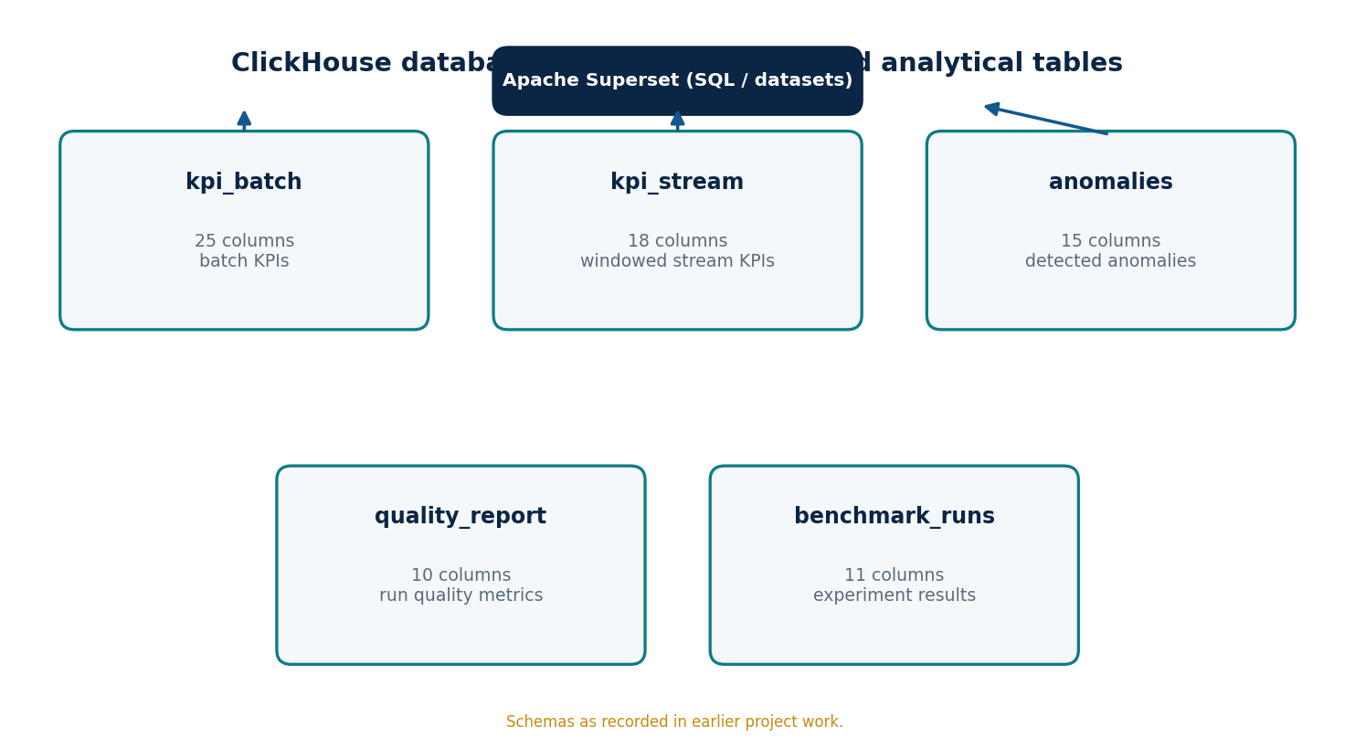
Figure 15 | ClickHouse analytical model

17.2 The five recorded tables
The schemas below are the recorded column lists and types. The DDL in Listing below adds the reference engine, partitioning, ordering key and (for the stream) a 30-day TTL. These choices suit the access patterns of the dashboards: time-range filters first, then technology and station.
Table 31 | Tables of telecom_db
Table | Columns | Fed by | Used by
kpi_batch | 25 | load_clickhouse_batch.py | RAN Performance, Executive Overview
kpi_stream | 18 | stream_kpi.py | Streaming Monitor, anomaly detection
anomalies | 15 | stream_kpi.py, 03_anomaly_batch.sql | Anomaly Detection
quality_report | 10 | batch_curate.py, 04_quality_stream.sql | Data Quality, Executive Overview
benchmark_runs | 11 | benchmark_runner.py | Platform Benchmarking

Listing 36 | Create the five tables
Environment: clickhouse-client or SQL Lab (runs automatically on first start through docker-entrypoint-initdb.d).
-- TelcoPulse ClickHouse DDL. Column names and types follow the recorded schemas.
-- Engines, ordering keys, partitioning and TTL are the reference design.
CREATE DATABASE IF NOT EXISTS telecom_db;

CREATE TABLE IF NOT EXISTS telecom_db.kpi_batch
(
base_station LowCardinality(String),
sector String,
ts DateTime,
source_file String,
frequency_mhz Int32,
radio_unit_energy_consumption Nullable(Float64),
baseband_energy_consumption Nullable(Float64),
max_active_users_dl Nullable(Float64),
max_active_users_ul Nullable(Float64),
data_volume_dl Nullable(Float64),
data_volume_ul Nullable(Float64),
max_rrc_users Nullable(Float64),
rb_utilization Nullable(Float64),
cqi_rank_1 Nullable(Float64),
cqi_rank_2 Nullable(Float64),
cqi_rank_3 Nullable(Float64),
cqi_rank_4 Nullable(Float64),
rrc_users Nullable(Float64),
active_users_ul Nullable(Float64),
active_users_dl Nullable(Float64),
mimo_rank_dl Nullable(Float64),
ts_available Nullable(Float64),
ts_used Nullable(Float64),
ts_utilization Nullable(Float64),
has_network_metrics UInt8
)
ENGINE = MergeTree
PARTITION BY toYYYYMM(ts)
ORDER BY (base_station, sector, ts);

CREATE TABLE IF NOT EXISTS telecom_db.kpi_stream
(
window_start DateTime,
window_end DateTime,
ingested_at DateTime,
base_station LowCardinality(String),
sector UInt8,
technology LowCardinality(String),
frequency_band UInt16,
data_volume_dl Float32,
data_volume_ul Float32,
rb_utilization Float32,
radio_quality_cqi Float32,
active_users_dl Float32,
radio_unit_energy Float32,
baseband_energy Float32,
data_source LowCardinality(String),
is_synthetic UInt8,
scenario_id LowCardinality(String),
generation_version LowCardinality(String)
)
ENGINE = MergeTree
PARTITION BY toDate(window_start)
ORDER BY (technology, base_station, sector, window_start)
TTL window_start + INTERVAL 30 DAY;

CREATE TABLE IF NOT EXISTS telecom_db.anomalies
(
detected_at DateTime,
event_timestamp DateTime,
pipeline LowCardinality(String),
base_station LowCardinality(String),
sector UInt8,
technology LowCardinality(String),
kpi_name LowCardinality(String),
observed_value Float32,
expected_mean Float32,
detection_method LowCardinality(String),
anomaly_score Float32,
severity LowCardinality(String),
is_synthetic UInt8,
injected_label UInt8,
scenario_id LowCardinality(String)
)
ENGINE = MergeTree
PARTITION BY toYYYYMM(detected_at)
ORDER BY (detected_at, technology, kpi_name);

CREATE TABLE IF NOT EXISTS telecom_db.benchmark_runs
(
experiment_id LowCardinality(String),
run_timestamp DateTime,
workload_size_gb Float32,
num_spark_workers UInt8,
network_mode LowCardinality(String),
runtime_seconds Float32,
throughput_rows_per_sec Float32,
streaming_delay_ms Float32,
cpu_usage_pct Float32,
ram_usage_mb Float32,
notes String
)
ENGINE = MergeTree
ORDER BY (experiment_id, run_timestamp);

CREATE TABLE IF NOT EXISTS telecom_db.quality_report
(
run_id String,
run_timestamp DateTime,
pipeline LowCardinality(String),
dataset_name LowCardinality(String),
total_records UInt64,
valid_records UInt64,
invalid_records UInt64,
missing_value_count UInt64,
duplicate_count UInt64,
validity_rate_pct Float32
)
ENGINE = MergeTree
ORDER BY (pipeline, dataset_name, run_timestamp);

Table 32 | kpi_batch columns
Column | Type
base_station | LowCardinality(String)
sector | String
ts | DateTime
source_file | String
frequency_mhz | Int32
radio_unit_energy_consumption, baseband_energy_consumption | Nullable(Float64)
max_active_users_dl, max_active_users_ul | Nullable(Float64)
data_volume_dl, data_volume_ul | Nullable(Float64)
max_rrc_users, rb_utilization | Nullable(Float64)
cqi_rank_1 .. cqi_rank_4 | Nullable(Float64)
rrc_users, active_users_ul, active_users_dl, mimo_rank_dl | Nullable(Float64)
ts_available, ts_used, ts_utilization | Nullable(Float64)
has_network_metrics | UInt8

Table 33 | kpi_stream columns
Column | Type
window_start, window_end, ingested_at | DateTime
base_station | LowCardinality(String)
sector | UInt8
technology | LowCardinality(String)
frequency_band | UInt16
data_volume_dl, data_volume_ul, rb_utilization, radio_quality_cqi, active_users_dl, radio_unit_energy, baseband_energy | Float32
data_source, scenario_id, generation_version | LowCardinality(String)
is_synthetic | UInt8

Table 34 | anomalies columns
Column | Type
detected_at, event_timestamp | DateTime
pipeline, technology, kpi_name, detection_method, severity, scenario_id | LowCardinality(String)
base_station | LowCardinality(String)
sector | UInt8
observed_value, expected_mean, anomaly_score | Float32
is_synthetic, injected_label | UInt8

Table 35 | benchmark_runs columns
Column | Type
experiment_id, network_mode | LowCardinality(String)
run_timestamp | DateTime
workload_size_gb, runtime_seconds, throughput_rows_per_sec, streaming_delay_ms, cpu_usage_pct, ram_usage_mb | Float32
num_spark_workers | UInt8
notes | String

The quality_report columns are in Chapter 14.

17.3 Compatibility assumptions
- kpi_batch has no `technology` column (recorded schema). Technology is carried by the source file name (Dataset_NN_<TECH>_<band>.csv) and exposed through the view kpi_batch_v; the schema itself is unchanged.
- kpi_batch.sector is a String and kpi_stream.sector is UInt8. Comparisons use the view kpi_stream_v; batch anomalies convert with toUInt8OrZero, so a non-numeric sector identifier maps to 0.
- kpi_batch uses Float64 and nullable measures; kpi_stream uses Float32 and non-nullable ones. Averages across the two are compared as Float64.
- Time: ts in the batch is an instant at the source granularity (15 minutes); the stream stores a window (window_start, window_end) and the ingestion time.

Listing 37 | Support objects: pipeline_inventory, kpi_batch_v, kpi_stream_v
Environment: clickhouse-client or SQL Lab.
-- Support objects added to the five recorded tables.

-- Stage ledger: records the reported row counts of each pipeline stage.
CREATE TABLE IF NOT EXISTS telecom_db.pipeline_inventory
(
stage LowCardinality(String), -- Processed | Curated
technology LowCardinality(String), -- LTE | NR | GSM | ALL
row_count UInt64,
file_count Nullable(UInt32),
source LowCardinality(String), -- reported | measured
recorded_at DateTime DEFAULT now()
)
ENGINE = MergeTree ORDER BY (stage, technology, recorded_at);

INSERT INTO telecom_db.pipeline_inventory (stage, technology, row_count, file_count, source) VALUES
('Curated','LTE',18750012,NULL,'reported'),
('Curated','NR',7558148,NULL,'reported'),
('Curated','GSM',5595932,NULL,'reported'),
('Curated','ALL',31904092,NULL,'reported'),
('Processed','ALL',34117453,44,'reported');

-- kpi_batch has no technology column; the file-name convention
-- Dataset_NN_<TECH>_<band>.csv carries it, so technology is derived in a view.
CREATE VIEW IF NOT EXISTS telecom_db.kpi_batch_v AS
SELECT *,
multiIf(positionCaseInsensitive(source_file,'_LTE_')>0,'LTE',
positionCaseInsensitive(source_file,'_NR_')>0,'NR',
positionCaseInsensitive(source_file,'_GSM_')>0,'GSM','UNKNOWN') AS technology
FROM telecom_db.kpi_batch;

-- Stream-to-batch comparable view (sector cast to String, Float32 widened)
CREATE VIEW IF NOT EXISTS telecom_db.kpi_stream_v AS
SELECT window_start, base_station, toString(sector) AS sector, technology,
toFloat64(rb_utilization) AS rb_utilization,
toFloat64(active_users_dl) AS active_users_dl,
toFloat64(data_volume_dl) AS data_volume_dl,
scenario_id, ingested_at, window_end
FROM telecom_db.kpi_stream;

pipeline_inventory is the one table added to the five recorded ones. It stores the recorded stage counts (Curated LTE, NR, GSM and total, and the historical Processed result) so that the Executive Overview can display them next to measured counts without hard-coding numbers in charts.

17.4 Query patterns
Listing 38 | Representative analytical queries (ClickHouse SQL)
Environment: Superset SQL Lab.
-- Average resource-block utilisation per technology and hour (batch)
SELECT technology, toStartOfHour(ts) AS hour, avg(rb_utilization) AS avg_rb
FROM telecom_db.kpi_batch_v GROUP BY technology, hour ORDER BY hour;

-- Ingestion lag per window (stream), seconds
SELECT window_end, dateDiff('second', window_end, ingested_at) AS lag_s
FROM telecom_db.kpi_stream ORDER BY window_end DESC LIMIT 20;

-- Row counts per technology: measured (kpi_batch_v) versus recorded (pipeline_inventory)
SELECT m.technology, m.rows AS loaded, i.row_count AS recorded
FROM (SELECT technology, count() AS rows FROM telecom_db.kpi_batch_v GROUP BY technology) m
LEFT JOIN (SELECT technology, row_count FROM telecom_db.pipeline_inventory
WHERE stage = 'Curated' AND technology != 'ALL') i USING (technology);

17.5 Interpreting metrics
- Utilisation fields are percentages: average them, never sum them.
- Energy units follow the source definitions; label chart axes with the unit of the dataset.
- data_volume_* in the batch data may be cumulative counters; use differences between consecutive readings, with resets handled, rather than sums, unless the dataset definition states interval volumes.
- Do not mix technologies in one aggregate unless the metric means the same in each.

CHAPTER 18

Anomaly Detection

18.1 Definition
An anomaly in TelcoPulse is an observation of a monitored KPI whose deviation from the cell's own recent baseline is at least three standard deviations. Monitored KPIs in the stream are rb_utilization, active_users_dl, data_volume_dl and radio_quality_cqi; the batch method monitors rb_utilization. Two methods share the same logic:
Table 36 | Detection methods
Method | Pipeline | Baseline | Value stored in detection_method
Streaming | stream (kpi_stream) | Mean and population standard deviation of the previous 60 windows of the same base station and sector; at least 20 windows required | zscore-rolling-60
Batch | batch (kpi_batch_v) | Previous 96 intervals (24 h at 15 minutes) of the same station and sector; at least 24 required | zscore-rolling-96

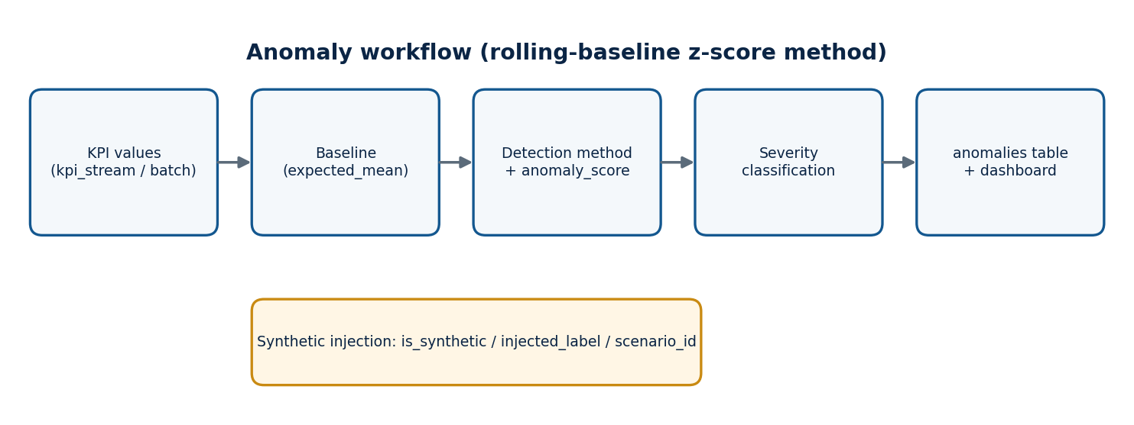
Figure 16 | Anomaly workflow

18.2 Scoring and severity
Table 37 | Score and severity
Field | Definition
observed_value | The KPI value of the window (stream) or interval (batch)
expected_mean | Baseline mean for that cell and KPI
anomaly_score | Absolute z-score: |observed - expected_mean| / max(std, 0.0001)
severity | low: score 3 to below 4; medium: 4 to below 6; high: 6 or above
event_timestamp | Window start (stream) or ts (batch)
detected_at | Time the detector wrote the record

Listing 39 | anomaly_common.py: streaming detector
Runs in: the driver, inside foreachBatch of stream_kpi.py.
"""Rolling-baseline z-score detector shared by the streaming job (reference implementation).
Baseline = mean and population std of the previous 60 windows of the same cell."""
from datetime import datetime
import numpy as np, pandas as pd

KPIS = ["rb_utilization", "active_users_dl", "data_volume_dl", "radio_quality_cqi"]
THRESHOLD, MIN_SAMPLES, METHOD = 3.0, 20, "zscore-rolling-60"

def severity(z):
return "high" if z >= 6 else "medium" if z >= 4 else "low"

def load_baselines(ch, before):
cols = ", ".join(f"avg({k}) AS m_{k}, stddevPop({k}) AS s_{k}" for k in KPIS)
sql = f"""SELECT base_station, sector, count() AS n, {cols}
FROM (SELECT * FROM kpi_stream WHERE window_start < {{ws:DateTime}}
ORDER BY window_start DESC LIMIT 60 BY base_station, sector)
GROUP BY base_station, sector"""
return ch.query_df(sql, parameters={"ws": before})

def detect(batch_pdf, ch):
"""batch_pdf: new kpi_stream rows (not yet inserted). Returns anomalies DataFrame."""
if batch_pdf.empty:
return pd.DataFrame()
base = load_baselines(ch, batch_pdf["window_start"].min().to_pydatetime())
if base.empty:
return pd.DataFrame()
m = batch_pdf.merge(base, on=["base_station", "sector"], how="inner")
m = m[m["n"] >= MIN_SAMPLES]
out, now = [], datetime.utcnow()
for k in KPIS:
z = (m[k] - m[f"m_{k}"]) / np.maximum(m[f"s_{k}"], 1e-4)
hit = m[np.abs(z) >= THRESHOLD]
for idx, row in hit.iterrows():
score = float(abs(z[idx]))
out.append(dict(detected_at=now, event_timestamp=row["window_start"].to_pydatetime(),
pipeline="stream", base_station=row["base_station"], sector=int(row["sector"]),
technology=row["technology"], kpi_name=k, observed_value=float(row[k]),
expected_mean=float(row[f"m_{k}"]), detection_method=METHOD,
anomaly_score=score, severity=severity(score), is_synthetic=1,
injected_label=int(row["scenario_id"] != "baseline"),
scenario_id=row["scenario_id"]))
return pd.DataFrame(out)

Listing 40 | Batch anomaly detection (ClickHouse SQL)
Environment: clickhouse-client or SQL Lab; parameter since selects the interval to scan. Window functions run inside ClickHouse, so no Spark job is needed.
-- Batch anomaly detection: rolling baseline of the previous 96 intervals (24 h at 15 min)
-- per base station and sector. Parameter: KPI column (rb_utilization shown).
INSERT INTO telecom_db.anomalies
SELECT now() AS detected_at, ts AS event_timestamp, 'batch' AS pipeline,
base_station, toUInt8OrZero(sector) AS sector, technology,
'rb_utilization' AS kpi_name,
toFloat32(v) AS observed_value, toFloat32(m) AS expected_mean,
'zscore-rolling-96' AS detection_method,
toFloat32(abs(z)) AS anomaly_score,
multiIf(abs(z) >= 6,'high', abs(z) >= 4,'medium','low') AS severity,
0 AS is_synthetic, 0 AS injected_label, 'batch' AS scenario_id
FROM
(
SELECT base_station, sector, technology, ts, v, m, s, n,
(v - m) / greatest(s, 0.0001) AS z
FROM
(
SELECT base_station, sector, technology, ts, rb_utilization AS v,
avg(rb_utilization) OVER w AS m,
stddevPop(rb_utilization) OVER w AS s,
count(rb_utilization) OVER w AS n
FROM telecom_db.kpi_batch_v
WHERE rb_utilization IS NOT NULL AND technology != 'UNKNOWN'
WINDOW w AS (PARTITION BY base_station, sector ORDER BY ts
ROWS BETWEEN 96 PRECEDING AND 1 PRECEDING)
)
)
WHERE n >= 24 AND abs(z) >= 3
AND ts >= {since:DateTime};

18.3 Synthetic versus detected anomalies
The generator marks injected events with scenario_id = inject-<id>; the detector copies that label into injected_label (1 when the window's scenario is not baseline) and sets is_synthetic = 1. The detector itself never uses the label to decide: baselines are computed from past values only, so the label can be used afterwards to evaluate it. Batch anomalies are found in public data, so they carry is_synthetic = 0, injected_label = 0 and scenario batch.
Listing 41 | Evaluate the detector against injected scenarios (ClickHouse SQL)
Environment: SQL Lab. Counts are read from the live tables; no accuracy figure is stated in this book.
-- Injected scenarios seen in the stream, and how many were flagged at least once
SELECT count() AS injected_windows,
countIf((base_station, sector, window_start) IN
(SELECT base_station, sector, event_timestamp FROM telecom_db.anomalies
WHERE pipeline = 'stream')) AS flagged_windows
FROM telecom_db.kpi_stream WHERE scenario_id != 'baseline';

18.4 Limitations of the method
- A z-score assumes a roughly stable baseline; strong daily cycles raise false alerts at ramps unless the baseline window is short, as the 60-window baseline is.
- Injected spikes that persist inflate the baseline std and can hide a second spike; the severity bands remain comparable because the same rule applies to every cell.
- Scores from the streaming and batch methods use different baseline lengths and should be compared within a method.

PART V
Analytics and Dashboards
Apache Superset over ClickHouse: integration and six dashboard areas.
CHAPTER 19

Apache Superset Integration

19.1 Role
AS-BUILT Superset runs in the same compose project as ClickHouse on laptop 5 (container superset-node5, port 8088) with a SQLite metadata database. setup.sh installs the ClickHouse driver and then runs provision_dashboard.py (Listing 74), but that file is empty (0 bytes) in the repository, so no dashboard named telcopulse-ops is created. The six dashboard areas below are the design target; build them in the Superset interface or write the provisioning script (Section 32.19).
Apache Superset is the presentation layer. It stores metadata (connections, datasets, charts, dashboards) and sends SQL to ClickHouse at query time; it holds no telecom data. A dashboard is therefore exactly as correct as the SQL behind its charts, which is why every chart in this book is defined by a dataset query and validated against SQL Lab.
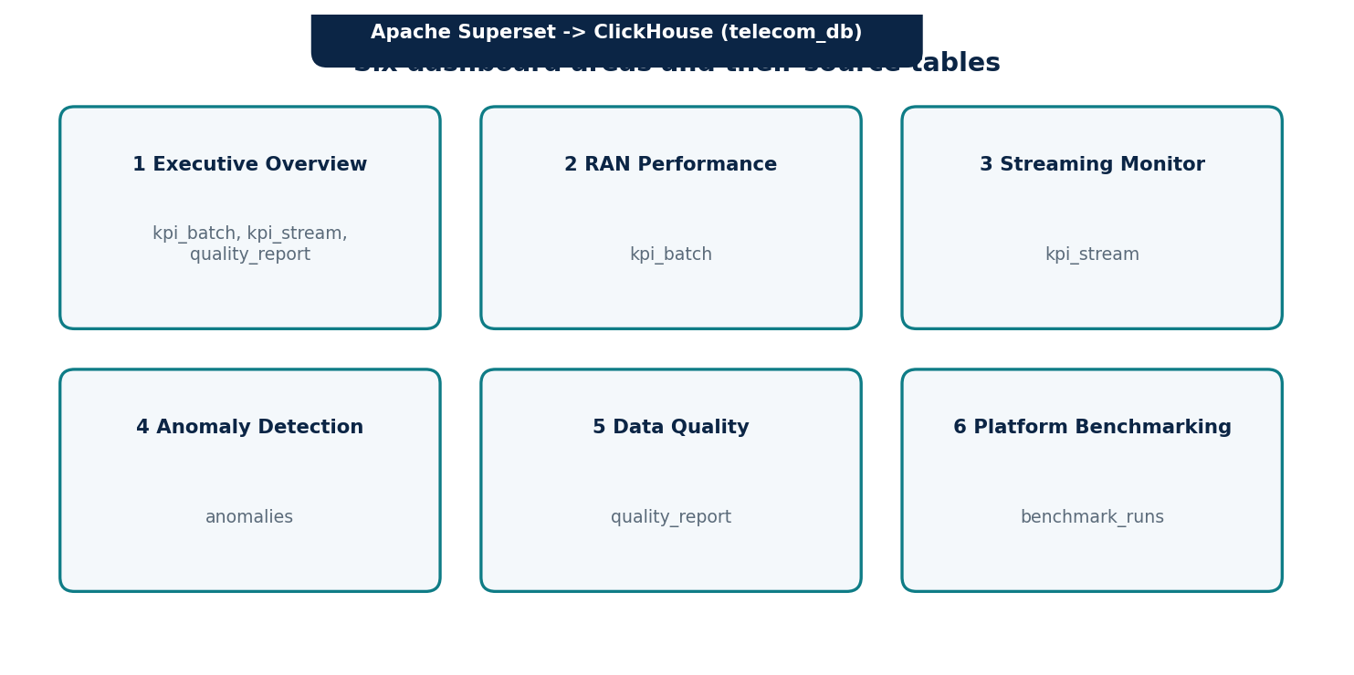
Figure 17 | Six dashboard areas and their source tables

19.2 Connecting Superset to ClickHouse
Superset reaches ClickHouse through the clickhouse-connect SQLAlchemy dialect installed in the Superset image (Chapter 7). The connection uses the HTTP interface at 192.168.1.15:8123 and the database telecom_db.
Listing 42 | Superset database connection (Settings, Database Connections, + Database, ClickHouse Connect)
Environment: Superset web UI at http://<SUPERSET_HOST>:8088. Use a read-only ClickHouse user for dashboards.
Host: 192.168.1.15
Port: 8123
Database: telecom_db
Username: <CH_USER>
Password: <CH_PASSWORD> (entered in the form; stored by Superset, never in this book)
SQLAlchemy URI: clickhousedb://<CH_USER>:<CH_PASSWORD>@192.168.1.15:8123/telecom_db

Listing 43 | Read-only ClickHouse user for Superset (ClickHouse SQL)
Environment: clickhouse-client as an administrative user.
CREATE USER IF NOT EXISTS superset_ro IDENTIFIED BY '<SET_AT_DEPLOYMENT>';
GRANT SELECT ON telecom_db.* TO superset_ro;

19.3 Working method
- Datasets: create one virtual dataset per query given in the dashboard chapters (SQL Lab, Save as dataset).
- Metrics and columns: mark time columns (hour, window_start, detected_at, run_timestamp) as temporal; define averages as metrics, never sums of percentages.
- Charts: build each chart from its specification table.
- Dashboards: arrange charts in the layout described, add native filters, set auto-refresh.
- Validation: run the dataset SQL in SQL Lab with a fixed filter and compare with the chart; see the validation step of each chapter.

19.4 Aggregation rules applied in all dashboards
Table 38 | Aggregation rules
Measure type | Examples | Rule
Percentage or ratio | rb_utilization, ts_utilization, validity_rate_pct | Average (weighted by records where group sizes differ); never sum
Instantaneous counts | active users, RRC users | Average or maximum; not summed over time
Interval volumes (stream) | data_volume_dl, data_volume_ul | Sum per window, by generator design
Possibly cumulative counters (batch) | data_volume_dl, data_volume_ul | Use differences unless the dataset says interval; shown only as averages of per-interval values
Different technologies | LTE, NR, GSM | Compare as separate series; do not blend into one average

19.5 Operating conventions
- Dashboard auto-refresh: 30 seconds for the streaming monitor, 5 minutes for the Executive Overview, off for batch-only dashboards.
- Native filters (technology, time range, base station) apply across all charts of a dashboard.
- Export dashboards from Superset (Settings, Import/Export) after changes and store the ZIP under docs/ for recovery.

CHAPTER 20

Executive Overview Dashboard
Table 39 | Dashboard summary: Executive Overview Dashboard
Item | Detail
Purpose | One-screen view of pipeline volume, data quality, stream health and anomaly activity.
Source | pipeline_inventory, kpi_batch_v, quality_report, kpi_stream, anomalies
Refresh | See filters and controls below

20.1 Analytical questions
- What are the recorded Curated and Processed row counts, and does the warehouse agree?
- Is data quality acceptable per dataset?
- Is the streaming path alive and how large is the lag?
- How many anomalies were raised recently?

20.2 Layout
Top row: four Big Number tiles (Curated total, Processed historical total, rows loaded into kpi_batch, latest stream window). Second row: bar chart of Curated rows by technology and a table comparing recorded and loaded counts. Third row: latest validity per dataset and an anomaly-count trend.

20.3 Chart specifications
Table 40 | Charts: Executive Overview Dashboard
Chart | Type | Dataset / dimensions | Measure | Interpretation
Curated total | Big Number | ds_inventory, stage = Curated, technology = ALL | row_count | Recorded 31,904,092 rows
Processed (historical) | Big Number | ds_inventory, stage = Processed | row_count | Recorded 34,117,453 rows in 44 files; intermediate stage
Loaded into kpi_batch | Big Number | ds_loaded | sum(rows) | Warehouse total
Rows by technology | Bar chart | ds_compare: technology | recorded, loaded | LTE, NR and GSM side by side
Latest quality | Table | ds_quality_latest | validity_pct, invalid, duplicates | Per dataset, latest run
Stream freshness | Big Number | ds_stream_health | minutes since last window | Alive if under 5 minutes
Anomalies per hour | Time-series bar | ds_anoms_24h: hour, severity | count | Recent anomaly activity

20.4 Dataset queries
Listing 44 | ds_inventory
Environment: Superset SQL Lab (ClickHouse SQL), saved as a virtual dataset.
SELECT stage, technology, row_count, file_count FROM telecom_db.pipeline_inventory

Listing 45 | ds_compare
Environment: Superset SQL Lab (ClickHouse SQL), saved as a virtual dataset.
SELECT m.technology AS technology, m.rows AS loaded, i.row_count AS recorded
FROM (SELECT technology, count() AS rows FROM telecom_db.kpi_batch_v GROUP BY technology) m
LEFT JOIN (SELECT technology, row_count FROM telecom_db.pipeline_inventory
WHERE stage = 'Curated' AND technology != 'ALL') i USING (technology)

Listing 46 | ds_quality_latest
Environment: Superset SQL Lab (ClickHouse SQL), saved as a virtual dataset.
SELECT dataset_name, argMax(validity_rate_pct, run_timestamp) AS validity_pct,
argMax(invalid_records, run_timestamp) AS invalid, argMax(duplicate_count, run_timestamp) AS duplicates
FROM telecom_db.quality_report GROUP BY dataset_name

Listing 47 | ds_stream_health
Environment: Superset SQL Lab (ClickHouse SQL), saved as a virtual dataset.
SELECT max(window_end) AS last_window, dateDiff('minute', max(window_end), now()) AS minutes_since,
avg(dateDiff('second', window_end, ingested_at)) AS avg_lag_s
FROM telecom_db.kpi_stream WHERE window_start > now() - INTERVAL 1 HOUR

Listing 48 | ds_anoms_24h
Environment: Superset SQL Lab (ClickHouse SQL), saved as a virtual dataset.
SELECT toStartOfHour(detected_at) AS hour, severity, count() AS n
FROM telecom_db.anomalies WHERE detected_at > now() - INTERVAL 24 HOUR GROUP BY hour, severity

20.5 Filters and time controls
No dashboard-level time filter on inventory and quality tiles (they show the latest recorded state). Stream and anomaly tiles use a fixed trailing window. Auto-refresh every 5 minutes.

20.6 Validation
Compare each Big Number with SELECT row_count FROM pipeline_inventory and SELECT count() FROM kpi_batch. After a full batch load the loaded total equals the recorded Curated total when the same inputs are used; a difference is shown by the comparison table and is investigated through quality_report.

20.7 Interpretation and limitations
- The recorded counts come from the inventory table; the loaded counts are measured. Both are shown so that a difference is visible, not hidden.
- Processed and Curated tiles are different stages; do not subtract them on the dashboard.
- Stream freshness is meaningful only while the generator and streaming job are running.

CHAPTER 21

RAN Performance Analytics Dashboard
Table 41 | Dashboard summary: RAN Performance Analytics Dashboard
Item | Detail
Purpose | Analyse radio-access KPIs of the Curated batch data by technology, station, frequency and time.
Source | kpi_batch_v (batch)
Refresh | See filters and controls below

21.1 Analytical questions
- How does resource-block utilisation vary by hour and day for each technology?
- Which base stations carry the highest user load?
- How do energy consumption and load relate?
- How are CQI ranks and MIMO rank distributed?

21.2 Layout
Row 1: utilisation time series by technology and a busy-hour heat map. Row 2: top stations by peak users and energy versus utilisation scatter. Row 3: CQI rank profile and MIMO rank by frequency. A table at the bottom lists stations and sectors for drill-down.

21.3 Chart specifications
Table 42 | Charts: RAN Performance Analytics Dashboard
Chart | Type | Dataset / dimensions | Measure | Interpretation
Utilisation trend | Line | ds_ran_hourly: hour, series technology | avg_rb | Load pattern per technology
Busy-hour heat map | Heatmap | hour_of_day x weekday | avg_rb | Peak periods
Top stations by users | Bar (top 10) | base_station | avg_peak_users | Highest user load
Energy versus load | Scatter | base_station (bubble) | avg_energy, avg_rb | Efficiency relationship
CQI profile | Bar | technology: cqi_rank_1..4 | avg of each | Channel quality mix
MIMO rank | Bar | frequency_mhz | avg_mimo_rank | Spatial multiplexing use
Cell table | Table | base_station, sector | averages | Drill-down

21.4 Dataset queries
Listing 49 | ds_ran_hourly
Environment: Superset SQL Lab (ClickHouse SQL), saved as a virtual dataset.
SELECT toStartOfHour(ts) AS hour, technology, base_station, sector, frequency_mhz,
avg(rb_utilization) AS avg_rb, avg(max_active_users_dl) AS avg_peak_users,
avg(radio_unit_energy_consumption + baseband_energy_consumption) AS avg_energy,
avg(mimo_rank_dl) AS avg_mimo_rank,
avg(cqi_rank_1) AS cqi1, avg(cqi_rank_2) AS cqi2, avg(cqi_rank_3) AS cqi3, avg(cqi_rank_4) AS cqi4
FROM telecom_db.kpi_batch_v WHERE technology != 'UNKNOWN'
GROUP BY hour, technology, base_station, sector, frequency_mhz

Listing 50 | ds_ran_busyhour
Environment: Superset SQL Lab (ClickHouse SQL), saved as a virtual dataset.
SELECT technology, toDayOfWeek(ts) AS weekday, toHour(ts) AS hour_of_day, avg(rb_utilization) AS avg_rb
FROM telecom_db.kpi_batch_v GROUP BY technology, weekday, hour_of_day

21.5 Filters and time controls
Native filters: time range on hour, technology, base_station, frequency_mhz, has_network_metrics. Hourly grouping keeps charts readable on 15-minute data. Auto-refresh off.

21.6 Validation
Pick one station, one day and one technology; compute avg(rb_utilization) for that hour in SQL Lab directly on kpi_batch_v and compare with the chart tooltip. Check that the row count behind the dataset (count() per technology) equals the loaded counts in Chapter 20.

21.7 Interpretation and limitations
- Utilisation is averaged, never summed. Nullable fields are ignored by avg, so averages describe only intervals that reported the KPI.
- Energy is shown with the source unit; the sum of radio and baseband energy is meaningful only when both are reported.
- data_volume_* is not charted as a sum because it may be a cumulative counter.
- Technology comes from the file name; rows whose file does not follow the naming convention are excluded as UNKNOWN.

CHAPTER 22

Real-Time Streaming Monitor
Table 43 | Dashboard summary: Real-Time Streaming Monitor
Item | Detail
Purpose | Observe the near-real-time KPI windows produced from synthetic events, and the health of the streaming path.
Source | kpi_stream
Refresh | See filters and controls below

22.1 Analytical questions
- Are windows arriving and how late are they?
- How do KPIs trend by technology over the last hour?
- Which scenarios are active?
- How much traffic is carried per window?

22.2 Layout
Top: freshness and lag tiles. Middle: line charts of utilisation and active users per technology, and a bar of traffic per minute. Bottom: a scenario table highlighting windows labelled injected.

22.3 Chart specifications
Table 44 | Charts: Real-Time Streaming Monitor
Chart | Type | Dataset / dimensions | Measure | Interpretation
Minutes since last window | Big Number | ds_stream_health | minutes_since | Path is alive when low
Ingestion lag | Time-series line | window_end | avg lag seconds | ingested_at - window_end
Utilisation by technology | Time-series line | window_start, series technology | avg rb_utilization | Trend
Active users | Time-series line | window_start, technology | avg active_users_dl | Load
Traffic per minute | Time-series bar | window_start, technology | sum data_volume_dl | Interval volume
Scenarios | Table | scenario_id | windows, avg rb | Injected versus baseline

22.4 Dataset queries
Listing 51 | ds_stream_trend
Environment: Superset SQL Lab (ClickHouse SQL), saved as a virtual dataset.
SELECT window_start, technology, avg(rb_utilization) AS rb, avg(active_users_dl) AS users,
sum(data_volume_dl) AS dl_volume, avg(dateDiff('second', window_end, ingested_at)) AS lag_s
FROM telecom_db.kpi_stream WHERE window_start >= now() - INTERVAL 1 HOUR
GROUP BY window_start, technology ORDER BY window_start

Listing 52 | ds_stream_scenarios
Environment: Superset SQL Lab (ClickHouse SQL), saved as a virtual dataset.
SELECT scenario_id, count() AS windows, avg(rb_utilization) AS avg_rb, max(window_start) AS last_seen
FROM telecom_db.kpi_stream WHERE window_start >= now() - INTERVAL 1 HOUR GROUP BY scenario_id

22.5 Filters and time controls
Native filters: technology, base_station, scenario type. Time range defaults to the last hour. Auto-refresh every 30 seconds.

22.6 Validation
While the generator runs at a known rate, SELECT count() FROM kpi_stream WHERE window_start > now() - INTERVAL 5 MINUTE should grow by roughly one row per active cell per minute; compare with the tile. Stop the generator and confirm the freshness tile rises.

22.7 Interpretation and limitations
- The monitor is near real time: a window appears after its end plus the watermark and trigger interval (Chapter 16).
- Event time (window_start) is used for trends; ingestion time (ingested_at) only for lag.
- Data is synthetic; trends demonstrate platform behaviour, not real network conditions.
- After a restart, replayed micro-batches can duplicate a window row; use argMax per key if exact counts matter.

CHAPTER 23

Anomaly Detection Dashboard
Table 45 | Dashboard summary: Anomaly Detection Dashboard
Item | Detail
Purpose | Inspect detected anomalies by KPI, technology, severity, station and time, and compare detections with injected scenarios.
Source | anomalies
Refresh | See filters and controls below

23.1 Analytical questions
- Which KPIs and technologies raise the most anomalies?
- How severe are they and how do scores evolve?
- How quickly are they detected?
- Are injected scenarios being found?

23.2 Layout
Row 1: counts by severity and by KPI. Row 2: score scatter over time and technology mix. Row 3: detail table with observed and expected values. Row 4: detection latency and detected-versus-injected summary.

23.3 Chart specifications
Table 46 | Charts: Anomaly Detection Dashboard
Chart | Type | Dataset / dimensions | Measure | Interpretation
Anomalies by KPI | Bar | kpi_name, severity | count | Which KPIs misbehave
Severity mix | Pie | severity | count | Share low, medium, high
Scores over time | Scatter | event_timestamp, size anomaly_score | score | Intensity pattern
By technology | Stacked bar | technology, severity | count | Affected technologies
Detail | Table | all key columns | observed, expected, score | Drill-down
Detection latency | Histogram | detected_at - event_timestamp | seconds | Responsiveness
Detected vs injected | Table | injected_label, pipeline | count | Evaluation view

23.4 Dataset queries
Listing 53 | ds_anomalies
Environment: Superset SQL Lab (ClickHouse SQL), saved as a virtual dataset.
SELECT detected_at, event_timestamp, pipeline, base_station, sector, technology, kpi_name,
observed_value, expected_mean, anomaly_score, severity, injected_label, scenario_id,
dateDiff('second', event_timestamp, detected_at) AS latency_s
FROM telecom_db.anomalies

Listing 54 | ds_anom_eval
Environment: Superset SQL Lab (ClickHouse SQL), saved as a virtual dataset.
SELECT pipeline, injected_label, severity, count() AS n, avg(anomaly_score) AS avg_score
FROM telecom_db.anomalies GROUP BY pipeline, injected_label, severity

23.5 Filters and time controls
Native filters: time range on detected_at, technology, severity, kpi_name, pipeline, injected_label. Auto-refresh every 60 seconds during streaming runs.

23.6 Validation
Pick one row of the detail table and recompute its z-score by hand from observed_value, expected_mean and the baseline standard deviation in SQL Lab; confirm severity matches the bands of Chapter 18.

23.7 Interpretation and limitations
- The table contains detections only; injected spikes that were not detected do not appear, so recall is evaluated with the query in Chapter 18.
- Scores are comparable within a detection method only.
- No accuracy figure is shown on the dashboard.

CHAPTER 24

Data Quality Dashboard
Table 47 | Dashboard summary: Data Quality Dashboard
Item | Detail
Purpose | Visualise validity, invalid records, missing values and duplicates per dataset and run.
Source | quality_report
Refresh | See filters and controls below

24.1 Analytical questions
- What share of each dataset is valid?
- How do invalid rows, missing values and duplicates compare?
- Are quality levels stable across runs?

24.2 Layout
Top: validity gauge-style tiles per dataset. Middle: validity trend across runs and a stacked bar of valid versus invalid. Bottom: missing values and duplicate counts, and the run audit table.

24.3 Chart specifications
Table 48 | Charts: Data Quality Dashboard
Chart | Type | Dataset / dimensions | Measure | Interpretation
Validity per dataset | Big Number (one per dataset) | ds_dq_latest | validity_pct | Latest run
Validity trend | Time-series line | run_timestamp, series dataset_name | validity_rate_pct | Stability
Valid versus invalid | Stacked bar | dataset_name | valid, invalid | Composition
Missing values | Bar | dataset_name | missing_value_count | Completeness (values)
Duplicates | Bar | dataset_name | duplicate_count | Removed duplicates
Run audit | Table | run_id, pipeline | all columns | Traceability

24.4 Dataset queries
Listing 55 | ds_dq_latest
Environment: Superset SQL Lab (ClickHouse SQL), saved as a virtual dataset.
SELECT dataset_name, argMax(validity_rate_pct, run_timestamp) AS validity_pct,
argMax(total_records, run_timestamp) AS total, argMax(valid_records, run_timestamp) AS valid
FROM telecom_db.quality_report GROUP BY dataset_name

Listing 56 | ds_dq_runs
Environment: Superset SQL Lab (ClickHouse SQL), saved as a virtual dataset.
SELECT run_id, run_timestamp, pipeline, dataset_name, total_records, valid_records,
invalid_records, missing_value_count, duplicate_count, validity_rate_pct
FROM telecom_db.quality_report

Listing 57 | ds_dq_overall
Environment: Superset SQL Lab (ClickHouse SQL), saved as a virtual dataset.
SELECT pipeline, sum(valid_records) AS valid, sum(total_records) AS total,
100 * sum(valid_records) / greatest(sum(total_records), 1) AS weighted_validity_pct
FROM telecom_db.quality_report GROUP BY pipeline

24.5 Filters and time controls
Native filters: pipeline, dataset_name, run_timestamp range. Auto-refresh off.

24.6 Validation
For one dataset, check that valid_records + invalid_records = total_records and that valid_records for the batch datasets equals the Curated count of the same run (read back with verify_curated.py).

24.7 Interpretation and limitations
- Combine runs with total valid over total records (ds_dq_overall), not by averaging percentages.
- missing_value_count counts values and invalid_records counts rows; they are different units.
- invalid_records includes removed duplicates; duplicate_count shows that part separately.

CHAPTER 25

Platform Benchmarking Dashboard
Table 49 | Dashboard summary: Platform Benchmarking Dashboard
Item | Detail
Purpose | Compare runtime, throughput, streaming delay and resource usage across controlled experiments.
Source | benchmark_runs
Refresh | See filters and controls below

25.1 Analytical questions
- How does runtime change with the number of Spark Workers?
- How do Ethernet and Wi-Fi network modes compare?
- How does the workload size scale?
- What streaming delay was measured?

25.2 Layout
Top: runtime and throughput by worker count. Middle: comparison by network mode and scaling with workload size. Bottom: CPU and RAM usage and the full run table with notes.

25.3 Chart specifications
Table 50 | Charts: Platform Benchmarking Dashboard
Chart | Type | Dataset / dimensions | Measure | Interpretation
Runtime by workers | Bar or line | num_spark_workers | avg runtime_seconds | Scaling
Throughput by workers | Bar | num_spark_workers | avg throughput_rows_per_sec | Rows per second
By network mode | Grouped bar | network_mode | avg runtime, throughput | Network effect
Scaling with workload | Scatter/line | workload_size_gb | runtime_seconds | Data scaling
Streaming delay | Bar | experiment_id | streaming_delay_ms | Measured delay
Resources | Bar | experiment_id | cpu_usage_pct, ram_usage_mb | Utilisation during run
Run table | Table | experiment_id | all columns | Audit with notes

25.4 Dataset queries
Listing 58 | ds_bench
Environment: Superset SQL Lab (ClickHouse SQL), saved as a virtual dataset.
SELECT experiment_id, run_timestamp, workload_size_gb, num_spark_workers, network_mode,
runtime_seconds, throughput_rows_per_sec, streaming_delay_ms, cpu_usage_pct, ram_usage_mb, notes
FROM telecom_db.benchmark_runs

Listing 59 | ds_bench_by_workers
Environment: Superset SQL Lab (ClickHouse SQL), saved as a virtual dataset.
SELECT num_spark_workers, network_mode, count() AS runs, avg(runtime_seconds) AS avg_runtime,
min(runtime_seconds) AS best, max(runtime_seconds) AS worst, avg(throughput_rows_per_sec) AS avg_tp
FROM telecom_db.benchmark_runs GROUP BY num_spark_workers, network_mode ORDER BY num_spark_workers

25.5 Filters and time controls
Native filters: experiment_id, network_mode, workload_size_gb. Auto-refresh off.

25.6 Validation
Recompute throughput_rows_per_sec as rows divided by runtime_seconds for one experiment from the job output, and compare with the table.

25.7 Interpretation and limitations
- The dashboard shows only runs recorded by benchmark_runner.py; no numbers are pre-filled. Chapter 28 defines the experiments that populate it.
- Compare runs only when workload, configuration and conditions are the same except the variable under test.
- Repeat each condition and compare medians; show the spread (best, worst) with the average.

PART VI
Testing, Operations and Evaluation
How the platform is validated and operated, how problems are diagnosed, how performance is evaluated, and what was learned.
CHAPTER 26

End-to-End Integration Testing
Testing a distributed pipeline means testing each hop and then the whole chain. Every test has an objective, a command in a named environment, and an acceptance criterion that is decided before the test runs. The sequence below follows the data from the network to the dashboards.

26.1 Test matrix
Table 51 | Test matrix with acceptance criteria
Component | Objective | Command or method (environment) | Acceptance criterion
Network | All laptops reachable | ping 192.168.1.11 ... .16 (PowerShell) | Replies from all six hosts
Ports | Service ports open | powershell/healthcheck.ps1 (PowerShell) | All five checked endpoints OPEN; ClickHouse returns Ok.
Docker | Containers running | docker ps (PowerShell, each laptop) | tp-spark-master, tp-spark-workerN, tp-rustfs, tp-kafka, tp-clickhouse, tp-superset Up
Spark Master and UI | Master reachable | Browse http://192.168.1.11:8080 | Master page loads, status ALIVE
Worker registration | Workers join | Master UI, Workers table | Each worker ALIVE with the configured cores and memory
Distributed job | Tasks on several hosts | s3a_cluster_test.py (container shell) | EXECUTOR_HOSTS lists more than one host
RustFS | Buckets and objects | aws s3 ls (PowerShell) | raw, processed, curated exist; ten Dataset_*.csv in raw
S3A read | Spark reads CSV | s3a_cluster_test.py | ROWS printed, no S3A error
Batch stage 1 | Raw to Processed | submit_batch.sh | FILES_FOUND=10; PROCESSED lines per technology
Batch stage 2 | Processed to Curated | submit_batch.sh | CURATED lines; CURATED_TOTAL_ROWS printed
Curated validation | Counts and rules | verify_curated.py | match=True per technology against LTE 18,750,012, NR 7,558,148, GSM 5,595,932; total 31,904,092; 0 violations
ClickHouse load | kpi_batch filled | SELECT count() FROM kpi_batch_v GROUP BY technology (SQL Lab) | Counts equal the Curated counts
Kafka | Events flow | kafka-console-consumer (container shell) | JSON events visible on telco.events
Streaming | Windows written | SELECT max(window_end), count() FROM kpi_stream (SQL) | New rows every minute while the generator runs
Anomalies | Detections stored | SELECT count() FROM anomalies WHERE pipeline = 'stream' | Rows appear during injected scenarios
Data quality | Metrics recorded | SELECT * FROM quality_report | One row per technology per curate run
Superset | Connection and datasets | Test Connection; run each dataset SQL | Connection succeeds; queries return rows
Dashboards | Chart equals SQL | Validation step of each dashboard chapter | Chart values match SQL Lab results
Benchmark | Run recorded | benchmark_runner.py | One new row in benchmark_runs per run

26.2 Test record
Each execution is recorded in logs/ with the date, operator, command, the output lines named in the acceptance criterion and a pass or fail decision. A test passes only when its acceptance criterion is met by the recorded output; the book itself contains no sample outputs for that reason.

26.3 Acceptance sequence
- Run healthcheck.ps1 from two different laptops.
- Confirm Workers on the Master UI; run s3a_cluster_test.py.
- Run submit_batch.sh; keep the log.
- Run verify_curated.py; compare with the recorded counts.
- Run the quality query and the reconciliation query of Chapter 17.
- Start the streaming job and generator; wait three minutes; check kpi_stream and anomalies.
- Open every dashboard and perform its validation step.

CHAPTER 27

Troubleshooting and Engineering Decisions

27.1 Engineering decisions
Table 52 | Decisions that shaped the platform
Decision | Reason
Latest endpoints replace earlier ones | Spark Master moved from 192.168.1.10 to 192.168.1.11:7077; the S3A endpoint moved from 192.168.1.11:9000 to RustFS at 192.168.1.12:9000. One inventory file (hosts.env) now holds the addresses.
Six-laptop range 192.168.1.11-.16 | The earlier .10-.15 plan was superseded and is not used.
Separate Processed and Curated | Intermediate results stay reusable; only Curated feeds ClickHouse.
Smoke tests before the full batch | S3A smoke test, single-file test, RustFS batch test, then the ten-file job isolate connectivity from data problems.
Registration is not completion | A Master log showing the application is not proof of output; counts and read-back are.
NiFi and Airflow excluded | Keeps the ten-day scope achievable; jobs are scripts run from the Master container.
Credentials from the environment | No secrets in code, images or documents.

27.2 Diagnostic guide
The entries below follow Symptom, Likely cause, Checks and Fix. They are operating guidance for this architecture.
Table 53 | Diagnostic guide
Symptom | Likely cause | Checks | Fix
Ping works, Spark connection fails | Port blocked or not published | Test-NetConnection to :7077; docker ps ports; firewall rule | Publish the port in Compose; add the firewall rule
Worker not listed on Master UI | Wrong master URL or blocked port | Worker log (docker logs tp-spark-workerN); URL spark://192.168.1.11:7077 | Correct URL; open 7077 on .11
Application waits with no executors | No free cores or memory; executors cannot reach driver | Master UI cores; 7078/7079 reachable from workers | Reduce executor sizing; open driver ports; check spark.driver.host
Tasks fail with connection errors between executors | Block-manager ports unreachable | Executor logs; ports 7100-7120 on worker laptops | Publish and allow the range
S3A error on first read | Endpoint, path-style flag or credentials wrong | Endpoint 192.168.1.12:9000; path.style.access true; env variables set | Correct configuration; recreate keys if exposed
Job looks stalled | Slow shuffle, skew, pending tasks, or lost executor | Driver UI :4040 Stages and Executors tabs; GC time | Increase partitions or memory; remove skew; restart failed Worker
Fewer or more than ten files | Naming or upload problem | aws s3 ls s3://raw/ | Fix names to Dataset_NN_<TECH>_<band>.csv
Curated count differs from the recorded value | Different inputs or changed rules | quality_report rows; rule definitions | Explain and record before changing recorded figures
Kafka connects then fails | Advertised listener wrong | KAFKA_ADVERTISED_LISTENERS=192.168.1.12:9092 | Correct and restart the broker
No rows in kpi_stream | Generator or job stopped; checkpoint problem; ClickHouse unreachable | docker logs; streaming job stdout; curl :8123/ping | Restart; clear the checkpoint only when a full reprocess is intended
Superset chart empty | Time filter, dataset SQL or permissions | Run dataset SQL in SQL Lab; check the filter | Fix filter or grant SELECT
Dashboard number looks wrong | Summed percentage or cumulative counter | Aggregation rules table in Chapter 19 | Use average or differences

CHAPTER 28

Performance Evaluation and Limitations

28.1 Approach
Performance evaluation compares controlled runs and records them in benchmark_runs through benchmark_runner.py. This book states no measured results: every value in the table is produced by running the experiments below on the lab, and the Benchmarking dashboard displays them.
Table 54 | Measures
Measure | Definition | Recorded in
Runtime | Wall-clock seconds for the submitted batch command | runtime_seconds
Throughput | Rows processed (PROCESSED_TOTAL_ROWS or CURATED_TOTAL_ROWS) / runtime | throughput_rows_per_sec
Streaming delay | Mean of ingested_at - window_end, in milliseconds | streaming_delay_ms
CPU and RAM | Mean CPU percent and used RAM sampled each second on the host running the command | cpu_usage_pct, ram_usage_mb
Speed-up | Runtime with one Worker / runtime with N Workers | Computed on the dashboard

Listing 60 | benchmark_runner.py
Runs in: the Master container (driver host). CPU and RAM are sampled on that host only; add per-host sampling with docker stats when comparing resource use across laptops.
"""Runs a Spark submission under measurement and records one benchmark_runs row.
No values are assumed: every field is measured by this script or supplied by the operator."""
import argparse, re, subprocess, threading, time, datetime as dt
import psutil
from common import ch_client

def sample(stop, cpu, ram):
while not stop.is_set():
cpu.append(psutil.cpu_percent(interval=1.0))
ram.append(psutil.virtual_memory().used / 1048576)

def main():
ap = argparse.ArgumentParser()
ap.add_argument("--experiment-id", required=True)
ap.add_argument("--workload-gb", type=float, required=True)
ap.add_argument("--workers", type=int, required=True)
ap.add_argument("--network-mode", required=True, help="e.g. ethernet | wifi | mixed")
ap.add_argument("--stream-delay-ms", type=float, default=0.0)
ap.add_argument("--notes", default="")
ap.add_argument("--cmd", required=True, help="submit command that prints *_TOTAL_ROWS=")
a = ap.parse_args()
cpu, ram, stop = [], [], threading.Event()
t = threading.Thread(target=sample, args=(stop, cpu, ram), daemon=True); t.start()
t0 = time.time()
proc = subprocess.run(a.cmd, shell=True, capture_output=True, text=True)
runtime = time.time() - t0
stop.set(); t.join()
m = re.findall(r"(?:PROCESSED|CURATED)_TOTAL_ROWS=\s*(\d+)", proc.stdout)
rows = int(m[-1]) if m else 0
if proc.returncode != 0 or rows == 0:
raise SystemExit(f"run failed or no row count found (rc={proc.returncode})")
row = [a.experiment_id, dt.datetime.utcnow(), a.workload_gb, a.workers, a.network_mode,
runtime, rows / runtime, a.stream_delay_ms,
sum(cpu) / max(len(cpu), 1), sum(ram) / max(len(ram), 1), a.notes]
ch_client().insert("benchmark_runs", [row], column_names=["experiment_id",
"run_timestamp", "workload_size_gb", "num_spark_workers", "network_mode",
"runtime_seconds", "throughput_rows_per_sec", "streaming_delay_ms", "cpu_usage_pct",
"ram_usage_mb", "notes"])
print(f"RECORDED {a.experiment_id}: runtime={runtime:.1f}s rows={rows}")

if __name__ == "__main__":
main()

28.2 Experiment plan
Table 55 | Experiments
Experiment | Variable | Fixed conditions
EXP-W1, W2, W3 ... | Number of Spark Workers (1, 2, 3 ...) | Same ten files, same executor settings, same network mode
EXP-NET-ETH, EXP-NET-WIFI | Network mode (Ethernet or Wi-Fi/mixed) | Same Workers and workload
EXP-SIZE-n | Workload size (subsets of the ten files) | Same Workers and network mode
EXP-STREAM-r | Generator rate (events per second) | Same Workers; record streaming delay

Listing 61 | Run one experiment (Linux shell inside tp-spark-master)
Replace <WORKLOAD_GB> with the measured size of the input files. Run each experiment several times.
python3 /opt/telcopulse/jobs/benchmark_runner.py --experiment-id EXP-W2 \
--workload-gb <WORKLOAD_GB> --workers 2 --network-mode ethernet \
--notes "two workers, executors 2c/2g" \
--cmd "/opt/spark/bin/spark-submit --master spark://192.168.1.11:7077 \
--total-executor-cores 4 /opt/telcopulse/jobs/batch_curate.py lte nr gsm"

28.3 Fair-comparison rules
- Same input data, code and Spark options; only the variable under test changes.
- Distinguish cold and warm runs and note caching.
- Record the link type in network_mode.
- Close other applications; fix laptop power mode.
- Repeat each condition at least three times and compare medians with the spread.

28.4 Limitations of a six-laptop lab
- Ordinary laptop CPU, RAM and disk shared with Windows, WSL 2 and Docker Desktop.
- A mixed Ethernet and Wi-Fi network: shuffle-heavy stages are sensitive to it.
- Single-node RustFS, a single Kafka broker and one Spark Master: no high availability.
- Services share hardware, so benchmarks include interference.
- The stream is synthetic; real operator traffic has different volume and burstiness.
- Laptop power management can change CPU speed between runs.

CHAPTER 29

Lessons Learned and Future Work

29.1 Lessons
- Separate concepts that look alike: host IP, container IP, published port and endpoint; PowerShell and container shells; Processed and Curated.
- Test in layers: ping, port, protocol, application, data.
- Registration is not completion; a write is not correctness.
- Keep one inventory of addresses: endpoints changed during development.
- Scope discipline: removing NiFi and Airflow kept the project achievable.
- Never put secrets into code or documents.
- Define aggregation rules per KPI before building charts.

29.2 Future work
Table 56 | Future work
Area | Improvement
Deployment | Scripted, one-command deployment per laptop role
Configuration | Central configuration and secrets management
Observability | Metrics and alerting for Spark, Kafka, ClickHouse and the hosts
Data quality | Per-KPI rule catalogue and automatic gates
Streaming | More scenarios; idempotent sink for exactly-once behaviour
Fault tolerance | Multi-broker Kafka, replicated storage, Spark Master recovery
Benchmarking | Per-host resource sampling and larger workloads
Anomaly detection | Seasonal baselines and labelled evaluation sets

PART VII
As-Built Guide, Challenges and Evaluation
What was actually built, how to rebuild it, what went wrong, and what the platform is and is not.
CHAPTER 30

As-Built Repository Reference
The earlier chapters explain the platform as a design: what each component does and why. This chapter records what the repository (TelcoPulseCluster) and its run logs actually contain. Wherever an earlier chapter and the repository disagree, the repository wins when you rebuild the lab. Credentials found in the repository files are replaced by placeholders such as <your-password> in every listing.
AS-BUILT Listings 67 to 83 are the repository files, copied line for line, with secrets replaced and, for generator.py, the KPI engine lines omitted (marked in the listing). One file referenced by the README and by Order.txt, env.ps1, is not in the repository; Listing 82 is a reference version reconstructed from the run logs and is marked as such.
CAUTION Read Sections 30.8 and 30.9 before you quote any number from this book. The recorded Curated total of 31,904,092 rows covers nine of the ten source files: Dataset_03_NR_3500.csv failed during ingestion and was never curated.

30.1 Repository contents
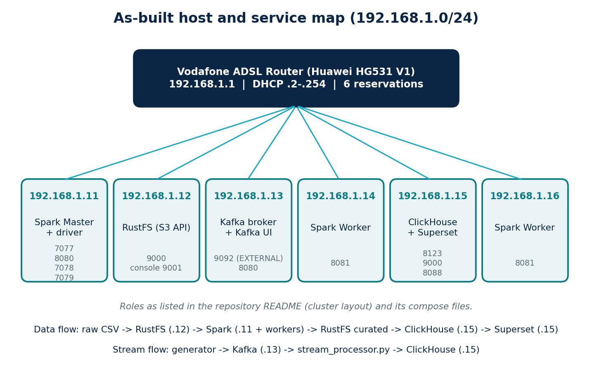
Figure 18 | As-built host and service map
Roles as listed in the repository README (cluster layout) and its compose files.
Table 66 | Repository files and their role
Repository path | Purpose | Runs on | Listing
rustfs.env | RustFS access keys, API port 9000, console port 9001 (lab layout: config\rustfs.env) | .12 | 67
spark-defaults.conf | Driver host, bind address and pinned ports (lab layout: config\spark-defaults.conf) | .11 | 68
docker/spark/Dockerfile | Spark 3.5.9 image plus S3A JARs: telcopulse-spark-s3a:3.5.9 | build host | 69
docker/docker-compose.yml | Spark Master container tp-spark-master | .11 | 70
docker/rustfs-compose.yml | RustFS container tp-rustfs, data on G:/TelcoPulse/data/rustfs | .12 | 71
kafka-cluster/docker-compose.yml | Kafka 4.1.0 (KRaft) and Kafka UI | .13 | 72
docker-compose.yml | ClickHouse, Superset and the idle kafka-sim | .15 | 73
setup.sh | Starts ClickHouse and Superset, installs the driver, creates admin, runs the provisioning script | .15 | 74
Clickhouse/01_init_schema.sql | Database telecom_db and five tables | .15 | 75
jobs/ingest_raw.py | Raw CSV to Processed Parquet with row-count check | Spark | 76
jobs/clean_curate.py | Quality audit and Curated Parquet per technology | Spark | 77
docker/spark/batch_all_10.py | Earlier single-job union of all ten files | Spark | 78
kafka-cluster/generator.py | Synthetic RAN event generator | any laptop | 79
kafka-cluster/stream_processor.py | Kafka consumer, four anomaly rules, ClickHouse inserts | any laptop | 80
jobs/Order.txt | The spark-submit commands run in the lab | .11 | 81
jobs/show_curated.py | Profiling of the Curated layer | Spark | 83
jobs/ingest_out.txt, clean_out.txt, show_out.txt | Real run logs of 21 October 2026 (UTF-16 text) | .11 | Tables 68, 68a, 68b
superset/superset_config.py | Superset settings (not mounted by the compose file) | .15 | n/a
Superset/provision_dashboard.py | Dashboard provisioning script: empty, 0 bytes | .15 | n/a
env.ps1 | Referenced by README and Order.txt; absent | .11 | 82 (reference)
Document/ | Project book, showcase GIF, cover image, screen recording | n/a | n/a

30.2 Where the repository differs from the design chapters
Table 67 is the most important page of this chapter for anyone rebuilding the lab. Each row names the topic, what the design chapters say, what the repository does, and which to follow.
Table 67 | Design chapters versus repository
Topic | Design chapters | Repository (as built) | Follow
Kafka address | 192.168.1.12:9092 | Advertised EXTERNAL listener 192.168.1.13:9092; consumer uses the same address | Repository
Kafka topic | telco.events | telecom_stream | Repository
Stream engine | Spark Structured Streaming, 1-minute windows, 30 s watermark | Plain Python consumer (README: not Spark Structured Streaming); each event carries a 300 s window | Repository
Anomaly detection | Rule and statistical design in Chapter 18 | Four threshold rules (Listing 80); README: no statistical or machine-learning detector yet | Repository
Batch job names | batch_ingest_process.py, batch_curate.py, load_clickhouse_batch.py | ingest_raw.py, clean_curate.py, show_curated.py, batch_all_10.py | Repository
Batch to ClickHouse load | Stage 3 loads Curated into kpi_batch | Not implemented (README roadmap); kpi_batch stays empty | Repository
Files in the Curated layer | Ten source files, 31,904,092 rows | Nine files (no Dataset_03_NR_3500); 31,904,092 rows | Repository logs
Table widths | kpi_stream 18, anomalies 15, quality_report 10, benchmark_runs 11 columns | 15, 10, 7 and 7 columns; kpi_batch 25 in both | Repository
quality_report, benchmark_runs | Populated by the pipeline | Created but not populated (README) | Repository
Superset dashboards | Six dashboard areas, provisioned | Provisioning script is empty; no dashboard is created | Repository
Spark image | Adds Kafka and ClickHouse client JARs | Adds only hadoop-aws 3.3.4 and aws-java-sdk-bundle 1.12.262 | Repository
Workers | Worker or support roles to be assigned | .14 and .16 are Spark Workers (README), Web UI 8081 | Repository

30.3 Infrastructure files
Listing 67 | RustFS environment
rustfs.env
RUSTFS_ACCESS_KEY=<your-access-key>
RUSTFS_SECRET_KEY=<your-secret-key>
RUSTFS_ADDRESS=0.0.0.0:9000
RUSTFS_CONSOLE_ADDRESS=0.0.0.0:9001
RUSTFS_CONSOLE_ENABLE=true
The repository copy uses identical lab values for key and secret. Choose two different strong values.

Listing 68 | Spark network settings
spark-defaults.conf
# Lines 1-4 are NOT Spark properties and have no effect. The Master is configured
# by the command arguments in docker/docker-compose.yml (Listing 70).
spark.master.host 192.168.1.11
spark.master.bindAddress 0.0.0.0
spark.master.port 7077
spark.master.webui.port 8080

spark.driver.host 192.168.1.11
spark.driver.bindAddress 0.0.0.0
spark.driver.port 7078
spark.driver.blockManager.port 7079
spark.blockManager.port 7079

# REFERENCE (not in the repository): S3A settings, see Appendix E
# spark.hadoop.fs.s3a.endpoint http://192.168.1.12:9000
# spark.hadoop.fs.s3a.path.style.access true
# spark.hadoop.fs.s3a.connection.ssl.enabled false
# spark.hadoop.fs.s3a.access.key <your-access-key>
# spark.hadoop.fs.s3a.secret.key <your-secret-key>
The repository file holds no S3A settings; in the lab they reached Spark through the `$conf` arguments of `env.ps1` (Listing 82).

Listing 69 | Spark image with S3A JARs
docker/spark/Dockerfile
FROM apache/spark:3.5.9-scala2.12-java11-python3-r-ubuntu

USER root

COPY jars/hadoop-aws-3.3.4.jar /opt/spark/jars/
COPY jars/aws-java-sdk-bundle-1.12.262.jar /opt/spark/jars/

RUN chown spark:spark \
/opt/spark/jars/hadoop-aws-3.3.4.jar \
/opt/spark/jars/aws-java-sdk-bundle-1.12.262.jar

USER spark
Build with: docker build -t telcopulse-spark-s3a:3.5.9 docker/spark (the two JARs must be in docker/spark/jars; the repository does not contain them).

Listing 70 | Spark Master container
docker/docker-compose.yml
services:
spark-master:
image: telcopulse-spark-s3a:3.5.9
container_name: tp-spark-master
hostname: tp-spark-master
command:
- /opt/spark/bin/spark-class
- org.apache.spark.deploy.master.Master
- --host
- 0.0.0.0
- --port
- "7077"
- --webui-port
- "8080"
volumes:
- G:/TelcoPulse/config/spark-defaults.conf:/opt/spark/conf/spark-defaults.conf:ro
ports:
- "7077:7077"
- "8080:8080"
- "7078:7078"
- "7079:7079"
restart: unless-stopped

Listing 71 | RustFS object storage
docker/rustfs-compose.yml
services:
rustfs:
image: rustfs/rustfs:latest
container_name: tp-rustfs
env_file:
- ../config/rustfs.env
command: ["/data"]
ports:
- "9000:9000"
- "9001:9001"
volumes:
- G:/TelcoPulse/data/rustfs:/data
restart: unless-stopped
The compose file reads ../config/rustfs.env (lab layout); in the repository the file sits at the root. Pin a version instead of latest when you rebuild (Chapter 33, Table 77).

Listing 72 | Kafka broker and Kafka UI
kafka-cluster/docker-compose.yml
services:
kafka:
image: apache/kafka:4.1.0
container_name: kafka-broker
ports:
- "9092:9092"
environment:
- KAFKA_NODE_ID=1
- KAFKA_PROCESS_ROLES=broker,controller
- KAFKA_LISTENERS=INTERNAL://0.0.0.0:29092,EXTERNAL://0.0.0.0:9092,CONTROLLER://0.0.0.0:9093
- KAFKA_ADVERTISED_LISTENERS=INTERNAL://kafka:29092,EXTERNAL://192.168.1.13:9092
- KAFKA_LISTENER_SECURITY_PROTOCOL_MAP=INTERNAL:PLAINTEXT,EXTERNAL:PLAINTEXT,CONTROLLER:PLAINTEXT
- KAFKA_INTER_BROKER_LISTENER_NAME=INTERNAL
- KAFKA_CONTROLLER_LISTENER_NAMES=CONTROLLER
- KAFKA_CONTROLLER_QUORUM_VOTERS=1@localhost:9093
- KAFKA_OFFSETS_TOPIC_REPLICATION_FACTOR=1
- KAFKA_TRANSACTION_STATE_LOG_MIN_ISR=1
- KAFKA_TRANSACTION_STATE_LOG_REPLICATION_FACTOR=1
restart: unless-stopped

kafka-ui:
image: provectuslabs/kafka-ui:latest
container_name: kafka-ui
ports:
- "8080:8080"
environment:
- KAFKA_CLUSTERS_0_NAME=TelcoPulse-Cluster
- KAFKA_CLUSTERS_0_BOOTSTRAPSERVERS=kafka:29092
depends_on:
- kafka
restart: unless-stopped
The EXTERNAL listener carries the LAN address; containers on the same host use INTERNAL (kafka:29092).

Listing 73 | ClickHouse, Kafka simulator and Superset
docker-compose.yml
services:
# 1. Main Production Database (Laptop 5)
clickhouse:
image: clickhouse/clickhouse-server:latest
container_name: clickhouse-node5
ports:
- "0.0.0.0:8123:8123" # HTTP API for Spark Workers & Superset
- "0.0.0.0:9000:9000" # Native TCP for CLI / drivers
environment:
- CLICKHOUSE_DB=telecom_db
- CLICKHOUSE_USER=admin
- CLICKHOUSE_PASSWORD=<your-password>
- CLICKHOUSE_DEFAULT_ACCESS_MANAGEMENT=1
volumes:
- ./ch_data:/var/lib/clickhouse
- ./ch_logs:/var/log/clickhouse-server
ulimits:
nofile:
soft: 262144
hard: 262144
restart: unless-stopped

# 2. Local Kafka Simulator (Kept idle until Phase 4)
kafka-sim:
image: apache/kafka:latest
container_name: kafka-simulator
ports:
- "9092:9092"
environment:
- KAFKA_NODE_ID=1
- KAFKA_PROCESS_ROLES=broker,controller
- KAFKA_LISTENERS=PLAINTEXT://:9092,CONTROLLER://:9093
- KAFKA_ADVERTISED_LISTENERS=PLAINTEXT://kafka-sim:9092
- KAFKA_CONTROLLER_LISTENER_NAMES=CONTROLLER
- KAFKA_LISTENER_SECURITY_PROTOCOL_MAP=CONTROLLER:PLAINTEXT,PLAINTEXT:PLAINTEXT
- KAFKA_CONTROLLER_QUORUM_VOTERS=1@kafka-sim:9093
- KAFKA_OFFSETS_TOPIC_REPLICATION_FACTOR=1
# 3. Visualization Layer
superset:
image: apache/superset:latest
container_name: superset-node5
ports:
- "8088:8088"
environment:
- SUPERSET_SECRET_KEY=<long-random-string>
volumes:
- ./superset_home:/app/superset_home
depends_on:
- clickhouse
restart: unless-stopped
kafka-sim (advertised kafka-sim:9092) is kept idle and superseded by Listing 72.

Listing 74 | One-command ClickHouse and Superset setup
setup.sh
#!/usr/bin/env bash
set -e

echo "[1/5] Setting up local directory permissions..."
mkdir -p superset_home ch_data ch_logs
sudo chmod -R 777 superset_home ch_data ch_logs

echo "[2/5] Starting ClickHouse and Superset containers..."
docker compose up -d clickhouse superset

echo "[3/5] Installing ClickHouse Python connector inside Superset..."
docker exec -i --user root superset-node5 pip install --target /app/.venv/lib/python3.10/site-packages clickhouse-connect
docker exec -i --user root superset-node5 chmod -R 755 /app/.venv/lib/python3.10/site-packages

echo "[4/5] Running Superset database migrations and creating admin..."
docker exec -i superset-node5 superset db upgrade
docker exec -i superset-node5 superset fab create-admin \
--username admin \
--firstname Admin \
--lastname User \
--email admin@telcopulse.local \
--password <your-admin-password> || true
docker exec -i superset-node5 superset init

echo "[5/5] Provisioning visual charts and dashboard..."
docker exec -i superset-node5 python < superset/provision_dashboard.py

echo "=========================================================="
echo " TelcoPulse Analytics Stack is live!"
echo " ClickHouse Native: 127.0.0.1:9000 (HTTP: 8123)"
echo " Superset UI: http://localhost:8088/superset/dashboard/telcopulse-ops/"
echo " Credentials: admin / <your-admin-password>"
echo "=========================================================="
Step 5 runs a provisioning script that is empty in the repository (Section 32.19). The script reads superset/ (lower case) while the empty file sits in Superset/ (capital S). The driver installed in step 3 is lost if the container is re-created (Section 32.10).

30.4 ClickHouse schema as built
Listing 75 | ClickHouse DDL as built
Clickhouse/01_init_schema.sql
CREATE DATABASE IF NOT EXISTS telecom_db;

-- 1. Batch Historical KPI Table (25-column multi-technology schema)
CREATE TABLE IF NOT EXISTS telecom_db.kpi_batch (
ts DateTime,
base_station LowCardinality(String),
sector UInt8,
technology LowCardinality(String),
frequency_mhz UInt32,
bandwidth_mhz Nullable(Float64),
data_volume_dl Nullable(Float64),
data_volume_ul Nullable(Float64),
throughput_dl_mbps Nullable(Float64),
throughput_ul_mbps Nullable(Float64),
active_users_dl Nullable(Float64),
active_users_ul Nullable(Float64),
max_active_users_dl Nullable(Float64),
rb_utilization Nullable(Float64),
cqi_mean Nullable(Float64),
mcs_mean Nullable(Float64),
packet_loss_rate Nullable(Float64),
latency_ms Nullable(Float64),
radio_unit_energy_consumption Nullable(Float64),
baseband_energy_consumption Nullable(Float64),
cooling_energy_consumption Nullable(Float64),
power_amplifier_temp Nullable(Float64),
mimo_layers Nullable(UInt8),
tx_power_dbm Nullable(Float64),
coverage_distance_km Nullable(Float64)
) ENGINE = MergeTree()
PARTITION BY toYYYYMM(ts)
ORDER BY (base_station, technology, ts);

-- 2. Real-Time Streaming KPI Table (Windowed Kafka telemetry)
CREATE TABLE IF NOT EXISTS telecom_db.kpi_stream (
window_start DateTime,
window_end DateTime,
base_station LowCardinality(String),
sector UInt8,
technology LowCardinality(String),
data_volume_dl Float64,
data_volume_ul Float64,
throughput_dl_mbps Float64,
throughput_ul_mbps Float64,
rb_utilization Float64,
active_users_dl Float64,
packet_loss_rate Float64,
latency_ms Float64,
scenario_id LowCardinality(String),
ingested_at DateTime DEFAULT now()
) ENGINE = MergeTree()
PARTITION BY toDate(window_start)
ORDER BY (base_station, window_start);

-- 3. Network Anomaly & Security Incident Alerts Table
CREATE TABLE IF NOT EXISTS telecom_db.anomalies (
detected_at DateTime,
base_station LowCardinality(String),
sector UInt8,
technology LowCardinality(String),
kpi_name LowCardinality(String),
observed_value Float64,
expected_mean Float64,
anomaly_score Float64,
severity LowCardinality(String),
scenario_id LowCardinality(String)
) ENGINE = MergeTree()
ORDER BY (detected_at, severity, base_station);

-- 4. Data Quality Assurance Reports Table
CREATE TABLE IF NOT EXISTS telecom_db.quality_report (
report_id UUID DEFAULT generateUUIDv4(),
check_timestamp DateTime DEFAULT now(),
source_layer LowCardinality(String),
total_records UInt64,
null_violations UInt64,
range_violations UInt64,
status LowCardinality(String)
) ENGINE = MergeTree()
ORDER BY check_timestamp;

-- 5. System Benchmark Metrics (Throughput and Latency Verification)
CREATE TABLE IF NOT EXISTS telecom_db.benchmark_runs (
run_id UUID DEFAULT generateUUIDv4(),
executed_at DateTime DEFAULT now(),
test_scenario LowCardinality(String),
records_processed UInt64,
ingestion_rate_eps Float64,
query_latency_ms Float64,
status LowCardinality(String)
) ENGINE = MergeTree()
ORDER BY executed_at;
Apply with the README command, adding the credentials of Listing 73: docker exec -i clickhouse-node5 clickhouse-client --user admin --password <your-password> --multiquery.

30.5 Batch jobs as built
The batch path is two small, restartable jobs. ingest_raw.py reads a CSV from the Raw bucket as strings (inferSchema=false), stamps it with source file, technology (from the file name) and frequency, and writes Parquet to s3a://processed/ingested/<file>/. It then re-reads the output and prints OK or MISMATCH by comparing row counts. clean_curate.py reads that Parquet, counts empty values, non-numeric values, unparseable timestamps and null keys, reports duplicate keys without deleting them, renames columns to snake_case, casts metrics to double and writes s3a://curated/<lte|nr|gsm>/<file>/. Both accept a list of file names or the word all.
Listing 76 | Raw to Processed
jobs/ingest_raw.py
import sys
from pyspark.sql import SparkSession, functions as F

ALL = [
"Dataset_01_LTE_2100.csv", "Dataset_01_NR_1800.csv",
"Dataset_02_LTE_1800.csv", "Dataset_02_NR_2100.csv",
"Dataset_03_GSM_900.csv", "Dataset_03_LTE_1800.csv",
"Dataset_03_LTE_700.csv", "Dataset_03_LTE_800.csv",
"Dataset_03_NR_2100.csv", "Dataset_03_NR_3500.csv",
]
args = sys.argv[1:]
if not args or args[0] == "all":
targets = ALL
else:
targets = [a if a.endswith(".csv") else a + ".csv" for a in args]

spark = SparkSession.builder.appName("TelcoPulse-Ingest").getOrCreate()
spark.sparkContext.setLogLevel("WARN")

for i, name in enumerate(targets, 1):
stem = name[:-4]
parts = stem.split("_")
dst = "s3a://processed/ingested/" + stem + "/"
print("INGEST [%d/%d] reading %s" % (i, len(targets), name), flush=True)
df = (spark.read.option("header", "true").option("inferSchema", "false")
.csv("s3a://raw/" + name)
.withColumn("source_file", F.lit(name))
.withColumn("technology", F.lit(parts[2]))
.withColumn("frequency_mhz", F.lit(parts[-1]))
.withColumn("processed_at", F.current_timestamp()))
n_in = df.count()
df.write.mode("overwrite").parquet(dst)
n_out = spark.read.parquet(dst).count()
status = "OK" if n_in == n_out else "MISMATCH"
print("INGEST", name, "rows_in:", n_in, "rows_out:", n_out, status, "->", dst, flush=True)
spark.stop()

Listing 77 | Processed to Curated
jobs/clean_curate.py
import sys
from functools import reduce
from pyspark.sql import SparkSession, functions as F

ALL = [
"Dataset_01_LTE_2100.csv", "Dataset_01_NR_1800.csv",
"Dataset_02_LTE_1800.csv", "Dataset_02_NR_2100.csv",
"Dataset_03_GSM_900.csv", "Dataset_03_LTE_1800.csv",
"Dataset_03_LTE_700.csv", "Dataset_03_LTE_800.csv",
"Dataset_03_NR_2100.csv", "Dataset_03_NR_3500.csv",
]
PREFIX = {"LTE": "4G ", "NR": "5G ", "GSM": "2G "}
ENERGY = ["Radio unit energy consumption", "Baseband energy consumption"]
KEY = ["Base station", "Sector", "Timestamp"]
SRC = "s3a://processed/ingested/"
CURATED = "s3a://curated"

def q(c):
return F.col("`" + c + "`")

def snake(s):
return s.strip().lower().replace(" ", "_")

args = sys.argv[1:]
if not args or args[0] == "all":
targets = ALL
else:
targets = [a if a.endswith(".csv") else a + ".csv" for a in args]

spark = SparkSession.builder.appName("TelcoPulse-Clean-Curate").getOrCreate()
spark.sparkContext.setLogLevel("WARN")
summary = []

for i, name in enumerate(targets, 1):
stem = name[:-4]
tech = stem.split("_")[2]
prefix = PREFIX[tech]
df = spark.read.parquet(SRC + stem + "/")
metric = [c for c in df.columns if c.startswith(prefix)]
numeric = ENERGY + metric
total = df.count()
print("CHECK [%d/%d] %s | technology: %s | rows: %d" % (i, len(targets), stem, tech, total), flush=True)

aggs = []
for k, c in enumerate(numeric):
aggs.append(F.sum(F.when(q(c).isNull() | (F.trim(q(c)) == ""), 1).otherwise(0)).alias("e%d" % k))
aggs.append(F.sum(F.when(q(c).isNotNull() & (F.trim(q(c)) != "") & q(c).cast("double").isNull(), 1).otherwise(0)).alias("b%d" % k))
aggs.append(F.sum(F.when(F.to_timestamp(q("Timestamp")).isNull(), 1).otherwise(0)).alias("ts_bad"))
aggs.append(F.sum(F.when(q("Base station").isNull() | q("Sector").isNull(), 1).otherwise(0)).alias("key_null"))
r = df.agg(*aggs).collect()[0].asDict()
print("CHECK", stem, "timestamp_parse_failures:", r["ts_bad"], "| null_base_station_or_sector:", r["key_null"], flush=True)
for k, c in enumerate(numeric):
if r["e%d" % k] or r["b%d" % k]:
print("CHECK", stem, "col '%s' empty: %d | not_numeric: %d" % (c, r["e%d" % k], r["b%d" % k]), flush=True)

dup = df.groupBy(*[q(c) for c in KEY]).count().filter(F.col("count") > 1)
nd = dup.count()
extra = dup.agg(F.sum(F.col("count") - 1)).collect()[0][0] or 0
print("CHECK", stem, "duplicate_keys:", nd, "| extra_rows:", extra, "(kept, not deleted)", flush=True)

cols = [q("Base station").alias("base_station"), q("Sector").alias("sector"),
F.to_timestamp(q("Timestamp")).alias("ts"), F.col("source_file"),
F.col("frequency_mhz").cast("int").alias("frequency_mhz")]
cols += [q(c).cast("double").alias(snake(c)) for c in ENERGY]
cols += [q(c).cast("double").alias(snake(c[len(prefix):])) for c in metric]
has = reduce(lambda a, b: a | b, [q(c).cast("double").isNotNull() for c in metric])
cols.append(has.alias("has_network_metrics"))

dst = CURATED + "/" + tech.lower() + "/" + stem + "/"
df.select(*cols).write.mode("overwrite").parquet(dst)
back = spark.read.parquet(dst)
n_back = back.count()
with_m = back.filter(F.col("has_network_metrics")).count()
status = "OK" if n_back == total else "MISMATCH"
print("CLEAN", stem, "rows:", n_back, "input:", total, status, "| with_metrics:", with_m, "->", dst, flush=True)
summary.append((stem, status, r["ts_bad"]))

print("DONE summary:", flush=True)
for s in summary:
print("DONE", s[0], s[1], "ts_failures:", s[2], flush=True)
spark.stop()

Listing 78 | Earlier single-job version
docker/spark/batch_all_10.py
import os
from pyspark.sql import SparkSession
from pyspark.sql.functions import lit, current_timestamp

spark = (
SparkSession.builder
.appName("TelcoPulse-Batch-10-Files")
.master("spark://192.168.1.11:7077")
.getOrCreate()
)

spark.sparkContext.setLogLevel("WARN")

files = [
"Dataset_01_LTE_2100.csv",
"Dataset_01_NR_1800.csv",
"Dataset_02_LTE_1800.csv",
"Dataset_02_NR_2100.csv",
"Dataset_03_GSM_900.csv",
"Dataset_03_LTE_1800.csv",
"Dataset_03_LTE_700.csv",
"Dataset_03_LTE_800.csv",
"Dataset_03_NR_2100.csv",
"Dataset_03_NR_3500.csv",
]

frames = []

for name in files:
path = f"s3a://raw/{name}"
print(f"Reading: {path}", flush=True)

df = (
spark.read
.option("header", "true")
.option("inferSchema", "false")
.option("mode", "PERMISSIVE")
.csv(path)
)

tech = name.split("_")[2]
frequency = name.removesuffix(".csv").split("_")[-1]

df = (
df.withColumn("source_file", lit(name))
.withColumn("technology", lit(tech))
.withColumn("frequency_mhz", lit(frequency))
.withColumn("processed_at", current_timestamp())
)

frames.append(df)

combined = frames[0]
for frame in frames[1:]:
combined = combined.unionByName(frame, allowMissingColumns=True)

output = "s3a://processed/telcopulse_batch_v1/"

print("Starting distributed Parquet write...", flush=True)

(
combined
.repartition(12)
.write
.mode("overwrite")
.parquet(output)
)

print(f"BATCH_SUCCESS: {output}", flush=True)
spark.stop()
This version sets the master in code and unions all files into one wide table. Section 32.6 explains why the per-file jobs replaced it.

30.6 Streaming components as built
The generator emits one event every 0.10 s. Each event describes a 300-second window for one cell, so ten events per second cover four sites and 21 cells. The consumer writes every event to kpi_stream, then evaluates four rules and writes each hit to anomalies. The generator listing omits the KPI engine and calibration tables (marked inside the listing); the processor listing is complete.
Listing 79 | Synthetic RAN generator (selected parts)
kafka-cluster/generator.py
# CONFIG

KAFKA_BROKER = "localhost:9092"
KAFKA_TOPIC = "telecom_stream"
EMIT_INTERVAL_S = 0.10 # seconds between emitted events
WINDOW_DURATION_S = 300 # each event represents a 5-min measurement window
GENERATION_VERSION = "v2.0"

# Set a fixed numpy seed for reproducibility during development (remove for live use)
# np.random.seed(42)

# SITE PROFILES
# Each site has a character that determines its baseline load and tech stack.

class SiteType(Enum):
URBAN = "urban"
SUBURBAN = "suburban"
RURAL = "rural"

@dataclass
class SiteProfile:
name: str
site_type: SiteType
# (technology, frequency_band) pairs served by this site
tech_bands: List[Tuple[str, int]]
sectors: int = 3
# Multiplier on the reference load curve (1.0 = reference urban density)
load_scale: float = 1.0
# Gaussian noise seed offset so sites don't produce identical patterns
seed_offset: int = 0

SITES: List[SiteProfile] = [
SiteProfile("Site 36", SiteType.URBAN, [("4G", 1800), ("5G", 3500)], load_scale=1.20, seed_offset=0),
SiteProfile("Site 42", SiteType.URBAN, [("4G", 2100), ("5G", 3500)], load_scale=1.10, seed_offset=7),
SiteProfile("Site 88", SiteType.SUBURBAN, [("4G", 1800), ("4G", 2100)], load_scale=0.75, seed_offset=13),
SiteProfile("Site 101", SiteType.RURAL, [("4G", 1800)], load_scale=0.35, seed_offset=19),
]

# TECHNOLOGY × BAND KPI ENVELOPES
# Calibrated from Zenodo 17815388 PM counter statistics + 3GPP reference values.

@dataclass

# ... lines 90-212 omitted: tech/band calibration tables and the circadian load model

class AnomalyState(Enum):
NORMAL = "normal"
LOADING = "loading" # gradual traffic ramp before a peak
CONGESTED = "congested" # RB utilisation > 80 %, CQI degrades
SPIKE = "traffic_spike" # sudden burst (event / viral content)
RF_DEGRADED = "rf_degradation" # radio channel quality collapse

# Transition matrix — rows must sum to 1.0
# Tuned so anomaly states last plausible durations at 0.1 s emit rate
_TRANSITIONS: Dict[AnomalyState, Dict[AnomalyState, float]] = {
AnomalyState.NORMAL: {AnomalyState.NORMAL: 0.938, AnomalyState.LOADING: 0.042, AnomalyState.RF_DEGRADED: 0.020},
AnomalyState.LOADING: {AnomalyState.LOADING: 0.600, AnomalyState.CONGESTED: 0.240, AnomalyState.SPIKE: 0.110, AnomalyState.NORMAL: 0.050},
AnomalyState.CONGESTED: {AnomalyState.CONGESTED: 0.710, AnomalyState.NORMAL: 0.210, AnomalyState.SPIKE: 0.080},
AnomalyState.SPIKE: {AnomalyState.SPIKE: 0.280, AnomalyState.CONGESTED: 0.510, AnomalyState.NORMAL: 0.210},
AnomalyState.RF_DEGRADED: {AnomalyState.RF_DEGRADED: 0.760, AnomalyState.NORMAL: 0.240},
}

class AnomalyEngine:
"""Per-cell Markov chain that advances one step per generated event."""

def __init__(self):
self.state = AnomalyState.NORMAL

def step(self) -> AnomalyState:
row = _TRANSITIONS[self.state]
states = list(row.keys())
probs = list(row.values())
self.state = random.choices(states, weights=probs, k=1)[0]
return self.state

@property
def scenario_id(self) -> str:
return self.state.value

# CORRELATED KPI ENGINE

# ... lines 254-368 omitted: KPIEngine (correlated KPI chain)

def build_cell_registry() -> List[Dict]:
"""Return one engine+anomaly context per (site, tech, band, sector) cell."""
cells = []
for site in SITES:
for (tech, band) in site.tech_bands:
profile = TECH_BAND_PROFILES.get((tech, band), _FALLBACK_PROFILE)
for sector_id in range(1, site.sectors + 1):
cells.append({
"site": site,
"tech": tech,
"band": band,
"sector": sector_id,
"engine": KPIEngine(profile, site),
"anomaly": AnomalyEngine(),
})
return cells

# EVENT BUILDER

def build_event(cell: Dict, now: datetime) -> Dict:
"""Compose a single Kafka payload — schema identical to v1.0."""
site = cell["site"]
anomaly = cell["anomaly"].step() # returns AnomalyState enum
load_f = circadian_load_factor(now, site.site_type)
kpis = cell["engine"].generate(load_f, anomaly)

window_start = now.strftime("%Y-%m-%d %H:%M:%S")
window_end = (now + timedelta(seconds=WINDOW_DURATION_S)).strftime("%Y-%m-%d %H:%M:%S")

return {
"window_start": window_start,
"window_end": window_end,
"base_station": site.name,
"sector": cell["sector"],
"technology": cell["tech"],
"frequency_band": cell["band"],
**kpis,
"data_source": "synthetic_stream",
"is_synthetic": 1,
"scenario_id": anomaly.value, # FIX: was anomaly.scenario_id
"generation_version": GENERATION_VERSION,
}

# ENTRY POINT

def main() -> None:
# FIX: removed value_serializer to avoid DeprecationWarning;
# bytes are serialized manually before each send() call instead.
producer = KafkaProducer(
bootstrap_servers=[KAFKA_BROKER],
acks=1,
retries=3,
)

cells = build_cell_registry()

print(f"╔══ TelcoPulse Pro Generator {GENERATION_VERSION} ══╗")
print(f"║ Sites : {len(SITES)} │ Cells : {len(cells)}")
print(f"║ Broker : {KAFKA_BROKER} │ Topic : {KAFKA_TOPIC}")
print(f"╚{'═' * 45}╝\n")

try:
while True:
now = datetime.now()
cell = random.choice(cells)
ev = build_event(cell, now)

# FIX: serialize manually — producer has no value_serializer
producer.send(KAFKA_TOPIC, value=json.dumps(ev).encode("utf-8"))

state_tag = f"[{ev['scenario_id']:<14}]"
print(
f" {ev['base_station']} S{ev['sector']} "
f"({ev['technology']}@{ev['frequency_band']} MHz) "
f"DL:{ev['data_volume_dl']:>8.1f} MB "
f"RB:{ev['rb_utilization']:>5.1f}% "
f"CQI:{ev['radio_quality_cqi']:>4.1f} "
f"Users:{ev['active_users_dl']:>5.1f} "
f"RU:{ev['radio_unit_energy']:>6.1f} W "
f"{state_tag}"
)

time.sleep(EMIT_INTERVAL_S)

except KeyboardInterrupt:
print("\n[*] Shutting down — flushing remaining messages…")
producer.flush()
producer.close()
print("[*] Done.")

if __name__ == "__main__":
main()
The default broker is localhost; set KAFKA_BROKER to 192.168.1.13:9092 when the generator runs on another laptop.

Listing 80 | Stream consumer and rule detector
kafka-cluster/stream_processor.py
"""
TelcoPulse Pro — Stream Processor & Anomaly Detector v2.0
===========================================================
Consumes events from Kafka, writes KPIs to ClickHouse, and runs
multi-rule anomaly detection (upgraded from single-threshold v1.0).

Anomaly rules (Section 11.2 expansion)
---------------------------------------
Rule 1 — RB Utilisation spike (rb_utilization > 80 %)
Rule 2 — Throughput collapse (data_volume_dl < low_threshold while users > 5)
Rule 3 — Radio quality degradation (radio_quality_cqi < 6.0)
Rule 4 — Energy anomaly (radio_unit_energy > expected ceiling)

All detected anomalies are written to telecom_db.anomalies with a
consistent schema, including severity grading and a numeric anomaly_score.
"""

import json
from typing import Dict, Optional

import requests
from kafka import KafkaConsumer

# CONNECTION CONFIG

KAFKA_BROKER = "192.168.1.13:9092"
KAFKA_TOPIC = "telecom_stream"

CLICKHOUSE_URL = "http://192.168.1.15:8123/"
CH_AUTH = ("admin", "<your-password>")

# ANOMALY RULE THRESHOLDS
# Reference baselines derived from the Zenodo 17815388 PM counter dataset.

RB_UTIL_WARNING_PCT = 80.0 # > 80 % → warning
RB_UTIL_CRITICAL_PCT = 90.0 # > 90 % → critical

CQI_DEGRADED_THRESH = 6.0 # below 6 → poor radio quality
CQI_CRITICAL_THRESH = 4.0 # below 4 → critical RF degradation

# Expected mean RB utilisation for anomaly score normalisation
RB_EXPECTED_MEAN = 28.0
CQI_EXPECTED_MEAN = 11.0

# Energy ceilings per technology (radio unit, in W)
# Exceeded = possible hardware fault or cooling failure
RU_ENERGY_CEILING: Dict[str, float] = {
"4G": 125.0,
"5G": 250.0,
}

# DL collapse detection: if DL < this threshold AND active users > LOW_USERS_MIN,
# it signals a throughput collapse (RF degradation or misconfiguration)
DL_COLLAPSE_FLOOR_MB = 15.0
DL_COLLAPSE_MIN_USERS = 5.0
# Expected DL at normal mid-load for anomaly score baseline
DL_EXPECTED_NORMAL_MB = 120.0

# CLICKHOUSE WRITER

def ch_insert(table: str, row: Dict) -> bool:
"""Insert a single JSON row into a ClickHouse table. Returns True on success."""
query = f"INSERT INTO {table} FORMAT JSONEachRow"
resp = requests.post(
f"{CLICKHOUSE_URL}?query={requests.utils.quote(query)}",
auth=CH_AUTH,
data=json.dumps(row),
timeout=5,
)
if resp.status_code != 200:
print(f" [CH ERROR] {table} → {resp.status_code}: {resp.text.strip()[:120]}")
return False
return True

# KPI ROW BUILDER

def build_kpi_row(event: Dict) -> Dict:
"""Normalise and type-cast the incoming Kafka event into a KPI row."""
return {
"window_start": event.get("window_start", "2023-01-01 00:00:00"),
"window_end": event.get("window_end", "2023-01-01 00:05:00"),
"base_station": event.get("base_station", "Unknown"),
"sector": int(event.get("sector", 1)),
"technology": event.get("technology", "4G"),
"frequency_band": int(event.get("frequency_band", 1800)),
"data_volume_dl": float(event.get("data_volume_dl", 0.0)),
"data_volume_ul": float(event.get("data_volume_ul", 0.0)),
"rb_utilization": float(event.get("rb_utilization", 0.0)),
"radio_quality_cqi": float(event.get("radio_quality_cqi", 0.0)),
"active_users_dl": float(event.get("active_users_dl", 0.0)),
"radio_unit_energy": float(event.get("radio_unit_energy", 0.0)),
"baseband_energy": float(event.get("baseband_energy", 0.0)),
"data_source": event.get("data_source", "synthetic_stream"),
"is_synthetic": int(event.get("is_synthetic", 1)),
"scenario_id": event.get("scenario_id", "normal"),
"generation_version": event.get("generation_version", "v1.0"),
}

def _anomaly_severity(score: float) -> str:
if score >= 1.5:
return "critical"
if score >= 1.0:
return "warning"
return "info"

# ANOMALY DETECTION RULES

def detect_anomalies(kpi: Dict, event: Dict) -> None:
"""
Run all anomaly detection rules against a normalised KPI row.
Writes each detected anomaly to telecom_db.anomalies.
"""
base_fields = {
"event_timestamp": kpi["window_start"],
"pipeline": "streaming",
"base_station": kpi["base_station"],
"sector": kpi["sector"],
"technology": kpi["technology"],
"detection_method":"threshold",
"is_synthetic": kpi["is_synthetic"],
"injected_label": int(event.get("injected_label", 1)),
"scenario_id": kpi["scenario_id"],
}

# ── Rule 1 : High RB Utilisation ────────────────────────────────────────
rb = kpi["rb_utilization"]
if rb > RB_UTIL_WARNING_PCT:
score = round(rb / RB_UTIL_WARNING_PCT, 2)
anomaly = {
**base_fields,
"kpi_name": "rb_utilization",
"observed_value": rb,
"expected_mean": RB_EXPECTED_MEAN,
"anomaly_score": score,
"severity": "critical" if rb > RB_UTIL_CRITICAL_PCT else "warning",
}
if ch_insert("telecom_db.anomalies", anomaly):
severity_tag = "CRITICAL" if rb > RB_UTIL_CRITICAL_PCT else "WARNING"
print(f" [{severity_tag}] RB Util = {rb:.1f}% → anomaly_score={score}")

# ── Rule 2 : Throughput Collapse ─────────────────────────────────────────
dl = kpi["data_volume_dl"]
users = kpi["active_users_dl"]
if dl < DL_COLLAPSE_FLOOR_MB and users > DL_COLLAPSE_MIN_USERS:
# Score: how far below normal → higher = worse collapse
score = round(max(DL_EXPECTED_NORMAL_MB - dl, 1.0) / DL_EXPECTED_NORMAL_MB, 2)
anomaly = {
**base_fields,
"kpi_name": "data_volume_dl",
"observed_value": dl,
"expected_mean": DL_EXPECTED_NORMAL_MB,
"anomaly_score": score,
"severity": _anomaly_severity(score),
}
if ch_insert("telecom_db.anomalies", anomaly):
print(f" [WARNING] DL Collapse: {dl:.1f} MB with {users:.0f} users → anomaly_score={score}")

# ── Rule 3 : CQI Degradation ─────────────────────────────────────────────
cqi = kpi["radio_quality_cqi"]
if cqi < CQI_DEGRADED_THRESH:
score = round(max(CQI_EXPECTED_MEAN - cqi, 0.1) / CQI_EXPECTED_MEAN, 2)
anomaly = {
**base_fields,
"kpi_name": "radio_quality_cqi",
"observed_value": cqi,
"expected_mean": CQI_EXPECTED_MEAN,
"anomaly_score": score,
"severity": "critical" if cqi < CQI_CRITICAL_THRESH else "warning",
}
if ch_insert("telecom_db.anomalies", anomaly):
severity_tag = "CRITICAL" if cqi < CQI_CRITICAL_THRESH else "WARNING"
print(f" [{severity_tag}] CQI = {cqi:.1f} → anomaly_score={score}")

# ── Rule 4 : Radio Unit Energy Anomaly ───────────────────────────────────
ru_energy = kpi["radio_unit_energy"]
tech_key = kpi["technology"][:2] # "4G" or "5G"
ru_ceiling = RU_ENERGY_CEILING.get(tech_key, 150.0)
if ru_energy > ru_ceiling:
score = round(ru_energy / ru_ceiling, 2)
anomaly = {
**base_fields,
"kpi_name": "radio_unit_energy",
"observed_value": ru_energy,
"expected_mean": ru_ceiling * 0.65, # typical mid-load energy
"anomaly_score": score,
"severity": _anomaly_severity(score),
}
if ch_insert("telecom_db.anomalies", anomaly):
print(f" [WARNING] RU Energy = {ru_energy:.1f} W (ceiling {ru_ceiling} W) → anomaly_score={score}")

# MAIN CONSUMER LOOP

def main() -> None:
consumer = KafkaConsumer(
KAFKA_TOPIC,
bootstrap_servers=[KAFKA_BROKER],
auto_offset_reset="latest",
value_deserializer=lambda m: json.loads(m.decode("utf-8")),
)

print(f"╔══ TelcoPulse Pro Stream Processor v2.0 ══╗")
print(f"║ Kafka : {KAFKA_BROKER} │ Topic : {KAFKA_TOPIC}")
print(f"║ CH : {CLICKHOUSE_URL}")
print(f"╚{'═' * 44}╝\n")

for message in consumer:
event = message.value
kpi = build_kpi_row(event)

# ── Write KPI stream record ──────────────────────────────────────────
ok = ch_insert("telecom_db.kpi_stream", kpi)
if ok:
print(
f"[OK] {kpi['base_station']} S{kpi['sector']} "
f"({kpi['technology']}@{kpi['frequency_band']} MHz) "
f"DL:{kpi['data_volume_dl']:>8.1f} MB "
f"RB:{kpi['rb_utilization']:>5.1f}% "
f"CQI:{kpi['radio_quality_cqi']:>4.1f} "
f"[{kpi['scenario_id']}]"
)

# ── Run anomaly detection rules ──────────────────────────────────────
detect_anomalies(kpi, event)

if __name__ == "__main__":
main()
One HTTP request is sent per row. The row fields do not match the DDL of Listing 75 (Section 32.17), and the per-row insert is the main throughput limit (Section 32.12).

30.7 How the jobs were run
The jobs ran as short-lived containers from the Spark image on the Master laptop, with output redirected to text files. Set-ExecutionPolicy -Scope Process lets the session load env.ps1, which defines $JOBS (the folder with the Python jobs) and $conf (the list of spark-submit arguments, applied with @conf). Listing 81 is the command set recorded in Order.txt; Listing 82 is a reference env.ps1; Listing 83 is the profiling job whose output is summarised in Section 30.8.
Listing 81 | Job submission commands
jobs/Order.txt (long lines wrapped with PowerShell backticks)
Set-ExecutionPolicy -Scope Process -ExecutionPolicy Bypass
. G:\TelcoPulse\env.ps1

# 1. Ingestion (the recorded file list omits Dataset_01_LTE_2100.csv)
docker run --rm -p 7080:7080 -p 7081:7081 -p 4040:4040 -v "${JOBS}:/jobs" `
telcopulse-spark-s3a:3.5.9 /opt/spark/bin/spark-submit @conf /jobs/ingest_raw.py `
Dataset_01_NR_1800.csv Dataset_02_LTE_1800.csv Dataset_02_NR_2100.csv `
Dataset_03_GSM_900.csv Dataset_03_LTE_1800.csv Dataset_03_LTE_700.csv `
Dataset_03_LTE_800.csv Dataset_03_NR_2100.csv Dataset_03_NR_3500.csv `
> G:\TelcoPulse\jobs\ingest_out.txt 2>&1
Select-String -Path G:\TelcoPulse\jobs\ingest_out.txt -Pattern "^INGEST"

# 2. Cleaning and curation
docker run --rm -p 7080:7080 -p 7081:7081 -p 4040:4040 -v "${JOBS}:/jobs" `
telcopulse-spark-s3a:3.5.9 /opt/spark/bin/spark-submit @conf /jobs/clean_curate.py all `
> G:\TelcoPulse\jobs\clean_out.txt 2>&1
Select-String -Path G:\TelcoPulse\jobs\clean_out.txt `
-Pattern "^(CHECK|CLEAN|DONE)|FetchFailed|OutOfMemory|NoSuchBucket|Path does not exist"

# 3. Inspect the curated Parquet
docker run --rm -p 7080:7080 -p 7081:7081 -p 4040:4040 -v "${JOBS}:/jobs" `
telcopulse-spark-s3a:3.5.9 /opt/spark/bin/spark-submit @conf /jobs/show_curated.py `
> G:\TelcoPulse\jobs\show_out.txt 2>&1
Select-String -Path G:\TelcoPulse\jobs\show_out.txt -Pattern "^SHOW|^\||^\+-"

Listing 82 | Reference env.ps1 (reconstructed, not from the repository)
G:\TelcoPulse\env.ps1
# REFERENCE: reconstructed from the run logs and Listing 81. Keep secrets in environment variables.
$JOBS = "G:\TelcoPulse\jobs"
$conf = @(
"--master", "spark://192.168.1.11:7077",
"--conf", "spark.driver.host=192.168.1.11",
"--conf", "spark.driver.bindAddress=0.0.0.0",
"--conf", "spark.driver.port=7080",
"--conf", "spark.driver.blockManager.port=7081",
"--conf", "spark.hadoop.fs.s3a.endpoint=http://192.168.1.12:9000",
"--conf", "spark.hadoop.fs.s3a.path.style.access=true",
"--conf", "spark.hadoop.fs.s3a.connection.ssl.enabled=false",
"--conf", "spark.hadoop.fs.s3a.access.key=$env:RUSTFS_ACCESS_KEY",
"--conf", "spark.hadoop.fs.s3a.secret.key=$env:RUSTFS_SECRET_KEY"
)
Confirmed by the logs: the master URL spark://192.168.1.11:7077, the driver on port 7080, the block manager on 7081 and host 192.168.1.11, and executors with 2 cores and 1024 MB. The S3A lines are the recorded settings of Appendix E. Ports in the conf, in docker run -p and in the Windows firewall must match.

Listing 83 | Curated-layer profiling
jobs/show_curated.py
import sys
from pyspark.sql import SparkSession, functions as F

CURATED = "s3a://curated"
spark = SparkSession.builder.appName("TelcoPulse-Show-Curated").getOrCreate()
spark.sparkContext.setLogLevel("WARN")

for t in ["lte", "nr", "gsm"]:
path = CURATED + "/" + t + "/*"
try:
df = spark.read.parquet(path)
except Exception:
print("SHOW", t.upper(), "no data found at", path, flush=True)
continue
df = df.cache()
n = df.count()
print("SHOW ==========", t.upper(), "==========", flush=True)
print("SHOW rows:", n, flush=True)
print("SHOW schema:", flush=True)
for f in df.schema.fields:
print("SHOW %-34s %s" % (f.name, f.dataType.simpleString()), flush=True)

print("SHOW rows per source file:", flush=True)
df.groupBy("source_file").count().orderBy("source_file").show(20, False)

r = df.agg(F.min("ts"), F.max("ts"), F.countDistinct("base_station"), F.countDistinct("sector"),
F.sum(F.col("has_network_metrics").cast("int"))).collect()[0]
print("SHOW time_range:", r[0], "->", r[1], flush=True)
print("SHOW distinct_base_stations:", r[2], "| distinct_sectors:", r[3], flush=True)
print("SHOW rows_with_network_metrics:", r[4], "of", n, flush=True)

nulls = df.agg(*[F.sum(F.col(c).isNull().cast("int")).alias(c) for c in df.columns]).collect()[0].asDict()
print("SHOW null counts (columns that have nulls):", flush=True)
for c, v in nulls.items():
if v:
print("SHOW %-34s %d" % (c, v), flush=True)

num = [f.name for f in df.schema.fields if f.dataType.simpleString() == "double"]
print("SHOW stats (count/min/mean/max):", flush=True)
for i in range(0, len(num), 5):
df.select(*num[i:i + 5]).summary("count", "min", "mean", "max").show(truncate=False)

print("SHOW sample rows:", flush=True)
df.select("base_station", "sector", "ts", "source_file", *num[:3]).limit(8).show(truncate=False)

m = "data_volume_dl" if "data_volume_dl" in df.columns else "ts_utilization"
ok = df.filter(F.col("has_network_metrics"))
print("SHOW KPI preview: avg", m, "per frequency (rows with metrics only):", flush=True)
ok.groupBy("frequency_mhz").agg(F.count("*").alias("rows"), F.round(F.avg(m), 3).alias("avg_" + m)).orderBy("frequency_mhz").show()
print("SHOW KPI preview: avg", m, "per hour of day:", flush=True)
ok.groupBy(F.hour("ts").alias("hour")).agg(F.round(F.avg(m), 3).alias("avg_" + m)).orderBy("hour").show(24)
df.unpersist()
spark.stop()
The fallback column name ts_utilization is never present; it only matters if data_volume_dl is missing.

30.8 Recorded results of the curated inspection
Table 68 | Curated inspection summary (show_out.txt)
Measure | LTE | NR | GSM
Source files in Curated | 5 | 3 (no Dataset_03_NR_3500) | 1
Rows | 18,750,012 | 7,558,148 | 5,595,932
Rows with network metrics | 15,920,197 | 6,305,773 | 5,049,216
Distinct base stations | 279 | 279 | 263
Time range | 2023-03-03 08:30 to 2025-11-22 23:30 | 2023-03-03 08:30 to 2025-11-22 23:30 | 2025-08-31 23:45 to 2025-11-22 23:30
Total rows (nine files) | 31,904,092
Rows with network metrics, all | 27,275,186 (85.5 percent)

30.9 What the run logs show
The three log files are UTF-16 text produced by redirecting PowerShell output. Table 68a is their timeline and Table 68b the per-file audit. Both are read directly from the logs.
Table 68a | Run history, 21 October 2026
Job | Start | What happened
ingest_raw.py | 16:53:31 | First connection to the Master was refused; the next attempt 20 s later succeeded. Files 1 to 8 reported OK with equal rows_in and rows_out over about 50 minutes, with executors lost for heartbeat timeouts on the way. File 9 of 9, Dataset_03_NR_3500.csv, never reported: executors were lost, the driver disconnected from the Master and the log ends.
clean_curate.py all | 18:31:26 | Nine files audited and curated with OK. The tenth, Dataset_03_NR_3500, stopped the job with UNABLE_TO_INFER_SCHEMA because no Parquet existed for it.
show_curated.py | 18:59:18 | Profiled LTE, NR and GSM successfully (Table 68).

Table 68b | Quality audit per file (clean_out.txt)
File | Rows | Duplicate keys | Extra rows | Rows with metrics
Dataset_01_LTE_2100 | 151,026 | 0 | 0 | 147,470
Dataset_01_NR_1800 | 151,026 | 0 | 0 | 147,470
Dataset_02_LTE_1800 | 1,800,920 | 722,137 | 1,078,375 | 690,402
Dataset_02_NR_2100 | 1,800,920 | 722,137 | 1,078,375 | 690,514
Dataset_03_GSM_900 | 5,595,932 | 0 | 0 | 5,049,216
Dataset_03_LTE_1800 | 5,606,202 | 0 | 0 | 5,467,773
Dataset_03_LTE_700 | 5,595,932 | 0 | 0 | 4,042,663
Dataset_03_LTE_800 | 5,595,932 | 0 | 0 | 5,571,889
Dataset_03_NR_2100 | 5,606,202 | 0 | 0 | 5,467,789
Dataset_03_NR_3500 | not processed | n/a | n/a | n/a
No file had unparseable timestamps or null base station or sector. No non-numeric metric values were found. Duplicates are kept, so the two Dataset_02 files hold 1,078,375 surplus rows each.
CAUTION The 2,213,361-row gap quoted in earlier chapters between the earlier Processed result (34,117,453) and the Curated total is not explained by this data: the README states that the two numbers are not comparable, because batch_all_10.py writes a different intermediate dataset. Do not present the difference as removed duplicates.
CHAPTER 31

Replication Guide: Rebuilding TelcoPulse Step by Step
This chapter is the shortest path from six unconfigured laptops to the same results the team obtained. It does not re-explain the design; it tells you what to do, in what order, and what you should see after each phase. Do not start a phase until the check of the previous phase passes. When a check fails, the last column points to the section of Chapter 32 that explains the likely cause.
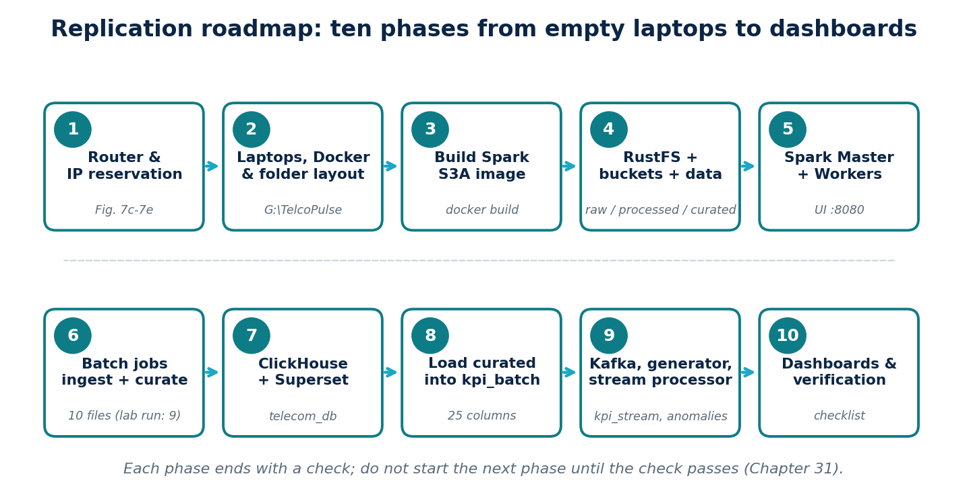
Figure 19 | Replication roadmap
Ten phases; each ends with a check.

31.1 Phase 0: what to prepare before you start
Table 69 | Prerequisites and offline kit
Item | Requirement | Why
Laptops | Six Windows 10/11 laptops that can join one local network | Roles in Table 7c
Router | Any router with DHCP address reservation (HG531 V1 as built) | Stable addresses (Section 4.5)
Docker | Docker Desktop with the WSL 2 backend on every laptop | All services are containers
Shell | PowerShell on Windows; Git Bash or WSL to run setup.sh | Order.txt is PowerShell; setup.sh is bash
Drive layout | A folder G:\TelcoPulse with config, data\rustfs, jobs, jars (change the paths in the compose files if you use another drive) | Compose files mount G:/TelcoPulse/...
Datasets | The ten CSV files named in Listing 76 (Chapter 9 describes their origin) | Raw zone input
Images to pull | apache/spark:3.5.9-scala2.12-java11-python3-r-ubuntu, rustfs/rustfs, apache/kafka:4.1.0, provectuslabs/kafka-ui, clickhouse/clickhouse-server, apache/superset | The router has no Internet (Section 4.4)
JAR files | hadoop-aws-3.3.4.jar and aws-java-sdk-bundle-1.12.262.jar placed in jars | Built into the Spark image
Python packages | kafka-python, numpy, requests on the laptop that runs the generator and the stream processor | Listings 79 and 80

31.2 Phases 1 to 10
Table 70 | Phases 1 to 4: network, laptops, image and object storage
Phase | Do this | Check (expected result) | If it fails
1 | Configure the router and reserve .11 to .16 by MAC (Tables 7b and 7c). Reconnect every laptop. | ipconfig shows the reserved address; the ping matrix of Chapter 5 has no timeouts. | 32.1, 32.2
2 | Install Docker Desktop (WSL 2). Create the folder layout. Open the Windows firewall for the ports of the roles on each laptop (Appendix B). | docker version works on every laptop; folders exist on .11 and .12. | Chapter 6
3 | On the build laptop: docker build -t telcopulse-spark-s3a:3.5.9 . in the folder holding the Dockerfile and jars. To copy the image to other laptops without Internet: docker save -o spark-s3a.tar telcopulse-spark-s3a:3.5.9, then docker load -i spark-s3a.tar on each. | docker run --rm telcopulse-spark-s3a:3.5.9 bash -c "ls /opt/spark/jars | grep -E 'hadoop-aws|aws-java'" lists both JARs. | 32.4
4 | On .12: fill rustfs.env (Listing 67), run docker compose -f rustfs-compose.yml up -d. Open http://192.168.1.12:9001, create buckets raw, processed, curated, upload the ten CSV files into raw. | The console shows ten objects in raw; http://192.168.1.12:9000 answers. | 32.4, 32.11

Table 71 | Phases 5 to 8: Spark, batch jobs, ClickHouse and Superset
Phase | Do this | Check (expected result) | If it fails
5 | On .11: docker compose -f docker-compose_3.yml up -d (Listing 70). On each worker laptop start a Worker container pointed at spark://192.168.1.11:7077 (the README lists .14 and .16 as Spark Workers with Web UI port 8081; worker settings are in Chapter 8, and the worker compose file is not in the repository). Give each executor explicit memory and cores (Section 32.16). | http://192.168.1.11:8080 lists the Workers as ALIVE. | 32.5, 32.16
6 | On .11: load env.ps1 (Listing 82). Smoke test first: run ingest_raw.py and clean_curate.py for one file name. Then run the full commands of Listing 81. | Every INGEST and CLEAN line ends in OK for all ten files. The lab run stopped at the tenth, Dataset_03_NR_3500; its nine files give the totals of Table 68 (31,904,092 rows). Re-run that file alone if it fails. | 32.6 to 32.8, 32.14, 32.16
7 | On .15: copy the ClickHouse/Superset compose file and setup.sh; set passwords (Listings 73, 74). Start the containers, run the DDL of Listing 75 (setup.sh does not create tables), then run the remaining steps of setup.sh: docker exec -i clickhouse-node5 clickhouse-client --user admin --password <your-password> --multiquery < ddl.sql. | http://192.168.1.15:8123/ping returns Ok.; SHOW TABLES FROM telecom_db lists five tables. | 32.10, 32.11
8 | Load the Curated Parquet into kpi_batch. No loader exists in the repository (README roadmap). Adapt the reference loader of Chapter 12.5 to the column names of Listing 75, or leave kpi_batch empty as in the lab. | If you load, SELECT count() FROM telecom_db.kpi_batch is explained by Table 68 (state whether you filtered on has_network_metrics). In the lab the table stayed empty. | 32.14

Table 72 | Phases 9 and 10: streaming, dashboards and acceptance
Phase | Do this | Check (expected result) | If it fails
9 | On .13: docker compose -f docker-compose_2.yml up -d (Listing 72). Open Kafka UI at http://192.168.1.13:8080. On a laptop with Python: set KAFKA_BROKER = "192.168.1.13:9092" in generator.py, run python generator.py; in another terminal run python stream_processor.py. The topic telecom_stream is created on first use or in Kafka UI. First align the stream columns with the DDL (Section 32.17); otherwise the processor prints [CH ERROR]. | Kafka UI shows messages on telecom_stream. After at least five minutes (the 300 s window) SELECT count() FROM telecom_db.kpi_stream is above zero and anomalies receives rows. | 32.9, 32.12, 32.17
10 | Open http://192.168.1.15:8088. Add a ClickHouse connection: clickhousedb://admin:<your-password>@clickhouse:8123/telecom_db (the service name works because both containers share one compose project). The provisioning script is empty in the repository, so create the dashboard and charts in the Superset interface. | Charts load from kpi_stream and anomalies (and kpi_batch if you loaded it). | 32.10, 32.19

31.3 Rebuilding on fewer laptops
Six laptops are not required, but the as-built port map assumes one service per laptop. If you place several services on one machine, two port pairs collide and must be changed in the compose files before you start.
Table 73 | Port conflicts when services share a laptop
Port | Services that both want it | What to change
8080 | Spark Master UI (.11) and Kafka UI (.13) | Publish Kafka UI on another host port, for example "8082:8080".
9000 | RustFS S3 API (.12) and ClickHouse native TCP (.15) | Change the ClickHouse native mapping, for example "9100:9000", or move RustFS to another host.
7078/7079 | Spark driver and block-manager ports versus 7080/7081 published by the job containers | Choose one pair and use it in the conf, in docker run -p and in the firewall.

31.4 Final acceptance checklist
Table 74 | Acceptance checks
Check | How | Expected
Addresses are stable | ipconfig on each laptop after a restart | .11 to .16 unchanged
Object storage reachable from Spark | A job reads s3a://raw/<file>.csv | No S3A exception
Batch counts | clean_out.txt and show_out.txt | Nine files: LTE 18,750,012; NR 7,558,148; GSM 5,595,932; total 31,904,092. With Dataset_03_NR_3500 the NR count is higher (not recorded)
Coverage | show_out.txt | LTE and NR: 279 base stations, 2023-03-03 08:30 to 2025-11-22 23:30; GSM: 263 base stations, from 2025-08-31 23:45
Tables exist | SHOW TABLES FROM telecom_db | kpi_batch, kpi_stream, anomalies, quality_report, benchmark_runs
Stream flows | Kafka UI and SELECT count() FROM telecom_db.kpi_stream | Messages on telecom_stream; rows in kpi_stream once the columns match the DDL
Anomalies detected | SELECT severity, count() FROM telecom_db.anomalies GROUP BY severity | Rows with warning and critical severities
Dashboard opens | http://192.168.1.15:8088 | Superset opens; dashboard built by you (the provisioning script is empty)

CHAPTER 32

Problems, Challenges and Solutions
Every entry below follows the same pattern: the problem, the evidence for it, the solution that the project adopted, and advice for anyone who rebuilds the platform. The evidence line states its source honestly. Log means it is visible in a real run log. Repository means the problem is visible in a repository file. Screenshot means it is visible in a captured screen. Inference means the reason is deduced from the code and should be confirmed by the team.
FACT CHECK Entries are drawn from the repository files, the three real run logs of 21 October 2026 and the router screenshots, not from the team’s memory. Where the reason for a decision is an inference, the entry says so.

32.1 Laptop addresses kept changing
Problem. Spark, Kafka, RustFS and ClickHouse are reached by IP address. With ordinary DHCP a laptop can receive a new address after a restart, and every endpoint in every configuration file silently becomes wrong.
Evidence. Screenshot: the router holds six reservations (Figure 7e) and a one-day lease (Figure 7d). Earlier chapters record that the Master moved from 192.168.1.10 to 192.168.1.11.
Solution. Reserve one IP per laptop by MAC address in the router and keep a single address inventory (Table 7c).
If you rebuild. Reserve before you write any configuration file. After editing reservations, renew leases on every laptop.

32.2 Reserving the wrong network adapter
Problem. A reservation is bound to a MAC address. A laptop has several adapters (Wi-Fi, Ethernet, VMware, Bluetooth), and only one carries traffic.
Evidence. Screenshot: getmac /v lists Wi-Fi, two VMware adapters, Ethernet marked Media disconnected, and Bluetooth (Figure 7f). The Wi-Fi MAC equals reservation 1 (.11) in Figure 7e.
Solution. Reserve the MAC of the adapter that is connected, and read it with getmac /v instead of guessing.
If you rebuild. Disable Windows random hardware addresses for the lab network and update the reservation if you change from Wi-Fi to Ethernet.

32.3 A router without Internet access
Problem. Container images, the S3A JARs and Python packages must be downloaded, but the lab network had no working uplink.
Evidence. Screenshot: both WAN connections are Disconnected (Figure 7b). Inference: the cluster was used as an isolated LAN.
Solution. Prepare an offline kit (Table 69) and move images between laptops with docker save and docker load.
If you rebuild. Download everything while you still have Internet; test a clean pull-free rebuild before demonstration day.

32.4 Spark cannot talk to S3-compatible storage out of the box
Problem. The stock Spark image has no S3A connector, so s3a:// paths fail even though RustFS is running.
Evidence. Repository: the Dockerfile copies hadoop-aws-3.3.4.jar and aws-java-sdk-bundle-1.12.262.jar into /opt/spark/jars (Listing 69).
Solution. Build one custom image, telcopulse-spark-s3a:3.5.9, and use it for the Master, the Workers and every job container. The versions match the Hadoop 3.3.4 line that Spark 3.5 ships with.
If you rebuild. Never mix connector versions. A ClassNotFoundException for the S3A file system or a NoSuchMethodError usually means mismatched JARs. Copy the same image to every laptop.

32.5 Spark nodes on different laptops must reach the driver
Problem. In client mode the executors connect back to the driver and its block manager. Inside Docker the default addresses are container addresses that other laptops cannot reach.
Evidence. Repository: spark.driver.host is the LAN address of the Master laptop, with a bind address of 0.0.0.0 and pinned ports (Listing 68); the Master compose publishes 7077, 8080, 7078 and 7079 (Listing 70). Order.txt publishes 7080, 7081 and 4040 for job containers, and the logs show the driver on port 7080 and the block manager on 192.168.1.11:7081, so the job containers override the 7078/7079 pair.
Solution. Advertise the laptop LAN address as the driver host and pin the driver and block-manager ports so they can be published and opened in the firewall.
If you rebuild. The four spark.master.* lines in the supplied conf are not Spark properties and do nothing; the Master is configured by its command arguments. Keep one port pair across conf, docker run -p and the firewall, and run job containers on the laptop named as spark.driver.host.

32.6 One big job versus small restartable jobs
Problem. Reading ten CSV files, unioning them and writing one table is a single long job: any failure restarts everything, and a failure gives little information about which file caused it.
Evidence. Repository: batch_all_10.py (Listing 78) unions all ten files and repartitions to 12. It was followed by ingest_raw.py and clean_curate.py (Listings 76, 77), which take file names as arguments and verify the row count of every file. Inference: this is why the pipeline was split.
Solution. Process one file at a time, verify rows_in against rows_out, and write logs to files (Listing 81).
If you rebuild. Always smoke-test one file first. Keep the per-file design; it makes re-runs cheap and failures easy to locate.

32.7 2G, 4G and 5G files do not share a schema
Problem. The metric columns carry a technology prefix (4G , 5G , 2G ). A plain union produces a wide table that is mostly empty.
Evidence. Repository: clean_curate.py selects metric columns by prefix, strips the prefix, converts names to snake_case and writes one Curated folder per technology (Listing 77).
Solution. Curate each technology separately into a common naming scheme and add a has_network_metrics flag.
If you rebuild. Decide the common column names before loading ClickHouse; Listing 75 shows the target names.

32.8 Dirty data without losing evidence
Problem. The CSV files contain empty cells, non-numeric text, timestamps that do not parse and repeated keys.
Evidence. Repository: the files are read as strings (inferSchema=false); the job counts empty, non-numeric, timestamp and key problems and reports duplicate keys as kept, not deleted (Listing 77). Log: the audit found no timestamp or key problems and no non-numeric values, but 722,137 duplicate keys (1,078,375 surplus rows) in each Dataset_02 file and only 690,402 and 690,514 of 1,800,920 rows carrying any metric (Table 68b).
Solution. Report every quality problem, delete nothing silently, and let later layers decide. Overall 85.5 percent of Curated rows carry network metrics (Table 68).
If you rebuild. Keep reporting duplicates even if you later choose to remove them. Remove or flag the Dataset_02 duplicates before any average, sum or count, otherwise totals are inflated by up to 60 percent for those files.

32.9 Kafka reachable inside Docker but not from other laptops
Problem. A broker that advertises only its container name can be reached by containers on the same host and by nobody else.
Evidence. Repository: the early kafka-sim advertises kafka-sim:9092; the working broker defines separate INTERNAL and EXTERNAL listeners, and EXTERNAL advertises 192.168.1.13:9092 (Listing 72).
Solution. Use two listeners: INTERNAL for containers (Kafka UI uses kafka:29092) and EXTERNAL with the LAN address for laptops.
If you rebuild. Set the EXTERNAL address to the Kafka laptop address before starting the broker. A client that connects and then fails is almost always an advertised-listener mistake.

32.10 Superset has no ClickHouse driver
Problem. The Superset image cannot connect to ClickHouse until a driver is installed, and the image is re-created from scratch whenever the container is removed.
Evidence. Repository: setup.sh runs pip install clickhouse-connect inside the running container and then fixes permissions (Listing 74).
Solution. Install the driver after start-up as part of a one-command script.
If you rebuild. Better: build a small image that already contains the driver. As built, re-creating the container silently removes it. Also replace the default administrator password and the secret key.

32.11 Persisting container data on Windows
Problem. Databases and object stores lose their data if it lives only inside a container, and Windows bind mounts can run into permission problems.
Evidence. Repository: ClickHouse and Superset use ./ch_data, ./ch_logs and ./superset_home, and setup.sh applies chmod -R 777; RustFS stores data on G:/TelcoPulse/data/rustfs (Listings 71, 73, 74).
Solution. Mount host folders for every stateful service.
If you rebuild. Use the narrowest permissions that work, because 777 is a lab shortcut. Keep the data folders out of version control.

32.12 One HTTP request per streamed row
Problem. ClickHouse is designed for large batched inserts. Sending each row as its own request creates many small parts and limits throughput.
Evidence. Repository: ch_insert posts one row per call with a five-second timeout (Listing 80).
Solution. Accept this for a synthetic stream of modest volume; it keeps the code very simple.
If you rebuild. For higher volumes batch rows (for example hundreds per request), or use the Kafka table engine or Spark. Measure with the benchmark table before choosing.

32.13 Unpinned container images
Problem. Tags such as latest change over time, so a rebuild next year may behave differently from the original build.
Evidence. Repository: RustFS, ClickHouse, Superset, Kafka UI and kafka-sim use latest; only Spark (3.5.9) and the main Kafka broker (4.1.0) are pinned (Listings 69 to 73).
Solution. None in the repository; the lab worked with the images available at build time.
If you rebuild. Pin every image to the version you actually ran, and record the digests.

32.14 Numbers that do not add up
Problem. The earlier Processed result (34,117,453 rows), the Curated total (31,904,092 rows) and the claim of ten source files cannot all be true at once.
Evidence. Log: show_out.txt lists nine source files and no Dataset_03_NR_3500; the recorded ingest command also omits Dataset_01_LTE_2100, which had been ingested earlier. Repository: the README says the two intermediate and curated counts are not comparable, because batch_all_10.py writes a different dataset.
Solution. Report the Curated total as nine files, explain the missing file (Section 32.16) and never describe the earlier Processed figure as a before-cleaning count.
If you rebuild. Treat an unexplained count as a defect. Keep the logs and quote the number of files with every row count.

32.15 Credentials in configuration files
Problem. Configuration files hold access keys, passwords and secret keys. Anything committed to a repository or pasted into a document is exposed.
Evidence. Repository: lab credentials appear in the RustFS environment file, both compose files and the stream processor, and setup.sh creates an administrator with a default password. Identical values are used for the RustFS key and secret.
Solution. This book replaces every secret with a placeholder.
If you rebuild. Generate your own values, keep them in an untracked .env file or environment variables, add that file to .gitignore, and rotate any value that has ever been committed.

32.16 The tenth file failed: executors lost during ingestion
Problem. Dataset_03_NR_3500.csv never reached the Processed zone, so the Curated layer is missing one of ten files.
Evidence. Log: ingest_out.txt reports executors lost with the message that no heartbeat arrived for 60 seconds, the driver then warns that the connection to 0.0.0.0:7077 failed and that it is disconnected from the cluster, and the next executor loss cites containers exceeding thresholds or network issues. The log ends on file 9 of 9. clean_out.txt then stops on the same file with UNABLE_TO_INFER_SCHEMA. The executors ran on container addresses 172.17.0.2 and 172.17.0.3 with 2 cores and 1024 MB each. Inference: memory or Wi-Fi pressure on the worker laptops, and a Master that advertises 0.0.0.0.
Solution. The pipeline is restartable by design: only that file needs to be re-run. The lab run left it unprocessed, and the book reports nine files.
If you rebuild. Start the Master with its LAN address instead of 0.0.0.0, give executors explicit memory and cores, use Ethernet for the workers, then run ingest_raw.py Dataset_03_NR_3500 and clean_curate.py Dataset_03_NR_3500 and finally show_curated.py. Check for FetchFailed, OutOfMemory and Lost executor in the log (the pattern in Listing 81).

32.17 The stream processor and the ClickHouse tables disagree
Problem. The processor posts rows whose fields are not in the tables, so the inserts are expected to be rejected.
Evidence. Repository: build_kpi_row sends frequency_band, radio_quality_cqi, radio_unit_energy, baseband_energy, data_source, is_synthetic and generation_version, but kpi_stream defines throughput, packet-loss and latency columns instead. Anomaly rows carry event_timestamp, pipeline, detection_method, is_synthetic and injected_label, while anomalies defines detected_at. ClickHouse rejects unknown JSON fields by default. Inference: the live tables were changed by hand, or the inserts failed and printed [CH ERROR]; the repository does not say which.
Solution. None in the repository.
If you rebuild. Make the DDL match the code (add the missing columns) or make the code emit the DDL columns. As a quick workaround add input_format_skip_unknown_fields=1 to the insert URL. Confirm with SELECT count() FROM telecom_db.kpi_stream after one minute of streaming.

32.18 The batch layer never reaches ClickHouse
Problem. kpi_batch, quality_report and benchmark_runs exist but nothing fills them, so dashboards over historical data have no source.
Evidence. Repository: the README marks the load job as planned and says the quality and benchmark tables are not populated; no loader script is present.
Solution. Left as roadmap items.
If you rebuild. Write the loader before building historical dashboards. Choose the filter on has_network_metrics deliberately, because 14.5 percent of Curated rows carry no metrics (Table 68).

32.19 The dashboard script is empty
Problem. The setup script announces a ready dashboard that does not exist.
Evidence. Repository: Superset/provision_dashboard.py is 0 bytes; setup.sh reads superset/provision_dashboard.py (lower case) while the empty file is in Superset/; superset_config.py is not mounted by the compose file.
Solution. None; the empty file means step 5 of setup.sh does nothing on Windows and fails on a case-sensitive system.
If you rebuild. Create the database connection and charts in the Superset interface, or write the provisioning script, and keep one folder name. Never describe the dashboard as automated until the script has content.

32.20 A required file is missing from the repository
Problem. env.ps1 defines the Spark arguments and the S3A settings, but it is not in the repository, although the README and Order.txt depend on it.
Evidence. Repository: Order.txt and the README both source env.ps1; spark-defaults.conf contains no S3A settings. Log: the driver, block-manager and master values are visible in the logs.
Solution. Listing 82 reconstructs the file from the logs and Listing 81.
If you rebuild. Commit a sanitised env.ps1 (secrets read from environment variables) next to the jobs.

32.21 Log files that look broken
Problem. The three log files open as garbage in many editors and begin with a PowerShell error.
Evidence. Log: all three files are UTF-16 little-endian with CRLF line ends, and start with NativeCommandError because Windows PowerShell treats Spark messages on standard error as errors.
Solution. The key lines are still found with Select-String, as in Listing 81.
If you rebuild. Redirect with cmd /c or Out-File -Encoding utf8 to get plain UTF-8 files, and ignore the first error block.
CHAPTER 33

Features, Advantages and Disadvantages
This chapter summarises the platform honestly: what it can do, where it is strong, where it is weak, and what you should expect if you rebuild it. Every claim can be traced to a listing, a screenshot or a recorded figure.

33.1 Feature catalogue
Table 75 | Features of the platform
Area | Feature | Where
Network | Six laptops on one router with fixed addresses through MAC reservations | Tables 7a to 7c
Containers | One custom Spark 3.5.9 image with S3A; every service runs as a container | Listings 69 to 73
Storage | S3-compatible object storage (RustFS) with raw, processed and curated buckets | Listings 67, 71
Batch | Per-file ingestion and curation with row-count verification and per-technology schemas | Listings 76, 77
Data quality | Counts of empty, non-numeric, timestamp and key problems; duplicates reported, never silently removed | Listing 77
Scale | Curated output of 31,904,092 rows (LTE, NR, GSM) from nine files, 279 base stations (LTE, NR) and almost three years of history | Table 68
Streaming | Synthetic RAN generator for four sites, Kafka transport, Python consumer | Listings 72, 79, 80
Anomalies | Four rules with warning, critical and info levels and numeric scores (writes depend on the schema fix of Section 32.17) | Listing 80
Analytics | ClickHouse with five tables (batch, stream, anomalies, quality, benchmark) | Listing 75
Visualisation | Superset with the ClickHouse driver installed by a one-command setup (the dashboard script itself is empty) | Listing 74

33.2 Advantages
Table 76 | Advantages
Advantage | Why it matters | Evidence
Real distributed cluster | Spark work runs across physical machines, so networking, ports and data locality are experienced rather than simulated | Listings 68, 70
Cheap and reproducible | Ordinary laptops, a consumer router and open-source software | Chapter 31
Restartable batch jobs | Any file can be re-processed alone, and every file is verified | Listings 76, 77
Honest data handling | Problems are counted and reported; nothing is dropped without a record | Listing 77
Fast analytical queries | Columnar ClickHouse tables sorted for the dashboard filters | Listing 75
Two complete paths | Historical batch and live streaming both reach the same database and dashboards | Chapters 12 and 15
Fully containerised | Services are started with compose files; setup is scripted | Listings 70 to 74
Documented evidence | Screenshots, real run logs and per-file audit counts support the claims | Chapter 4, Tables 68 to 68b

33.3 Disadvantages and limitations
Table 77 | Limitations and how to mitigate them
Limitation | Impact | Mitigation
Plain-text secrets and default administrator | Anyone with the files or LAN access can log in | Environment files, strong generated values, rotation (Section 32.15)
HTTP everywhere, no TLS | Traffic and logins can be read on the LAN | Keep the lab isolated; add TLS before any wider use
Single Kafka broker, single Spark Master, one ClickHouse node | Any one failure stops that layer | Replication and standby masters for production
One HTTP insert per streamed row | Limits streaming throughput and stresses ClickHouse parts | Batch inserts or Kafka engine (Section 32.12)
Unpinned images | A later rebuild may differ | Pin versions and record digests (Section 32.13)
Superset driver not persistent | Dashboards break after the container is re-created | Custom image with the driver (Section 32.10)
Windows laptops and Wi-Fi | Interference and variable speed | Use Ethernet where possible; treat benchmarks as relative
Synthetic stream | Real operator traffic has a different volume and burstiness | State this wherever results are shown
Partly manual steps | DDL, workers, loader and datasets are not in one script | Follow Chapter 31 and script the manual parts
Tenth file not curated | Dataset_03_NR_3500 failed at ingestion; NR and the total are understated | Re-run that file alone (Section 32.16)
Code and schema disagree | Stream inserts are expected to be rejected until columns match | Align DDL and processor (Section 32.17)
No batch loader, empty dashboard script | kpi_batch stays empty; no automated dashboard | Write both (Sections 32.18, 32.19)
Duplicates kept | Dataset_02 files hold 1,078,375 surplus rows each | Flag or remove before aggregating (Section 32.8)

33.4 What you will achieve if you follow this book
Table 78 | Expected outcomes and how to verify them
Outcome | Expected result | How to verify
Stable six-node network | Six fixed addresses .11 to .16 | ipconfig, ping matrix
Working cluster | Master with live Workers; jobs run across laptops | Spark UI on port 8080
Curated data lake | 31,904,092 rows from nine files in three technologies (more once NR_3500 is processed) | show_out.txt, Table 68
Analytical database | Five tables in telecom_db | SHOW TABLES FROM telecom_db
Live stream with alerts | Rows in kpi_stream and anomalies | SQL counts after at least five minutes
Dashboards | Charts you build in Superset over ClickHouse tables | Superset interface

33.5 Hardening roadmap
Table 79 | Recommended improvements, in priority order
Priority | Improvement | Reason | Effort
1 | Process Dataset_03_NR_3500 and re-run the profiling job | Complete the ten-file dataset | Low
1 | Align the stream processor with the ClickHouse DDL | Streaming inserts | Low
1 | Remove secrets from files; rotate every committed value | Security | Low
2 | Pin all image versions | Reproducibility | Low
3 | Bake the ClickHouse driver into a Superset image | Reliability | Low
4 | Batch the stream inserts | Throughput | Medium
5 | Write the Curated-to-ClickHouse loader, the provisioning script and a sanitised env.ps1; script workers and DDL | One-command rebuild | Medium
6 | Flag Dataset_02 duplicates and report file counts with every total | Auditability | Low
7 | Add TLS and authentication to Kafka, RustFS and ClickHouse | Security | High
8 | Add broker, master and database redundancy | Availability | High

33.6 Verdict
TelcoPulse is a convincing teaching and demonstration platform: it exercises a real distributed Spark cluster, an object store, a message broker, a columnar database and a dashboard layer on commodity hardware, and its batch jobs document their own data-quality decisions. It is not a production system, and it is not yet complete. The honest status is: the batch path worked for nine of ten files; the stream is generated and carried by Kafka, but its ClickHouse inserts need the schema fix; the batch load, the benchmark tables and the dashboard are still to be built. Close the gaps listed in Table 79 and say so plainly wherever results are shown.
APPENDIX A

Project Directory and File Inventory
Listing 62 | Project tree (G:\TelcoPulse)
Layout of the reference deployment. The root and the folders config, data, docker, jobs, docs and logs are the recorded project folders.
G:\TelcoPulse
config\ hosts.env, spark-defaults.conf
data\ raw source files, rustfs data directory (earlier: data\minio)
docker\ spark\ rustfs-kafka\ clickhouse\ superset\ generator\
jobs\ common.py, batch_ingest_process.py, batch_curate.py,
load_clickhouse_batch.py, verify_curated.py, event_generator.py,
stream_kpi.py, anomaly_common.py, benchmark_runner.py,
s3a_cluster_test.py
sql\ 01_create_tables.sql, 02_support_objects.sql,
03_anomaly_batch.sql, 04_quality_stream.sql
scripts\ submit_batch.sh, submit_stream.sh, create_topic.sh, run_generator.ps1
powershell\ firewall.ps1, healthcheck.ps1, wslconfig.txt
docs\ this book, Superset dashboard exports
logs\ run logs

Table 57 | Recorded historical script names
Name | Corresponds to
/tmp/s3a_smoke_test.py | S3A smoke test (precursor of s3a_cluster_test.py)
/tmp/one_file_test.py | Single-file read test
/tmp/test_rustfs_batch.py | RustFS batch test reading s3a://raw/Dataset_01_LTE_2100.csv
/tmp/batch_all_10.py | Ten-file batch (application TelcoPulse-Batch-10-Files); corresponds to batch_ingest_process.py
docker\spark\test_s3a_cluster.py | Distributed S3A test; corresponds to s3a_cluster_test.py

APPENDIX B

Network and Service Inventory
Table 58 | Service endpoints (latest configuration)
Component | Endpoint
Spark Master | 192.168.1.11:7077; UI 8080; driver 7078, 7079; app UI 4040
Spark Worker | tp-spark-worker1 (and further workers): UI 8081; executor range 7100-7120
RustFS S3 API | http://192.168.1.12:9000; console 9001
Kafka | 192.168.1.12:9092; topic telco.events
ClickHouse HTTP | 192.168.1.15:8123; native 9000; database telecom_db
Superset | http://<SUPERSET_HOST>:8088
Laptop addresses | 192.168.1.11 to 192.168.1.16

Worker, Superset and generator laptops are drawn from .13, .14 and .16 and recorded in config/hosts.env.
DESIGN HISTORY Superseded values, kept for reference only: Spark Master 192.168.1.10 (bind 0.0.0.0, port 7077, UI 8080); S3A endpoint http://192.168.1.11:9000; the proposed range 192.168.1.10 to 192.168.1.15.
APPENDIX C

Docker and Deployment Commands
Listing 63 | Windows PowerShell: inspect and control containers
Environment: Windows PowerShell in G:\TelcoPulse.
docker ps
docker ps -a
docker logs tp-spark-master --tail 100
docker logs tp-spark-worker1 --tail 100
docker inspect tp-spark-worker1 --format "{{.HostConfig.NetworkMode}}"
docker compose -f docker/spark/compose.master.yml up -d
docker compose -f docker/spark/compose.master.yml down
# DESTRUCTIVE: "down -v" deletes named volumes and the data in them

Listing 64 | Container shell
Environment: first line in PowerShell; the others inside the container (Linux).
docker exec -it tp-spark-master bash
ls /opt/spark/jars | grep -E "hadoop-aws|aws-java|kafka"
env | grep -E "AWS_|CH_" | sed "s/=.*/=<hidden>/"

All Compose templates are listed in Chapter 7 and shipped in the companion assets under docker/.
APPENDIX D

Spark Configuration and Job Submission
Table 59 | spark-submit parameters
Parameter | Meaning | Reference value
--master | Cluster endpoint | spark://192.168.1.11:7077
--name | Application name | TelcoPulse-Batch-10-Files (and others in Chapter 12)
--executor-cores | Cores per executor | 2
--executor-memory | Memory per executor | 2g
--total-executor-cores | Cap across the cluster | 4
--py-files | Helper modules | common.py, anomaly_common.py

The submission scripts are listed in Chapter 8. The configuration file is in spark/spark-defaults.conf.
APPENDIX E

S3A and RustFS Configuration
Table 60 | S3A properties
Property | Value
spark.hadoop.fs.s3a.endpoint | http://192.168.1.12:9000 (latest); earlier test: http://192.168.1.11:9000
spark.hadoop.fs.s3a.path.style.access | true
spark.hadoop.fs.s3a.connection.ssl.enabled | false
spark.hadoop.fs.s3a.aws.credentials.provider | org.apache.hadoop.fs.s3a.SimpleAWSCredentialsProvider
spark.hadoop.fs.s3a.access.key / secret.key | From AWS_ACCESS_KEY_ID and AWS_SECRET_ACCESS_KEY; never published

Table 61 | Bucket layout
Bucket | Content
raw | Dataset_*.csv (ten source files); early test object raw/test.txt
processed | <technology>/ Parquet; _checkpoints/ for streaming
curated | <technology>/dt=<date>/ Parquet

APPENDIX F

Code Listings Index
The code of the reference implementation is listed in the chapters where it is explained and shipped in TelcoPulse_Project_Assets.zip.
Table 62 | Code index
File | Purpose | Chapter
jobs/common.py | Spark session, ClickHouse client, run ids | 12
jobs/batch_ingest_process.py | Raw to Processed | 12
jobs/batch_curate.py | Processed to Curated and quality accounting | 12, 14
jobs/load_clickhouse_batch.py | Curated to kpi_batch | 12
jobs/verify_curated.py | Read-back validation | 13
jobs/event_generator.py | Synthetic events to Kafka | 15
jobs/stream_kpi.py | Structured Streaming job | 16
jobs/anomaly_common.py | Streaming anomaly detector | 18
jobs/benchmark_runner.py | Benchmark recording | 28
jobs/s3a_cluster_test.py | Distributed S3A test | 8
sql/01 to 04 | Tables, support objects, batch anomalies, stream quality | 14, 17, 18
docker/, scripts/, powershell/ | Deployment and operation | 7, 8, 15

APPENDIX G

ClickHouse Schemas and SQL
The complete DDL is Listing in Chapter 17 (sql/01_create_tables.sql); support objects are in sql/02_support_objects.sql. Useful administration queries:
Listing 65 | Administration queries (ClickHouse SQL)
Environment: clickhouse-client or SQL Lab.
SHOW TABLES FROM telecom_db;
SHOW CREATE TABLE telecom_db.kpi_batch;
SELECT table, sum(rows) AS rows, formatReadableSize(sum(bytes_on_disk)) AS size
FROM system.parts WHERE database = 'telecom_db' AND active GROUP BY table;
OPTIMIZE TABLE telecom_db.kpi_stream FINAL; -- merges parts; use sparingly

APPENDIX H

Dashboard Inventory
Table 63 | Dashboard inventory
Dashboard | Source | Datasets | Refresh
1 Executive Overview | pipeline_inventory, kpi_batch_v, quality_report, kpi_stream, anomalies | ds_inventory, ds_compare, ds_quality_latest, ds_stream_health, ds_anoms_24h | 5 min
2 RAN Performance | kpi_batch_v | ds_ran_hourly, ds_ran_busyhour | Off
3 Streaming Monitor | kpi_stream | ds_stream_trend, ds_stream_scenarios | 30 s
4 Anomaly Detection | anomalies | ds_anomalies, ds_anom_eval | 60 s
5 Data Quality | quality_report | ds_dq_latest, ds_dq_runs, ds_dq_overall | Off
6 Platform Benchmarking | benchmark_runs | ds_bench, ds_bench_by_workers | Off

APPENDIX I

Deployment and Reproducibility Checklist
- Six Windows 10/11 laptops with Docker Desktop (WSL 2 backend) and .wslconfig applied.
- Router set for local network use; laptops addressed 192.168.1.11 to 192.168.1.16; ping passes between all.
- config/hosts.env created; secrets set outside version control.
- Firewall rules added on every laptop for its role ports.
- Build telcopulse-spark-s3a:3.5.9; start Spark Master on .11 and Workers on the worker laptops.
- Start RustFS and Kafka on .12; create buckets raw, processed, curated; create topic telco.events.
- Start ClickHouse on .15; confirm the five tables and support objects exist.
- Upload the ten Dataset_*.csv files to raw.
- Run s3a_cluster_test.py; run submit_batch.sh; run verify_curated.py.
- Compare Curated counts with 18,750,012, 7,558,148, 5,595,932 and 31,904,092.
- Start the generator and submit_stream.sh; confirm rows in kpi_stream and anomalies.
- Start Superset; connect to ClickHouse; create the datasets; assemble the six dashboards and perform each validation step.
- Run the benchmark experiments and record them.

APPENDIX J

Glossary and References
Table 64 | Glossary
Term | Meaning
Bucket / object | Container and item in S3-style storage
Checkpoint | Saved streaming progress (offsets and state)
Curated | Final cleaned data zone
Executor | Process running Spark tasks
KPI | Key performance indicator
Parquet | Columnar file format
Processed | Intermediate data zone
Raw | Original data zone
S3A | Hadoop connector for S3-compatible storage
WSL 2 | Windows Subsystem for Linux, version 2
Watermark | Bound on how late streaming data may arrive
Z-score | Deviation from a mean in standard deviations
Advertised listener | Address Kafka returns to clients for connections

References
- Apache Spark documentation: https://spark.apache.org/docs/latest/
- Apache Kafka documentation: https://kafka.apache.org/documentation/
- ClickHouse documentation: https://clickhouse.com/docs
- Apache Superset documentation: https://superset.apache.org/docs/intro
- Docker documentation: https://docs.docker.com/
- WSL documentation: https://learn.microsoft.com/windows/wsl/
- Hadoop S3A (hadoop-aws): https://hadoop.apache.org/docs/stable/hadoop-aws/tools/hadoop-aws/index.html
- RustFS: official project documentation (use the release matching the chosen image tag)
- Dataset: "Performance Management Counters from Live 5G, 4G and 2G Radio Access Network" (publisher page and licence as cited by the dataset)

APPENDIX K

Operations Runbooks

K.1 Daily start-up
- ClickHouse laptop: docker compose -f docker/clickhouse/compose.yml up -d.
- RustFS/Kafka laptop: docker compose -f docker/rustfs-kafka/compose.yml up -d.
- Master laptop, then Worker laptops: bring up the Spark Compose files; confirm Workers on http://192.168.1.11:8080.
- Run healthcheck.ps1.
- Start Superset.

K.2 Re-running the batch pipeline
Listing 66 | Full reload (Linux shell inside tp-spark-master)
Run after the Master and Workers are healthy. The load step truncates kpi_batch.
/opt/telcopulse/scripts/submit_batch.sh # ingest, curate, load with --truncate
/opt/spark/bin/spark-submit --py-files /opt/telcopulse/jobs/common.py \
/opt/telcopulse/jobs/verify_curated.py

K.3 Starting and stopping streaming
- Start the job with submit_stream.sh; start the generator.
- To stop: stop the generator, then stop the job (Ctrl+C in its shell or kill the application in the Master UI).
- To reprocess from scratch only: stop the job, delete the checkpoint path in processed/_checkpoints/stream_kpi, truncate kpi_stream and anomalies if required, restart.

K.4 Backup and recovery
Table 65 | Backup and recovery
Asset | Backup | Recovery
RustFS data directory | Copy the host data folder while RustFS is stopped | Restore the folder and restart
ClickHouse | clickhouse-client export or volume copy while stopped | Restore volume; sql/ re-creates missing tables
Superset | Dashboard export ZIP; superset-home volume | Import the export or restore the volume
Configuration and code | Version control of config/, jobs/, sql/, docker/ (without secrets) | Check out and redeploy

K.5 Rotating credentials
- Create new RustFS and ClickHouse credentials.
- Update the shell environment or private .env files on the Master, RustFS and ClickHouse laptops.
- Recreate the affected containers; re-enter the password in the Superset database connection.
- Invalidate the old keys.

