# User Authentication:

* Log in using username and password.
* Consider implementing a password change function along with a user profile page if time permits.

**Admin Sidebar:**

* Dashboard
* Students
* Staff
* Clubs & Activities
* Budget
* Inventory

**Admin Dashboard:**

*(Already finished, no changes)*

**Students & Teachers:**

*(No Sidebar)*

**Teachers Dashboard:**

* Club list (table)
* Activities List (Table)
* Create activity button
* All activities button

**Parents Dashboard:**

* Club table OR enroll club button (if no club joined yet)
* Activities table
* External activities table
* Submit external activities button

# Administration:

**Club Creation:**

* Admin selects club category.
* Admin inputs club information based on ERD (name, description, capacity).
* Admin assigns initial budget.

**Advisor Assignment:**

* Admin assigns club advisors (via button next to each club).
* Admin checks the advisors for each club.

**Student and Staff Management:**

* Admin can view a list of all students.
* Admin can view a list of all staff and the supervised clubs for each member of staff.

**Activity Management:**

* Admin can view a list of all activities for each club.
* Admin can approve activity budgets.

**Financial Management:**

* Admins can update club budgets by borrowing from other clubs.
* Admin can approve activity budgets.

**Inventory Management:**

* Admin can access and update inventory.
* Edit button available for modifications.
* Report button generates a comprehensive Inventory Report (*report name is InventoryReport_*date*).

**Reporting:**

* Admin can generate reports on club and activity budgets and inventory.

# Staff/ Teacher

**Teacher Dashboard:**

* View clubs assigned to them (with a student list button for each club, displayed in a table).
* Inside each student, display the activities and external activities they are involved in.

**Current Activities Table:**

* View activity details.
* Record attendance using checkboxes (with a list of students inside that club).
* Upload documentation.
* Bottom left of the table: View all activities.
* Bottom right of the table: Create new activities.

*Note: Activities with dates that have passed will not be displayed in the table.*

**Create Activities:**

* Activity name
* Start/End date
* Description
* Requested budget
* Club

*Validation: If the activity date has passed, it will not be displayed in the table.*

# Parent

**Parent Dashboard:**

* View a list of all clubs their child is a member of
* View a list of all activities their child is participating in.
* View a list of all external activities.

**Start of Year:**

* Assign their child to a club per category if the child has not joined any club yet.

**Submit External Activities:**

Button to submit external activities with the following details:

* Activity name
* Description
* Start/End date
* Evidence (no approval required by teachers)

# Inventory Table:

* Equipment Name
* Equipment Description
* Equipment Quantity

# Flow Chart:

**Administrator:**

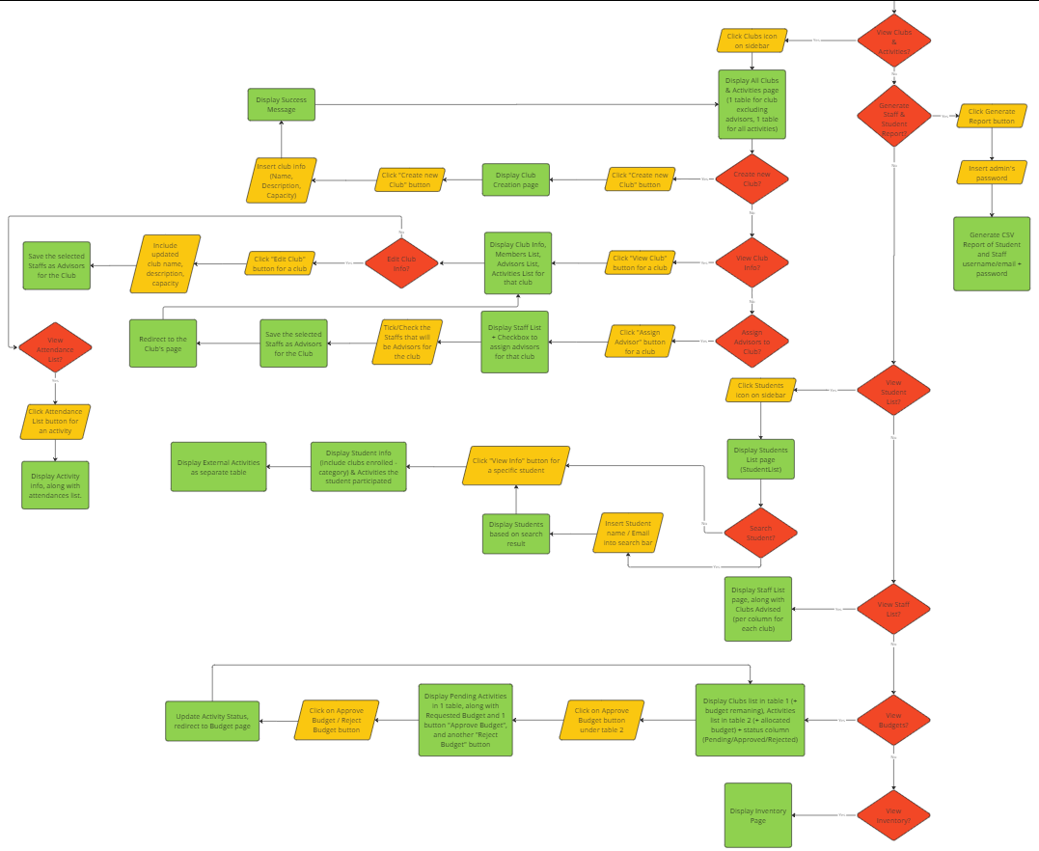

**Staff:**

**Parent:**