

Database final project

Car rental system

Mohannad Bashar | 6656

Youssef Victor | 6668

Ahmed Abdulkabier | 6669

Mohamed Medhat Zayton | 6670

# Business logic

The application flow goes as follows:

* Customers are able to sign up and login into the application.
* They can view all the cars in the system.
* They can also search with specific car attributes.
* They can reserve the car they like, if it’s available.
* Then, when the customer goes to the office and take the car, an admin in the office will mark the car as “picked up”.
* When the customer returns the car back to the office, an admin will mark it as “returned”. A car won’t be available for renting if it’s picked up but not yet returned.
* An admin can record a reservation payment anytime.
* Each car is associated with an office.
* Each car has a status, active or out of service.
* An active car is available for rental unless it’s already picked up and not yet returned.
* An out of service car is in “maintenance” mode, hence can’t be reserved.
* Customers can search in cars, offices, and their own reservations.
* An admin can search in cars, offices, and all reservations.
* An admin can add/edit/search cars, add/edit/search offices, search customers, and mark reservations as picked up, returned, and paid.
* An admin can view some reports:
* Show all reservations within a specified period.
* Show all reservations of any car within a specified period
* Show status of all cars on a specific day (active/out of service)
* Show all reservations of specific customer
* Show daily payments within a specific period

## Application screens

**Home page:**

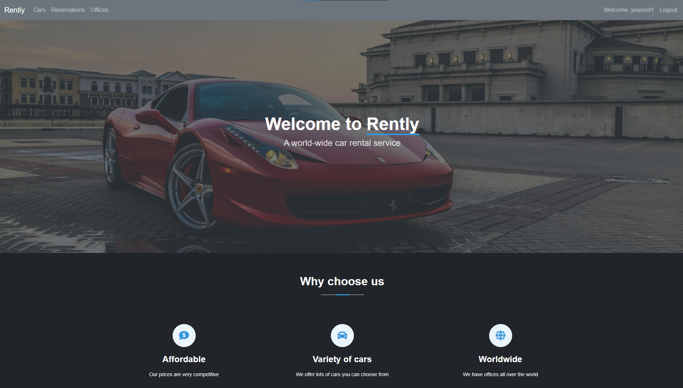

**Login page:**

**Signup page:**

**Cars page:**

**Reservations page:**

**Offices page:**

**Customers page: (admin only)**

**Reports pages: (admin only)**