close all;
clear;
[file, path] = uigetfile('*.wav');
fullFileName = fullfile(path, file);
[data, original_fs] = audioread(fullFileName);
disp('File information:');
disp(['Path: ' fullFileName]);
disp(['Data dimensions: ' mat2str(size(data))]);
disp(['Frequency: ' num2str(original_fs)]);
bands = get_bands();
fs = original_fs;
if bands(end, end) >= fs / 2
margin = 11;
fs = 2 * (bands(end, end) + margin);
data = resample(data, fs, original_fs);
end
gains = zeros(1, length(bands));
for i = 1:length(bands)
gains(i) = get_number(['Enter gain for ' mat2str(bands(i,:)) 'Hz (between -20 dB and 20 dB): '], @(x) x >= -20 && x <= 20);
end
filter_type = get_string('Enter filter type ("fir" or "iir"):', @(x) strcmp('fir', x) || strcmp('iir', x));
output_fs = get_number('Enter a valid output sample rate: ', @(x) x > 340);
if strcmp('fir', filter_type)
fir_order = 150;
filters = fir_filters(fir_order, fs, bands);
else
iir_order = 4;
filters = iir_filters(iir_order, fs, bands);
end
acc_filtered = data .* 0;
freq_range_plt = [' 0-170 Hz'; '170-310 Hz'; '310-600 Hz'; '0.6-1 kHz'; '1-3 kHz'; '3-6 kHz'; '6-12 kHz'; '12-14 kHz'; '14-16 KHZ'];
for i = 1:length(filters)
plot_requirements(filters(i), fs, [mat2str(bands(i,:)) 'Hz']);
filtered = filter(filters(i).Numerator, filters(i).Denominator, data);
plot_time_frequency_domain(filtered, fs, ['Output in time-domain for filter ' freq_range_plt(i,:)], ['Output in frequency-domain for filter ' freq_range_plt(i,:)]);
acc_filtered = acc_filtered + filtered * db2mag(gains(i));
[z, p, k] = tf2zpk(filters(i).Numerator, filters(i).Denominator);
order = filtord(filters(i).Numerator, filters(i).Denominator);
fprintf('The gain of %s filter : %s is %f , Order is %d \n',filter_type, freq_range_plt(i,:), k, order);
end
acc_filtered = resample(acc_filtered, output_fs, fs); % resample to the output fs
plot_time_frequency_domain(data, original_fs, 'Input in time ', 'Input in freq. ', acc_filtered, output_fs, 'Output in freq.', 'Output in time.');
[file, path] = uiputfile('*.wav');
fullFileName = fullfile(path, file);
audiowrite(fullFileName, acc_filtered, output_fs);
File information:
Path: D:\SSP\term 6\DSP\CantinaBand60.wav
Data dimensions: [1323000 1]
Frequency: 22050
The gain of iir filter : 0-170 Hz is 0.000000 , Order is 4
The gain of iir filter : 170-310 Hz is 0.000000 , Order is 8
The gain of iir filter : 310-600 Hz is 0.000001 , Order is 8
The gain of iir filter : 0.6-1 kHz is 0.000002 , Order is 8
The gain of iir filter : 1-3 kHz is 0.000931 , Order is 8
The gain of iir filter : 3-6 kHz is 0.003860 , Order is 8
The gain of iir filter : 6-12 kHz is 0.037890 , Order is 8
The gain of iir filter : 12-14 kHz is 0.000931 , Order is 8
The gain of iir filter : 14-16 KHZ is 0.000931 , Order is 8
Warning: Data clipped when writing file.
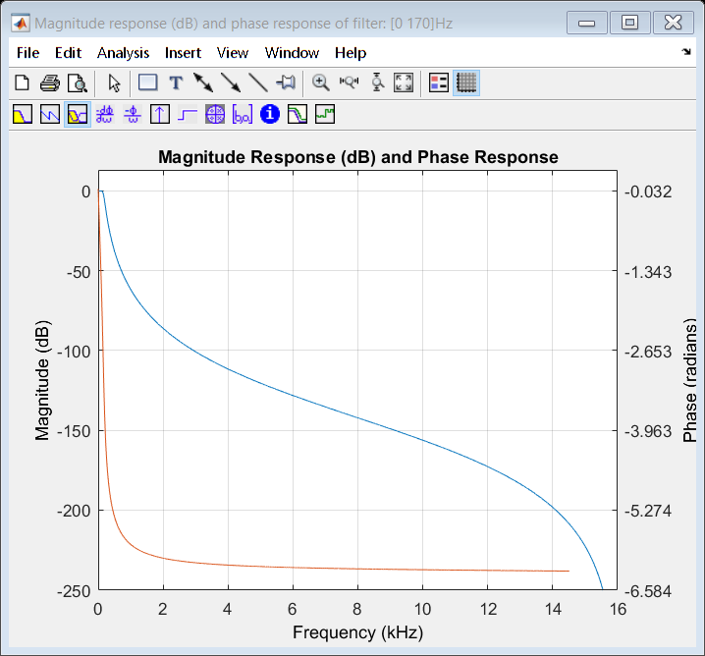
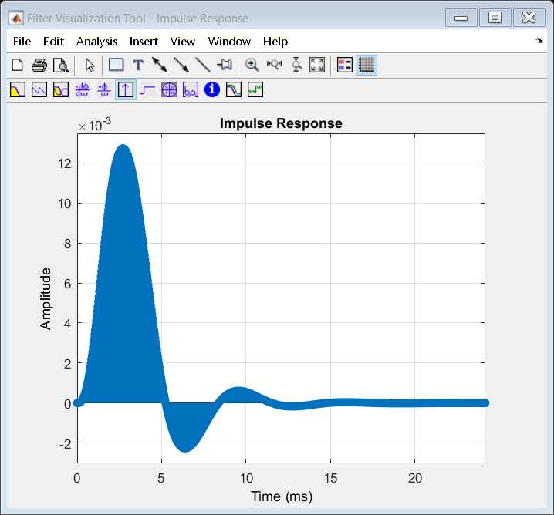
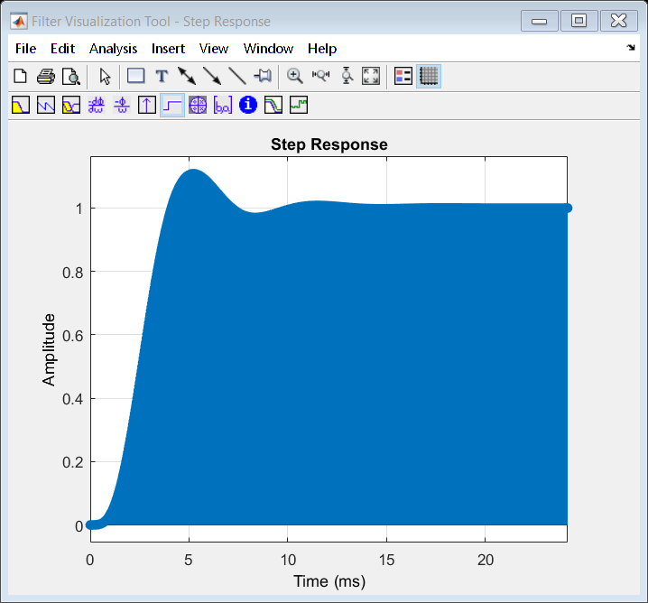
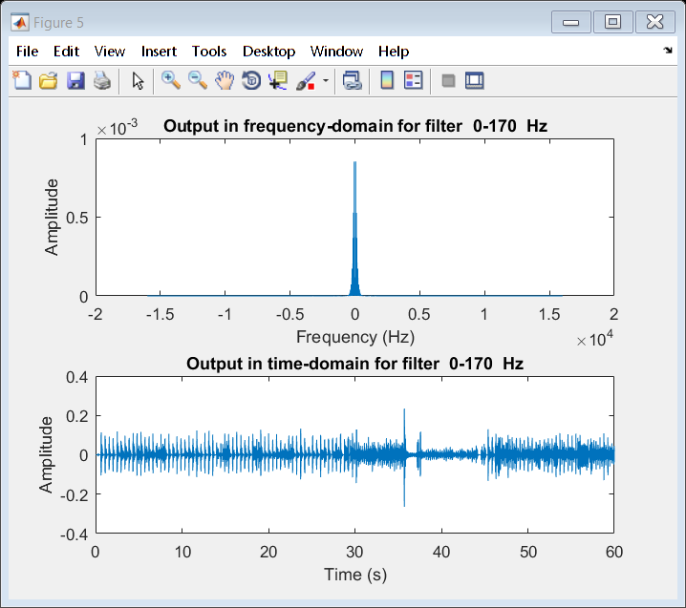
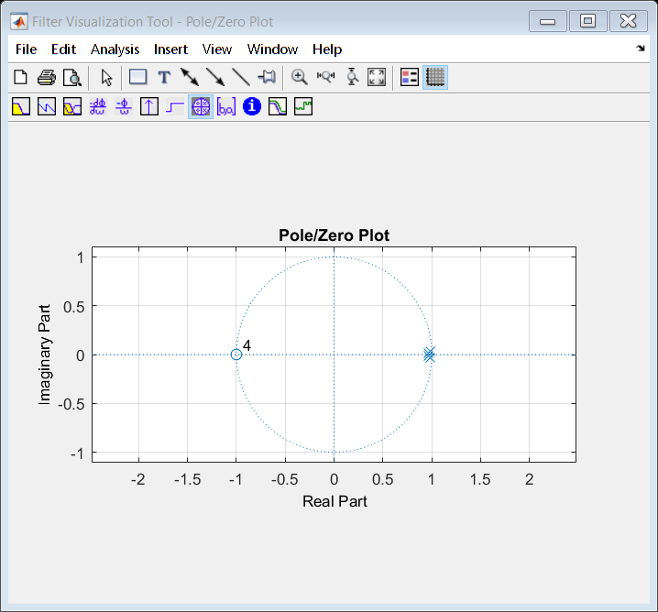
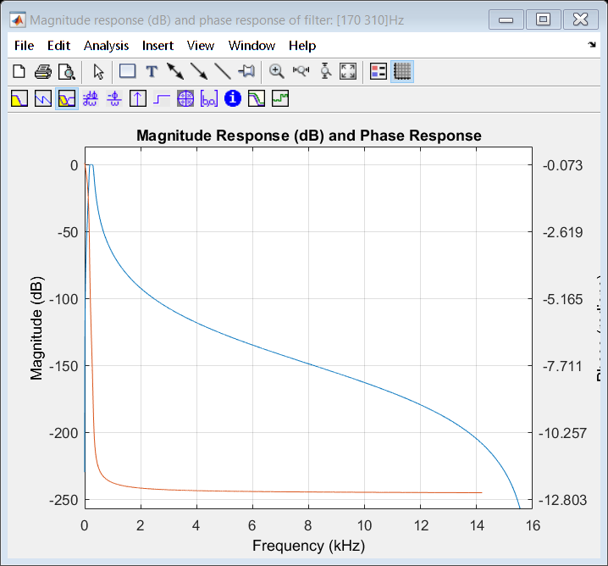
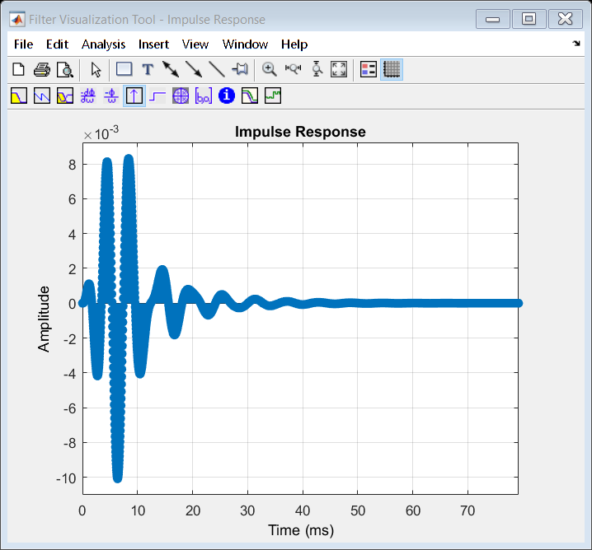
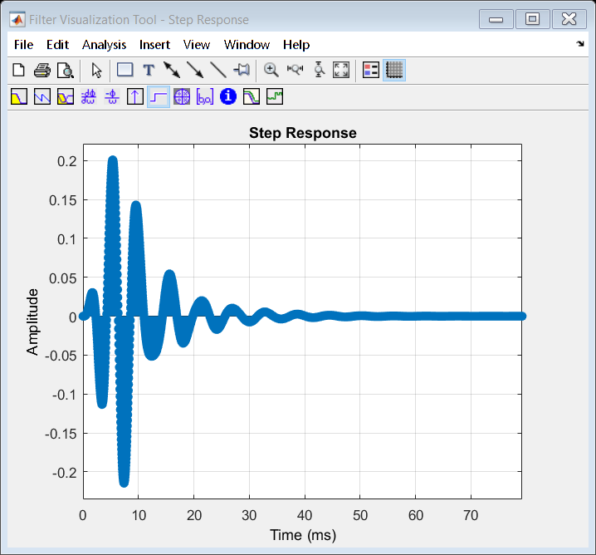
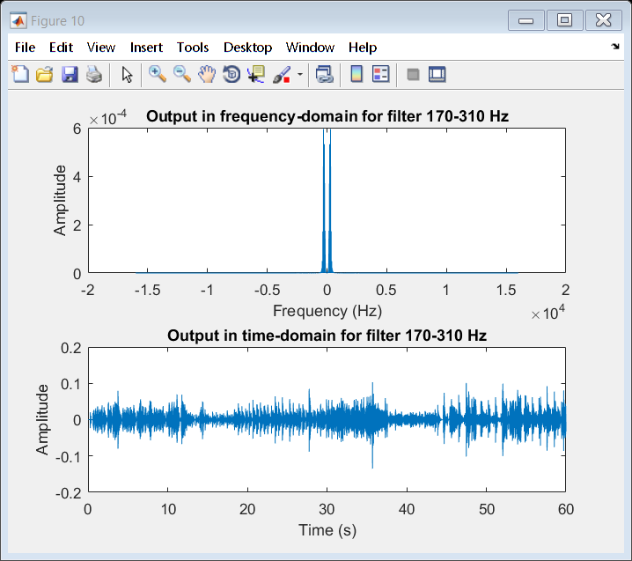
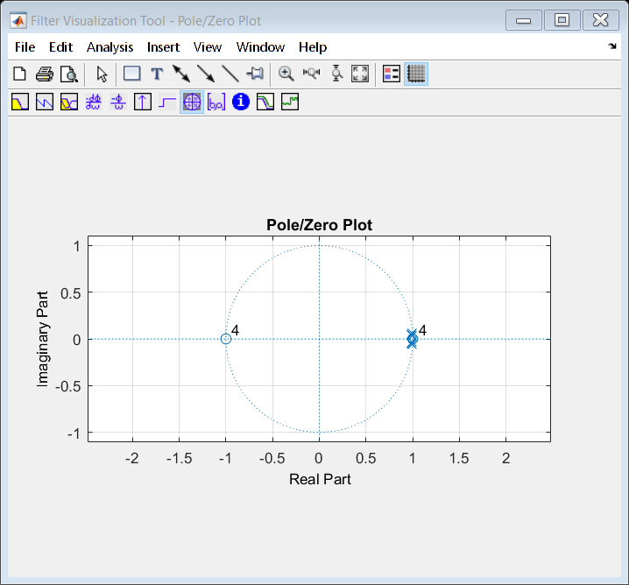
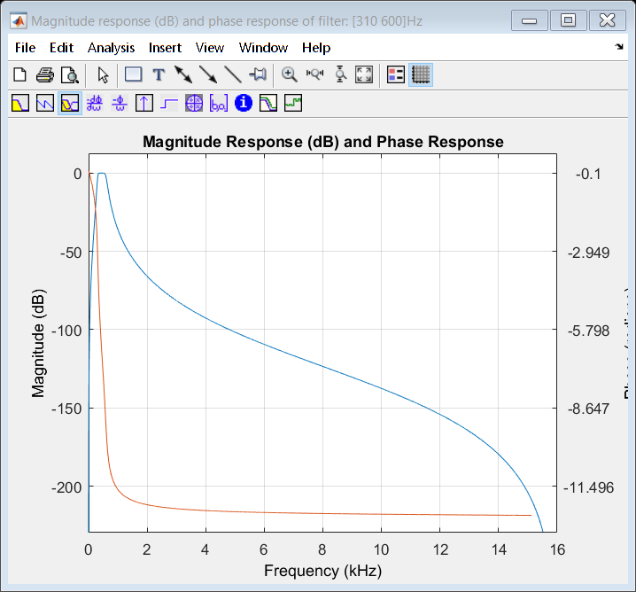
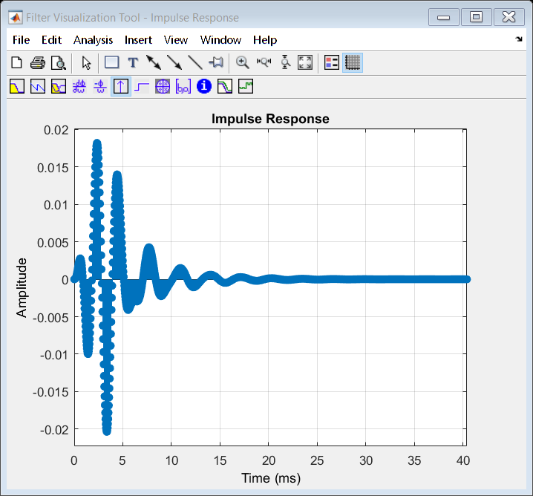
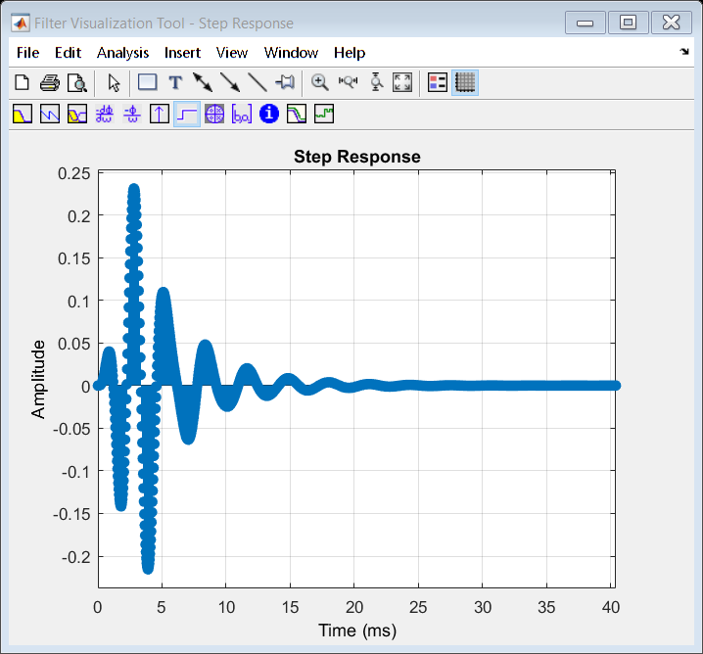
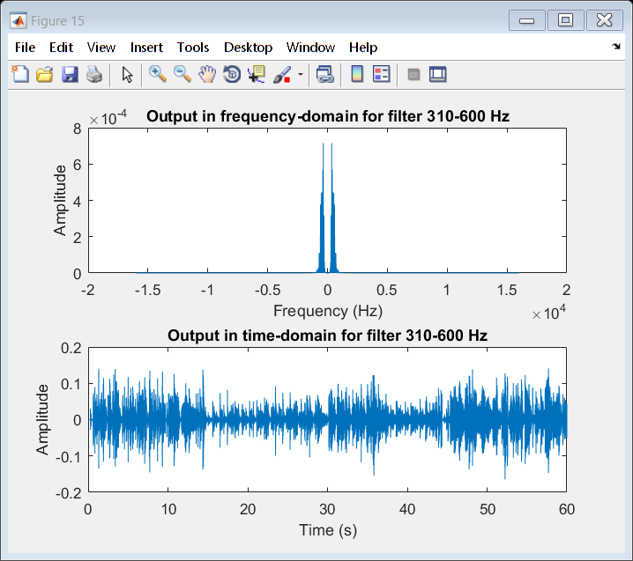
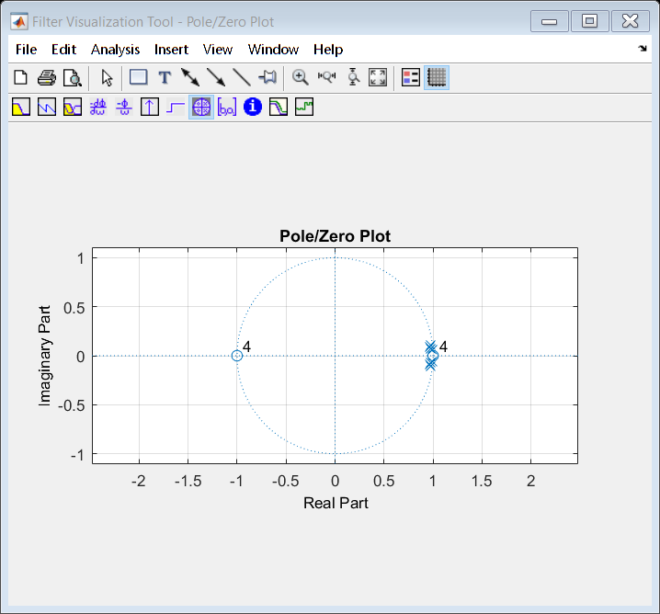
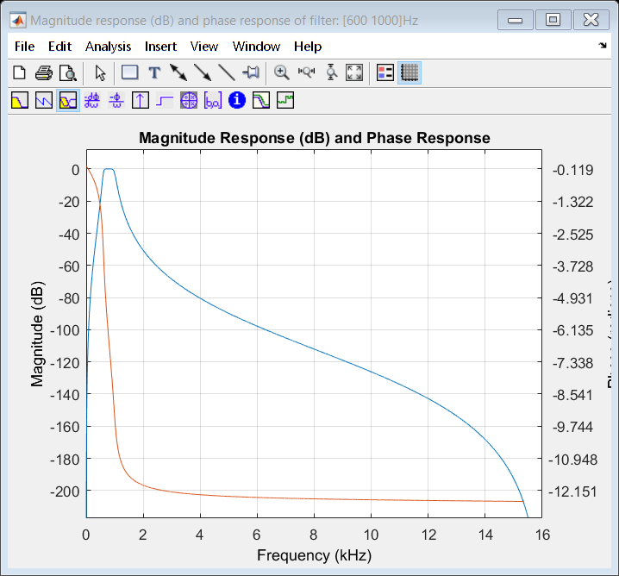
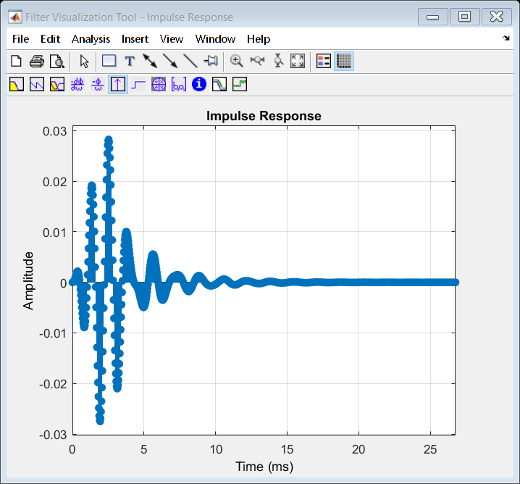
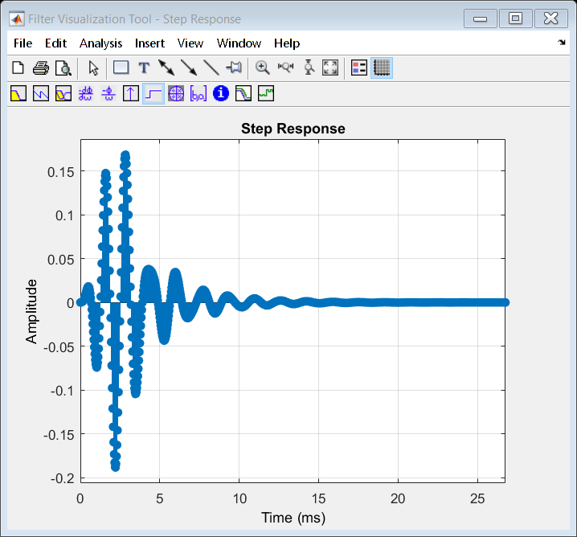
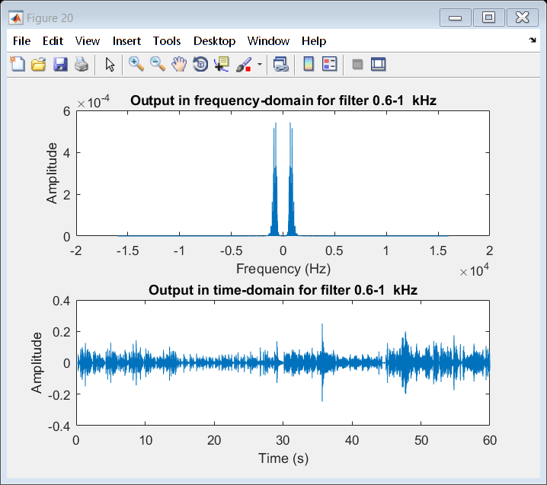
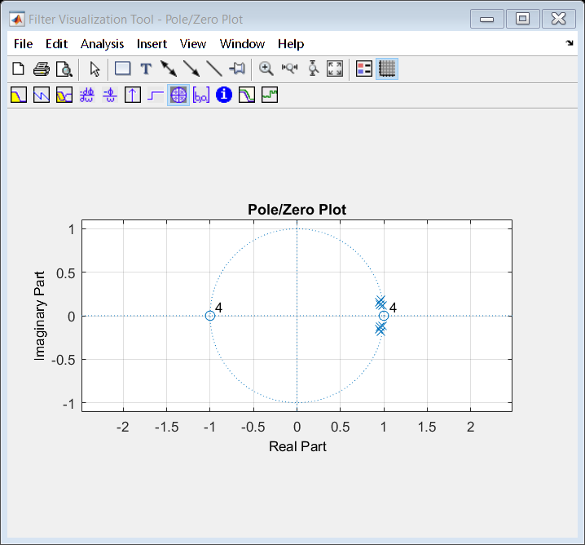
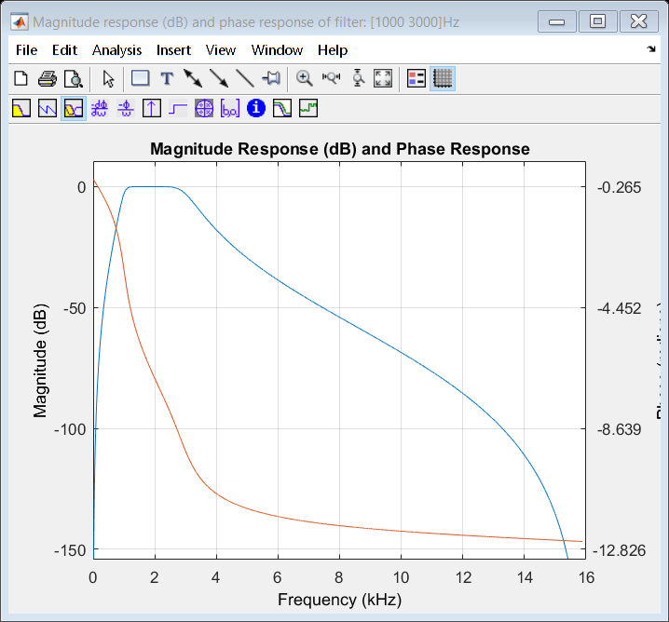
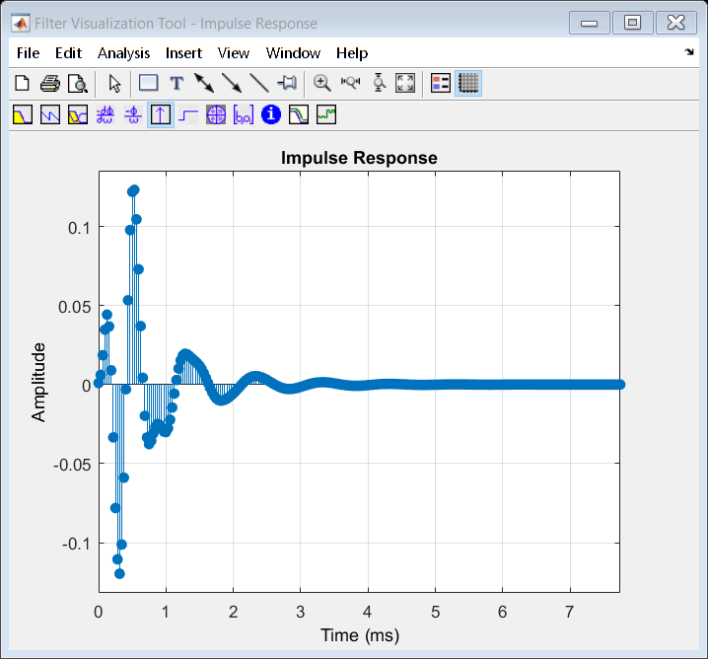
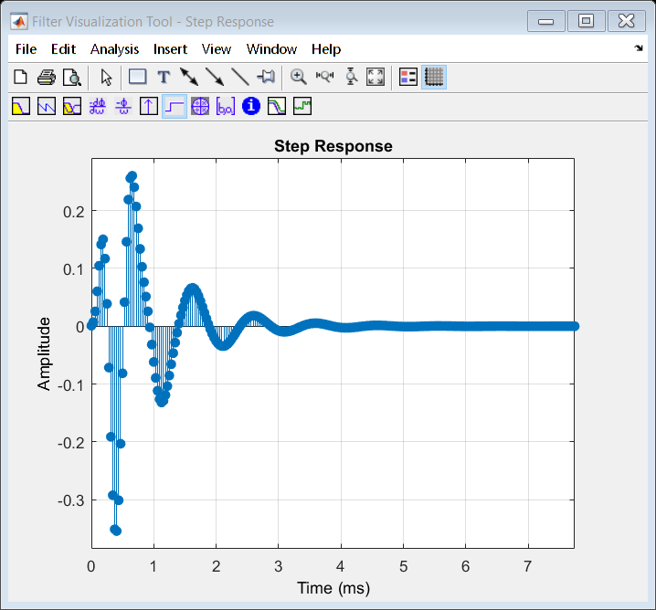
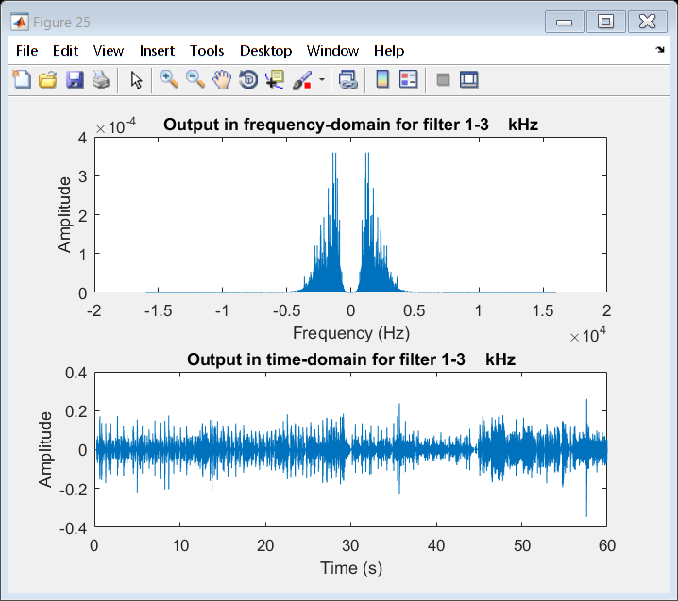
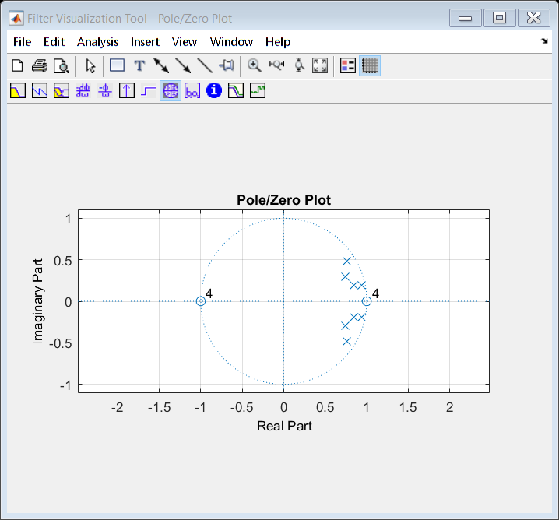
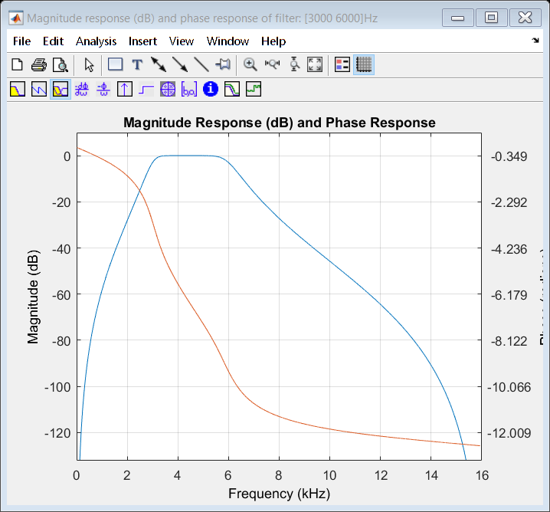
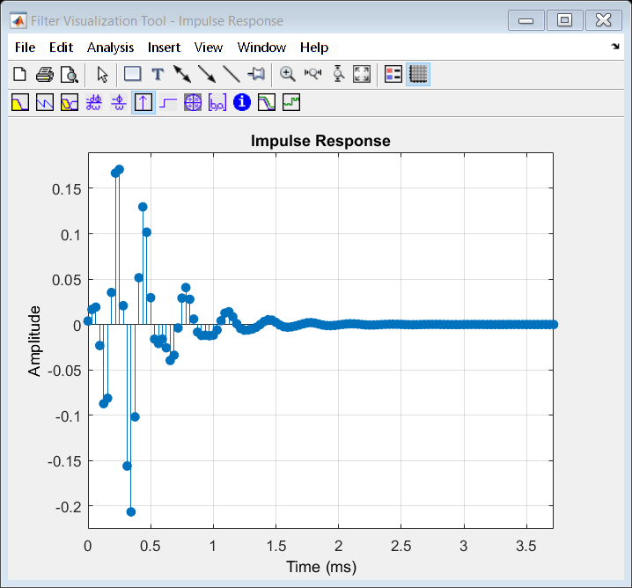
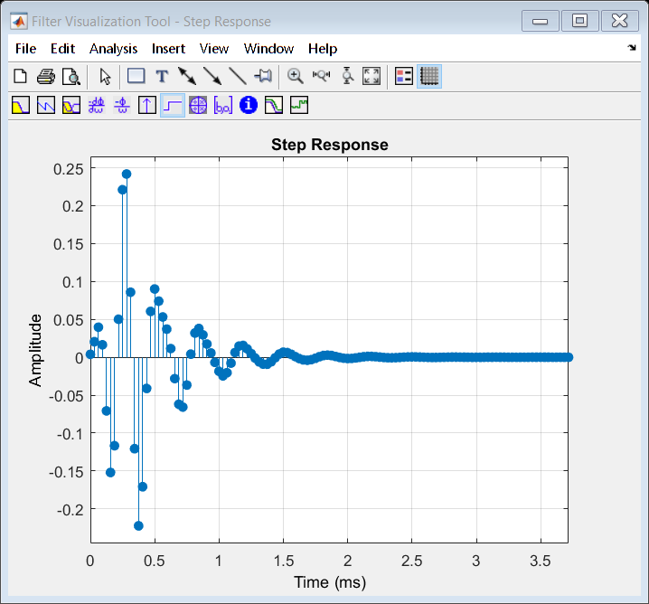
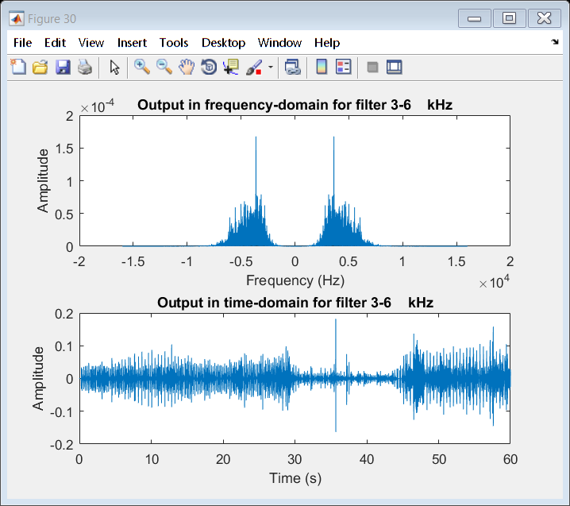
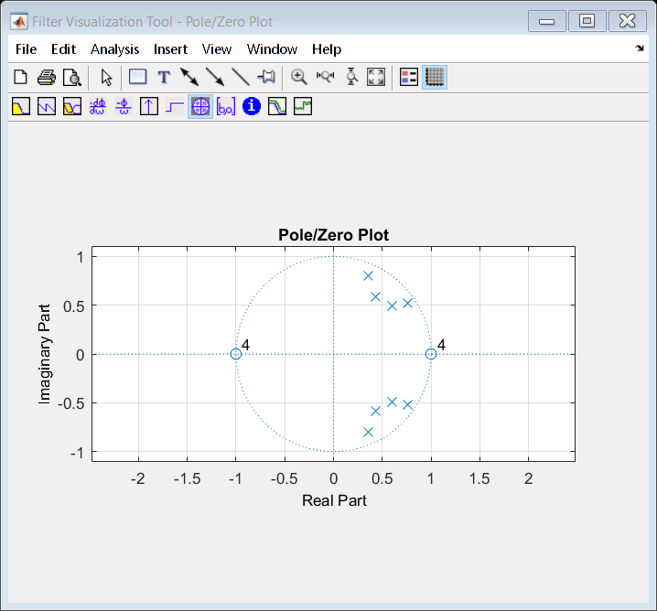
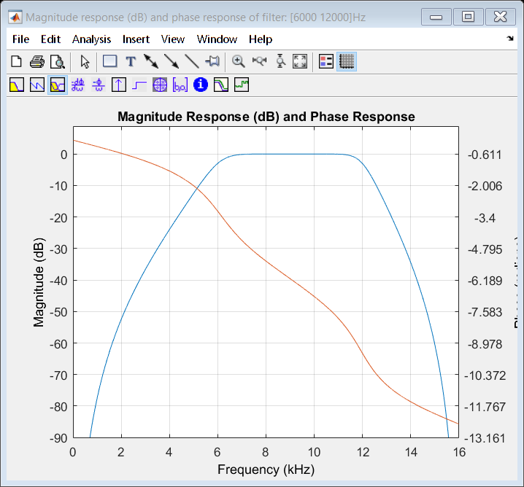
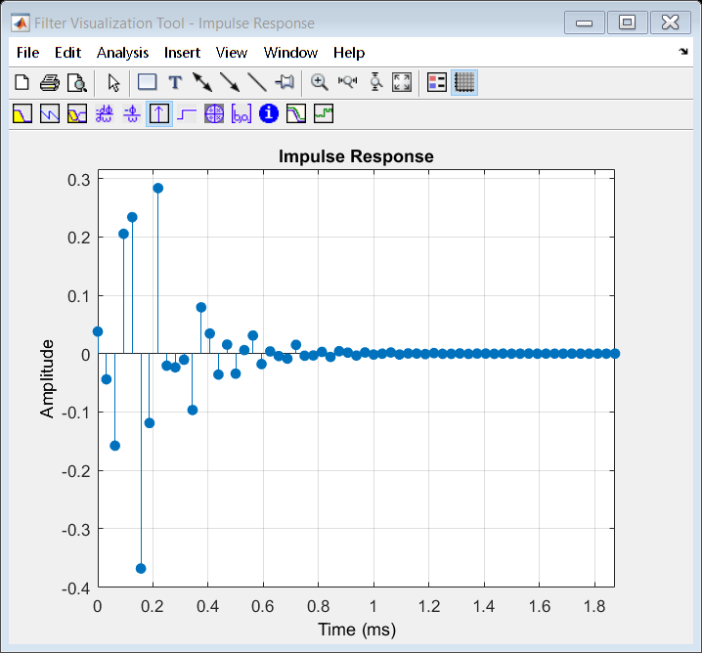
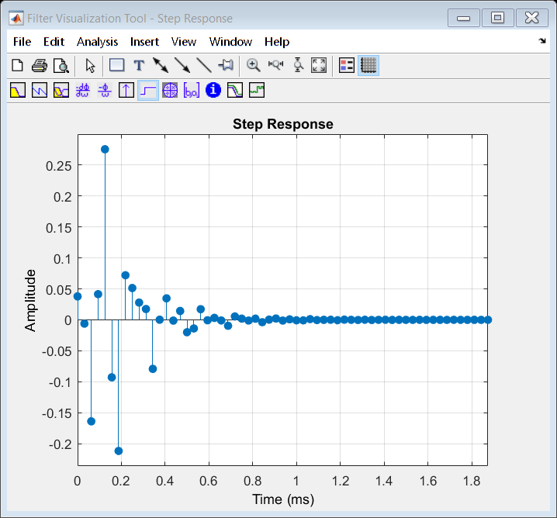
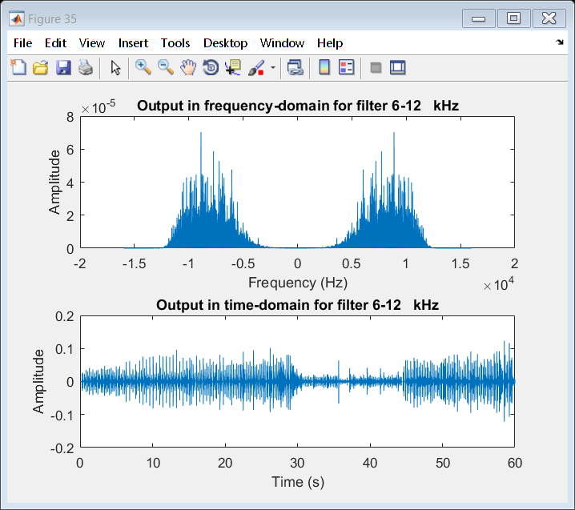
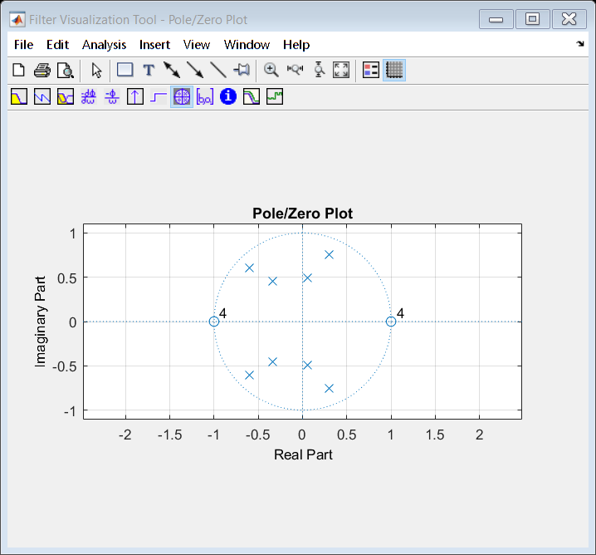
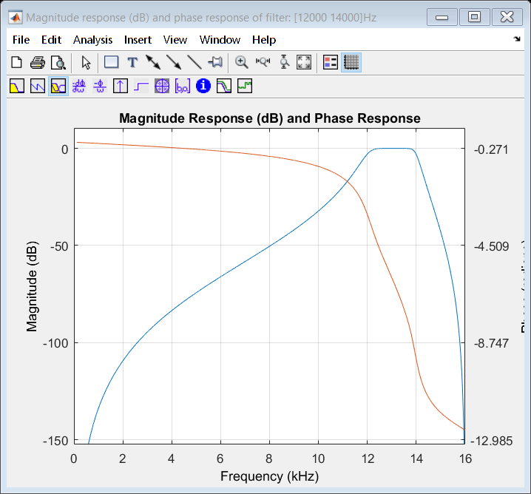
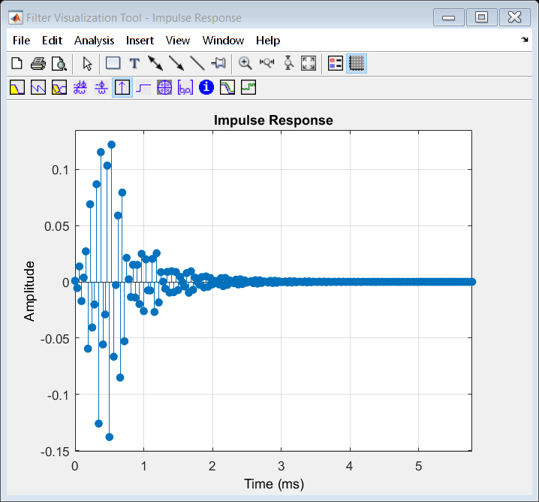
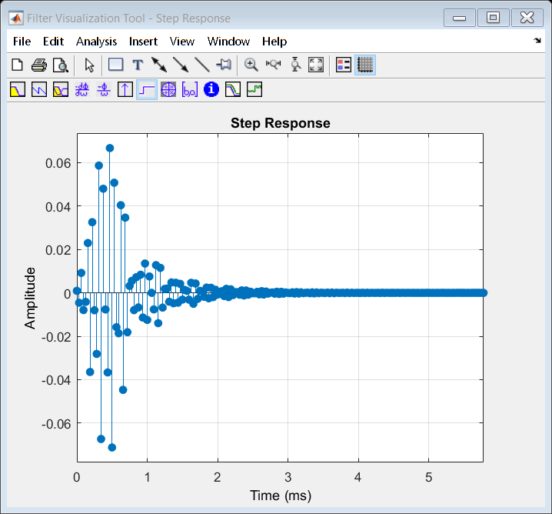
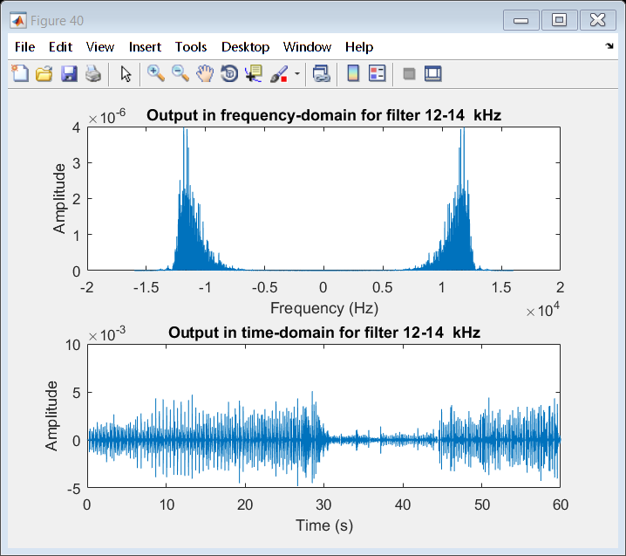
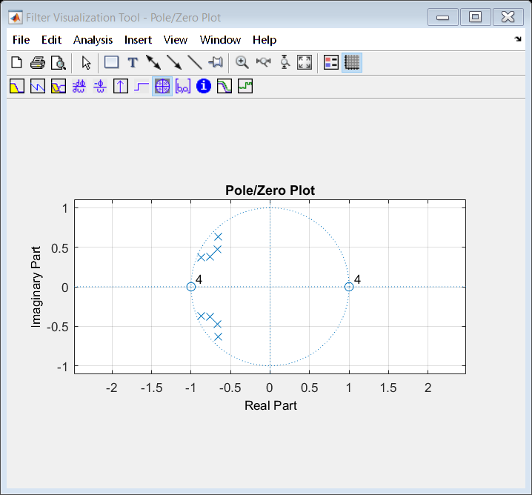
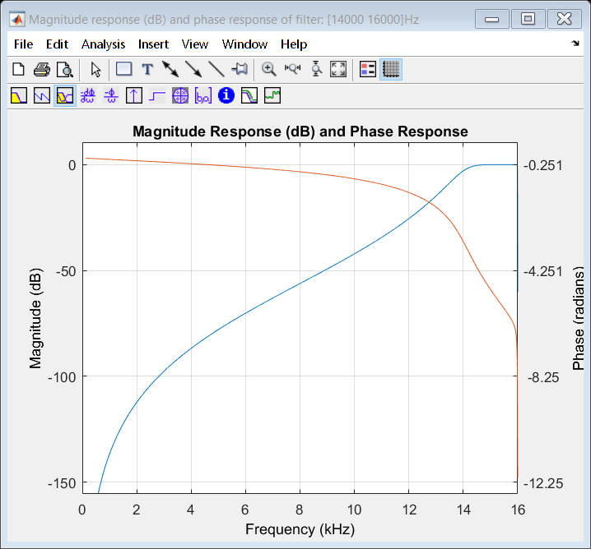
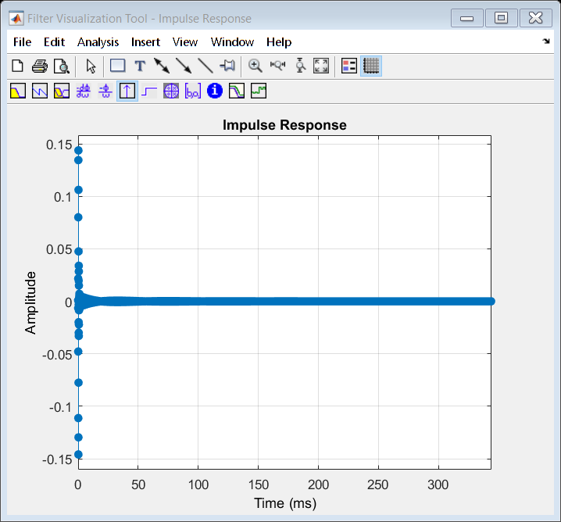
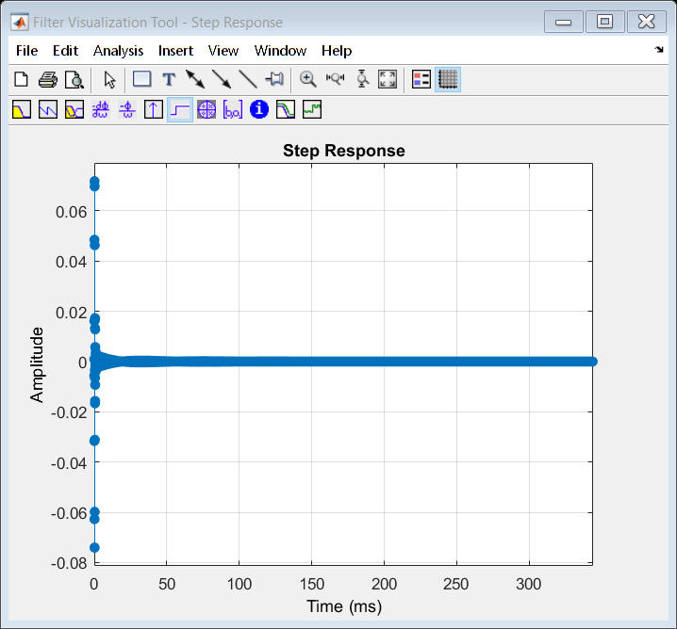
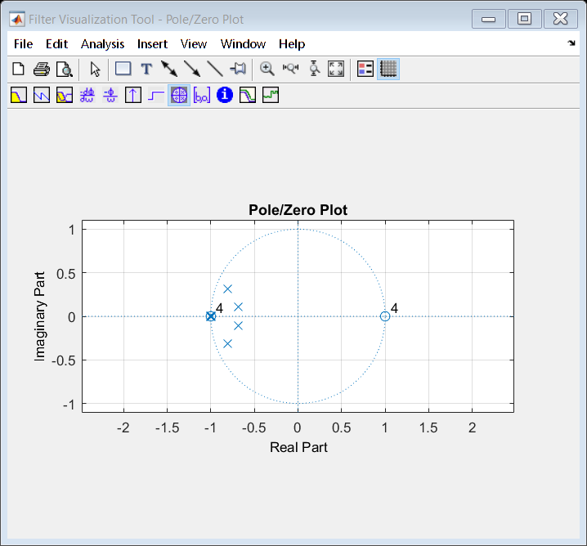
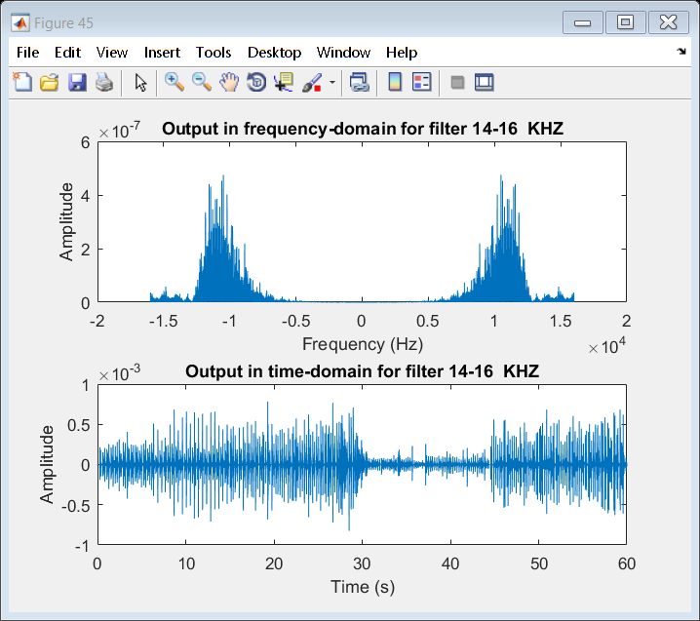
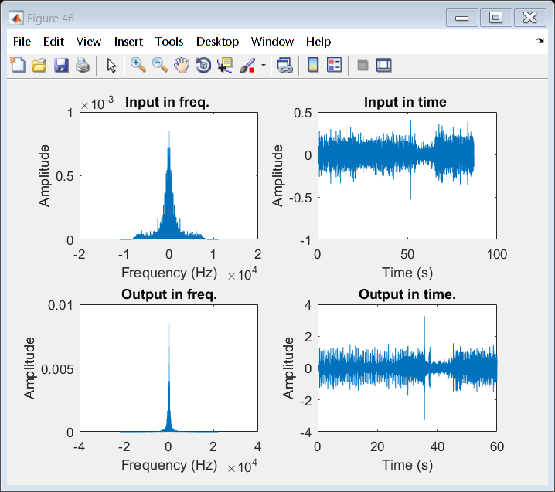
Published with MATLAB® R2016b

