**Data structures II**

**Assignment 1**

**Students:**

|  |  |
| --- | --- |
| ID | Name |
| 6668 | Youssef Victor |
| 6656 | Muhanned Basher |
| 6670 | Mohamed Zayton |

**Pseudocode of $O(n^{2})$ algorithms**

### Bubble Sort

Let arr be the array we want to sort, and arr[i] the ith (0-indexed) element of the array.

Let N be the length of the array

For i From 0 To N-1

MadeSwaps ← False

For j from 0 to N-2-i

If arr[j] > arr[j+1]

Swap arr[j], arr[j+1]

MadeSwaps ← True

End If

End For

If Not MadeSwaps: Exit For: End If

End For

### ****Insertion Sort****

INSERTION_SORT(unsorted):

length = unsorted.length

for i = 1 to length:

hole ← i

key ← unsorted[i]

while hole > 0 && unsorted[hole - 1] > key:

unsorted[hole] ← unsorted[hole-1]

hole ← hole - 1

unsorted[hole] ← key

### ****Selection Sort****

SELECTION_SORT(unsorted):

length = unsorted.length

for i = 0 to length

min_index = i

for j = i to length

if unsorted[min_index] > unsorted[j]:

min_index = j

SWAP( unsorted[i], unsorted[min_index])

**Pseudocode of $O(nlogn)$ algorithms**

### Heap Sort

|  |
| --- |
| Function HeapSort(unsorted)  For i From unsorted.Length / 2 To 0  Heapify(unsorted, length, i)  End For  For i From unsorted.Length - 1 To 0  Swap unsorted[0], unsorted[i]  Heapify(unsorted, i, 0)  End For  End Function  Function Heapify(array, length, i)  IndexOfMaximumElement ← i  IndexOfLeftChild ← 2 * i + 1  IndexOfRightChild ← 2 * i + 2  If IndexOfLeftChild < length AndAlso arr[IndexOfLeftChild ] > array[IndexOfMaximumElement] Then  IndexOfMaximumElement ← IndexOfLeftChild  EndIf  If IndexOfRightChild < length AndAlso array[IndexOfRightChild] > arr[IndexOfMaximumElement] Then  IndexOfMaximumElement ← IndexOfRightChild  End If  If i <> IndexOfMaximumElement Then  Swap array[i], arr[IndexOfMaximumElement]  Heapify(array, length, IndexOfMaximumElement)  End If  End Function |

窗体顶端

窗体底端

### Quick Sort

QUICK_SORT_LAST_PIVOT(unsorted):

QUICK_SORT(unsorted, 0, len(unsorted), GET_PIVOT_LAST)

QUICK_SORT_RANDOM_PIVOT(unsorted):

QUICK_SORT(unsorted, 0, len(unsorted), GET_PIVOT_RANDOM)

QUICK_SORT(unsorted, first, last, GET_PIVOT)

if first < last

return

p = PARTITION(unsorted, first, last, GET_PIVOT)

QUICK_SORT(unsorted, first, p, GET_PIVOT)

QUICK_SORT(unsorted, p+1, last, GET_PIVOT)

PARTITION(unsorted, first, last, GET_PIVOT):

i = first - 1

j = first

piv_ind = GET_PIVOT(unsorted, first, last)

piv = piv_ind[0]

ind = piv_ind[1]

unsorted[ind], unsorted[last] = unsorted[last], unsorted[ind]

while i < (last) and j < (last)

if unsorted[j] < piv:

i ++

SWAP(unsorted[i], unsorted[j)

j ++

SWAP(unsorted[i+1], unsorted[ind)

return i + 1

GET_PIVOT_LAST(unsorted, first, last):

return unsorted[last], last

GET_PIVOT_RANDOM(unsorted, first, last):

rand:= random(first, last)

return unsorted[rand], rand

### ****Merge Sort****

MERGE_SORT(unsorted):

if unsorted.length <= 1:

return unorted

unsorted_half1, unsorted_half2 = divide(unsorted)

merge_sort(unsorted_half1)

merge_sort(unsorted_half2)

merge(unsorted_half1, unsorted_half2, unsorted)

DIVIDE(unsorted):

half_i = unsorted.length / 2

return unsorted[:half_i], unsorted[half_i:]

MERGE(sorted_half1, sorted_half2, unsorted):

i, j, k = 0, 0, 0

half1_length, half2_length = sorted_half1.length, sorted_half2.length

while i != half1_length and j != half2_length:

if sorted_half1[i] < sorted_half2[j]:

unsorted[k] = sorted_half1[i]

i ← i + 1

else:

unsorted[k] = sorted_half2[j]

j ← j + 1

k ← k + 1

unsorted[k:] = sorted_half1[i:] if i != half1_length else sorted_half2[j:]

**Sample graph on large range of input sizes:**

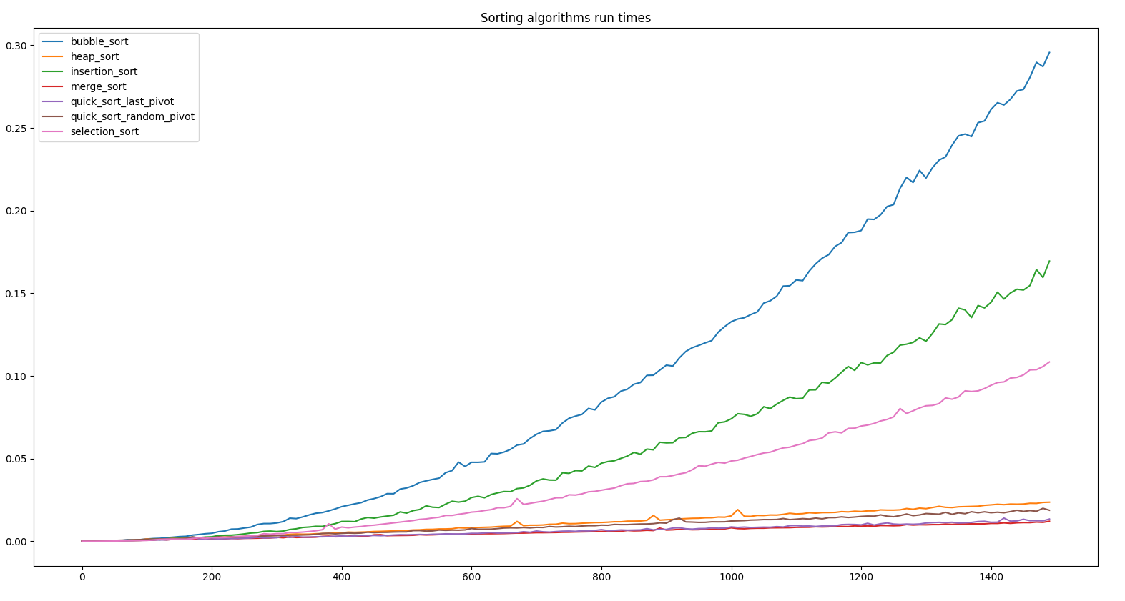

**Sample graph (lengths 10, 100, 1000, 10000, 100000):**

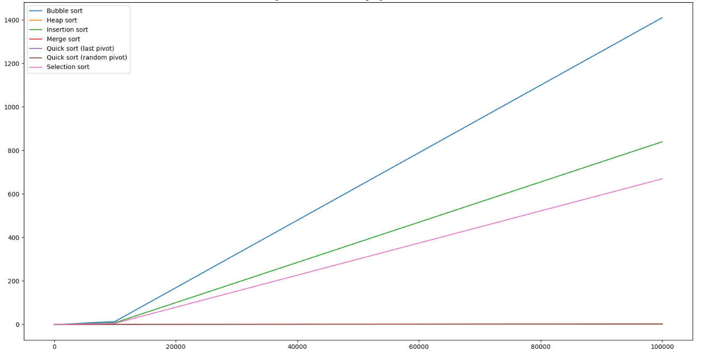

**Sample graph (both x-axis and y-axis are logarithmic scale):**

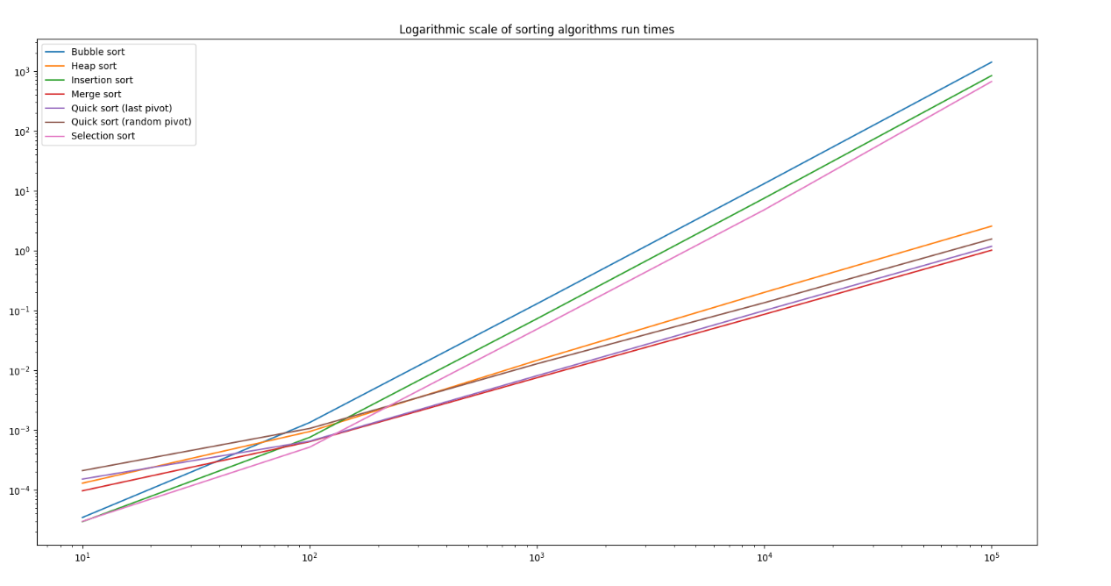

**Sample graph (y-axis logarithmic scale):**

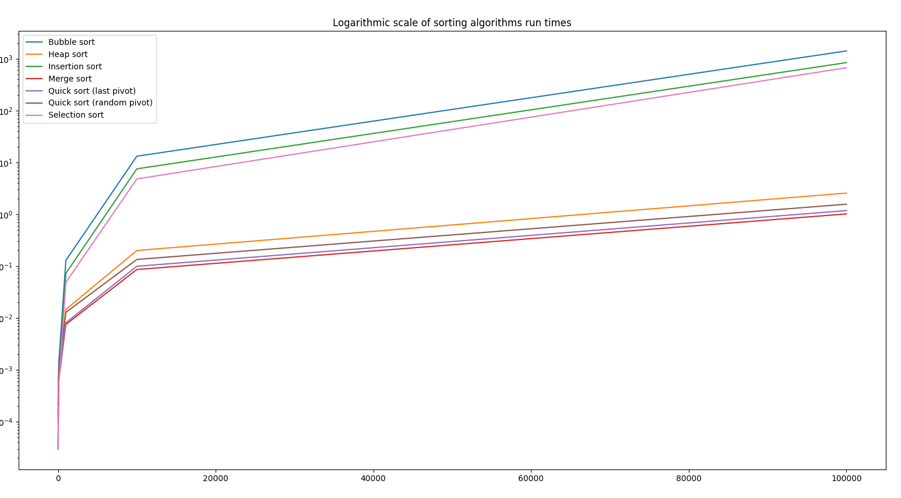

**NOTE: The graphs (other than the first) may not look accurate, this is a result of taking small number of samples (n = 10, 100, 1000, 10000, 100000) which is stated in the assignment requirements PDF.**