Q1:

Q2:

The containers are temporary so any file you will make in it will be discarded when you stop and remove the container itself.

Q3:

Q4:

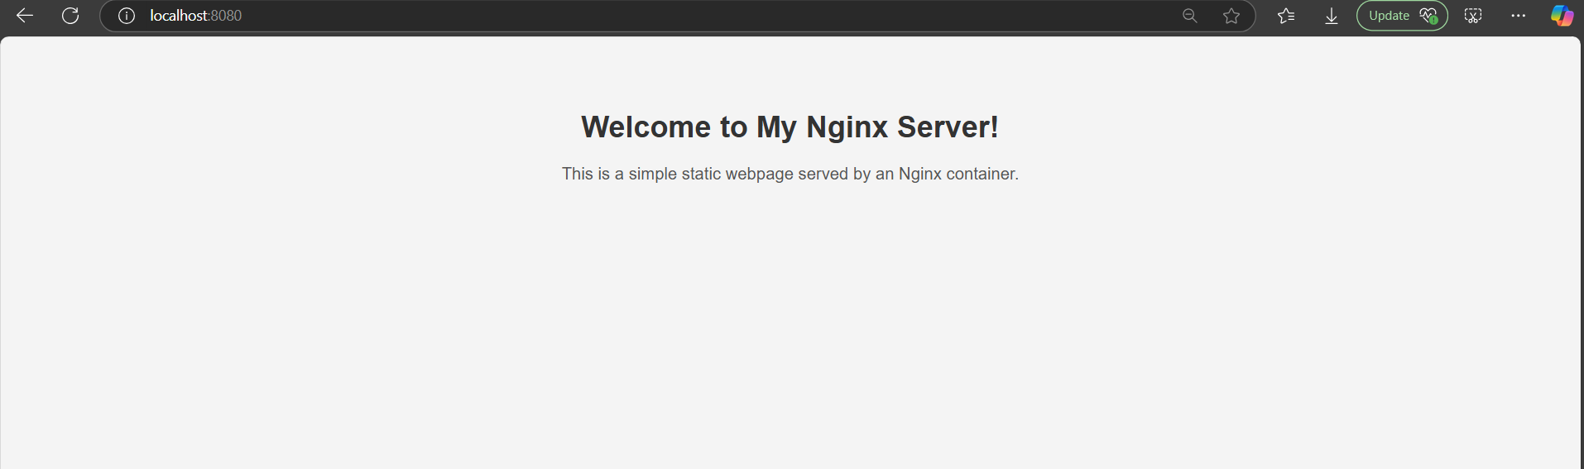

Q5 BONUS:

