1. Install k8s cluster (minikube)   
   A screen shot of a computer program

   AI-generated content may be incorrect.
2. Create a pod with the name redis and with the image redis.   
   A screen shot of a computer

   AI-generated content may be incorrect.
3. Create a pod with the name nginx and with the image “nginx123” Use a pod-definition YAML file.   
   Yaml file from the document:  
   A screen shot of a computer

   AI-generated content may be incorrect.  
   
4. What is the nginx pod status?A screen shot of a computer

   AI-generated content may be incorrect.
5. Change the nginx pod image to “nginx” check the status again   
   A screen shot of a computer

   AI-generated content may be incorrect.
6. How many ReplicaSets exist on the system?   
   just one ReplicaSet.
7. create a ReplicaSet with name= replica-set-1 image= busybox replicas= 3   
   A screen shot of a computer program

   AI-generated content may be incorrect.  
    A screen shot of a computer

   AI-generated content may be incorrect.
8. Scale the ReplicaSet replica-set-1 to 5 PODs.   
   A computer screen shot of a program

   AI-generated content may be incorrect.  
   and we can just do it in the yaml file and make it 5 replicas and re-apply the file.
9. How many PODs are READY in the replica-set-1?   
   there are 5   
   
10. Delete any one of the 5 PODs then check How many PODs exist now? Why are there still 5 PODs, even after you deleted one?   
    A screen shot of a computer

    AI-generated content may be incorrect.  
    Because Kubernetes when it comes to replicaset insures the same amount of pods will be the same even you delete number of pods it will run again the same amount of pods you delete it.
11. How many Deployments and ReplicaSets exist on the system?  
     A screen shot of a computer

    AI-generated content may be incorrect.
12. create a Deployment with name= deployment-1 image= busybox replicas= 3   
    A screen shot of a computer program

    AI-generated content may be incorrect.   
    A screen shot of a computer

    AI-generated content may be incorrect.
13. How many Deployments and ReplicaSets exist on the system now?   
    A screen shot of a computer

    AI-generated content may be incorrect.
14. How many pods are ready with the deployment-1?   
    A screen shot of a computer

    AI-generated content may be incorrect.
15. Update deployment-1 image to nginx then check the ready pods again   
    A computer screen shot of a program

    AI-generated content may be incorrect.
16. Run kubectl describe deployment deployment-1 and check events What is the deployment strategy used to upgrade the deployment-1?   
    RollingUpdate  
    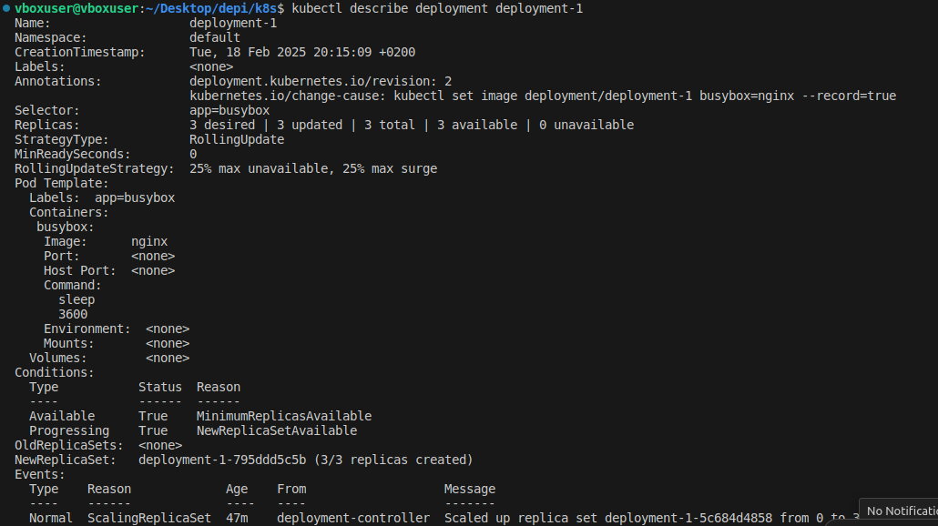
17. Rollback the deployment-1 What is the used image with the deployment-1?   
    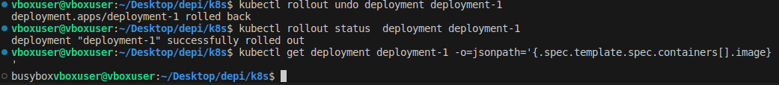
18. Create a deployment using nginx image with latest tag only and remember to mention tag i.e nginx:latest and name it as nginx-deployment. App labels should be app: nginx-app and type: front-end. The container should be named as nginx-container; also make sure replica counts are 3  
      
    A screen shot of a computer

    AI-generated content may be incorrect.  
    A computer screen shot of a computer program

    AI-generated content may be incorrect.  
    A black screen with white text

    AI-generated content may be incorrect.