Q1:



Q2:  


Q3:  
  


Q4:

  
------------------------------------------------------------------------------------------------------------------

Q5:



Q6:  
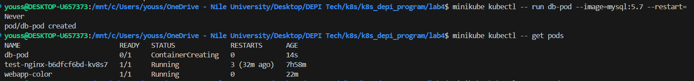



Q7:

Q8 & Q9:

Q10:

minikube kubectl -- apply -f multi-container-yellow.yaml

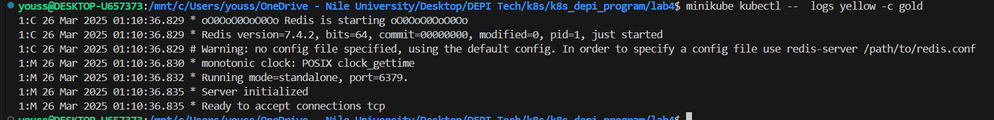

Q11:

minikube kubectl -- apply -f init-container-red.yaml

Q12:

Q13: Where is the default kubeconfig file located?

Q14: How many clusters are defined in the default kubeconfig file?

  
Q15: What is the user configured in the current context?

Q16,17,18:

