# INTRODUCTION:

The title of project is "**Control Home Devices using** **Android Application**". It is an Home automation project through Android Application. In this project a user can control his/her home devices by using his android mobile phone. User can also check the current status of devices by click on Room name from the list. Synchronization is also implemented in this project. This project is a combination of a software and hardware. In hardware there is an ESP8266 baord ,Leds ,Breadboard ,jumper wires and Resistors. This android application control the lights and other devices by connecting to web server using websocket and sending and receiving messages to and from the server which is made on ESP8266 NodeMCU Board. When ESP8266 NodeMCU board receives the values from android application it checks that and turn off/on it. There is an other functionality that when someone turn on or off room lights then a Text Message will be sent to the server and the server will send that message to the Application. Android Application has a very decent and professional interface. On The main screen there is a list of rooms widgets that shows the rooms in the house. When User clicks on room then there are some switches to turn on/off lights and the other devices in the room.

# Purpose:

The main purpose of the project is to help control the lights and devices from anywhere. It is an energy efficient too user can check the status of lights if are these on. If lights are on he/she can turn off by only a single tap on android application.

# Scope:

The project is developed as an android Mobile application, and it will work for every android mobile user. Project has no link with Desktop Application.

# System Requirements:

This unit lists the minimum software and hardware requirements needed to run our application **Control Home Devices using** **Android Application**.

* SDK: Android Studio latest Edition.
* JDK
* Emulator.
* Android actual device e.g. android mobile ,tablet etc

# System Design:

* System based on two basic things The Hardware and The Software.

## Hardware Architecture:

**Components**:

* ESP8266 NodeMCU**:**

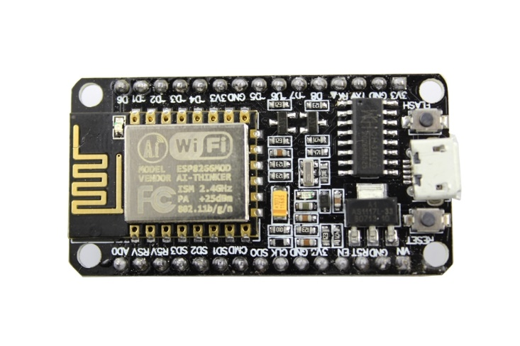

* Leds

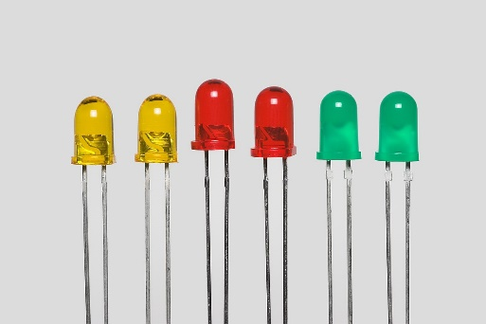

* BreadBoard**:**

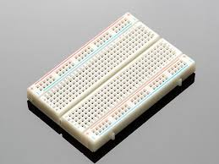

* Jumper Wires**:**

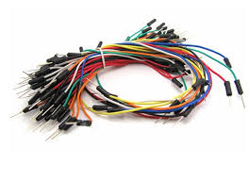

* Push buttons:

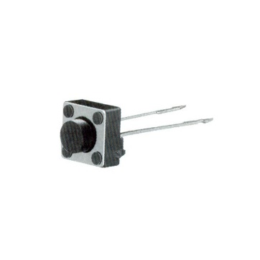

* Resistors:

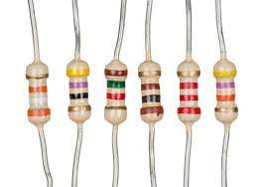

## Software Architecture:

The software architecture consists of :

### Application Program:

The application program is developed with flutter using Android Studio and it provides a user interface for home Devices Android Application.

### Application server:

The application server functionality is provided using JAVA programming language.

# Tools and Technology Used:

**For Android Application:**

* Latest Android Studio
* Emulator and Android actual Device
* Language**:** dart

**For Application server:**

* Java 8
* Spring framework

**For Hardware Programming:**

* Arduino IDE
* **Language:** C/C++

# Application diagram:

## Android Application diagram:

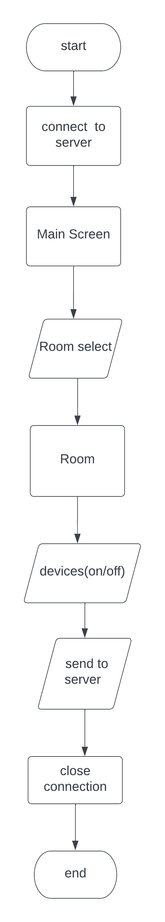

How it works:

User will access the Main screen of application where Navigation Drawer is placed. Navigation Drawer contains the list of rooms of the house. For this project only living room is functional due to hardware cost. When living room is accessed by user then there are some devices. And when the user tap on the button of any device then a message request goes on the Web server and light turn on or off according to the value.

## Application server diagram:

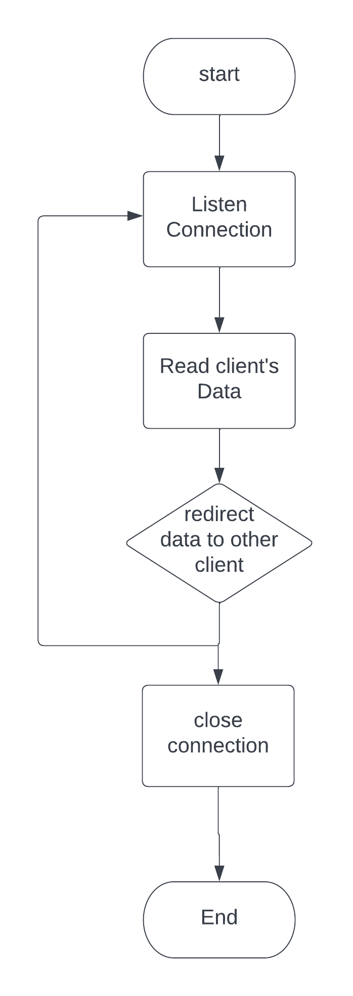

How it works:

The server is started and listen to any request connection and wait to receive data from any client and then redirect this data to other client.

Diagram to show how ESP8266 & client(android app) interacted with the server :

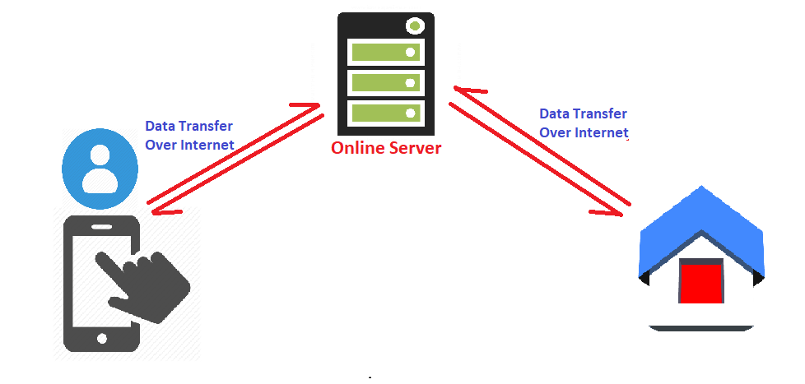

Circuit diagram:

Shows how component connected:

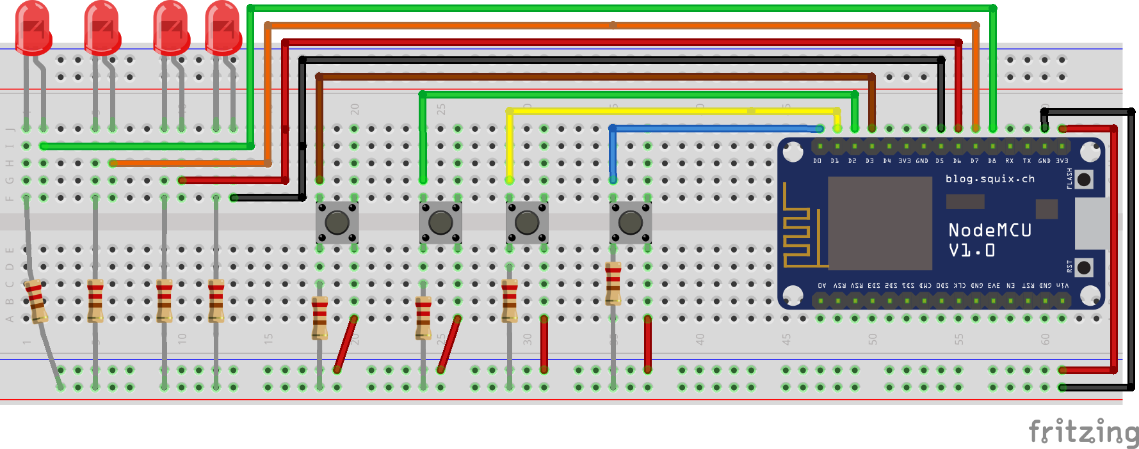

# Application user interface:

Main window:

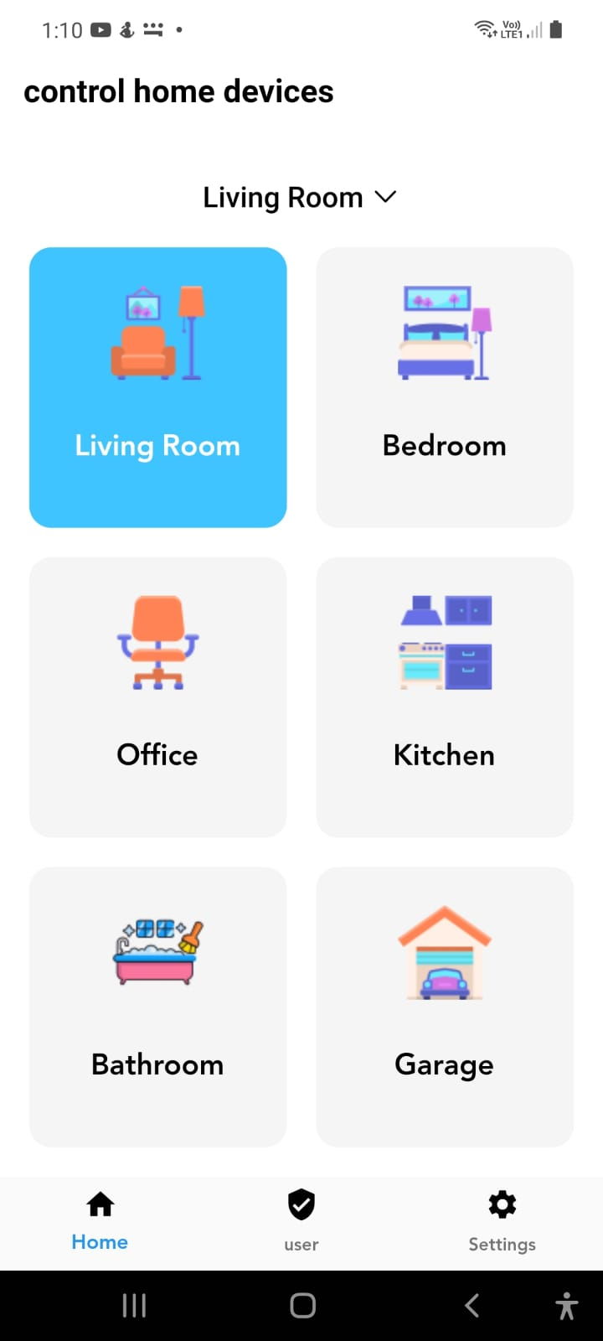

Living room:

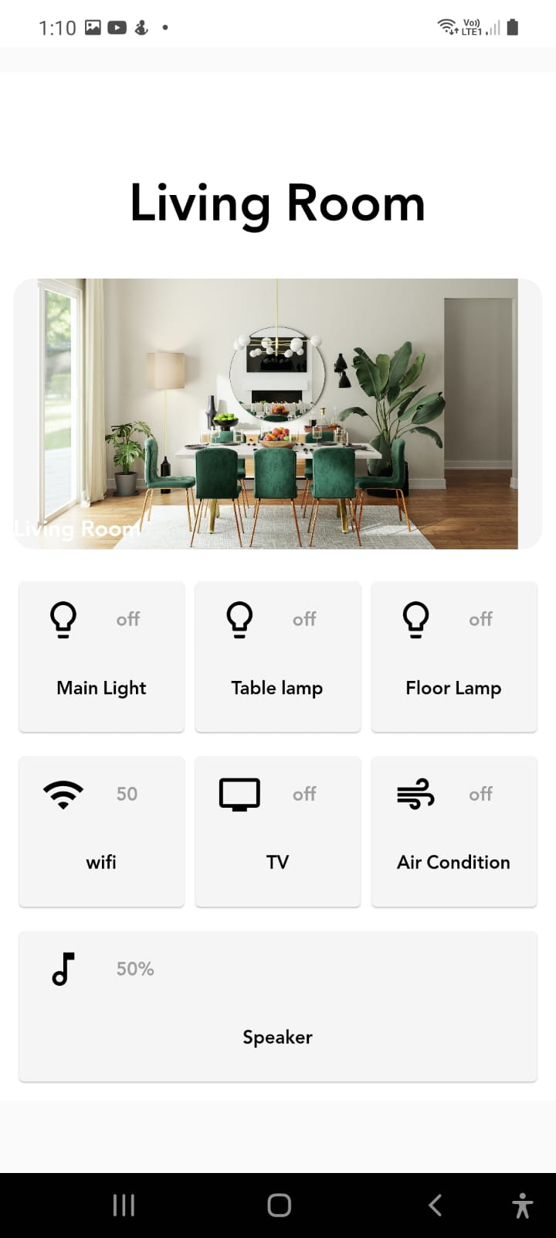

# Code:

[Code for ESP8266](https://github.com/YoussefAgagg/graduation-project/blob/master/control-home-devices-demo/control-home-devices-demo.ino)

[Code for application server](https://github.com/YoussefAgagg/graduation-project/tree/master/control-home-devices-server)

[Code for android app](https://github.com/YoussefAgagg/graduation-project/tree/master/control-home-devices-app)