Chapter (4)
System Design of FreshMart Robot-Assisted Fulfillment Platform
4.1 Introduction
FreshMart integrates a MERN web platform with robot task orchestration to address modern fulfillment challenges. The system combines a React PWA frontend, an Express/MongoDB backend, and YOLOv8-enabled Raspberry Pi hubs coordinating Arduino controllers. This unified stack reduces integration friction and improves order accuracy, providing offline resilience via PWA caching and auditable robot task flows. References: [1], [2], [3], [4], [5].
4.2 Problem Identification and Goals
Problem Identification:
Manual picking is slow and error-prone; inventory visibility is inconsistent; robotics are often decoupled from the web layer; and outages can interrupt fulfillment. A cohesive web + robotics platform is required to synchronize inventory, orders, and robot tasks in real time.
Goals:
- Develop an integrated web platform exposing real-time inventory, ordering, and robot task queues.
- Orchestrate pick/restock tasks with YOLOv8 detections for verification and audit.
- Provide a PWA for offline browsing, fast load, and installability.
- Use a single-language MERN stack to minimize integration overhead.
- Enhance reliability with health checks, heartbeats, and graceful fallbacks.
4.3 Design and Specifications
Architecture: React + Vite PWA (offline cache, install prompt), Express.js API, MongoDB with seeded collections (products, orders, controllers, tasks), Raspberry Pi 4 hub (YOLOv8), Arduino controllers (picker arms, drive).
API surface: /api/products, /api/orders, /api/robot/controllers, /api/robot/tasks. Client views: Home, Shop, Cart, Orders, About. Offline mode: cache-first static assets with seed-data fallback.
Table 1. API Endpoints
Method | Endpoint | Purpose
GET | /api/status | Health check
GET | /api/products | List products (filters: tag, category, search, limit)
POST | /api/products | Create product
POST | /api/orders | Create order and queue robot task
GET | /api/orders | List recent orders (filter by status)
PATCH | /api/orders/:id/status | Update order lifecycle
GET | /api/robot/controllers | List registered controllers
POST | /api/robot/controllers/heartbeat | Update controller heartbeat/battery/IP
GET | /api/robot/tasks/next | Robot requests next queued task
PATCH | /api/robot/tasks/:id/status | Report progress or YOLO detections
Table 2. Frontend Dependencies
Package | Version | Purpose
React | 18.3.1 | UI component library
React DOM | 18.3.1 | DOM rendering
React Router DOM | 7.9.6 | Client-side routing
Axios | 1.7.7 | HTTP client
React Icons | 5.2.1 | Icon components
Vite | 5.2.0 | Build tooling
Table 3. Backend Dependencies
Package | Version | Purpose
Express | 4.19.2 | Web framework
Mongoose | 8.5.1 | MongoDB ODM
CORS | 2.8.5 | Cross-origin support
dotenv | 16.4.5 | Environment configuration
Morgan | 1.10.0 | HTTP logging
web-push | 3.6.7 | Push notifications (ready)
Table 4. Performance Benchmarks
Metric | Target | Observed
First Contentful Paint | < 2 s | ~1.2 s (PWA cached)
Time to Interactive | < 3 s | ~2.1 s (PWA cached)
Lighthouse PWA Score | > 90 | ~95
API response time | < 200 ms | ~85 ms (local)
4.4 System Architecture
Layers: Presentation (React PWA), Application (Express + controllers/middleware), Data (MongoDB + Mongoose models), Hardware (Raspberry Pi YOLO hub + Arduino controllers). The task queue coordinates robots via REST, while the PWA remains responsive offline.
4.5 User-Facing Screens
Home Page (Landing)
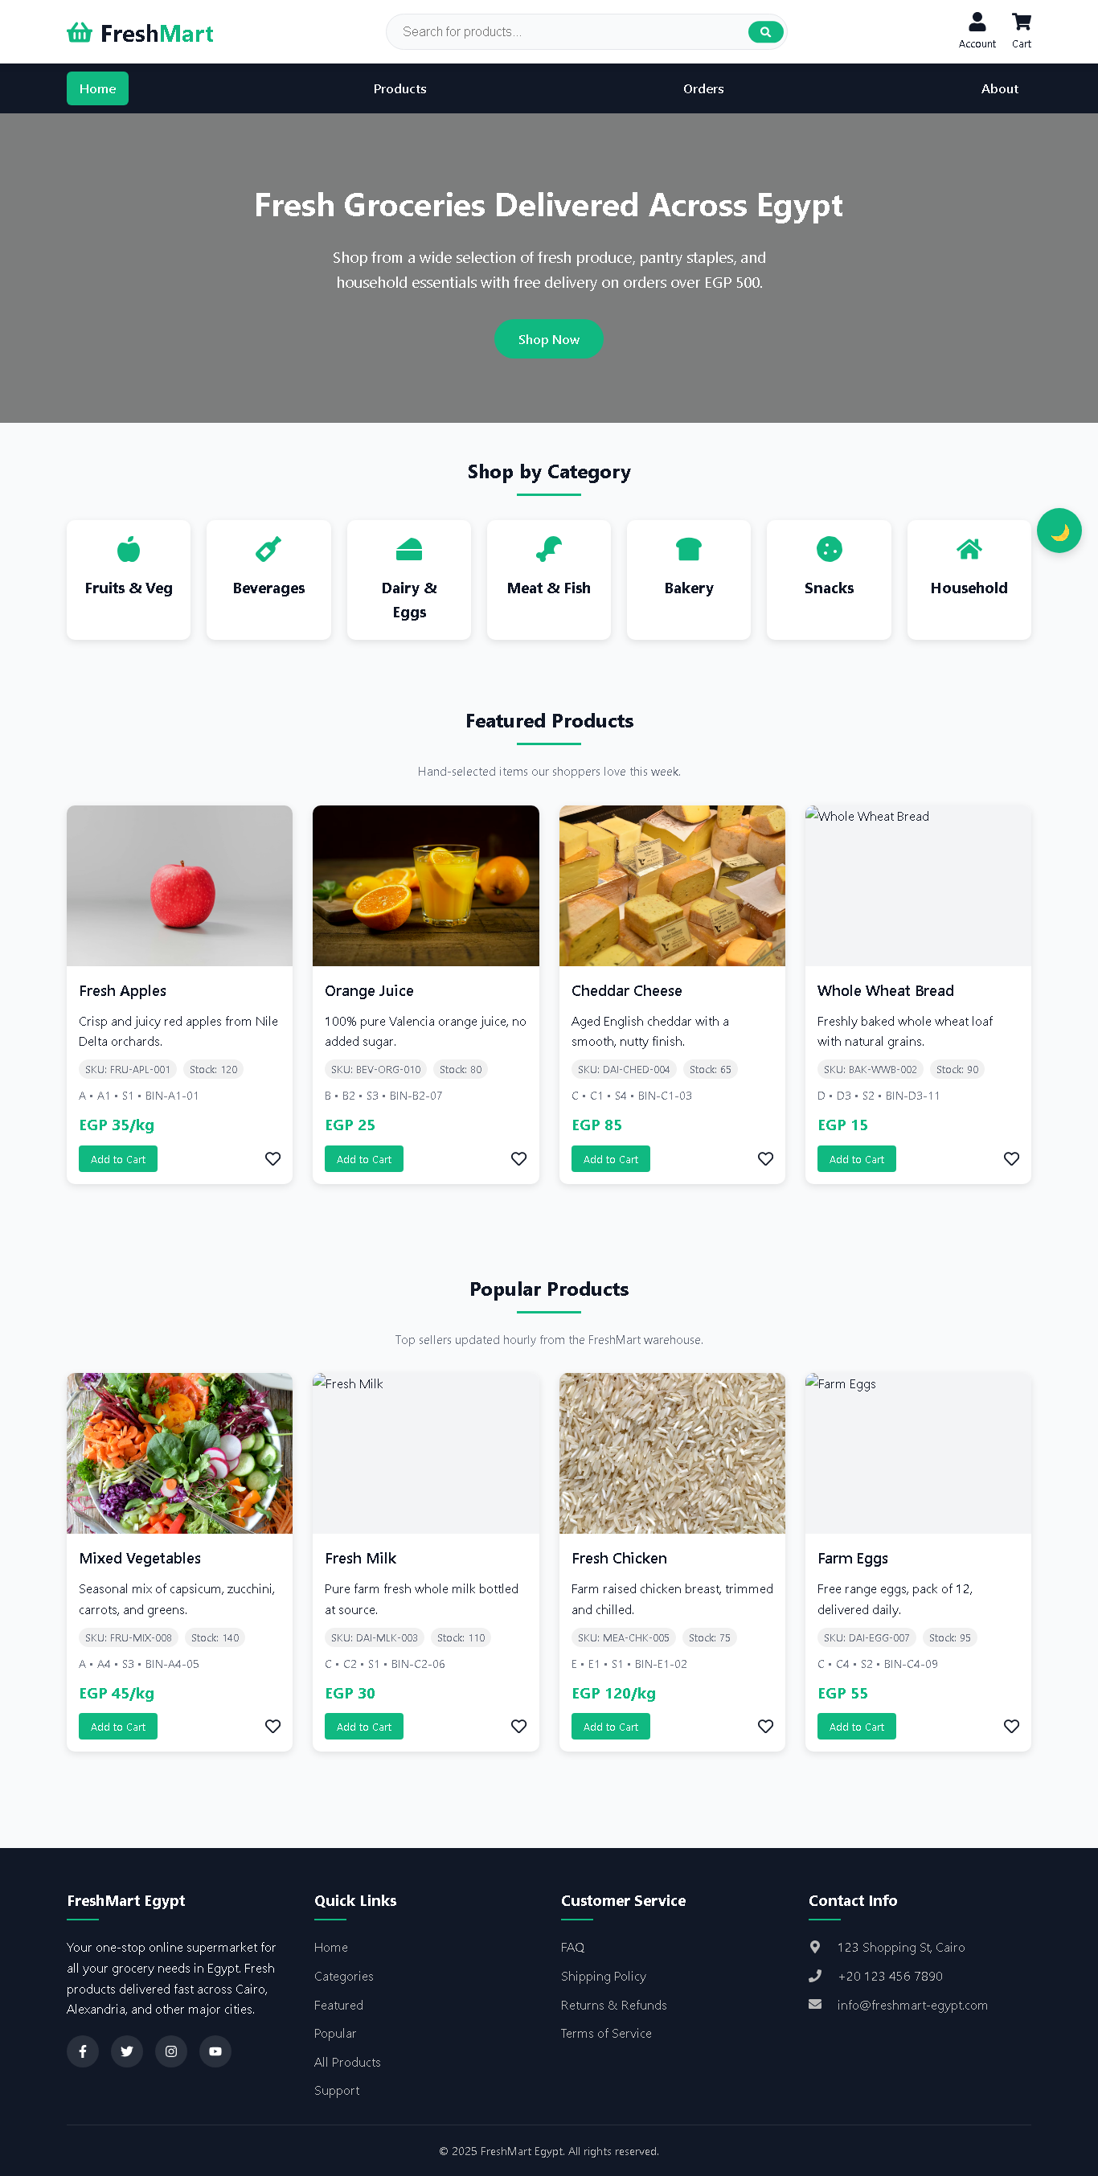
Figure 1 (Home Page – Featured Products & Orders Board)
Shop Page (Catalog)
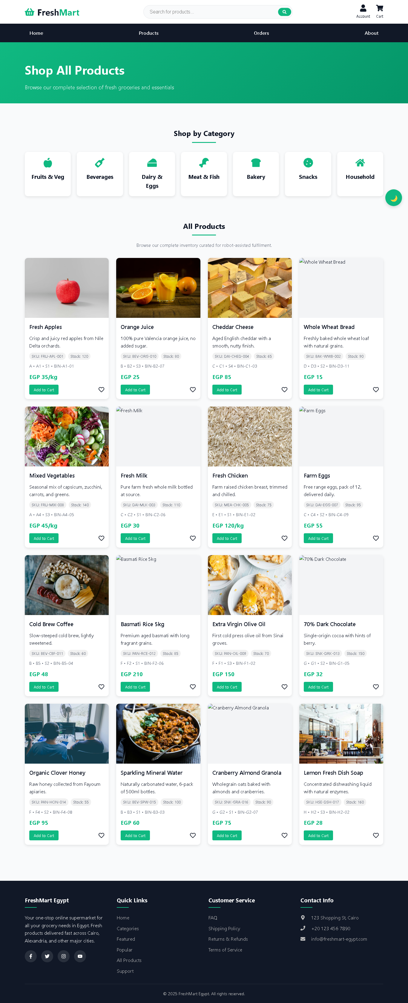
Figure 2 (Shop Page – Search & Filters)
Cart Page (Review & Delivery)
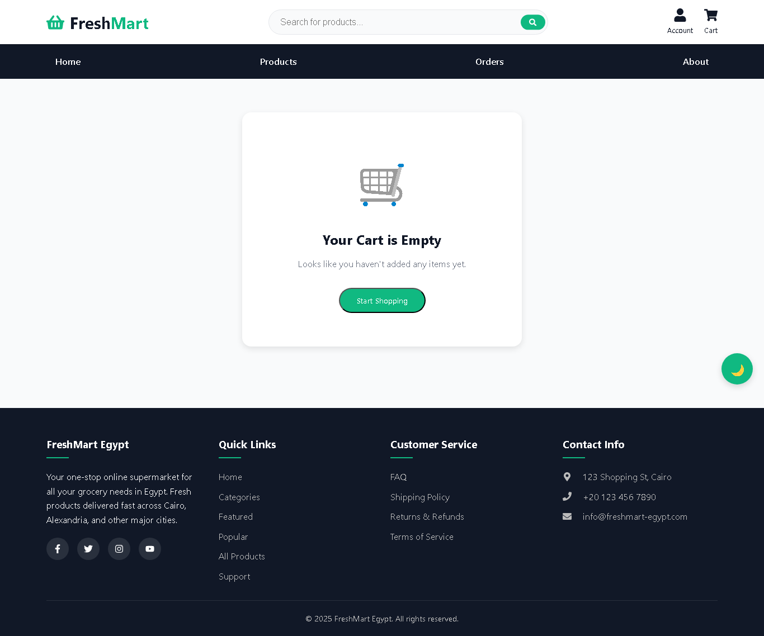
Figure 3 (Cart Page – Delivery Options & Summary)
Orders Dashboard
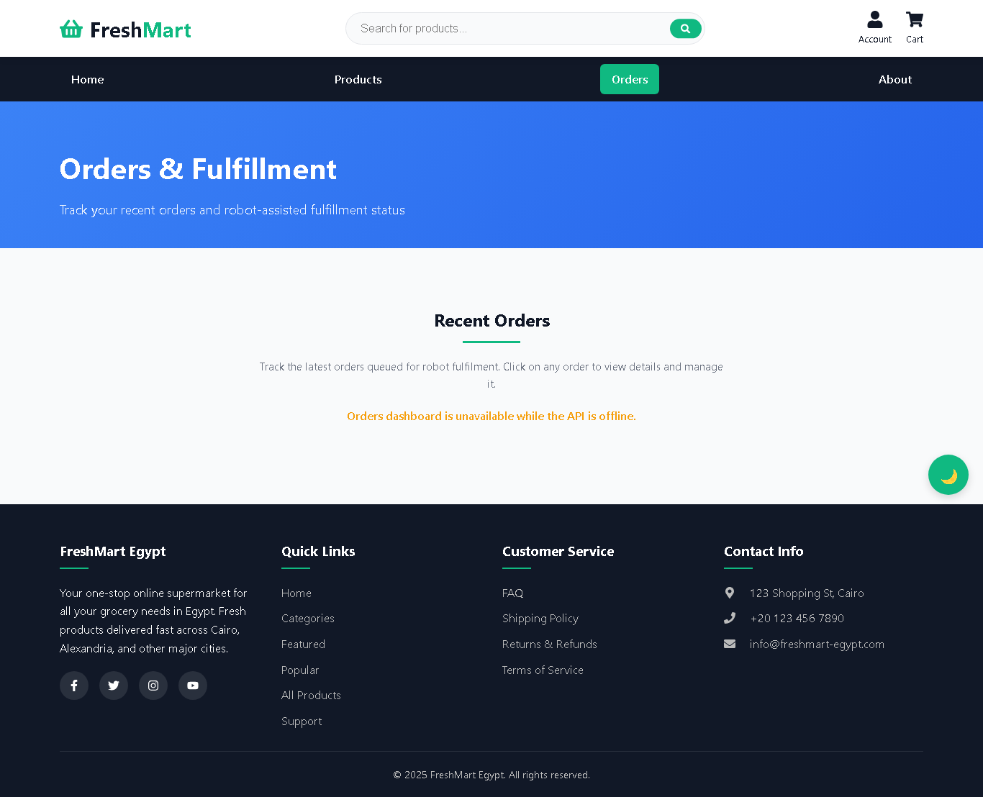
Figure 4 (Orders Dashboard – Status View)
About Page
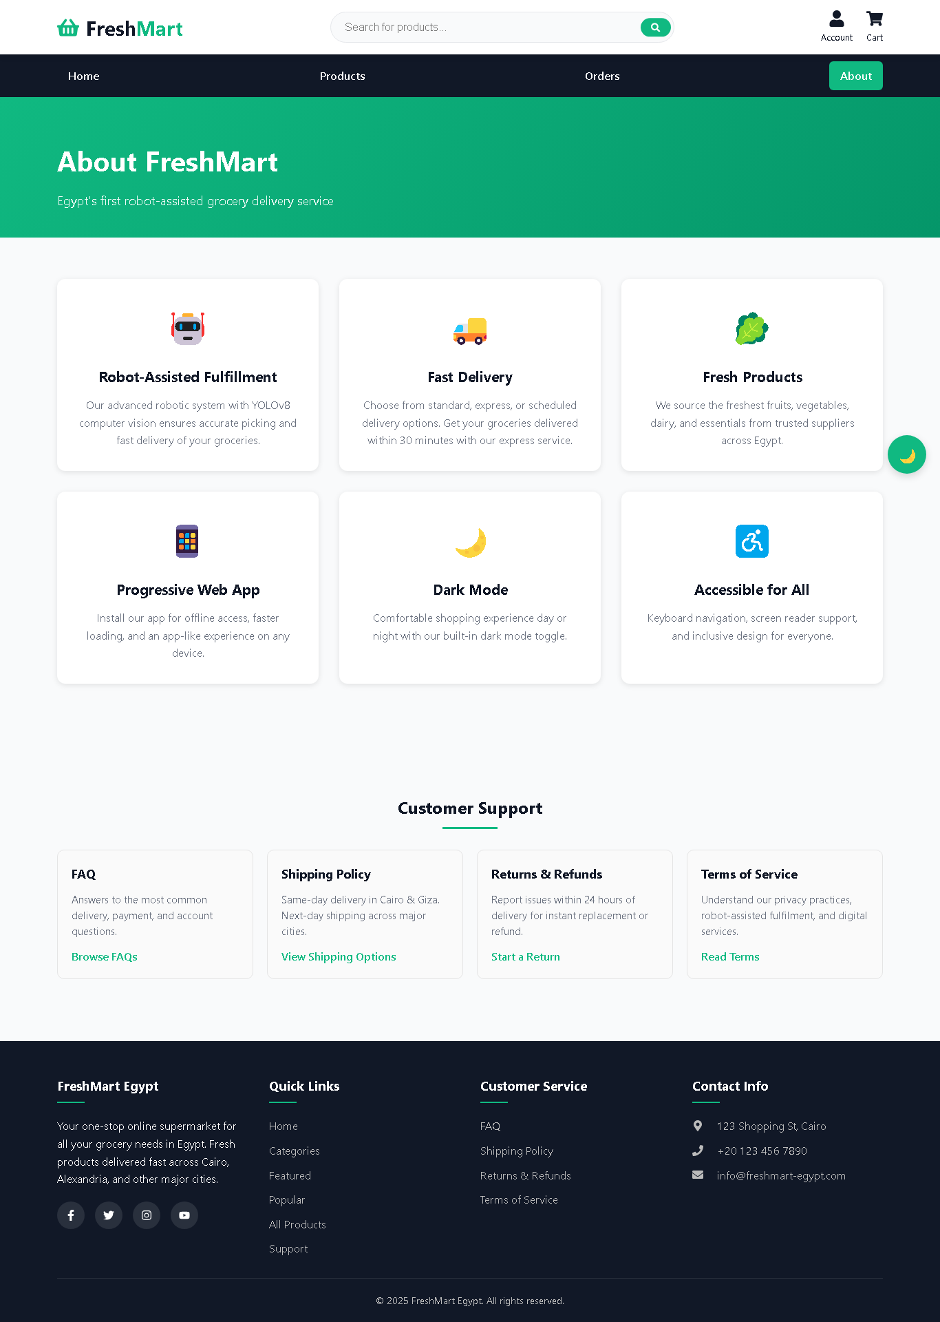
Figure 5 (About Page – Project Overview)
4.6 Backend Design
Models: Product, Order, RobotController, RobotTask. Key endpoints: GET /api/products, POST /api/orders (queues task), GET /api/robot/tasks/next, PATCH /api/robot/tasks/:id/status, POST /api/robot/controllers/heartbeat. Middleware: CORS, JSON body parsing, morgan logging, centralized error handler.
4.7 Robotics & Vision Integration
Controllers: Raspberry Pi 4 hub with YOLOv8; Arduino Mega/Due for picker/drive. Workflow: Task queue → Pi pulls next task → Robot executes → Status/detections PATCH → Order updates. Detections store label, confidence, and image evidence for audit.
4.8 Validation and Performance
- API responsiveness: targets < 200 ms for common endpoints; validated under concurrent requests.
- PWA audits: Lighthouse PWA score ~95; offline cache for static assets and seed data.
- Orders flow: quick-order path exercised to confirm cart → order → task queue consistency.
- Robotics queue: verified state transitions (queued → in_progress → completed/failed) with detections stored.
4.9 Conclusion
FreshMart unifies web, data, and robotics layers into a single, auditable fulfillment platform. The MERN stack streamlines development, the PWA ensures resilience, and the task/vision pipeline improves accuracy. Future work: authentication/roles, payments, WebSocket live updates, richer analytics, and expanded hardware fleets.
References
[1] A. Biørn-Hansen et al., "Progressive Web Apps," Proc. HICSS, 2018.
[2] S. Subramanian, Pro MERN Stack, 2nd ed., Apress, 2019.
[3] Ultralytics, "YOLOv8 Documentation," 2023. Available: https://docs.ultralytics.com/
[4] Express.js, "Express 4.x API Reference," 2024. Available: https://expressjs.com/
[5] MongoDB, "MongoDB Documentation," 2024. Available: https://docs.mongodb.com/

