### PATH 1

1. **Login/Authentication**

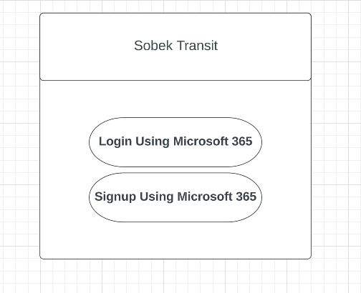 

1. **Map and bus route**

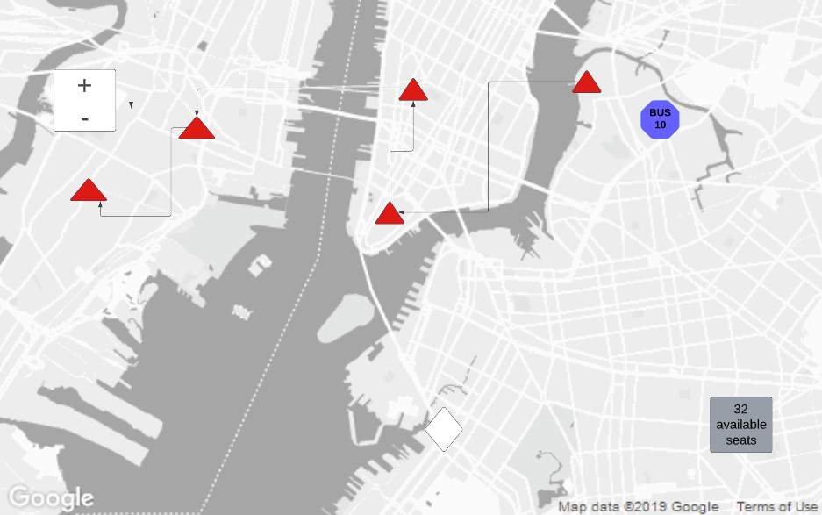



1. **Number of seats left**

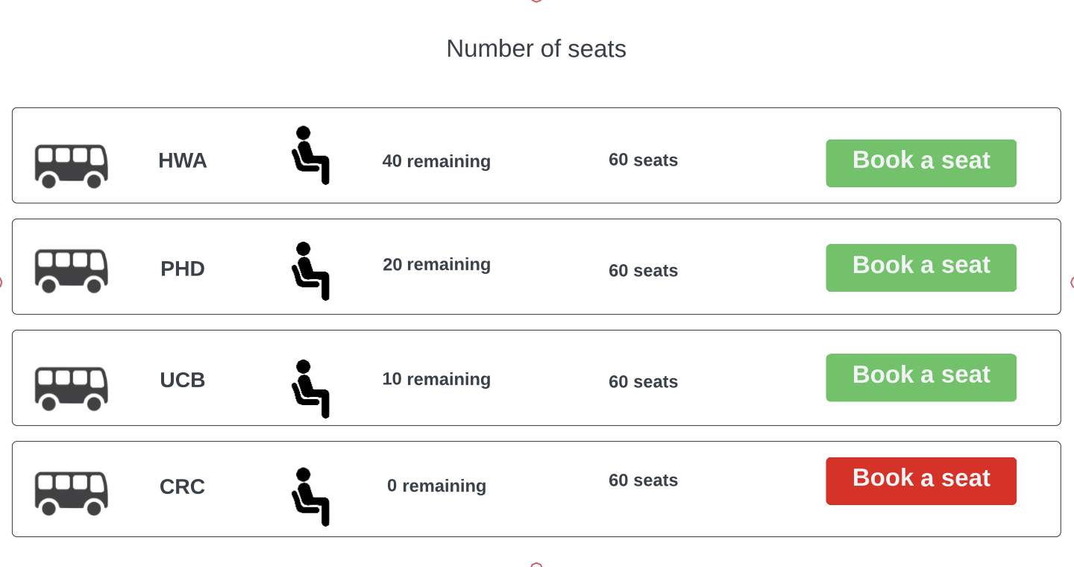



1. **Updated Weather/Bus information**

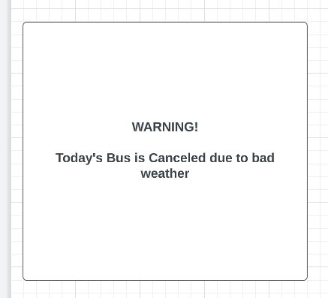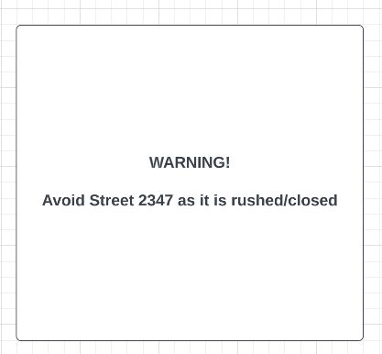

1. **Bus Info  
     
   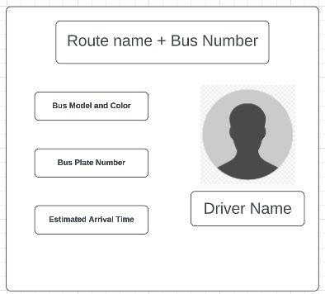**

**6. View Driver’s rating screen**

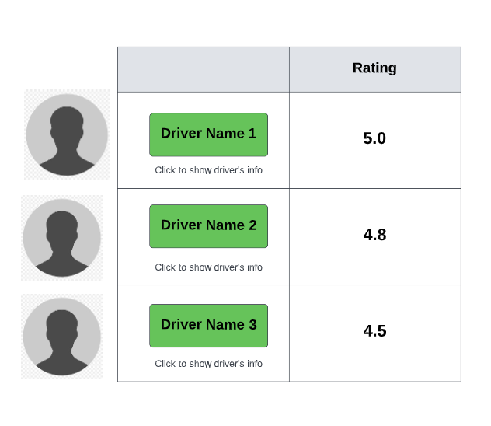

7. **Driver Information**

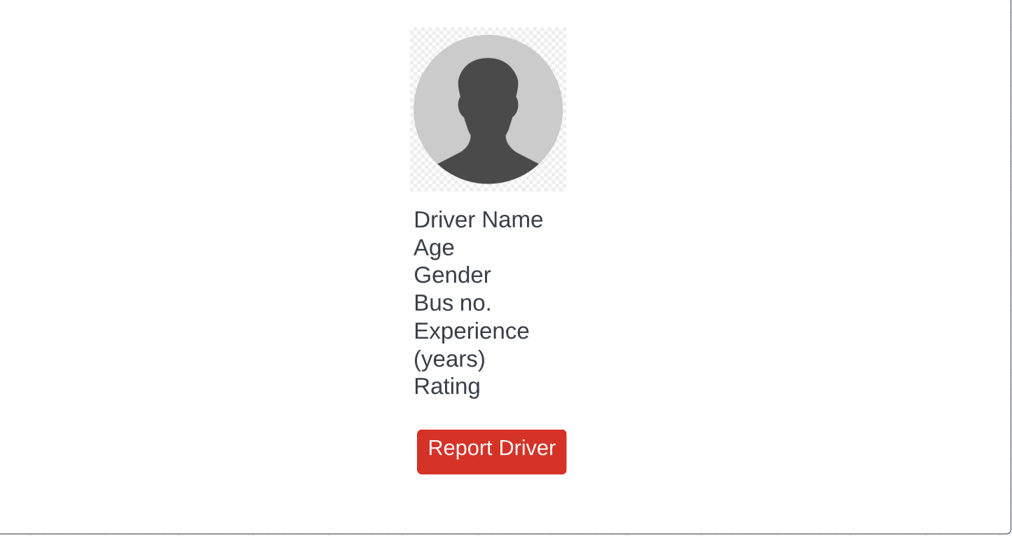

8. **Report a driver**

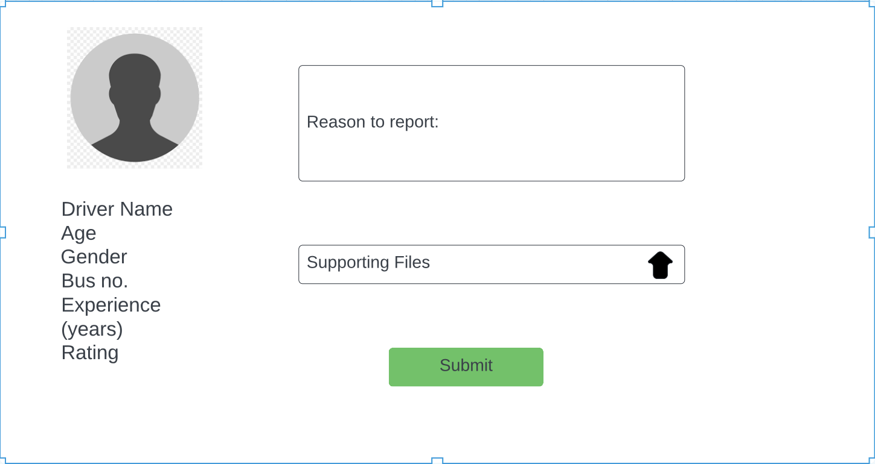

**9.Updated Weather/Bus information**



10.  **Bus Route Information**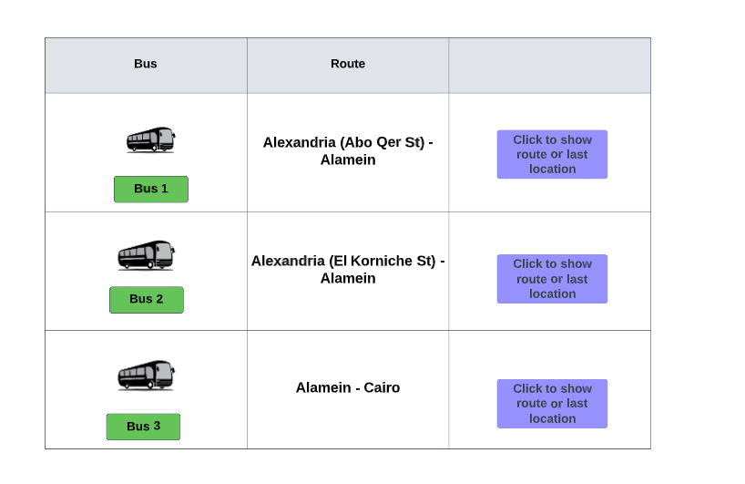

11. **Bus recent location:**

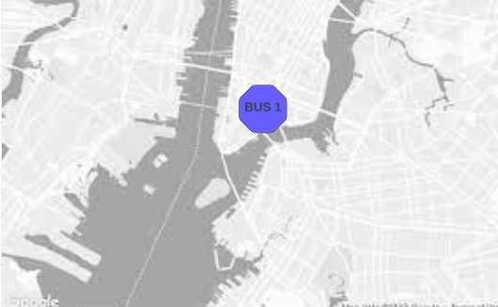

### PATH 2















### PATH 3



















### 

### 

### PATH 4



















### PATH 5















