**Architecture Diagrams**

We are using MVC Architecture:

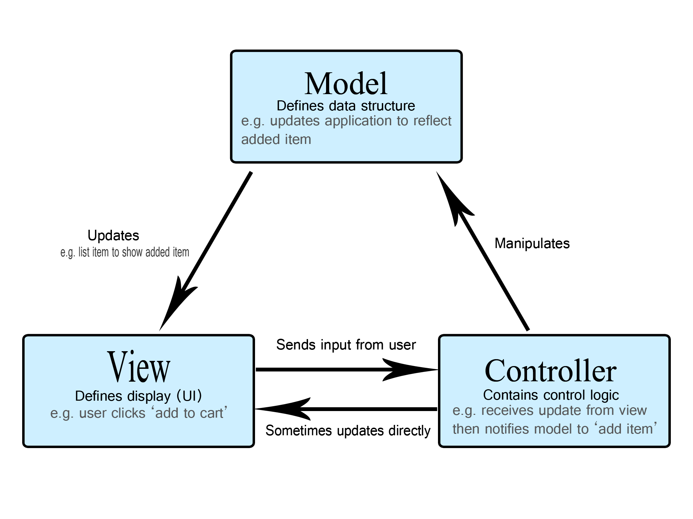

We used MVC because we saw it as the best fit for our project, as it will help us make our code more reusable, as it keeps everything organized and clean.

It also offers a lot of flexibility in designing (adding and removing components)

Also, it will help in the testing phase since each component will be separated and will be tested individually.

**Architecture diagram (level 0):**

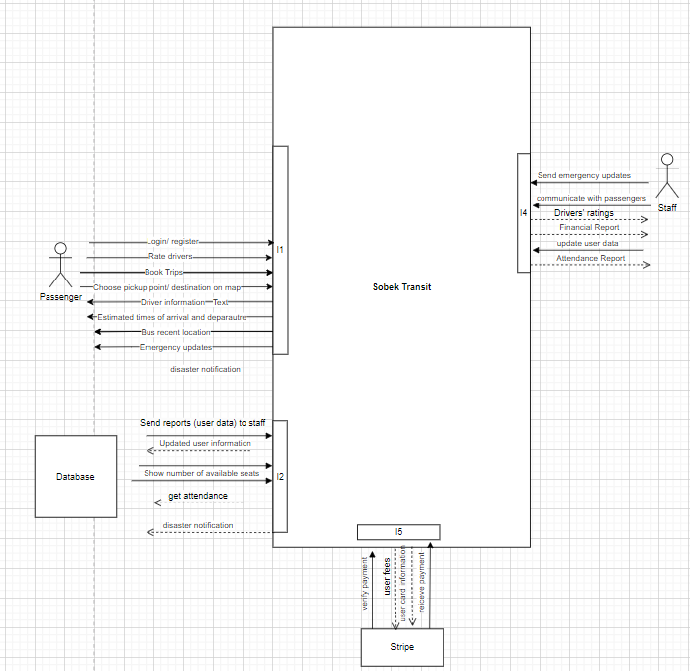

**Use case diagram:**

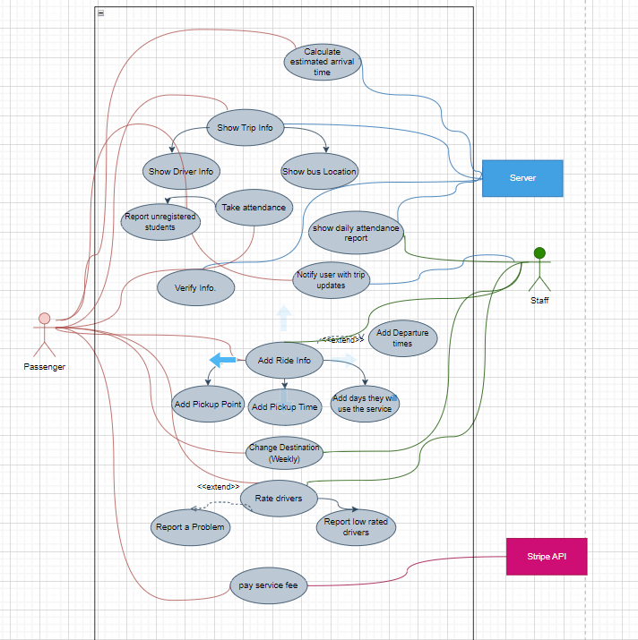

**Class diagram:**

