Portsaid international bank
Team Members:
1-Youssef ihab 23-101138
2-youssef ASHOUSH 23-101049
3-OMAR ABOELNAGA 23-101149
4-HAMDY ELSAEED 23-101232

Deliverable #1 Template – Database Project (Fall 2025)

1. English Requirements (Business Rules)

System Overview

Portsaid International Bank web app for retail banking customers and bank employees.

Two user roles: Customers (self-service banking) and Employees (ops/teller/loan staff).

Business Scenario

Customers manage their accounts: view balances/history, move money, request loans, and see overdraft events.

Employees operate on behalf of customers: create customer profiles, perform cash operations, review/update loans, adjust account status, run summaries/reports, and clean old records.

Functional Requirements

Authentication with username/PIN; role detected (customer vs employee).

Customer capabilities:

View owned accounts and balances.

View transaction history with filters (date range, type).

Deposit and withdraw cash on owned accounts.

Transfer funds between accounts (own → other).

Request loans and view loan status.

View overdraft events recorded on their accounts.

Employee capabilities:

Create customer profiles (username, PIN, full name, email, phone, address, national ID).

Perform deposits/withdrawals for a specified account.

Review all loans and update loan status.

Update account status (ACTIVE/FROZEN/CLOSED).

Run account summary reports (inflow/outflow, overdraft counts).

Delete pending loans;

purge overdraft events older than N days.

Data persistence:

Accounts, Customers, Employees, Transactions, Transfers, Loans, OverDraftEvents stored in SQL Server.

All state-changing actions logged to Transactions; transfers mirrored for both accounts.

Overdraft attempts logged to OverDraftEvents.

Business Rules and Constraints

Role-based access: customer UIs are limited to their own accounts; employee UIs expose operational tools.

Account status must be ACTIVE to transact (deposits/withdrawals/transfers) or request loans.

Transfers validate source and destination accounts exist and are ACTIVE.

Withdrawals/transfers with insufficient funds are blocked and create an overdraft event.

Loan requests allowed on ACTIVE accounts; loan status changes only via employee actions.

Pending loans can be deleted; non-pending loans cannot.

Overdraft event cleanup deletes only events older than the chosen age.

Transactions are always recorded with timestamps; transfers generate paired in/out entries.

Customer creation requires unique username and national ID.

Employees can change account status but not customer status.

Report summaries use deterministic aggregates (total inflow, total outflow, overdraft count) per account.

Illustrative Constraints (examples)

A transfer cannot proceed if source balance < transfer amount; an overdraft event is recorded and the transfer is rejected.

A deposit/withdrawal is rejected if the account status is not ACTIVE.

A loan can only be requested on an ACTIVE account; its initial status is PENDING until an employee updates it.

A pending loan is the only loan type eligible for deletion; approved/rejected/closed loans are retained.

Overdraft events older than the specified “days” threshold are eligible for bulk deletion; newer events remain.

Usernames and national IDs must be unique when creating customers; duplicates are rejected

2. Entity–Relationship Diagram (ERD)
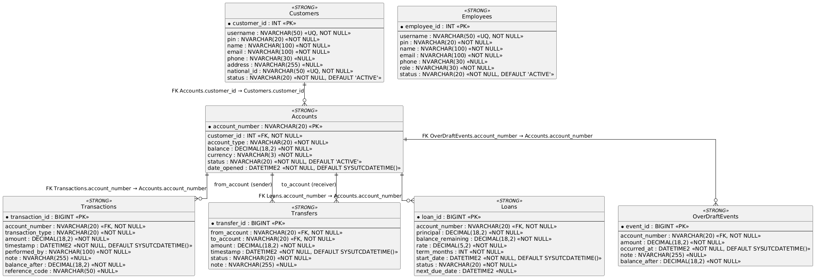

3. Relational Schema
CUSTOMERS(
customer_id PK,
username UQ,
pin,
name,
email,
phone,
address,
national_id UQ,
status
)
EMPLOYEES(
employee_id PK,
username UQ,
pin,
name,
email,
phone,
role,
status
)
ACCOUNTS(
account_number PK,
customer_id FK → CUSTOMERS(customer_id),
account_type,
balance,
currency,
status,
date_opened
)
TRANSACTIONS(
transaction_id PK,
account_number FK → ACCOUNTS(account_number),
transaction_type,
amount,
timestamp,
performed_by,
note,
balance_after,
reference_code
)
TRANSFERS(
transfer_id PK,
from_account FK → ACCOUNTS(account_number),
to_account FK → ACCOUNTS(account_number),
amount,
timestamp,
status,
note
)
LOANS(
loan_id PK,
account_number FK → ACCOUNTS(account_number),
principal,
balance_remaining,
rate,
term_months,
start_date,
status,
next_due_date
)
OVERDRAFTEVENTS(
event_id PK,
account_number FK → ACCOUNTS(account_number),
amount,
occurred_at,
note,
balance_after
)

RELATIONSHIPS (from FKs; cardinality/participation)
- CUSTOMERS 1 —— N ACCOUNTS
  - ACCOUNTS.customer_id is NOT NULL ⇒ each Account must belong to exactly 1 Customer
  - a Customer can have 0..N Accounts
- ACCOUNTS 1 —— N TRANSACTIONS
  - TRANSACTIONS.account_number is NOT NULL ⇒ each Transaction belongs to exactly 1 Account
  - an Account can have 0..N Transactions
- ACCOUNTS 1 —— N LOANS
  - LOANS.account_number is NOT NULL ⇒ each Loan belongs to exactly 1 Account
  - an Account can have 0..N Loans
- ACCOUNTS 1 —— N OVERDRAFTEVENTS
  - OVERDRAFTEVENTS.account_number is NOT NULL ⇒ each OverDraftEvent belongs to exactly 1 Account
  - an Account can have 0..N OverDraftEvents
- ACCOUNTS 1 —— N TRANSFERS (Sender role)
  - TRANSFERS.from_account is NOT NULL ⇒ each Transfer has exactly 1 sender Account
  - an Account can send 0..N Transfers
- ACCOUNTS 1 —— N TRANSFERS (Receiver role)
  - TRANSFERS.to_account is NOT NULL ⇒ each Transfer has exactly 1 receiver Account
  - an Account can receive 0..N Transfers

4. list of all queries (not the ad hoc ones)
1) Schema Definition (scripts/create_tables.sql)
- Purpose: Defines the relational model used by all DAOs/UI flows.
- Actions:
  - Creates database BankDB if missing; drops existing tables in dependency-safe order.
  - Creates tables:
    - Customers (identity PK, unique username, national_id, contact info, status).
    - Employees (identity PK, unique username, role, status).
    - Accounts (PK account_number, FK to customer, type, balance, status, dates).
    - Transactions (identity PK, FK to account, type, amount, timestamp, balance_after, reference_code).
    - Transfers (identity PK, from/to account FKs, amount, status, note).
    - Loans (identity PK, FK to account, principal, remaining balance, rate, term, status, due date).
    - OverDraftEvents (identity PK, FK to account, amount, occurred_at, balance_after).
- Used by: Initial schema setup; required before seeding or running the app. All DAOs assume these tables exist and match the defined columns.
2) Bulk Seed Data (scripts/seed_data.sql)
- Purpose: Populate a rich dataset for demos/testing (100 customers, 300 accounts, 30 loans, transactions, transfers, overdrafts).
- Actions:
  - Clears all business tables (OverDraftEvents → Transfers → Transactions → Loans → Accounts → Customers → Employees).
  - Inserts 4 employees with roles (TELLER, LOAN_OFFICER, OPS).
  - Inserts 100 customers using a recursive CTE; generates usernames/pins/national IDs/contact info.
  - Inserts 300 accounts (3 per customer) with rotating account types and deterministic balances/dates.
  - Inserts 30 loans on the first 30 accounts with varying amounts, rates, and statuses.
  - Inserts transactions (2 per first 150 accounts) for seed deposits/withdrawals.
  - Inserts 50 transfers between sequential accounts and mirrors them into transaction logs (TRANSFER_IN/OUT).
  - Inserts 40 overdraft events tied to early accounts.
- Used by: Demo environment to exercise UI flows (history, transfers, loans, overdrafts, reports). Provides enough volume for aggregates and filters.
3) Reporting / Analytical Queries (scripts/report_queries.sql)
These queries answer business questions; each includes the SQL and the business perspective.
- Account inflow/outflow and overdraft risk (aggregate + joins)
Business: How much has this account received and paid out, and how risky is it (overdraft count)? Staff use it to assess account health.
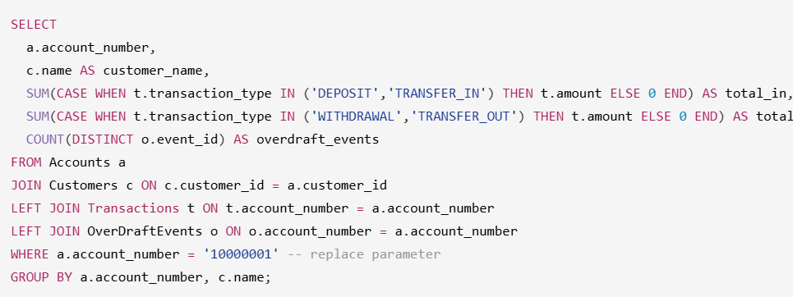
- Overdraft frequency by customer (aggregate + join)
Business: Which customers trigger overdrafts, and how often? Highlights customers who may need outreach or account reviews.
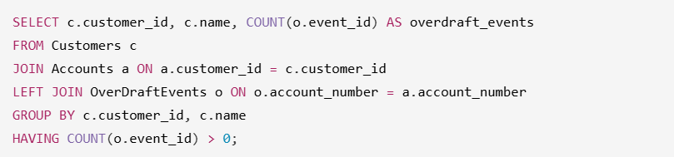
- High-balance accounts (subquery)
Business: Identify accounts above the bank-wide average balance to target premium servicing or retention efforts.
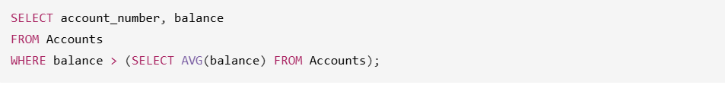
- Loans with above-average remaining balance (subquery)
Business: Surface loans with unusually high remaining balances compared to all approved loans, to prioritize monitoring or follow-up.
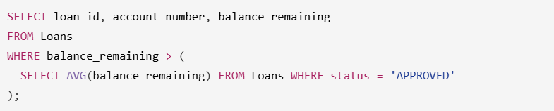
- Customer transaction history (join >2 tables)
Business: Produce a statement-like view of all transactions for a customer across accounts, including the customer name for clarity in investigations or support.
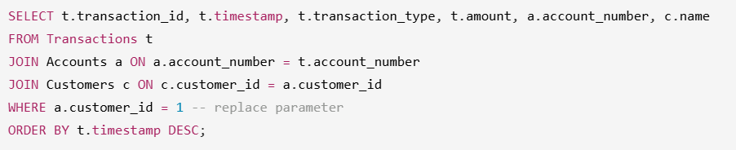
- Loan portfolio with ownership (join >2 tables)
Business: Show each loan with its status, remaining balance, and who owns it (account + customer), for loan-ops dashboards.
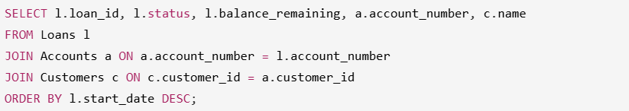
- Housekeeping: close dormant frozen accounts (conditional UPDATE)
Business: Automatically close accounts that are frozen and have zero balance to keep the ledger clean.
- Housekeeping: purge old overdraft events (conditional DELETE with date)
Business: Trim overdraft incident history older than the retention window to keep the table lean.
4) Core Application Queries (DAOs)
These run via parameterized SQL in the DAOs. Each query is shown with placeholders and its business meaning.
- Authenticate customer — Verify active customer credentials to start a customer session.
- 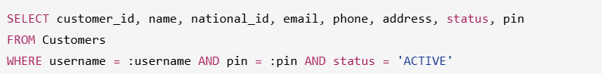
Screenshot:
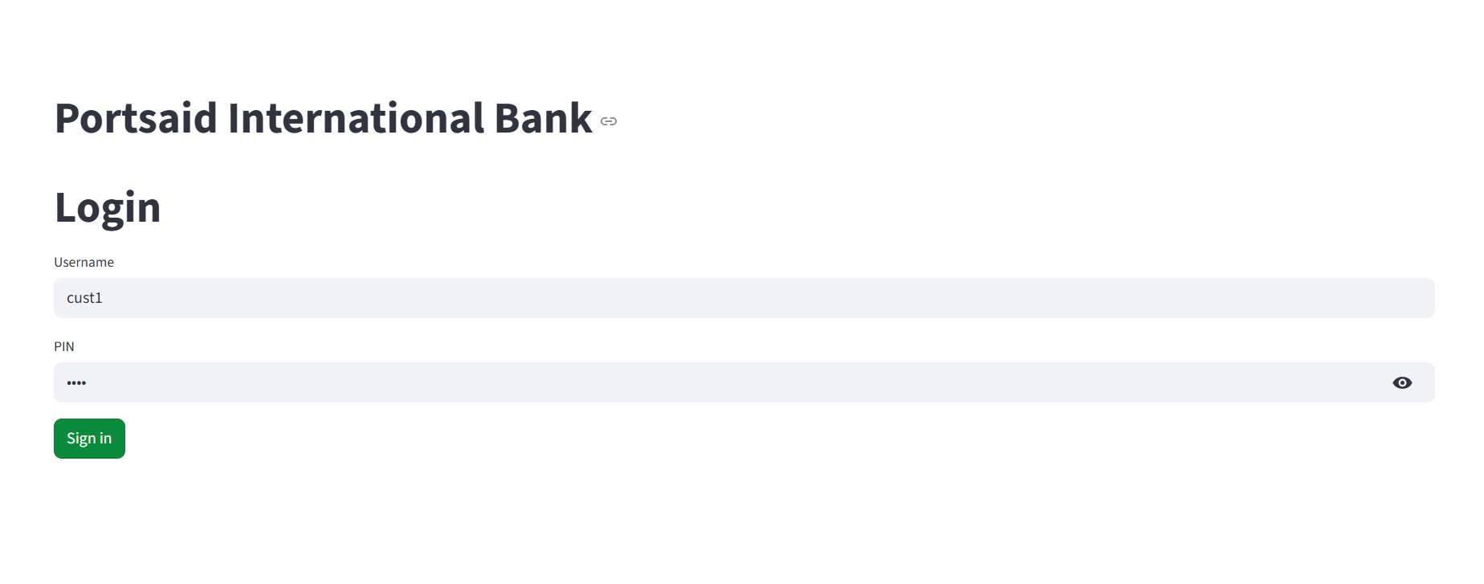
- Create customer — Register a new customer profile with contact and national ID, set to ACTIVE.
- List customers — Retrieve all customers for employee/admin views.
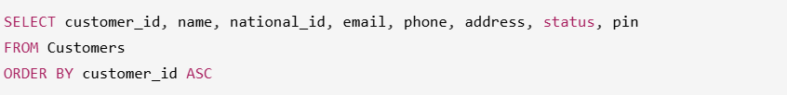
EmployeeDAO
- Authenticate employee — Verify active employee credentials to start an employee session.
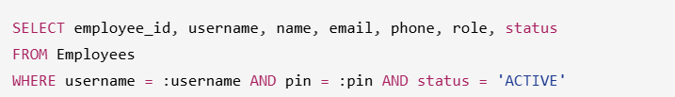AccountDAO
- Accounts by customer — Show all accounts owned by a customer (balances, types, status).
- 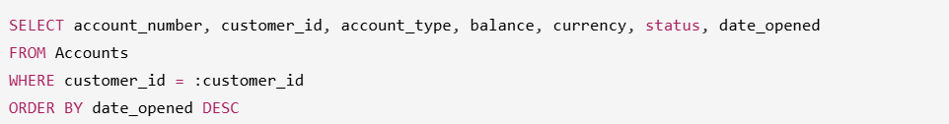
- Screenshot:
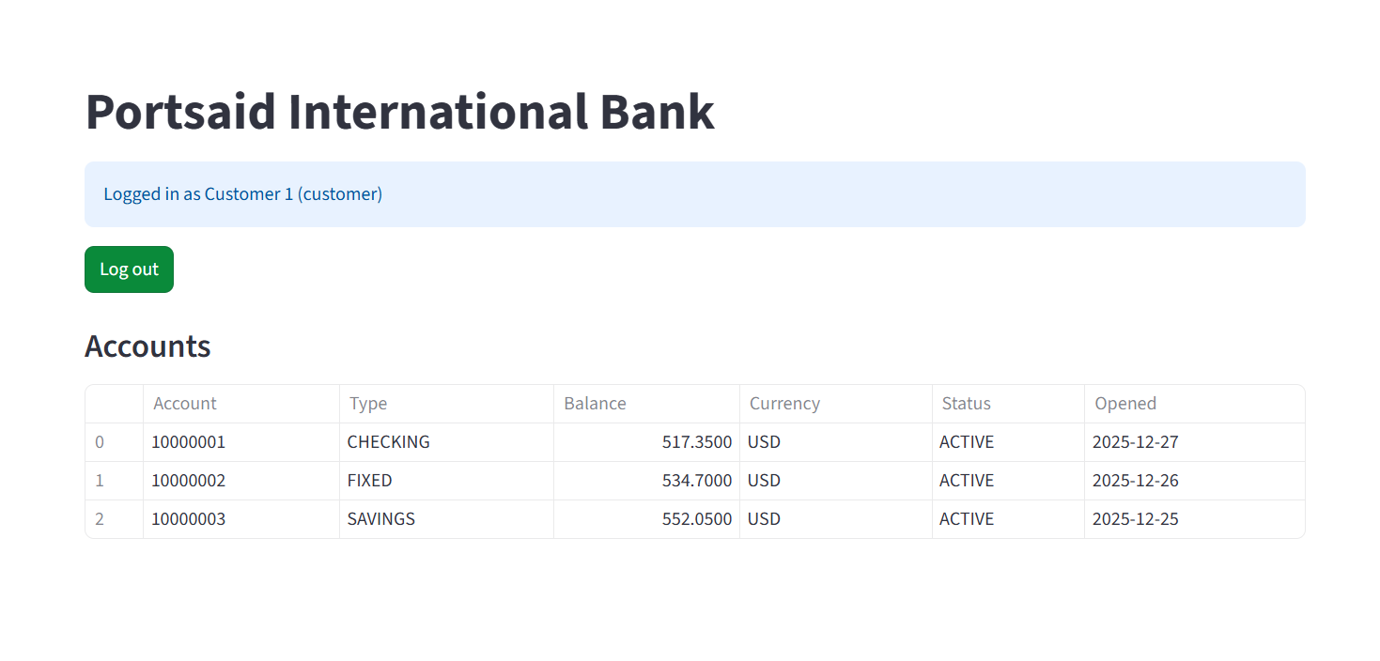
- Single account — Fetch one account to validate ownership/status/balance.
- 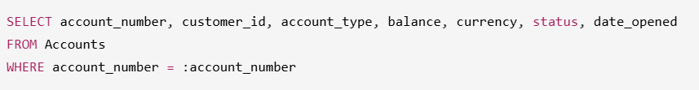Update balance — Apply balance changes after deposits/withdrawals/transfers.
- 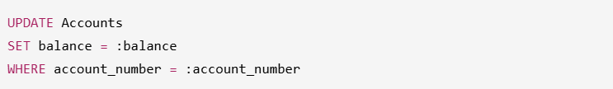
- 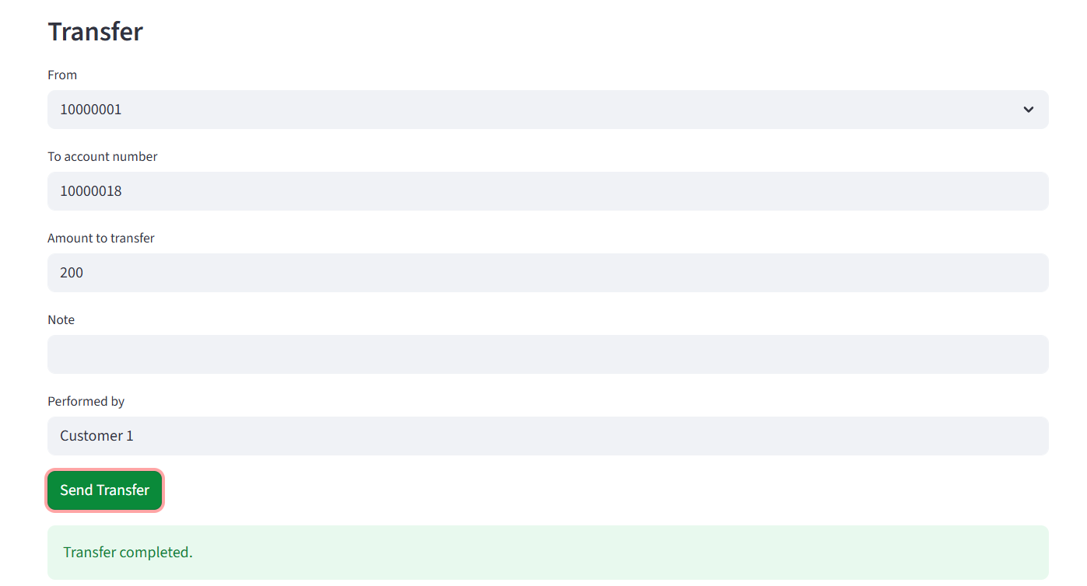
- Update status — Freeze/close/activate an account by staff.
- 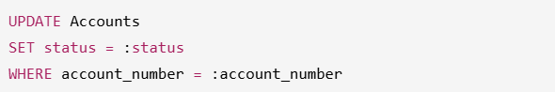Create account — Open a new account for a customer.
Screenshot:
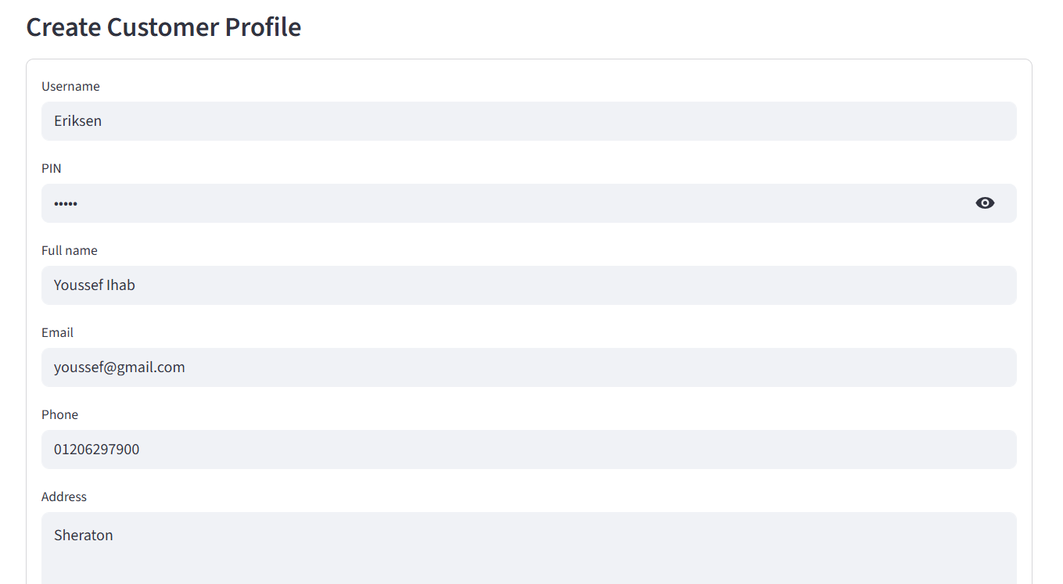
TransactionDAO
- List history with filters — Provide statement/history view with optional date/type filters.
SELECT transaction_id, account_number, transaction_type, amount, timestamp, performed_by, note, balance_after, reference_code
FROM Transactions
WHERE <dynamic filters: account_number = :account_number AND optional date/type clauses>
ORDER BY timestamp DESC
- Insert transaction — Log any cash/transfer operation with the resulting balance.
INSERT INTO Transactions (account_number, transaction_type, amount, timestamp, performed_by, note, balance_after, reference_code)
OUTPUT INSERTED.transaction_id
VALUES (:account_number, :transaction_type, :amount, SYSUTCDATETIME(), :performed_by, :note, :balance_after, :reference_code)
- Get transaction by id — Fetch a specific transaction (post-insert confirmation/audit).
SELECT transaction_id, account_number, transaction_type, amount, timestamp, performed_by, note, balance_after, reference_code
FROM Transactions
WHERE transaction_id = :transaction_id
TransferDAO
- List transfers for an account — Show inbound and outbound transfers for an account.
- 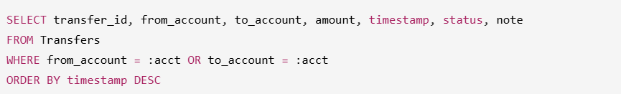Insert transfer — Record a funds move between accounts.
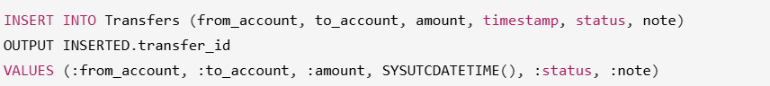LoanDAO
- List loans by account — Show loans tied to a specific account for the customer view.
SELECT loan_id, account_number, principal, balance_remaining, rate, term_months, start_date, status, next_due_date
FROM Loans
WHERE account_number = :account_number
ORDER BY start_date DESC
- List all loans — Portfolio view for employees to review/update.
SELECT loan_id, account_number, principal, balance_remaining, rate, term_months, start_date, status, next_due_date
FROM Loans
ORDER BY start_date DESC
- Get loan by id — Retrieve a specific loan for status changes or display.
SELECT loan_id, account_number, principal, balance_remaining, rate, term_months, start_date, status, next_due_date
FROM Loans
WHERE loan_id = :loan_id
- Request/insert loan — Create a loan request with initial status (e.g., PENDING).
INSERT INTO Loans (account_number, principal, balance_remaining, rate, term_months, start_date, status)
OUTPUT INSERTED.loan_id
VALUES (:account_number, :principal, :principal, :rate, :term_months, :start_date, :status)
- Update loan status — Approve/reject/close a loan.
UPDATE Loans SET status = :status WHERE loan_id = :loan_id
- Delete pending loan — Remove only loans that never advanced (PENDING).
DELETE FROM Loans WHERE loan_id = :loan_id AND status = 'PENDING'
Screenshot:
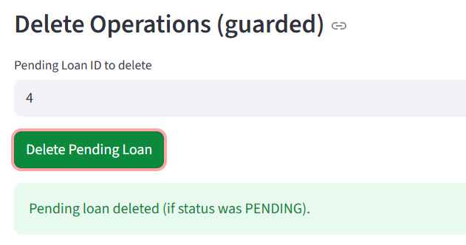
OverDraftEventDAO
- List overdraft events — Show overdraft incidents for an account to inform the customer/staff.
SELECT event_id, account_number, amount, occurred_at, note, balance_after
FROM OverDraftEvents
WHERE account_number = :account_number
ORDER BY occurred_at DESC
- Insert overdraft event — Log a blocked operation due to insufficient funds.
INSERT INTO OverDraftEvents (account_number, amount, occurred_at, note, balance_after)
VALUES (:account_number, :amount, SYSUTCDATETIME(), :note, :balance_after)
- Delete old overdraft events — Purge events older than N days per retention.
DELETE FROM OverDraftEvents
WHERE occurred_at < DATEADD(day, -:days, SYSUTCDATETIME())
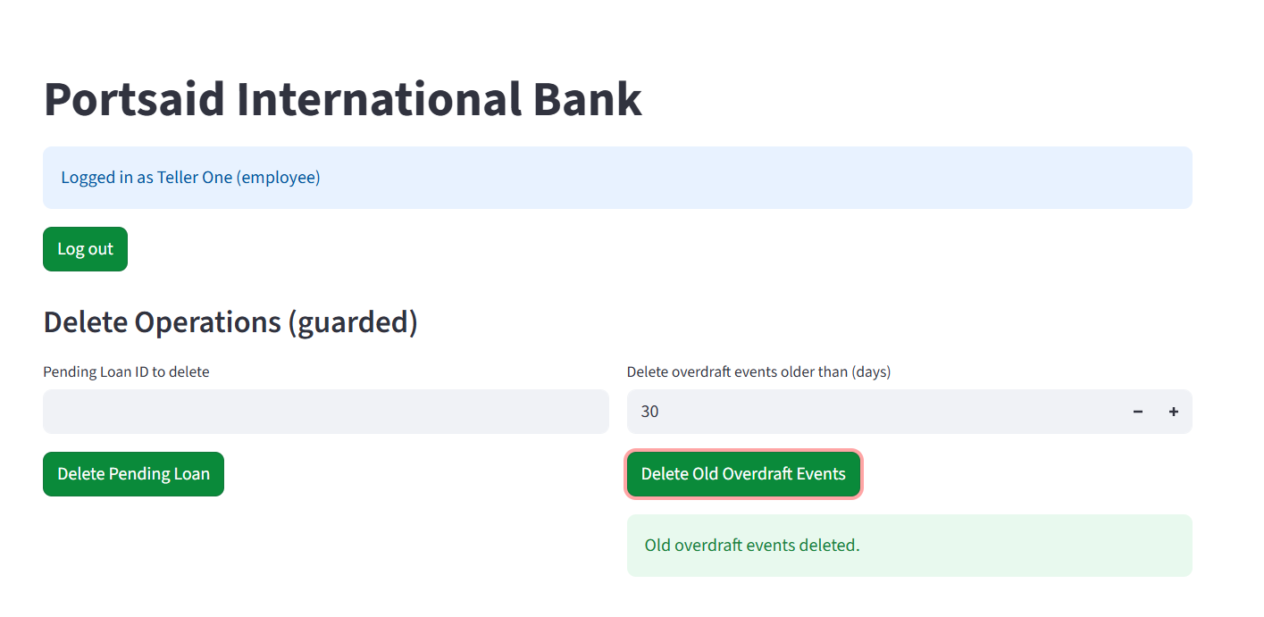
ReportingDAO
- Account summary (inflow/outflow/overdrafts) — Produce a concise health snapshot for an account.
