- Data Preprocessing
To prepare the raw dataset for training models, a comprehensive preprocessing pipeline was implemented. This pipeline ensures data consistency, handles categorical variables correctly across training and test sets, and scales features for distance-based algorithms

  - Data Integration and Cleaning
- Unified Processing: The training and test datasets were temporarily concatenated. This was a critical step to ensure that categorical features (like Brand or OS Version) were encoded consistently. For example, brands present in the test set but missing from the training set would otherwise cause encoding errors.
- Duplicate Removal: Duplicate entries were identified and removed from the training set to prevent bias during model training.
- String Parsing:
- Storage Conversion: Complex string values in the memory_card_size column (e.g., "1 TB", "512 GB") were parsed into standard numerical values (Gigabytes).
- OS Version Extraction: Inconsistent version strings (e.g., "v12", "Android 10") were cleaned using regular expressions to extract the primary version number as a float.

  - Feature Encoding
We applied different encoding strategies based on the nature of the data:
- Binary Encoding: Categorical features with only two options (e.g., 4G, NFC, Dual_Sim) were mapped to binary values (1 for Yes, 0 for No). The target variable price was similarly encoded (expensive=1, non-expensive=0).
- Ordinal Encoding: Features with an inherent hierarchy (Performance_Tier, RAM Tier) were mapped to integers preserving their rank (e.g., Budget=1, Mid-Range=2 ... Flagship=4).
- One-Hot Encoding: Nominal categorical features with no inherent order (Brand, OS Name, Notch Type) were transformed using One-Hot Encoding.
- Note: The Processor_Series column was dropped due to high cardinality (too many unique values), which would have introduced excessive noise.

  - Feature Scaling
- Min-Max Scaling: All numerical features were scaled to a range of [0, 1] using MinMaxScaler.
- Leakage Prevention: The scaler was fit only on the training data and then applied to the validation and test sets to ensure no information leakage.
- Rationale: This scaling method was chosen to satisfy the requirements of multiple models:
- KNN & SVM: require scaled data to calculate distances accurately.
- Naive Bayes (Multinomial): requires non-negative input values, making Min-Max superior to Standard Scaling (which produces negative values) for this specific project.

  - Data Splitting
The processed training data was split into Training (80%) and Validation (20%) sets.
- Stratification: A stratified split was used based on the price column. This ensures that the ratio of "Expensive" to "Non-Expensive" phones remains consistent across both sets, preventing class imbalance issues during validation.

- Exploratory Data Analysis (EDA)
Post-processing, we performed a statistical analysis to identify which features most strongly influence the price classification. This step validates the predictive power of our dataset before model training.

  - Feature Correlation Analysis
To determine the primary drivers of smartphone cost, we calculated the Pearson Correlation
Coefficient between all features and the target variable (price).
- Visualization: Feature Drivers Bar Chart - displays the top 10 features with the strongest positive and negative correlations.

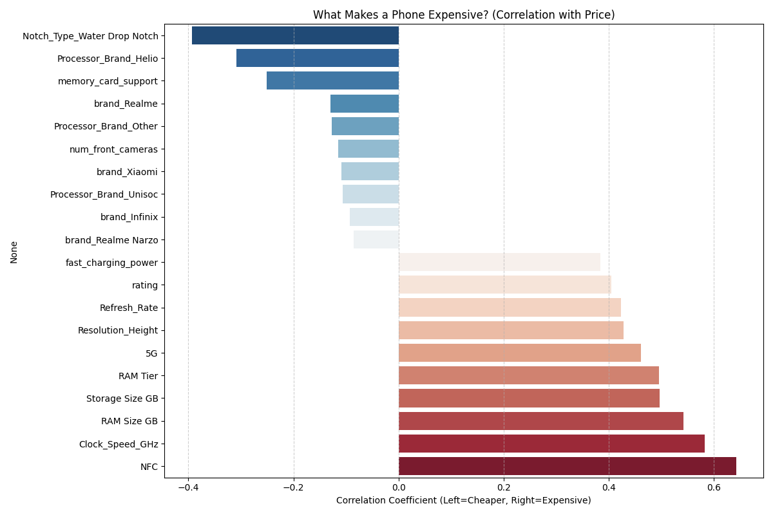

- Key Insights:
- Premium Indicators (Positive Correlation): Features such as NFC, Clock Speed, and RAM Size show strong positive correlations (red bars extending to the right). This indicates that as these specifications increase, the likelihood of the phone being "Expensive" rises significantly. NFC, in particular, emerged as a top differentiator, likely due to its ubiquity in flagship devices and absence in entry-level models.
- Budget Indicators (Negative Correlation): Features such as Water Drop Notch and specific processor brands (e.g., Helio) show strong negative correlations (blue bars extending to the left). These features are historically associated with cost-effective manufacturing and lower price points.

- Model Training and Evaluation
To classify smartphones into "Expensive" or "Non-Expensive" categories, we implemented a
supervised learning approach. We began with a Random Forest Classifier, chosen for its robustness
against overfitting and ability to handle high-dimensional data without extensive feature selection.

  - Random Forest Classifier
Algorithm Description: The Random Forest is an ensemble learning method that constructs a
multitude of Decision Trees during training.

- Mechanism: It operates by creating many individual decision trees. Each tree is trained on a random subset of the data (bootstrapping) and considers a random subset of features at each split. The final output is determined by the "majority vote" of all individual trees.
- Hyperparameter Tuning: To optimize performance, we conducted a Grid Search over two key hyperparameters:
- n_estimators (Number of Trees): We tested values of [50, 100, 200]. Increasing the number of trees generally stabilizes the prediction error but increases computational cost.
- max_depth (Tree Depth): We tested values of [5, 10, None]. Restricting depth prevents the model from memorizing noise (overfitting), while None allows trees to grow until all leaves are pure (maximizing potential accuracy if aggregated correctly).
- Results: The model was trained and validated on all 9 hyperparameter combinations:
- Best Configuration: The highest validation accuracy was achieved with n_estimators=100 and max_depth=5.
- Performance:
- Validation Accuracy: 93.64%
- Impact of Depth: The preference for a constrained depth (max_depth=5) indicates that simpler trees generalized better to unseen data. Allowing the trees to grow indefinitely (max_depth=None) likely caused them to "memorize" noise in the training set (overfitting), reducing their effectiveness on the validation set.
- Impact of Estimators: Increasing trees from 50 to 100 provided a measurable boost, but increasing to 200 yielded diminishing returns, confirming that 100 trees provided the optimal balance of speed and accuracy.
- Final Model Evaluation (Test Set)
After selecting the optimal hyperparameters (100 Trees, Max Depth 5) based on validation performance, we performed a final evaluation on the held-out Test Set.
- Confusion Matrix Analysis: True Negatives (106) - True Positives (36) - False Positives (4) - False Negatives (7)
- Accuracy: 92.81% – The model correctly classified the vast majority of phones.
- Precision: 90.00% – When the model predicted a phone was "Expensive," it was correct 90% of the time.
- Recall: 83.72% – The model successfully caught 83.7% of all actual expensive phones, missing only a few.
- F1 Score: 0.8675 – Indicates a strong balance between precision and recall.

  - Logistic Regression Classifier
Algorithm Description: Logistic Regression is a statistical method for predicting binary classes.
Logistic Regression is a linear model that estimates the probability of an event occurring based
on a given dataset of independent variables.

- Mechanism: It operates by calculating a weighted sum of the input features (linear combination) and passing this result through a Sigmoid Function. This transforms the output into a probability value between 0 and 1. If the probability is above a threshold (typically 0.5), the instance is classified as "Expensive" (1); otherwise, it is "Non-Expensive" (0).
- Hyperparameter Tuning: To optimize performance, we conducted a Grid Search over the regularization parameter:
- C (Inverse of Regularization Strength): We tested values of [0.1, 1.0, 10.0]. This parameter controls the trade-off between achieving a low training error and keeping the model simple to avoid overfitting.
- Small C (e.g., 0.1): Implies strong regularization. The model is penalized for having large weights, leading to a simpler, more generalized model.
- Large C (e.g., 10.0): Implies weak regularization. The model is allowed to fit the training data more closely, which can increase accuracy but risks overfitting.
- Results: The model was trained and validated on the defined hyperparameter values:
- Best Configuration: The highest validation accuracy was achieved with C=[10.0].
- Performance:
- Validation Accuracy: [0.9017]
- Impact of Regularization (C): The preference for a higher C value suggests that the decision boundary between "Budget" and "Expensive" phones is quite sharp, and the model benefited from fitting the training data more aggressively.
- Final Model Evaluation (Test Set)
After selecting the optimal hyperparameter (C = [10.0]) based on validation performance, we performed a final evaluation on the held-out Test Set.
- Confusion Matrix Analysis: True Negatives (102) - True Positives (37) - False Positives (8) - False Negatives (6)
- Accuracy: 0.9085
- Precision: 0.8222
- Recall: 0.8605
- F1 Score: 0.8409

  - Naive Bayes Classifier
Algorithm Description: Naive Bayes is a probabilistic classifier based on Bayes' Theorem with a strong (naive) assumption of independence between features. We specifically utilized Gaussian Naive Bayes, which assumes that continuous features (like Clock Speed and RAM) follow a normal (Gaussian) distribution.
- Mechanism: It calculates the probability that a phone belongs to a specific class (e.g., "Expensive") given its features. It estimates the mean and variance of each feature for both classes. To predict a new phone, it calculates the likelihood of the phone's specs appearing under the "Budget" curve vs. the "Expensive" curve.
- Hyperparameter Tuning: While Naive Bayes has few parameters, we optimized the stability of the calculation by tuning:
- var_smoothing (Variance Smoothing): We tested values of [1e-6, 1e-5, 1e-4, 1e-3, 1e-2]. This parameter adds a small portion of the largest variance of all features to the variance of each feature.
- Purpose: It artificially "widens" the Gaussian curve. This prevents the model from assigning zero probability to data points that are slightly far from the mean (numerical stability) and helps handling irregular data distributions.
- Results: The model was trained and validated on the defined smoothing values:
- Best Configuration: The highest validation accuracy was achieved with var_smoothing=[ 0.01].
- Performance:
- Validation Accuracy: [0.8613]
- Impact of Smoothing: This suggests the model benefited from a "flatter" curve, allowing it to generalize better to data points that deviated from the exact mean of the training set.
- Final Model Evaluation (Test Set)
After selecting the optimal hyperparameter (var_smoothing=[ 0.01]) based on validation performance, we performed a final evaluation on the held-out Test Set.
- Confusion Matrix Analysis: True Negatives (98) - True Positives (38) - False Positives (12) - False Negatives (5)
- Accuracy: 0.8889
- Precision: 0.7600
- Recall: 0.8837
- F1 Score: 0.8172

  - Decision Tree Classifier
Algorithm Description: The Decision Tree is a non-parametric supervised learning method. This model builds a single, transparent tree structure to make decisions.
- Mechanism: It learns simple decision rules inferred from the data features. It starts at the root node and splits the data into subsets based on the feature that results in the highest information gain (or lowest impurity). This process repeats recursively until a stopping criterion is met (e.g., maximum depth or pure leaf nodes).
- Hyperparameter Tuning: To strike the right balance between model complexity and generalization, we performed an extensive Grid Search (5-fold Cross-Validation) optimized for the F1 Score. We varied four key hyperparameters:
- Criterion: We tested ['gini', 'entropy']. This determines the mathematical formula used to calculate the "purity" of a split.
- Max Depth: We tested values of [5, 10, 15, 20, None]. Controlling the depth is the primary way to prevent the tree from becoming too complex and memorizing noise (overfitting).
- Min Samples Split: We tested [2, 4, 6, 8]. This is the minimum number of samples required to split an internal node. Higher values force the model to be more conservative, creating broader, more generalized rules.
- Min Samples Leaf: We tested [1, 2, 4]. This guarantees that every leaf (final decision) has at least this many samples, preventing the model from creating rules for single "outlier" data points.
- Results: The model was trained and validated on all parameter combinations:
- Best Configuration: The grid search identified the optimal parameters as: ['criterion': entropy, max_depth: 15, min_samples_leaf: 1, min_samples_split: 4].
- Performance:
- Best CV Score (F1): [0.8061]
- Validation Accuracy: [0.9017]
- Impact of Regularization: This indicates that preventing the model from isolating tiny groups of data points helped improve generalization.
- Final Model Evaluation (Test Set)
After selecting the optimal hyperparameter (var_smoothing=[ 0.01]) based on validation performance, we performed a final evaluation on the held-out Test Set.
- Confusion Matrix Analysis: True Negatives (105) - True Positives (37) - False Positives (5) - False Negatives (6)
- Accuracy: 0.9281
- Precision: 0.8810
- Recall: 0.8605
- F1 Score: 0.8706

  - K-Nearest Neighbors (KNN) Classifier
Algorithm Description: K-Nearest Neighbors is a non-parametric, instance-based learning algorithm. Unlike other models that "learn" a set of rules or coefficients, KNN simply memorizes the training dataset.
- Mechanism: When classifying a new smartphone, the algorithm calculates the mathematical distance between the new phone's features and every other phone in the training set. It then identifies the K closest data points ("neighbors") and assigns the class based on a majority vote.
- Hyperparameter Tuning: To determine the optimal structure for the neighborhood voting process, we utilized Grid Search (5-fold Cross-Validation) maximizing the F1 Score. We tuned three critical hyperparameters:
- n_neighbors (K): We tested values of [3, 5, 7, 9, 11, 15].
Small K (e.g., 3): Makes the model sensitive to local patterns and noise (risk of overfitting).
Large K (e.g., 15): Smooths the decision boundaries, ignoring outliers but potentially missing finer details (risk of underfitting).
- Weights: We tested ['uniform', 'distance'].
Uniform: Every neighbor gets 1 vote, regardless of distance.
Distance: Closer neighbors have a stronger influence on the vote. This is often better when data clusters are dense.
- Metric: We tested ['euclidean', 'manhattan', 'minkowski']. This determines how "distance" is measured (e.g., straight-line vs. grid-like paths) in the high-dimensional feature space.
- Results: The model was trained and validated on all parameter combinations:
- Best Configuration: The grid search identified the optimal parameters as: [metric: manhattan, n_neighbors: 11, weights: distance].
- Performance:
- Best CV Score (F1): [0.8405]
- Validation Accuracy: [0.9017]
- Impact of Weights:
weights='distance': This suggests that "nearby" phones (very similar specs) were much more reliable indicators of price than neighbors slightly further away.
metric='manhattan': This often works better in high-dimensional spaces where features are on different scales or "grid-like" structures (like integer tiers).
- Final Model Evaluation (Test Set)
After selecting the optimal hyperparameter based on validation performance, we performed a final evaluation on the held-out Test Set.
- Confusion Matrix Analysis: True Negatives (104) - True Positives (37) - False Positives (6) - False Negatives (6)
- Accuracy: 0.9216
- Precision: 0.8605
- Recall: 0.8605
- F1 Score: 0.8605
  - Support Vector Machine (SVM) Classifier
Algorithm Description: The Support Vector Machine (SVM) is a powerful supervised learning algorithm. Unlike Decision Trees that split data using rules, SVM attempts to find the optimal "hyperplane" (boundary) that separates "Expensive" phones from "Budget" phones with the widest possible margin.
- Mechanism:
- The Margin: SVM looks for the "street" between the two classes. The wider the street, the better the model will generalize.
- Kernel Trick: Since smartphone data is not always linearly separable (you can't draw a straight line to separate budget from expensive), we use a "Kernel" function. This projects the data into a higher dimension where a linear separation becomes possible.
- Hyperparameter Tuning: To optimize the shape and flexibility of this boundary, we performed a Grid Search varying three key parameters:
- Kernel: We tested ['linear', 'rbf'].
Linear: Assumes the data can be separated by a straight line (or flat plane). Fast and simple.
RBF (Radial Basis Function): Capable of creating complex, curved decision boundaries. This is often better for capturing intricate relationships between specs.
- C (Regularization): We tested [0.1, 1, 10].
Low C (0.1): Prioritizes a wider margin, even if it misclassifies a few training points. Good for preventing overfitting.
High C (10): Penalizes misclassifications heavily. It tries to get every training point right, leading to a "wiggly" boundary that risks overfitting.
- Gamma: We tested ['scale', 0.01, 0.1] (specifically for the RBF kernel).
Low Gamma: Points far away from the separation line are considered in the calculation. Result: A smoother, gentler curve.
High Gamma: Only points very close to the line matter. Result: A complex, jagged curve that hugs the training data.
- Results: The model was trained and validated on all combinations:
- Best Configuration: The highest validation accuracy was achieved with: [Kernel=linear, C=10, Gamma=scale].
- Performance:
- Validation Accuracy: [0.9133]
- Impact of C: It suggests the decision boundary is quite sharp and the model needed strict penalties to differentiate high-end "flagship killers" from true flagships.
- Final Model Evaluation (Test Set)
After selecting the optimal hyperparameter based on validation performance, we performed a final evaluation on the held-out Test Set.
- Confusion Matrix Analysis: True Negatives (100) - True Positives (37) - False Positives (10) - False Negatives (6)
- Accuracy: 0.8954
- Precision: 0.7872
- Recall: 0.8605
- F1 Score: 0.8222
- Conclusion
In this project, we successfully built and evaluated six machine learning models to predict smartphone price categories ("Expensive" vs. "Non-Expensive").
- Best Model: The Random Forest Classifier was the superior model, achieving a Test Accuracy of 92.81%. It outperformed others by balancing complexity and generalization, specifically using 100 trees with a maximum depth of 5.
- Critical Features: Our analysis confirmed that NFC support, RAM size, and Processor Speed are the strongest indicators of a high price tag. Conversely, older features like "Water Drop Notches" strongly indicate budget devices.
- Final Verdict: The model is robust and reliable, demonstrating high precision (90%) in identifying expensive devices. It is ready for deployment to help users or retailers estimate smartphone tiers based on technical specifications alone.

