

**Program: Computer Engineering and Software Systems**

***Course Code: ECE251***

***Course Name: Signals and Systems***

***Submitted to***

**Prof. Wagdy Anis**

**Ain Shams University**

**Faculty of Engineering**

**Spring Semester – 2023**

**MATLAB Project**

**Students Personal Information**

|  |  |  |
| --- | --- | --- |
| **Student Name:** | **Heba Hesham Hashem AbdElbakey** | **Yousef Emad Eldin Elshahat** |
| **Student Code:** | **20P8736** | **20P3844** |

|  |  |
| --- | --- |
| **Student Name:** | **Youssef Emad Eldin Elshahat Barakat** |
| **Student Code:** | **20P3844** |

T = 2;

E = 2;

% Define the signal f(t)

f = @(t) E*(mod(t,T) <= (T/6)) - E*((mod(t,T) >= (T/3)) & (mod(t,T) <= (2*T/3))) + E*((mod(t,T) >= (5*T/6)) & (t <= T));

% Define the time vector for one period of the signal

t_period = linspace(0, T, 1000);

% Calculate a1, a2, and a3 using the Fourier series formulas

a1 = round((2/T) * trapz(t_period, f(t_period) .* cos(2*pi*t_period/T)), 2);

a2 = round((2/T) * trapz(t_period, f(t_period) .* cos(4*pi*t_period/T)), 2);

a3 = round((2/T) * trapz(t_period, f(t_period) .* cos(6*pi*t_period/T)), 2);

% Calculate P1, P2, and P3 using the Fourier series formulas

P1 = round((a1^2)/2, 2);

P2 = round((a2^2)/2, 2);

P3 = round((a3^2)/2, 2);

% Calculate PT using the Parseval's theorem

N = 100;

a = zeros(1, N+1);

b = zeros(1, N+1);

for n = 0:N

cosTerm = cos(2*pi*n*t_period/T);

sinTerm = sin(2*pi*n*t_period/T);

a(n+1) = round((2/T) * trapz(t_period, f(t_period) .* cosTerm), 2);

b(n+1) = round((2/T) * trapz(t_period, f(t_period) .* sinTerm), 2);

end

stem(0:N, a)

hold on

stem(0:N, b)

hold off

xlabel ('Coefficient Index, n' )

ylabel( 'Real Coefficients')

legend('a_n','b_n')

title('Real Valued Fourier Coefficients')

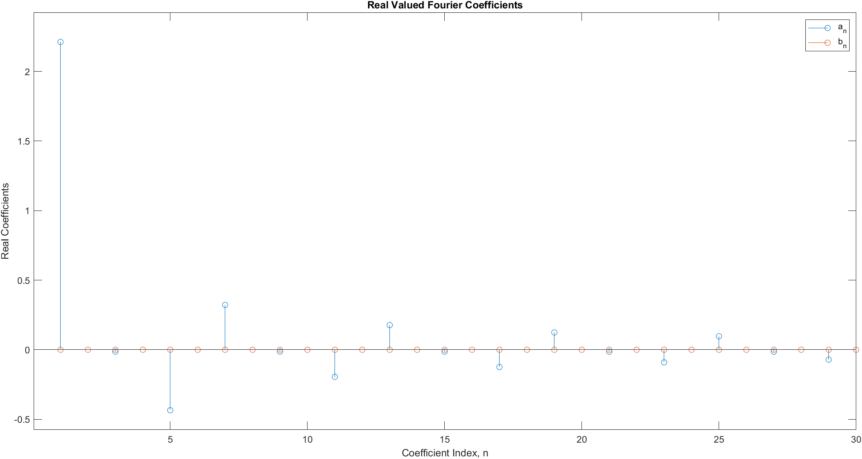

PT = round((1/T) * sum(abs(a).^2 + abs(b).^2), 2);

% Calculate the ratios of P3/PT and P2/PT

ratio_P1 = round((P1/PT)*100, 2);

ratio_P3 = round((P3/PT)*100, 2);

ratio_P2 = round((P3/PT)*100, 2);

% Plot both the original signal and its Fourier series approximation

f_periodic = repmat(f(t_period), 1, 3);

f_s = zeros(size(t_period));

for n = 0:N

cosTerm = cos(2*pi*n*t_period/T);

sinTerm = sin(2*pi*n*t_period/T);

f_s = f_s + a(n+1)*cosTerm + b(n+1)*sinTerm;

end

figure;

subplot(2,1,1);

plot(linspace(0, 3*T, length(f_periodic)), f_periodic);

xlabel('t (seconds)');

ylabel('f(t)');

title('Signal f(t) with periodic repetition');

grid on;

subplot(2,1,2);

plot(t_period, f_s);

xlabel('t (seconds)');

ylabel('f_s(t)');

title('Fourier series approximation of f(t)');

grid on;

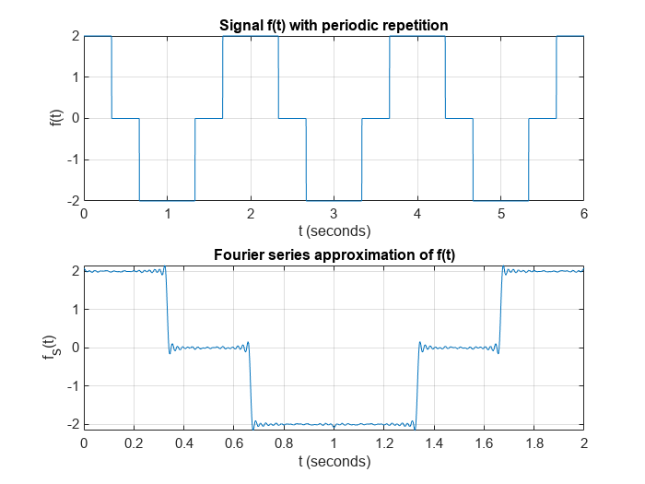

% Display the results

disp(['a1 = ', num2str(a1)]);

a1 = 2.21

disp(['a2 = ', num2str(a2)]);

a2 = 0

disp(['a3 = ', num2str(a3)]);

a3 = 0

disp(['P1 = ', num2str(P1)]);

P1 = 2.44

disp(['P2 = ', num2str(P2)]);

P2 = 0

disp(['P3 = ', num2str(P3)]);

P3 = 0

disp(['P1/PT = ', num2str(ratio_P1),'%']);

P1/PT = 91.39%

disp(['P3/PT = ', num2str(ratio_P3),'%']);

P3/PT = 0%

disp(['P2/PT = ', num2str(ratio_P2),'%']);

P2/PT = 0%

