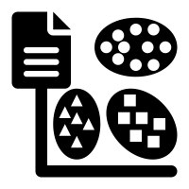
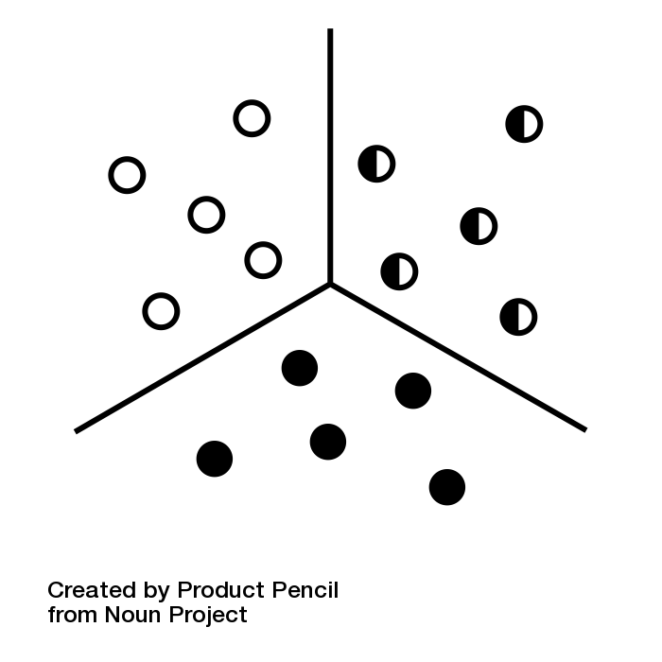

K-MEANS CLUSTER
  - intro to ai
Youssef Eslam Hussein | 231000070 | 9/10/2026

INTRODUCTION TO K-MEANS
K-Means clustering algorithm is an unsupervised machine learning technique that takes Data points and organizes them into groups. Used to partition an unlabeled dataset into K distinct, non-overlapping groups (clusters) based on feature similarity. But our cluster isn’t just a normal cluster it’s a satellite image cluster that uses a group pixel with similar spectral values into k distinct land-cover classes (such as water, vegetation, urban areas, and bare soil) without requiring pre-labeled training data.

How the Algorithm Works
Every cluster algorithm differs from another for example we have in the in the normal data points cluster

