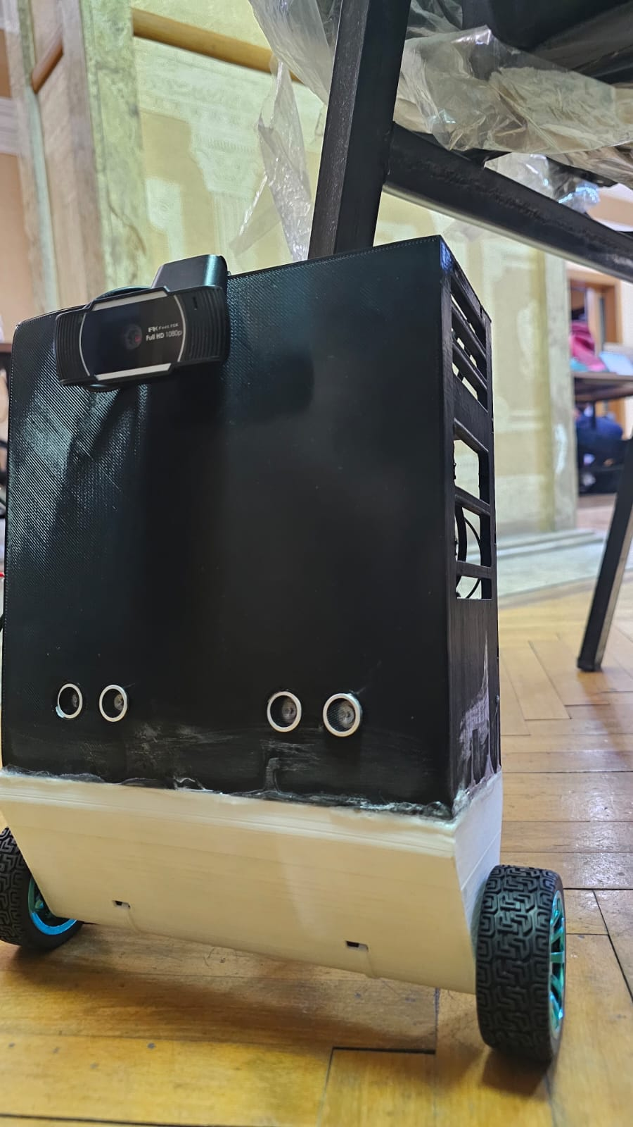
  - Surveillance Automobile
  - Youssef eslam hussein || 231000070
  - belal tamer || 231001148
  - yousef hesham ahmef || 231010735
  - yousef khaled hashem || 231000337
  - Adham Sewelam ||
EVE | Advanced networks | 5/21/2026

INRODUCTION
- EVE IS A Surveillance Automobile that contains hardware components such as, Raspberry Pi 4, USB Camera, h bridge, 2 ultrasonic sensors 2 motors + 2 wheels, MEMS IMU, raspberry pi Pico ,DC to DC adapter, 12v battery. Software include ROS 2, platform io, and c++ code. The GUI includes a server host by the raspberry pi and exposed using Cloudflare, and it also includes cam view and controller input data.
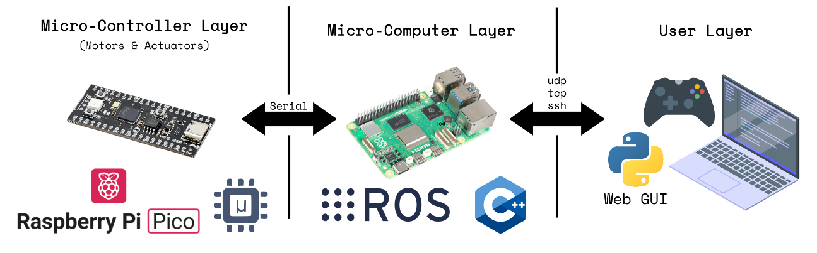

system architecture
EVE's architecture is organized into three distinct layers that communicate with each other over well-defined interfaces:
Layer | Components | Responsibilities
Micro-Controller Layer | Raspberry Pi Pico, Arduino, H-Bridge, Motors, IMU | Motor actuation, low-level sensor reading, balance corrections
Micro-Computer Layer | Raspberry Pi 4, ROS, C++ nodes | High-level logic, sensor fusion, running ROS nodes, web server
User Layer | Web GUI (Python/JS), Gamepad, Laptop | Remote control via UDP/TCP/SSH; live video and diagnostic dashboard
The Micro-Controller Layer communicates with the Micro-Computer Layer over a Serial interface. The Micro-Computer Layer communicates with the User Layer over UDP, TCP, and SSH protocols.

the hardware components
Here is a list of every hardware component used in EVE, its quantity, and its functional role within the system.
Component | Role
Raspberry Pi 4 | Main micro-computer; runs ROS, C++ nodes, and the web server
Raspberry Pi Pico | Micro-controller layer; directly drives motors and actuators via serial
DC to DC adapter | regulate output voltages to ensure safe, stable power for electronic components
MEMS IMU | Inertial Measurement Unit providing tilt/orientation data for self-balancing
H-Bridge Motor Driver | Bidirectional motor control; translates PWM signals to motor power
DC Motors + Wheels | Primary drive wheels for locomotion and balancing corrections
Ultrasonic Sensors | Obstacle detection and distance measurement
USB Camera | Live video feed streamed through the web GUI (EVE Camera view)
Battery 12v | Onboard power supply for all electronics

software
The Raspberry Pi 4 runs ROS as the primary robotic middleware. ROS manages communication between components handling sensor data, control logic, and network interfaces. The main application nodes are implemented in C++.
- The Raspberry Pi 4 communicates with the Raspberry Pi Pico over a usb. Commands such as motor speed setpoints are sent from the micro-computer layer down to the micro-controller layer, and sensor data flows back up.
- We use the c++ to program the Arduino and raspberry pi pico. The program read the ultra sonic sensor data and the IMU and based on the data it moves the moters to be able to balance.

Graphical User Interface (GUI)
The GUI is a web-based application developed in Python (backend) and JavaScript (frontend). It is hosted by the Raspberry Pi 4 and accessible from any browser on the same network. Key features include:
- Live camera feed from the USB camera ('EVE Camera' view)
- Live diagnostics panel showing FRONT / LEFT / RIGHT / BACK distance and positional data
- Gamepad integration using the browser's Gamepad API, bridged to EVE over Socket.IO
- Controller toggle button to enable/disable gamepad-driven movement

Simulation
A simulation environment is included in the project scope, developed by Youssef Moussa on Webots. The simulation provides a virtual model of EVE's dynamics, enabling software testing and control algorithm tuning without requiring the physical robot. This is particularly useful for iterating on the balancing control parameters before deploying to hardware.
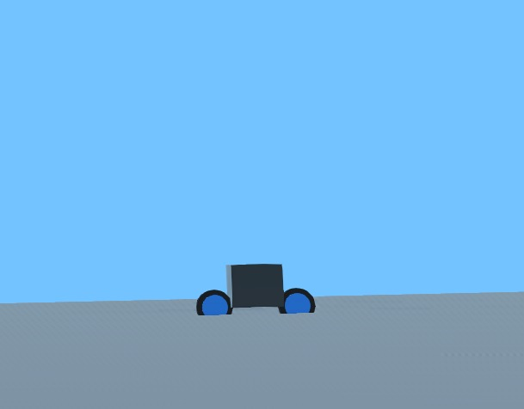

Conclusion
EVE demonstrates an end-to-end embedded robotics project that integrates multiple engineering disciplines: hardware electronics, real-time embedded control, robotic middleware, computer networking, and full-stack web development. The three-wheel, self-balancing form factor presents a classical control challenge that the team addressed through sensor fusion with the MEMS IMU and closed-loop motor control on the Raspberry Pi Pico.

The layered architecture — separating the micro-controller, micro-computer, and user interaction layers — provides a clean separation of concerns that simplifies development, testing, and future extension of the platform.
Name | Domain | Contribution
Adham Sewelam | Architecture | Overall system design and EVE concept definition
Youssef Khalid | Software / Hardware | Software stack and hardware-software integration
Youssef Eslam Hussein | GUI | Web-based graphical user interface and gamepad integration
Belal Tamer | Hardware | Hardware component selection, assembly, and wiring
Youssef Moussa | Simulation | Robot simulation environment development

