OPERATING SYSTEMS PROJECT
Cloud / Data Center Manager
Load Balancer Simulation
CPU Scheduling · Multithreading · Load Balancing · Geo-IP Routing
Youssef Eslam | 231000070
Yossef El-Sayed | 231002087
Mohammed Yasser | 231002001

Course: Operating Systems | Project: Load Balancer | Date: August 13, 2026

Table of Contents

1. Project Overview
The Cloud / Data Center Manager simulates how a cloud environment receives incoming client requests, determines their geographic origin, distributes them fairly across available servers, and processes many of them concurrently. Four core concepts work together as a single pipeline:
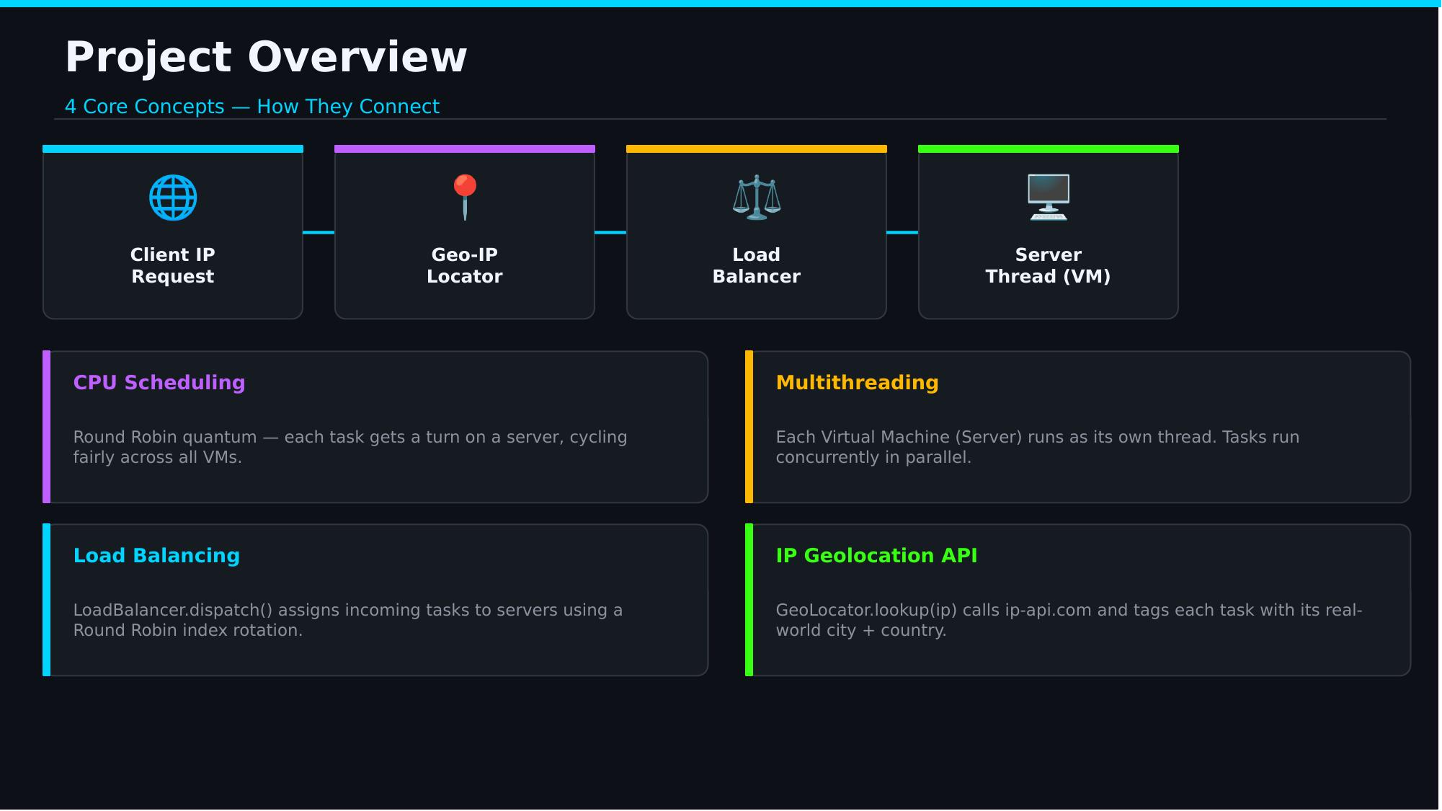
Figure 1 — The four core concepts and how they connect.

CPU Scheduling
Round Robin quantum-based scheduling — each task gets a turn on a server, cycling fairly across all virtual machines.

Multithreading
Each Virtual Machine (Server) runs as its own independent Java thread, so tasks are processed concurrently rather than one at a time.

Load Balancing
LoadBalancer.dispatch() assigns each incoming task to a server using Round Robin index rotation.

IP Geolocation API
GeoLocator.lookup(ip) calls the ip-api.com web service and tags every task with its real-world city and country of origin.

2. System Architecture — Understanding the Request Flow
Designing a system that can serve millions of users is challenging, so the architecture starts from a simple baseline before scaling up. In a single-server setup, the entire application — web app, database, and cache — runs on one machine. The diagram below traces a single request from the client device all the way to the server and back.
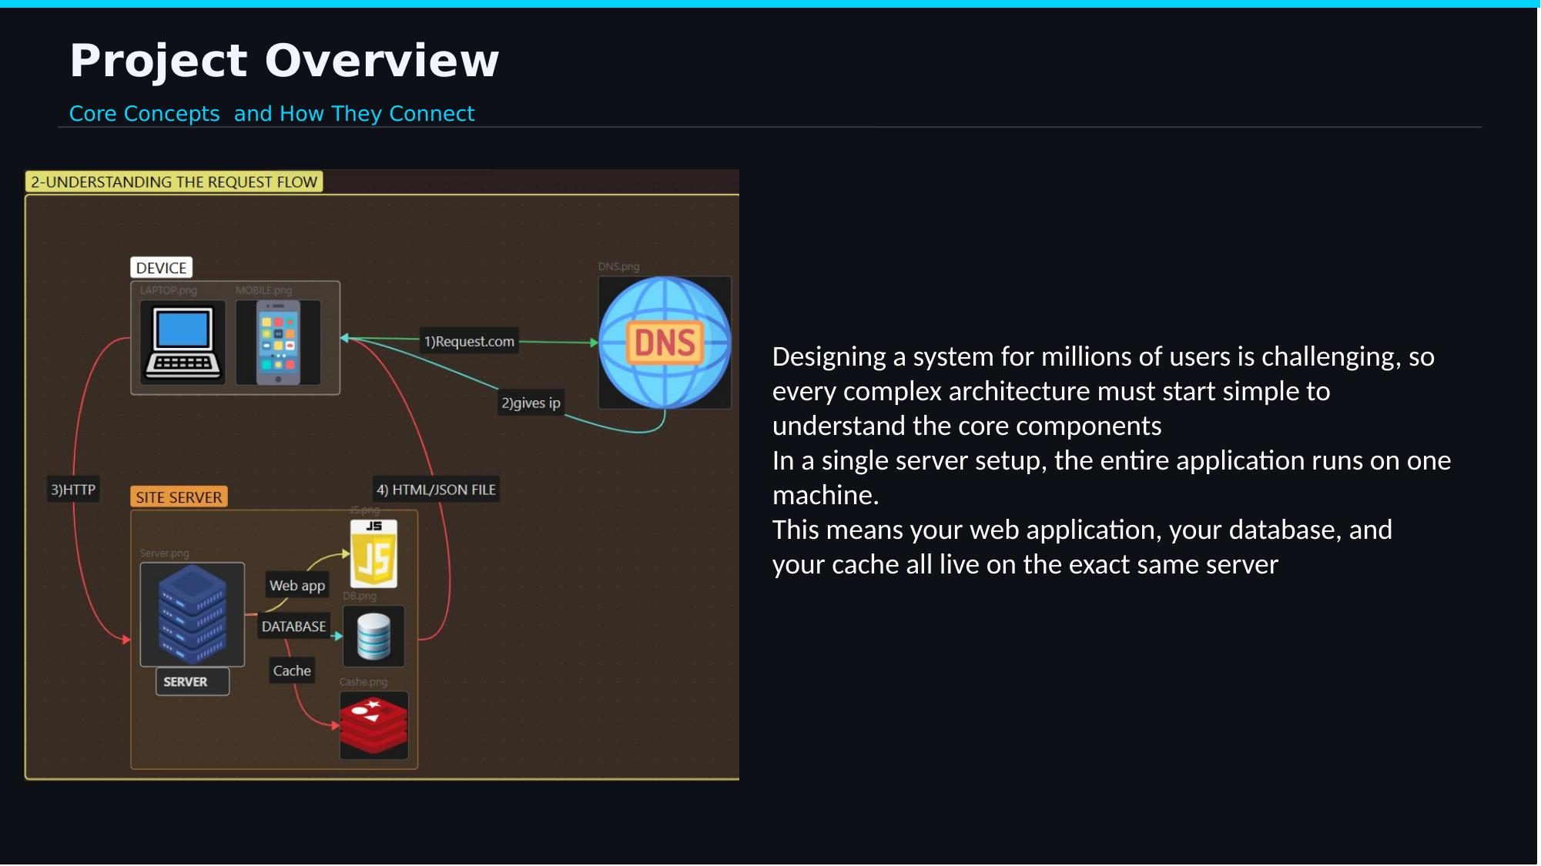
Figure 2 — Request flow: device → DNS → site server → response.
1) The client device sends a request (e.g. Request.com).
2) DNS resolves the domain name and returns the server's IP address.
3) The device sends an HTTP request directly to that IP.
4) The server's web app, database, and cache work together to build and return an HTML/JSON response.

3. Multithreading Implementation
Each Virtual Machine (server) is implemented as an independent Java thread running concurrently. A single server cannot handle every incoming request on its own, so the system needs a way to scale. There are two classic strategies for doing this:
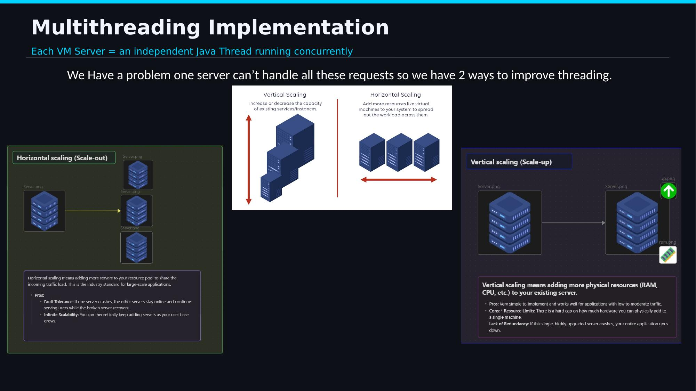
Figure 3 — Vertical scaling vs. horizontal scaling.

Vertical Scaling (Scale-up)
Adding more physical resources (RAM, CPU, etc.) to the existing server.
- Pros: very simple to implement; works well for low-to-moderate traffic.
- Cons: hard resource limits, and no redundancy — if the single upgraded server crashes, the whole application goes down.

Horizontal Scaling (Scale-out)
Adding more servers to the resource pool to share the incoming load — the industry standard for large-scale applications.
- Pros: fault tolerance — if one server crashes, the others stay online.
- Pros: near-infinite scalability — more servers can be added as the user base grows.
This project models horizontal scaling: every additional VM/server is its own Java thread, and the Load Balancer decides how work is spread across them.

4. Load Balancing
Load balancing distributes incoming tasks fairly across all available virtual machine servers. In practice, there are several well-known strategies for deciding where each request should go; this project focuses on Round Robin, but the underlying design supports swapping in alternative strategies.
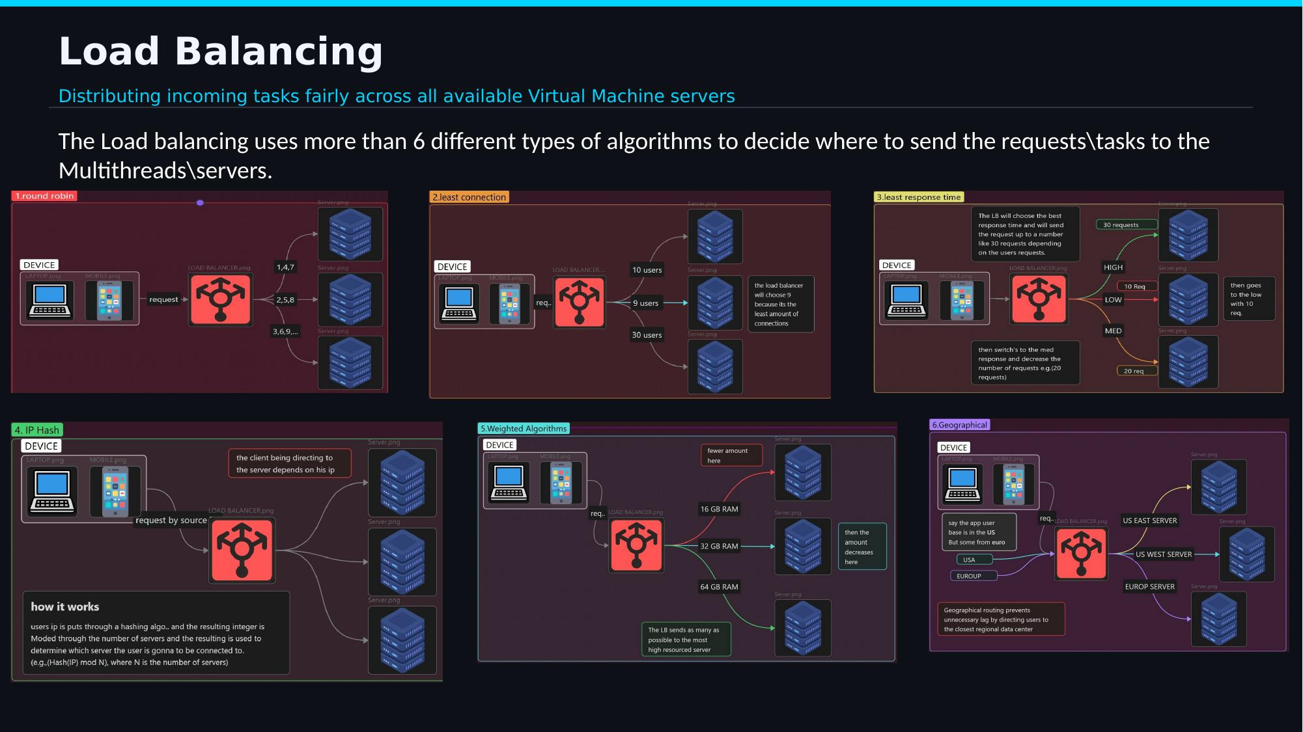
Figure 4 — Common load-balancing algorithm strategies.
Choosing an algorithm is a trade-off between simplicity, fairness, and awareness of real server conditions (such as current load, response time, or geographic distance to the client).

5. Round Robin CPU Scheduling
Round Robin gives each task a fair time slot before any task gets a second turn. Requests are sent in a sequential, rotating order — Server 1, then Server 2, then Server 3, then back to Server 1 — which works best when all servers have identical hardware capabilities.
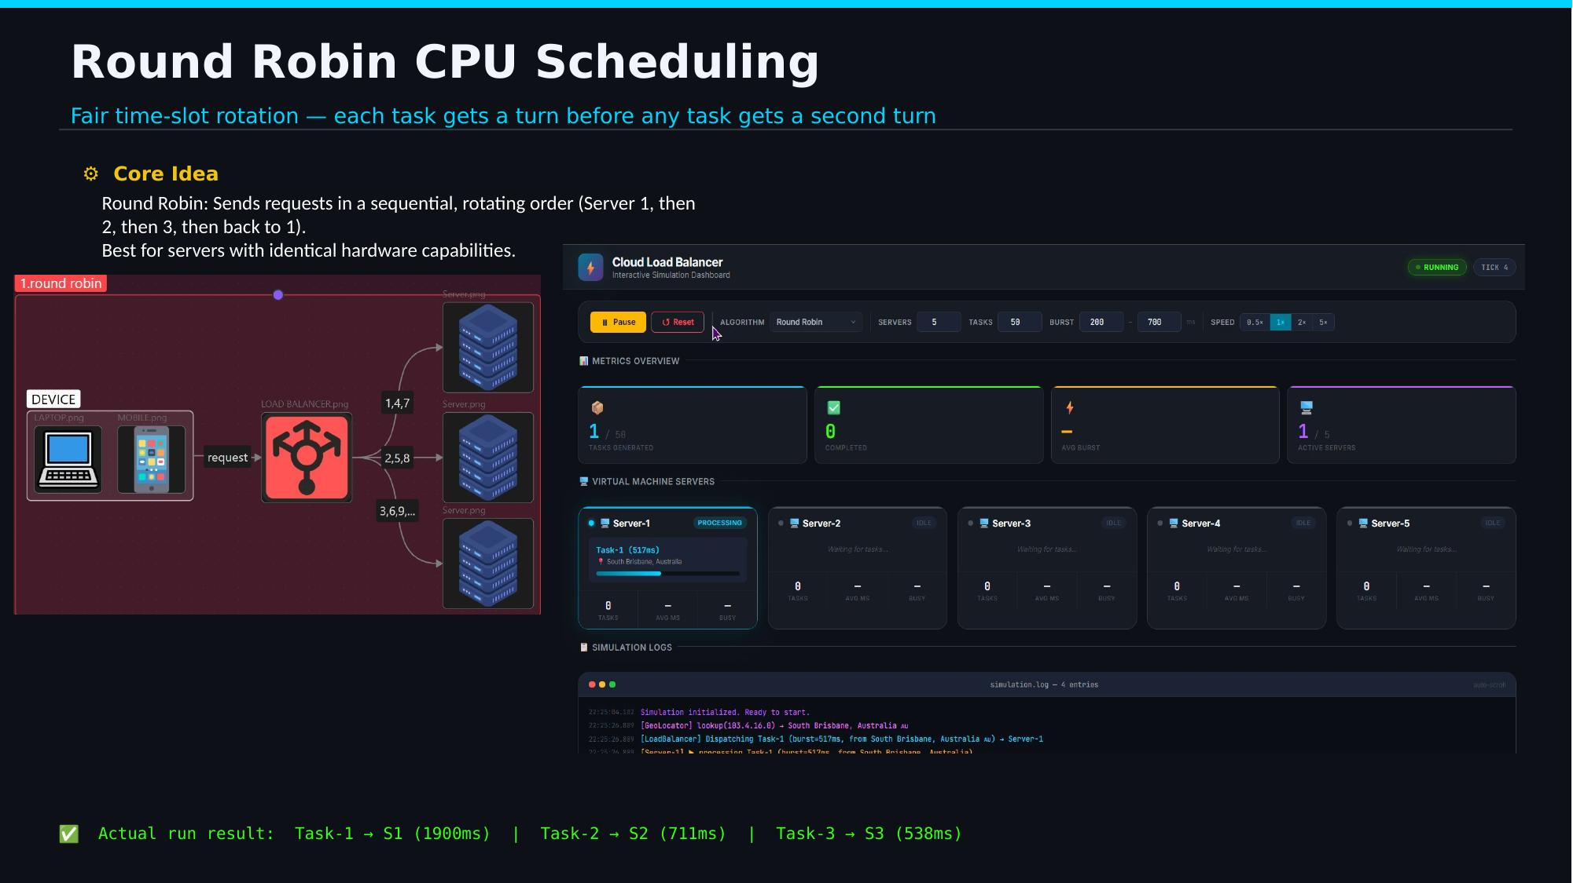
Figure 5 — Live simulation dashboard showing Round Robin dispatch in action.

Actual Run Result
A sample run of the simulator produced the following dispatch and completion times:
Task-1 -> Server-1 (1900 ms)
Task-2 -> Server-2 (711 ms)
Task-3 -> Server-3 (538 ms)

6. IP Geolocation API Integration
The system makes real HTTP calls to ip-api.com to tag every incoming task with its geographic origin. This mirrors how production load balancers route users to the physical server closest to them (e.g. routing an Egyptian user to a European or Middle Eastern data center rather than a US-based one) in order to reduce latency.
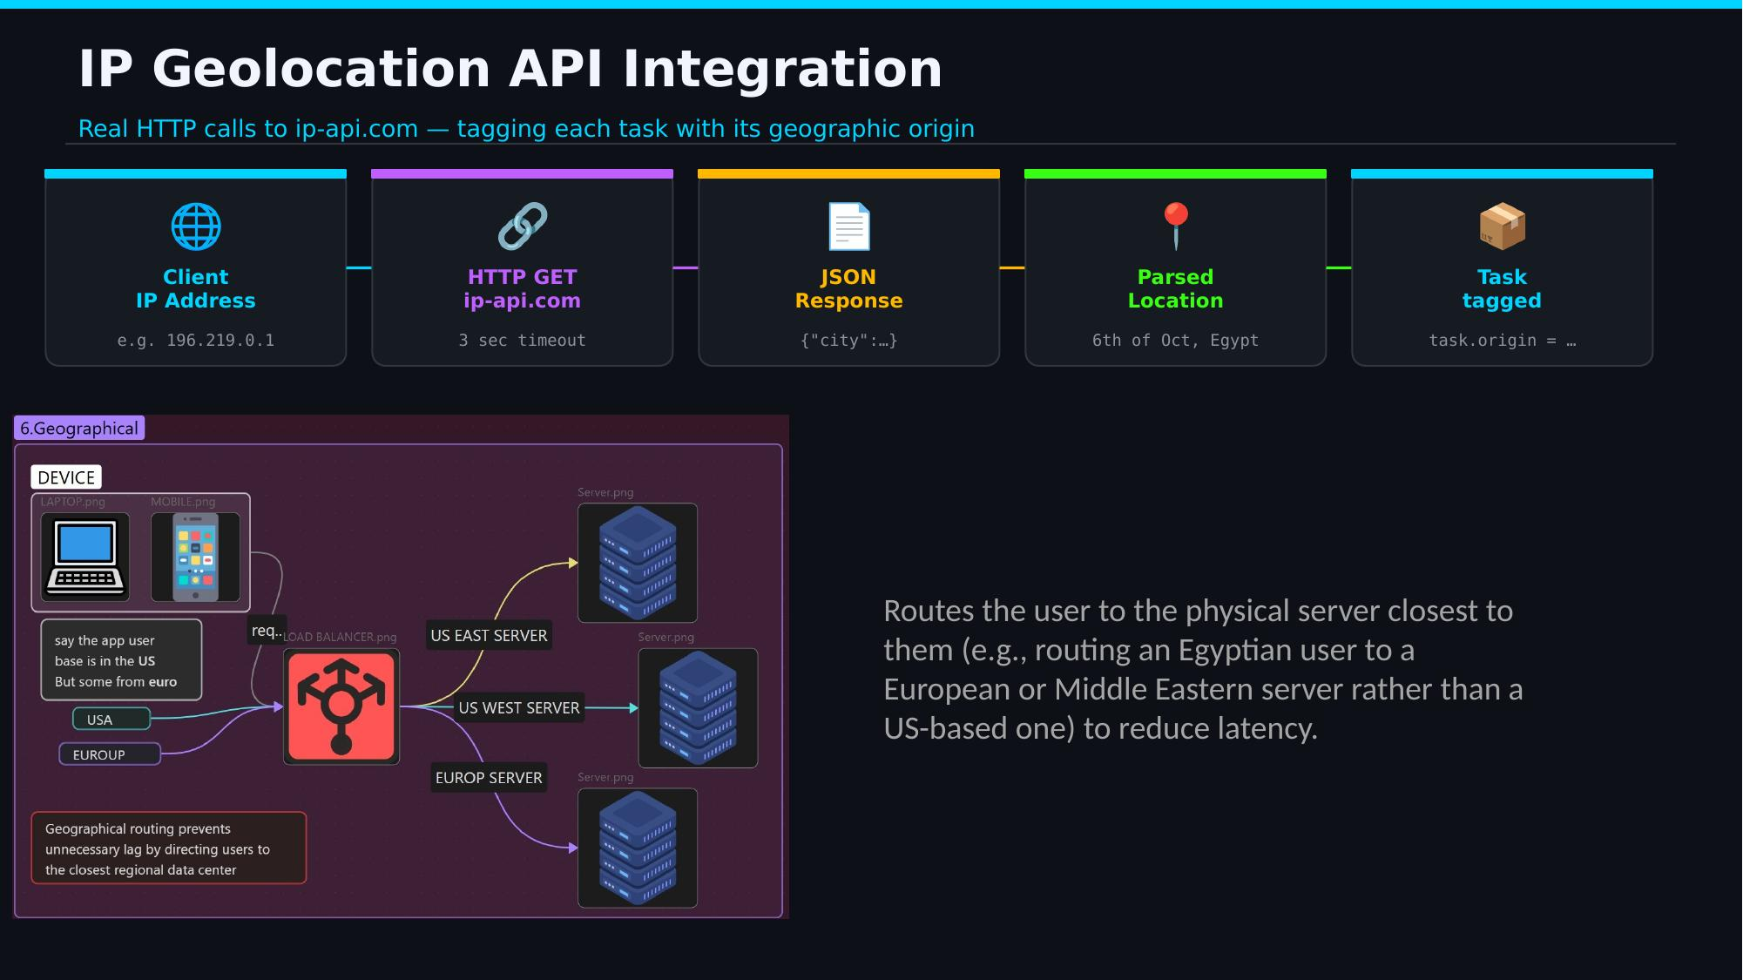
Figure 6 — Geolocation pipeline: IP address → HTTP GET → JSON response → parsed location → tagged task.
Pipeline steps:
- Client IP address is captured (e.g. 196.219.0.1).
- An HTTP GET request is sent to ip-api.com with a 3-second timeout.
- The JSON response (e.g. { "city": ... }) is parsed.
- The resolved location (e.g. "6th of Oct, Egypt") is attached to the task as task.origin.

7. Round Robin — Pseudocode
The following pseudocode matches the actual LoadBalancer.dispatch() logic used in the Java implementation:
// State: integer index, starts at 0
GLOBAL nextIndex <- 0

FUNCTION dispatch(task, servers[]):
index <- nextIndex
server <- servers[index]
nextIndex <- (nextIndex + 1) mod len(servers)
// wraps back to 0 after the last server

PRINT "[LoadBalancer] Dispatching " + task + " -> " + server
server.assignTask(task)
END FUNCTION

// Thread-safe in Java:
// AtomicInteger.getAndUpdate(i -> (i + 1) % servers.size())

Key Property
This is an O(1) dispatch — constant time regardless of how many servers or tasks exist. Using AtomicInteger makes the pointer update lock-free and thread-safe under high concurrency.

8. Load Balancing — Full Pipeline Pseudocode
This pseudocode traces the complete pipeline: task creation, geolocation lookup, dispatch, and server-side processing.
// TaskGenerator thread - produces tasks every 200-800 ms
FOR i <- 1 TO numTasks:
burstTime <- random(500, 2000)
task <- new Task(burstTime)
ip <- randomSample(SAMPLE_IPS)
location <- GeoLocator.lookup(ip) // HTTP GET -> ip-api.com
task.origin <- location
loadBalancer.dispatch(task)
SLEEP random(200, 800)

// Server thread - consumes tasks from its BlockingQueue
LOOP WHILE running:
task <- taskQueue.take() // blocks until a task arrives
PRINT "[Server-N] processing " + task
SLEEP(task.burstTime) // simulate CPU work
tasksCompleted <- tasksCompleted + 1
totalBusyTime <- totalBusyTime + task.burstTime
In short: a producer thread continuously generates tasks and tags each with a real geolocation lookup before handing it to the Round Robin dispatcher; each server thread independently consumes tasks from its own blocking queue and simulates the CPU work with a sleep proportional to the task's burst time.

9. Key Takeaways
- Load Balancing chooses which server receives a task.
- Round Robin chooses the order in which tasks (or servers) get their turn.
- Multithreading lets every server operate concurrently instead of waiting in line.
- The IP Geolocation API supplies the real-world location behind every request, enabling location-aware routing.
Together, these four concepts form a complete, working simulation of how a modern cloud data center distributes and processes incoming traffic.

