**Assignment #2**

**Action Recognition From Still Images Using**

**Deep Learning Networks**

* **Libraries used**

1. OpenCV Python Library
2. NumPy Python Library
3. MatplotLib Python plotting Library
4. Keras API in tensorflow platform
5. Pandas tool

* **Algorithm**
  1. Read **actions.txt** file to determine the 40 actions names
  2. Assign labels from 0 to 39 to these actions in a dictionary type e.g. action **applauding** is assigned label **0**
  3. read and parse the **train.txt** file to determine the 4000 train image filenames
  4. assign a label to every train filename according to the name of the file e.g. file **applauding_001.jpg** is assigned **0** because it’s name contains string “**applauding”** which is the action name
  5. read all the 4000 train images from folder **"\Stanford40\JPEGImages"** based on train image filenames determined above
  6. resize all the train images to be of size **128 * 128 * 3**
  7. normalize the pixel values of train images to be from -0.5 to 0.5 instead of 0 to 255
  8. repeat above steps 3, 4, 5, 6, 7 to obtain 5532 test images
  9. train and validate the CNN using Keras model with parameters shown in code ,CNN code similar to <https://victorzhou.com/blog/keras-cnn-tutorial/> with parameters modified.

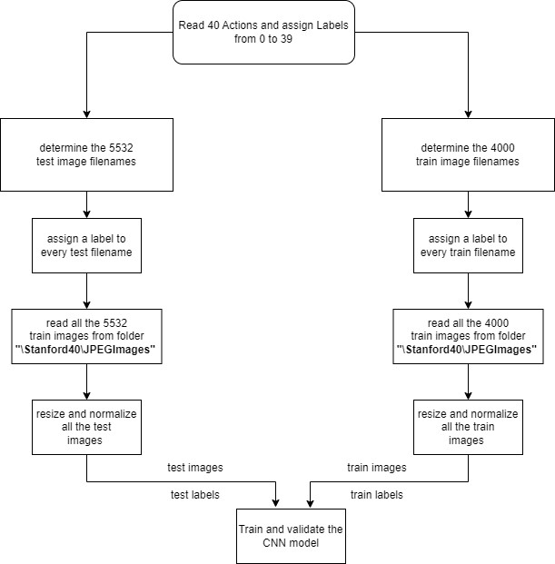

* **Results**

Run **Assignment2.ipynb** Jupyter notebook fileto get the following results

The CNN was trained with 10 epochs the accuracy reached 99% at the last epoch as shown below starting from 0.0518 at the first epoch and the loss reached 0.1498 in the last epoch starting from 3.6484 in the first epoch

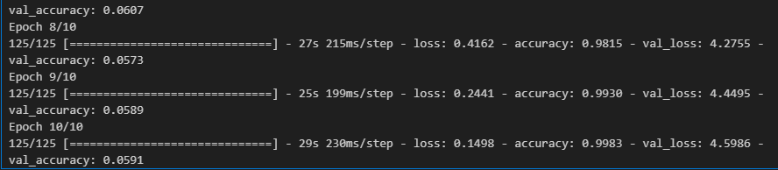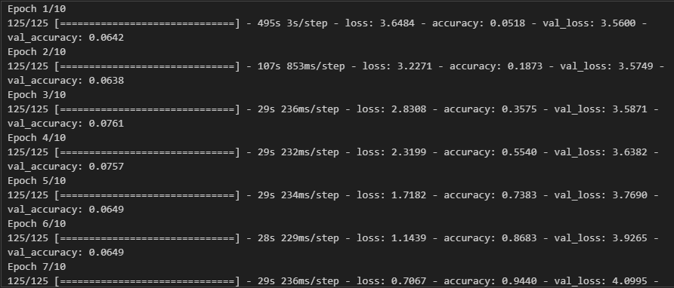

* **Bibliograpgy**
* <https://victorzhou.com/blog/keras-cnn-tutorial/>
* <https://victorzhou.com/blog/intro-to-cnns-part-1/>
* <https://machinelearningmastery.com/building-a-convolutional-neural-network-in-pytorch/>
* <http://vision.stanford.edu/Datasets/40actions.html>