**Assignment #1: Automatic pieces detection and quantification in thermographic images**

* The deadline for the delivery of this exercise is **November 26th, 2023**
* A zip file with the source codes in Python and a PDF file must be sent.
* The code files and the results should be exported from Visual studio code, Google Colab or Jupyter. If not, include the necessary instructions files to understand the program.
* A detailed documentation in PDF is required
* The submission of the source and documentation must be done using Moodle.

**Description:**

The primary goal of this assignment is to design and implement a system capable of automatically detecting pieces within images captured by a thermographic camera as shown in **Figure 1**.

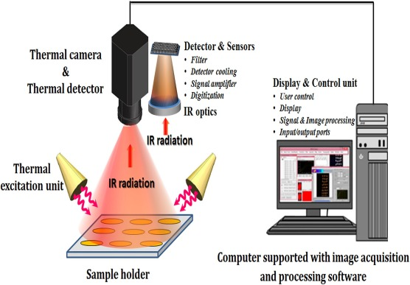

**Figure 1**

In this particular assignment, the objective is to harness the power of image processing and computer vision techniques to precisely identify and delineate individual components or objects, such as circles, within the thermal imagery.

The scenario involves a thermographic camera focused on a thermal sealing line, and the specific task is to determine the count of complete pieces that are discernible in the input image. By applying feature detection methods, we can efficiently locate and isolate these distinct pieces, facilitating a comprehensive analysis and accurate quantification of the thermal sealing line's components. This process not only aids in the visual inspection of the thermal imagery but also lays the groundwork for further investigations and decision-making based on the identified components.

For example, in **Figure 2**, we have **three complete pieces** are in the image:

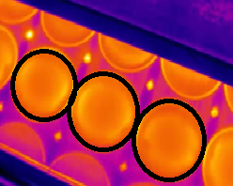

**Figure 2:** An example of 3 complete pieces.

Another example is shown in **Figure 3**, we have only **two complete pieces** are in the image:

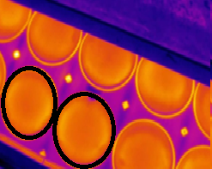

**Figure 3:** An example of 3 complete pieces.

**Deliverables [Due 26/11/2023 - 23:59:00]:**

**Deliverables:**

* A comprehensive report documenting the methodology, algorithms, and techniques employed in the automatic pieces detection system.
* Codebase in Python (using OpenCV, matplotlib, etc..) with clear comments and documentation to facilitate understanding the flow chart of the code.
* Visual outputs demonstrating the effectiveness of the detection system on sample thermographic images in the shared zip file (i.e., including 7 images).