Browser Fingerprinting Laboratory Report

Part 1 Passive Fingerprinting
Before JavaScript runs, the request already exposes network, browser, language, content preference, navigation, and security metadata. The server reads these values directly from Flask's request object.
Header group | Information revealed
User-Agent and Client Hints | Browser family, platform, and mobile status
Accept-Language | Preferred languages and their priority
Accept and Accept-Encoding | Supported formats and compression methods
Referer and Sec-Fetch | Navigation source, context, mode, and destination
Upgrade-Insecure-Requests | Preference for an encrypted navigation response

print("User-Agent :", request.headers.get("User-Agent"))
print("Accept-Language :", request.headers.get("Accept-Language"))
print("Accept :", request.headers.get("Accept"))
print("Accept-Encoding :", request.headers.get("Accept-Encoding"))
print("Sec-Fetch-Site :", request.headers.get("Sec-Fetch-Site"))
print("Sec-CH-UA :", request.headers.get("Sec-CH-UA"))

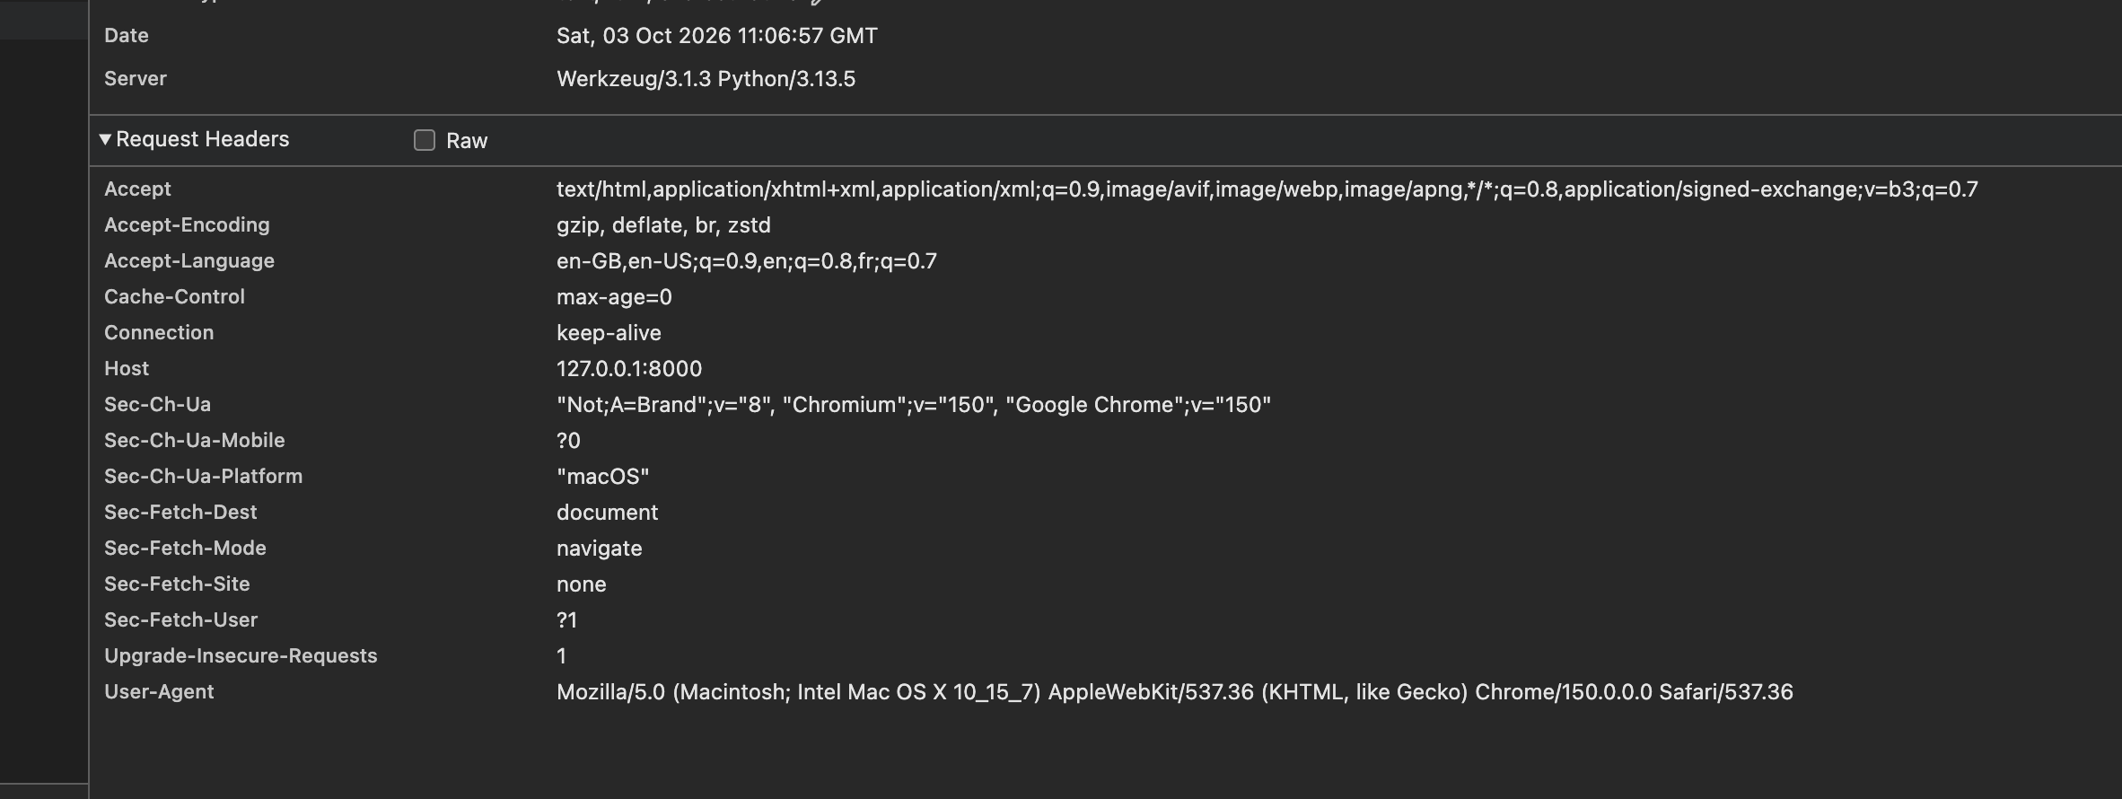
Figure 1 Request headers visible before active JavaScript collection
Finding. The request identified Chrome on macOS, exposed language preferences beginning with en-GB, and advertised accepted formats and compression methods. Private browsing or cookie blocking does not inherently remove these headers.

Part 2 Active Feature Collection
JavaScript queried several browser objects and displayed the values before submission. The chosen signals describe regional settings, screen geometry, processing capacity, and the rendering environment.
const activeFeatures = {
language: navigator.language,
logicalProcessors: navigator.hardwareConcurrency ?? null,
screenResolution: `${screen.width}x${screen.height}`,
colorDepth: screen.colorDepth,
viewportSize: `${window.innerWidth}x${window.innerHeight}`,
devicePixelRatio: window.devicePixelRatio,
timeZone: Intl.DateTimeFormat().resolvedOptions().timeZone,
};

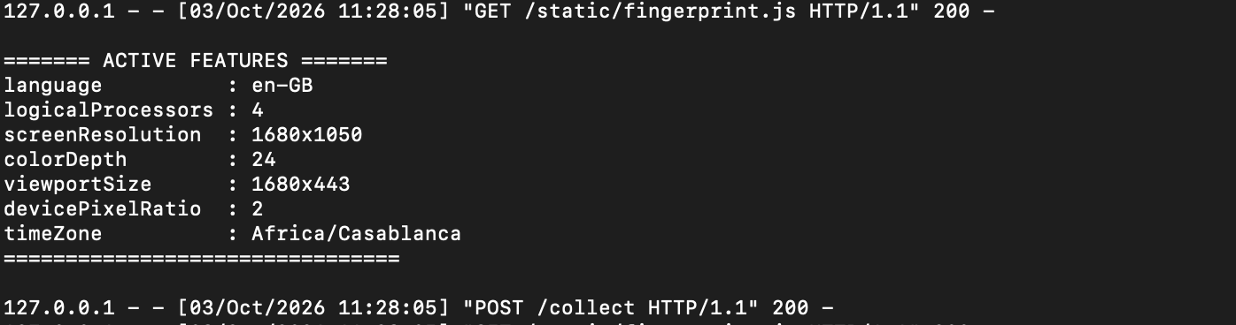
Figure 2 Active features received during the Part 2 experiment
The observed client reported four logical processors, a 1680 x 1050 screen, 24-bit color, a device pixel ratio of 2, and the Africa/Casablanca time zone. These values are not unique individually, but their combination narrows the set of matching browsers.
Signal | Fingerprinting value
Language | Distinguishes regional and locale preferences
Logical processors | Approximates the device's processing capacity
Screen and color depth | Describes display hardware and configuration
Viewport and pixel ratio | Describes the current rendering environment
Time zone | Provides a regional setting that can remain stable

Part 3 Behavioral Fingerprinting
The behavioral prototype starts timing at the first printable character, counts Backspace presses, and stops when the entered text exactly matches the target sentence. Typing speed is calculated in characters per minute.
totalTimeSeconds = (endTime - startTime) / 1000;
charactersPerMinute =
(targetSentence.length / totalTimeSeconds) * 60;
const behavioralFeatures = {
totalTimeSeconds: Number(totalTimeSeconds.toFixed(2)),
typingSpeedCPM: Number(charactersPerMinute.toFixed(2)),
correctionCount: correctionCount,
};

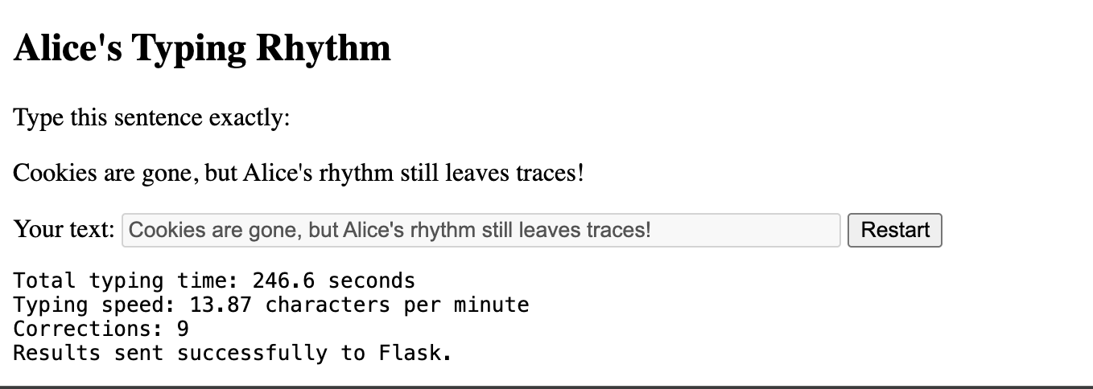
Figure 3 Completed typing experiment and submitted measurements
Measurement | Observed value | Interpretation
Total time | 246.6 seconds | Duration from first character to exact match
Typing speed | 13.87 CPM | Characters typed per minute
Corrections | 9 | Backspace presses during the attempt

Behavioral measurements are probabilistic rather than permanent identifiers. They can change with fatigue, stress, keyboard layout, posture, or deliberate changes in typing.

Part 4 Fingerprint Identifier
For the final stage, active features are serialized in an explicit order and hashed with SHA-256. Typing behavior is excluded so repeated page loads can test the stability of the browser and device fingerprint independently.
const canonicalInput = featureOrder
.map((name) => `${name}=${String(activeFeatures[name])}`)
.join("|");
const bytes = new TextEncoder().encode(canonicalInput);
const digest = await crypto.subtle.digest("SHA-256", bytes);
const fingerprint = Array.from(new Uint8Array(digest))
.map((byte) => byte.toString(16).padStart(2, "0"))
.join("");

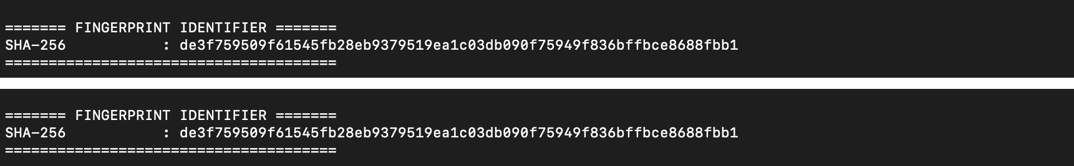
Figure 4 The same SHA-256 fingerprint returned on two consecutive loads
Only the lowercase 64-character hash is sent in the fingerprint request. The Flask route validates its length and hexadecimal format before printing it. The repeated value in Figure 4 confirms stability while the selected inputs remain unchanged.

Results and Limitations
Observation | Meaning
Cookies were not required | Passive and active signals were still observable.
The hash repeated | Identical ordered inputs produced the same identifier.
Window size is included | Resizing the viewport can change the fingerprint.
SHA-256 hides readability only | Hashing does not prevent tracking or make collection anonymous.
Behavior varies | Typing rhythm should be treated as supporting evidence, not proof of identity.

Conclusion
The laboratory achieved its objective: it built a transparent local prototype that combines passive, active, and behavioral observations without relying on cookies. The final SHA-256 identifier was repeatable under unchanged conditions, but it remains sensitive to feature changes and cannot establish a person's identity with certainty. The exercise therefore shows both the practical power and the limitations of browser fingerprinting.

