Stateful Web Tracking Lab Report

Warm Up

Inspecting HTTP Headers
The Flask application prints the browser request headers and the response headers. The Network panel and the terminal expose the same exchange from client-side and server-side viewpoints. The request includes the Host and User-Agent headers, while the response includes content metadata and any custom or cookie headers added by Flask.

Creating and Reusing the Cookie
aid = request.cookies.get("aid")
is_new = aid is None
if is_new:
aid = secrets.token_hex(8)
response = make_response(render_template("index.html"))
if is_new:
response.set_cookie(key="aid", value=aid)

On the first request, no aid cookie exists, so the server generates a 16-character hexadecimal identifier and returns it in Set-Cookie. Later requests send the same value in the Cookie request header, allowing the server to recognize the browser.
Browser restart question. The default Flask cookie has no Max-Age or Expires attribute, so it is a session cookie.

Challenge 1 Third Party Tracking
The TP requires two publishers, one shared tracker, a browser identifier stored in a cookie, request logging, and an association between the identifier and the publisher page.

Publisher and Tracker Implementation
Publisher 1 runs on port 8001 and Publisher 2 runs on port 8002. Each page supplies its publisher name and page name in the tracker iframe URL.
<!-- Publisher 1 -->
<iframe src="http://tracker-one.test:9000/
?publisher=publisher-one&page=Travel"></iframe>
<!-- Publisher 2 -->
<iframe src="http://tracker-one.test:9000/
?publisher=publisher-two&page=Technology"></iframe>

publisher = request.args.get("publisher", "unknown publisher")
page = request.args.get("page", "unknown page")
aid = request.cookies.get("aid")
if aid is None:
aid = secrets.token_hex(8)
response.set_cookie(key="aid", value=aid)
print(request.headers)
print(response.headers)

The query parameters identify the source page, and the terminal output records each received request.

Observed Cookie Behaviour
The following earlier test used 127.0.0.1 for the publishers and tracker. Ports create different origins, but they do not create different sites for SameSite cookie evaluation. The cookie was therefore accepted and reused.
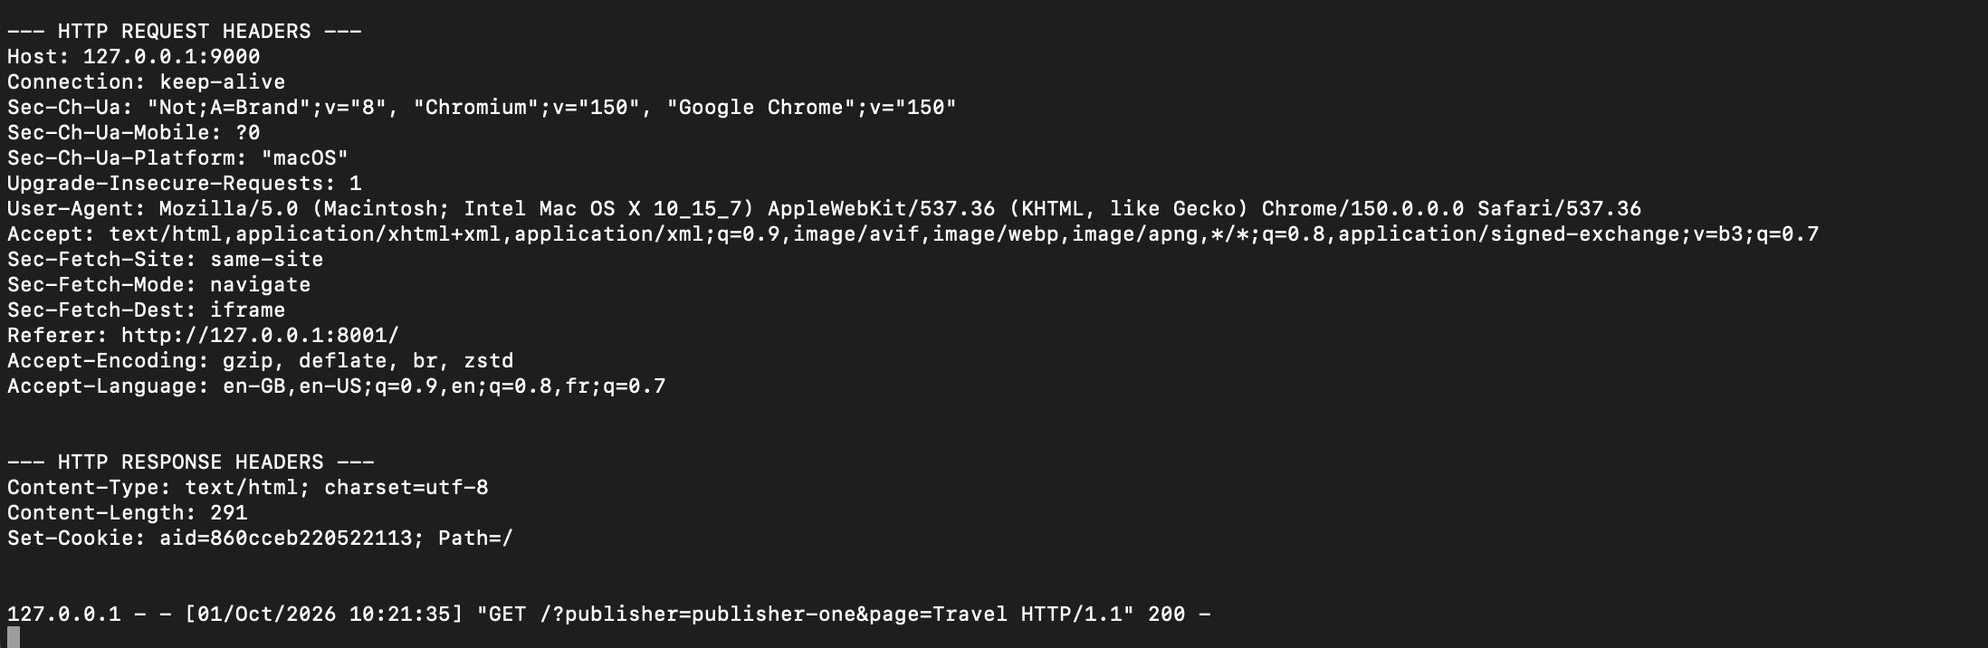
Figure 1 The first tracker request has no aid cookie, so Tracker 1 returns Set-Cookie with aid=860cceb220522113.
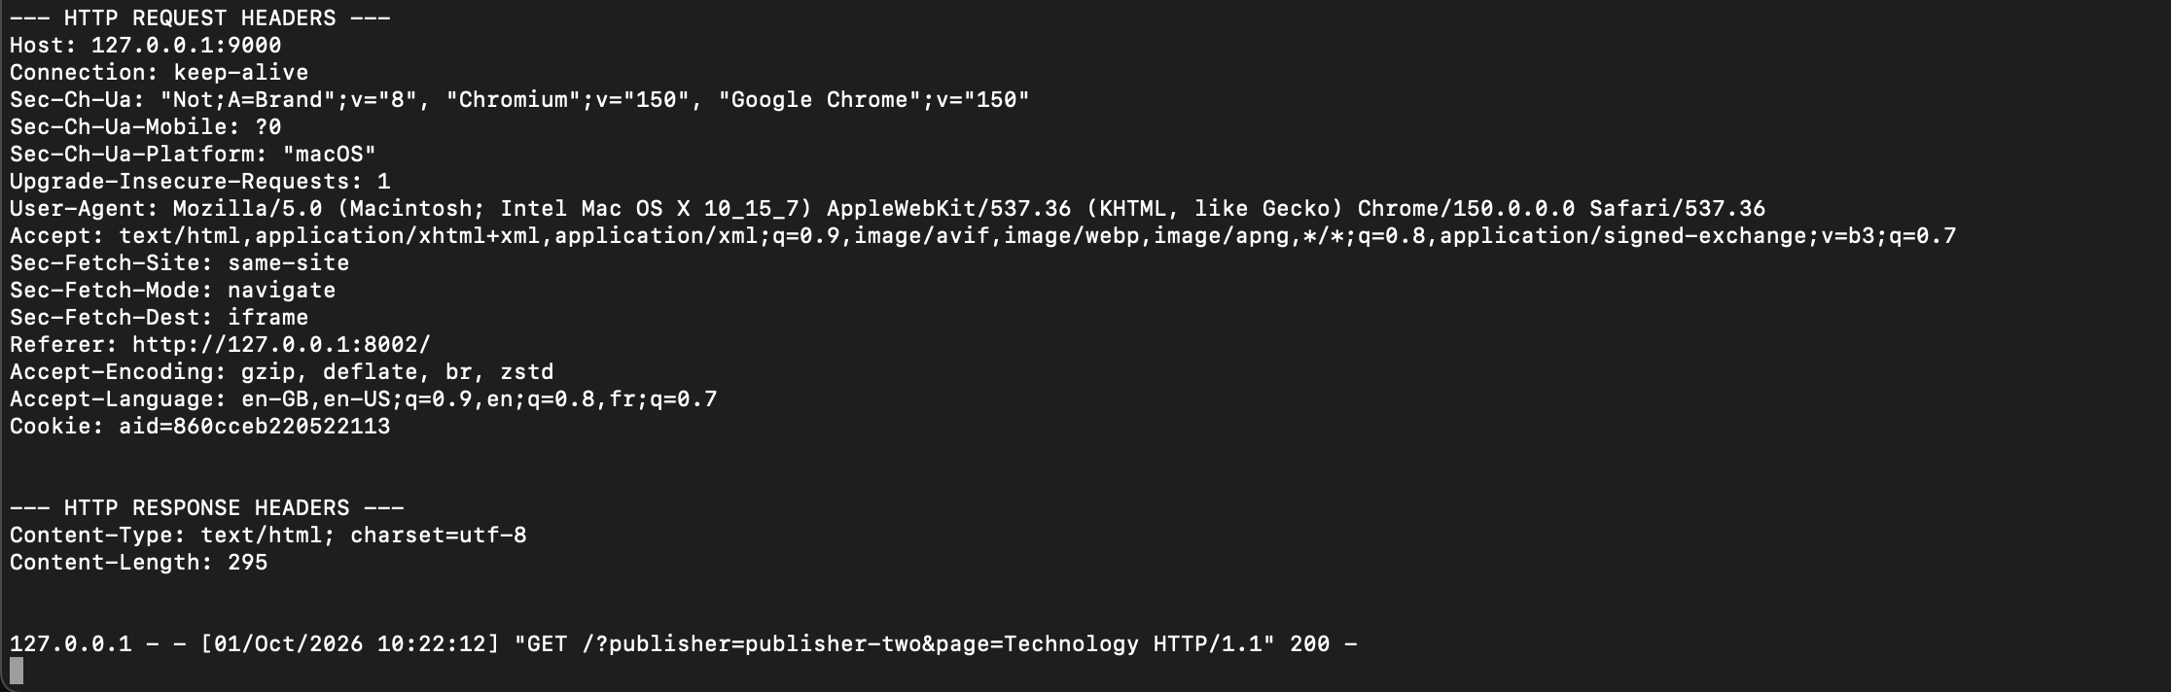
Figure 2 A later request from Publisher 2 sends the same aid value, demonstrating identifier reuse.

Effect of the Hostname Change
The current publisher URLs use publisher-one.test and publisher-two.test, while the iframe uses tracker-one.test. These hostnames are different sites. The live tracker response sends only the following cookie attributes:
Set-Cookie: aid=<random identifier>; Path=/

Because SameSite is omitted, Chrome treats the cookie as SameSite=Lax. A Lax cookie cannot be set from this cross-site iframe. Browser diagnostics reported isSameSite: false, no associated cookies, and the rejection reason SameSiteUnspecifiedTreatedAsLax. The next iframe request therefore contains no aid, and the tracker creates a new value. Using SameSite=None was going to solve the issue, however it requires Secure using HTTPS protocol.
Configuration | Browser classification | Result
127.0.0.1 on different ports | Same-site | aid is accepted and reused
publisher-one.test and tracker-one.test | Cross-site | Current aid is rejected in the iframe

Challenge 1 Result
The warm-up demonstrated stateful recognition with a session cookie. Challenge 1 established the required publisher and tracker applications and showed that one tracker identifier can follow visits across publishers when the cookie is accepted. The distinct-host test exposes a modern browser restriction: SameSite=None alone is insufficient because it also requires Secure, and Secure requires HTTPS for these custom hostnames.

Challenge 2 First Party Analytics
Challenge 2 changes where the identifier is stored and how it reaches the analytics service. The external analytics.js file executes inside each publisher page, creates an analytics_id cookie for that publisher, and uses fetch() to send the identifier and page data to analytics.test. Because the cookie belongs to the publisher, the two publisher hostnames receive separate identifiers.
Does the analytics server automatically receive the publisher cookie? No. A cookie scoped to publisher-one.test is sent automatically only to publisher-one.test. JavaScript must read the value and include it in the cross-origin request body. The browser still applies CORS to that request.
const analyticsId = readCookie("analytics_id") || generateIdentifier();
document.cookie = `analytics_id=${analyticsId}; Max-Age=31536000; Path=/; SameSite=Lax`;
fetch("http://analytics.test:9100/collect", {
method: "POST",
headers: { "Content-Type": "application/json" },
body: JSON.stringify({ analytics_id: analyticsId, publisher, page, page_title, timestamp })
});

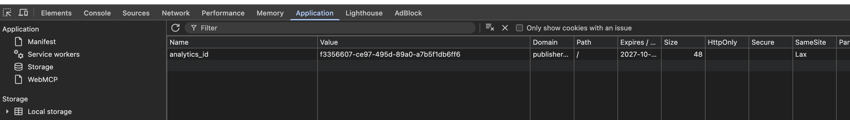
Figure 3 Publisher 1 stores analytics_id as a first-party cookie scoped to publisher-one.test.
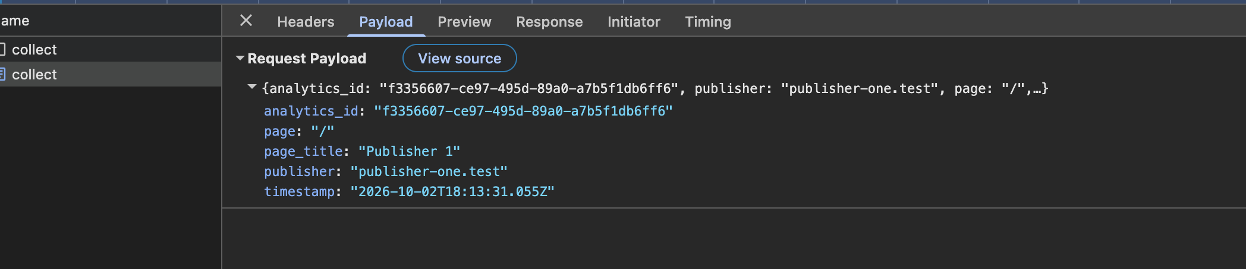
Figure 4 The collect request body explicitly carries the identifier, publisher, page, title and timestamp.

Challenge 2 Request Flow and Evidence
CORS preflight. The JSON POST crosses from publisher-one.test to analytics.test, so the browser first sends an OPTIONS request. A 204 response authorizes the origin, POST method and Content-Type header; the browser then sends the actual POST, which also returns 204. The OPTIONS request is a permission check, not a second analytics event.
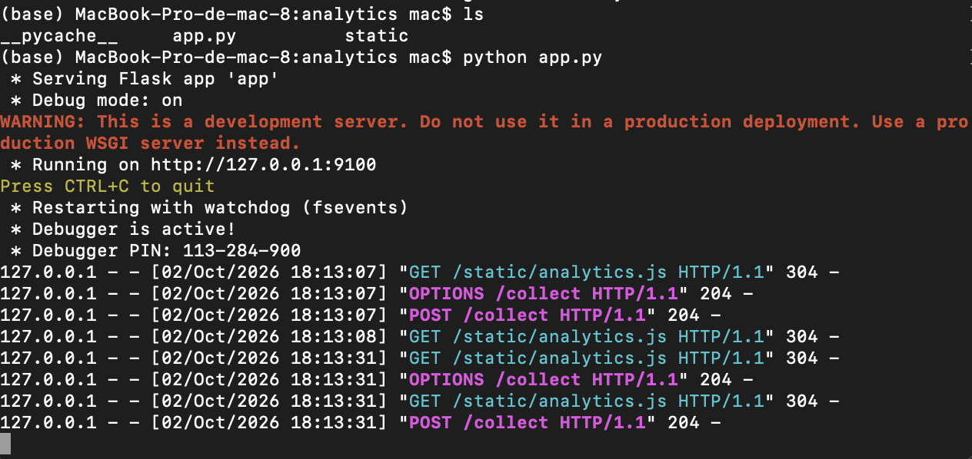
Figure 5 Analytics server log: script delivery followed by successful OPTIONS and POST requests to /collect.
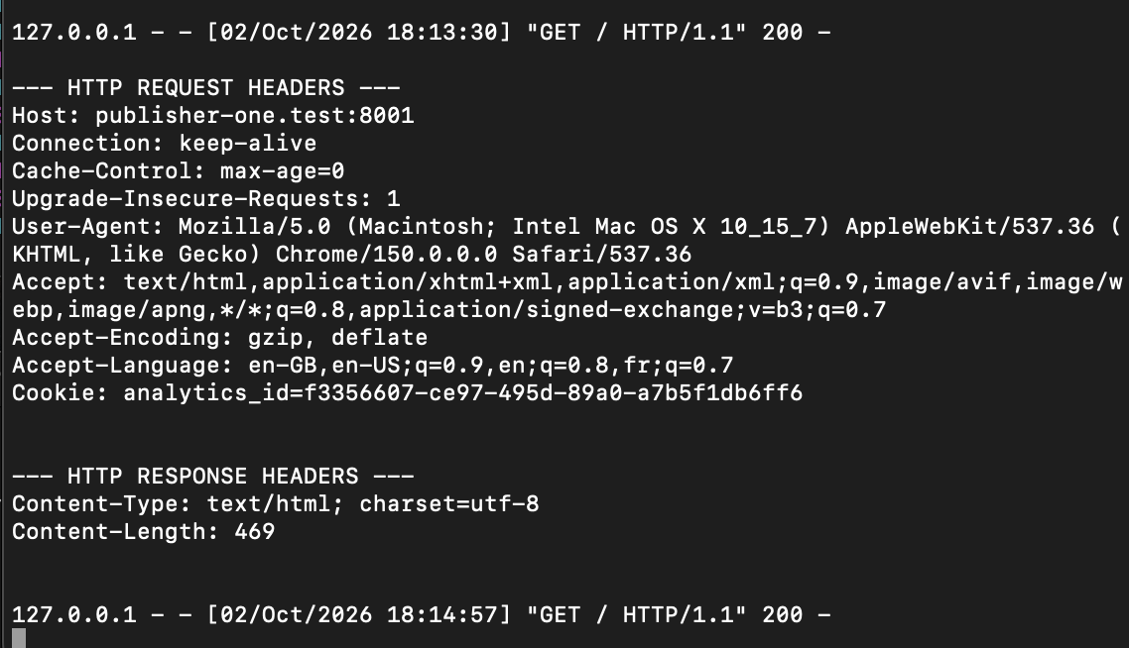
Figure 6 Publisher 1 receives analytics_id in its Cookie request header, confirming first-party persistence.
Unlike Challenge 1, this approach keeps a separate identifier in each publisher's cookie jar; linking those identifiers would require a later mechanism.

