Breaking the Classics Lab Report
  - Caesar Substitution and Vigenere Cryptanalysis

Report Overview
The lab was completed in three stages. The warm-up implemented Caesar encryption, decryption, and exhaustive key search. Room 1 implemented a fixed monoalphabetic substitution cipher and then used frequency analysis to attack an unknown substitution. Room 2 reused the frequency idea against four Caesar-like columns of a Vigenere ciphertext. The recovered Vigenere key was CODE, and the final access word was ECLIPSE.

Results at a Glance
Stage | Technique | Verified result
Warm-up | Caesar shift and brute force | K = 4 encryption; K = 8 decryption; unknown key recovered as 11
Room 1 | Substitution and frequency analysis | Known-key tests succeeded; intercepted message revealed a four-letter key clue
Room 2 | Vigenere column analysis | Key CODE; access word ECLIPSE

1 Caesar Cipher Warm Up
A Caesar cipher replaces each letter with the letter found a fixed number of positions later in the alphabet. Encryption adds the key modulo 26, while decryption subtracts it. Spaces and punctuation are preserved by copying every non-letter directly to the result.

1.1 Encryption and Decryption
Code excerpt 1 Caesar encryption in warmup.py
def ceasar_encrypt(text, K):
result = ""
for char in text:
if char.isupper():
result += chr((ord(char) + K - 65) % 26 + 65)
elif char.islower():
result += chr((ord(char) + K - 97) % 26 + 97)
else:
result += char
return result
K = 4 result: GVCTXS MW JYR YRXMP XLI TVSJIWWSV WECW UYMD
For the supplied K = 8 ciphertext, subtracting eight positions from every letter produces YOUD BETTER NOT BE USING TOOLS TO SOLVE THIS. The ciphertext does not contain an apostrophe, so the program correctly preserves the exact letter sequence YOUD.

1.2 Recovering a Missing Caesar Key
Caesar has only 26 shifts, and one shift is the unchanged alphabet. Testing keys 1 through 25 is therefore practical. The program prints every candidate so that the meaningful English result can be identified visually.
Code excerpt 2 Exhaustive Caesar search
def ceasar_brute_force(text):
for K in range(1, 26):
decrypted_text = ceasar_decrypt(text, K)
print(f"Key {K}: {decrypted_text}")
Key 11: THE KEY IS UNKNOWN TRY BRUTE FORCE
Figure 1 Caesar outputs and the key 11 brute-force candidate
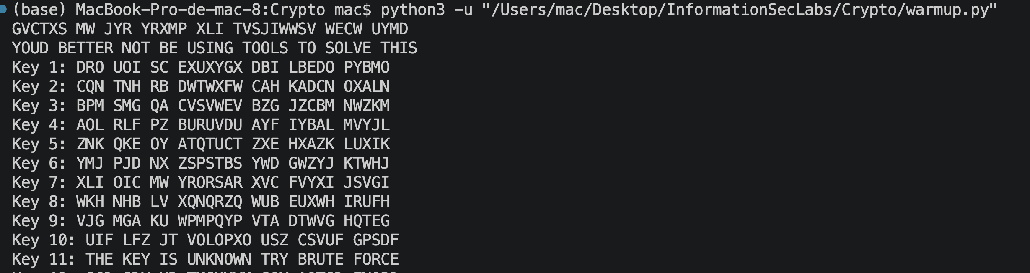

2 Room 1 The Letter Wall
A monoalphabetic substitution uses a fixed one-to-one correspondence between plaintext and ciphertext letters. Unlike Caesar, the substitution is not restricted to a rotation: any permutation of the alphabet may be used. The first two tasks supplied the complete mapping.

2.1 Known Substitution Alphabet
Alphabet half | Plain letters | Cipher letters
A to M | A B C D E F G H I J K L M | Q M J Z T G F K P W L S B
N to Z | N O P Q R S T U V W X Y Z | O X N C R Y E V H I A D U

The encoding function finds the plaintext letter's position and takes the character at the same position in the cipher alphabet. Decoding reverses the lookup. Both functions preserve letter case and copy non-letter characters unchanged.
Code excerpt 3 Substitution encoding in room1.py
def substitution_encode(text):
result = ""
for char in text:
if char.isupper():
index = PLAIN_ALPHABET.index(char)
result += CIPHER_ALPHABET[index]
elif char.islower():
index = PLAIN_ALPHABET.index(char.upper())
result += CIPHER_ALPHABET[index].lower()
else:
result += char
return result
Encryption: KEEP THE SECRET SAFE becomes LTTN EKT YTJRTE YQGT
Decryption: ERVYE DXVR SXFPJ becomes TRUST YOUR LOGIC

2.2 Why Brute Force Is Not Practical
A general substitution key may be any ordering of 26 letters, producing 26! possible keys, or approximately 4.03 x 10^26 candidates. This key space is too large for the simple exhaustive strategy used against Caesar. The attack must instead exploit statistical patterns that remain visible because the same plaintext letter always maps to the same ciphertext letter.

2.3 Frequency Analysis
The program removes spaces and punctuation, counts letters, converts each count into a percentage of the 197 letters in the message, and sorts the output from highest to lowest frequency. The top ciphertext symbols were T at 17.26%, E at 9.64%, R at 9.14%, and X and Y at 8.12% each.
Code excerpt 4 Frequency analysis in room1.py
def analyze_frequency(ciphertext):
letters = [char.upper() for char in ciphertext
if char.upper() in PLAIN_ALPHABET]
counts = Counter(letters)
total_letters = len(letters)
for letter, count in sorted(
counts.items(), key=lambda item: (-item[1], item[0])
):
percentage = count / total_letters * 100
print(f"{letter}: {count} ({percentage:.2f}%)")
Figure 2 Known substitution results and descending frequency counts
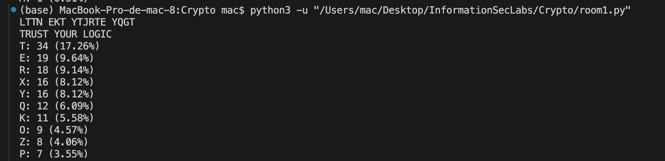
Frequency suggested that ciphertext T likely represented plaintext E. Repeated three-letter patterns such as EKT then supported the reading THE, giving E to T and K to H as well. Short words, repeated forms, and sentence context extended the mapping. The partial-mapping output below records the intermediate stage of the attack; unresolved ciphertext letters remain visible until the full mapping is inferred.
Figure 3 Intermediate substitution recovery from a partial mapping
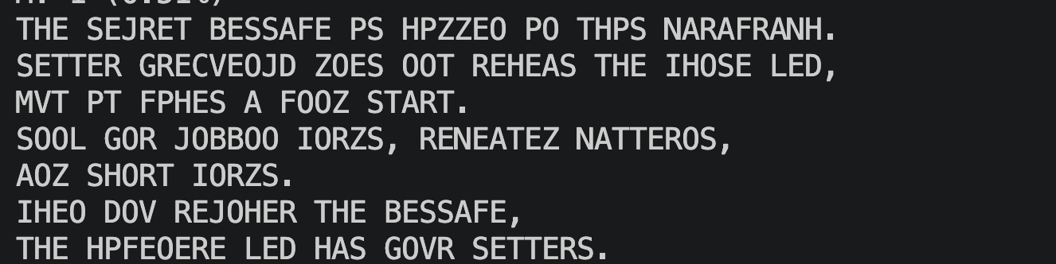

2.4 Recovered Message
THE SECRET MESSAGE IS HIDDEN IN THIS PARAGRAPH.
LETTER FREQUENCY DOES NOT REVEAL THE WHOLE KEY,
BUT IT GIVES A GOOD START.
LOOK FOR COMMON WORDS, REPEATED PATTERNS, AND SHORT WORDS.
WHEN YOU RECOVER THE MESSAGE,
THE VIGENERE KEY HAS FOUR LETTERS.
The important clue is the final sentence: the next cipher uses a four-letter Vigenere key.

3 Room 2 Breaking the Vigenere Cipher
Vigenere applies a repeating sequence of Caesar shifts. Because Room 1 revealed a key length of four, ciphertext positions 0, 4, 8, and so on share the first shift; positions 1, 5, 9, and so on share the second shift; and the pattern continues for four groups. Each group can therefore be analyzed as a separate Caesar cipher.

3.1 Splitting the Ciphertext
Code excerpt 5 Four Vigenere columns in room2.py
group1 = ciphertext[0::4]
group2 = ciphertext[1::4]
group3 = ciphertext[2::4]
group4 = ciphertext[3::4]
The most frequent symbol in each group was assumed to encrypt plaintext E, as directed by the lab hint. Subtracting the alphabet position of E from the observed symbol yields the Caesar shift and therefore the corresponding Vigenere key letter.
Group | Most frequent ciphertext letter | Assumption | Shift | Key letter
1 | G | E maps to G | 2 | C
2 | S | E maps to S | 14 | O
3 | H | E maps to H | 3 | D
4 | I | E maps to I | 4 | E

Recovered Vigenere key: CODE

3.2 Decrypting with the Recovered Key
Code excerpt 6 Vigenere decryption in room2.py
def vigenere_decrypt(ciphertext, key):
result = ""
key_length = len(key)
key_index = 0
for char in ciphertext:
if char.upper() in PLAIN_ALPHABET:
shift = ord(key[key_index % key_length].upper()) - ord('A')
decrypted_char = chr((ord(char.upper()) - shift - 65) % 26 + 65)
result += decrypted_char
key_index += 1
else:
result += char
return result
Figure 4 Recovered group frequencies, key CODE, and decrypted message
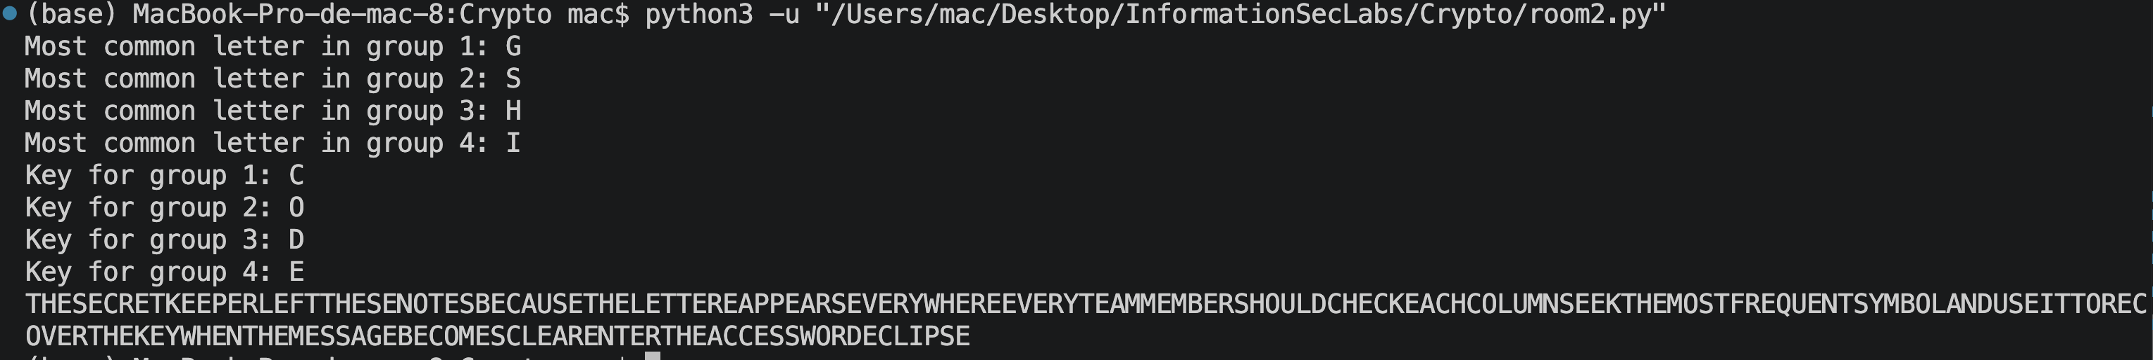

3.3 Recovered Plaintext and Access Word
THE SECRET KEEPER LEFT THESE NOTES BECAUSE THE LETTER E APPEARS EVERYWHERE. EVERY TEAM MEMBER SHOULD CHECK EACH COLUMN, SEEK THE MOST FREQUENT SYMBOL, AND USE IT TO RECOVER THE KEY. WHEN THE MESSAGE BECOMES CLEAR, ENTER THE ACCESS WORD ECLIPSE.
Final access word: ECLIPSE

4 Security Discussion
The exercises show why classical ciphers do not provide modern security. Caesar fails because its key space is tiny: every candidate can be displayed immediately. A general substitution cipher has a much larger key space, but it preserves single-letter frequencies, repeated-letter structures, word lengths, and repeated word patterns. Vigenere hides simple whole-message frequencies better, but a repeating key creates periodic groups. Once the period is known, each group reduces to a Caesar cipher and becomes vulnerable to the same frequency assumptions.
The practical lesson is that a large nominal key space is not sufficient when the encryption process leaks language structure or repeats predictable transformations. Modern encryption avoids these weaknesses through rigorously analyzed algorithms, large keys, non-repeating randomness, and authenticated modes that protect both secrecy and integrity.

5 Conclusion
All required stages were implemented and executed successfully. The Python programs preserved non-letter characters where required, automated the Caesar key search, measured substitution frequencies, recovered a partial substitution mapping using language patterns, separated the Vigenere ciphertext into four statistical groups, and decrypted the final message with key CODE. The completed chain ends with the access word ECLIPSE.

Source Inventory
File | Purpose
warmup.py | Caesar encryption, decryption, and brute-force enumeration
room1.py | Substitution operations, letter-frequency analysis, and partial mapping
room2.py | Four-group analysis, key recovery, and Vigenere decryption
screenshots/*.png | Terminal execution evidence for each stage
TP___Breaking_the_Classics.pdf | Lab specification and cipher inputs

