Lab Report

1. Guided DAC Experiment
A file was created in DAC_Lab using touch report.txt. The chmod 740 command set owner permissions to read/write/execute (7), group permissions to read only (4), and no permissions for others (0).
The lab uses Linux groupadd; on macOS it was replaced with dseditgroup. The file owner and group were changed with chown root:accounting.
touch report.txt ; chmod 740 report.txt
sudo dseditgroup -o create accounting
sudo chown root:accounting report.txt
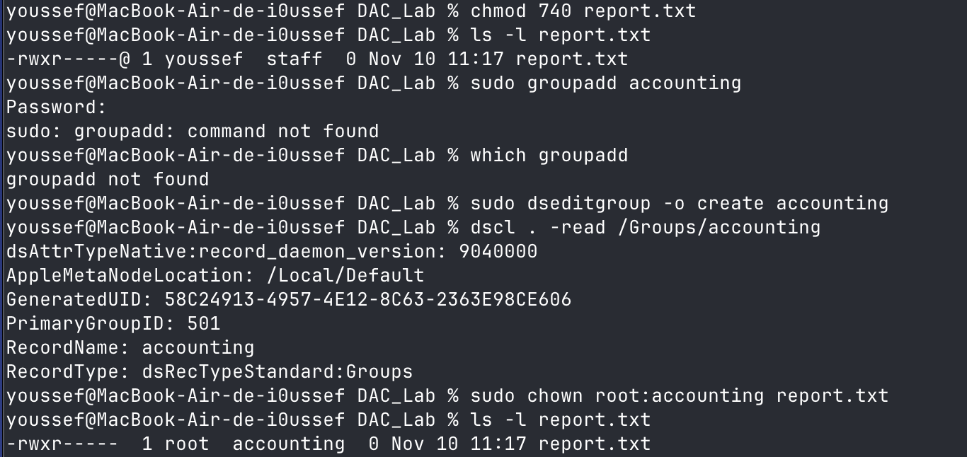

2. Challenge 1 : Confidential Documents
Policy: the owner may read and modify; members of accounting may read only; others must have no access.
The example was implemented in the finance directory inside DAC_Lab, rather than the lab sheet’s absolute /company/finance path. A new report.txt was created there.

Ownership and permissions
sudo chown root:accounting report.txt
sudo chown root:accounting ../finance
sudo chmod 640 report.txt
sudo chmod 750 ../finance
File 640 = owner rw-, accounting r--, others ---. Directory 750 = owner rwx, accounting r-x, others ---. Directory execute (x) allows traversal to a file; file read (r) allows reading its contents.
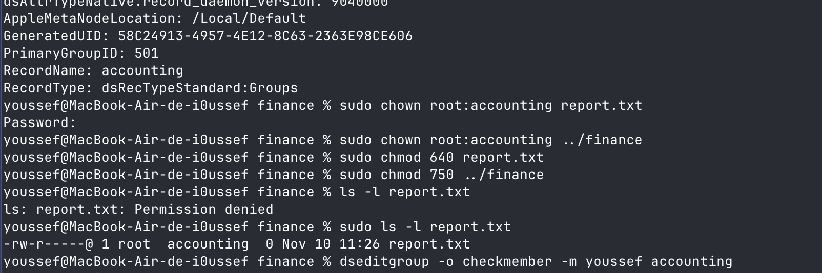

Access verification
Initially, ls -l report.txt returned Permission denied because youssef was not a member of accounting and could not traverse the finance directory. After adding youssef to the group, listing the file succeeded. Attempting to append data still returned Permission denied, consistent with read-only group access.
dseditgroup -o checkmember -m youssef accounting
sudo dseditgroup -o edit -a youssef -t user accounting
ls -l report.txt
echo "Confidential financial data" >> report.txt
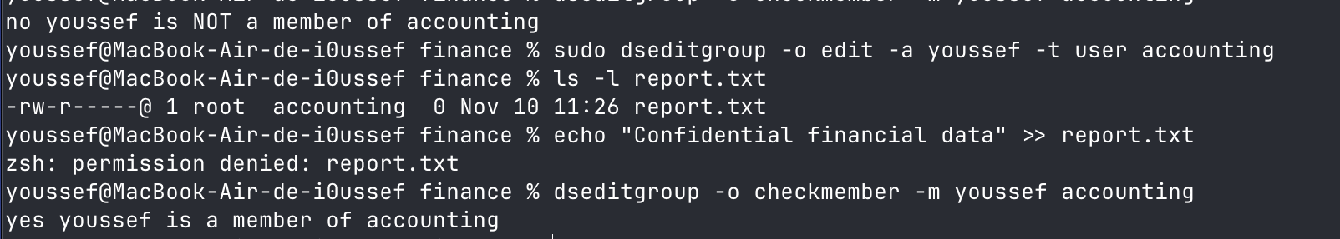

Question 6 : Directory 750 and file 600
No. An accounting member who is not the owner cannot read or write the file. File mode 600 grants rw- only to the owner and --- to the group.

3. Mandatory Access Control (MAC): Challenge 2
Security hierarchy: Secret > Confidential > Public. Bell–LaPadula enforces “No Read Up” and “No Write Down” to protect confidentiality.

Question 1 : Read access matrix
User / Clearance | Document_A / Secret | Document_B / Confidential | Document_C / Public
Alice / Secret | Allow | Allow | Allow
Bob / Confidential | Deny | Allow | Allow
Charlie / Public | Deny | Deny | Allow
Read access is allowed only when the user’s clearance is at least the document’s classification (No Read Up).

Question 2 : Bob reads Document_A
Denied. Bob has Confidential clearance, which is lower than Document_A’s Secret classification. Reading it would violate No Read Up.

Question 3 : Alice writes into Document_C
Denied. Alice has Secret clearance, while Document_C is Public. Writing to a lower classification would violate No Write Down.

Question 4 : Preventing information leakage
No Read Up prevents users from reading information above their clearance. No Write Down prevents a high-clearance user from transferring sensitive information into lower-classification documents. Together, these rules protect confidentiality.

Question 5 : MAC clearance versus DAC permissions
Access is not necessarily granted. On systems enforcing both MAC and DAC, both checks must allow the operation. Even with sufficient MAC clearance, ordinary file permissions can deny access.

4. Role-Based Access Control (RBAC): Challenge 3
Enterprise Access Management. Unix groups were used to simulate three roles: developers (Alice), viewers (Bob), and administrators (Charlie). This section records the setup, corrections, and access tests performed so far.

Tasks 1–2: Users, groups, and initial permissions
On macOS, dseditgroup replaced groupadd/usermod, and sysadminctl was used to create the test accounts. Membership checks confirmed Alice in developers, Bob in viewers, and Charlie in administrators.
sudo dseditgroup -o create administrators # similarly: developers, viewers
sudo dseditgroup -o edit -a alice -t user developers
sudo dseditgroup -o edit -a bob -t user viewers
sudo dseditgroup -o edit -a charlie -t user administrators
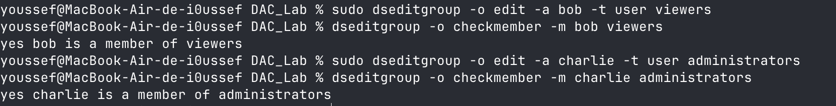

Because the macOS root filesystem is read-only, /company was replaced by ~/DAC_Lab/company. The source directory was owned by root:developers with mode 770; reports was owned by root:viewers with mode 750. The parent company directory was mode 755.
mkdir -p company/source company/reports
sudo chown root:developers company/source && sudo chmod 770 company/source
sudo chown root:viewers company/reports && sudo chmod 750 company/reports

Task 3: Does the initial setup satisfy the policy?
Role | Required access | Initial configuration
Developer | Source: read/write; Reports: read | Source permitted; reports missing
Viewer | Source: none; Reports: read | Directory permissions correct
Administrator | Full access to both | Missing on both directories
Therefore, the initial Unix permission bits alone do not satisfy the full policy: one directory has only one associated group.

Task 4: Additional macOS ACL permissions
ACL entries were added to grant developers read/traverse access to reports and administrators broad directory access to both locations without changing the existing group bits. The + shown by ls -lde confirms ACLs are present.
sudo chmod +a "group:developers allow list,search,readattr,readextattr,readsecurity" company/reports
sudo chmod +a "group:administrators allow read,write,execute,delete,append,readattr,writeattr,readextattr,writeextattr,readsecurity,writesecurity,chown" company/source
# The same administrators ACL was added to company/reports
ls -lde company/source company/reports
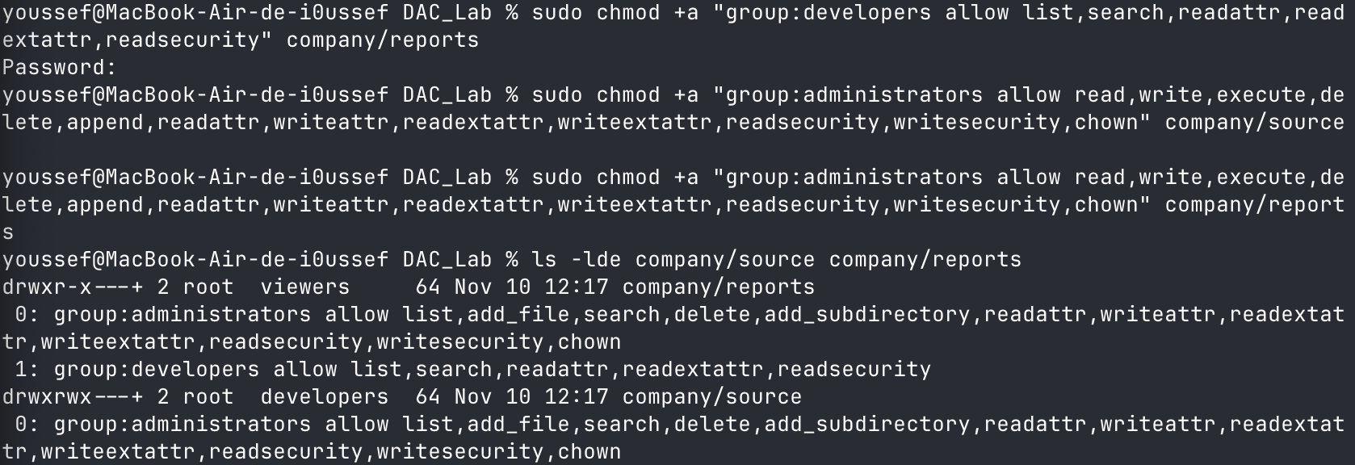

Initial verification: Alice (Developer)
Two sample files were created: code.txt (root:developers, 660) and report.txt (root:viewers, 640). Alice successfully listed both directories and created a file in source. Creating a file in reports was denied, as intended.
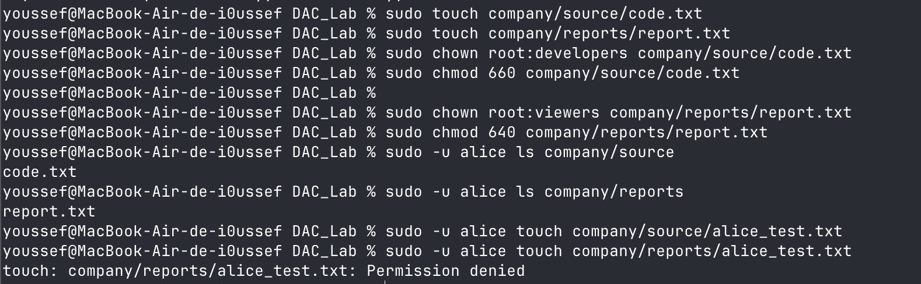

4. Attribute-Based Access Control (ABAC)
ABAC determines access based on attributes of the user, resource, and environment. In this challenge, a banking system grants access only when all three conditions are satisfied:
- The user's department matches the document's department.
- The user's clearance is sufficient for the document's classification.
- The request occurs between 08:00 and 18:00.

Q1:
User | Department | Clearance | Document | Time | Decision
Alice | Finance | Secret | Finance / Secret | 10:00 | Granted
Bob | HR | Confidential | Finance / Confidential | 11:00 | Denied
Charlie | Finance | Public | Finance / Secret | 14:00 | Denied
David | Finance | Secret | Finance / Secret | 22:00 | Denied

Q2:
- Alice: Access granted because all three conditions are satisfied.
- Bob: Access denied because his department (HR) does not match the document's department (Finance).
- Charlie: Access denied because his clearance (Public) is lower than the document's classification (Secret).
- David: Access denied because 22:00 is outside the authorized access period.

Q3:
Access is denied because Alice belongs to the Finance department, while the requested document belongs to HR. The department-matching condition is not satisfied, regardless of her security clearance.

Q4:
Access is granted. David belongs to Finance, has Secret clearance, and requests access within the authorized time interval. Therefore, all three conditions are satisfied.

Q5:
RBAC grants permissions based mainly on predefined user roles, whereas ABAC evaluates multiple attributes, including department, clearance, document classification, and access time.
ABAC is more flexible because it supports context-dependent access decisions without requiring a separate role for every possible situation.

